国 际 电 信 联 盟
电信标准化局
2022年7月1日 ，日内瓦

参考号:  电话:  传真:  电子邮件: | 电信标准化局AAP-8  AAP/CL  +41 22 730 5860  +41 22 730 5853  tsbdir@itu.int | – 致国际电联成员国各主管部门；  – 致ITU-T各部门成员；  – 致ITU-T 部门准成员；  – 国际电联学术成员  抄送：  – 电信标准化局研究组主席和副主席；  – 电信发展局主任；  – 无线电通信局主任

事由: | 有关采用替换批准程序（AAP）处理的建议书的情况

先生/女士，
ITU-T A.8 建议书中规定的建议书替换批准程序 (AAP) 适用于那些不会产生政策或 监管影响、因而不需与成员国正式协商的建议书（见国际电联《公约》第246B款）。
附件1列出了那些在以往电信标准化局AAP预告后地位发生变化的案文。
如您希望针对某个适用AAP的建议书提出意见，请使用可在ITU-T网站AAP区域 （https://www.itu.int/ITU-T/aap）的“建议书”网页上获取的《AAP意见在线提交表格》 （见附件2）。或者，可填妥附件3 中的表格并将意见发送给相关研究组的秘书处。
敬请留意，我们不鼓励提交仅支持通过所涉案文而没有实质内容的意见。

顺致敬意！

李在摄
电信标准化局主任

附件：3件

Annex 1
(to TSB AAP-8)

Status codes used in the AAP announcements:
LC = Last Call
LJ = Last Call Judgment (includes comment resolution)
AR = Additional Review
AJ = Additional Review Judgment (includes comment resolution)
SG = For Study Group approval
A = Approved
AT = Approved with typographic corrections
AC = Approved after Additional Review of Comments
NA = Not approved
TAP = Moved to TAP (ITU-T A.8 / § 5.2)
ITU-T website entry page:
https://www.itu.int/ITU-T
Alternative approval process (AAP) welcome page:
https://www.itu.int/ITU-T/aapinfo
Note – A tutorial on the ITU-T AAP application is available under the AAP welcome page
ITU-T website AAP Recommendation search page:
https://www.itu.int/ITU-T/aap/
Study Group web pages and contacts:
SG 2 | https://www.itu.int/ITU-T/studygroups/com02 | tsbsg2@itu.int
SG 3 | https://www.itu.int/ITU-T/studygroups/com03 | tsbsg3@itu.int
SG 5 | https://www.itu.int/ITU-T/studygroups/com05 | tsbsg5@itu.int
SG 9 | https://www.itu.int/ITU-T/studygroups/com09 | tsbsg9@itu.int
SG 11 | https://www.itu.int/ITU-T/studygroups/com11 | tsbsg11@itu.int
SG 12 | https://www.itu.int/ITU-T/studygroups/com12 | tsbsg12@itu.int
SG 13 | https://www.itu.int/ITU-T/studygroups/com13 | tsbsg13@itu.int
SG 15 | https://www.itu.int/ITU-T/studygroups/com15 | tsbsg15@itu.int
SG 16 | https://www.itu.int/ITU-T/studygroups/com16 | tsbsg16@itu.int
SG 17 | https://www.itu.int/ITU-T/studygroups/com17 | tsbsg17@itu.int
SG 20 | https://www.itu.int/ITU-T/studygroups/com20 | tsbsg20@itu.int

Situation concerning Study Group 2 Recommendations under AAP
Rec # | Title | Last Call (LC) Period |  |  |  | Additional Review (AR) Period |  |  |  | Status
 |  | LC Start | LC End | LC  Result | LJ  Result | AR Start | AR End | AR  Result | AJ  Result
M.3382 (M.rwop-AI) | Requirements for work order processing in telecom management with AI (Summary) | 2022-06-01 | 2022-06-28 | A |  |  |  |  |  | A
Situation concerning Study Group 12 Recommendations under AAP
Rec # | Title | Last Call (LC) Period |  |  |  | Additional Review (AR) Period |  |  |  | Status
 |  | LC Start | LC End | LC  Result | LJ  Result | AR Start | AR End | AR  Result | AJ  Result
E.803 | Quality of service parameters for supporting service aspects (Summary) | 2022-07-01 | 2022-07-28 |  |  |  |  |  |  | LC
G.191 | Software tools for speech and audio coding standardization (Summary) | 2022-07-01 | 2022-07-28 |  |  |  |  |  |  | LC
G.1023 (G.NCAP) | Framework for capacity assessment of packet data services in mobile networks (Summary) | 2022-07-01 | 2022-07-28 |  |  |  |  |  |  | LC
G.1036 (G.QoE-AR) | Quality of experience (QoE) influencing factors for augmented reality (AR) services (Summary) | 2022-07-01 | 2022-07-28 |  |  |  |  |  |  | LC
P.64 | Determination of sensitivity/frequency characteristics of local telephone systems (Summary) | 2022-07-01 | 2022-07-28 |  |  |  |  |  |  | LC
P.380 | Electro-acoustic measurements on headsets (Summary) | 2022-07-01 | 2022-07-28 |  |  |  |  |  |  | LC
P.581 | Use of head and torso simulator for hands-free and handset terminal testing (Summary) | 2022-07-01 | 2022-07-28 |  |  |  |  |  |  | LC
P.852 (P.SEC) | Subjective quality evaluation of text-based chatbots (Summary) | 2022-07-01 | 2022-07-28 |  |  |  |  |  |  | LC
P.863.2 (P.AMD) | Extension of P.863 for multi-dimensional assessment of degradations in telephony speech signals up to full-band (Summary) | 2022-07-01 | 2022-07-28 |  |  |  |  |  |  | LC
P.910 | Subjective video quality assessment methods for multimedia applications (Summary) | 2022-07-01 | 2022-07-28 |  |  |  |  |  |  | LC
P.1140 | Speech communication requirements for emergency calls originating from vehicles (Summary) | 2022-07-01 | 2022-07-28 |  |  |  |  |  |  | LC
P.1204.4 | Video quality assessment of streaming services over reliable transport for resolutions up to 4K with access to full and reduced reference pixel information (Summary) | 2022-07-01 | 2022-07-28 |  |  |  |  |  |  | LC
P.1320 (P.QXM) | QoE assessment of extended reality (XR) meetings (Summary) | 2022-07-01 | 2022-07-28 |  |  |  |  |  |  | LC
P.1402 (P.MLGuide) | Guidance for the development of machine learning based solutions for QoS/QoE prediction and network performances management in telecommunication scenarios (Summary) | 2022-07-01 | 2022-07-28 |  |  |  |  |  |  | LC
Y.1545.2 (Y.COPI) | QoS metrics for continuity-of-performance of packet data based services (Summary) | 2022-07-01 | 2022-07-28 |  |  |  |  |  |  | LC
Situation concerning Study Group 17 Recommendations under AAP
Rec # | Title | Last Call (LC) Period |  |  |  | Additional Review (AR) Period |  |  |  | Status
 |  | LC Start | LC End | LC  Result | LJ  Result | AR Start | AR End | AR  Result | AJ  Result
X.1409 (X.ss-dlt) | Security services based on distributed ledger technology (Summary) | 2022-07-01 | 2022-07-28 |  |  |  |  |  |  | LC

Annex 2
(to TSB AAP-8)
Using the on-line comment submission form
Comment submission
1) Go to AAP search Web page at https://www.itu.int/ITU-T/aap/
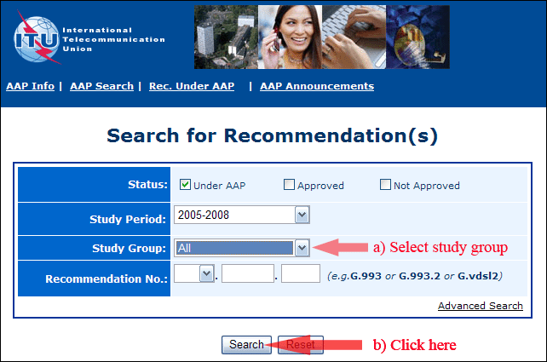
2) Select your Recommendation
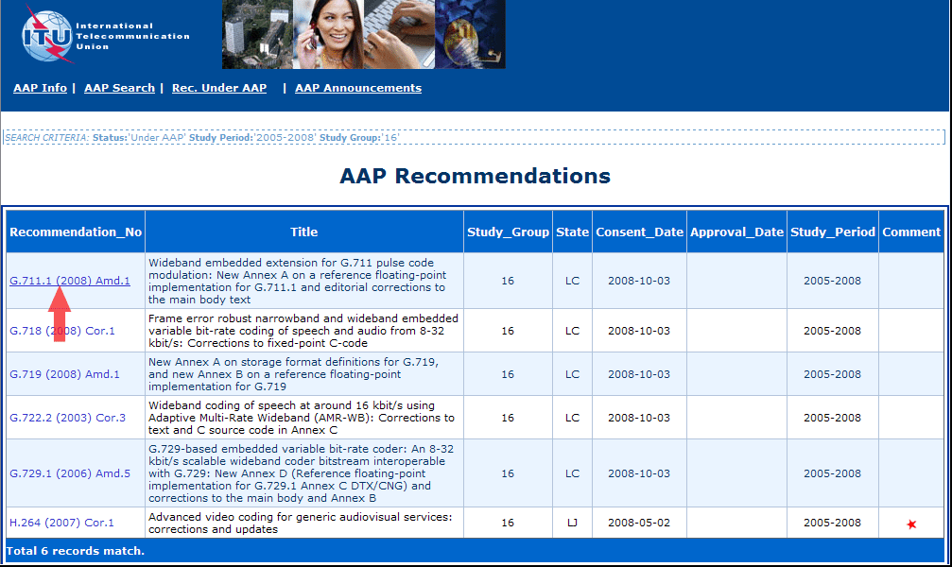
3) Click the "Submit Comment" button
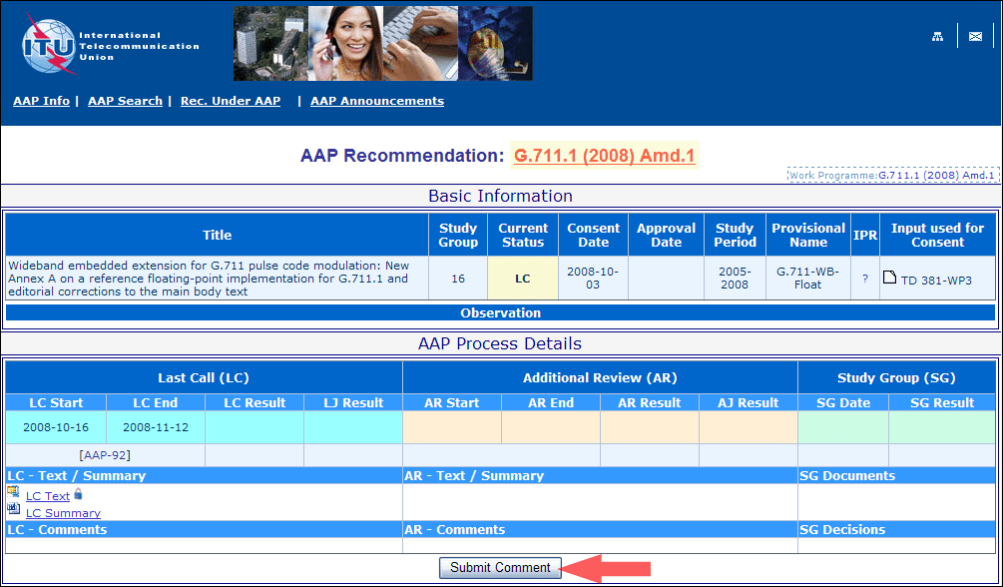
4) Complete the on-line form and click on "Submit"
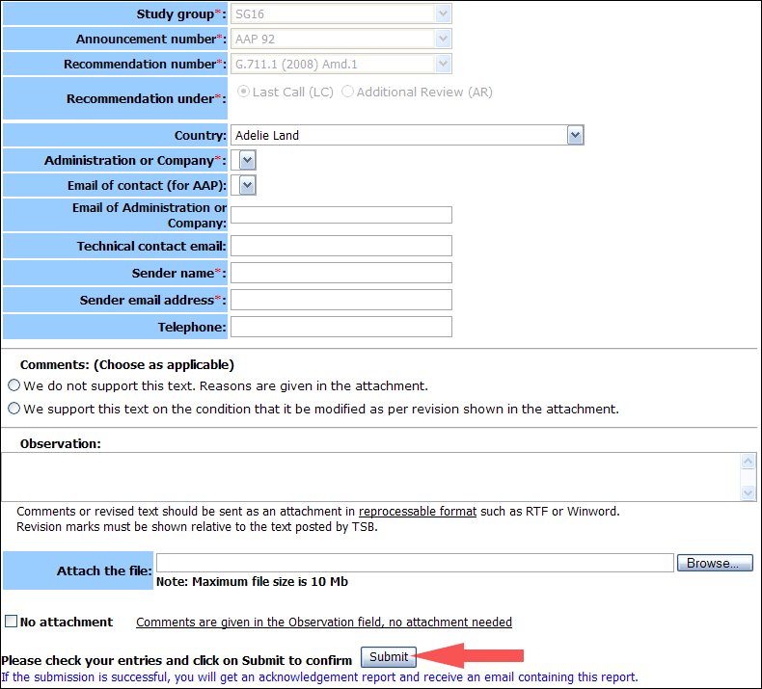
For more information, read the AAP tutorial on:
https://www.itu.int/ITU-T/aapinfo/files/AAPTutorial.pdf
Annex 3
(to TSB AAP-8)
Recommendations under LC/AR – Comment submission form
(Separate form for each Recommendation being commented upon)
ITU-T AAP comment submission form
Study Group:
Announcement number:
Recommendation number:
Date consented:
Recommendation under: | Last call (LC)  Additional Review (AR)
Country:
Administration/Company:
Name of AAP Contact Person:
Email of AAP Contact Person:
Sender name:
(if different from AAP Contact Person)
Sender email address:
Telephone:
Comments:  (Choose as applicable) | We do not support this text. Reasons are given in the attachment.  We support this text on the condition that it be modified as per revision shown in the attachment.
Observations:
No attachment: Comments are given in the Observation field, no attachment needed
To be returned to: email: tsbsg....@itu.int
[or fax +41 22 730 5853]
Comments or revised text should be sent as an attachment in RTF or WinWord format.
Revision marks must be shown relative to the text posted by TSB.

