|  |
| --- |
| **Recommendation ITU-R BS.1283-2**  **(10/2019)** |
| **Guidance for the selection of the most appropriate ITU-R Recommendation(s) for subjective assessment of sound quality** |
| **BS Series**  **Broadcasting service (sound)** |

Foreword

The role of the Radiocommunication Sector is to ensure the rational, equitable, efficient and economical use of the radio-frequency spectrum by all radiocommunication services, including satellite services, and carry out studies without limit of frequency range on the basis of which Recommendations are adopted.

The regulatory and policy functions of the Radiocommunication Sector are performed by World and Regional Radiocommunication Conferences and Radiocommunication Assemblies supported by Study Groups.

# Policy on Intellectual Property Right (IPR)

ITU-R policy on IPR is described in the Common Patent Policy for ITU-T/ITU-R/ISO/IEC referenced in Resolution ITU‑R 1. Forms to be used for the submission of patent statements and licensing declarations by patent holders are available from <http://www.itu.int/ITU-R/go/patents/en> where the Guidelines for Implementation of the Common Patent Policy for ITU‑T/ITU‑R/ISO/IEC and the ITU-R patent information database can also be found.

|  |  |
| --- | --- |
| Series of ITU-R Recommendations  (Also available online at <http://www.itu.int/publ/R-REC/en>) | |
| **Series** | Title |
| **BO** | Satellite delivery |
| **BR** | Recording for production, archival and play-out; film for television |
| BS | Broadcasting service (sound) |
| **BT** | Broadcasting service (television) |
| **F** | Fixed service |
| **M** | Mobile, radiodetermination, amateur and related satellite services |
| **P** | Radiowave propagation |
| **RA** | Radio astronomy |
| **RS** | Remote sensing systems |
| **S** | Fixed-satellite service |
| **SA** | Space applications and meteorology |
| **SF** | Frequency sharing and coordination between fixed-satellite and fixed service systems |
| **SM** | Spectrum management |
| **SNG** | Satellite news gathering |
| **TF** | Time signals and frequency standards emissions |
| **V** | Vocabulary and related subjects |

|  |
| --- |
|  |

|  |
| --- |
| ***Note***: *This ITU-R Recommendation was approved in English under the procedure detailed in Resolution ITU-R 1.* |

*Electronic Publication*

Geneva, 2019

© ITU 2019

All rights reserved. No part of this publication may be reproduced, by any means whatsoever, without written permission of ITU.

RECOMMENDATION ITU-R BS.1283-2

Guidance for the selection of the most appropriate ITU-R Recommendation(s)  
for subjective assessment of sound quality

(1997-2003-2019)

Scope

This Recommendation provides guidance for the selection of the most appropriate ITU-R Recommendation(s) for the subjective assessment of sound quality. A number of ITU-R Recommendations provide assessment methods and the method to be used is dependent upon the intended purpose of the assessment and the performance of the systems under test. An overview of the available methods is given and guidance for selection is provided.

Keywords

Listening test, artefacts, audio quality, audio coding, subjective assessment, attribute, perceptual evaluation, rating scale

The ITU Radiocommunication Assembly,

considering

*a)* that ITU-R has issued several Recommendations on subjective methods of assessing sound quality;

*b)* that methods used for the subjective assessment depend on the intended purpose of the assessment of sound quality itself and of the performance of audio systems,

recommends

**1** that for the selection of the most appropriate method of subjective assessment of sound quality, the guidance given in Annex1 should be referred to;

**2** that subjective assessments should be carried out according to the following ITU-R Recommendations:

ITU-R BS.1284 General methods for the subjective assessment of sound quality;

ITU-R BS.1116 Methods for the subjective assessment of small impairments in audio systems, including multichannel sound systems;

ITU-R BS.1285 Pre-selection methods for the subjective assessment of small impairments in audio systems;

ITU-R BS.2126 Methods for the subjective assessment of audio systems with accompanying picture;

ITU-R BS.1534 Method for the subjective assessment of intermediate quality level of coding systems;

ITU-R BS.2132 Method for the subjective quality assessment of audible differences of sound systems using multiple stimuli without a given reference,

**3** that the applicability of one or more of the Recommendations should be decided, based on the purpose of the subjective assessment tests, before the tests are designed.

Annex 1  
  
General considerations governing the range of applications of ITU‑R Recommendations relating to the subjective assessment of sound quality

The methods used for the subjective assessment of sound quality itself and of the performance of audio systems depend to some extent on the intended purpose of the assessment. A number of Recommendations exist and this Recommendation gives guidance on the use of the other Recommendations.

Recommendation ITU-R BS.1284 – General methods for the subjective assessment of sound quality, is intended for the general assessment of sound quality. It refers to Recommendation ITU‑R BS.1116 which contains common requirements.

Recommendation ITU-R BS.1116 – Methods for the subjective assessment of small impairments in audio systems, including multichannel sound systems, is intended as the most critical methodology. It is intended for use in the assessment of systems which introduce impairments so small as to be undetectable without rigorous control of the experimental conditions and appropriate statistical analysis. If used for systems that introduce relatively large and easily detectable impairment, it leads to excessive expenditure of time and effort and may also lead to less reliable results than those obtained by employing a simpler test method. Recommendation ITU-R BS.1116 forms the base reference for the other Recommendations, which may contain additional special conditions or relaxations of the requirements of Recommendation ITU‑R BS.1116.

Recommendation ITU-R BS.1285 –Pre-selection methods for the subjective assessment of small impairments in audio systems, is intended for the preliminary screening of audio systems, prior to the application of the more stringent assessment methods of Recommendation ITU-R BS.1116. This screening will obviate the need for further tests of systems which introduce large impairments.

Recommendation ITU-R BS.2126 – Methods for the subjective assessment of audio systems with accompanying picture, is intended to cover those aspects of subjective assessment which are especially relevant to the case where the sound is accompanied by related pictures. Some aspects of the perceived sound quality are affected by the accompanying visual material.

Recommendation ITU-R BS.1534 – Method for the subjective assessment of intermediate quality level of coding systems, is intended to cover those aspects of subjective assessment of intermediate quality level of coding systems. It is intended to give a reliable and repeatable measure of systems having audio quality, which would normally fall in the lower half of the impairment scale used by Recommendation ITU-R BS.1116.

Recommendation ITU-R BS.2132 – Method for the subjective quality assessment of audible differences of sound systems using multiple stimuli without a given reference, is intended to cover those aspects of sound quality assessment where rating fidelity to a reference signal is not appropriate or not possible, and descriptive assessment is optionally required to characterise the quality of multiple systems in detail.

Clearly, some areas of application overlap. The applicability of one or more of the Recommendations should be decided, based on the purpose of the tests, before the tests are designed. The flow chart shown in Fig. 1 may be used to assist in the choice of appropriate Recommendations, or alternatively Table 1.

FIGURE 1

Flow chart guiding selection of methods

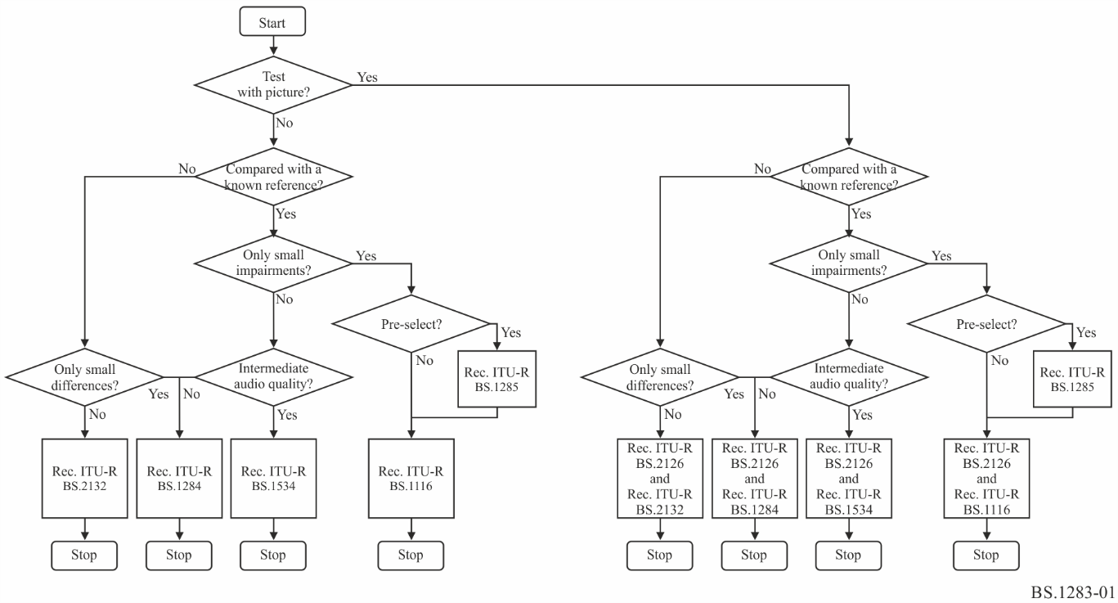

TABLE 1

Guidelines on selection of methods

|  |  |
| --- | --- |
| Only small impairments from a reference? | Use Rec. ITU-R BS.1116. If not sure, first pre-select only systems with small impairments, according to Rec. ITU-R BS.1285. |
| Assessing coding systems and intermediate sound quality levels expected? | Use Rec. ITU-R BS.1534. |
| Not comparing to a reference and audible differences of sound quality expected? | Use Rec. ITU-R BS.2132. |
| Need to test with picture? | Use Rec. ITU-R BS.2126 with other methods. |
| When other conditions do not apply | Methods from Rec. ITU-R BS.1284 can be considered. |

Attachment 1   
to Annex 1   
(informative)  
  
Use Cases for Quality evaluation of audio systems

A list of example uses cases for quality evaluation of audio systems within the scope of ITU-R Working Party 6C:

− Codec system tests, comparing the uncompressed reference to stimuli that have been processed through one or more codecs with various configurations. Such systems should ideally be perceptually transparent.

• Such tests where only small impairments are present.

• Such tests where intermediate quality levels are present.

− Evaluating the perceptual effects of audio watermarking systems for audience measurement in broadcasting. Such systems should ideally be perceptually transparent.

• Such tests where only small impairments are present.

• Such tests where intermediate quality levels are present.

− Testing systems for home theatre reproduction of cinema content, where the reference system is a defined quality target described by objective parameters identified prior to the testing, compared to one or more other systems.[1]

− Testing systems for home theatre reproduction of cinema content, where there is no system giving a known best quality target *a priori*. Which (if any) system has the highest perceived quality?

− Evaluating the rendering of an advanced sound production represented in an ADM file that was produced with a certain renderer profile, when rendered with that renderer profile (as reference, so representing the producer’s intent) and other renderer profiles. This would tell the experimenter if there are perceivable differences between the results of the renderer profiles.

− Evaluating the rendering of an advanced sound production represented in an ADM file that was produced with a certain renderer profile, when rendered with that renderer profile and other renderer profiles. This would tell the experimenter whether or not there are differences in perceived overall quality amongst the renderer profiles. [For clarification: one ADM file, different renderers]

− Evaluating systems for binaural reproduction of signals for a 3D multichannel loudspeaker system (such as those in Recommendation ITU-R BS.2051) i.e. headphone virtualisation systems.

− Evaluating multi-band dynamics processing systems and settings for radio distribution.

− Evaluating up-mixing or down-mixing algorithms.

− Evaluating reverberation processors for 3D audio production.

− Comparison of multichannel microphone techniques.

− Evaluation of HOA microphone arrays performance.

− Comparison of scene-based program material at different HOA orders.

− Comparison of different scene-based loudspeaker renderers (e.g. 9+10+3 (system H) vs. 4+7+0 (system J)).

− Comparing the reproduction of an advanced sound programme on different loudspeaker layouts by a single renderer.

− Evaluating personalization features in advanced sound systems such as a dialogue enhancement control.

1. This shows that the reference does not always need to be unprocessed.