Recommendation ITU-R F.1520-4
(02/2023)
Radio-frequency arrangements for systems in the fixed service operating
in the band 31.8-33.4 GHz

F Series
Fixed service

Foreword
The role of the Radiocommunication Sector is to ensure the rational, equitable, efficient and economical use of the radio-frequency spectrum by all radiocommunication services, including satellite services, and carry out studies without limit of frequency range on the basis of which Recommendations are adopted.
The regulatory and policy functions of the Radiocommunication Sector are performed by World and Regional Radiocommunication Conferences and Radiocommunication Assemblies supported by Study Groups.

Policy on Intellectual Property Right (IPR)
ITU-R policy on IPR is described in the Common Patent Policy for ITU-T/ITU-R/ISO/IEC referenced in Resolution ITU-R 1. Forms to be used for the submission of patent statements and licensing declarations by patent holders are available from http://www.itu.int/ITU-R/go/patents/en where the Guidelines for Implementation of the Common Patent Policy for ITU-T/ITU-R/ISO/IEC and the ITU-R patent information database can also be found.

Series of ITU-R Recommendations
(Also available online at http://www.itu.int/publ/R-REC/en)
Series | Title
BO | Satellite delivery
BR | Recording for production, archival and play-out; film for television
BS | Broadcasting service (sound)
BT | Broadcasting service (television)
F | Fixed service
M | Mobile, radiodetermination, amateur and related satellite services
P | Radiowave propagation
RA | Radio astronomy
RS | Remote sensing systems
S | Fixed-satellite service
SA | Space applications and meteorology
SF | Frequency sharing and coordination between fixed-satellite and fixed service systems
SM | Spectrum management
SNG | Satellite news gathering
TF | Time signals and frequency standards emissions
V | Vocabulary and related subjects

Note: This ITU-R Recommendation was approved in English under the procedure detailed in Resolution ITU-R 1.

Electronic Publication
Geneva, 2023

© ITU 2023
All rights reserved. No part of this publication may be reproduced, by any means whatsoever, without written permission of ITU.

RECOMMENDATION ITU-R F.1520-4
Radio-frequency arrangements for systems in the fixed service
operating in the band 31.8-33.4 GHz
(Question ITU-R 247/5)
(2001-2002-2003-2011-2023)
Scope
This Recommendation specifies radio-frequency channel arrangements for fixed service systems with channel separation of 3.5, 7, 14, 28, 56, 112 and 224 MHz (including 56 MHz block arrangements) in the band 31.8-33.4 GHz which has been identified for use for high density applications in the fixed service (HDFS).
Keywords
Fixed service, point-to-point, channel bandwidth, channel arrangement, 32 GHz
Abbreviations
FDD Frequency division duplex
FS Fixed service
HDFS High density applications in the fixed service
RF Radio frequency
RNS Radionavigation service
RR Radio Regulations
TDD Time division duplex
Related ITU Recommendations and Reports
Recommendation ITU-R F.746 – Radio-frequency arrangements for fixed service systems
Recommendation ITU-R F.1571 – Mitigation techniques for use in reducing the potential for interference between airborne stations in the radionavigation service and stations in the fixed service in the band 31.8-33.4 GHz
The ITU Radiocommunication Assembly,
considering
a) that the band 31.8-33.4 GHz is allocated, among others, to the fixed service (FS) on a primary basis;
b) that the 31.8-33.4 GHz band is available for high-density applications in the FS;
c) that sharing in the 31.8-33.4 GHz band with radionavigation service (RNS), space research service (deep space, space-to-Earth) and inter-satellite service is considered to be feasible;
d) that harmonized radio frequency (RF) arrangements can facilitate effective use of the spectrum;
e) that several systems with various transmission signal characteristics and capacities may be in simultaneous use in this frequency band;
f) that certain frequency block arrangements can be achieved by aggregating the frequency channels given in Annex 1;
g) that it may sometimes be desirable to interleave additional RF channels between those of the main pattern;
h) that a high degree of compatibility between FS systems of different frequency arrangements can be achieved by selecting channel centre frequencies within a homogeneous basic pattern;
i) that each region or country will have specific needs in how to use the band;
j) that different block sizes may be required to suit various applications;
k) that the traffic capacity required for fixed wireless links is continuously growing,
recognizing
a) that some applications in this frequency band may require differing architectures (point-to-point and multipoint systems), channel bandwidths, and systems characteristics including the accommodation of symmetrical and asymmetrical traffic; and may require the use of frequency block-based arrangements that may or may not align with the channel arrangement in Annex 1;
b) that, in accordance with No. 5.547A of the Radio Regulations (RR), administrations should take practical measures to minimize the potential interference between stations in the FS and airborne stations in the RNS in the 31.8-33.4 GHz band, taking into account the operational needs of the airborne radar systems,
noting
a) that Recommendation ITU-R F.1571 recommends that the airborne stations in the RNS are encouraged to use the centre gap in the RF arrangements for the FS in order to facilitate the compatibility between stations in the FS and RNS, in particular in the vicinity of urban areas;
b) that additionally, where an administration is planning to operate airborne stations in the RNS within spectrum extending beyond the centre gap of the RF arrangements for the FS, further planning at the national level of the specific frequencies used by both FS and RNS may need to be considered,
recommends
1 that administrations should consider the RF channel arrangement given in Annex 1 for FS systems deployment in the 31.8-33.4 GHz frequency band;
2 that when additional RF channels interleaved between those of the main pattern, as described in Annex 1, are required, the values of the centre frequencies of these RF channels should be below those of the corresponding main channel frequencies by a value of half the considered channel spacing;
3 that those administrations wishing to implement FS systems in this band using a block-based frequency arrangement should consider the guidance given in Recommendation ITU-R F.1519;
4 that administrations wishing to implement block based arrangements, based on block-size increments of 56 MHz, should consider the arrangement in Annex 2;
5 that administrations are encouraged to avoid, where practicable, the use of the centre gap of the RF arrangements by the fixed service.

Annex 1
Radio-frequency channel arrangement in the band 31.8-33.4 GHz
The RF channels for separations of 3.5 MHz, 7 MHz, 14 MHz, 28 MHz, 56 MHz, 112 MHz and 224 MHz shall be derived as follows:
let fr be the reference frequency of 32 599 MHz,
fn be the centre frequency (MHz) of the RF channel in the lower half of the band,
$f_{n}^{'}$ be the centre frequency (MHz) of the RF channel in the upper half of the band,
frequency duplex spacing = 812 MHz,
then the frequencies (MHz) of individual channels are expressed by the following relationships:
a) for channel separation of 224 MHz with interleaved arrangement by granularity of 112 MHz:
lower half of the band: $f_{n}=f_{r}-728+112 n$
upper half of the band: ${f^{'}}_{n}=f_{r}+84+112 n$
where:
n = 1, 2, 3, … 5
b) for channel separation of 224 MHz without interleaved arrangement:
lower half of the band: $f_{n}=f_{r}-840+224 n$
upper half of the band: ${f^{'}}_{n}=f_{r}-28+224 n$
where:
n = 1, 2, 3
c) for channel separation of 112 MHz:
lower half of the band: $f_{n}=f_{r}-784+112 n$
upper half of the band: ${f^{'}}_{n}=f_{r}+28+112 n$
where:
n = 1, 2, 3, … 6
d) for channel separation of 56 MHz:
lower half of the band: $f_{n}=f_{r}-756+56 n$
upper half of the band: ${f^{'}}_{n}=f_{r}+56+56 n$
where:
n = 1, 2, 3, … 12
e) for a channel separation of 28 MHz:
lower half of the band: $f_{n}=f_{r}-798+28 n$
upper half of the band: ${f^{'}}_{n}=f_{r}+14+28 n$
where:
n = 1, 2, 3, … 27
f) for a channel separation of 14 MHz:
lower half of the band: $f_{n}=f_{r}-791+14 n$
upper half of the band: ${f^{'}}_{n}=f_{r}+21+14 n$
where:
n = 1, 2, 3, … 54
g) for a channel separation of 7 MHz:
lower half of the band: $f_{n}=f_{r}-787.5+7 n$
upper half of the band: ${f^{'}}_{n}=f_{r}+24.5+7 n$
where:
n = 1, 2, 3, … 108
h) for a channel separation of 3.5 MHz:
lower half of the band: $f_{n}=f_{r}-785.75+3.5 n$
upper half of the band: ${f^{'}}_{n}=f_{r}+26.25+3.5 n$
where:
n = 1, 2, 3, … 216.
NOTE 1 – Systems using time division duplex (TDD) techniques can also operate in the above-defined sub-bands.
Centre gap = 56 MHz for the 3.5, 7, 14 and 28 MHz channel separations, 140 MHz for the 56 MHz, 112 MHz and 224 MHz channel separations.
TABLE 1
Calculated parameters according to Recommendation ITU-R F.746
XS  (MHz) | n | $$f_{1}$$(MHz) | $$f_{n}$$(MHz) | $$f_{1}^{'}$$(MHz) | $$f_{n}^{'}$$(MHz) | ZS1  (MHz) | ZS2  (MHz) | YS  (MHz) | DS  (MHz)
224 | 1, …, 5 | 31 983 | 32 431 | 32 795 | 33 243 | 183 | 157 | 364 | 812
224 | 1, …, 3 | 31 983 | 32 431 | 32 795 | 33 243 | 183 | 157 | 364 | 812
112 | 1, …, 6 | 31 927 | 32 487 | 32 739 | 33 299 | 127 | 101 | 252 | 812
56 | 1, ..., 12 | 31 899 | 32 515 | 32 711 | 33 327 | 99 | 73 | 196 | 812
28 | 1, ..., 27 | 31 829 | 32 557 | 32 641 | 33 369 | 29 | 31 | 84 | 812
14 | 1, ..., 54 | 31 822 | 32 564 | 32 634 | 33 376 | 22 | 24 | 70 | 812
7 | 1, ..., 108 | 31 818.5 | 32 567.5 | 32 630.5 | 33 379.5 | 18.5 | 20.5 | 63 | 812
3.5 | 1, ..., 216 | 31 816.75 | 32 569.25 | 32 628.75 | 33 381.25 | 16.75 | 18.75 | 59.5 | 812
XS: separation between centre frequencies of adjacent channels.
YS: separation between centre frequencies of the closest go and return channels.
ZS1: separation between the lower band edge and the centre frequency of the lowest channel in the lower sub-band.
ZS2: separation between centre frequency of the highest channel in the upper sub-band and the upper band edge.
DS: duplex spacing $\left(f_{n}^{'}-f_{n}\right)$.

figure 1
Occupied spectrum: 31.8 to 33.4 GHz
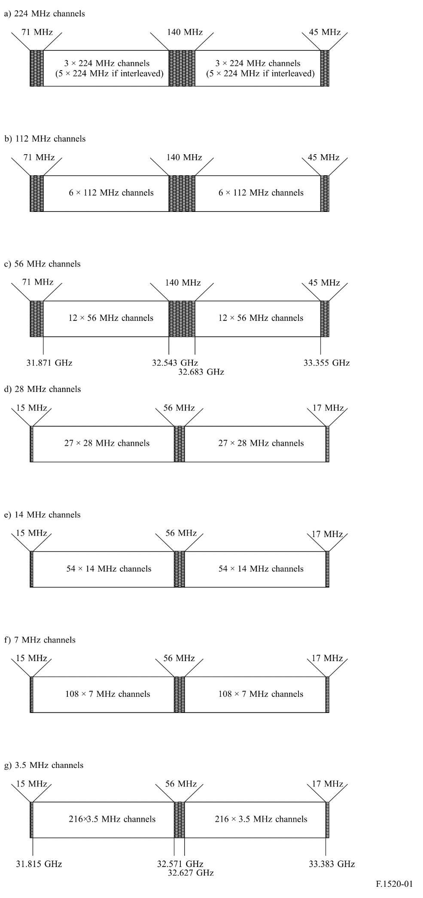
Annex 2
Radio-frequency block arrangement in the band 31.8-33.4 GHz
using block size increments of 56 MHz
This Annex provides an example RF block arrangement for the band 31.8-33.4 GHz using block size increments of 56 MHz. Guidance is provided on a flexible approach to specifying portions of the band for RF channel assigned point-to-point systems and RF block allocated systems.
For frequency division duplex (FDD) the band is divided into twelve (56 + 56) MHz symmetrically paired frequency blocks as follows:
TABLE 2
Paired block | Lower frequency  sub-band block  (MHz) | Upper frequency  sub-band block  (MHz)
A/A'  B/B'  C/C'  D/D'  E/E'  F/F'  G/G'  H/H'  I/I'  K/K'  L/L'  M/M' | 31 871-31 927  31 927-31 983  31 983-32 039  32 039-32 095  32 095-32 151  32 151-32 207  32 207-32 263  32 263-32 319  32 319-32 375  32 375-32 431  32 431-32 487  32 487-32 543 | 32 683-32 739  32 739-32 795  32 795-32 851  32 851-32 907  32 907-32 963  32 963-33 019  33 019-33 075  33 075-33 131  33 131-33 187  33 187-33 243  33 243-33 299  33 299-33 355

Different RF block arrangements can be achieved by aggregating the frequency blocks specified in Table 2.
As an example, the band may contain several aggregated blocks, arranged in a way shown in Table 3.
TABLE 3
Paired block | Lower frequency block  (MHz) | Upper frequency block  (MHz)
1 (2 × 112 MHz block)  2 (2 × 112 MHz block)  3 (2 × 112 MHz block)  4 (2 × 56 MHz block)  5 (2 × 56 MHz block)  6 (2 × 56 MHz block)  7 (2 × 168 MHz block) | 31 871-31 983  31 983-32 095  32 095-32 207  32 207-32 263  32 263-32 319  32 319-32 375  32 375-32 543 | 32 683-32 795  32 795-32 907  32 907-33 019  33 019-33 075  33 075-33 131  33 131-33 187  33 187-33 355

The 56 MHz block arrangement and possible aggregation are shown below in Figs 2 and 3, respectively.
FIGURE 2
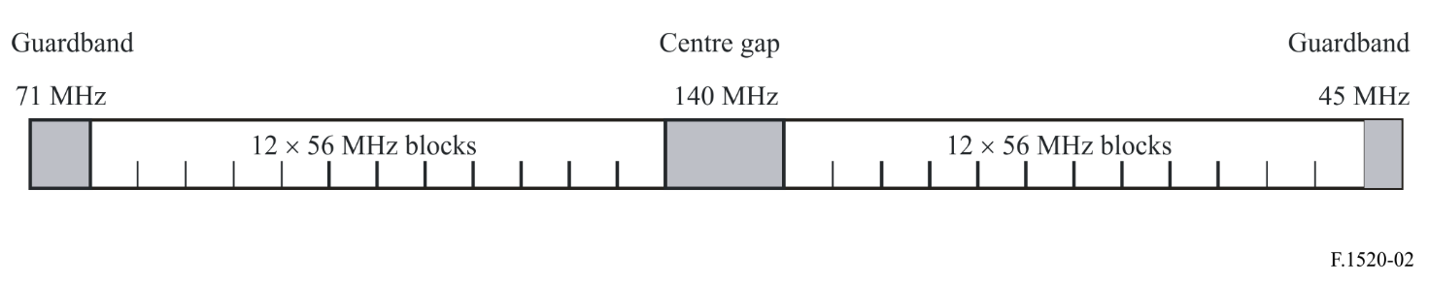
FIGURE 3
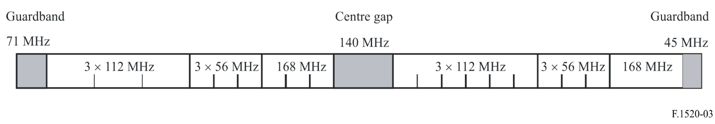
For FDD systems, the blocks located in the lower part of each sub-band should be used preferably with the upper sub-band for uplink transmissions, and lower sub-band for downlink transmissions. Systems using TDD can also operate in the above-defined sub-bands.
Arrangements stated in Figs 2 and 3 do not preclude the use of other blocks or block pairs.

This refers to channel separation of 224 MHz with interleaved arrangement as specified in item a).
This refers to channel separation of 224 MHz without interleaved arrangement as specified in item b).

