Recommendation ITU-R F.1568-2
(12/2023)
F Series: Fixed service
Radio-frequency block arrangements for fixed wireless access systems in the range 10.15-10.3/10.5-10.65 GHz

Foreword
The role of the Radiocommunication Sector is to ensure the rational, equitable, efficient and economical use of the radio-frequency spectrum by all radiocommunication services, including satellite services, and carry out studies without limit of frequency range on the basis of which Recommendations are adopted.
The regulatory and policy functions of the Radiocommunication Sector are performed by World and Regional Radiocommunication Conferences and Radiocommunication Assemblies supported by Study Groups.

Policy on Intellectual Property Right (IPR)
ITU-R policy on IPR is described in the Common Patent Policy for ITU-T/ITU-R/ISO/IEC referenced in Resolution ITU-R 1. Forms to be used for the submission of patent statements and licensing declarations by patent holders are available from http://www.itu.int/ITU-R/go/patents/en where the Guidelines for Implementation of the Common Patent Policy for ITU-T/ITU-R/ISO/IEC and the ITU-R patent information database can also be found.

Series of ITU-R Recommendations
(Also available online at https://www.itu.int/publ/R-REC/en)
Series | Title
BO | Satellite delivery
BR | Recording for production, archival and play-out; film for television
BS | Broadcasting service (sound)
BT | Broadcasting service (television)
F | Fixed service
M | Mobile, radiodetermination, amateur and related satellite services
P | Radiowave propagation
RA | Radio astronomy
RS | Remote sensing systems
S | Fixed-satellite service
SA | Space applications and meteorology
SF | Frequency sharing and coordination between fixed-satellite and fixed service systems
SM | Spectrum management
SNG | Satellite news gathering
TF | Time signals and frequency standards emissions
V | Vocabulary and related subjects

Note: This ITU-R Recommendation was approved in English under the procedure detailed in Resolution ITU-R 1.

Electronic Publication
Geneva, 2024

© ITU 2024
All rights reserved. No part of this publication may be reproduced, by any means whatsoever, without written permission of ITU.

RECOMMENDATION ITU-R F.1568-2
Radio-frequency block arrangements for fixed wireless access systems
in the range 10.15-10.3/10.5-10.65 GHz
(Question ITU-R 247-1/5)
(2002-2005-2023)
Scope
This Recommendation provides radiofrequency (RF) block arrangements for fixed wireless access (FWA) systems in the range 10.15-10.3/10.5-10.65 GHz. Annexes 1 and 2 present RF block arrangements based on 28 MHz blocks and 30 MHz blocks, respectively. Homogeneous patterns with a channel slot of 0.25 MHz are also given in Annexes 1 and 2.
Keywords
Fixed wireless system, point to point, channel arrangement, 10.15-10.3/10.5-10.65 GHz
Abbreviations
FWA Fixed wireless access
P-P Point-to-point
Related ITU Recommendations
Recommendation ITU-R F.746 – Radio-frequency arrangements for fixed service systems
Recommendation ITU-R F.747 – Radio-frequency channel arrangements for fixed wireless system operating in the 10.0-10.68 GHz band
Recommendation ITU-R F.1191 – Necessary and occupied bandwidths and unwanted emissions of digital fixed service systems
The ITU Radiocommunication Assembly,
considering
a) that fixed wireless access (FWA) systems in the range 10.15-10.65 GHz can provide enhanced telephony and data services;
b) that several administrations have introduced FWA systems in bands within the range 10.15-10.65 GHz;
c) that a flexible block (sub-band) arrangement, rather than use of a conventional point-to-point (P-P) channel arrangement can accommodate various FWA technologies, whilst remaining consistent with good spectrum management principles, including provision for inter-systems/services operation and overall spectrum efficiency;
d) that in some countries there may be cases where FWA systems need to coexist with P-P systems in the same fixed service (FS) allocation;
e) that a standardized block width might offer benefits through economies of scale and simplified inter-system and inter-operator frequency planning in the same deployment area;
f) that there are a number of different access technologies that may be used, for which different channelling and/or frequency allocation schemes may be appropriate;
g) that Recommendation ITU-R F.747, Annexes 1 and 2, presents radiofrequency arrangements for fixed wireless systems operating in the 10.5-10.68 GHz band;
h) that in some cases administrations may use other Recommendations to harmonize more readily with P-P channel arrangements;
i) that Recommendation ITU-R F.1191 provides limitation of unwanted emissions of FS systems for the adjacent bands,
recognizing
a) that according to Article 5 of the Radio Regulations (RR), the frequency band 10.5-10.68 GHz is allocated to the FS on a worldwide basis and the frequency band 10-10.45 GHz in Regions 1 and 3;
b) that the band 10.6-10.68 GHz is allocated to the Earth exploration-satellite service (passive), space research service (passive) and radio astronomy service on a primary basis;
c) that according to No. 5.480 of the RR, the frequency band 10-10.45 GHz is allocated to the FS in a number of countries in Region 2,
noting
that Recommendation ITU-R F.746 provides the basis for the development of radio-frequency arrangements and defines the main parameters affecting the choice of radio-frequency channel arrangements,
recommends
1 that those administrations planning to implement FWA systems in the frequency bands 10.15-10.3/10.5-10.65 GHz should consider the block arrangements presented in Annexes 1 and 2;
2 that administrations should consider the adoption of carrier centre frequencies, within the preferred frequency blocks, from the channel slots of 0.25 MHz, as derived in Annexes 1 and 2;
3 that administrations wishing to adopt other homogeneous patterns should consider the use of one or multiple slots of 0.25 MHz, as derived in Annexes 1 and 2.

Annex 1
Radio-frequency arrangement based on 28 MHz blocks
1 This arrangement consists of five adjacent blocks of 28 MHz bandwidth in the band 10.15-10.3 GHz, paired with five adjacent blocks of 28 MHz in the band 10.5-10.65 GHz, as per Fig. 1 (see Note 1).
figure 1
28 MHz block plan for the ranges 10.15-10.3/10.5-10.65 GHz
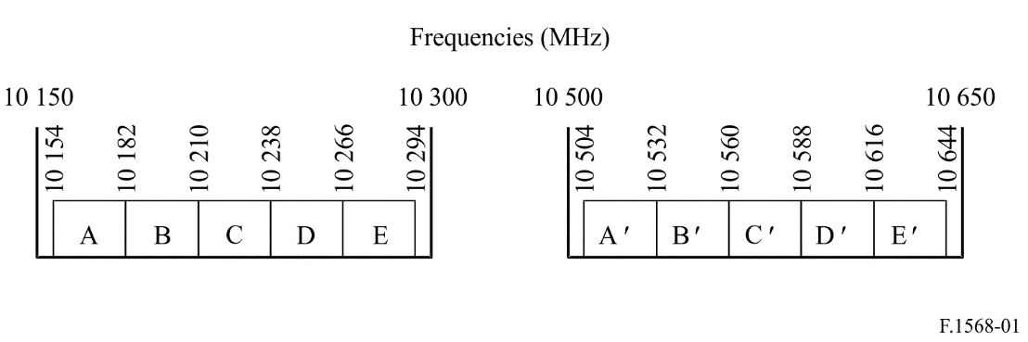
NOTE 1 – In some countries, blocks of 7 MHz may be accommodated within each 28 MHz block. These blocks can be aggregated to form larger blocks.

2 Derivation of discrete channel slots of 0.25 MHz
The discrete channel slots of 0.25 MHz are derived as follows:
f_{n} = 10 150 + 0.25 n MHz
where f_{n} is the centre frequency (MHz) of each slot, and n ranges from 17 to 575, within the band 10.15-10.3 GHz, and from 1 417 to 1 975, within the band 10.5 to 10.65 GHz.

Annex 2
Radio-frequency arrangement based on 30 MHz blocks
This arrangement consists of five adjacent blocks of 30 MHz bandwidth in the band 10.15-10.3 GHz, paired with five adjacent blocks of 30 MHz in the band 10.5-10.65 GHz, as per Fig. 2.
figure 2
30 MHz block plan for the ranges 10.15-10.3/10.5-10.65 GHz
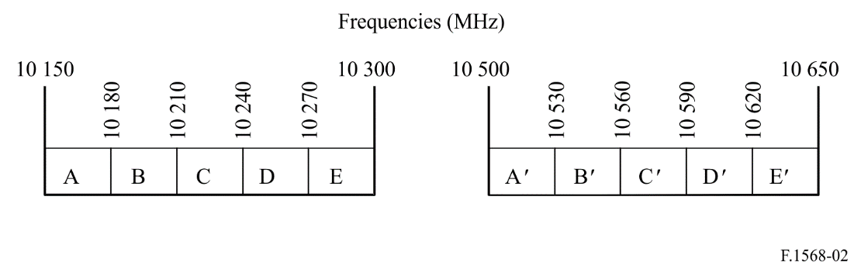

1 Derivation of discrete channel slots of 0.25 MHz
The discrete channel slots of 0.25 MHz are derived as follows:
f_{n} = 10 150 + 0.25 n MHz
where f_{n} is the centre frequency (MHz) of each slot, and n ranges from 1 to 599 within the band 10.15-10.3 GHz, and from 1 401 to 1 999 within the band 10.5 to 10.65 GHz.

