|  |
| --- |
| **Recommendation ITU-R F.595-11**  **(02/2022)** |
| **Radio-frequency channel arrangements for fixed wireless systems operating in the 17.7-19.7 GHz frequency band** |
| **F Series**  **Fixed service** |

Foreword

The role of the Radiocommunication Sector is to ensure the rational, equitable, efficient and economical use of the radio-frequency spectrum by all radiocommunication services, including satellite services, and carry out studies without limit of frequency range on the basis of which Recommendations are adopted.

The regulatory and policy functions of the Radiocommunication Sector are performed by World and Regional Radiocommunication Conferences and Radiocommunication Assemblies supported by Study Groups.

**Policy on Intellectual Property Right (IPR)**

ITU-R policy on IPR is described in the Common Patent Policy for ITU-T/ITU-R/ISO/IEC referenced in Resolution ITU‑R 1. Forms to be used for the submission of patent statements and licensing declarations by patent holders are available from <http://www.itu.int/ITU-R/go/patents/en> where the Guidelines for Implementation of the Common Patent Policy for ITU‑T/ITU‑R/ISO/IEC and the ITU-R patent information database can also be found.

|  |  |
| --- | --- |
| Series of ITU-R Recommendations  (Also available online at <http://www.itu.int/publ/R-REC/en>) | |
| **Series** | Title |
| **BO** | Satellite delivery |
| **BR** | Recording for production, archival and play-out; film for television |
| **BS** | Broadcasting service (sound) |
| **BT** | Broadcasting service (television) |
| F | Fixed service |
| **M** | Mobile, radiodetermination, amateur and related satellite services |
| **P** | Radiowave propagation |
| **RA** | Radio astronomy |
| **RS** | Remote sensing systems |
| **S** | Fixed-satellite service |
| **SA** | Space applications and meteorology |
| **SF** | Frequency sharing and coordination between fixed-satellite and fixed service systems |
| **SM** | Spectrum management |
| **SNG** | Satellite news gathering |
| **TF** | Time signals and frequency standards emissions |
| **V** | Vocabulary and related subjects |

|  |
| --- |
|  |

|  |
| --- |
| ***Note***: *This ITU-R Recommendation was approved in English under the procedure detailed in Resolution ITU-R 1.* |

*Electronic Publication*

Geneva, 2022

© ITU 2022

All rights reserved. No part of this publication may be reproduced, by any means whatsoever, without written permission of ITU.

RECOMMENDATION ITU-R F.595-11

Radio-frequency channel arrangements for fixed wireless systems  
operating in the 17.7-19.7 GHz frequency band

(Question ITU-R 247-1/5)

(1982-1986-1990-1992-1995-1997-1999-2002-2003-2006-2012-2022)

Scope

This Recommendation provides radio-frequency channel arrangements for fixed wireless systems operating in the 18 GHz band (17.7-19.7 GHz), which may be used for high, medium and low capacity fixed service applications including mobile infrastructure. The channel spacings recommended in the main text are 220, 110, 55 and 27.5 MHz for co-channel arrangements as well as interleaved arrangements for 220 and 110 MHz spacings. Other arrangements used in some countries are also provided.

Keywords

Fixed service, point-to-point, channel bandwidth, channel arrangement, 18 GHz

Abbreviations/Glossary

FDD Frequency division duplex

FWS Fixed wireless systems

QAM Quadrature amplitude modulation

QPSK Quadrature phase shift keying

RF Radio-frequency

STM Synchronous transport module

Related ITU Recommendations and Reports

Recommendation ITU-R F.746 – Radio-frequency arrangements for fixed service systems

The ITU Radiocommunication Assembly,

considering

*a)* that there may be economic and operational advantages in the use of fixed wireless systems (FWS) for the transmission of digital signals in the frequency band 17.7 to 19.7 GHz;

*b)* that it may be desirable to interconnect such systems at radio frequencies on international circuits;

*c)* that a sufficient degree of compatibility between systems of different capacities should be assured;

*d)* that frequency block arrangements allow flexible deployment of fixed wireless systems,

recognizing

that Recommendation ITU-R SM.1540 provides guidelines for managing the unwanted emissions in the out-of-band domain falling into adjacent allocated bands,

recommends

**1** that the preferred radio-frequency (RF) channel arrangement for digital FWS systems with a capacity of the order of 280 Mbit/s, the order of 140 Mbit/s and 34 Mbit/s or synchronous digital hierarchy bit rates operating in the 17.7 to 19.7 GHz band should be derived as follows:

Let *f*0 be the frequency of the centre of the band of frequencies occupied (MHz),

*fn* be the centre frequency of a RF channel in the lower half of the band (MHz),

 be the centre frequency of a RF channel in the upper half of the band (MHz),

then the frequencies (MHz) of individual channels are expressed by the following relationships:

## 1.1 Co-channel arrangement

**1.1.1** for systems with a capacity of the order of 280 Mbit/s:

lower half of the band: *fn* = *f*0 – 1 110 + 220 *n* MHz

upper half of the band:  = *f*0 + 10 + 220 *n* MHz

where:

*n* = 1, 2, 3 or 4.

The frequency arrangement is illustrated in Fig. 1a).

**1.1.2** for systems with a capacity of the order of 140 Mbit/s:

lower half of the band: *fn* = *f*0 – 1 000 + 110 *n* MHz

upper half of the band:  = *f*0 + 10 + 110 *n* MHz

where:

*n* = 1, 2, 3, 4, 5, 6, 7 or 8.

The frequency arrangement is illustrated in Fig. 1b).

**1.1.3** for systems with a capacity of the order of 34 Mbit/s:

lower half of the band: *fn* = *f*0 – 1 000 + 27.5 *n* MHz

upper half of the band:  = *f*0 + 10 + 27.5 *n* MHz

where:

*n* = 1, 2, 3, . . . 35.

The frequency arrangement is illustrated in Fig. 1c).

**1.1.4** for systems with a capacity of the order of 140 Mbit/s or synchronous transport module (STM)-1 with multi-state modulation formats:

lower half of the band: *fn* = *f*0 – 1 000 + 55 *n* MHz

upper half of the band:  = *f*0 + 10 + 55 *n* MHz

where:

*n* = 1, 2, 3, . . . 17.

The frequency arrangement is illustrated in Fig. 1d).

## 1.2 Interleaved arrangement

**1.2.1a)** for systems with a capacity of the order of 280 Mbit/s with 1 120 MHz duplex spacing:

lower half of the band: *fn* = *f*0 – 1 000 + 110 *n* MHz

upper half of the band:  = *f*0 + 120 + 110 *n* MHz

where:

*n* = 1, 2, 3, 4, 5, 6 or 7.

The frequency arrangement is illustrated in Fig. 2a).

**1.2.1b)** for systems with a capacity of the order of 280 Mbit/s with 1 010 MHz duplex spacing:

lower half of the band: *fn* = *f*0 – 945 + 110 *n* MHz

upper half of the band:  = *f*0 + 65 + 110 *n* MHz

where:

*n* = 1, 2, 3, 4, 5, 6 or 7.

The frequency arrangement is illustrated in Fig. 2b).

**1.2.2** for systems with a capacity of the order of 140 Mbit/s with 1 010 MHz duplex spacing:

lower half of the band: *fn* = *f*0 – 945 + 55 *n* MHz

upper half of the band:  = *f*0 + 65 + 55 *n* MHz

where:

*n* = 1, 2, 3, . . . 15.

The frequency arrangement is illustrated in Fig. 2c);

figure 1

Radio-frequency channel arrangement for fixed wireless systems  
operating in the 17.7 to 19.7 GHz band  
(Co-channel arrangement)  
(All frequencies in MHz)

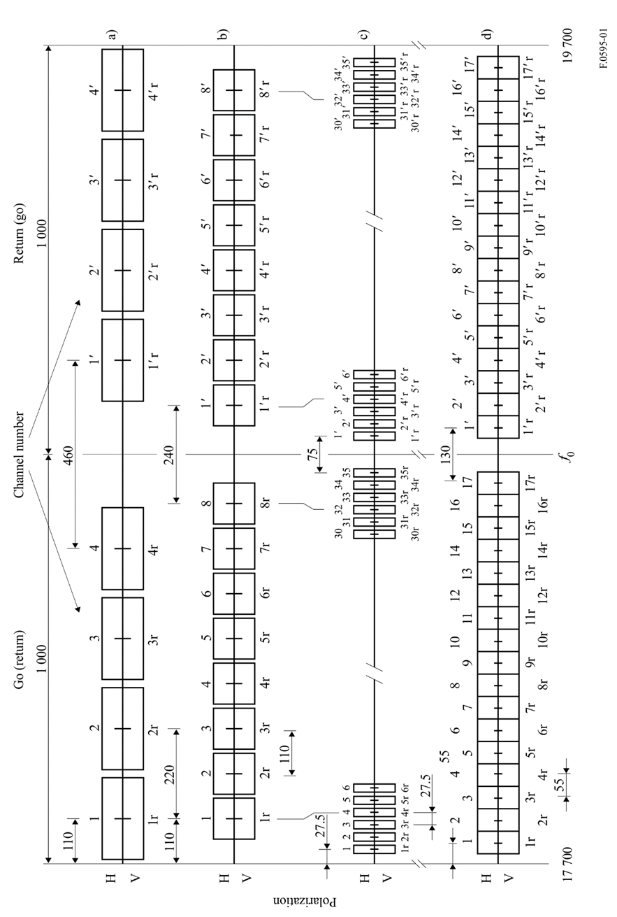

figure 2

Radio-frequency channel arrangement for fixed wireless systems  
operating in the 17.7 to 19.7 GHz band  
(Interleaved arrangement)  
(All frequencies in MHz)

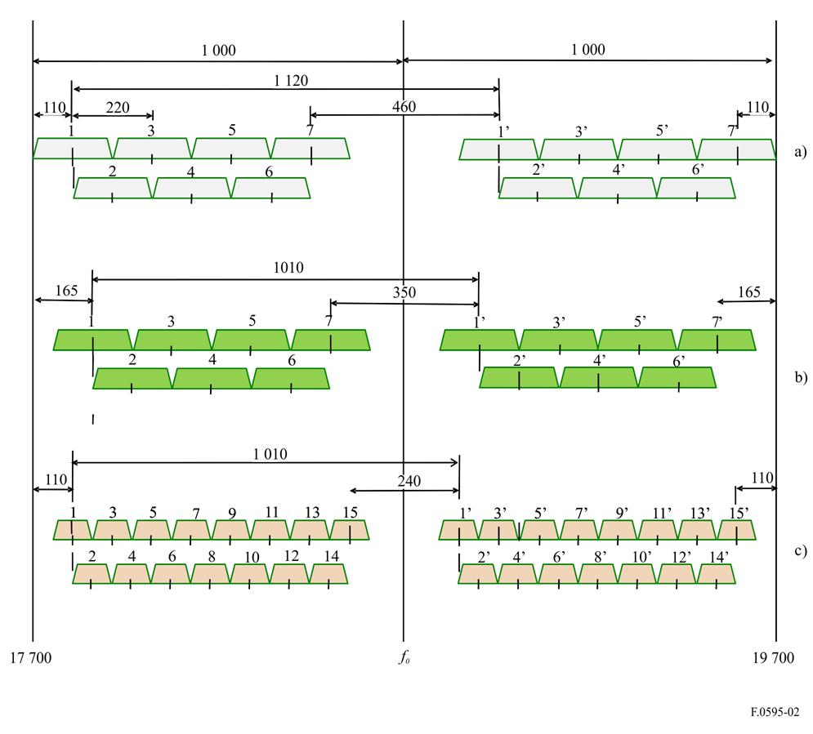

**2** that the preferred RF channel arrangement for digital FWS with a capacity of 155 Mbit/s for use in the synchronous digital hierarchy should be as given in § 1.1.2 (co-channel arrangement) and § 1.2.2 (alternated channel arrangement) for systems using quadrature phase shift keying (QPSK)-like modulation.

While for systems using 16-QAM-like modulation the RF channel arrangement shown in Fig. 1d) is preferred for co-channel operation.

The frequencies of channels 2, 3, 4, . . . 16 in Fig. 1d) are the same as the centre frequencies in § 1.2.2 for channels 1, 2, 3, . . . 15 respectively.

Channels 1 and 17 in Fig. 1d) are allocated 55 MHz below channel 2 and above channel 16 respectively;

**3** that, in the section through which an international connection is arranged to pass, all the go channels should be in one half of the band and all the return channels should be in the other half of the band;

**4** that both horizontal and vertical polarizations should be used for each RF channel in the co‑channel arrangement;

**5** that the centre frequency *f*0 is 18 700 MHz;

**6** that for low capacity digital systems, i.e. below about 10 Mbit/s, frequency allocations may be accommodated within any of the high-capacity channels or guardbands as shown by Annexes 3 and 5. Channels 1,  and 8,  of Fig. 1b) or channels 1,  and 17,  of Fig. 1d) and the guardbands are the most suitable choice for sub-band allocations for such low capacity utilizations, however, when more band is required, the adjacent channels may be used as shown by the example in Annex 5 where also channels 2,  of Fig. 1d) are assigned to low capacity use. The selection of alternative allocations should not prevent the pairing of the go and return channels in the manner described in Figs 1 and 2;

**7** that for medium-capacity systems with bit rates different from that given in § 1.1.3 above and for low capacity systems, administrations may adopt other RF channel arrangements in conformity with the recommended pattern for high-capacity systems (see Annex 4);

**8** that due regard should be taken of the fact that in some countries another arrangement of the go and return channels which incorporates a mid-band allocation for low capacity systems may be used, as shown in Fig. 3;

figure 3

Co-channel radio-frequency arrangement for fixed wireless systems  
operating in the 18 GHz band referred to in *recommends* 7  
(All frequencies in MHz)

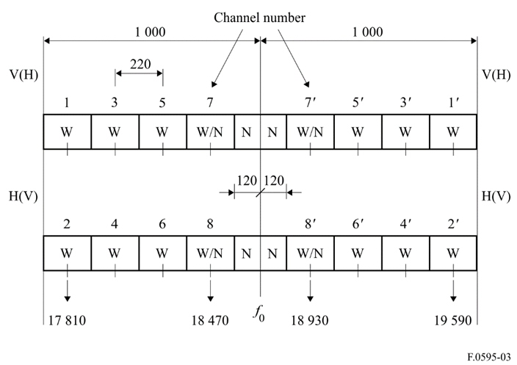

W: wideband channel (high-capacity of the order of 280 Mbit/s)

N: narrow-band channel (small-capacity, below 10 Mbit/s)

W/N: wideband or narrow-band channel

**9** that due regard should be taken of the fact that based on the above *considering* d) frequency block arrangements may be used (see Annex 1);

**10** that due regard should be taken of the fact that in some countries the band 17.7 to 19.7 GHz is subdivided to serve different applications in separate parts of the band (see Annex 2) or is used for low capacity systems (see Annex 3) with different go-return (Tx/Rx duplex) and channel spacings;

**11** that due regard should be taken of the fact that in one country, another channel arrangement is used (see Annexes 6 and 7);

**12** that if multi-carrier transmission (Note 3) is employed the overall number of *n* carriers will occupy a single channel the centre frequency and channel spacing of which will be that defined according to Figs 1 and 2, disregarding the actual centre frequencies of the individual carriers, which may vary, for technical reasons according to practical implementations.

NOTE 1 − In establishing these systems, account should be taken of the primary allocation to the Earth exploration‑satellite service (passive) in the band 18.6 to 18.8 GHz, the provisions of No. **5.522A** of the Radio Regulations and the need to protect passive sensors in this band.

NOTE 2 – Actual gross bit rates may be as much as 5% or more higher than net transmission rates.

NOTE 3 – A multi-carrier system is a system with *n* (where *n* > 1) digitally modulated carrier signals simultaneously transmitted (or received) by the same RF equipment.

Annex 1  
  
Description of RF block arrangements in the band   
17.7 to 19.7 GHz referred to in *recommends* 9

# 1 Introduction

The following example arrangements can be referred to for use by administrations wishing to implement arrangements based on frequency blocks.

# 2 RF block arrangement description

|  |  |  |
| --- | --- | --- |
| Paired block | Lower frequency block (MHz) | Upper frequency block (MHz) |
| CH-4/CH-4’ | 17 730-17 790 | 18 480-18 540 |
| CH-5/CH-5’ | 17 790-17 850 | 18 540-18 600 |
| CH-9/CH-9’ | 17 970-18 030 | 19 220-19 280 |
| CH-10/CH-10’ | 18 030-18 090 | 19 280-19 340 |
| CH-11/CH-11’ | 18 090-18 150 | 19 340-19 400 |
| CH-12/CH-12’ | 18 150-18 210 | 19 400-19 460 |
| CH-13/CH-13’ | 18 210-18 270 | 19 460-19 520 |
| CH-14/CH-14’ | 18 270-18 330 | 19 520-19 580 |
| CH-15/CH-15’ | 18 330-18 390 | 19 580-19 640 |
| CH-16/CH-16’ | 18 390-18 450 | 19 640-19 700 |
| NOTE 1 – In the band 17.70-17.73 GHz paired with 18.45-18.48 GHz, 3 pairs of RF channels (CH‑1,2, and 3/CH-1’, 2’ and 3’) are accommodated for small capacity systems for the purpose of disaster protection.  NOTE 2 – In the band 17.85-17.97 GHz paired with 18.60-18.72 GHz, 3 pairs of RF channels (CH‑6, 7, and 8/CH-6’, 7’ and 8’) are accommodated for high capacity systems for the purpose of mobile infrastructure. | | |

Annex 2  
  
Description of an RF channel arrangement in the  
band 17.7 to 19.7 GHz referred to in *recommends* 10

In North America this band is structured to accommodate the implementation of low, medium and high capacity point-to-point, digital fixed wireless systems. Such structuring allows for more efficient and effective use of the spectrum for applications including fixed wireless access and mobile infrastructure support networks.

The resulting composite RF channel arrangement is illustrated in Fig. 4.

figure 4

Radio-frequency channel arrangements for digital fixed wireless systems  
in the 17.7 to 19.7 GHz band (North America)  
(All frequencies in MHz)

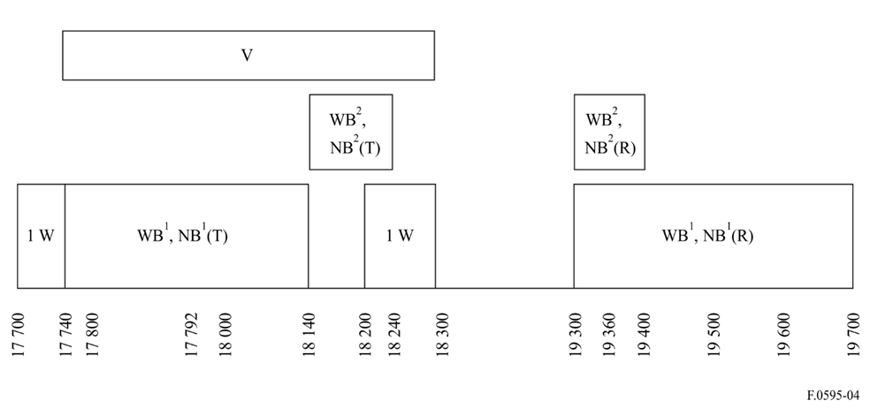

WB: 50, 40, 30, 20 MHz "wideband" channels

NB: 10, 5, 2.5 MHz "narrowband" channels

1W: 50, 40, 30, 20, 10, 5, 2.5 MHz unpaired channels

V: video radio relay and distribution

(T): transmit frequencies: go (return)

(R): receive frequencies: return (go)

1: T/R spacing = 1 560 MHz

2: T/R spacing = 1 160 MHz

NOTE 1 – In Canada, the bands 17.7-17.8 GHz and 18.3-19.3 GHz are no longer available for new FS stations.

NOTE 2 – Other channel arrangements to be covered under this Annex are under study in the United States of America.

Annex 3  
  
Description of the RF channel arrangements in the band  
17.7 to 19.7 GHz referred to in *recommends* 10

In the United Kingdom, this band is also used (in addition to certain channel plans referred to in *recommends* 1 and *recommends* 7) for low capacity equipment, in accordance with the following plans:

– Channel plan based on a 3.5 MHz channel spacing (Fig. 5):

lower half of the band: *fn* = *f*0 – 981.25 + 3.5 *n* MHz

upper half of the band:  = *f*0 + 26.75 + 3.5 *n* MHz

where:

*f*0 = 18 700 MHz

*n* = 1, 2, 3, . . . 272.

– Channel plan based on a 7 MHz channel spacing (Fig. 6):

lower half of the band: *fn* = *f*0 – 983 + 7 *n* MHz

upper half of the band:  = *f*0 + 25 + 7 *n* MHz

where:

*f*0 = 18 700 MHz

*n* = 1, 2, 3, . . . 136.

figure 5

Radio-frequency channel arrangement for low capacity fixed wireless systems  
with 3.5 MHz channel spacing operating in the 18 GHz band (United Kingdom)  
(All frequencies in MHz)

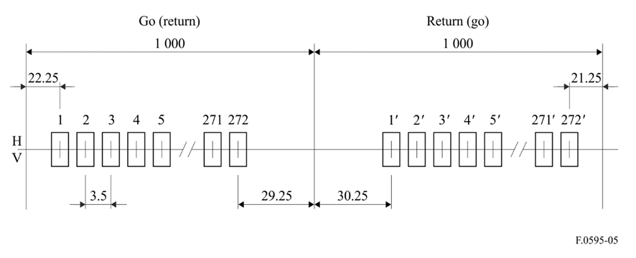

NOTE 1 – Within the UK channels 212 to 272 are available on the 3.5 MHz plan.

figure 6

Radio-frequency channel arrangement for low capacity fixed wireless systems  
with 7 MHz channel spacing operating in the 18 GHz band (United Kingdom)  
(All frequencies in MHz)

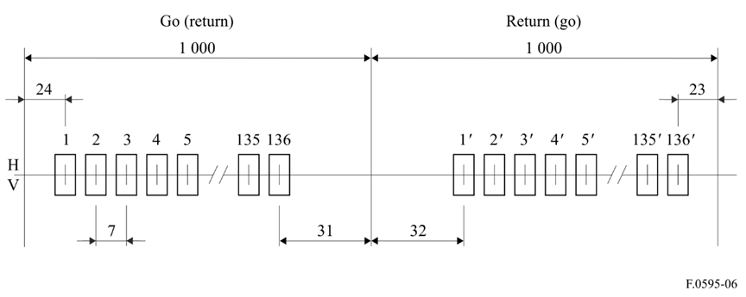

NOTE 1 – Within the UK channels 107 to 136 are available on the 7 MHz plan.

Annex 4  
  
Description of two RF channel arrangements for medium capacity FWS with  
13.75 MHz channel spacing in co-channel arrangement (Fig. 7) and with  
27.5 MHz channel spacing in interleaved channel arrangement (Fig. 8)  
and an example of co-channel arrangements for low capacity FWS  
in (Fig. 9) referred to in *recommends* 7

# 1 13.75 MHz co-channel and 27.5 MHz interleaved arrangements

The channel arrangements are in accordance with the following plans:

*Co-channel arrangement* (Fig. 7):

lower half of the band: *fn* = *f*0 – 1 000 + 13.75 *n* MHz

upper half of the band:  = *f*0 + 10 + 13.75 *n* MHz

where:

*n* = 1, 2, 3, . . . 70.

*Interleaved channel arrangement* (Fig. 8):

lower half of the band: *fn* = *f*0 – 986.25 + 13.75 *n* MHz

upper half of the band:  = *f*0 + 23.75 + 13.75 *n* MHz

where:

*n* = 1, 2, 3, . . . 69.

figure 7

Radio-frequency channel arrangement for medium capacity fixed wireless systems  
with 13.75 MHz channel spacing in co-channel arrangement  
(All frequencies in MHz)

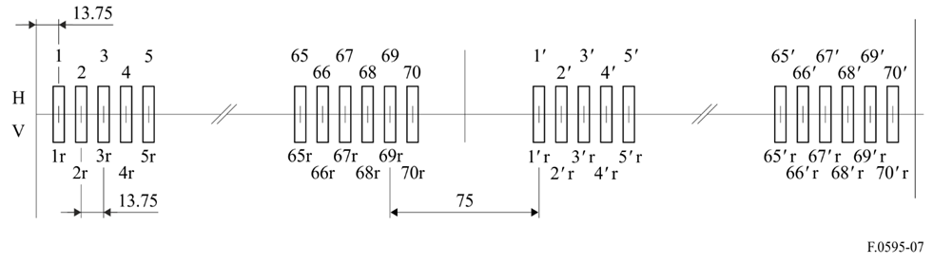

figure 8

Radio-frequency channel arrangement for medium capacity fixed wireless systems  
with 27.5 MHz channel spacing in interleaved channel arrangement  
(All frequencies in MHz)

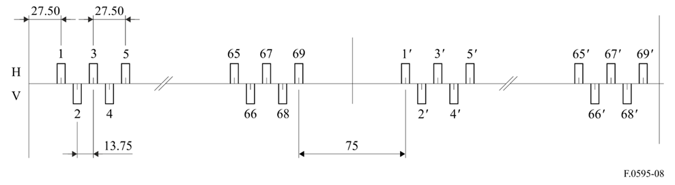

# 2 7.5 MHz arrangement

This channel arrangement is for channel spacing of 7.5 MHz and is used as follows (Fig. 9):

lower half of the band: *fn* = *f*0 – 997.5 + 7.5 *n* MHz

upper half of the band:  = *f*0 + 12.5 + 7.5 *n* MHz

where:

*n* = 1, 2, 3, . . . 131.

Figure 9

Radio-frequency channel arrangement for low capacity fixed wireless system   
with 7.5 MHz spacing in co-channel arrangement

Annex 5  
  
Description of a RF channel arrangement for low capacity digital   
FWS obtained by the sub-division of high capacity channels   
in the band 17.7 to 19.7 GHz referred to in *recommends* 6

In Italy a mixed usage of high, medium and low capacity digital FWS is envisaged; the frequency channel arrangements of *recommends* 1.1.3 and 1.1.4 are used for medium and high capacity systems, respectively.

For low capacity systems, the high capacity channels 1,  and 2,  are subdivided on a 1.75, 3.5 and 7 MHz basis together with the adjacent guard bands, following the rule for the centre frequencies reported below:

a) For systems requiring channel spacing of 7 MHz, the channel centre frequencies are given by:

lower half of the band: *fn* = *f*0 – 997 + 7 *n* MHz

upper half of the band:  = *f*0 + 13 + 7 *n* MHz

where:

*n* = 1, 2, 3, . . . 18.

b) For systems requiring channel spacing of 3.5 MHz the channel centre frequencies are given by:

lower half of the band: *fn* = *f*0 – 998.75 + 3.5 *n* MHz

upper half of the band:  = *f*0 + 11.25 + 3.5 *n* MHz

where:

*n* = 1, 2, 3, . . . 37.

c) For systems requiring channel spacing of 1.75 MHz the channel centre frequencies are given by:

lower half of the band: *fn* = *f*0 – 997.875 + 1.75 *n* MHz

upper half of the band:  = *f*0 + 12.125 + 1.75 *n* MHz

where:

*n* = 1, 2, 3, . . . 74.

In areas where interference from other services, sharing the same band, do not allow the use of part of the above channels, the high capacity channels 3,  and 4,  may alternatively be subdivided, creating 1.75, 3.5 and 7 MHz channels, which centre frequencies are given by the same formulas with the values of *n* expanded as follows:

*n* = 19, 20, 21, . . . 33 (7 MHz channels)

*n* = 38, 39, 40, . . . 68 (3.5 MHz channels)

*n* = 75, 76, 77, . . . 136 (1.75 MHz channels)

Figure 10 shows graphically the subdivision of channels 1,  and 2, .

Figure 10

Radio-frequency channel arrangement for low capacity fixed wireless systems (co-channel arrangement).  
Example of subdivision of the first two 55 MHz channels 1, 1' and 2, 2'  
and of the guard band according to *recommends* 6   
(All frequencies in MHz)

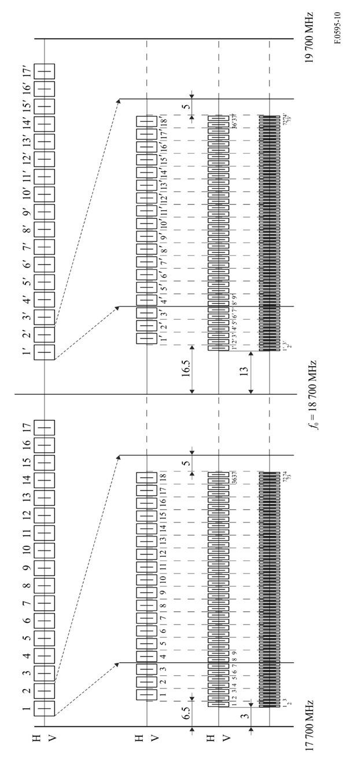

Annex 6  
  
Description of a RF channel arrangement in the band 17.7‑19.7 GHz   
referred to in *recommends* 11

The following arrangement is planned to be implemented by Indonesia.

Let *f*0 be the middle of the band 17.7-19.7 GHz, i.e. *f*0 = 18 700MHz,

*fn* be the middle frequency of the radio-frequency channel in the lower half of the 17.7‑19.7 GHz band,

 be the middle frequency of the radio-frequency channel in the upper half of the 17.7‑19.7 GHz band,

then the frequencies (MHz) of individual channels are expressed by the following relationships:

Co-channel arrangement

a) for systems with a carrier spacing of 110 MHz:

lower half of the band: *fn* = *f*0 – 450 + 110 *n*

upper half of the band:  = *f*0 + 560 + 110 *n*

where:

*n* = 1, ..., 3

– Tx/Rx separation band (in the frequency division duplex (FDD) mode) = 1 010MHz

lower half of the band: *fn* = *f*0 – 1 110 + 110 *n*

upper half of the band:  = *f*0 – 495 + 110 *n*

where:

*n* = 4

– Tx/Rx separation band (in the FDD mode) = 615 MHz

lower half of the band: *fn* = *f*0 – 1 495 + 110 *n*

upper half of the band:  = *f*0 – 1 010 + 110 *n*

where:

*n* = 5, 6

– Tx/Rx separation band (in the FDD mode) = 485 MHz

b) for systems with a carrier spacing of 55 MHz:

lower half of the band: *fn* = *f*0 – 422.5 + 55 *n*

upper half of the band:  = *f*0 + 587.5 + 55 *n*

where:

*n* = 1, ..., 6

– Tx/Rx separation band (in the FDD mode) = 1 010 MHz

lower half of the band: *fn* = *f*0 – 1 082.5 + 55 *n*

upper half of the band:  = *f*0 – 467.5 + 55 *n*

where:

*n* = 7, 8

– Tx/Rx separation band (in the FDD mode) = 615 MHz

lower half of the band: *fn* = *f*0 – 1 467.5 + 55 *n*

upper half of the band:  = *f*0 – 982.5 + 55 *n*

where:

*n* = 9, ...,12

– Tx/Rx separation band (in the FDD mode) = 485 MHz

lower half of the band: *fn* = *f*0 – 752.5 + 55 *n*

upper half of the band:  = *f*0 + 257.5 + 55 *n*

where:

*n* = 13

– Tx/Rx separation band (in the FDD mode) = 1 010 MHz

Figure 11

Channelization plan for the 17.7-19.7 GHz band of Annex 6

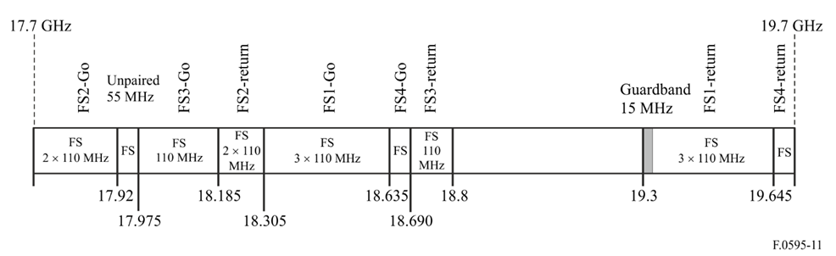

Annex 7

In Brazil, the bands 18.58 to 18.82 GHz paired with 18.92 to 19.16 GHz and 17.7 to 18.14 GHz paired with 19.26 to 19.7 GHz are used by digital radio systems with channel arrangements as shown respectively in the following insets 1 and 2.

# 1 Block-based frequency arrangement for the sub-band 18.58‑18.82 GHz and 18.92‑19.16 GHz

The sub-band is divided in four 60 MHz-wide bandwidth blocks as follows:

– Block A: 18 580 to 18 640 MHz paired with 18 920 to 18 980 MHz

– Block B: 18 640 to 18 700 MHz paired with 18 980 to 19 040 MHz

– Block C: 18 700 to 18 760 MHz paired with 19 040 to 19 100 MHz

– Block D: 18 760 to 18 820 MHz paired with 19 100 to 19 160 MHz.

Inside each block, carrier centre frequencies *fn* andwith 5 MHz separations, are assigned as follows:

*fn* = 18 577.5 + 5.0 × *n* MHz

 = 18 917.5 + 5.0 × *n* MHz

where:

*n* = 1, 2, 3, ... 48

# 2 Frequency channel arrangement for the band 17.7‑18.14 GHz and 19.26‑19.7 GHz with channel width of 13.75 MHz, 27.5 MHz and 55 MHz

## 2.1 Channel plan with 13.75 MHz bandwidth

The carrier centre frequencies *fn* andmay be obtained as follows:

*fn* = 17 700 + 13.75 × *n* MHz

 = 19 260 + 13.75 × *n* MHz

where:

*n* = 1, 2, 3, ... 31

## 2.2 Channel plan with 27.5 MHz bandwidth

The carrier centre frequencies *fn* andmay be obtained as follows:

*fn* = 17 700 + 27.5 × *n* MHz

 = 19 260 + 27.5 × *n* MHz

where:

*n* = 1, 2, 3, ... 15

## 2.3 Channel plan with 55 MHz bandwidth

The carrier centre frequencies *fn* and may be obtained as follows:

*fn* = 17 672.5 + 55 × *n* MHz

 = 19 232.5 + 55 × *n* MHz

where:

*n* = 1, 2, 3, ... 8