Recommendation ITU-R F.749-4
(02/2022)
Radio-frequency channel arrangements for systems of the fixed service operating in sub-bands in the 36-40.5 GHz band

F Series
Fixed service

Foreword
The role of the Radiocommunication Sector is to ensure the rational, equitable, efficient and economical use of the radio-frequency spectrum by all radiocommunication services, including satellite services, and carry out studies without limit of frequency range on the basis of which Recommendations are adopted.
The regulatory and policy functions of the Radiocommunication Sector are performed by World and Regional Radiocommunication Conferences and Radiocommunication Assemblies supported by Study Groups.

Policy on Intellectual Property Right (IPR)
ITU-R policy on IPR is described in the Common Patent Policy for ITU-T/ITU-R/ISO/IEC referenced in Resolution ITU-R 1. Forms to be used for the submission of patent statements and licensing declarations by patent holders are available from http://www.itu.int/ITU-R/go/patents/en where the Guidelines for Implementation of the Common Patent Policy for ITU-T/ITU-R/ISO/IEC and the ITU-R patent information database can also be found.

Series of ITU-R Recommendations
(Also available online at http://www.itu.int/publ/R-REC/en)
Series | Title
BO | Satellite delivery
BR | Recording for production, archival and play-out; film for television
BS | Broadcasting service (sound)
BT | Broadcasting service (television)
F | Fixed service
M | Mobile, radiodetermination, amateur and related satellite services
P | Radiowave propagation
RA | Radio astronomy
RS | Remote sensing systems
S | Fixed-satellite service
SA | Space applications and meteorology
SF | Frequency sharing and coordination between fixed-satellite and fixed service systems
SM | Spectrum management
SNG | Satellite news gathering
TF | Time signals and frequency standards emissions
V | Vocabulary and related subjects

Note: This ITU-R Recommendation was approved in English under the procedure detailed in Resolution ITU-R 1.

Electronic Publication
Geneva, 2022

© ITU 2022
All rights reserved. No part of this publication may be reproduced, by any means whatsoever, without written permission of ITU.

RECOMMENDATION ITU-R F.749-4
Radio-frequency channel arrangements for systems of the fixed service
operating in sub-bands in the 36-40.5 GHz band
(Question ITU-R 247-1/5)
(1992-1994-2001-2012-2022)
Scope
This Recommendation provides specifications for radio-frequency channel arrangements for systems in the fixed service with channel separations ranging from 2.5 to 224 MHz in the bands 36-37 GHz, 37.0-39.5 GHz, 38.6-40 GHz and 39.5-40.5 GHz. Annex 3 includes block-based arrangements with bandwidths of 50 MHz and 60 MHz in the frequency range 38.06 to 40 GHz.
Keywords
Fixed service, point-to-point, channel bandwidth, channel arrangement, 38 GHz
Abbreviations / Glossary
BWA Broadband wireless access
CEPT European Conference of Postal and Telecommunications Administrations
RF Radio-frequency
Related ITU Recommendations and Reports
Recommendation ITU-R F.746 – Radio-frequency arrangements for fixed service systems
The ITU Radiocommunication Assembly,
considering
a) that the band 36.0-40.5 GHz is allocated to the fixed and mobile services and that the propagation characteristics of this band are ideally suited to short-range digital and analogue radio system applications;
b) that differing applications of various administrations may require different radio-frequency (RF) channel arrangements;
c) that the band may also be used for broadband wireless access (BWA) systems in the fixed service;
d) that several services with various transmission signal characteristics and capacities may be in simultaneous use in this frequency band;
e) that lower and upper limits of the bands are not uniform and vary internationally;
f) that the applications in this frequency band may require differing channel bandwidths;
g) that a high degree of compatibility between radio-frequency channels of different arrangements can be achieved by selecting channel centre frequencies within a homogeneous basic pattern;
h) that the differing digital hierarchies used in various countries or regions may require the use of homogeneous basic patterns with differing intervals;
i) that allocation of frequency blocks to BWA systems allows flexible deployment of various technologies including provisions for intersystem/services operation and overall spectrum efficiency,
recognizing
that Recommendation ITU-R SM.1540 provides guidelines for managing the unwanted emissions in the out-of-band domain falling into adjacent allocated bands,
recommends
1 that the preferred RF channel arrangements for the band 36.0-40.5 GHz should be based on homogeneous patterns;
2 that the homogeneous pattern with a preferred 3.5 MHz interval be defined by the relation:
fp = fr + 1 + 3.5 p MHz
where:
1 ≤ p ≤ 1 285
fr: reference frequency of the homogeneous pattern;
3 that the homogeneous pattern with a preferred 2.5 MHz interval be defined by the relation:
f_{p} = f_{r} + 2.5 p MHz
where:
1 ≤ p ≤ 1 799
f_{r}: reference frequency of the homogeneous pattern;
4 that the reference frequency of the homogeneous pattern for international connections should be 36 000 MHz;
5 that all go channels should be in one half of any bidirectional band, and all return channels in the other;
6 that the channel spacings, XS, the centre gap, YS, and the distance to the lower and upper-band limits, Z1S and Z2S, should be agreed by the administrations concerned, dependent on the application and channel capacity envisaged (see Recommendation ITU-R F.746 for definitions of XS, YS and ZS);
7 that allocated blocks should result from aggregation of contiguous channels in accordance with the homogeneous patterns.
NOTE 1 – Examples of RF channel arrangements based on recommends 2 and 3 are described in Annexes 1 and 2.
NOTE 2 – Due regard has to be taken that, in certain countries, a 3.5 MHz homogeneous pattern, interleaved by 1.75 MHz from that referred in recommends 2, is used in conjunction with the main pattern.
NOTE 3 – Examples of BWA system block (sub-band) arrangements are described in Annex 3.

Annex 1
Radio-frequency channel arrangements in the band 37.0-39.5 GHz used by
some CEPT administrations in accordance with recommends 2
The radio-frequency channel arrangement for carrier spacings of 224 MHz, 112 MHz, 56 MHz, 28 MHz, 14 MHz, 7 MHz and 3.5 MHz shall be derived as follows:
Let f₀ be the centre frequency of 38 248 MHz = f$_{r}$ + 1 + (642 × 3.5) MHz;
f$_{n}$ be the centre frequency of a RF channel in the lower half of the band (MHz);
$f ¢_{n}$ be the centre frequency of a RF channel in the upper half of the band (MHz);
then the frequencies of individual channels are expressed by the following relationships:

1 Non-interleaved channel arrangements
a) for systems with a carrier spacing of 112 MHz:
lower half of band: f$_{n}$ = f0 – 1 246 + 112 n MHz
upper half of band: $f ¢_{n}$ = f0 + 14 + 112 n MHz
where:
n = 1, 2, 3, . . . 10
b) for systems with a carrier spacing of 56 MHz:
lower half of band: f$_{n}$ = f0 – 1 218 + 56 n MHz
upper half of band: $f ¢_{n}$ = f0 + 42 + 56 n MHz
where:
n = 1, 2, 3, . . . 20
c) for systems with a carrier spacing of 28 MHz:
lower half of band: f$_{n}$ = f0 – 1 204 + 28 n MHz
upper half of band: $f ¢_{n}$ = f0 + 56 + 28 n MHz
where:
n = 1, 2, 3, . . . 40.
In addition, where practical, administrations may consider the use of channels with index n = 0 and 41;
d) for systems with a carrier spacing of 14 MHz:
lower half of band: f$_{n}$ = f0 – 1 197 + 14 n MHz
upper half of band: $f ¢_{n}$ = f0 + 63 + 14 n MHz
where:
n = 1, 2, 3, . . . 80.
In addition, where practical, administrations may consider the use of channels with index n = −2, −1, 0 and 81, 82, 83.
e) for systems with a carrier spacing of 7 MHz:
lower half of band: f$_{n}$ = f0 – 1 193.5 + 7 n MHz
upper half of band: $f ¢_{n}$ = f0 + 66.5 + 7 n MHz
where:
n = 1, 2, 3, . . . 160.
In addition, where practical, administrations may consider the use of channels with index n = −5, −4, −3, −2, −1, 0 and 161, 162, 163, 164, 165, 166;
f) for systems with a carrier spacing of 3.5 MHz:
lower half of band: f$_{n}$ = f0 – 1 191.75 + 3.5 n MHz
upper half of band: $f ¢_{n}$ = f0 + 68.25 + 3.5 n MHz
where:
n = 1, 2, 3, . . . 320.
In addition, where practical, administrations may consider the use of channels with index n = −11, −10, ..., −1, 0 and 321, 322, ..., 331, 332.

2 Interleaved channel arrangements
Administrations may consider merging any two adjacent 112 MHz channels recommended in 1a) to create 224 MHz channels, with centre frequencies between the merged channels in interleaved arrangements as in the formulas below and as shown in Fig. 2.
For systems with a carrier spacing of 224 MHz:
Lower half of band: f_{n} = (f₀ − 1 190 + 112 n) MHz
Upper half of band: f´_{n} = (f₀ + 70 + 112 n) MHz
where:
n = 1, 2, 3, …. 9
NOTE 1 – The RF channel arrangements of a) to e) above use channel centre frequencies fn and $f ¢_{n}$ selected from the homogeneous pattern of recommends 2. The arrangement f) above uses channel centre frequencies spaced by 3.5 MHz but interleaved between the homogeneous pattern of recommends 2, with an offset of 1.75 MHz.
figure 1
Occupied spectrum in non-interleaved channel arrangement: 37.0 GHz-39.5 GHz band
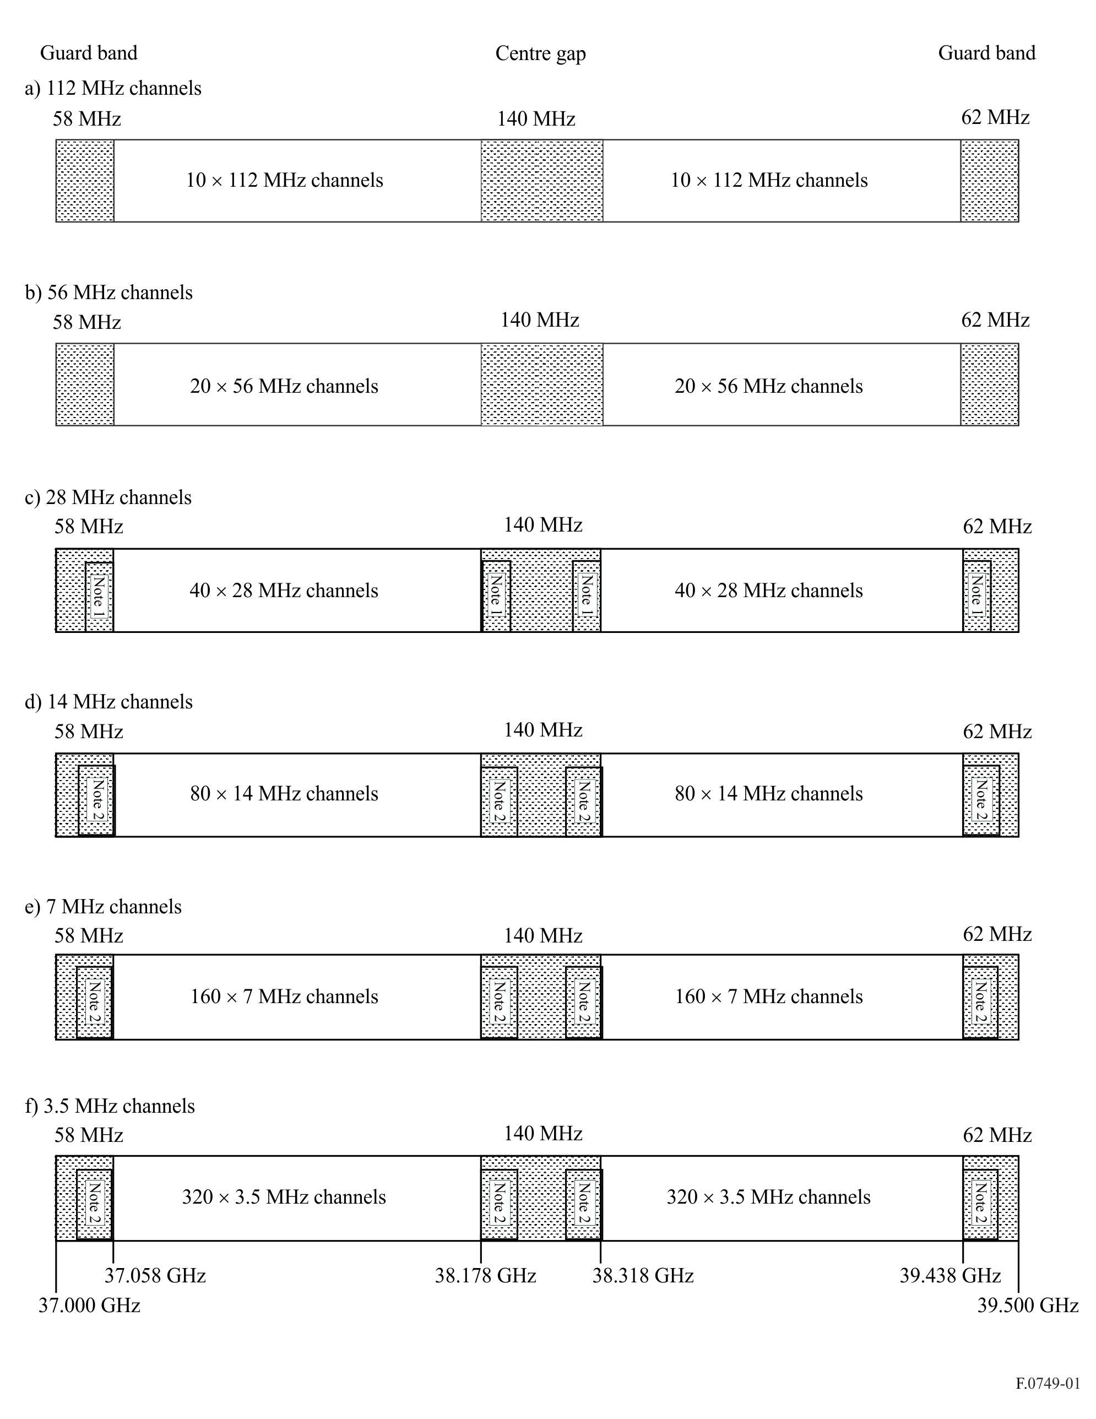
NOTE 1 – One additional 28 MHz channel.
NOTE 2 – 42 MHz for additional 3.5, 7 and 14 MHz channels.
Figure 2
Interleaved channel arrangement with channel width of 224 MHz
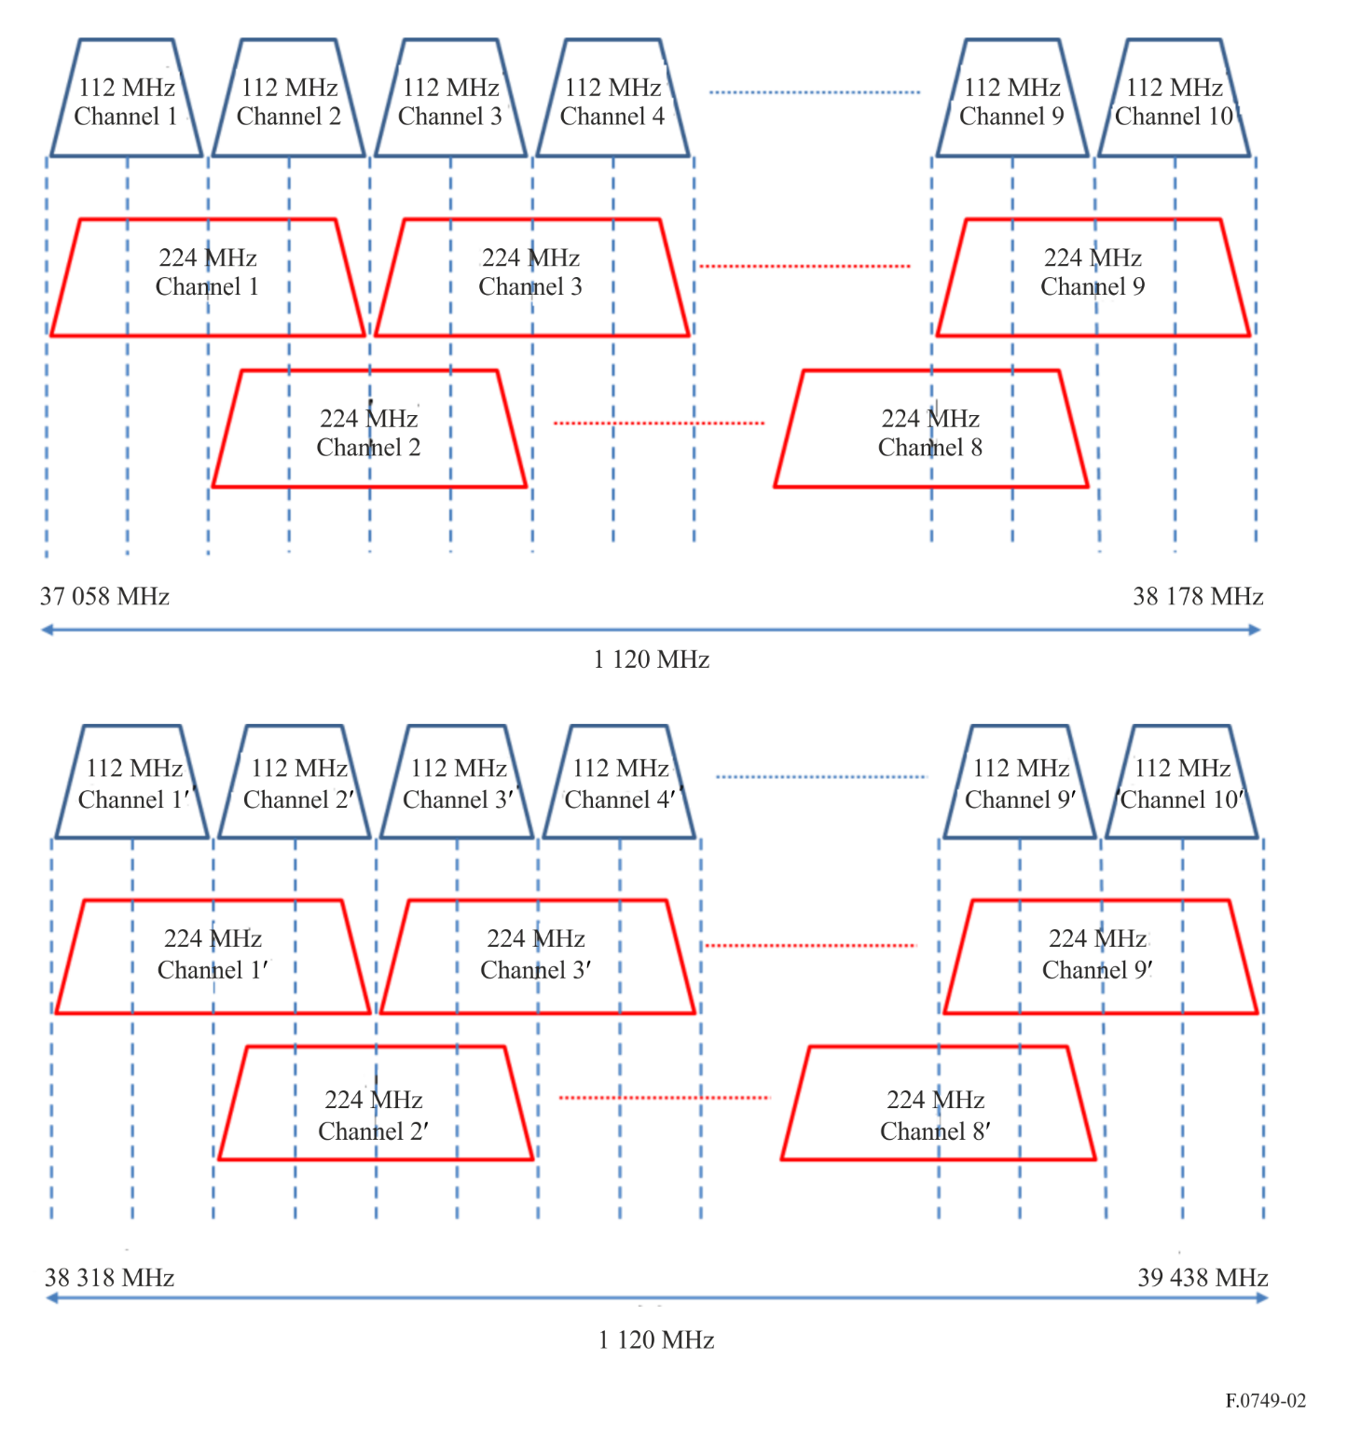

Annex 2
RF channel arrangements for radio-relay systems operating
in the 36.0-37.0 GHz and in the 39.5-40.5 GHz bands in accordance
with recommends 2 (Russia)
The RF channel arrangement for carrier spacings of 112 MHz, 56 MHz, 28 MHz, 14 MHz, 7 MHz and 3.5 MHz shall be derived as follows:
Let f0 be the centre frequency of 36 498 MHz = f$_{r}$ + 1 + (142 × 3.5) MHz for the frequency band 36 000-37 000 MHz, and
f0 be the centre frequency of 39 998 MHz = f$_{r}$ + 1 + (1 142 × 3.5) MHz for the frequency band 39 500-40 500 MHz;
f$_{n}$ be the centre frequency of a RF channel in the lower half of the band (MHz);
$f ¢_{n}$ be the centre frequency of a RF channel in the upper half of the band (MHz);
then the frequencies of individual channels are expressed by the following relationships:
a) for systems with a carrier spacing of 112 MHz:
lower half of band: f$_{n}$ = f0 – 532 + 112 n MHz
upper half of band: $f ¢_{n}$ = f0 – 70 + 112 n MHz
where:
n = 1, 2, 3, 4
b) for systems with a carrier spacing of 56 MHz:
lower half of band: f$_{n}$ = f0 – 476 + 56 n MHz
upper half of band: $f ¢_{n}$ = f0 – 14 + 56 n MHz
where:
n = 1, 2, . . . 8
c) for systems with a carrier spacing of 28 MHz:
lower half of band: f$_{n}$ = f0 – 448 + 28 n MHz
upper half of band: $f ¢_{n}$ = f0 + 14 + 28 n MHz
where:
n = 1, 2, . . . 15
d) for systems with a carrier spacing of 14 MHz:
lower half of band: f$_{n}$ = f0 – 434 + 14 n MHz
upper half of band: $f ¢_{n}$ = f0 + 28 + 14 n MHz
where:
n = 1, 2, . . . 29
e) for systems with a carrier spacing of 7 MHz:
lower half of band: f$_{n}$ = f0 – 427 + 7 n MHz
upper half of band: $f ¢_{n}$ = f0 + 35 + 7 n MHz
where:
n = 1, 2, ... 57
f) for systems with a carrier spacing of 3.5 MHz:
lower half of band: f$_{n}$ = f0 – 423.5 + 3.5 n MHz
upper half of band: $f ¢_{n}$ = f0 + 38.5 + 3.5 n MHz
where:
n = 1, 2, . . . 113.
NOTE 1 – The centre and edge guardbands may be reduced, by agreement between the administrations concerned, for lower capacity systems by the addition of extra channels using frequencies derived from the homogeneous pattern of recommends 2.

Annex 3
RF block arrangements in the band 38.6-40.0 GHz using the homogeneous pattern in accordance with recommends 7

1 Arrangement in Canada and the United States of America

1.1 Radio-frequency block arrangement description
In Canada and the United States of America the band 38.6-40.0 GHz is divided into 14 paired frequency blocks (50 MHz + 50 MHz) as follows:
TABLE 1
Radio-frequency block arrangements in Canada and USA
Block designation | Lower frequency blocks | Upper frequency blocks
Frequency band limits
(MHz)
1 | 38 600-38 650 | 39 300-39 350
2 | 38 650-38 700 | 39 350-39 400
3 | 38 700-38 750 | 39 400-39 450
4 | 38 750-38 800 | 39 450-39 500
5 | 38 800-38 850 | 39 500-39 550
6 | 38 850-38 900 | 39 550-39 600
7 | 38 900-38 950 | 39 600-39 650
8 | 38 950-39 000 | 39 650-39 700
9 | 39 000-39 050 | 39 700-39 750
10 | 39 050-39 100 | 39 750-39 800
11 | 39 100-39 150 | 39 800-39 850
12 | 39 150-39 200 | 39 850-39 900
13 | 39 200-39 250 | 39 900-39 950
14 | 39 250-39 300 | 39 950-40 000

1.2 Usage
– Block designations are A/A' to N/N' for Canada, and 1-A/1-B to 14-A/14-B for the United States of America.
– Frequency blocks are paired to facilitate frequency division duplex systems. Preference is given to the lower frequency blocks for downlink operation and to the upper frequency blocks for uplink operation. Time division duplex systems may operate in either the lower or upper frequency blocks.
– Operators may subdivide the 50 MHz blocks according to their needs.
– Larger frequency blocks can be made available through the aggregation of 50 MHz paired blocks.

2 Arrangement in Japan

2.1 Radio-frequency block arrangement description
In Japan, the band 38.06-38.48/39.06-39.48 GHz is divided into seven paired frequency blocks (60 MHz + 60 MHz) as follows:
TABLE 2
Radio-frequency block arrangements in Japan
Paired block | Lower frequency block (MHz) | Upper frequency block (MHz)
C1/C'1 | 38 060-38 120 | 39 060-39 120
C2/C'2 | 38 120-38 180 | 39 120-39 180
C3/C'3 | 38 180-38 240 | 39 180-39 240
C4/C'4 | 38 240-38 300 | 39 240-39 300
C5/C'5 | 38 300-38 360 | 39 300-39 360
C6/C'6 | 38 360-38 420 | 39 360-39 420
C7/C'7 | 38 420-38 480 | 39 420-39 480

2.2 Usage
– Frequency blocks are paired to facilitate frequency division duplex systems. Preference is given to the lower frequency blocks for uplink operation and to the upper frequency blocks for downlink operation. Time division duplex systems may operate in either the lower or upper frequency blocks.
– Operators may subdivide the 60 MHz blocks according to their needs.
– Larger frequency blocks can be made available through the aggregation of 60 MHz paired blocks.

European Conference of Postal and Telecommunications Administrations.

