|  |
| --- |
| **Recommendation ITU-R P.676-12**  **(08/2019)** |
| **Attenuation by atmospheric gases and related effects** |
| **P Series**  **Radiowave propagation** |

Foreword

The role of the Radiocommunication Sector is to ensure the rational, equitable, efficient and economical use of the radio-frequency spectrum by all radiocommunication services, including satellite services, and carry out studies without limit of frequency range on the basis of which Recommendations are adopted.

The regulatory and policy functions of the Radiocommunication Sector are performed by World and Regional Radiocommunication Conferences and Radiocommunication Assemblies supported by Study Groups.

# Policy on Intellectual Property Right (IPR)

ITU-R policy on IPR is described in the Common Patent Policy for ITU-T/ITU-R/ISO/IEC referenced in Resolution ITU‑R 1. Forms to be used for the submission of patent statements and licensing declarations by patent holders are available from <http://www.itu.int/ITU-R/go/patents/en> where the Guidelines for Implementation of the Common Patent Policy for ITU‑T/ITU‑R/ISO/IEC and the ITU-R patent information database can also be found.

|  |  |
| --- | --- |
| Series of ITU-R Recommendations  (Also available online at <http://www.itu.int/publ/R-REC/en>) | |
| **Series** | Title |
| **BO** | Satellite delivery |
| **BR** | Recording for production, archival and play-out; film for television |
| **BS** | Broadcasting service (sound) |
| **BT** | Broadcasting service (television) |
| **F** | Fixed service |
| **M** | Mobile, radiodetermination, amateur and related satellite services |
| P | Radiowave propagation |
| **RA** | Radio astronomy |
| **RS** | Remote sensing systems |
| **S** | Fixed-satellite service |
| **SA** | Space applications and meteorology |
| **SF** | Frequency sharing and coordination between fixed-satellite and fixed service systems |
| **SM** | Spectrum management |
| **SNG** | Satellite news gathering |
| **TF** | Time signals and frequency standards emissions |
| **V** | Vocabulary and related subjects |

|  |
| --- |
| ***Note***: *This ITU-R Recommendation was approved in English under the procedure detailed in Resolution ITU-R 1.* |

*Electronic Publication*

Geneva, 2020

© ITU 2020

All rights reserved. No part of this publication may be reproduced, by any means whatsoever, without written permission of ITU.

RECOMMENDATION ITU-R P.676-12[1]*

Attenuation by atmospheric gases and related effects

(Question ITU-R 201/3)

(1990-1992-1995-1997-1999-2001-2005-2007-2009-2012-2013-2016-2019)

Scope

This Recommendation provides methods to estimate the attenuation of atmospheric gases on terrestrial and slant paths using:

a) a method in Annex 1 to estimate the gaseous attenuation computed by a summation of individual absorption lines that is valid for the frequency range 1-1 000 GHz;

b) two simplified approximate methods in Annex 2 to estimate the gaseous attenuation that are valid in the frequency range 1‑350 GHz; and

c) other propagation effects that can be computed by a summation of functions of individual absorption lines.

Keywords

Gaseous absorption, specific attenuation, slant path attenuation, total attenuation, water vapour, oxygen, dry air, dispersion, upwelling, downwelling

The ITU Radiocommunication Assembly,

considering

the necessity of estimating the attenuation, dispersion, upwelling noise, and downwelling noise on slant paths and the attenuation on terrestrial paths due to atmospheric gases,

recommends

**1** that, for general application, the procedure in Annex 1 should be used to calculate gaseous attenuation and related effects;

**2** that, for approximate estimates, the computationally less intensive procedure in Annex 2 should be used to calculate gaseous attenuation.

Guide to this Recommendation

This Recommendation provides the following three methods of predicting the specific and path gaseous attenuation due to oxygen and water vapour:

1 Calculation of specific and path gaseous attenuation using the line-by-line summation in Annex 1 assuming the atmospheric pressure, temperature, and water vapour density vs. height;

2 An approximate estimate of specific and path gaseous attenuation in Annex 2 assuming the water vapour density at the surface of the Earth;

3 An approximate estimate of path attenuation in Annex 2 assuming the integrated water vapour content along the path.

These prediction methods can use local meteorological data, or, in the absence of local data, reference atmospheres or meteorological maps corresponding to a desired probability of exceedance that are provided in other ITU-R P-series Recommendations.

In addition to specific and path gaseous attenuation, this Recommendation provides methods to predict dispersion, upwelling and downwelling noise temperature, atmospheric bending, and excess atmospheric path delay using the line-by-line summation in Annex 1.

Specific attenuation

Equation (1), which is applicable to frequencies up to 1 000 GHz, may be used to predict specific attenuation. This method requires the pressure, temperature, and water vapour density at the applicable location. If local data is not available, a combination of: a) the mean annual global reference atmosphere given in Recommendation ITU-R P.835, b) the map of mean annual surface temperature in Recommendation ITU-R P.1510 and c) the maps of surface water vapour density vs. exceedance probability given in Recommendation ITU-R P.836 may be used in lieu of the standard ground-level surface water vapour density of 7.5 g/m3.

Slant path (Earth-space) attenuation

Equation (13), or equations (40) or (41) may be used.

– Equation (13) requires knowledge of the temperature, pressure, and water vapour density profiles along the path. If local profile data is not available, the reference atmospheric profiles given in Recommendation ITU-R P.835 may be used. The surface water vapour density vs. exceedance probability given in Recommendation ITU-R P.836 may be used in lieu of the standard ground-level surface water vapour density of 7.5 g/m3.

– Equation (40) requires knowledge of the surface pressure, surface temperature, and surface water vapour density. Equation (40) is an approximation to equation (13) applicable to frequencies up to 350 GHz assuming a mean annual global reference atmosphere and an arbitrary surface water vapour density with a negative exponential water vapour density profile vs. height. Equation (40) can be used to predict: a) the instantaneous gaseous attenuation for a specific value of surface pressure, surface temperature, and surface water vapour density or b) the gaseous attenuation corresponding to the surface water vapour density at a desired probability of exceedance. If local surface water vapour density data is not available, the surface water vapour density maps in Recommendation ITU-R P.836 may be used.

– Equation (41) requires knowledge of the surface temperature, surface pressure, and integrated water vapour content along the path. Similar to equation (40), equation (41) can be used to predict: a) the instantaneous gaseous attenuation for a specific value of surface pressure, surface temperature, and integrated water vapour content, or b) the gaseous attenuation corresponding to the integrated water vapour content at a desired probability of exceedance. If local surface integrated water vapour content data is not available, the integrated water vapour maps in Recommendation ITU-R P.836 may be used.

If local surface water vapour density and integrated water vapour content data are both available, equation (41) using local integrated water vapour content is considered to be more accurate than equation (40) using local surface water vapour density data. Similarly, if local data is not available, equation (41) using the maps of integrated water vapour content in Recommendation ITU-R P.836 is considered to be more accurate than equation (40) using the maps of surface water vapour density in Recommendation ITU-R P.836.

|  |  |  |  |
| --- | --- | --- | --- |
|  | Equation (13) | Equation (40) | Equation (41) |
| Frequency range | <1 000 GHz | <350 GHz | <350 GHz |
| Accuracy | Best, line-by-line sum | Approximation | |
| Pressure  vs. height | Arbitrary | Mean Annual Global Reference Atmospheric Profile | |
| Temperature  vs. height |
| Water vapour density  vs. height | Surface value with negative exponential profile vs. height | Integrated water vapour content in lieu of water vapour density vs. height |

Annex 1  
  
Line-by-line calculation of gaseous attenuation

# 1 Specific attenuation

The specific attenuation at frequencies up to 1 000 GHz, due to dry air and water vapour, can be accurately evaluated at any value of pressure, temperature and humidity as a summation of the individual spectral lines from oxygen and water vapour, together with small additional factors for the non-resonant Debye spectrum of oxygen below 10 GHz, pressure-induced nitrogen attenuation above 100 GHz and a wet continuum to account for the excess water vapour-absorption found experimentally. Figure 1 shows the specific attenuation using the prediction method, calculated from 0 to 1 000 GHz at 1 GHz intervals, for a pressure of 1 013.25 hPa, temperature of 15C for the cases of a water vapour density of 7.5 g/m3 (Standard) and a dry atmosphere (Dry).

Near 60 GHz, many oxygen absorption lines merge together at sea-level pressures to form a single, broad absorption band, which is shown in more detail in Fig. 2. This Figure also shows the oxygen attenuation at higher altitudes, with the individual lines becoming resolved as the pressure decreases with increasing altitude. Some additional molecular species (e.g. oxygen isotopic species, oxygen vibrationally excited species, ozone, ozone isotopic species, and ozone vibrationally excited species, and other minor species) are not included in the line-by-line prediction method. These additional lines are insignificant for typical atmospheres but may be important for a dry atmosphere.

The specific gaseous attenuation is given by:

 (1)

where γ*o* and γ*w* are the specific attenuations (dB/km) due to dry air (oxygen, pressure-induced nitrogen and non-resonant Debye attenuation) and water vapour, respectively,  *f* is the frequency (GHz), and *N* ″*Oxygen*( *f*  and *N* ″*Water Vapour*( *f*  are the imaginary parts of the frequency-dependent complex refractivities:

$N_{Oxygen}^{''}\left(f\right)=\sum_{i (Oxygen)}{S_{i}F_{i}+N_{D}^{''}(f)}$ (2a)

$N_{Water Vapour}^{''}\left(f\right)=\sum_{i (Water Vapour)}{S_{i}F_{i}}$ (2b)

*Si* is the strength of the *i*th oxygen or water vapour line, *Fi* is the oxygen or water vapour line shape factor, and the summations extend over all the spectral lines in Tables 1 and 2;

 is the dry continuum due to pressure-induced nitrogen absorption and the Debye spectrum as given by equation (8).

The line strength is given by:

 (3)

where:

*p*: dry air pressure (hPa)

*e* : water vapour partial pressure (hPa) (total barometric pressure, *ptot*  *p*  *e*)

❑ = 300/*T*

*T*: temperature (K).

FIGURE 1

Specific attenuation due to atmospheric gases, calculated at 1 GHz intervals, including line centres

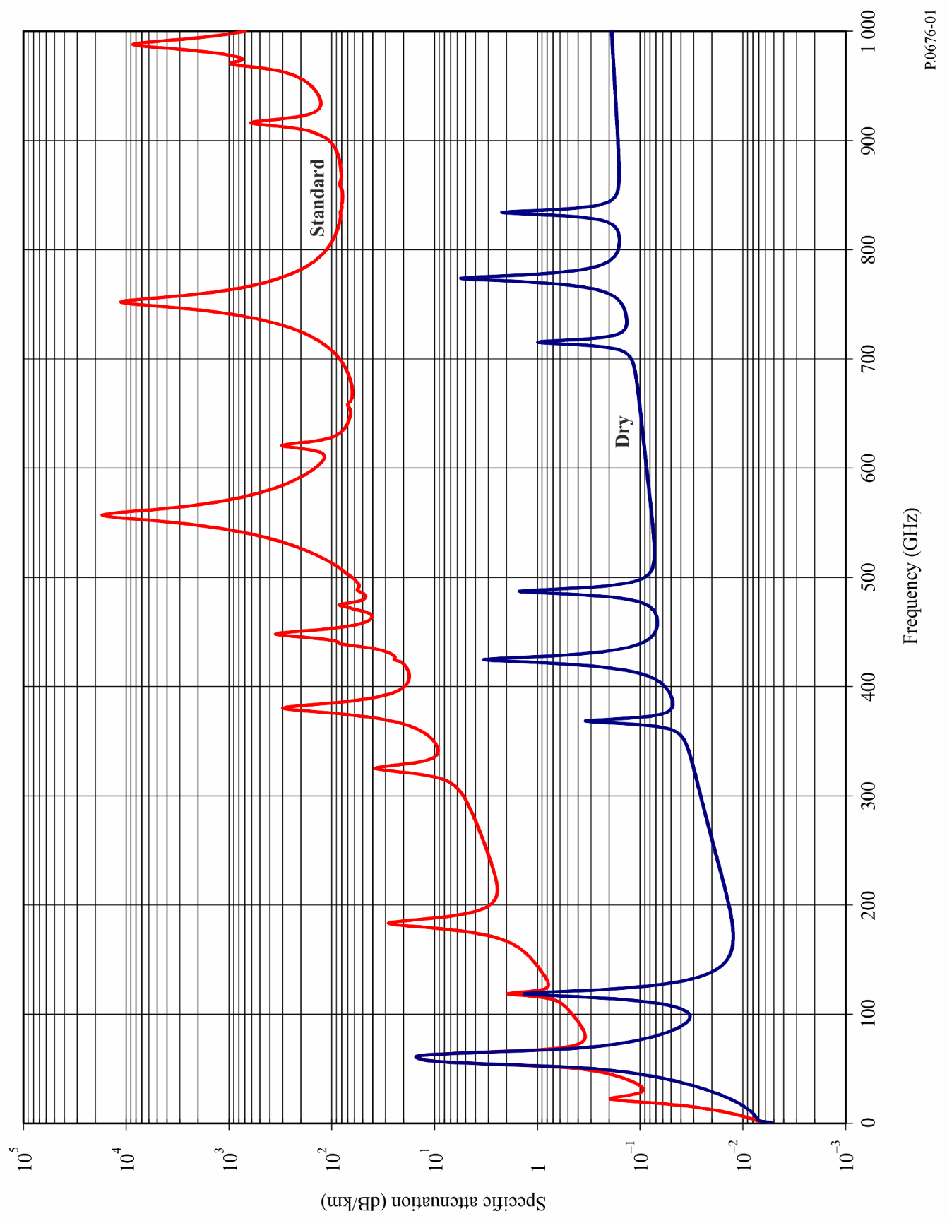

FIGURE 2

Specific attenuation in the range 50-70 GHz at the altitudes indicated, calculated at intervals of 10 MHz,   
including line centres (0 km, 5 km, 10 km, 15 km and 20 km)

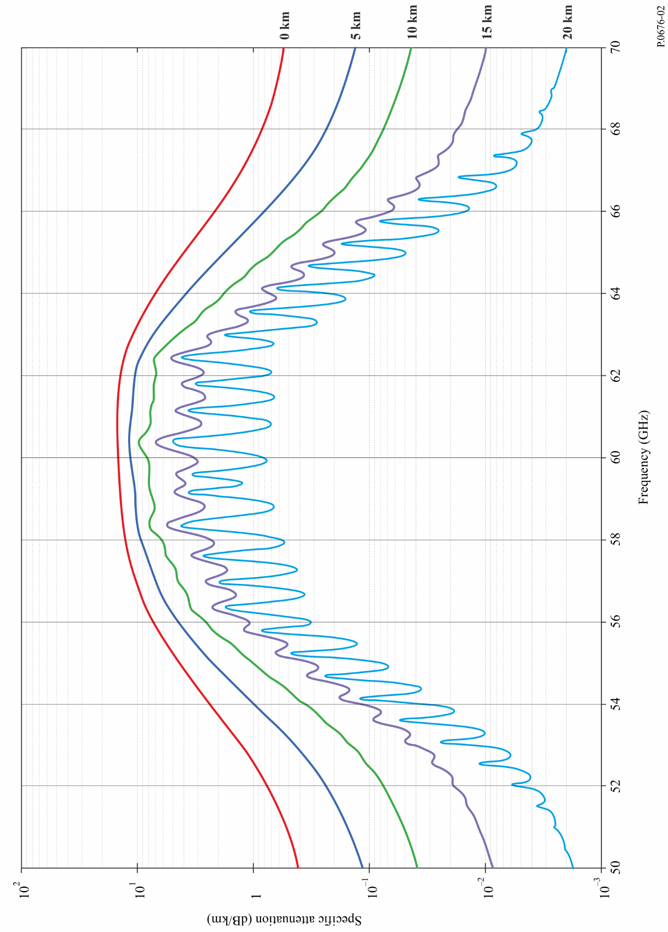

If available, local altitude profiles of *p*, *e* and *T* (e.g. using radiosondes) should be used. In the absence of local data, an appropriate reference standard atmosphere given in Recommendation ITU-R P.835 should be used. (Note that where total atmospheric attenuation is calculated, the same-water vapour partial pressure is used for the attenuation attributable to oxygen and the attenuation attributable to water vapour.)

The water vapour partial pressure, *e*, at any altitude may be obtained from the water vapour density,  and the temperature, *T*, at that altitude using the expression:

 (4)

Spectroscopic data for oxygen is given in Table 1, and spectroscopic data for water vapour is given in Table 2. The last entry in Table 2 is a pseudo-line centred at 1 780 GHz whose lower wing represents the combined contribution below 1 000 GHz of water vapour resonances not included in the line-by-line prediction method (i.e. the wet continuum). The pseudo-line's parameters are adjusted to account for the difference between the measured absorption in the atmospheric windows and the calculated local-line absorption.

The line-shape factor is given by:

 (5)

where *fi* is the oxygen or water vapour line frequency and Δ*f* is the width of the line:

 (6a)

The line width Δ*f* is modified to account for Zeeman splitting of oxygen lines and Doppler broadening of water vapour lines:

 (6b)

δ is a correction factor that arises due to interference effects in oxygen lines:

 (7)

TABLE 1

Spectroscopic data for oxygen attenuation

|  |  |  |  |  |  |  |
| --- | --- | --- | --- | --- | --- | --- |
| *f*0 | *a*1 | *a*2 | *a*3 | *a*4 | *a*5 | *a*6 |
| 50.474214 | 0.975 | 9.651 | 6.690 | 0.0 | 2.566 | 6.850 |
| 50.987745 | 2.529 | 8.653 | 7.170 | 0.0 | 2.246 | 6.800 |
| 51.503360 | 6.193 | 7.709 | 7.640 | 0.0 | 1.947 | 6.729 |
| 52.021429 | 14.320 | 6.819 | 8.110 | 0.0 | 1.667 | 6.640 |
| 52.542418 | 31.240 | 5.983 | 8.580 | 0.0 | 1.388 | 6.526 |
| 53.066934 | 64.290 | 5.201 | 9.060 | 0.0 | 1.349 | 6.206 |
| 53.595775 | 124.600 | 4.474 | 9.550 | 0.0 | 2.227 | 5.085 |
| 54.130025 | 227.300 | 3.800 | 9.960 | 0.0 | 3.170 | 3.750 |
| 54.671180 | 389.700 | 3.182 | 10.370 | 0.0 | 3.558 | 2.654 |
| 55.221384 | 627.100 | 2.618 | 10.890 | 0.0 | 2.560 | 2.952 |
| 55.783815 | 945.300 | 2.109 | 11.340 | 0.0 | –1.172 | 6.135 |
| 56.264774 | 543.400 | 0.014 | 17.030 | 0.0 | 3.525 | –0.978 |
| 56.363399 | 1331.800 | 1.654 | 11.890 | 0.0 | –2.378 | 6.547 |
| 56.968211 | 1746.600 | 1.255 | 12.230 | 0.0 | –3.545 | 6.451 |
| 57.612486 | 2120.100 | 0.910 | 12.620 | 0.0 | –5.416 | 6.056 |
| 58.323877 | 2363.700 | 0.621 | 12.950 | 0.0 | –1.932 | 0.436 |
| 58.446588 | 1442.100 | 0.083 | 14.910 | 0.0 | 6.768 | –1.273 |
| 59.164204 | 2379.900 | 0.387 | 13.530 | 0.0 | –6.561 | 2.309 |
| 59.590983 | 2090.700 | 0.207 | 14.080 | 0.0 | 6.957 | –0.776 |
| 60.306056 | 2103.400 | 0.207 | 14.150 | 0.0 | –6.395 | 0.699 |
| 60.434778 | 2438.000 | 0.386 | 13.390 | 0.0 | 6.342 | –2.825 |
| 61.150562 | 2479.500 | 0.621 | 12.920 | 0.0 | 1.014 | –0.584 |
| 61.800158 | 2275.900 | 0.910 | 12.630 | 0.0 | 5.014 | –6.619 |
| 62.411220 | 1915.400 | 1.255 | 12.170 | 0.0 | 3.029 | –6.759 |
| 62.486253 | 1503.000 | 0.083 | 15.130 | 0.0 | –4.499 | 0.844 |
| 62.997984 | 1490.200 | 1.654 | 11.740 | 0.0 | 1.856 | –6.675 |
| 63.568526 | 1078.000 | 2.108 | 11.340 | 0.0 | 0.658 | –6.139 |
| 64.127775 | 728.700 | 2.617 | 10.880 | 0.0 | –3.036 | –2.895 |
| 64.678910 | 461.300 | 3.181 | 10.380 | 0.0 | –3.968 | –2.590 |
| 65.224078 | 274.000 | 3.800 | 9.960 | 0.0 | –3.528 | –3.680 |
| 65.764779 | 153.000 | 4.473 | 9.550 | 0.0 | –2.548 | –5.002 |
| 66.302096 | 80.400 | 5.200 | 9.060 | 0.0 | –1.660 | –6.091 |
| 66.836834 | 39.800 | 5.982 | 8.580 | 0.0 | –1.680 | –6.393 |
| 67.369601 | 18.560 | 6.818 | 8.110 | 0.0 | –1.956 | –6.475 |
| 67.900868 | 8.172 | 7.708 | 7.640 | 0.0 | –2.216 | –6.545 |
| 68.431006 | 3.397 | 8.652 | 7.170 | 0.0 | –2.492 | –6.600 |
| 68.960312 | 1.334 | 9.650 | 6.690 | 0.0 | –2.773 | –6.650 |
| 118.750334 | 940.300 | 0.010 | 16.640 | 0.0 | –0.439 | 0.079 |

TABLE 1 (*end*)

|  |  |  |  |  |  |  |
| --- | --- | --- | --- | --- | --- | --- |
| *f*0 | *a*1 | *a*2 | *a*3 | *a*4 | *a*5 | *a*6 |
| 368.498246 | 67.400 | 0.048 | 16.400 | 0.0 | 0.000 | 0.000 |
| 424.763020 | 637.700 | 0.044 | 16.400 | 0.0 | 0.000 | 0.000 |
| 487.249273 | 237.400 | 0.049 | 16.000 | 0.0 | 0.000 | 0.000 |
| 715.392902 | 98.100 | 0.145 | 16.000 | 0.0 | 0.000 | 0.000 |
| 773.839490 | 572.300 | 0.141 | 16.200 | 0.0 | 0.000 | 0.000 |
| 834.145546 | 183.100 | 0.145 | 14.700 | 0.0 | 0.000 | 0.000 |

TABLE 2

Spectroscopic data for water vapour attenuation

| *f*0 | *b*1 | *b*2 | *b*3 | *b*4 | *b*5 | *b*6 |
| --- | --- | --- | --- | --- | --- | --- |
| 22.235080 | .1079 | 2.144 | 26.38 | .76 | 5.087 | 1.00 |
| 67.803960 | .0011 | 8.732 | 28.58 | .69 | 4.930 | .82 |
| 119.995940 | .0007 | 8.353 | 29.48 | .70 | 4.780 | .79 |
| 183.310087 | 2.273 | .668 | 29.06 | .77 | 5.022 | .85 |
| 321.225630 | .0470 | 6.179 | 24.04 | .67 | 4.398 | .54 |
| 325.152888 | 1.514 | 1.541 | 28.23 | .64 | 4.893 | .74 |
| 336.227764 | .0010 | 9.825 | 26.93 | .69 | 4.740 | .61 |
| 380.197353 | 11.67 | 1.048 | 28.11 | .54 | 5.063 | .89 |
| 390.134508 | .0045 | 7.347 | 21.52 | .63 | 4.810 | .55 |
| 437.346667 | .0632 | 5.048 | 18.45 | .60 | 4.230 | .48 |
| 439.150807 | .9098 | 3.595 | 20.07 | .63 | 4.483 | .52 |
| 443.018343 | .1920 | 5.048 | 15.55 | .60 | 5.083 | .50 |
| 448.001085 | 10.41 | 1.405 | 25.64 | .66 | 5.028 | .67 |
| 470.888999 | .3254 | 3.597 | 21.34 | .66 | 4.506 | .65 |
| 474.689092 | 1.260 | 2.379 | 23.20 | .65 | 4.804 | .64 |
| 488.490108 | .2529 | 2.852 | 25.86 | .69 | 5.201 | .72 |
| 503.568532 | .0372 | 6.731 | 16.12 | .61 | 3.980 | .43 |
| 504.482692 | .0124 | 6.731 | 16.12 | .61 | 4.010 | .45 |
| 547.676440 | .9785 | .158 | 26.00 | .70 | 4.500 | 1.00 |
| 552.020960 | .1840 | .158 | 26.00 | .70 | 4.500 | 1.00 |
| 556.935985 | 497.0 | .159 | 30.86 | .69 | 4.552 | 1.00 |
| 620.700807 | 5.015 | 2.391 | 24.38 | .71 | 4.856 | .68 |
| 645.766085 | .0067 | 8.633 | 18.00 | .60 | 4.000 | .50 |
| 658.005280 | .2732 | 7.816 | 32.10 | .69 | 4.140 | 1.00 |
| 752.033113 | 243.4 | .396 | 30.86 | .68 | 4.352 | .84 |
| 841.051732 | .0134 | 8.177 | 15.90 | .33 | 5.760 | .45 |
| 859.965698 | .1325 | 8.055 | 30.60 | .68 | 4.090 | .84 |
| 899.303175 | .0547 | 7.914 | 29.85 | .68 | 4.530 | .90 |
| 902.611085 | .0386 | 8.429 | 28.65 | .70 | 5.100 | .95 |
| 906.205957 | .1836 | 5.110 | 24.08 | .70 | 4.700 | .53 |

TABLE 2 (*end*)

|  |  |  |  |  |  |  |
| --- | --- | --- | --- | --- | --- | --- |
| *f*0 | *b*1 | *b*2 | *b*3 | *b*4 | *b*5 | *b*6 |
| 916.171582 | 8.400 | 1.441 | 26.73 | .70 | 5.150 | .78 |
| 923.112692 | .0079 | 10.293 | 29.00 | .70 | 5.000 | .80 |
| 970.315022 | 9.009 | 1.919 | 25.50 | .64 | 4.940 | .67 |
| 987.926764 | 134.6 | .257 | 29.85 | .68 | 4.550 | .90 |
| 1 780.000000 | 17506. | .952 | 196.3 | 2.00 | 24.15 | 5.00 |

The dry air continuum arises from the non-resonant Debye spectrum of oxygen below 10 GHz and a pressure‑induced nitrogen attenuation above 100 GHz.

 (8)

where *d* is the width parameter for the Debye spectrum:

 (9)

# 2 Path attenuation

## 2.1 Terrestrial paths

For a terrestrial path, or for slightly inclined paths close to the ground, the path attenuation, *A*, may be calculated as:

 (10)

where *r*0 is the path length (km).

## 2.2 Slant paths

Sections 2.2.1 and 2.2.2 provide methods to calculate the Earth-space slant path gaseous attenuation for an ascending path between a location on or near the surface of the Earth and a location above the surface of the Earth or in space using the line-by-line method in Annex 1 for a known temperature, dry air pressure, and water vapour density profile. Section 2.2.3 extends the method to a descending path between a location above the surface of the Earth or in space and a location on or near the surface of the Earth. Sections 2.2.4 and 2.2.5 provide methods to calculate the bending and excess atmospheric path length, respectively, on an Earth-space path.

### 2.2.1 Non-negative apparent elevation angles

The slant path gaseous attenuation on an ascending path between heights $h_{1}$ and $h_{2}$  
( $h_{2}>h_{1}≥0$ km) is:

$A_{gas}=\int_{h_{1}}^{h_{2}}{\frac{γ(h)}{\sin{φ(h)}}dh}$ = $\int_{h_{1}}^{h_{2}}{\frac{γ(h)}{\sqrt{{1-cos}^{2}{φ(h)}}}dh}$ (11)

where:

$\cos{φ\left(h\right)=\frac{\left(R_{E}+h_{1}\right) n(h_{1})}{\left(R_{E}+h\right) n(h)}}\cos{φ_{1}}$ (12)

$γ(h)$ is the specific attenuation at height $h$, $R_{E}$ is the average Earth radius (6 371 km), $φ_{1}$ is the local apparent elevation angle at height $h_{1}$, and $n\left(h\right)$ is the refractive index at height $h$.

While equation (11) can be evaluated by numerical integration[2], the slant path gaseous attenuation is well-approximated by dividing the atmosphere into exponentially increasing layers, determining the specific attenuation (dB/km) of each layer and the path length (km) through each layer, and summing the product of the specific attenuation of each layer and the path length through each layer as shown in equation (13). In the absence of local temperature, dry air pressure, and water vapour partial pressure profiles vs. height (e.g. from radiosonde data), any of the six reference standard atmospheres (i.e. the mean annual global reference atmosphere, the low-latitude reference atmosphere, the mid-latitude summer reference atmosphere, the mid-latitude winter reference atmosphere, the high-latitude summer reference atmosphere, or the high-latitude winter reference atmosphere) given in Recommendation ITU-R P.835 may be used.

$A_{gas}=\sum_{i=1}^{i_{max}}{a_{i} γ_{i}}$ (dB) (13)

where γ*i* is the specific attenuation (dB/km) of the *i*th layer per equation (1), and $a_{i}$ is the path length (km) through the *i*th layer.

For a slant path between the surface of the Earth and space and referring to the geometry in Fig. 5, the thickness of the layers increases exponentially from 10 cm at the surface of the Earth to ~1 km at a height of ~100 km to ensure an accurate estimate of the total slant path gaseous attenuation. The thickness of the $i^{th}$ layer, $δ_{i}$, is:

$δ_{i}=0.0001 e^{\frac{i-1}{100}}$ (km) (14)

$h_{1}=0$, and $h_{i}$, the height of the bottom of layer $i$ for $i≥2$, is:

$h_{i}=\sum_{j=1}^{i-1}{δ_{j}=0.0001 \frac{e^{\frac{i-1}{100}}-1}{e^{\frac{1}{100}}-1}}$ (15)

If one of the six reference standard atmospheres specified in Recommendation ITU-R P.835 is used, the atmospheric profile is defined for geometric heights up to 100 km, in which case $i_{max}=922$, $δ_{922}=0.999 66$ km, and $h_{922}=99.457$ km.

For a slant path between a lower height within the atmosphere, $h_{lower},$ and an upper height within the atmosphere, $h_{upper}$, ($0 km≤h_{lower}<h_{upper}≤100 km)$, the slant path attenuation can be calculated by setting $r_{1}$ to the radius of the lower height from the centre of the Earth and modifying equations (14) and (15) to approximately preserve the exponentially increasing height progression relative to the surface of the Earth as follows:

a) Calculate $i_{lower}$ and $i_{upper}$:

$i_{lower}=floor\left\{100 ln\left[{10}^{4} h_{lower}\left(e^{\frac{1}{100}}-1\right)+1\right]+1\right\}$ (16a)

$i_{upper}=ceiling\left\{100 ln\left[{10}^{4} h_{upper}\left(e^{\frac{1}{100}}-1\right)+1\right]+1\right\}$ (16b)

where floor($x$) rounds $x$ down to the next nearest integer, and ceiling($x$) rounds $x$ up to the next nearest integer.

b) Replace the lower limit in equation (13) with $i=$ $i_{lower}$ and the upper limit with $i_{upper}-1$.

c) Replace 0.0001 in equation (14) with $m$, where:

$m=\left(\frac{e^{\frac{2}{100}} - e^{\frac{1}{100}}}{e^{\frac{i_{upper}}{100} }- e^{\frac{i_{lower}}{100}}}\right)(h_{upper}-h_{lower})$ (16c)

d) Replace equation (15) with:

$h_{i}=h_{lower}+\sum_{j=i_{lower}}^{i-1}{δ_{j}=h_{lower}+m \frac{e^{\frac{i-1}{100}}-e^{\frac{i_{lower}-1}{100}}}{e^{\frac{1}{100}}-1}},i_{lower}≤ i≤i_{upper}$ (16d)

Equations (16a) to (16d) should be used with caution due to possible degraded accuracy for slant paths where $i_{upper}-i_{lower}<50$ (e.g. paths between two airborne platforms).

*ai* is the path length through the $i^{th}$ layer with thickness δ*i*, and *ni* is the radio refractive index of the $i^{th}$ layer. $n_{i}$ is a function of the dry air pressure, temperature and water vapour partial pressure of the $i^{th}$ layer using equations (1) and (2) of Recommendation ITU-R P.453. $α_{i}$ and $β_{i+1}$ are the entry and exit incidence angles at the interface between the $i^{th}$ and ${\left(i+1\right)}^{st}$ layer, *ri* is the radius from the centre of the Earth to the beginning of the $i^{th}$ layer, $r_{i+1}=r_{i}+δ_{i}$, and $r_{1}$ is the radius from the centre of the Earth to the beginning of the lowest layer, typically the average Earth radius (6 371 km). The refractive index, $n_{i}$, and the specific attenuation, $γ_{i}$, of the $i^{th}$ layer are their respective values at the midpoint of the $i^{th}$ layer; i.e. at the height $r_{i}+δ_{i}/2$.

The path length $a_{i}$ is:

$a_{i}=-r_{i}\cos{β_{i}+\sqrt{r_{i}^{2}\cos^{2}{β_{i}+2 r_{i} δ_{i}+ δ_{i}^{2}}}}$ (km) (17)

and the angle $α_{i}$ is:

$α_{i}={π-cos}^{-1}\left(\frac{-a_{i}^{2}-2 r_{i}{ δ}_{i}-δ_{i}^{2}}{2 a_{i }\left({ r}_{i}+δ_{i}\right)}\right)$ (18a)

$=\sin^{-1}\left(\frac{r_{i}}{r_{i}+δ_{i}}\sin{β_{i}}\right)$ (18b)

Equation (18a) is deprecated due to degraded accuracy. $β_{1}$ is the local zenith angle at or near the surface of the Earth (the complement of the apparent elevation angle, $φ$; i.e. $β_{1}=90°-φ$).

$β_{i+1}$ can be recursively calculated from α*i* using Snell’s law as follows:

$β_{i+1}=\sin^{-1}\left(\frac{n_{i}}{n_{i+1}}\sin{α_{i}}\right)$ (19a)

Alternatively, $β_{i}$ can be calculated directly without calculating $α_{i}$ using Snell’s law in polar coordinates as follows:

$β_{i}=\sin^{-1}\left(\frac{{n_{1 }r}_{1}}{n_{i} r_{i}}\sin{β_{1}}\right)$ (19b)

and similarly, $α_{i}$ can be calculated as follows:

$α_{i}=\sin^{-1}\left(\frac{n_{1}r_{1}}{{n_{i} r}_{i+1}}\sin{β_{1}}\right)$ (19c)

In the Earth-to-space direction, equations (19a) or (19b) and (19c) may be invalid at initial apparent elevation angles < 1° (i.e. initial apparent zenith angle, $β_{1},>{89}^{o})$ when the radio refractivity gradient $dN/dh$ is less than −157 N-units/km, which may occur when radiosonde data from certain regions of the world susceptible to ducting are used as the atmospheric profile. In these cases, the radio wave is reflected by the atmosphere and follows the curvature of the Earth (i.e. travels in ducts), and the argument of the inverse sine function in equations (19a) or (19b) and (19c) is greater than 1. Equations (19a), (19b), and (19c) are valid for all non-negative apparent elevation angles when any of the six reference standard atmospheres in Recommendation ITU-R P.835 are used as input, since these reference atmospheres do not have refractivity gradients characteristic of ducting.

Figure 4 shows the zenith attenuation calculated at 1 GHz intervals for the mean annual global reference standard atmosphere in Recommendation ITU-R P.835. The “Standard” atmosphere is the mean annual global reference atmosphere with = 7.5 g/m3, and the “Dry” atmosphere is the mean annual global reference atmosphere with = 0 g/m3.

### 2.2.2 Negative apparent elevation angles

Equation (13) assumes the height increases between the earth station and space. However, for negative apparent elevation angles from an elevated earth station, the height decreases along the propagation path between the earth station and the minimum grazing height and then increases along the propagation path between the minimum grazing height and space. This is shown in Fig. 3 for an earth station at height $h_{1}$ with an apparent elevation angle of ${{90}^{o}-β}_{1}$.

From Snell’s law in polar coordinates:

$n\left(h_{G}\right)\left(R_{E}+h_{G}\right)=n\left(h_{1}\right) \left(R_{E}+h_{1}\right)\sin{β_{1}}$ (20)

in which case the grazing height, $h_{G}$, can be determined by iteratively solving equation (20). The refractive index, $n\left(h\right)$, can be determined from equations (1) and (2) of Recommendation ITU‑R P.453 for the specific atmospheric profile of interest, typically one of the reference profiles in Recommendation ITU-R P.835.

The net gaseous attenuation is the sum of the gaseous attenuations for Path 1 and Path 2. Path 1 is the gaseous attenuation between a virtual earth station at height $h_{G}$ km and the actual earth station at a height of $h_{1}$ km at an apparent elevation angle of 0°, and Path 2 is the gaseous attenuation between a virtual earth station at height $h_{G}$ km and the maximum atmospheric height (typically 100 km) at an apparent elevation angle of 0°.

Figure 3

Grazing height geometry



### 2.2.3 Space-Earth Earth-space reciprocity

For a path between a space station and an earth station, where the apparent elevation angle, $φ_{s}$, at the space station is negative, and the apparent elevation angle at the earth station is $φ_{e}$, the apparent elevation angles are related by:

$φ_{s}=-\cos^{-1}\left(\frac{r_{e }n_{e}}{r_{s }n_{s}}\cos{φ_{e}}\right)$ (21a)

and

$φ_{e}=\cos^{-1}\left(\frac{r_{s}{ n}_{s}}{r_{e}{ n}_{e}}\cos{φ_{s}}\right)$ (21b)

where $n_{e}$ is the refractive index at the earth station height, $r_{e}$ is the radius from the centre of the Earth to the earth station ($r_{e}≥R_{E})$, $n_{s}$ is the refractive index at the space station height, and $r_{s}$ is the radius from the centre of the Earth to the space station ($r_{s}>r_{e})$. If the height of the space station is greater than 100 km above the surface of the Earth, then $n_{s}$ = 1.

Since propagation through the atmosphere is reciprocal, the gaseous attenuation for a space-Earth path, where the apparent elevation angle at the space station is $φ_{s}$, is identical to the gaseous attenuation for the reciprocal Earth-space path, where the apparent elevation angle at the earth station is $φ_{e}$. As a result, the gaseous attenuation for a descending space-Earth path can be calculated as the gaseous attenuation for the corresponding ascending Earth-space path. If $\frac{r_{s }n_{s}}{r_{e}{ n}_{e}}\cos{φ_{s}}>1$, then the space-Earth path does not intercept the Earth.

### 2.2.4 Atmospheric bending

The total atmospheric bending, $Bending$, along the Earth-space path is:

$Bending=\sum_{i=1}^{i_{max}-1{ }}{\left(β_{i+1}-α_{i}\right)}$ (22a)

$=\sum_{i=1}^{i_{max}-1{ }}{\left[\sin^{-1}\left(\frac{{n_{1 }r}_{1}}{n_{i+1} r_{i+1}}\sin{β_{1}}\right)-\sin^{-1}\left(\frac{n_{1 }r_{1}}{{n_{i} r}_{i+1}}\sin{β_{1}}\right) \right]}$ (22b)

where a positive value of bending means the ray bends toward the Earth. Equation (9) of Recomendation ITU‑R P.834 is an approximation to equations (22a) and (22b) for the mean annual global reference atmosphere.

### 2.2.5 Excess atmospheric path length

Since the tropospheric refractive index is greater than 1, the effective atmospheric path length exceeds the geometrical path length, in which case the excess atmospheric path length, $ΔL$, is:

$ΔL=\sum_{i=1}^{i_{max}}{{a_{i}(n}_{i}-1)}$ (km) (23)

The term excess atmospheric path length is synonymous with the term excess radio path length in Recommendation ITU-R P.834; and a method of predicting the excess radio path length as a function of location, day of the year, and apparent elevation angle is given in § 6 of Recommendation ITU‑R P.834.

FIGURE 4

Zenith attenuation due to atmospheric gases, calculated at 1 GHz intervals, including line centres

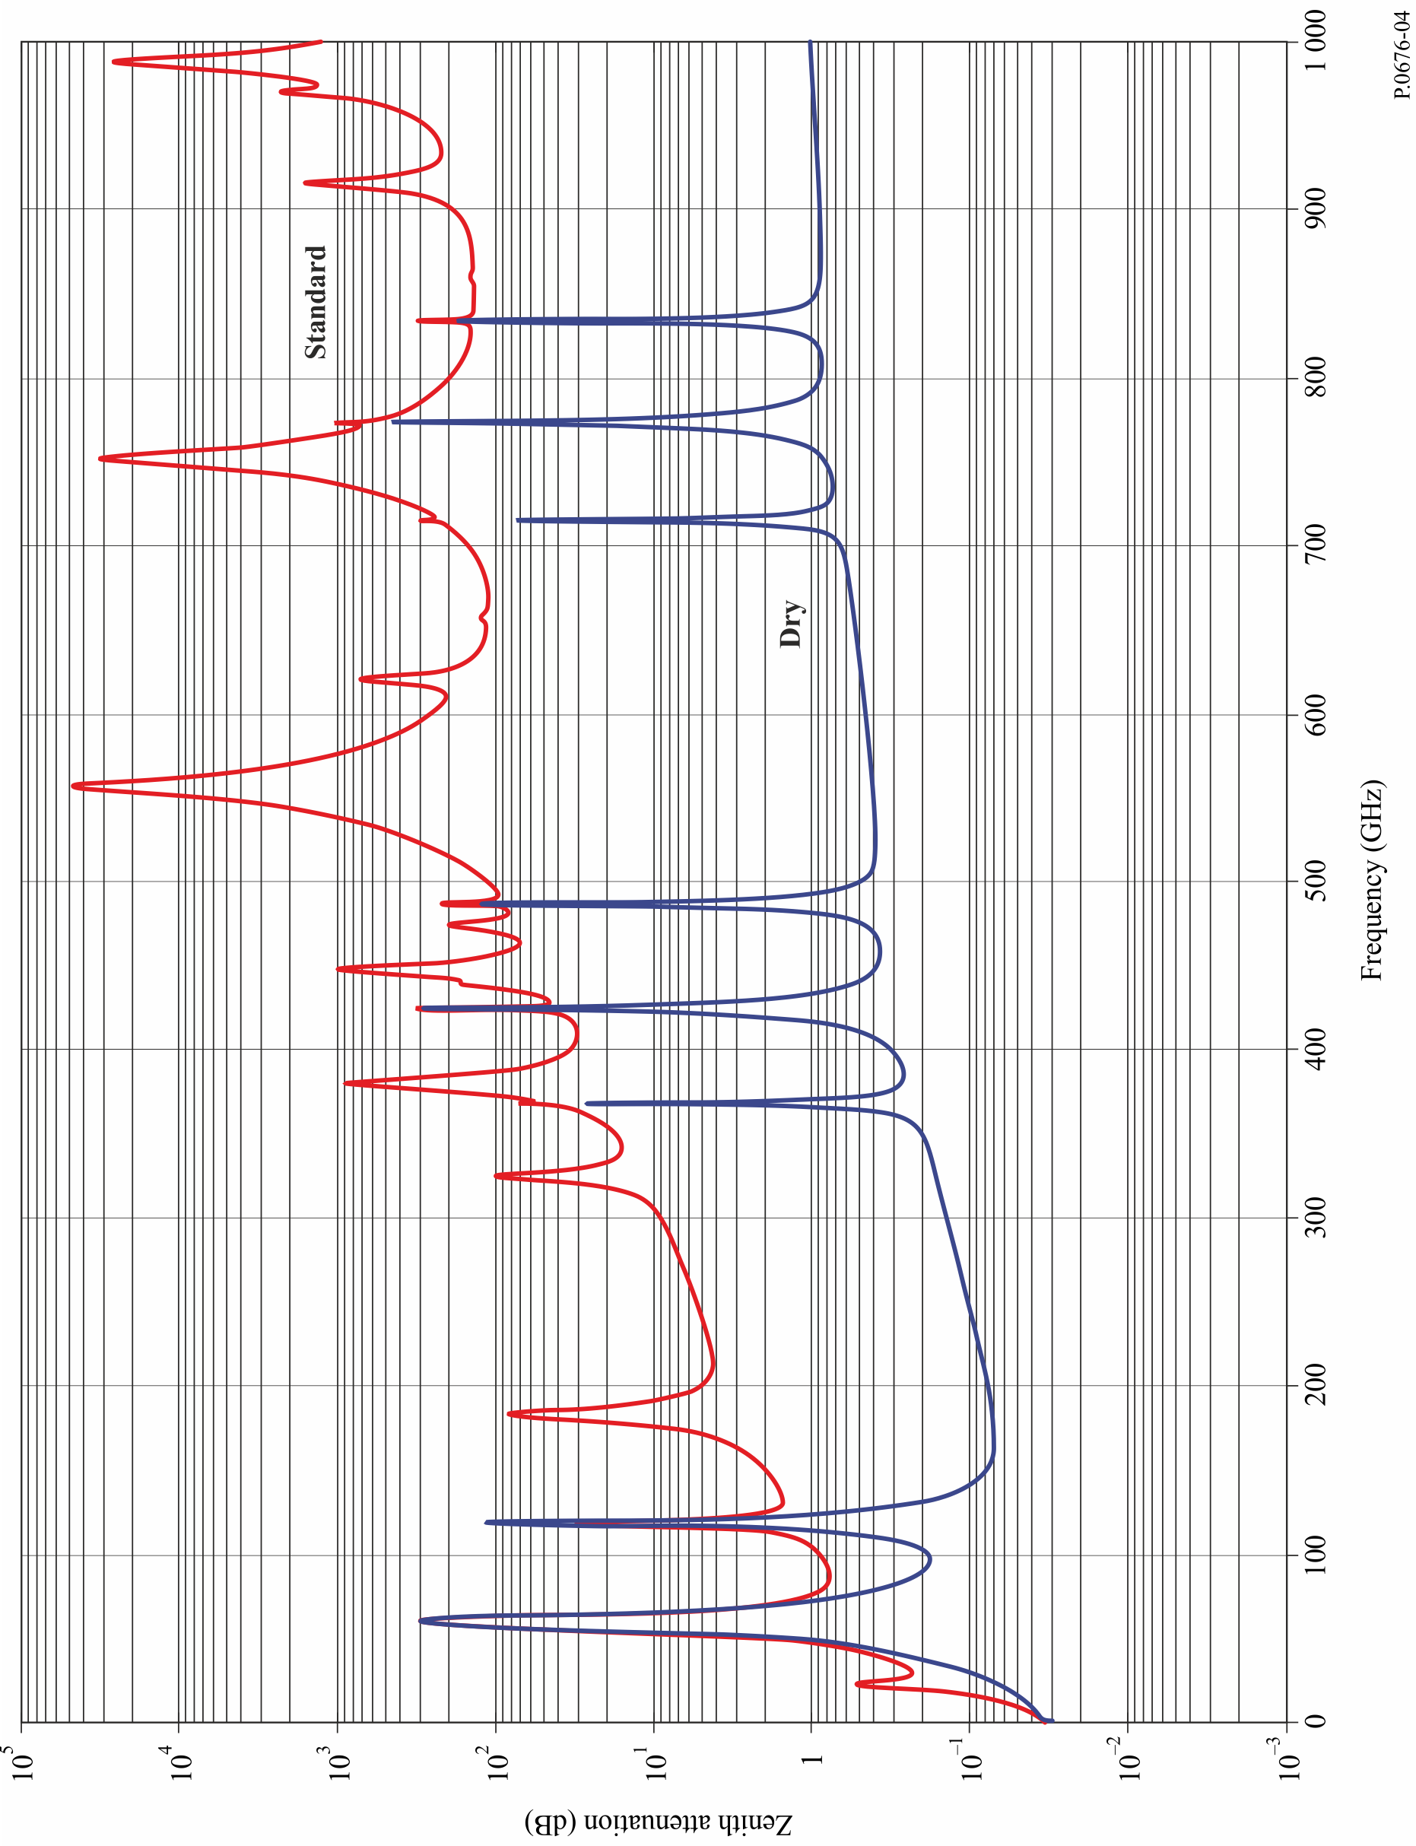

FIGURE 5

Path through the atmosphere

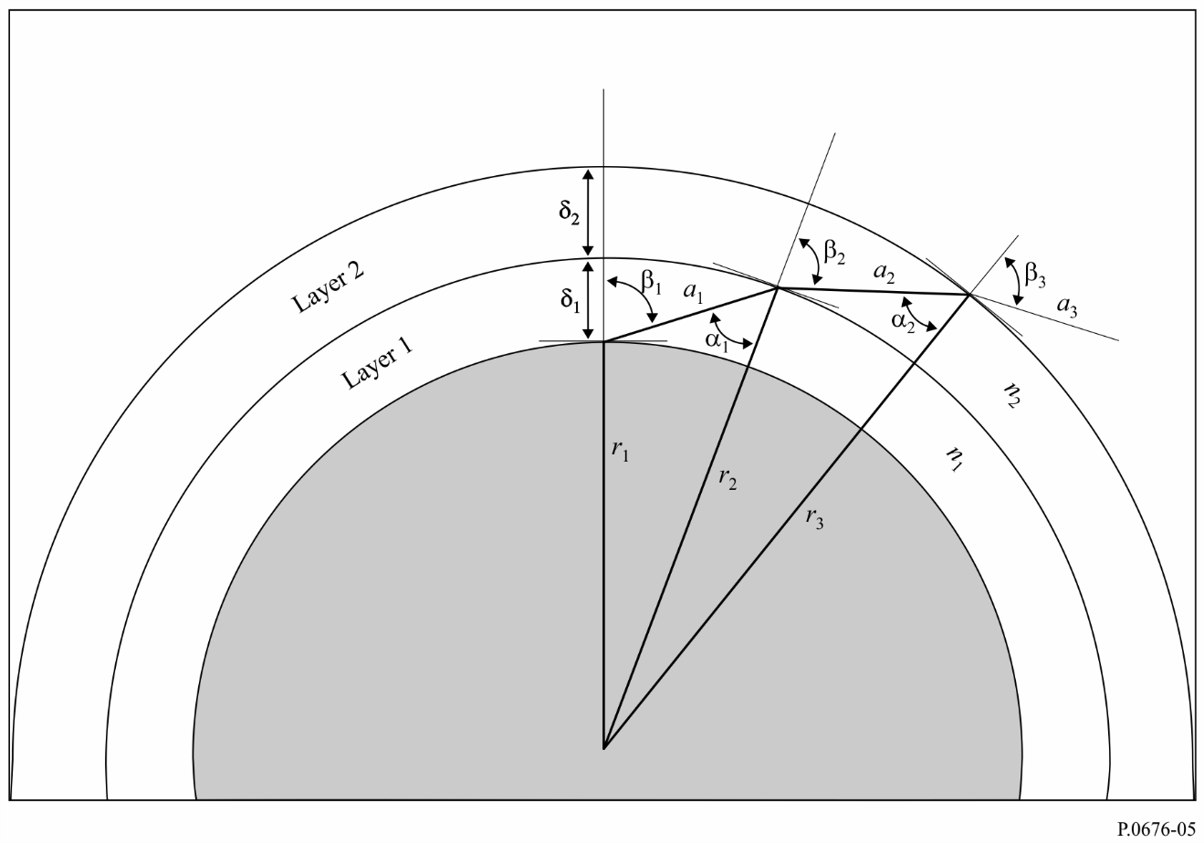

# 3 Dispersive effects

In addition to the attenuation described in the previous paragraph, which is based on the imaginary part of the frequency-dependent complex refractivity, oxygen and water vapour introduce dispersion, which is based on the real part of the frequency-dependent complex refractivity. This effect is described in terms of phase dispersion vs. frequency (deg/km) or group delay vs. frequency (ps/km), and, similar to attenuation, dispersion can be calculated for slant paths.

Similar to equation (1), the specific gaseous phase dispersion, $φ$, is given by:

$φ=φ_{o}+φ_{w}=-1.2008f(N_{Oxygen}^{'}\left(f\right)+N_{WaterVapour}^{'}\left(f\right))$ (deg/km) (24)

where $φ_{o}$ is the specific phase dispersion (deg/km) due to dry air, $φ_{w}$ is the specific phase dispersion due to water vapour; $f$ is the frequency (GHz); and $N_{Oxygen}^{'}(f)$ and $N_{WaterVapour}^{'}(f)$ are the real parts of the frequency-dependent complex refractivities:

$N_{Oxygen}^{'}\left(f\right)=\sum_{i (Oxygen)}{S_{i}F_{i}^{'}+N_{D}^{'}(f)}$ (25a)

$N_{Water Vapour}^{'}\left(f\right)=\sum_{i (Water Vapour)}{S_{i}F_{i}^{'}}$ (25b)

where:

*Si* is the strength of the *i*th oxygen or water vapour line from equation (3), $F_{i}^{'}$ is the real part of the oxygen or water vapour line shape factor:

$F_{i}^{'}=\frac{f}{f_{i}}\left[\frac{\left(f_{i}-f\right)+δΔf}{{\left(f_{i}-f\right)}^{2}+Δf^{2}}-\frac{\left(f_{i}+f\right)+δΔf}{{\left(f_{i}+f\right)}^{2}+Δf^{2}}\right]$ (25c)

and the summations extend over all spectral lines in Tables 1 and 2.

$N_{D}^{'}(f)$ is the real-part of the dry continuum due to pressure-induced nitrogen absorption:

$N_{D}^{'}(f)=\frac{-6.14 × {10}^{-5}p θ^{2}f^{2}}{f^{2}+d^{2}}$ (25d)

$Δf$ is defined in equation (6b), $Δf δ$ is defined in equation (7), and $d$ is defined in equation (9).

The frequency dependent specific phase dispersion is shown in Fig. 6 for a standard atmosphere   
( $p$ = 1 013.25 hPa, = 7.5 g/m3, = 15oC).

FIGURE 6

The frequency dependent specific phase dispersion for a standard atmosphere   
( $p$ = 1 013.25 hPa, = 7.5 g/m3, = 15oC)

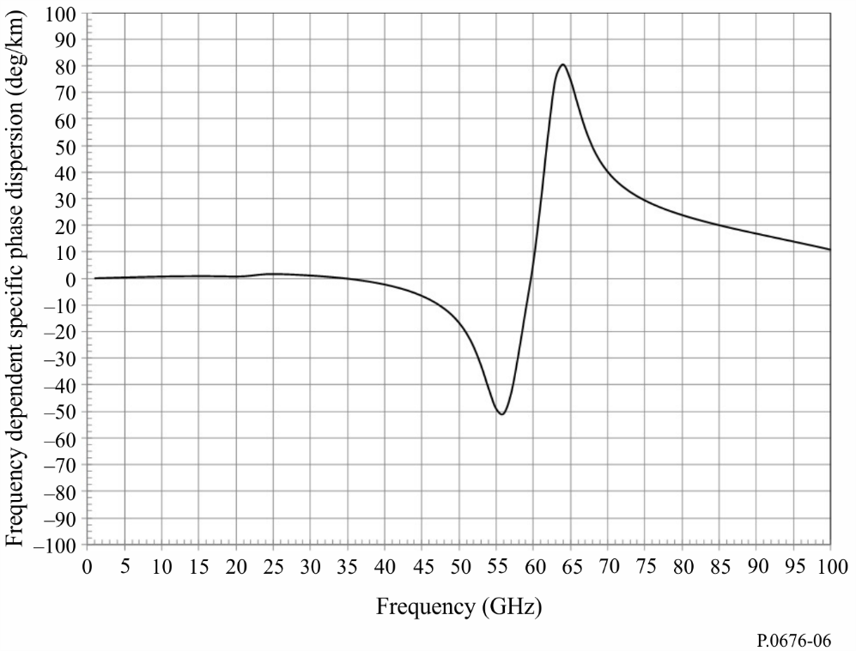

# 4 Downwelling and upwelling microwave brightness temperature

Microwave brightness temperature is defined as the noise temperature at the output of a lossless antenna due to the incident atmospheric brightness. Noise power spectral density, $S\left(f\right)$, and noise temperature, $T(f)$, are related by $S\left(f\right)=k T(f)$, where $k$ is Boltzmann’s constant. The downwelling space-to-Earth microwave brightness temperature looking up and the upwelling Earth-to-space microwave brightness temperature looking down can be calculated similar to equation (13). Layer 1 is typically at the surface of the Earth, and layer k is at the top of the atmosphere (typically 100 km). The aggregate microwave brightness temperature is the sum of the microwave brightness temperatures of each atmospheric layer multiplied by the loss between that atmospheric layer and the observation point. It is assumed that the atmosphere is in local thermodynamic equilibrium and scattering is negligible.

In the following paragraphs, $T_{B}(f_{GHz},T_{j})$ is the microwave brightness temperature of the jth layer defined by:

$T_{B}\left(f_{GHz}, T_{j}\right)=0.048 f_{GHz}\left[\frac{1}{\exp\left(\frac{0.048f_{GHz}}{T_{j}}\right)-1}\right]$ (K) (26)

where $T_{j}$ is the physical temperature of the jth layer. $T_{B}\left({f_{GHz},T}_{j}\right)$ can be well-approximated by $T_{j}$ for $f_{GHz}<0.42 T_{j}$; γ*j* is the specific attenuation (dB/km) of the *j*th layer given in equation (1), and $a_{j}$ is the path length (km) through the *j*th layer given in equation (17).

The difference between the physical temperature, $T$, and the microwave brightness temperature of a blackbody source, $T_{B}$, is shown in Fig. 7. For a given frequency, $f_{GHz}$, $T-T_{B}→0.024f_{GHz}$ as the physical temperature, $T$, increases.

## 4.1 Downwelling microwave brightness temperature

If the profiles of physical temperature, pressure and water vapour along the path are known, the downwelling microwave brightness temperature, which is the sum of: a) the cosmic microwave brightness temperature attenuated by the atmospheric attenuation and b) the downwelling atmospheric microwave brightness temperature, can be calculated as follows:

$$T_{downwelling}=T_{B}\left(f_{GHz}, 2.73\right) {10}^{-\left(\frac{\sum_{j=1}^{k}{a_{j}γ_{j}}}{10}\right)}$$

$+\sum_{j=1}^{k}{{T_{B}(f_{GHz},T}_{j})\left({10}^{\frac{a_{j}γ_{j}}{10}}-1\right){10}^{-\left(\frac{\sum_{i=1}^{j}{a_{i}γ_{i}}}{10}\right)}}$ (K) (27)

However, it may be more convenient to implement the net microwave brightness temperature as a recursion using the following recursive method:

Step 1: Set $T_{B,Downwelling}=0.048\left[\frac{f_{GHz}}{\exp\left(\frac{0.048f_{GHz}}{2.73}\right)-1}\right]$ (27a)

Repeat Steps 2 through 5 for $j=k$ to $j=1$ decrementing $j$ by 1 at each iteration:

Step 2: Set $T_{B,Downwelling,last}=T_{B,Downwelling}$ (27b)

Step 3: Set $T_{B}=0.048\left[\frac{f_{GHz}}{\exp\left(\frac{0.048f_{GHz}}{T_{j}}\right)-1}\right]$ (27c)

Step 4: Set $L_{j}={10}^{\frac{{-a}_{j}γ_{j}}{10}}$ (27d)

Step 5: Set ${T_{B},}_{Downwelling}=\left[{T_{B},}_{Downwelling,last}L_{j}+\left(1-L_{j}\right) T_{B}\right]$ (27e)

where 2.73 K is the exoatmospheric cosmic microwave background blackbody temperature.

The downwelling microwave brightness temperature for a zenith path and standard atmosphere is shown in Fig. 8.

If the profiles are not known, the method in § 3 of Annex 1 of Recommendation ITU-R P.618 can be used to estimate the downwelling microwave brightness temperature, including other effects from the total atmospheric attenuation.

Recommendation ITU-R P.372 can be used to determine the earth station system noise temperature from the brightness temperatures.

## 4.2 Upwelling microwave brightness temperature

The net upwelling microwave brightness temperature, which is the sum of: a) the upwelling atmospheric microwave brightness temperature, b) the downwelling atmospheric microwave brightness temperature reflected by the Earth’s surface attenuated by the net atmospheric attenuation, and c) upwelling microwave brightness temperature of the Earth’s surface attenuated by the atmospheric attenuation, can be calculated as follows:

$$T_{B,upwelling}=(ϵ{T_{B}(f_{GHz},T}_{Earth})+ρ T_{downwelling}) × {10}^{-\left(\frac{\sum_{j=1}^{k}{a_{j}γ_{j}}}{10}\right)}$$

$+\sum_{j=1}^{k}{ T_{B}(f_{GHz}, T_{j}){ \left({10}^{\frac{a_{j}γ_{j}}{10}}-1\right) 10}^{-\left(\frac{\sum_{i=j}^{k}{a_{i}γ_{i}}}{10}\right)}}$ (K) (28)

However, it may be more convenient to implement the net microwave brightness temperature as a recursion using the following recursive method:

Step 1: Set $T_{B,Upwelling}=ϵ 0.048\left[\frac{f_{GHz}}{\exp\left(\frac{0.048f_{GHz}}{T_{Earth}}\right)}-1\right]+ρ T_{B,downwelling}$ (28a)

Repeat Steps 2 through 5 for $j=1$ to $j=k$ incrementing $j$ by 1 after each iteration:

Step 2: Set $T_{B,Upwelling,last}=T_{B,Upwelling}$ (28b)

Step 3: Set $T_{B}=0.048\left[\frac{f_{GHz}}{\exp\left(\frac{0.048f_{GHz}}{T_{j}}\right)}-1\right]$ (28c)

Step 4: Set $L_{j}={10}^{\frac{{-a}_{j}γ_{j}}{10}}$ (28d)

Step 5: Set $T_{B,Upwelling}=\left[T_{B,Upwelling,last} L_{j}+\left(1-L_{j}\right) T_{B}\right]$ (28e)

where:

$ϵ$: emissivity of the Earth’s surface

$ρ$: reflectivity of the Earth’s surface

$ρ=1-ϵ$.

In the absence of local data or other guidance, a value of $ϵ$ of 0.95 can be used.

The upwelling microwave brightness temperature for a zenith path and the standard (i.e., the mean annual global reference atmosphere) is shown in Fig. 9, where $ϵ$ = 0.95, $ρ$ = 0.05, and $T_{Earth}$ = 290 K.

FIGURE 7

Difference between the physical and microwave brightness temperatures  
of a blackbody source

FIGURE 8

Zenith downwelling microwave brightness temperature for a   
standard atmosphere (1 GHz centres)

FIGURE 9

Zenith upwelling microwave brightness temperature for a   
standard atmosphere (1 GHz centres)



# 5 Slant path attenuation using vertical atmospheric profiles

The slant path gaseous attenuation for any specific profile in Annex 3 of Recommendation ITU‑R P.835 can be calculated using the procedure in § 2.2 of Annex 1 noting the following:

1 Convert the water vapour density, ρ, to water vapour partial pressure, *e*, using equation (4).

2 Convert the total air pressure (*ptot* = *pdry* + *e*) to dry air pressure, *pdry*, by subtracting the water vapour partial pressure, *e*.

3 Calculate the total attenuation using equation (13) where the exponential layer thicknesses are defined in equation (14).

4 If the height of the surface of the Earth above mean sea level is not available from local data, an estimate can be obtained from Recommendation ITU-R P.1511.

5 The summation in equation (13) should be from the height of the surface of the Earth above mean sea level to the maximum height in the data set.

6 The 32 levels in each profile should be interpolated and extrapolated (to the surface of the Earth, if required) per the exponential layer thicknesses defined in equation (14) assuming:

a) A linear relation between the logarithm of pressure and height.

b) A linear relation between temperature and height.

c) A linear relation between the logarithm of water vapour density and height.

If needed, equations (24a) to (24c) in Annex 1 of Recommendation ITU-R P.834 (and the associated maps) can be used for interpolation and extrapolation of these profiles.

7 The elevation angle at or near the surface of the Earth is the apparent rather than the free-space elevation angle. For free-space elevation angles less than or equal to 10 degrees, the apparent elevation angle can be calculated from the free-space elevation angle using equation (13) of Recommendation ITU-R P.834.

8 The estimated slant path gaseous attenuation at any latitude and longitude between grid points can be estimated by bilinear interpolation of the corresponding estimates of slant path gaseous attenuation at the surrounding grid points using the procedure in Annex 1 of Recommendation ITU-R P.1144. The slant path gaseous attenuation at each surrounding grid point should be from the height of the surface of the Earth above mean sea level at the latitude and longitude of interest to the maximum height in each profile.

Annex 2  
  
Approximate estimation of gaseous attenuation   
in the frequency range 1-350 GHz

This Annex contains simplified algorithms for approximate estimates of gaseous attenuation for the limited frequency range from 1 GHz to 350 GHz, path elevation angles of 5 degrees and above, a limited range of meteorological conditions, and a limited variety of geometrical configurations.

# 1 Specific attenuation

The specific attenuation attributable to oxygen, *γo* (dB/km), and the specific attenuation attributable to water vapour, *γw* (dB/km), are identical to *γo* and *γw* in equation (1). The specific attenuation for moist air attributable to oxygen, γ*o* (dB/km), and the specific attenuation for moist air attributable to water vapour, $γ_{w}$ (dB/km), used in these simplified methods are identical to γ*o* and $γ_{w}$ in equation (1).

The dry pressure, $p$, temperature, $T$, and water vapour density, , are values at the surface of the Earth. If local data is not available, the mean annual global reference atmosphere given in Recommendation ITU-R P.835 can be used to determine *p*, *T* and  .

Figure 10 shows the dry air (Dry), water vapour only with a density of 7.5 g/m3 (water vapour), and total (Total) specific attenuation from 1 to 350 GHz at sea-level for the mean annual global reference atmosphere given in Recommendation ITU-R P.835. Moreover, values for  at the surface of the Earth can be found in Recommendation ITU-R P.836.

# 2 Path attenuation

## 2.1 Terrestrial paths

For a horizontal path, or for slightly inclined paths close to the ground, the path attenuation, *A*, may be calculated as:

 (29)

where *r*0 is the path length (km).

FIGURE 10

Specific attenuation due to atmospheric gases  
(Pressure = 1 013.25 hPa; Temperature = 15°C; Water Vapour Density = 7.5 g/m3)

## 2.2 Slant paths

This section contains algorithms for estimating the total gaseous attenuation for slant paths through the Earth’s atmosphere by defining oxygen and water vapour equivalent heights by which the oxygen and water vapour specific attenuations are multiplied to estimate the corresponding zenith oxygen and water vapour attenuations. The oxygen and water vapour specific attenuations are calculated at the pressure, temperature, and water vapour density at the Earth station’s altitude using the method in section 1 of Annex 1; and the oxygen and water vapour equivalent heights are calculated at the pressure, temperature, and water vapour density at the surface of the Earth. The concept of equivalent height assumes an exponential decay in atmospheric specific attenuation versus altitude. These algorithms can be used to estimate the total slant path gaseous attenuation for frequencies outside of 0.5 GHz of spectral line centres for earth station altitudes up to 10 km above the surface of the Earth. For frequencies within 0.5 GHz of spectroscopic line centres at any earth station altitude, the line-by-line method in Annex 1 should be used. The expressions below were derived from the reference atmospheric profiles in Annex 1 of Recommendation ITU-R P.835 and are accurate to within 10% for these specific atmospheric profiles. The accuracy of these algorithms at a specific location and time can be assessed by comparing the attenuation estimated by these algorithms with the attenuation calculated using the method in Annex 1 for representative atmospheric profiles in Annex 2 and Annex 3 of Recommendation ITU-R P.835, or radiosonde data.

The equivalent height attributable to the oxygen component of gaseous attenuation is given by:

 (30)

where:

 (31)

 (32)

 (33)

 (34)

where $f_{i}$ and $c_{i}$ vs. $i$ are shown in Table 3.

TABLE 3

Parameters $f_{i}$ and $c_{i}$

|  |  |  |
| --- | --- | --- |
| *i* | c*i* | (GHz) |
| 1 | 0.1597 | 118.750334 |
| 2 | 0.1066 | 368.498246 |
| 3 | 0.1325 | 424.763020 |
| 4 | 0.1242 | 487.249273 |
| 5 | 0.0938 | 715.392902 |
| 6 | 0.1448 | 773.839490 |
| 7 | 0.1374 | 834.145546 |

with the constraint that:

 when  (35a)

$T$ is the temperature at the Earth’s surface in K, $ρ$ is the water vapour density at the Earth’s surface in g/m3, and .

The equivalent height attributable to the water vapour component of gaseous attenuation is:

 (35b)

where *ai*, and $f_{i}$ vs. $i$ are shown in Table 4, and:

 (36)

 (37)

 (38)

TABLE 4

Parameters $f_{i}$, $a_{i}$, and $b_{i}$

| *i* | $f_{i}$ (GHz) | *ai* | *bi* |
| --- | --- | --- | --- |
| 1 | 22.235080 | 1.52 | 2.56 |
| 2 | 183.310087 | 7.62 | 10.2 |
| 3 | 325.152888 | 1.56 | 2.70 |
| 4 | 380.197353 | 4.15 | 5.70 |
| 5 | 439.150807 | 0.20 | 0.91 |
| 6 | 448.001085 | 1.63 | 2.46 |
| 7 | 474.689092 | 0.76 | 2.22 |
| 8 | 488.490108 | 0.26 | 2.49 |
| 9 | 556.935985 | 7.81 | 10.0 |
| 10 | 620.70087 | 1.25 | 2.35 |
| 11 | 752.033113 | 16.2 | 20.0 |
| 12 | 916.171582 | 1.47 | 2.58 |
| 13 | 970.315022 | 1.36 | 2.44 |
| 14 | 987.926764 | 1.60 | 1.86 |

$T$ is the temperature at the Earth’s surface in K, $ρ$ is the water vapour density at the Earth’s surface in g/m3, hPa, and $r_{p}=(p+e)/1013.25$.

The zenith attenuation between 50 to 70 GHz is a complicated function of frequency, as shown in Fig. 12, and the above expressions for equivalent height can provide only an approximate estimate, in general, of the levels of attenuation likely to be encountered in this frequency range. For greater accuracy, the procedure in Annex 1 should be used.

The total zenith attenuation is then:

 (39)

Figure 11 shows the total zenith attenuation at sea level (Total), as well as the attenuation due to dry air (Dry) and water vapour (Water Vapour), using the mean annual global reference atmosphere given in Recommendation ITU‑R P.835.

### 2.2.1 Elevation angles between 5° and 90°

#### 2.2.1.1 Earth-space paths

For an elevation angle, ϕ, between 5° and 90°, the path attenuation is obtained using the cosecant law, as follows:

For path attenuation based on surface meteorological data:

 (40)



and for path attenuation based on integrated water vapour content:

 (41)

where, and  *Aw* is given in § 2.3.

#### 2.2.1.2 Inclined paths

To determine the attenuation values on an inclined path between a station situated at altitude *h*1 and another at a higher altitude *h*2, where both altitudes are less than 10 km above mean sea level, the values *ho* and *hw* in equation (39) must be replaced by the following  and  values:

 (42)

 (43)

it being understood that the value ρ of the water vapour density used in equation (1) is the hypothetical value at sea level calculated as follows:

 (44)

where ρ1 is the value corresponding to altitude *h*1 of the station in question, and the equivalent height of water vapour density is assumed as 2 km (see Recommendation ITU-R P.835).

Equations (42) and (43) use different normalizations for the dry air and water vapour equivalent heights. While the mean air pressure referred to sea level can be considered constant around the world (equal to 1 013.25 hPa), the water vapour density not only has a wide range of climatic variability but is measured at the surface (i.e. at the height of the ground station). For values of surface water vapour density, see Recommendation ITU-R P.836.

### 2.2.2 Elevation angles between 0 and 5 degrees

#### 2.2.2.1 Earth-space paths

In this case, Annex 1 of this Recommendation should be used. Annex 1 should also be used for elevations less than zero.

#### 2.2.2.2 Inclined paths

The attenuation on an inclined path between a station situated at altitude *h*1 and a higher altitude *h*2 (where both altitudes are less than 10 km above mean sea level), can be determined from the following:

 (45)

where:

*Re* : effective Earth radius including refraction, given in Recommendation ITU‑R P.834, expressed in km (a value of 8 500 km is generally acceptable for the immediate vicinity of the Earth's surface)

ϕ1 : elevation angle at altitude *h*1

F : function defined by:

 (46)

 (47a)

 (47b)

 (47c)

it being understood that the value ρ of the water vapour density used in equation (1) is the hypothetical value at sea level calculated as follows:

 (48)

where ρ1 is the value corresponding to altitude *h*1 of the station in question, and the equivalent height of water vapour density is assumed as 2 km (see Recommendation [ITU-R P.835](https://www.itu.int/rec/R-REC-P.835/en)).

FIGURE 11

Total, dry air and water vapour zenith attenuation from sea level

(Pressure = 1 013.25 hPa; Temperature = 15oC; Water Vapour Density = 7.5 g/m3)

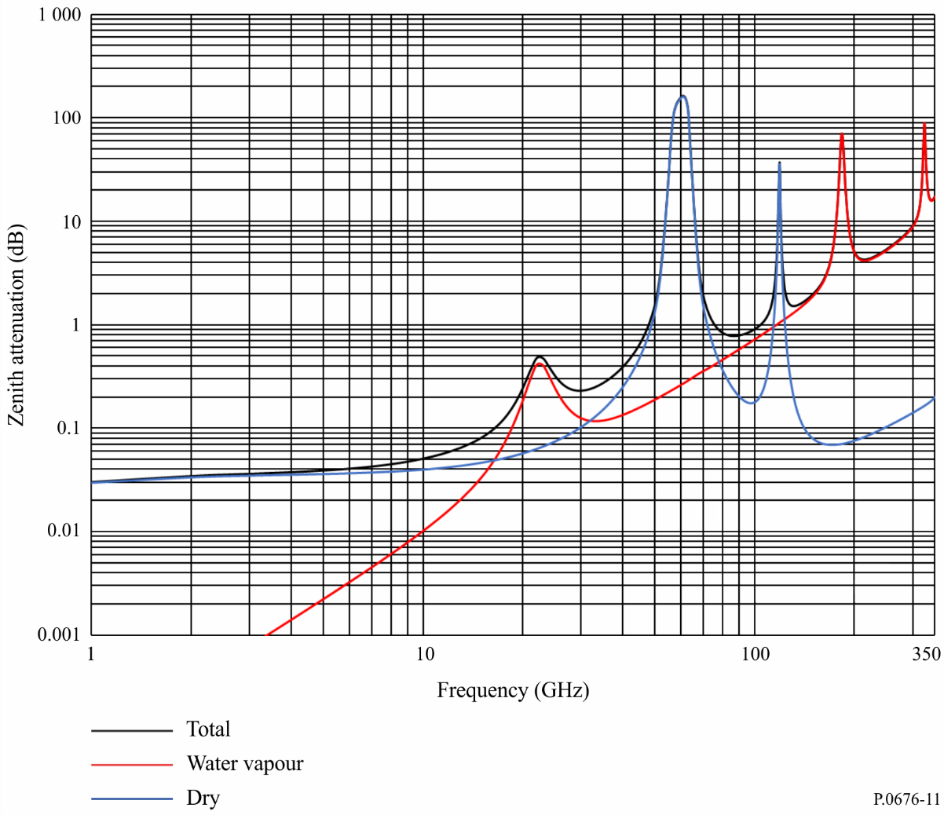

FIGURE 12

Zenith oxygen attenuation from the altitudes indicated, calculated at intervals of 10 MHz,  
including line centres (0 km, 5 km, 10 km, 15 km and 20 km)

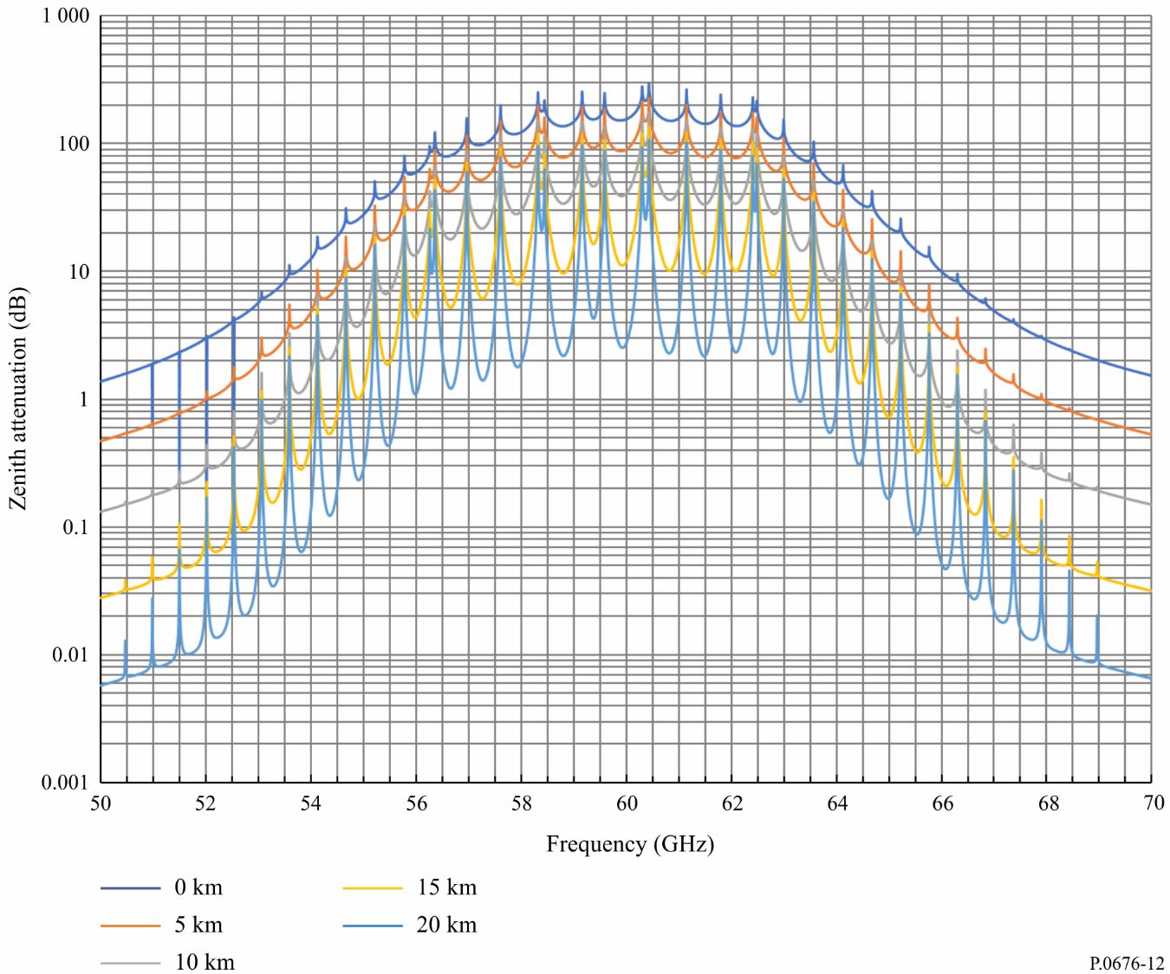

Values for ρ1 at the surface can be found in Recommendation ITU-R P.836.

The different formulation for dry air and water vapour is explained in § 2.2.2.2.

## 2.3 Zenith path water vapour attenuation

The above method for calculating slant path attenuation relies on knowledge of the water vapour density at the surface of the Earth. If the integrated water vapour content, *Vt*, is known, the total water vapour attenuation can be estimated as follows:

$A_{w}=\left\{\begin{matrix}\frac{0.0176 V_{t}γ_{w}(f,p_{ref},ρ_{v,ref},t_{ref})}{γ_{w}(f_{ref},p_{ref},ρ_{v,ref},t_{ref})}, & 1 GHz≤f≤20 GHz \\ \frac{0.0176 V_{t}γ_{w}\left(f,p_{ref},ρ_{v,ref},t_{ref}\right)}{γ_{w}\left(f_{ref},p_{ref},ρ_{v,ref},t_{ref}\right)}\left(ah^{b}+1\right), & 20 GHz<f≤350 GHz\end{matrix}\right.$ dB (49)

where:

$$a=0.2048 exp\left[-{\left(\frac{f-22.43}{3.097}\right)}^{2}\right]+0.2326 exp\left[-{\left(\frac{f-183.5}{4.096}\right)}^{2}\right]$$ $+0.2073 exp\left[-{\left(\frac{f-325}{3.651}\right)}^{2}\right]-0.1113$ (50)

$b=8.741 x {10}^{4}\exp\left(-0.587f\right)+312.2f^{-2.38}+0.723$ (51)

$h=\left\{\begin{matrix}0 & h_{s}<0 km \\ h_{s} & 0 km≤h_{s}≤4 km \\ 4 & h_{s}>4 km\end{matrix}\right.$ (km) (52)

 = (g/m3) (53)

 = (°C) (54)

and

: frequency (GHz)

: 20.6 (GHz)

 = 845 (hPa)

*Vt*: integrated water vapour content from: a) local radiosonde or radiometric data or b) at the required percentage of time (kg/m2 or mm) obtained from the digital maps in Recommendation ITU‑R P.836 (kg/m2 or mm)

γ*W*(*f*, *p*, ρ, *t*): specific attenuation as a function of frequency, pressure, water vapour density, and temperature calculated from the water vapour component of equation (1) (dB/km)

$h_{s}:$ earth station height above mean sea level (a.m.s.l) (km).

1. * Radiocommunication Study Group 3 made editorial amendments to this Recommendation in the years 2020 and 2021 in accordance with Resolution ITU-R 1.
2. Equation (11) can be evaluated using various methods depending on the implementation: e.g. a) the integral function in Matlab, b) the quad function in Octave, c) the quad function in Python, d) several Numerical Recipes functions, and other equivalent methods.