Recommendation ITU-R P.676-13
(08/2022)
Attenuation by atmospheric gases and related effects

P Series
Radiowave propagation

Foreword
The role of the Radiocommunication Sector is to ensure the rational, equitable, efficient and economical use of the radio-frequency spectrum by all radiocommunication services, including satellite services, and carry out studies without limit of frequency range on the basis of which Recommendations are adopted.
The regulatory and policy functions of the Radiocommunication Sector are performed by World and Regional Radiocommunication Conferences and Radiocommunication Assemblies supported by Study Groups.

Policy on Intellectual Property Right (IPR)
ITU-R policy on IPR is described in the Common Patent Policy for ITU-T/ITU-R/ISO/IEC referenced in Resolution ITU-R 1. Forms to be used for the submission of patent statements and licensing declarations by patent holders are available from http://www.itu.int/ITU-R/go/patents/en where the Guidelines for Implementation of the Common Patent Policy for ITU-T/ITU-R/ISO/IEC and the ITU-R patent information database can also be found.

Series of ITU-R Recommendations
(Also available online at http://www.itu.int/publ/R-REC/en)
Series | Title
BO | Satellite delivery
BR | Recording for production, archival and play-out; film for television
BS | Broadcasting service (sound)
BT | Broadcasting service (television)
F | Fixed service
M | Mobile, radiodetermination, amateur and related satellite services
P | Radiowave propagation
RA | Radio astronomy
RS | Remote sensing systems
S | Fixed-satellite service
SA | Space applications and meteorology
SF | Frequency sharing and coordination between fixed-satellite and fixed service systems
SM | Spectrum management
SNG | Satellite news gathering
TF | Time signals and frequency standards emissions
V | Vocabulary and related subjects

Note: This ITU-R Recommendation was approved in English under the procedure detailed in Resolution ITU-R 1.

Electronic Publication
Geneva, 2022

© ITU 2022
All rights reserved. No part of this publication may be reproduced, by any means whatsoever, without written permission of ITU.

RECOMMENDATION ITU-R P.676-13*
Attenuation by atmospheric gases and related effects
(Question ITU-R 201/3)
(1990-1992-1995-1997-1999-2001-2005-2007-2009-2012-2013-2016-2019-2022)
Scope
This Recommendation provides:
a) methods in Annex 1 to calculate the slant path gaseous attenuation, phase nonlinearity, atmospheric bending, excess atmospheric path length and downwelling and upwelling noise temperatures due to oxygen and water vapour for the frequency range from 1 to 1 000 GHz for arbitrary known pressure, temperature and water vapour height profiles;
b) an approximate method in Annex 2 to estimate the instantaneous slant path gaseous attenuation due to oxygen and water vapour for the frequency range from 1 to 350 GHz when the instantaneous surface pressure, surface temperature and surface water vapour density or integrated water vapour content are known from local data, a reference profile, or referenced digital maps;
c) an approximate method in Annex 2 to estimate the statistics of slant path gaseous attenuation due to oxygen and water vapour for the frequency range from 1 to 350 GHz when the surface pressure, surface temperature and surface water vapour density or integrated water vapour content statistics are known either from local data, a reference profile, or referenced digital maps;
d) a Weibull approximation to the slant path water vapour attenuation for use in Recommendation ITU-R P.1853.
Keywords
Gaseous attenuation, specific attenuation, slant path attenuation, water vapour, oxygen, phase dispersion, upwelling, downwelling, bending
Acronyms/Abbreviations/Glossary
Altitude Vertical distance relative to mean sea level
Dispersion Variation of time delay vs. frequency
Downwelling Downward propagation of noise through the atmosphere
Exoatmospheric Originating outside the atmosphere
Height Vertical distance relative to the surface of the Earth
Isotope Multiple species of a chemical element
Upwelling Upward propagation of noise through the atmosphere
Zeeman splitting Splitting of a spectral line into several components in the presence of a static magnetic field
Related ITU-R Recommendations and Handbook
Recommendation ITU-R P.528
Recommendation ITU-R P.530
Recommendation ITU-R P.618
Recommendation ITU-R P.619
Recommendation ITU-R P.676
Recommendation ITU-R P.836
Recommendation ITU-R P.1144
Recommendation ITU-R P.1510
Recommendation ITU-R P.1853
Recommendation ITU-R P.2001
Recommendation ITU-R P.2041
Handbook on Radiometeorology
NOTE – In every case, the latest revision/edition of the Recommendation in force should be used.
The ITU Radiocommunication Assembly,
considering
a) that there is a need to predict the slant path gaseous attenuation, phase nonlinearity, atmospheric bending, excess atmospheric path length and downwelling and upwelling noise temperatures due to oxygen and water vapour for the frequency range from 1 to 1 000 GHz for arbitrary known pressure, temperature and water vapour height profiles;
b) that there is a need to estimate the instantaneous slant path gaseous attenuation due to oxygen and water vapour for the frequency range from 1 to 350 GHz when the instantaneous surface pressure, surface temperature and surface water vapour density or integrated water vapour content statistics are known either from local data, a reference profile, or referenced digital maps;
c) that there is a need to estimate the statistics of slant path gaseous attenuation due to oxygen and water vapour for the frequency range from 1 to 350 GHz when the surface pressure, surface temperature and surface water vapour density or integrated water vapour content statistics are known;
d) that there is a need to provide a Weibull approximation to the slant path water vapour attenuation for use in Recommendation ITU-R P.1853,
recommends
1 that, for arbitrary temperature, pressure and water vapour density height profiles known from local data (e.g. radiosonde measurements or any of the reference profiles in Annexes 1, 2 or 3 of Recommendation ITU-R P.835), the method in Annex 1 should be used to calculate the slant path gaseous attenuation, phase nonlinearity, atmospheric bending, excess atmospheric path length and downwelling and upwelling noise temperatures due to oxygen and water vapour for the frequency range from 1 to 1 000 GHz;
2 that, for instantaneous values of surface temperature, surface pressure and surface water vapour density or integrated water vapour content known from local data (e.g. a weather station or historical data), the approximate method in Annex 2 should be used to estimate the instantaneous slant path gaseous attenuation due to oxygen and water vapour for the frequency range from 1 to 350 GHz;
3 that, for values of surface temperature, surface pressure and surface water vapour density or integrated water vapour content statistics known from long-term historical data or from the maps in Recommendation ITU-R P.2145, the approximate method in Annex 2 should be used to estimate statistics of the slant path gaseous attenuation due to oxygen and water vapour for the frequency range from 1 to 350 GHz;
4 that, in the application of Recommendation ITU-R P.1853, the method in Annex 2 should be used to estimate the Weibull approximation to the slant path water vapour attenuation.

Annex 1
Line-by-line calculation of gaseous attenuation

1 Specific attenuation
The specific attenuation at frequencies up to 1 000 GHz, due to dry air and water vapour, can be accurately evaluated at any value of pressure, temperature and humidity as a summation of the individual spectral lines from oxygen and water vapour, together with small additional factors for the non-resonant Debye spectrum of oxygen below 10 GHz, pressure-induced nitrogen attenuation above 100 GHz and a wet continuum to account for the excess water vapour-absorption found experimentally. Figure 1 shows the specific attenuation using the prediction method, calculated from 0 to 1 000 GHz at 1 GHz intervals, for a pressure of 1 013.25 hPa, temperature of 15 °C for the cases of a water vapour density of 7.5 g/m3 (Standard) and a dry atmosphere (Dry).
Near 60 GHz, many oxygen absorption lines merge together at sea-level pressures to form a single, broad absorption band, which is shown in more detail in Fig. 2. This Figure also shows the oxygen attenuation at higher altitudes, with the individual lines becoming resolved as the pressure decreases with increasing altitude. Some additional molecular species (e.g. oxygen isotopic species, oxygen vibrationally excited species, ozone, ozone isotopic species and ozone vibrationally excited species, and other minor species) are not included in the line-by-line prediction method. These additional lines are insignificant for typical atmospheres but may be important for a dry atmosphere.
The specific gaseous attenuation is given by:
(1)
where γo and γw are the specific attenuations (dB/km) due to dry air (oxygen, pressure-induced nitrogen and non-resonant Debye attenuation) and water vapour, respectively, f is the frequency (GHz), and N ″_{Oxygen}( f ) and N ″_{Water Vapour}( f ) are the imaginary parts of the frequency-dependent complex refractivities:

$N_{Oxygen}^{''}\left(f\right)=\sum_{i (Oxygen)}{S_{i}F_{i}+N_{D}^{''}(f)}$ (2a)
$N_{Water Vapour}^{''}\left(f\right)=\sum_{i (Water Vapour)}{S_{i}F_{i}}$ (2b)
Si is the strength of the i^{th} oxygen or water vapour line, Fi is the oxygen or water vapour line shape factor, and the summations extend over all the spectral lines in Tables 1 and 2;
is the dry continuum due to pressure-induced nitrogen absorption and the Debye spectrum as given by equation (8).
The line strength is given by:

$\begin{matrix}S_{i}=a_{1}×{10}^{-7} p θ^{3} exp\left[a_{2}(1-θ)\right] for oxygen \\ =b_{1}×{10}^{-1} e θ^{3.5} exp\left[b_{2}(1-θ)\right] for water vapour\end{matrix}$ (3)
where:
p : dry air pressure (hPa)
e : water vapour partial pressure (hPa) (total barometric pressure, p_{tot} = p + e)
θ = 300/T
T : temperature (K).
FIGURE 1
Specific attenuation due to atmospheric gases, calculated at 1 GHz intervals, including line centres
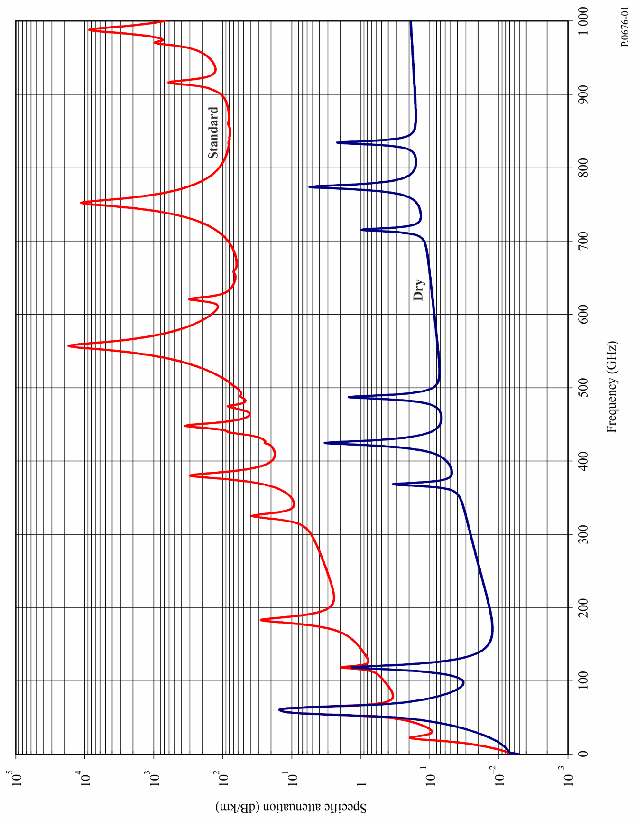
FIGURE 2
Specific attenuation in the range 50-70 GHz at the altitudes indicated, calculated at intervals of 10 MHz,
including line centres (0 km, 5 km, 10 km, 15 km and 20 km)
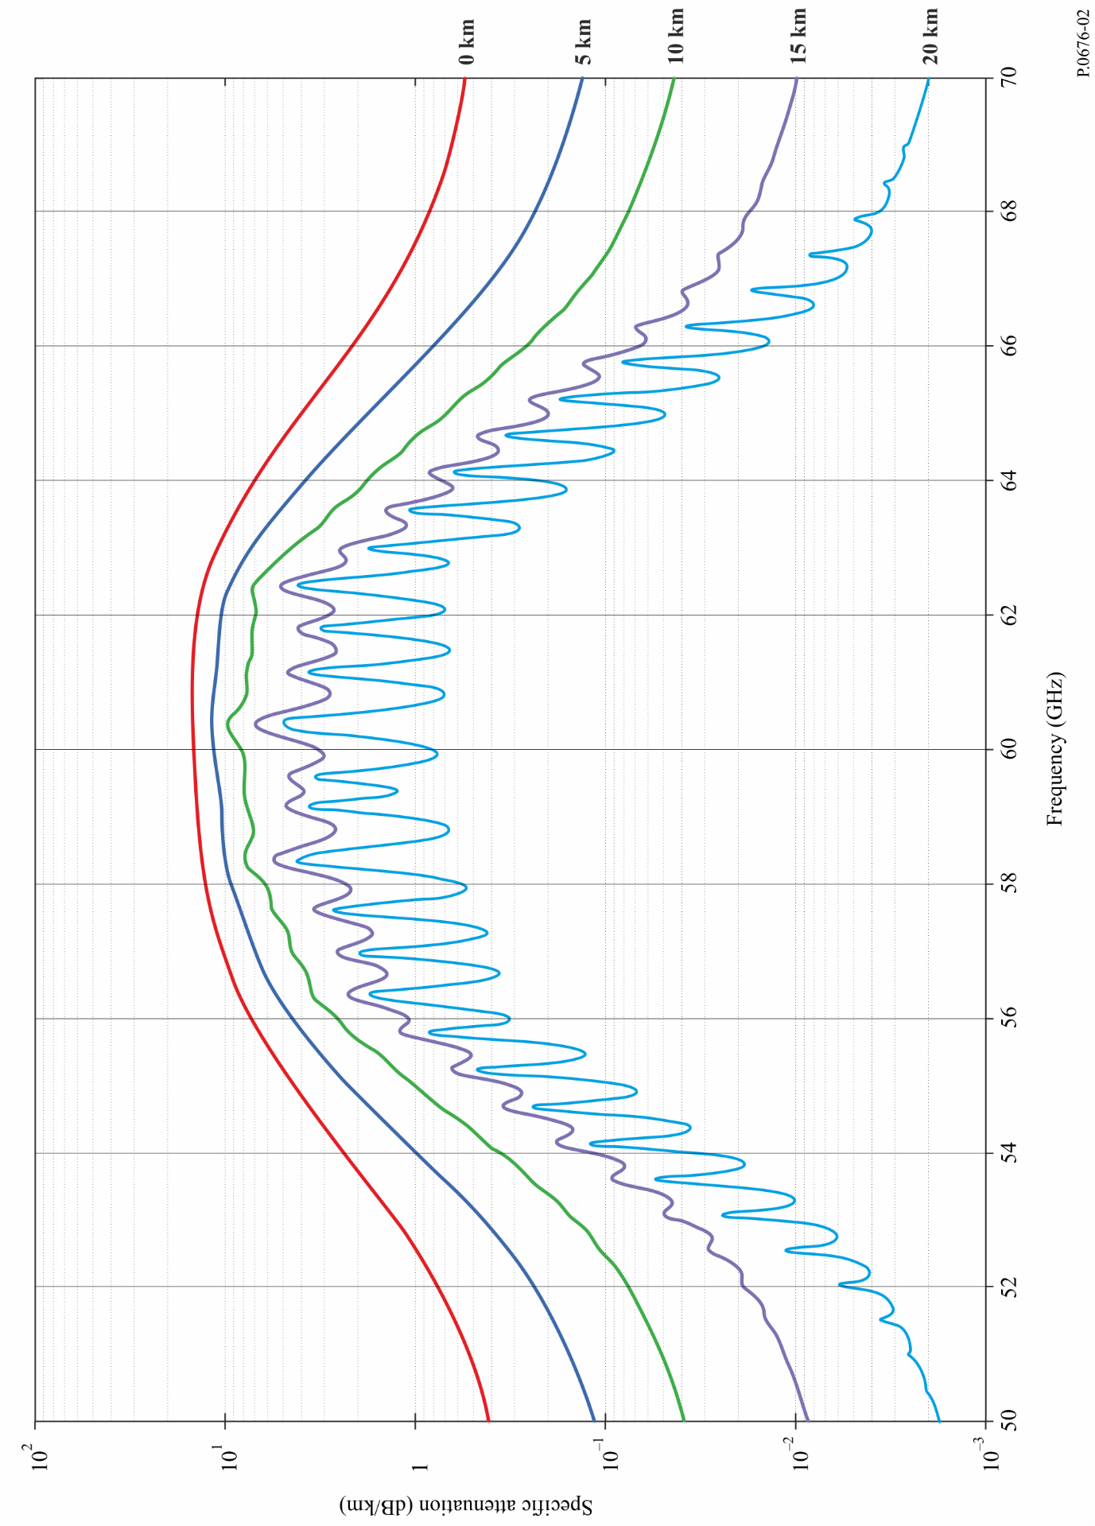
If available, local altitude profiles of p, e and T (e.g. using radiosondes) should be used. In the absence of local data, an appropriate reference standard atmosphere given in Recommendation ITU-R P.835 should be used. (Note that where total atmospheric attenuation is calculated, the same-water vapour partial pressure is used for the attenuation attributable to oxygen and the attenuation attributable to water vapour.)
The water vapour partial pressure, e, at any altitude may be obtained from the water vapour density, ρ, and the temperature, T, at that altitude using the expression:

(4)
Spectroscopic data for oxygen is given in Table 1, and spectroscopic data for water vapour is given in Table 2. The last entry in Table 2 is a pseudo-line centred at 1 780 GHz whose lower wing represents the combined contribution below 1 000 GHz of water vapour resonances not included in the line-by-line prediction method (i.e. the wet continuum). The pseudo-line's parameters are adjusted to account for the difference between the measured absorption in the atmospheric windows and the calculated local-line absorption.
The line-shape factor is given by:

(5)

where fi is the oxygen or water vapour line frequency and Δf is the width of the line:

(6a)

The line width Δf is modified to account for Zeeman splitting of oxygen lines and Doppler broadening of water vapour lines:

(6b)

δ is a correction factor that arises due to interference effects in oxygen lines:

(7)
TABLE 1
Spectroscopic data for oxygen attenuation
f₀ | a₁ | a₂ | a₃ | a₄ | a₅ | a₆
50.474214 | 0.975 | 9.651 | 6.690 | 0.0 | 2.566 | 6.850
50.987745 | 2.529 | 8.653 | 7.170 | 0.0 | 2.246 | 6.800
51.503360 | 6.193 | 7.709 | 7.640 | 0.0 | 1.947 | 6.729
52.021429 | 14.320 | 6.819 | 8.110 | 0.0 | 1.667 | 6.640
52.542418 | 31.240 | 5.983 | 8.580 | 0.0 | 1.388 | 6.526
53.066934 | 64.290 | 5.201 | 9.060 | 0.0 | 1.349 | 6.206
53.595775 | 124.600 | 4.474 | 9.550 | 0.0 | 2.227 | 5.085
54.130025 | 227.300 | 3.800 | 9.960 | 0.0 | 3.170 | 3.750
54.671180 | 389.700 | 3.182 | 10.370 | 0.0 | 3.558 | 2.654
55.221384 | 627.100 | 2.618 | 10.890 | 0.0 | 2.560 | 2.952
55.783815 | 945.300 | 2.109 | 11.340 | 0.0 | –1.172 | 6.135
56.264774 | 543.400 | 0.014 | 17.030 | 0.0 | 3.525 | –0.978
56.363399 | 1331.800 | 1.654 | 11.890 | 0.0 | –2.378 | 6.547
56.968211 | 1746.600 | 1.255 | 12.230 | 0.0 | –3.545 | 6.451
57.612486 | 2120.100 | 0.910 | 12.620 | 0.0 | –5.416 | 6.056
58.323877 | 2363.700 | 0.621 | 12.950 | 0.0 | –1.932 | 0.436
58.446588 | 1442.100 | 0.083 | 14.910 | 0.0 | 6.768 | –1.273
59.164204 | 2379.900 | 0.387 | 13.530 | 0.0 | –6.561 | 2.309
59.590983 | 2090.700 | 0.207 | 14.080 | 0.0 | 6.957 | –0.776
60.306056 | 2103.400 | 0.207 | 14.150 | 0.0 | –6.395 | 0.699
60.434778 | 2438.000 | 0.386 | 13.390 | 0.0 | 6.342 | –2.825
61.150562 | 2479.500 | 0.621 | 12.920 | 0.0 | 1.014 | –0.584
61.800158 | 2275.900 | 0.910 | 12.630 | 0.0 | 5.014 | –6.619
62.411220 | 1915.400 | 1.255 | 12.170 | 0.0 | 3.029 | –6.759
62.486253 | 1503.000 | 0.083 | 15.130 | 0.0 | –4.499 | 0.844
62.997984 | 1490.200 | 1.654 | 11.740 | 0.0 | 1.856 | –6.675
63.568526 | 1078.000 | 2.108 | 11.340 | 0.0 | 0.658 | –6.139
64.127775 | 728.700 | 2.617 | 10.880 | 0.0 | –3.036 | –2.895
64.678910 | 461.300 | 3.181 | 10.380 | 0.0 | –3.968 | –2.590
65.224078 | 274.000 | 3.800 | 9.960 | 0.0 | –3.528 | –3.680
65.764779 | 153.000 | 4.473 | 9.550 | 0.0 | –2.548 | –5.002
66.302096 | 80.400 | 5.200 | 9.060 | 0.0 | –1.660 | –6.091
66.836834 | 39.800 | 5.982 | 8.580 | 0.0 | –1.680 | –6.393
67.369601 | 18.560 | 6.818 | 8.110 | 0.0 | –1.956 | –6.475
67.900868 | 8.172 | 7.708 | 7.640 | 0.0 | –2.216 | –6.545
68.431006 | 3.397 | 8.652 | 7.170 | 0.0 | –2.492 | –6.600
68.960312 | 1.334 | 9.650 | 6.690 | 0.0 | –2.773 | –6.650
118.750334 | 940.300 | 0.010 | 16.640 | 0.0 | –0.439 | 0.079
TABLE 1 (end)
f₀ | a₁ | a₂ | a₃ | a₄ | a₅ | a₆
368.498246 | 67.400 | 0.048 | 16.400 | 0.0 | 0.000 | 0.000
424.763020 | 637.700 | 0.044 | 16.400 | 0.0 | 0.000 | 0.000
487.249273 | 237.400 | 0.049 | 16.000 | 0.0 | 0.000 | 0.000
715.392902 | 98.100 | 0.145 | 16.000 | 0.0 | 0.000 | 0.000
773.839490 | 572.300 | 0.141 | 16.200 | 0.0 | 0.000 | 0.000
834.145546 | 183.100 | 0.145 | 14.700 | 0.0 | 0.000 | 0.000

TABLE 2
Spectroscopic data for water vapour attenuation
f₀ | b₁ | b₂ | b₃ | b₄ | b₅ | b₆
22.235080 | .1079 | 2.144 | 26.38 | .76 | 5.087 | 1.00
67.803960 | .0011 | 8.732 | 28.58 | .69 | 4.930 | .82
119.995940 | .0007 | 8.353 | 29.48 | .70 | 4.780 | .79
183.310087 | 2.273 | .668 | 29.06 | .77 | 5.022 | .85
321.225630 | .0470 | 6.179 | 24.04 | .67 | 4.398 | .54
325.152888 | 1.514 | 1.541 | 28.23 | .64 | 4.893 | .74
336.227764 | .0010 | 9.825 | 26.93 | .69 | 4.740 | .61
380.197353 | 11.67 | 1.048 | 28.11 | .54 | 5.063 | .89
390.134508 | .0045 | 7.347 | 21.52 | .63 | 4.810 | .55
437.346667 | .0632 | 5.048 | 18.45 | .60 | 4.230 | .48
439.150807 | .9098 | 3.595 | 20.07 | .63 | 4.483 | .52
443.018343 | .1920 | 5.048 | 15.55 | .60 | 5.083 | .50
448.001085 | 10.41 | 1.405 | 25.64 | .66 | 5.028 | .67
470.888999 | .3254 | 3.597 | 21.34 | .66 | 4.506 | .65
474.689092 | 1.260 | 2.379 | 23.20 | .65 | 4.804 | .64
488.490108 | .2529 | 2.852 | 25.86 | .69 | 5.201 | .72
503.568532 | .0372 | 6.731 | 16.12 | .61 | 3.980 | .43
504.482692 | .0124 | 6.731 | 16.12 | .61 | 4.010 | .45
547.676440 | .9785 | .158 | 26.00 | .70 | 4.500 | 1.00
552.020960 | .1840 | .158 | 26.00 | .70 | 4.500 | 1.00
556.935985 | 497.0 | .159 | 30.86 | .69 | 4.552 | 1.00
620.700807 | 5.015 | 2.391 | 24.38 | .71 | 4.856 | .68
645.766085 | .0067 | 8.633 | 18.00 | .60 | 4.000 | .50
658.005280 | .2732 | 7.816 | 32.10 | .69 | 4.140 | 1.00
752.033113 | 243.4 | .396 | 30.86 | .68 | 4.352 | .84
841.051732 | .0134 | 8.177 | 15.90 | .33 | 5.760 | .45
859.965698 | .1325 | 8.055 | 30.60 | .68 | 4.090 | .84
899.303175 | .0547 | 7.914 | 29.85 | .68 | 4.530 | .90

TABLE 2 (end)
f₀ | b₁ | b₂ | b₃ | b₄ | b₅ | b₆
902.611085 | .0386 | 8.429 | 28.65 | .70 | 5.100 | .95
906.205957 | .1836 | 5.110 | 24.08 | .70 | 4.700 | .53
916.171582 | 8.400 | 1.441 | 26.73 | .70 | 5.150 | .78
923.112692 | .0079 | 10.293 | 29.00 | .70 | 5.000 | .80
970.315022 | 9.009 | 1.919 | 25.50 | .64 | 4.940 | .67
987.926764 | 134.6 | .257 | 29.85 | .68 | 4.550 | .90
1 780.000000 | 17506. | .952 | 196.3 | 2.00 | 24.15 | 5.00

The dry air continuum arises from the non-resonant Debye spectrum of oxygen below 10 GHz and a pressure-induced nitrogen attenuation above 100 GHz.

(8)

where d is the width parameter for the Debye spectrum:

(9)

2 Path attenuation

2.1 Terrestrial paths
For a terrestrial path, or for slightly inclined paths close to the ground, the path attenuation, A, may be calculated as:

(10)

where r0 is the path length (km).

2.2 Slant paths
Sections 2.2.1 and 2.2.2 provide methods to calculate the Earth-space slant path gaseous attenuation for an ascending path between a location on or near the surface of the Earth and a location above the surface of the Earth or in space using the line-by-line method in Annex 1 for a known temperature, dry air pressure, and water vapour density profile. Section 2.2.3 extends the method to a descending path between a location above the surface of the Earth or in space and a location on or near the surface of the Earth. Sections 2.2.4 and 2.2.5 provide methods to calculate the bending and excess atmospheric path length, respectively, on an Earth-space path.

2.2.1 Non-negative apparent elevation angles
The slant path gaseous attenuation on an ascending path between heights $h_{1}$ and $h_{2}$
($h_{2}>h_{1}≥0$ km) is:
$A_{gas}=\int_{h_{1}}^{h_{2}}{\frac{γ(h)}{\sin{φ(h)}}dh}$=$\int_{h_{1}}^{h_{2}}{\frac{γ(h)}{\sqrt{{1-cos}^{2}{φ(h)}}}dh}$ (11)
where:
$\cos{φ\left(h\right)=\frac{\left(R_{E}+h_{1}\right) n(h_{1})}{\left(R_{E}+h\right) n(h)}}\cos{φ_{1}}$ (12)
$γ(h)$ is the specific attenuation at height $h$, $R_{E}$ is the average Earth radius (6 371 km), $φ_{1}$ is the local apparent elevation angle at height $h_{1}$, and $n\left(h\right)$ is the refractive index at height $h$.
While equation (11) can be evaluated by numerical integration, the slant path gaseous attenuation is well-approximated by dividing the atmosphere into exponentially increasing layers, determining the specific attenuation (dB/km) of each layer and the path length (km) through each layer, and summing the product of the specific attenuation of each layer and the path length through each layer as shown in equation (13). In the absence of local temperature, dry air pressure, and water vapour partial pressure profiles vs. height (e.g. from radiosonde data), any of the six reference standard atmospheres (i.e. the mean annual global reference atmosphere, the low-latitude reference atmosphere, the mid-latitude summer reference atmosphere, the mid-latitude winter reference atmosphere, the high-latitude summer reference atmosphere, or the high-latitude winter reference atmosphere) given in Recommendation ITU-R P.835 may be used.
$A_{gas}=\sum_{i=1}^{i_{max}}{a_{i} γ_{i}}$ (dB) (13)
where γi is the specific attenuation (dB/km) of the i^{th} layer per equation (1), and $a_{i}$ is the path length (km) through the i^{th} layer.
For a slant path between the surface of the Earth and space and referring to the geometry in Fig. 5, the thickness of the layers increases exponentially from 10 cm at the surface of the Earth to ~1 km at a height of ~100 km to ensure an accurate estimate of the total slant path gaseous attenuation. The thickness of the $i^{th}$ layer, $δ_{i}$, is:
$δ_{i}=0.0001 e^{\frac{i-1}{100}}$ (km) (14)
$h_{1}=0$, and $h_{i}$, the height of the bottom of layer $i$ for $i≥2$, is:
$h_{i}=\sum_{j=1}^{i-1}{δ_{j}=0.0001 \frac{e^{\frac{i-1}{100}}-1}{e^{\frac{1}{100}}-1}}$ (15)
If one of the six reference standard atmospheres specified in Recommendation ITU-R P.835 is used, the atmospheric profile is defined for geometric heights up to 100 km, in which case $i_{max}=922$, $δ_{922}=0.999 66$ km, and $h_{922}=99.457$ km.
For a slant path between a lower height within the atmosphere, $h_{lower},$ and an upper height within the atmosphere, $h_{upper}$, ($0 km≤h_{lower}<h_{upper}≤100 km)$, the slant path attenuation can be calculated by setting $r_{1}$ to the radius of the lower height from the centre of the Earth and modifying equations (14) and (15) to approximately preserve the exponentially increasing height progression relative to the surface of the Earth as follows:
a) Calculate $i_{lower}$ and $i_{upper}$:
$i_{lower}=floor\left\{100 ln\left[{10}^{4} h_{lower}\left(e^{\frac{1}{100}}-1\right)+1\right]+1\right\}$ (16a)
$i_{upper}=ceiling\left\{100 ln\left[{10}^{4} h_{upper}\left(e^{\frac{1}{100}}-1\right)+1\right]+1\right\}$ (16b)
where floor($x$) rounds $x$ down to the next nearest integer, and ceiling($x$) rounds $x$ up to the next nearest integer.
b) Replace the lower limit in equation (13) with $i=$ $i_{lower}$ and the upper limit with $i_{upper}-1$.
c) Replace 0.0001 in equation (14) with $m$, where:
$m=\left(\frac{e^{\frac{2}{100}} - e^{\frac{1}{100}}}{e^{\frac{i_{upper}}{100} }- e^{\frac{i_{lower}}{100}}}\right)(h_{upper}-h_{lower})$ (16c)
d) Replace equation (15) with:
$h_{i}=h_{lower}+\sum_{j=i_{lower}}^{i-1}{δ_{j}=h_{lower}+m \frac{e^{\frac{i-1}{100}}-e^{\frac{i_{lower}-1}{100}}}{e^{\frac{1}{100}}-1}},i_{lower}≤ i≤i_{upper}$ (16d)
Equations (16a) to (16d) should be used with caution due to possible degraded accuracy for slant paths where $i_{upper}-i_{lower}<50$ (e.g. paths between two airborne platforms).
ai is the path length through the $i^{th}$ layer with thickness δi, and ni is the radio refractive index of the $i^{th}$ layer. $n_{i}$ is a function of the dry air pressure, temperature and water vapour partial pressure of the $i^{th}$ layer using equations (1) and (2) of Recommendation ITU-R P.453. $α_{i}$ and $β_{i+1}$ are the entry and exit incidence angles at the interface between the $i^{th}$ and ${\left(i+1\right)}^{st}$ layer, ri is the radius from the centre of the Earth to the beginning of the $i^{th}$ layer, $r_{i+1}=r_{i}+δ_{i}$, and $r_{1}$ is the radius from the centre of the Earth to the beginning of the lowest layer, typically the average Earth radius (6 371 km). The refractive index, $n_{i}$, and the specific attenuation, $γ_{i}$, of the $i^{th}$ layer are their respective values at the midpoint of the $i^{th}$ layer; i.e. at the height $r_{i}+δ_{i}/2$.
The path length $a_{i}$ is:
$a_{i}=-r_{i}\cos{β_{i}+\sqrt{r_{i}^{2}\cos^{2}{β_{i}+2 r_{i} δ_{i}+ δ_{i}^{2}}}}$ (km) (17)
and the angle $α_{i}$ is:
$α_{i}={π-cos}^{-1}\left(\frac{-a_{i}^{2}-2 r_{i}{ δ}_{i}-δ_{i}^{2}}{2 a_{i }\left({ r}_{i}+δ_{i}\right)}\right)$ (18a)
$=\sin^{-1}\left(\frac{r_{i}}{r_{i}+δ_{i}}\sin{β_{i}}\right)$ (18b)
Equation (18a) is deprecated due to degraded accuracy. $β_{1}$ is the local zenith angle at or near the surface of the Earth (the complement of the apparent elevation angle, $φ$; i.e. $β_{1}=90°-φ$).
$β_{i+1}$ can be recursively calculated from αi using Snell’s law as follows:
$β_{i+1}=\sin^{-1}\left(\frac{n_{i}}{n_{i+1}}\sin{α_{i}}\right)$ (19a)
Alternatively, $β_{i}$ can be calculated directly without calculating $α_{i}$ using Snell’s law in polar coordinates as follows:
$β_{i}=\sin^{-1}\left(\frac{{n_{1 }r}_{1}}{n_{i} r_{i}}\sin{β_{1}}\right)$ (19b)
and similarly, $α_{i}$ can be calculated as follows:
$α_{i}=\sin^{-1}\left(\frac{n_{1}r_{1}}{{n_{i} r}_{i+1}}\sin{β_{1}}\right)$ (19c)
In the Earth-to-space direction, equations (19a) or (19b) and (19c) may be invalid at initial apparent elevation angles < 1° (i.e. initial apparent zenith angle, $β_{1},>{89}^{o})$ when the radio refractivity gradient $dN/dh$ is less than −157 N-units/km, which may occur when radiosonde data from certain regions of the world susceptible to ducting are used as the atmospheric profile. In these cases, the radio wave is reflected by the atmosphere and follows the curvature of the Earth (i.e. travels in ducts), and the argument of the inverse sine function in equations (19a) or (19b) and (19c) is greater than 1. Equations (19a), (19b), and (19c) are valid for all non-negative apparent elevation angles when any of the six reference standard atmospheres in Recommendation ITU-R P.835 are used as input, since these reference atmospheres do not have refractivity gradients characteristic of ducting.
Figure 4 shows the zenith attenuation calculated at 1 GHz intervals for the mean annual global reference standard atmosphere in Recommendation ITU-R P.835. The “Standard” atmosphere is the mean annual global reference atmosphere with $ρ_{o}$ = 7.5 g/m³, and the “Dry” atmosphere is the mean annual global reference atmosphere with $ρ_{o}$ = 0 g/m³.

2.2.2 Negative apparent elevation angles
Equation (13) assumes the height increases between the earth station and space. However, for negative apparent elevation angles from an elevated earth station, the height decreases along the propagation path between the earth station and the minimum grazing height and then increases along the propagation path between the minimum grazing height and space. This is shown in Fig. 3 for an earth station at height $h_{1}$ with an apparent elevation angle of ${{90}^{o}-β}_{1}$.
From Snell’s law in polar coordinates:
$n\left(h_{G}\right)\left(R_{E}+h_{G}\right)=n\left(h_{1}\right) \left(R_{E}+h_{1}\right)\sin{β_{1}}$ (20)
in which case the grazing height, $h_{G}$, can be determined by iteratively solving equation (20). The refractive index, $n\left(h\right)$, can be determined from equations (1) and (2) of Recommendation ITU-R P.453 for the specific atmospheric profile of interest, typically one of the reference profiles in Recommendation ITU-R P.835.
The net gaseous attenuation is the sum of the gaseous attenuations for Path 1 and Path 2. Path 1 is the gaseous attenuation between a virtual earth station at height $h_{G}$ km and the actual earth station at a height of $h_{1}$ km at an apparent elevation angle of 0 degrees, and Path 2 is the gaseous attenuation between a virtual earth station at height $h_{G}$ km and the maximum atmospheric height (typically 100 km) at an apparent elevation angle of 0 degrees.
Figure 3
Grazing height geometry
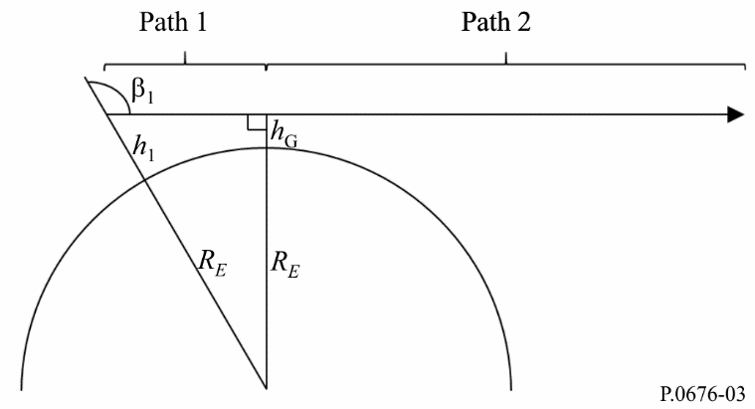

2.2.3 Space-Earth Earth-space reciprocity
For a path between a space station and an earth station, where the apparent elevation angle, $φ_{s}$, at the space station is negative, and the apparent elevation angle at the earth station is $φ_{e}$, the apparent elevation angles are related by:
$φ_{s}=-\cos^{-1}\left(\frac{r_{e }n_{e}}{r_{s }n_{s}}\cos{φ_{e}}\right)$ (21a)
and
$φ_{e}=\cos^{-1}\left(\frac{r_{s}{ n}_{s}}{r_{e}{ n}_{e}}\cos{φ_{s}}\right)$ (21b)
where $n_{e}$ is the refractive index at the earth station height, $r_{e}$ is the radius from the centre of the Earth to the earth station ($r_{e}≥R_{E})$, $n_{s}$ is the refractive index at the space station height, and $r_{s}$ is the radius from the centre of the Earth to the space station ($r_{s}>r_{e})$. If the height of the space station is greater than 100 km above the surface of the Earth, then $n_{s}$ = 1.
Since propagation through the atmosphere is reciprocal, the gaseous attenuation for a space-Earth path, where the apparent elevation angle at the space station is $φ_{s}$, is identical to the gaseous attenuation for the reciprocal Earth-space path, where the apparent elevation angle at the earth station is $φ_{e}$. As a result, the gaseous attenuation for a descending space-Earth path can be calculated as the gaseous attenuation for the corresponding ascending Earth-space path. If $\frac{r_{s }n_{s}}{r_{e}{ n}_{e}}\cos{φ_{s}}>1$, then the space-Earth path does not intercept the Earth.

2.2.4 Atmospheric bending
The total atmospheric bending, $Bending$, along the Earth-space path is:
$Bending=\sum_{i=1}^{i_{max}-1{ }}{\left(β_{i+1}-α_{i}\right)}$ (22a)
$=\sum_{i=1}^{i_{max}-1{ }}{\left[\sin^{-1}\left(\frac{{n_{1 }r}_{1}}{n_{i+1} r_{i+1}}\sin{β_{1}}\right)-\sin^{-1}\left(\frac{n_{1 }r_{1}}{{n_{i} r}_{i+1}}\sin{β_{1}}\right) \right]}$ (22b)
where a positive value of bending means the ray bends toward the Earth. Equation (9) of Recommendation ITU-R P.834 is an approximation to equations (22a) and (22b) for the mean annual global reference atmosphere.

2.2.5 Excess atmospheric path length
Since the tropospheric refractive index is greater than 1, the effective atmospheric path length exceeds the geometrical path length, in which case the excess atmospheric path length, $ΔL$, is:
$ΔL=\sum_{i=1}^{i_{max}}{{a_{i}(n}_{i}-1)}$ (km) (23)
The term excess atmospheric path length is synonymous with the term excess radio path length in Recommendation ITU-R P.834; and a method of predicting the excess radio path length as a function of location, day of the year, and apparent elevation angle is given in § 6 of Recommendation ITU-R P.834.
FIGURE 4
Zenith attenuation due to atmospheric gases, calculated at 1 GHz intervals, including line centres
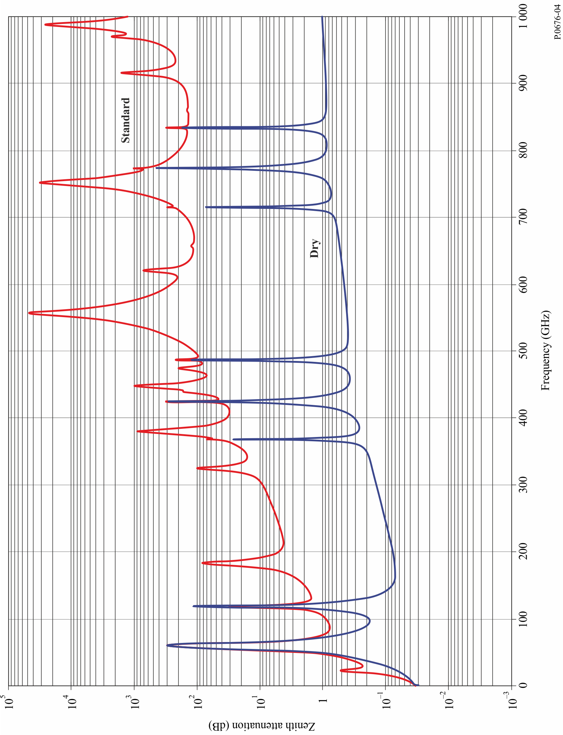
FIGURE 5
Path through the atmosphere
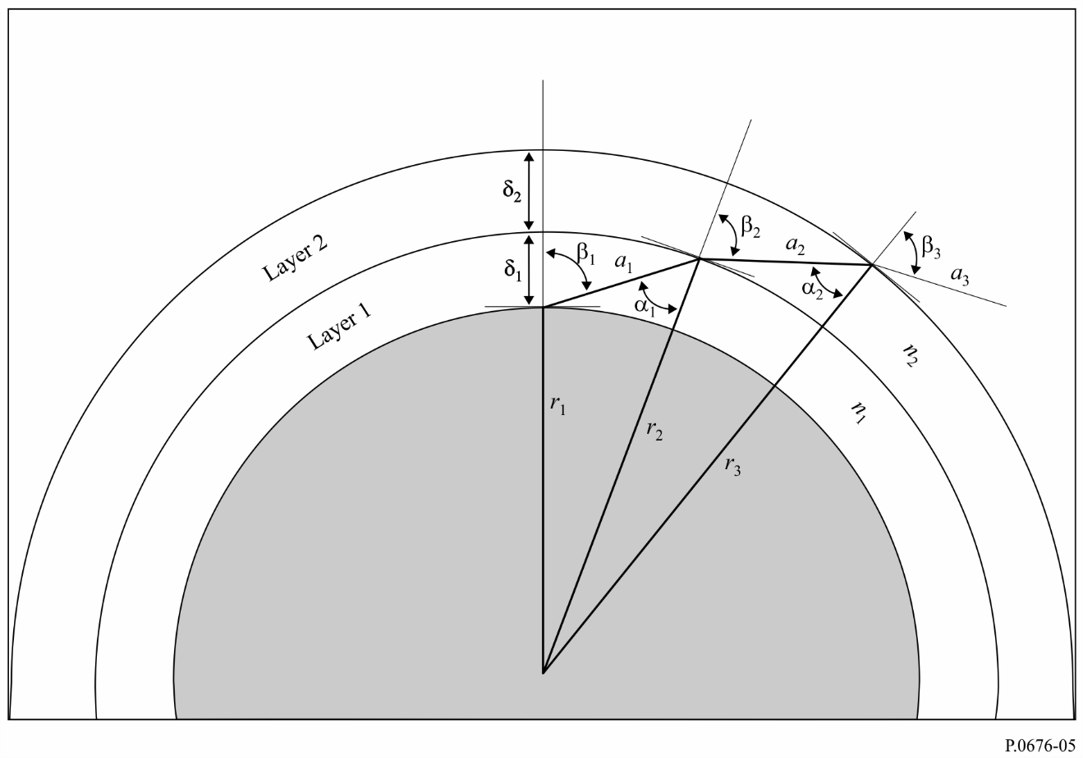

3 Dispersive effects
In addition to the attenuation described in the previous paragraph, which is based on the imaginary part of the frequency-dependent complex refractivity, oxygen and water vapour introduce dispersion, which is based on the real part of the frequency-dependent complex refractivity. This effect is described in terms of phase dispersion vs. frequency (deg/km) or group delay vs. frequency (ps/km), and, similar to attenuation, dispersion can be calculated for slant paths.
Similar to equation (1), the specific gaseous phase dispersion, $φ$, is given by:
$φ=φ_{o}+φ_{w}=-1.2008f(N_{Oxygen}^{'}\left(f\right)+N_{WaterVapour}^{'}\left(f\right))$ (deg/km) (24)
where $φ_{o}$ is the specific phase dispersion (deg/km) due to dry air, $φ_{w}$ is the specific phase dispersion due to water vapour; $f$ is the frequency (GHz); and $N_{Oxygen}^{'}(f)$ and $N_{WaterVapour}^{'}(f)$ are the real parts of the frequency-dependent complex refractivities:

$N_{Oxygen}^{'}\left(f\right)=\sum_{i (Oxygen)}{S_{i}F_{i}^{'}+N_{D}^{'}(f)}$ (25a)
$N_{Water Vapour}^{'}\left(f\right)=\sum_{i (Water Vapour)}{S_{i}F_{i}^{'}}$ (25b)
where:
Si is the strength of the i^{th} oxygen or water vapour line from equation (3), $F_{i}^{'}$ is the real part of the oxygen or water vapour line shape factor:
$F_{i}^{'}=\frac{f}{f_{i}}\left[\frac{\left(f_{i}-f\right)+δΔf}{{\left(f_{i}-f\right)}^{2}+Δf^{2}}-\frac{\left(f_{i}+f\right)+δΔf}{{\left(f_{i}+f\right)}^{2}+Δf^{2}}\right]$ (25c)
and the summations extend over all spectral lines in Tables 1 and 2.
$N_{D}^{'}(f)$ is the real-part of the dry continuum due to pressure-induced nitrogen absorption:
$N_{D}^{'}(f)=\frac{-6.14 × {10}^{-5}p θ^{2}f^{2}}{f^{2}+d^{2}}$ (25d)
$Δf$ is defined in equation (6b), $Δf δ$ is defined in equation (7), and $d$is defined in equation (9).
The frequency dependent specific phase dispersion is shown in Fig. 6 for a standard atmosphere
($p$ = 1 013.25 hPa, $ρ$ = 7.5 g/m³, $T$ = 15ºC).
FIGURE 6
The frequency dependent specific phase dispersion for a standard atmosphere
($p$ = 1 013.25 hPa, $ρ$ = 7.5 g/m³, $T$ = 15ºC)
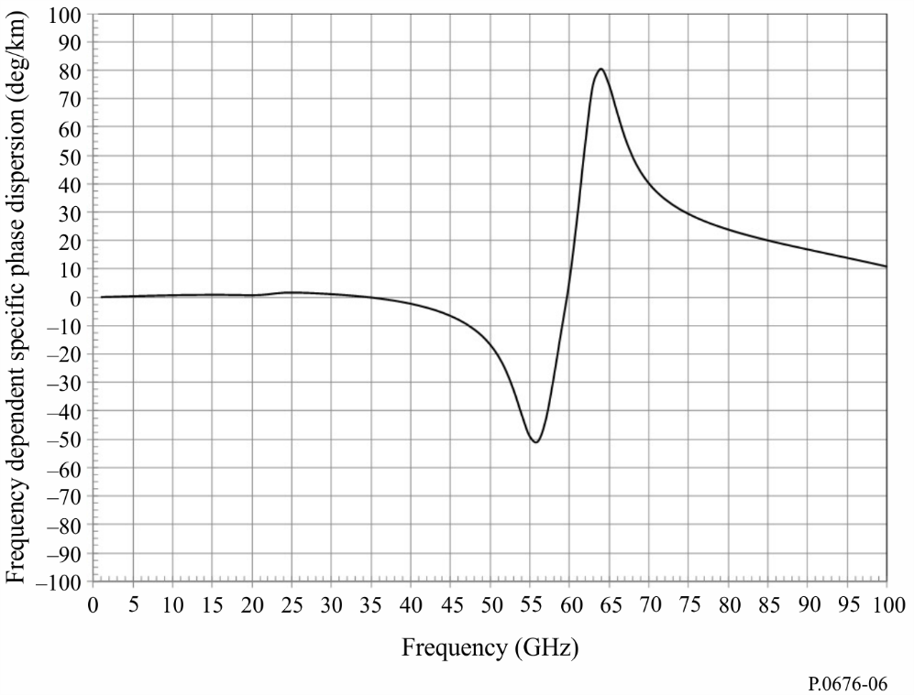

4 Downwelling and upwelling microwave brightness temperature
Microwave brightness temperature is defined as the noise temperature at the output of a lossless antenna due to the incident atmospheric brightness. Noise power spectral density, $S\left(f\right)$, and noise temperature, $T(f)$, are related by $S\left(f\right)=k T(f)$, where $k$ is Boltzmann’s constant. The downwelling space-to-Earth microwave brightness temperature looking up and the upwelling Earth-to-space microwave brightness temperature looking down can be calculated similar to equation (13). Layer 1 is typically at the surface of the Earth, and layer k is at the top of the atmosphere (typically 100 km). The aggregate microwave brightness temperature is the sum of the microwave brightness temperatures of each atmospheric layer multiplied by the loss between that atmospheric layer and the observation point. It is assumed that the atmosphere is in local thermodynamic equilibrium and scattering is negligible.
In the following paragraphs, $T_{B}(f_{GHz},T_{j})$ is the microwave brightness temperature of the j^{th} layer defined by:
$T_{B}\left(f_{GHz}, T_{j}\right)=0.048 f_{GHz}\left[\frac{1}{\exp\left(\frac{0.048f_{GHz}}{T_{j}}\right)-1}\right]$ (K) (26)
where $T_{j}$ is the physical temperature of the j^{th} layer. $T_{B}\left({f_{GHz},T}_{j}\right)$ can be well-approximated by $T_{j}$ for $f_{GHz}<0.42 T_{j}$; γj is the specific attenuation (dB/km) of the j^{th} layer given in equation (1), and $a_{j}$ is the path length (km) through the j^{th} layer given in equation (17).
The difference between the physical temperature, $T$, and the microwave brightness temperature of a blackbody source, $T_{B}$, is shown in Fig. 7. For a given frequency, $f_{GHz}$, $T-T_{B}→0.024f_{GHz}$ as the physical temperature, $T$, increases.

4.1 Downwelling microwave brightness temperature
If the profiles of physical temperature, pressure and water vapour along the path are known, the downwelling microwave brightness temperature, which is the sum of: a) the cosmic microwave brightness temperature attenuated by the atmospheric attenuation and b) the downwelling atmospheric microwave brightness temperature, can be calculated as follows:
$$T_{downwelling}=T_{B}\left(f_{GHz}, 2.73\right) {10}^{-\left(\frac{\sum_{j=1}^{k}{a_{j}γ_{j}}}{10}\right)}$$
$+\sum_{j=1}^{k}{{T_{B}(f_{GHz},T}_{j})\left({10}^{\frac{a_{j}γ_{j}}{10}}-1\right){10}^{-\left(\frac{\sum_{i=1}^{j}{a_{i}γ_{i}}}{10}\right)}}$ (K) (27)
However, it may be more convenient to implement the net microwave brightness temperature as a recursion using the following recursive method:
Step 1: Set $T_{B,downwelling}=0.048\left[\frac{f_{GHz}}{\exp\left(\frac{0.048f_{GHz}}{2.73}\right)-1}\right]$ (27a)
Repeat Steps 2 through 5 for $j=k$ to $j=1$ decrementing $j$ by 1 at each iteration:
Step 2: Set $T_{B,downwelling,last}=T_{B,downwelling}$ (27b)
Step 3: Set $T_{B}=0.048\left[\frac{f_{GHz}}{\exp\left(\frac{0.048f_{GHz}}{T_{j}}\right)-1}\right]$ (27c)
Step 4: Set $L_{j}={10}^{\frac{{-a}_{j}γ_{j}}{10}}$ (27d)
Step 5: Set $T_{B,downwelling}=\left[T_{B,downwelling,last}L_{j}+\left(1-L_{j}\right) T_{B}\right]$ (27e)
where 2.73 K is the exoatmospheric cosmic microwave background blackbody temperature.
The downwelling microwave brightness temperature for a zenith path and standard atmosphere is shown in Fig. 8.
If the profiles are not known, the method in § 3 of Annex 1 of Recommendation ITU-R P.618 can be used to estimate the downwelling microwave brightness temperature, including other effects from the total atmospheric attenuation.
Recommendation ITU-R P.372 can be used to determine the earth station system noise temperature from the brightness temperatures.

4.2 Upwelling microwave brightness temperature
The net upwelling microwave brightness temperature, which is the sum of: a) the upwelling atmospheric microwave brightness temperature, b) the downwelling atmospheric microwave brightness temperature reflected by the Earth’s surface attenuated by the net atmospheric attenuation, and c) upwelling microwave brightness temperature of the Earth’s surface attenuated by the atmospheric attenuation, can be calculated as follows:
$$T_{B,upwelling}=(ϵ{T_{B}(f_{GHz},T}_{Earth})+ρ T_{downwelling}) × {10}^{-\left(\frac{\sum_{j=1}^{k}{a_{j}γ_{j}}}{10}\right)}$$
$+\sum_{j=1}^{k}{ T_{B}(f_{GHz}, T_{j}){ \left({10}^{\frac{a_{j}γ_{j}}{10}}-1\right) 10}^{-\left(\frac{\sum_{i=j}^{k}{a_{i}γ_{i}}}{10}\right)}}$ (K) (28)
However, it may be more convenient to implement the net microwave brightness temperature as a recursion using the following recursive method:
Step 1: Set $T_{B,upwelling}=ϵ 0.048\left[\frac{f_{GHz}}{\exp\left(\frac{0.048f_{GHz}}{T_{Earth}}-1\right)}\right]+ρ T_{B,downwelling}$ (28a)
Repeat Steps 2 through 5 for $j=1$ to $j=k$ incrementing $j$ by 1 after each iteration:
Step 2: Set $T_{B,upwelling,last}=T_{B,upwelling}$ (28b)
Step 3: Set $T_{B}=0.048\left[\frac{f_{GHz}}{\exp\left(\frac{0.048f_{GHz}}{T_{j}}-1\right)}\right]$ (28c)
Step 4: Set $L_{j}={10}^{\frac{{-a}_{j}γ_{j}}{10}}$ (28d)
Step 5: Set $T_{B,upwelling}=\left[T_{B,upwelling,last} L_{j}+\left(1-L_{j}\right) T_{B}\right]$ (28e)
where:
$ϵ$ : emissivity of the Earth’s surface
$ρ$ : reflectivity of the Earth’s surface
$ρ=1-ϵ$.
In the absence of local data or other guidance, a value of $ϵ$ of 0.95 can be used.
The upwelling microwave brightness temperature for a zenith path and the standard (i.e. the mean annual global reference atmosphere) is shown in Fig. 9, where $ϵ$ = 0.95, $ρ$ = 0.05, and $T_{Earth}$ = 290 K.
FIGURE 7
Difference between the physical and microwave brightness temperatures
of a blackbody source
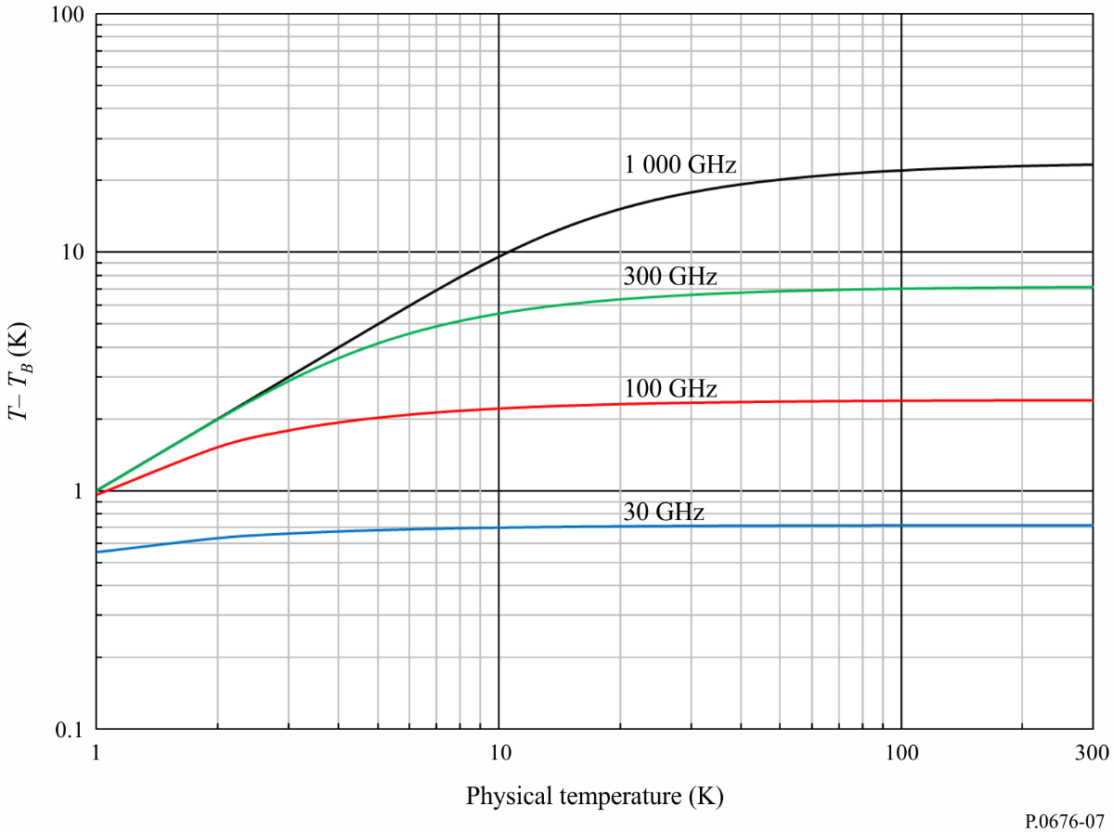
FIGURE 8
Zenith downwelling microwave brightness temperature for a
standard atmosphere (1 GHz centres)
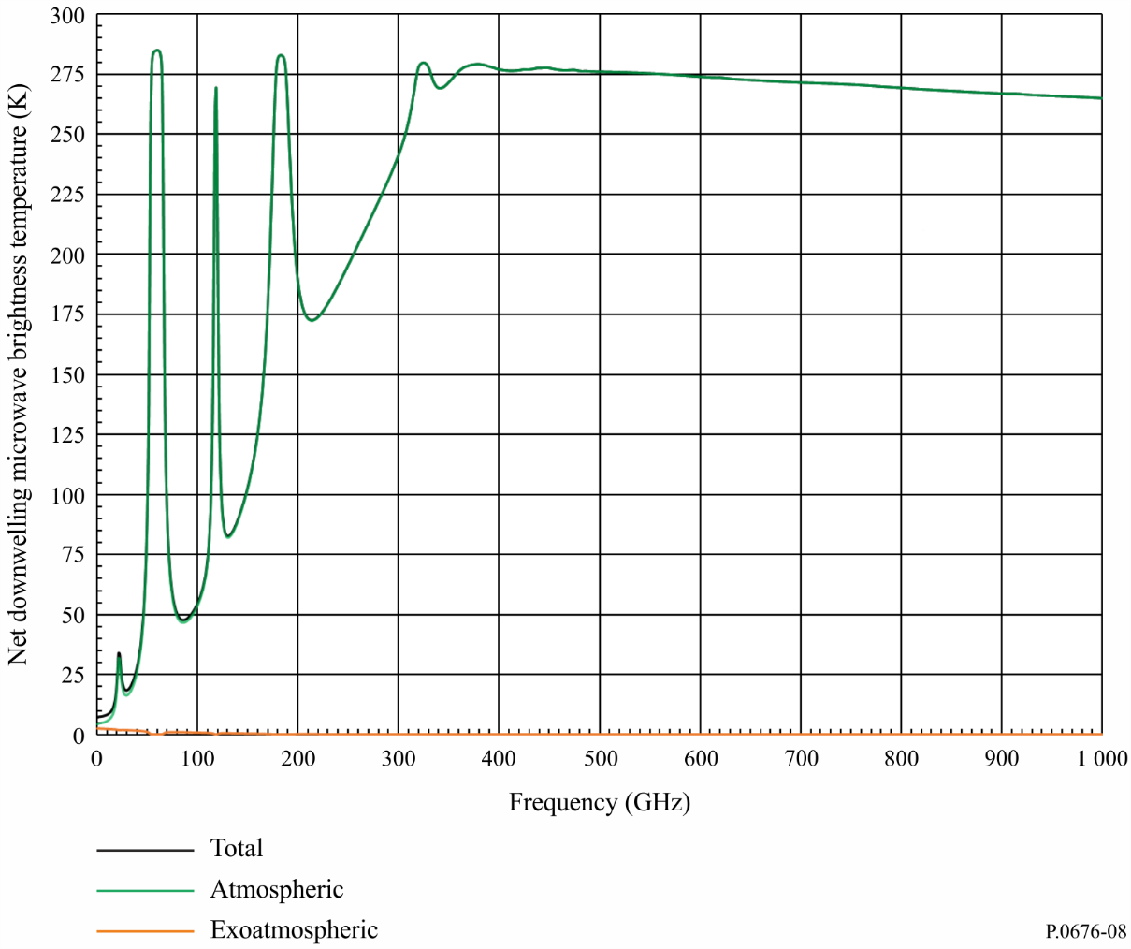
FIGURE 9
Zenith upwelling microwave brightness temperature for a
standard atmosphere (1 GHz centres)
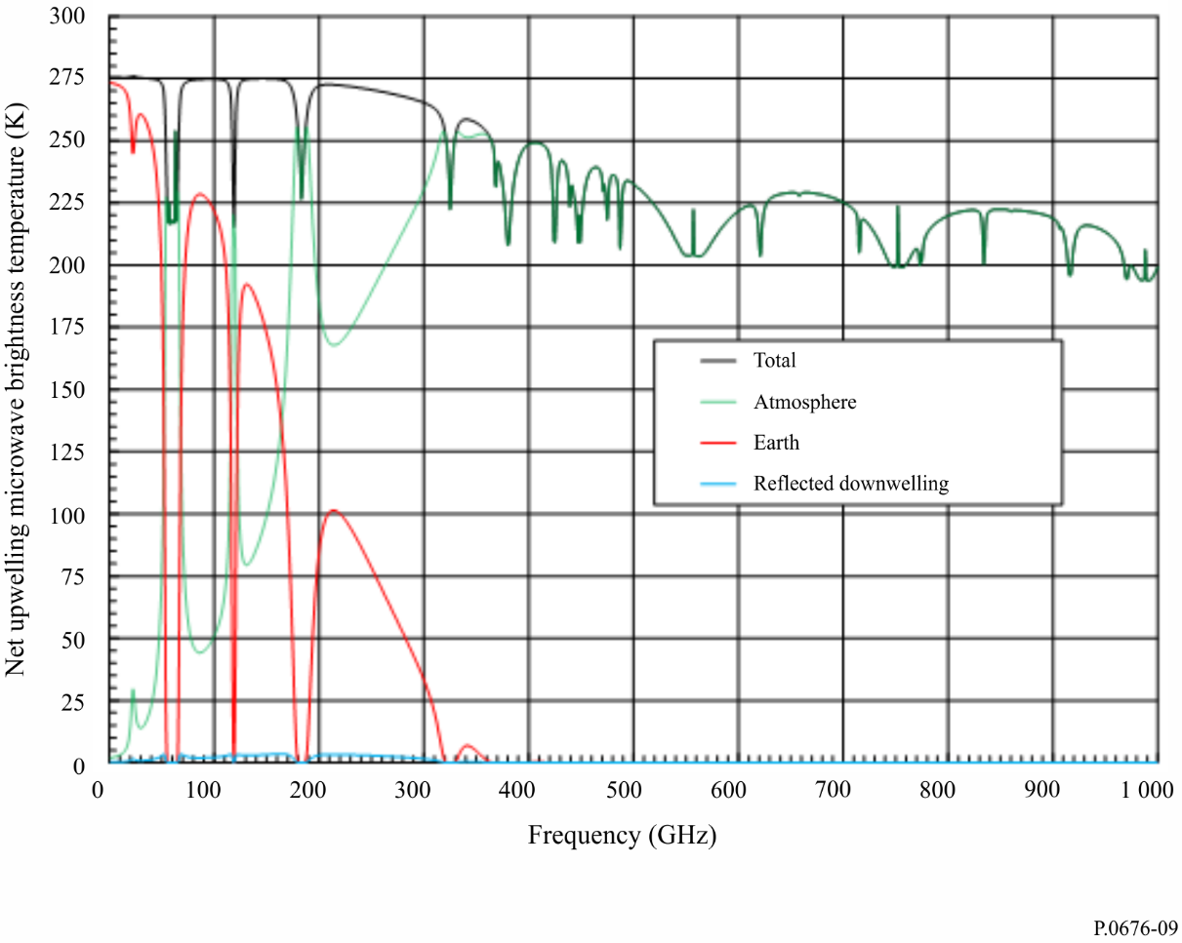

5 Slant path attenuation using vertical atmospheric profiles
The slant path gaseous attenuation for any specific profile in Annex 3 of Recommendation ITU-R P.835 can be calculated using the procedure in § 2.2 of Annex 1 noting the following:
1 Convert the water vapour density, ρ, to water vapour partial pressure, e, using equation (4).
2 Convert the total air pressure (p_{tot} = p_{dry} + e) to dry air pressure, p_{dry}, by subtracting the water vapour partial pressure, e.
3 Calculate the total attenuation using equation (13) where the exponential layer thicknesses are defined in equation (14).
4 If the height of the surface of the Earth above mean sea level is not available from local data, an estimate can be obtained from Recommendation ITU-R P.1511.
5 The summation in equation (13) should be from the height of the surface of the Earth above mean sea level to the maximum height in the data set.
6 The 32 levels in each profile should be interpolated and extrapolated (to the surface of the Earth, if required) per the exponential layer thicknesses defined in equation (14) assuming:
a) A linear relation between the logarithm of pressure and height.
b) A linear relation between temperature and height.
c) A linear relation between the logarithm of water vapour density and height.
If needed, equations (24a) to (24c) in Annex 1 of Recommendation ITU-R P.834 (and the associated maps) can be used for interpolation and extrapolation of these profiles.
7 The elevation angle at or near the surface of the Earth is the apparent rather than the free-space elevation angle. For free-space elevation angles less than or equal to 10 degrees, the apparent elevation angle can be calculated from the free-space elevation angle using equation (13) of Recommendation ITU-R P.834.
8 The estimated slant path gaseous attenuation at any latitude and longitude between grid points can be estimated by bilinear interpolation of the corresponding estimates of slant path gaseous attenuation at the surrounding grid points using the procedure in Annex 1 of Recommendation ITU-R P.1144. The slant path gaseous attenuation at each surrounding grid point should be from the height of the surface of the Earth above mean sea level at the latitude and longitude of interest to the maximum height in each profile.

Annex 2
Slant path gaseous attenuation in the frequency range 1-350 GHz
List of symbols
$$A_{o}$$ | slant path gaseous attenuation attributable to oxygen
$$A_{w}$$ | slant path gaseous attenuation attributable to water vapour
$$A_{total}$$ | slant path total gaseous attenuation
$$N_{oxygen}^{"}$$ | imaginary part of the complex refractivity attributable to oxygen
$$N_{water vapour}^{"}$$ | imaginary part of the complex refractivity attributable to water vapour
$$θ$$ | elevation angle
$$p$$ | exceedance probability
$$γ_{o}$$ | specific gaseous attenuation attributable to oxygen
$$γ_{w}$$ | specific gaseous attenuation attributable to water vapour
$$f$$ | frequency
$$P_{s}$$ | instantaneous total (barometric) surface pressure
$$P_{s}(p)$$ | total surface pressure vs. exceedance probability
$$p_{s}$$ | instantaneous dry surface pressure
$$\overline{p_{s}}$$ | mean dry surface pressure
$$T_{s}$$ | instantaneous surface temperature
$$\overline{T_{s}}$$ | mean surface temperature
$$T_{s}(p)$$ | surface temperature vs. exceedance probability
$$ρ_{w_{s}}$$ | instantaneous surface water vapour density
$$\overline{ρ_{w_{s}}}$$ | mean surface water vapour density
$${ρ_{w}}_{s}(p)$$ | surface water vapour density vs. exceedance probability
$$e_{s}$$ | instantaneous water vapour partial pressure
$$\overline{e_{s}}$$ | mean water vapour partial pressure
$$V_{s}$$ | mean integrated water vapour content
$$V_{s}(p)$$ | integrated water vapour content vs. exceedance probability
$$a_{o}, b_{o}, c_{o}, d_{o}$$ | coefficients of $h_{o}$
$$h_{o}$$ | oxygen equivalent height
$$A, B, f_{i}, a_{i}, b_{i}$$ | coefficients of $h_{w}$
$$h_{w}$$ | water vapour equivalent height
$$a_{V}, b_{V}, c_{V}, d_{V}$$ | coefficients of $K_{V}$
$$K_{V}$$ | water vapour mass absorption coefficient
$$k_{V_{s}}$$ | Weibull shape parameter of integrated water vapour content
$$λ_{V_{s}}$$ | Weibull scale parameter of integrated water vapour content

This Annex contains prediction methods that estimate the slant path gaseous attenuation between the surface of the Earth and space for elevation angles of 5 degrees and above and frequencies between 1 and 350 GHz. The prediction methods include instantaneous prediction methods, where the local total (barometric) surface pressure, surface temperature, and surface water vapour density or integrated water vapour content (see footnote 1) are known (e.g. from a weather station or radiosonde data); and statistical prediction methods, where the exceedance probabilities of total (barometric) surface pressure, surface temperature, surface water vapour density, integrated water vapour content, and Weibull scale and shape parameters are known either from long-term local data or from the integral digital maps in Recommendation ITU-R P.2145. The Weibull approximation to the slant path gaseous attenuation attributable to water vapour is provided for use in Recommendation ITU-R P.1853.
The net slant path gaseous attenuation is the sum of the slant path gaseous attenuation attributable to oxygen, $A_{o}$, and the slant path gaseous attenuation attributable to water vapour, $A_{w}$; i.e. $A_{total}=A_{o}+A_{w}$. A summary of the instantaneous and statistical slant path gaseous attenuation prediction methods is shown in Table 3. Similar to Annex 1, these prediction methods do not include the gaseous attenuation attributable to oxygen isotopes, vibrationally excited oxygen, ozone, ozone isotopes, vibrationally excited ozone, and other trace molecules. The gaseous attenuation due to these atmospheric constituents are relatively insignificant for typical slant paths between the surface of the Earth and space.

1 Slant path oxygen gaseous attenuation prediction methods
There are two prediction methods for slant path gaseous attenuation attributable to oxygen:
1) As described in § 1.1, an instantaneous prediction method where the total (barometric) surface pressure, surface temperature and surface water vapour density are known from instantaneous local measured data; and
2) As described in § 1.2, a statistical prediction method where the statistics of total (barometric) surface pressure, surface temperature and surface water vapour density are known, either from local data or from the integral maps in Recommendation ITU-R P.2145.

TABLE 3
Summary of instantaneous and statistical slant path gaseous attenuation prediction methods
 | Instantaneous prediction method | Statistical prediction method
Oxygen attenuation | Section 1.1  $$A_{o}\left(f,P_{s},T_{s},{ρ_{w}}_{s}\right)=\frac{γ_{o}\left(f,p_{s},T_{s},e_{s}\right)∙h_{o}\left(f,P_{s},T_{s},{ρ_{w}}_{s}\right) }{\sin{θ}}$$  where:  $$h_{o}\left(f,P_{s},T_{s},{ρ_{w}}_{s}\right)=a_{o}\left(f\right)+b_{o}\left(f\right)∙T_{s}+c_{o}\left(f\right)∙P_{s}+d_{o}\left(f\right)∙{ρ_{w}}_{s}$$  and:  $e_{s}=\frac{ρ_{w_{s}}T_{s}}{216.7}$ ; $p_{s}=P_{s}-e_{s}$ | Section 1.2  $$A_{o}\left(f,p\right)=\frac{γ_{o}\left(f,\overline{p_{s}},\overline{T_{s}},\overline{e_{s}}\right)∙h_{o}\left(f,P_{s}\left(p\right),T_{s}(p),{ρ_{w}}_{s}(p)\right) }{\sin{θ}}$$  where:  $$h_{o}\left(f,P_{s}\left(p\right),T_{s}\left(p\right),{ρ_{w}}_{s}\left(p\right)\right)=a_{o}\left(f\right)+b_{o}\left(f\right)∙T_{s}\left(p\right)+c_{o}\left(f\right)∙P_{s}\left(p\right)+d_{o}\left(f\right)∙{ρ_{w}}_{s}\left(p\right)$$  and:  $\overline{e_{s}}=\frac{\overline{ρ_{w_{s}}} \overline{T_{s}}}{216.7}$; $\overline{p_{s}}=\overline{P_{s}}-\overline{e_{s}}$
Water vapour attenuation | Section 2.1  $$A_{w}\left(f,p_{s},T_{s},{ρ_{w}}_{s}\right)=\frac{γ_{w}\left(f,p_{s},T_{s},e_{s}\right)∙h_{w}\left(f\right) }{\sin{θ}}$$  where:  $$h_{w}\left(f\right)=A∙f+B+\sum_{i=1}^{3}{\frac{a_{i}}{{\left(f-f_{i}\right)}^{2}+b_{i}}}$$  and:  $e_{s}=\frac{ρ_{w_{s}}T_{s}}{216.7}$ ; $p_{s}=P_{s}-e_{s}$
 | Section 2.2  $$A_{w}\left(f,P_{s},T_{s},{ρ_{w}}_{s}\right)=\frac{K_{V}\left(f,P_{s},T_{s},{ρ_{w}}_{s}\right)∙V_{s} }{\sin{θ}}$$  where:  $$K_{V}\left(f,P_{s},T_{s},{ρ_{w}}_{s}\right)=a_{V}\left(f\right)+b_{V}\left(f\right)∙ρ_{w_{s}}+c_{V}\left(f\right)∙T_{s}+d_{V}\left(f\right)∙P_{s}$$ | Section 2.3  $$A_{w}\left(f,p\right)=\frac{K_{V}\left(f,\overline{P_{s}},\overline{T_{s}},\overline{{ρ_{w}}_{s}}\right)∙V_{s}(p) }{\sin{θ}}$$  where:  $$K_{V}\left(f,\overline{P_{s}},\overline{T_{s}},\overline{{ρ_{w}}_{s}}\right)=a_{V}\left(f\right)+b_{V}\left(f\right)∙\overline{ρ_{w_{s}}}+c_{V}\left(f\right)∙\overline{T_{s}}+d_{V}\left(f\right)∙\overline{P_{s}}$$

1.1 Slant path instantaneous oxygen gaseous attenuation prediction method
The predicted slant path instantaneous gaseous attenuation attributable to oxygen, $A_{o}$, is:
$A_{o}\left(f,P_{s},T_{s},{ρ_{w}}_{s}\right)=\frac{γ_{o}\left(f,p_{s},T_{s},e_{s}\right)∙h_{o}\left(f,P_{s},T_{s},{ρ_{w}}_{s}\right) }{\sin{θ}}$ (29)
where:
$f$ : frequency of interest, in GHz
$P_{s}$ : instantaneous total (barometric) surface pressure, in hPa, at the desired location
$e_{s}$ : instantaneous surface water vapour partial pressure, in hPa, at the desired location, where $e_{s}=\frac{ρ_{w_{s}}T_{s}}{216.7}$
$p_{s}$ : instantaneous dry surface pressure, in hPa, at the desired location, $p_{s}=P_{s}-e_{s}$
$T_{s}$ : instantaneous surface temperature, in K, at the desired location
$ρ_{w_{s}}$ : instantaneous surface water vapour density, in g/m³, at the desired location
$θ$ : elevation angle
$γ_{o}$ : specific gaseous attenuation attributable to oxygen, in dB/km, given by:
$γ_{o}= 0.1820 f {N"}_{oxygen}(f)$ (30)
${N"}_{oxygen}(f)$ is the imaginary part of the oxygen complex radio refractivity given by equation (2a) of Annex 1; and:
$h_{o}\left(f,P_{s},T_{s},{ρ_{w}}_{s}\right)=a_{o}\left(f\right)+b_{o}\left(f\right)∙T_{s}+c_{o}\left(f\right)∙P_{s}+d_{o}\left(f\right)∙{ρ_{w}}_{s}$ (31)
The coefficients $a_{o}$, $b_{o}$, $c_{o}$ and $d_{o}$ at the frequency of interest should be linearly interpolated between the frequencies in the data file Part 1, which is an integral part of this Recommendation. The data file contains the coefficients $a_{o}$, $b_{o}$, $c_{o}$ and $d_{o}$ for frequencies between 1 GHz and 350 GHz in 0.5 GHz increments and an additional frequency of 118.75 GHz.

1.2 Slant path statistical oxygen gaseous attenuation prediction method
The predicted slant path statistical gaseous attenuation attributable to oxygen, $A_{o}$, is:
$A_{o}\left(f,p\right)=\frac{γ_{o}\left(f,\overline{p_{s}},\overline{T_{s}},\overline{e_{s}}\right)∙h_{o}\left(f,P_{s}\left(p\right),T_{s}(p),{ρ_{w}}_{s}(p)\right) }{\sin{θ}}$ (32)
where:
$f$ : frequency of interest, in GHz
$\overline{P_{s}}$ : mean total (barometric) surface pressure, in hPa, at the desired location
$\overline{e_{s}}$ : mean surface water vapour partial pressure, in hPa, at the desired location,
where:
$\overline{e_{s}}=\frac{\overline{ρ_{w_{s}}} \overline{T_{s}}}{216.7}$
$\overline{p_{s}}$ : mean dry surface pressure, in hPa, at the desired location, $\overline{p_{s}}=\overline{P_{s}}-\overline{e_{s}}$
$\overline{T_{s}}$ : mean surface temperature, in K, at the desired location
$\overline{ρ_{w_{s}}}$ : mean surface water vapour density, in g/m³, at the desired location
$p$ : exceedance probability (CCDF) of interest, in %
$P_{s}(p)$ : total (barometric) surface pressure at the exceedance probability $p$, in hPa, at the desired location
$T_{s}(p)$ : surface temperature at the exceedance probability $p$, in K, at the desired location
$ρ_{w_{s}}(p)$ : surface water vapour density at the exceedance probability, $p$, in g/m³, at the desired location
$θ$ : elevation angle
$γ_{o}$ : specific gaseous attenuation attributable to oxygen, in dB/km, given by:
$γ_{o}= 0.1820 f {N"}_{oxygen}(f)$ (33)
${N"}_{oxygen}(f)$ is the imaginary part of the oxygen complex radio refractivity given by equation (2a) of Annex 1; and
$h_{o}\left(f,P_{s}(p),T_{s}(p),{ρ_{w}}_{s}(p)\right)=a_{o}\left(f\right)+b_{o}\left(f\right)∙T_{s}(p)+c_{o}\left(f\right)∙P_{s}(p)+d_{o}\left(f\right)∙{ρ_{w}}_{s}(p)$ (34)
The coefficients $a_{o}$, $b_{o}$, $c_{o}$ and $d_{o}$ at the frequency of interest should be linearly interpolated between the frequencies in the data file Part 1, which is an integral part of this Recommendation. The data file contains the coefficients $a_{o}$, $b_{o}$, $c_{o}$ and $d_{o}$ for frequencies between 1 GHz and 350 GHz in 0.5 GHz increments and an additional frequency of 118.75 GHz.

2 Slant path water vapour gaseous attenuation prediction methods
There are four prediction methods for the slant path gaseous attenuation attributable to water vapour:
1) As described in § 2.1, an instantaneous prediction method, where the total (barometric) surface pressure, surface temperature and surface water vapour density are known from instantaneous local measured data;
2) As described in § 2.2, an instantaneous prediction method, where the total (barometric) surface pressure, surface temperature, surface water vapour density and integrated water vapour content are known from instantaneous local measured data;
3) As described in § 2.3, a statistical prediction method, where the statistics of total (barometric) surface pressure, surface temperature, surface water vapour density and integrated water vapour content are known, either from local data or from the integral maps at the desired location in Recommendation ITU-R P.2145; and
4) As described in § 2.4, the Weibull approximation to the slant path statistical prediction method, where the Weibull scale and shape parameters are known, either from local data or from the integral maps at the desired location in Recommendation ITU-R P.2145.
If the instantaneous surface water vapour density and instantaneous integrated water vapour content are available concurrently, the instantaneous water vapour prediction method using the instantaneous integrated water vapour content should be used.

2.1 Slant path instantaneous water vapour gaseous attenuation prediction method 1
The predicted slant path instantaneous gaseous attenuation attributable to water vapour, $A_{w}$, is:
$A_{w}\left(f,p_{s},T_{s},{ρ_{w}}_{s}\right)=\frac{γ_{w}\left(f,p_{s},T_{s},e_{s}\right)∙h_{w}\left(f\right) }{\sin{θ}}$ (35)
where:
$f$ : frequency of interest, in GHz
$P_{s}$ : instantaneous total (barometric) surface pressure, in hPa, at the desired location
$e_{s}$ : instantaneous surface water vapour partial pressure, in hPa, at the desired location, where $e_{s}=\frac{ρ_{w_{s}}T_{s}}{216.7}$
$p_{s}$ : instantaneous dry surface pressure, in hPa, at the desired location, $p_{s}=P_{s}-e_{s}$
$T_{s}$ : instantaneous surface temperature, in K, at the desired location
$ρ_{w_{s}}$ : instantaneous surface water vapour density, in g/m³, at the desired location
$θ$ : elevation angle
$γ_{w}$ : specific gaseous attenuation attributable to water vapour, in dB/km, given by:
$γ_{w}= 0.1820 f {N"}_{water vapour}(f)$ (36)
${N"}_{water vapour}(f)$ is the imaginary part of the water vapour complex radio refractivity given by equation (2b) of Annex 1; and
$h_{w}\left(f\right)=A∙f+B+\sum_{i=1}^{3}{\frac{a_{i}}{{\left(f-f_{i}\right)}^{2}+b_{i}}}$ (37)
where $A=5.6585×{10}^{-5}$, $B=1.8348$ and the coefficients $f_{i}$, $a_{i}$ and $b_{i}$ are shown in Table 4.
TABLE 4
Coefficients $f_{i}$, $a_{i}$ and $b_{i}$
i | $f_{i}$ (GHz) | $$a_{i}$$ | $$b_{i}$$
1 | 22.235080 | 2.6846 | 2.7649
2 | 183.310087 | 5.8905 | 4.9219
3 | 325.152888 | 2.9810 | 3.0748

2.2 Slant path instantaneous water vapour gaseous attenuation prediction method 2
The predicted slant path instantaneous gaseous attenuation attributable to water vapour, $A_{w}$, is:
$A_{w}\left(f,P_{s},T_{s},{ρ_{w}}_{s}\right)=\frac{K_{V}\left(f,P_{s},T_{s},{ρ_{w}}_{s}\right)∙V_{s} }{\sin{θ}}$ (38)
where:
$f$ : frequency of interest, in GHz
$P_{s}$ : instantaneous total (barometric) surface pressure, in hPa, at the desired location
$T_{s}$ : instantaneous surface temperature, in K, at the desired location
$ρ_{w_{s}}$ : instantaneous surface water vapour density, in g/m³, at the desired location
$V_{s}$ : integrated water vapour content, in kg/m² or mm, from the surface of the Earth at the desired location
$θ$ : elevation angle
and
$K_{V}\left(f,P_{s},T_{s},{ρ_{w}}_{s}\right)=a_{V}\left(f\right)+b_{V}\left(f\right)∙ρ_{w_{s}}+c_{V}\left(f\right)∙T_{s}+d_{V}\left(f\right)∙P_{s}$ (39)
The coefficients $a_{V}$, $b_{V}$, $c_{V}$ and $d_{V}$ at the frequency of interest should be linearly interpolated between the frequencies in the data file Part 2, which is an integral part of this Recommendation. The data file contains the coefficients $a_{V}$, $b_{V}$, $c_{V}$ and $d_{V}$ in columns 2, 3, 4 and 5, respectively, for frequencies between 1 GHz and 350 GHz in 0.5 GHz increments in column 1.

2.3 Slant path statistical water vapour gaseous attenuation prediction method
The predicted slant path statistical gaseous attenuation attributable to water vapour, $A_{w}$, is:
$A_{w}\left(f,p\right)=\frac{K_{V}\left(f,\overline{P_{s}},\overline{T_{s}},\overline{{ρ_{w}}_{s}}\right)∙V_{s}(p) }{\sin{θ}}$ (40)
where:
$f$ : frequency of interest, in GHz
$\overline{P_{s}}$ : mean total (barometric) surface pressure, in hPa, at the desired location
$\overline{T_{s}}$ : mean surface temperature, in K, at the desired location
$\overline{ρ_{w_{s}}}$ : mean surface water vapour density, in g/m³, at the desired location
$p$ : exceedance probability (CCDF) of interest, in %
$V_{s}(p)$ : integrated water vapour content at the exceedance probability $p,$ in kg/m² or mm, from the surface of the Earth at the desired location
$θ$ : elevation angle
and
$K_{V}\left(f,\overline{P_{s}},\overline{T_{s}},\overline{{ρ_{w}}_{s}}\right)=a_{V}\left(f\right)+b_{V}\left(f\right)∙\overline{ρ_{w_{s}}}+c_{V}\left(f\right)∙\overline{T_{s}}+d_{V}\left(f\right)∙\overline{P_{s}}$ (41)
The coefficients $a_{V}$, $b_{V}$, $c_{V}$ and $d_{V}$ at the frequency of interest should be linearly interpolated between the frequencies in the data file Part 2 which is an integral part of this Recommendation. The data file contains the coefficients $a_{V}$, $b_{V}$, $c_{V}$ and $d_{V}$ in columns 2, 3, 4 and 5, respectively, for frequencies between 1 GHz and 350 GHz in 0.5 GHz increments in column 1.

2.4 Weibull approximation to the slant path statistical water vapour gaseous attenuation
The Weibull approximation to the predicted slant path statistical gaseous attenuation attributable to water vapour, $A_{w}$, is:
$A_{w}\left(f,p\right)={ \frac{{{λ_{V}}_{s} ∙K}_{V}\left(f,\overline{P_{s}},{\overline{T}}_{s},\overline{{ρ_{w}}_{s}}\right) ∙ {\left[-\ln\left(\frac{p}{100}\right)\right]}^{\frac{1}{k_{V_{s}}}}}{\sin{θ}}}_{ }$ (42)
where:
$f$ : frequency of interest, in GHz
$\overline{P_{s}}$ : mean total (barometric) surface pressure, in hPa, at the desired location
$\overline{T_{s}}$ : mean surface temperature, in K, at the desired location
$\overline{ρ_{w_{s}}}$ : mean surface water vapour density, in g/m³, at the desired location
$p$ : exceedance probability (CCDF) of interest, in %
$λ_{V_{s}}$ : surface Weibull water vapour scale parameter at the desired location
$k_{V_{s}}$ : surface Weibull water vapour shape parameter at the desired location
$θ$ : elevation angle
and
$K_{V}\left(f,\overline{P_{s}},{\overline{T}}_{s},\overline{{ρ_{w}}_{s}}\right)=a_{V}\left(f\right)+b_{V}\left(f\right)∙\overline{ρ_{w_{s}}}+c_{V}\left(f\right)∙\overline{T_{s}}+d_{V}\left(f\right)∙\overline{P_{s}}$ (43)
The coefficients $a_{V}$, $b_{V}$, $c_{V}$ and $d_{V}$ at the frequency of interest should be linearly interpolated between the frequencies in the data file Part 2 which is an integral part of this Recommendation. The data file contains the coefficients $a_{V}$, $b_{V}$, $c_{V}$ and $d_{V}$ in columns 2, 3, 4 and 5, respectively, for frequencies between 1 GHz and 350 GHz in 0.5 GHz increments in column 1.

* Radiocommunication Study Group 3 made editorial amendments to this Recommendation in June 2024 in accordance with Resolution ITU-R 1.
Integrated water vapour content is the total amount of water vapour in a vertical column extending from the surface of the Earth to the top of the atmosphere. The terms integrated water vapour content, total water vapour content, total column(ar) water vapour, integrated columnar water vapour content and total columnar content of water vapour are synonymous.
Equation (11) can be evaluated using various methods depending on the implementation: e.g. a) the integral function in Matlab, b) the quad function in Octave, c) the quad function in Python, d) several Numerical Recipes functions and other equivalent methods.
Data files Part 1 and Part 2 can be also found here: https://www.itu.int/oth/R1101000002/en
The terms exceedance probability and complementary cumulative distribution function (CCDF) are synonymous.
Data files Part 1 and Part 2 can be also found here: https://www.itu.int/oth/R1101000002/en

