Recommendation ITU-R P.682-4
(08/2022)
Propagation data required for the design
of Earth-space aeronautical mobile telecommunication systems

P Series
Radiowave propagation

Foreword
The role of the Radiocommunication Sector is to ensure the rational, equitable, efficient and economical use of the radio-frequency spectrum by all radiocommunication services, including satellite services, and carry out studies without limit of frequency range on the basis of which Recommendations are adopted.
The regulatory and policy functions of the Radiocommunication Sector are performed by World and Regional Radiocommunication Conferences and Radiocommunication Assemblies supported by Study Groups.

Policy on Intellectual Property Right (IPR)
ITU-R policy on IPR is described in the Common Patent Policy for ITU-T/ITU-R/ISO/IEC referenced in Resolution ITU-R 1. Forms to be used for the submission of patent statements and licensing declarations by patent holders are available from http://www.itu.int/ITU-R/go/patents/en where the Guidelines for Implementation of the Common Patent Policy for ITU-T/ITU-R/ISO/IEC and the ITU-R patent information database can also be found.

Series of ITU-R Recommendations
(Also available online at http://www.itu.int/publ/R-REC/en)
Series | Title
BO | Satellite delivery
BR | Recording for production, archival and play-out; film for television
BS | Broadcasting service (sound)
BT | Broadcasting service (television)
F | Fixed service
M | Mobile, radiodetermination, amateur and related satellite services
P | Radiowave propagation
RA | Radio astronomy
RS | Remote sensing systems
S | Fixed-satellite service
SA | Space applications and meteorology
SF | Frequency sharing and coordination between fixed-satellite and fixed service systems
SM | Spectrum management
SNG | Satellite news gathering
TF | Time signals and frequency standards emissions
V | Vocabulary and related subjects

Note: This ITU-R Recommendation was approved in English under the procedure detailed in Resolution ITU-R 1.

Electronic Publication
Geneva, 2022

© ITU 2022
All rights reserved. No part of this publication may be reproduced, by any means whatsoever, without written permission of ITU.

RECOMMENDATION ITU-R P.682-4
Propagation data required for the design of Earth-space
aeronautical mobile telecommunication systems
(Question ITU-R 207/3)
(1990-1992-2007-2012-2022)
Scope
This Recommendation describes propagation effects of particular importance to aeronautical mobile-satellite systems. Relevant ionospheric and tropospheric propagation impairments are identified, and reference made to ITU-R Recommendations that provide guidance on these effects. Models are provided to predict the propagation effects caused by signal multipath and scattering from the Earth’s surface.
The ITU Radiocommunication Assembly,
considering
a) that for the proper planning of Earth-space aeronautical mobile systems it is necessary to have appropriate propagation data and prediction methods;
b) that the methods of Recommendation ITU-R P.618 are recommended for the planning of Earth-space telecommunication systems;
c) that further development of prediction methods for specific application to aeronautical mobile-satellite systems is required to give adequate accuracy for all operational conditions;
d) that, however, methods are available which yield sufficient accuracy for many applications,
recommends
that the methods contained in Annex 1 be adopted for current use in the planning of Earth-space aeronautical mobile telecommunication systems, in addition to the methods recommended in Recommendation ITU-R P.618.

Annex 1

1 Introduction
Propagation effects in the aeronautical mobile-satellite service differ from those in the fixed-satellite service and other mobile-satellite services because:
– small antennas are used on aircraft, and the aircraft body may affect the performance of the antenna;
– high aircraft speeds cause large Doppler spreads;
– aircraft terminals must accommodate a large dynamic range in transmission and reception;
– aircraft safety considerations require a high integrity of communications, making even short-term propagation impairments very important, and communications reliability must be maintained in spite of banking manoeuvres and three-dimensional operations.
This Annex discusses data and models specifically required to characterize the path impairments, which include:
– tropospheric effects, including gaseous attenuation, cloud and rain attenuation, fog attenuation, refraction and scintillation;
– ionospheric effects such as scintillation;
– surface reflection (multipath) effects;
– environmental effects (aircraft motion, sea state, land surface type).
Aeronautical mobile-satellite systems may operate on a worldwide basis, including propagation paths at low elevation angles. Several measurements of multipath parameters over land and sea have been conducted. In some cases, laboratory simulations are used to compare measured data and verify model parameters. The received signal is considered in terms of its possible components: a direct wave subject to atmospheric effects, and a reflected wave, which generally contains mostly a diffuse component.
There is current interest in using frequencies near 1.5 GHz for aeronautical mobile-satellite systems. As most experiments have been conducted in this band, data in this Recommendation are mainly applicable to these frequencies. As aeronautical systems mature, it is anticipated that other frequencies may be used.

2 Tropospheric effects
For the aeronautical services, the altitude of the mobile antenna is an important parameter. Estimates of tropospheric attenuation may be made with the methods in Recommendation ITU-R P.618.
The received signal may be affected both by large-scale refraction and by scintillations induced by atmospheric turbulence. These effects will diminish for aircraft at high altitudes.

3 Ionospheric effects
Ionospheric effects on slant paths are discussed in Recommendation ITU-R P.531. These phenomena are important for many paths at frequencies below about 10 GHz, particularly within ±15° of the geomagnetic equator, and to a lesser extent, within the auroral zones and polar caps. Ionospheric effects peak near the solar sunspot maximum.
Impairments caused by the ionosphere will not diminish for the typical altitudes used by aircraft. A summary description of ionospheric effects of particular interest to mobile-satellite systems is available in Recommendation ITU-R P.680. For most communication signals, the most severe impairment will probably be ionospheric scintillation. Table 1 of Recommendation ITU-R P.680 provides estimates of maximum expected ionospheric effects at frequencies up to 10 GHz for paths at a 30° elevation angle.

4 Fading due to surface reflection and scattering

4.1 General
Multipath fading due to surface reflections for aeronautical mobile-satellite systems differs from fading for other mobile-satellite systems because the speeds and altitudes of aircraft are much greater than those of other mobile platforms.

4.2 Fading due to sea-surface reflections
Characteristics of fading for aeronautical systems can be analysed with procedures similar to those for maritime systems described in Recommendation ITU-R P.680, taking careful account of Earth sphericity, which becomes significant with increasing antenna altitude above the reflecting surface.

4.2.1 Dependence on antenna height and antenna gain
The following simple method, based on a theoretical model, provides approximate estimates of multipath power or fade depth suitable for engineering applications.
The procedure is as follows:
Applicable range:
Frequency: 1-2 GHz
Elevation angle: θi ≥ 3° and G(1.5θi) ≥ –10 dB
where G(θ) is the main-lobe antenna pattern given by:
G(θ) = –4 × 10^{–4} ( – 1) θ² dB (1)
where:
Gm: value of the maximum antenna gain (dB)
θ: angle measured from boresight (degrees).
Polarization: circular and horizontal polarizations; vertical polarization for θi ≥ 8°
Sea condition: wave height of 1-3 m (incoherent component fully developed).
Step 1: Calculate the grazing angles of the specular reflection point, θsp, and the horizon, θhr, by:

θ_{sp} = 2 γ_{sp} + θ_{i} degrees (2a)
θ_{hr} = cos^{–1} [R_{e}/(R_{e} + H_{a})] degrees (2b)
where:
γsp = 7.2 × 10^{–3} Ha/tanθi
Re : radius of the Earth = 6 371 km
Ha : antenna height (km).
Step 2: Find the relative antenna gain G in the direction midway between the specular point and the horizon. The relative antenna gain is approximated by equation (1) where θ = θi + (θsp + θhr)/2 (degrees).
Step 3: Calculate the Fresnel reflection coefficient of the sea:
(horizontal polarization) (3a)
(vertical polarization) (3b)
(circular polarization) (3c)
η = ε_{r} (f) – j60 λ σ (f)
where:
εr(f) : relative permittivity of the surface at frequency f (from Recommendation ITU-R P.527)
σ(f) : conductivity (S/m) of the surface at frequency f (from Recommendation ITU-R P.527)
λ: free space wavelength (m).
Step 4: Calculate the correction factor Cθ (dB):

$C_{θ}=\left\{\begin{matrix}0 & \text{for}{ θ}_{sp}≥7° \\ {(θ}_{sp}-7)/2 & \text{for }θ_{sp}<7°\end{matrix}\right.$ (4)

Step 5: Calculate the divergence factor D (dB) due to the Earth’s curvature:

$D=-10\log_{10}\left[1+\frac{2\sin{γ_{sp}}}{\cos{θ_{sp}}\sin\left(γ_{sp}+θ_{i}\right)}\right]$ (5)

Step 6: The mean incoherent power of sea reflected waves, relative to the direct wave, Pr , is given by:

P_{r} = G + R + C_{θ} + D dB (6)
where:
$R=20\log_{10}\left|R_{i}\right|$
with R_{i} = R_{H}, R_{V} or R_{C} from equations (3).
Step 7: Fade depth is calculated as follows:
Step 7a: The reference signal power (the direct wave) is 1 (0 dB);
Step 7b: The mean incoherent power of sea reflected waves relative to the direct wave (i.e. the multipath power) is $P_{r}$ dB, see step 6;
Step 7c: The total received power is $10\log_{10}\left(1+{10}^{\frac{P_{r}}{10 }}\right)$ dB;
Step 7d: Calculate the received signal power exceeded for $1-p\%$ time. Because the fade depth exceeded for $p\%$ time can be calculated as the ratio between the direct wave signal power and the signal power exceeded for $1-p\%$ time. Assuming a Nakagami-Rice probability distribution, the total power is equal to 0 dB in Fig. 1, the received signal power exceeded for $1-p\%$ time is assumed to be A dB.
Step 7e: Since the total received power is $10\log_{10}\left(1+{10}^{\frac{P_{r}}{10 }}\right)$ dB which is different from Fig. 4, the received signal power exceeded for $1-p\%$ time is $A+10\log_{10}\left(1+{10}^{\frac{P_{r}}{10 }}\right)$ dB;
Step 7f: Noting that fade depth is positive for signal loss and negative for signal enhancement, the fade depth $F_{d}\left(p\right)$ exceeded for $p\%$ is:
$F_{d}\left(p\right)=0-\left[A+10\log_{10}\left(1+{10}^{\frac{P_{r}}{10 }}\right)\right]=-\left[A+10\log_{10}\left(1+{10}^{\frac{P_{r}}{10 }}\right)\right]$ dB (7)
FIGURE 1
Nakagami-Rice distribution for a constant total power with the parameter $α$
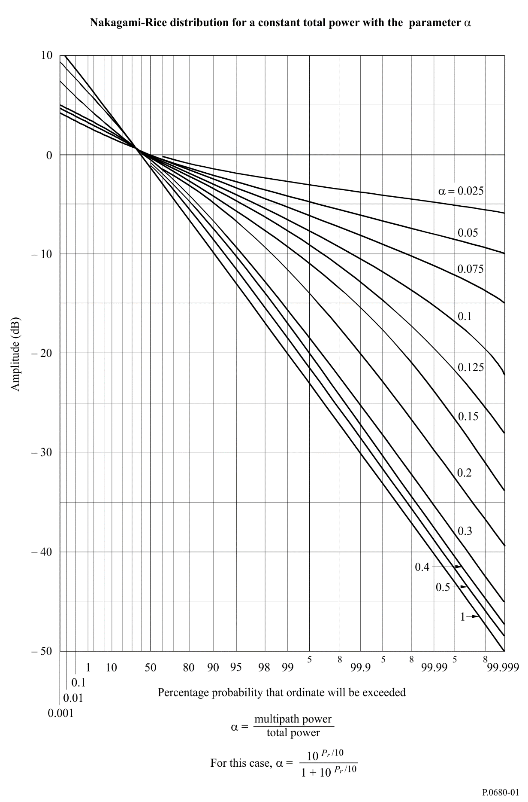
Figure 2 below shows the mean multipath power of the incoherent component obtained by the above method as a function of the elevation angle for different gains. By comparing with the case of maritime mobile-satellite systems (Fig. 2 of Recommendation ITU-R P.680), it can be seen that the reflected wave power P_{r} for aeronautical mobile-satellite systems is reduced by 1 to 3 dB at low elevation angles.
FIGURE 2
Mean multipath power relative to direct signal power as a function
of elevation angle for different antenna gains
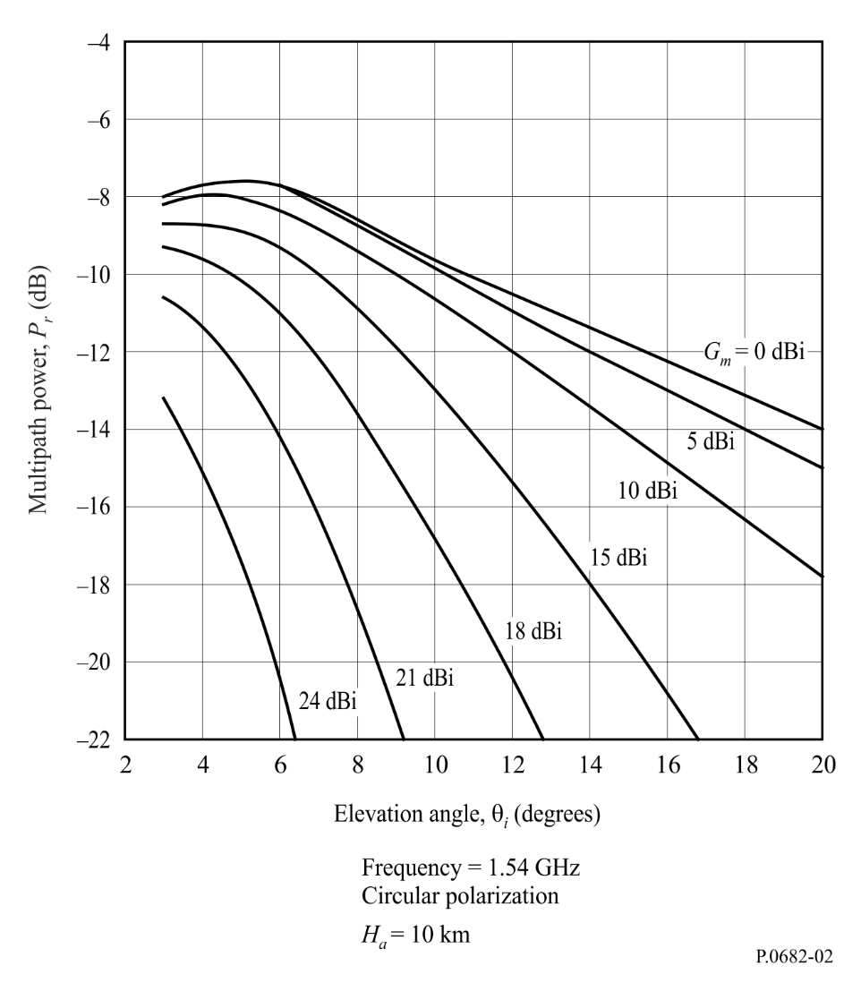

NOTE 1 – Analytical as well as experimental studies have shown that for circularly polarized waveforms at or near 1.5 GHz and an antenna gain of 7 dB, multipath fade depth for rough sea conditions is about 8 to 11 dB for low and moderate aircraft heights and about 7 to 9 dB for high altitudes (above 2 km). Multipath fade depth is about 2 dB lower for a 15 dB antenna gain.

4.2.2 Delay time and correlation bandwidth
The received signal consists of the direct and the reflected waveforms. Because the reflected component experiences a larger propagation delay than the direct component, the composite received signal may be subject to frequency-selective fading. Signal correlation decreases with increasing frequency separation. The dependence of correlation on the antenna gain is small for gains below 15 dB. Figure 3 shows the relationship between antenna height and the correlation bandwidth, defined here as the frequency separation for which the correlation coefficient between two radio waves equals 0.37 (1/e). The correlation bandwidth decreases as the antenna altitude increases, becoming about 10 to 20 kHz (delay time of 6 to 12 μs) for an antenna at an altitude of 10 km. Thus, multipath fading for aeronautical systems may have frequency-selective characteristics.
FIGURE 3
Correlation bandwidth vs antenna altitude
for antenna gain of 10 dBi
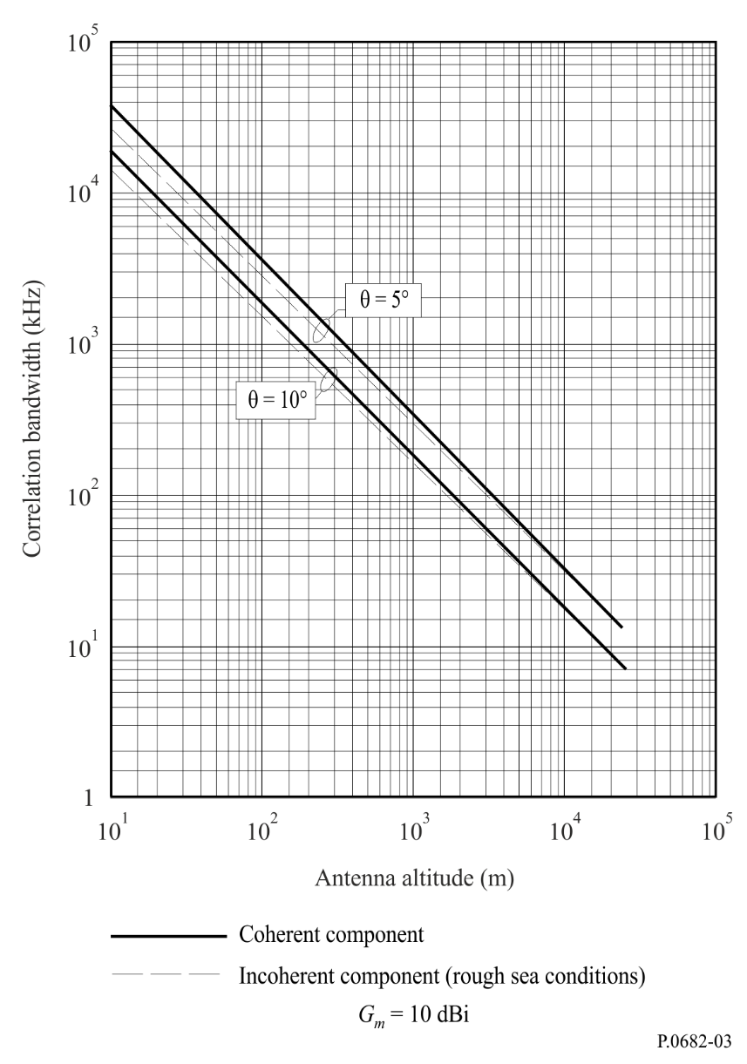

4.3 Measurements of sea-reflection multipath effects
Extensive experiments have been conducted in the 1.5 to 1.6 GHz band. Results of these measurements are summarized in this section for application to systems design.
Table 1 summarizes the oceanic multipath parameters observed in measurements, augmented with results from an analytical model. The delay spreads in Table 1 are the widths of the power-delay profile of the diffusely-scattered signal arriving at the receiver. The correlation bandwidth given in Table 1 is the 3 dB bandwidth of the frequency autocorrelation function (Fourier transform of the delay spectrum). Doppler spread is determined from the width of the Doppler power spectral density. The decorrelation time is the 3 dB width of the time autocorrelation function (inverse Fourier transform of the Doppler spectrum).
TABLE 1
Multipath parameters from ocean measurements
Parameter | Measured range | Typical value  at specified elevation angle
 |  | 8° | 15° | 30°
Normalized multipath power (dB)  Horizontal polarization  Vertical polarization | –5.5 to –0.5  –15 to –2.5 | –2.5  –14.5 | –1  –9 | –1.5  –3.5
Delay spread⁽¹⁾ (μs)  3 dB value  10 dB value | 0.25-1.8  2.2 -5.6 | 0.6  2.8 | 0.8  3.2 | 0.8  3.2
Correlation bandwidth⁽²⁾  3 dB value (kHz) | 70-380 | 160 | 200 | 200
Doppler spread⁽¹⁾ (Hz)  In-plane geometry  3 dB value  10 dB value | 14-190  13-350 | 45  44  40⁽³⁾ | 70  180 | 140  350
Cross-plane geometry  3 dB value  10 dB value | 179-240  180-560 | 179  180  180⁽³⁾ | 110  280 | 190  470
Decorrelation time⁽²⁾ (ms)  3 dB value | 1.3-10 | 7.5 | 3.2 | 2.2
⁽¹⁾ Two-sided.
⁽²⁾ One-sided.
⁽³⁾ Data from multipath model for aircraft altitude of 10 km and aircraft speed of 1 000 km/h.

Normalized multipath power for horizontal and vertical antenna polarizations for calm and rough sea conditions are plotted versus elevation angle in Fig. 4, along with predictions derived from a physical optics model. Sea condition has a minor effect for elevation angles above about 10 degrees. The agreement between measured coefficients and those predicted for a smooth flat Earth as modified by the spherical-Earth divergence factor increases as sea conditions become calm.
FIGURE 4
Oceanic normalized multipath power vs elevation angle at 1.6 GHz
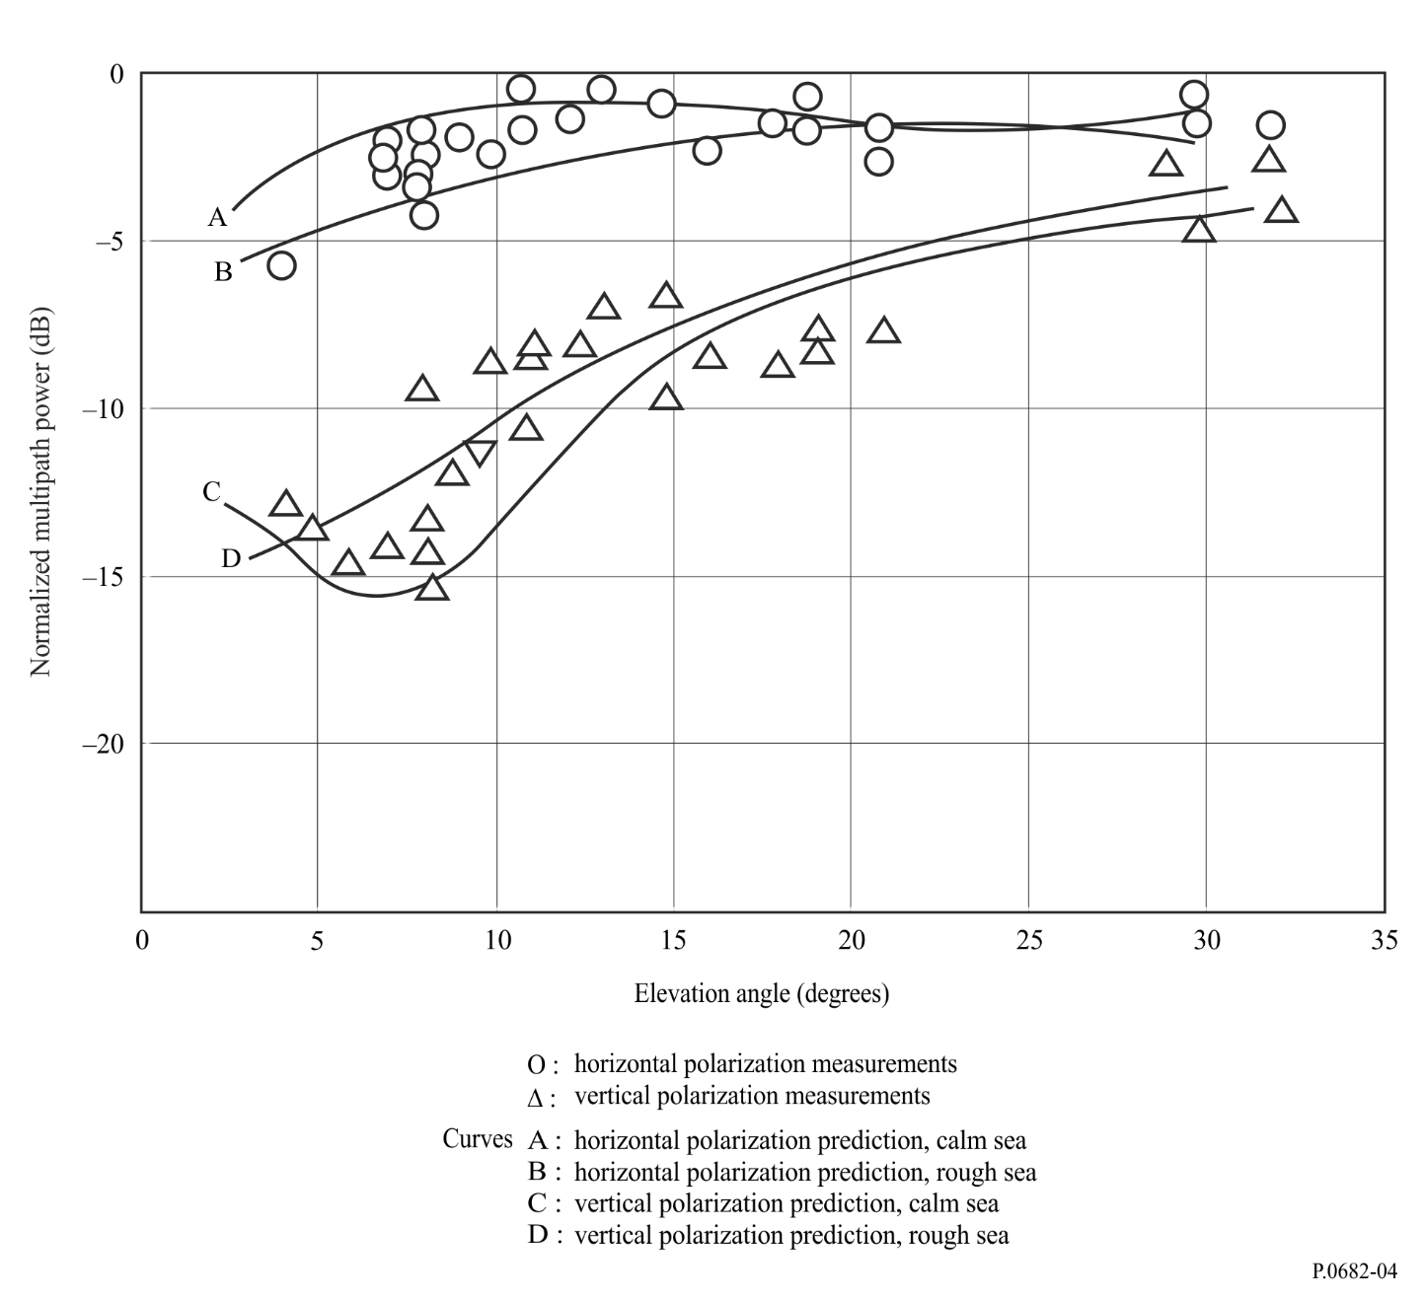

Multipath data were collected in a series of aeronautical mobile-satellite measurements conducted over the Atlantic Ocean and parts of Europe. Figure 5 shows the measured mean and standard deviations of 1.6 GHz fade durations as a function of elevation angle for these flights. (A crossed-dipole antenna with a gain of 3.5 dBi was used to collect these data. The aircraft flew at a nominal altitude of 10 km and with a nominal ground speed of 700 km/h.).
FIGURE 5
Fade duration vs elevation angle for circular polarization at 1.6 GHz (antenna gain = 3.5 dBi);
data collected over Atlantic Ocean and W. Europe
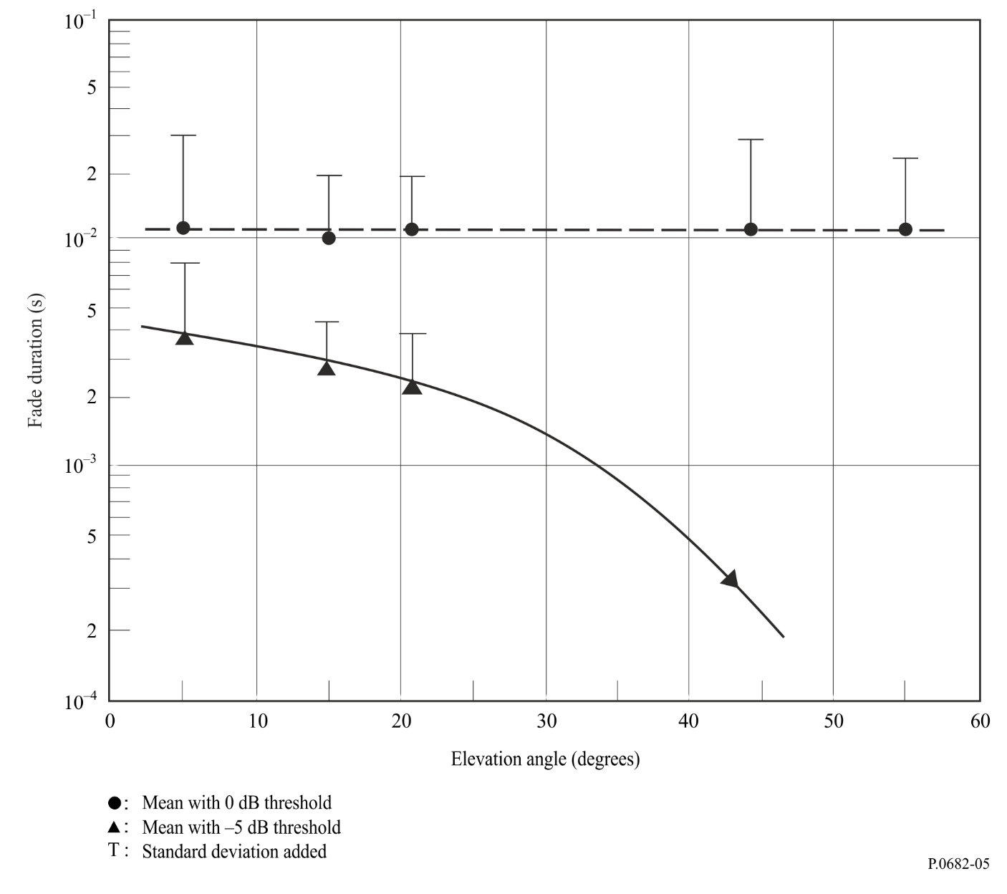

4.4 Measurements of land-reflection multipath effects
Table 2 supplies multipath parameters measured during flights over land; parameter definitions are the same as for Table 1. Land multipath signals are highly variable. No consistent dependence on elevation angle has been established, perhaps because ground terrain is highly variable (data were collected over wet and dry soil, marshes, dry and wet snow, ice, lakes, etc.).
NOTE 1 – Irreducible error rate; multipath fading in mobile channels gives rise to an irreducible error rate at which increases in the direct signal power do not reduce the corresponding error rate. Simulations indicate that the irreducible error rate is higher for an aeronautical mobile-satellite channel than for a land mobile-satellite channel.
TABLE 2
Multipath parameters from land measurements
Parameter | Measured range | Typical value
Normalized multipath power (dB)  Horizontal polarization  Vertical polarization | –18 to 2  –21 to –3 | –9  –13
Delay spread⁽¹⁾ (μs)  3 dB value  10 dB value | 0.1-1.2  0.2-3.2 | 0.3  1.2
Correlation bandwidth⁽²⁾ (kHz)  3 dB value | 150-3 000 | 600
Doppler spread⁽¹⁾ (Hz)  3 dB value  10 dB value | 20-140  40-500 | 260  200
Decorrelation time⁽²⁾ (ms)  3 dB value | 1-10 | 4
⁽¹⁾ Two-sided.
⁽²⁾ One-sided.

4.5 Multipath model for aircraft during approach over land and during landing
Short-delayed multipath in aeronautical communication and navigation systems has to be considered especially for broadband signals. The reflections on the aircraft structure produce significant disturbances. Especially during the final approach when communication availability and reliability as well as navigation accuracy and integrity are most important, the ground reflection and the reflection on the fuselage generate significant propagation effects.
Although the model primarily targets navigation applications, it is of course possible to use it with any satellite signal. However, due to the primary expected usage, the antenna is assumed to be on top of the cockpit (where usually a navigation antenna is placed). The complete model is intended to be used as a statistical simulator. Since the bandwidths of the reflections appear to be very low, the process will not yield sufficient statistics during the approach time of 200 s. To simulate a statistically valid navigation error, the model must be used for a large number of approaches. The simulation results of these approaches must be averaged to obtain the minimum, maximum and average navigation error.
A software implementation of the model is available on that part of the ITU-R website related to Radiocommunication Study Group 3.

4.5.1 Physical effects
The multipath propagation conditions of a receiving aircraft divide in two main parts:
– the aircraft structure; and
– the ground reflection.
The aircraft structure shows significant reflections only on the fuselage (when the antenna is mounted at the top of the cockpit). This very short-delayed reflection shows little time variance and dominates the channel.
A strong wing reflection was not observed (when the antenna is mounted at the top of the cockpit).
The ground reflection shows high time variance and is Doppler-shifted according to the aircraft sink rate.

4.5.2 Valid range of model
The model can be used for frequencies between 1 GHz and 3 GHz. The satellite azimuth can vary between 10 and 170 degrees, or 190 and 350 degrees. The elevation angle to the satellite can vary between 10 and 75 degrees.

4.5.3 Model

4.5.3.1 Overview
FIGURE 6
Complete aeronautical channel model
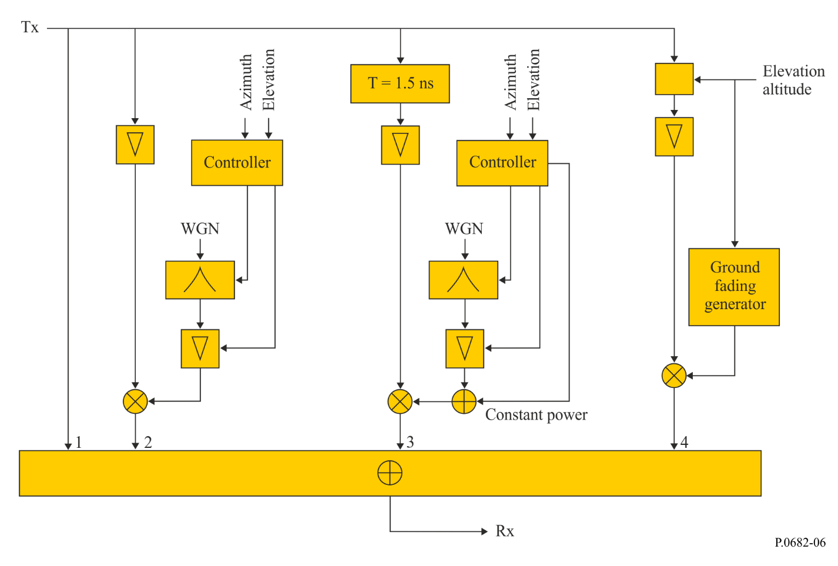
Figure 6 shows the complete aeronautical model for the final approach. The first branch is the direct signal (Branch 1), followed by the flat fading part modelling the line-of-sight (LoS) modulation (Branch 2). The third branch (Branch 3) consists of the fuselage multipath fading process, which is delayed by 1.5 ns. The last branch (Branch 4) is the ground echo, whose delay depends on elevation and altitude.
Time-variant input parameters of this model are:
– satellite azimuth, ϕ(t)
– satellite elevation, θ(t)
– altitude of the aircraft (above ground), h(t), where t denotes the time.
In addition the model requires the knowledge of the aircraft geometry and flight dynamics. Empirical coefficients are presented for the following aircraft types:
– Vereinigte Flugzeugwerke VFW 614 (ATTAS), representing a small jet
– Airbus A 340, representing a large commercial jet.
The azimuth and elevation dependence of the multipath fading processes, which are indicated in the above diagram as “controller”, are taken into account by the polynomial function used in equation (10). Furthermore, the delay of the ground reflection is a function of elevation and altitude; see equation (16).
The fading processes and time-variant blocks have input parameters for adjusting the model to different satellite positions (elevation and azimuth). The various fading processes are strongly dependent on the aircraft type.
TABLE 3
The parameters of the channel model – Overview
 | Delay  (ns) | Relative power  (dB) | Doppler bandwidth  (Hz)
LoS  DC component  Fading process | 0 | 0  (–14.2 – mean) | 0  < 0.1
Fuselage  DC component  Fading process | 1.5 | –14.2  (–14.2 – mean) | < 0.1
Ground | 900-10  (descending) | –15 to –25 | < 20  (biased due to sink rate)

4.5.3.2 Direct path
Beside the LoS (Branch 1), this path is affected by a strong modulation (Branch 2), which has a Rician amplitude distribution. This fading process is generated as given in equations (8), (9), (10) and (11).

4.5.3.3 Wing reflection
If the antenna is placed on the top of the cockpit (which is mandatory for satellite navigation antennas), the incoming ray is dispersed over a large angular range. Therefore the total power of the wing reflection is negligible (below –35 dB).
For antennas located at other positions (e.g. for communication systems), especially between the wings, a wing reflection contribution might be expected.

4.5.3.4 Fuselage reflection
To generate a time series of the fuselage reflection, the knowledge of its power spectral density is essential. The model is driven by a stochastic process, p_{proc}. This process can be generated by filtering complex white noise with the power spectral density given in equation (8), where b₂ and b₃ are the coefficients of the exponential process:
(8)
In addition to this noisy process, the fuselage reflection signal contains a mean (DC) component of −14.2 dB and the constant b₁ has been determined as:
(9)
As noted previously, the valid path elevation angle range is between 10° and 75°. The azimuth can vary from 15 to 165 degrees and 195 to 335 degrees, respectively.
To derive the mean and b₂ and b₃ coefficients, a 2-dimensional polynomial function of 4th order to each parameter (mean, b₂, b₃) is given. As an example,
(10)
gives the mean value as a function of elevation θ and azimuth ϕ, where A_{mean} is a 5-by-5 matrix of polynomial coefficients. Coefficients and are calculated similarly.
For the two aircraft examples (ATTAS and A340), these matrices are given respectively by:
(11)

4.5.3.5 Ground reflection
The ground reflection is Doppler-shifted by the aircraft sink rate (vertical speed), . Its Doppler offset is given by:
(12)
where λ denotes the wavelength. Around the mean frequency, given in equation (12), the Doppler spectrum of the ground reflection is well represented by the normalized Gaussian distribution:

(13)

denotes the power of the ground reflection obtained by the Markov model, where the standard deviation has been found experimentally to be:

(14)

To model the ground reflection, the final approach is divided into three different zones of altitude (high, mid and low altitude). In each zone, the ground reflection is characterized by a Markov state model.
TABLE 4
Altitude regions for the Markov model
Level | From  (m) | To  (m)
“High” | 1 000 | 400
“Mid” | 400 | 100
“Low” | 100 | 10

Figure 7
Altitude regions of the ground model
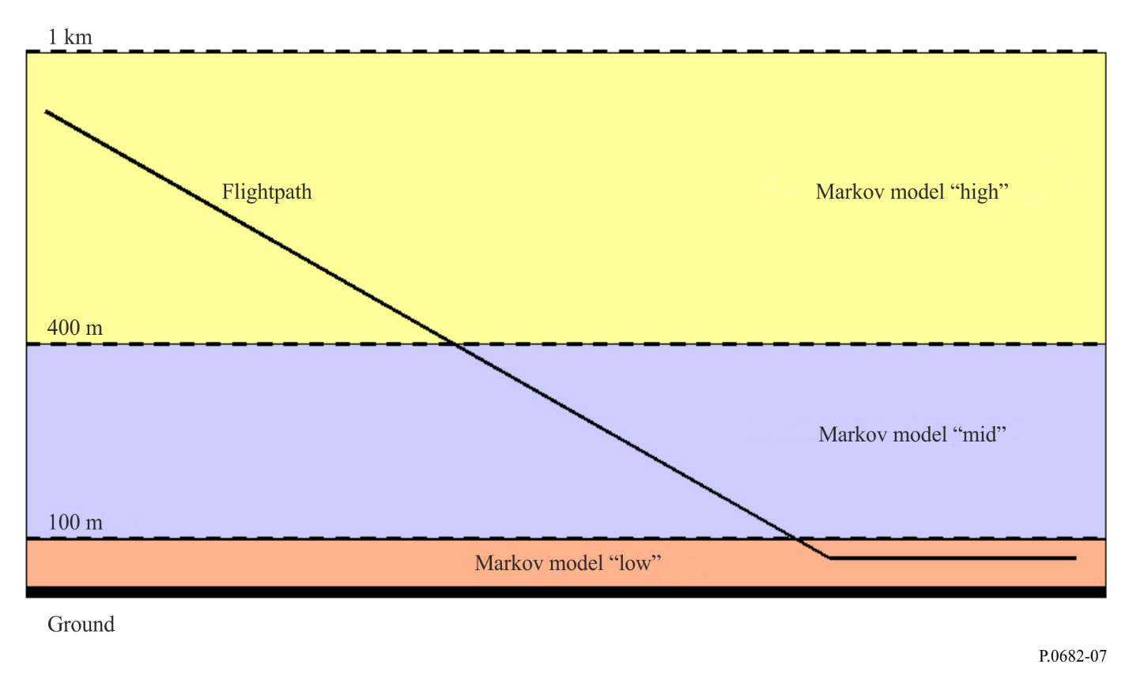
TABLE 5
States of the ground fading Markov model
State | Power  (dB)
1⁽¹⁾ | < –25
2 | –23
3 | –19
4 | –15
⁽¹⁾ No ground reflection.

Figure 8
Realisation of the ground fading generator module
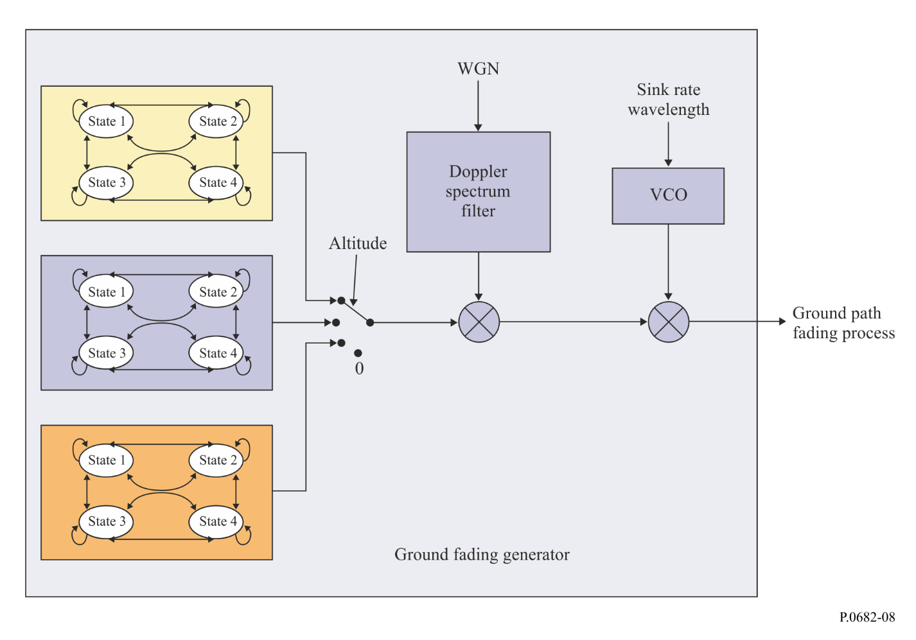

The Markov transition probabilities are obtained from the quantised measurement data. The transition matrix P, where P_{x,y} is the probability of changing from state x to state y, is determined for each altitude region independently.
The ground fading process is generated by an altitude-dependent Markov model for a sampling frequency of 25.4 Hz. Note that these transition probabilities are only valid for this frequency. The transition altitudes are given by Table 4 and illustrated in Fig. 7.
The output power states of the model are depicted in Table 5 and illustrated in Fig. 8.
From the measurements the following transition probability matrices were derived:
(15)
where P_{x–y} denotes the transition probability in the altitude region h(t) ≥ x and h(t) < y.
Note that this Markov model describes a landing in Graz airport in Austria. This region is dominated by forests, grasslands and occasionally streets. Weather conditions, environment, flight geometry and many other parameters may influence on the characteristics of the ground echo. So these numbers are to be seen as parameters to be adapted by the user if intended for other region types. In particular, an approach over (salt) water or a region with many canals is expected to show rather different behaviour.
The delay of the ground reflection as a function of the path elevation angle can be easily calculated assuming a flat environment around the airport by
(16)
where:
c: speed of light
h(t): aircraft altitude
θ: elevation angle.

