RECOMMENDATION ITU-R P.837-2
CHARACTERISTICS OF PRECIPITATION FOR PROPAGATION MODELLING
(Question ITU-R 201/3)
(1992-1994-1999)
Rec. ITU-R P.837-2
The ITU Radiocommunication Assembly,
considering
a) that information on the statistics of precipitation intensity is needed for the prediction of attenuation and scattering caused by precipitation;
b) that the information is needed for all locations on the globe and a wide range of probabilities,
recommends
1 that the model in Annex 1 be used to obtain the rainfall rate, Rp, exceeded for any given percentage of the average year, p, and for any location. This model is to be applied to the data supplied in the digital files ESARAINxxx.TXT; (the data files may be obtained from the ITU Radiocommunication Bureau (BR));
2 that, for easy reference, Figs. 1 to 6 in Annex 2 be used to select the rainfall rate exceeded for 0.01% of the average year. These figures were also derived from the model and data described in Annex 1.

ANNEX 1
Model to derive the rainfall rate exceeded for a given
probability of the average year and a given location
The data files ESARAINPR6.TXT, ESARAIN_MC.TXT and ESARAIN_MS.TXT contain respectively the numerical values for the variables Pr6, Mc and Ms while data files ESARAINLAT.TXT and ESARAINLON.TXT contain the latitude and longitude of each of the data entries in all other files. These data files were derived from 15 years of data of the European Centre of Medium-range Weather Forecast (ECMWF).
Step 1: Extract the variables Pr6, Mc and Ms for the four points closest in latitude and longitude to the geographical coordinates of the desired location. The latitude grid is from +90° N to –90° S in 1.5° steps; the longitude grid is from 0° to 360° in 1.5° steps.
Step 2: From the values of Pr6, Mc and Ms at the four grid points obtain the values Pr6(Lat,Lon), Mc(Lat,Lon) and Ms(Lat,Lon) at the desired location by performing a bi-linear interpolation.
Step 3: Derive the probability of rain, P0, from:

If the result of this operation is undetermined (Not-a-Number), the probability of rain P0(Lat,Lon) is equal to zero and consequently the rainfall intensity is also zero. In this case stop the procedure.
Step 4: Derive the rainfall rate Rp exceeded for p % of the average year from:

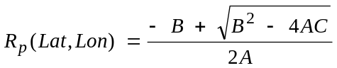
where:
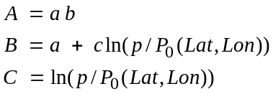
and:
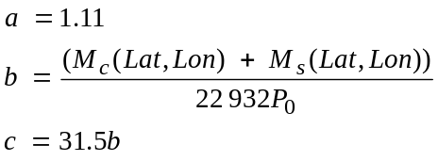
NOTE – An implementation of this model and the associated data in MATLAB is also available from the BR.

ANNEX 2


