Recommendation ITU-R RA.314-11
(12/2023)
RA Series: Radio astronomy
Preferred frequency bands for radio astronomical measurements below 1 THz

Foreword
The role of the Radiocommunication Sector is to ensure the rational, equitable, efficient and economical use of the radio-frequency spectrum by all radiocommunication services, including satellite services, and carry out studies without limit of frequency range on the basis of which Recommendations are adopted.
The regulatory and policy functions of the Radiocommunication Sector are performed by World and Regional Radiocommunication Conferences and Radiocommunication Assemblies supported by Study Groups.

Policy on Intellectual Property Right (IPR)
ITU-R policy on IPR is described in the Common Patent Policy for ITU-T/ITU-R/ISO/IEC referenced in Resolution ITU-R 1. Forms to be used for the submission of patent statements and licensing declarations by patent holders are available from http://www.itu.int/ITU-R/go/patents/en where the Guidelines for Implementation of the Common Patent Policy for ITU-T/ITU-R/ISO/IEC and the ITU-R patent information database can also be found.

Series of ITU-R Recommendations
(Also available online at https://www.itu.int/publ/R-REC/en)
Series | Title
BO | Satellite delivery
BR | Recording for production, archival and play-out; film for television
BS | Broadcasting service (sound)
BT | Broadcasting service (television)
F | Fixed service
M | Mobile, radiodetermination, amateur and related satellite services
P | Radiowave propagation
RA | Radio astronomy
RS | Remote sensing systems
S | Fixed-satellite service
SA | Space applications and meteorology
SF | Frequency sharing and coordination between fixed-satellite and fixed service systems
SM | Spectrum management
SNG | Satellite news gathering
TF | Time signals and frequency standards emissions
V | Vocabulary and related subjects

Note: This ITU-R Recommendation was approved in English under the procedure detailed in Resolution ITU-R 1.

Electronic Publication
Geneva, 2024

© ITU 2024
All rights reserved. No part of this publication may be reproduced, by any means whatsoever, without written permission of ITU.

RECOMMENDATION ITU-R RA.314-11
Preferred frequency bands for radio astronomical measurements below 1 THz
(Question ITU-R 145/7)
(1953-1956-1959-1966-1970-1974-1978-1982-1986-1990-1992-2002-2003-2023)
Scope
This Recommendation provides information regarding the preferred frequency bands for radio astronomical measurements up to 1 000 GHz. Tables 1 and 2 list the frequency bands associated with atomic and molecular transitions; Table 3 lists the frequency bands preferred for observations of radio continuum emission; Table 4 lists the frequency bands for several specific applications of redshifted neutral hydrogen. Figures in the Annex illustrate the natural processes that dictate the preferred frequency bands for radio astronomy.
Keywords
Radio astronomy, fundamental physics, atomic and molecular transitions, continuum emission, atmospheric transparency
The ITU Radiocommunication Assembly,
considering
a) that the development of radio astronomy has led to major technological advances, particularly in receiving techniques and to improved knowledge of fundamental radio-noise limitations of great importance to radiocommunication, and promises further important results;
b) that the advancement of radio astronomy requires the protection of certain frequency bands from interference;
c) that the International Astronomical Union (IAU) is maintaining and updating the list of spectral lines of the greatest importance to radio astronomy;
d) that radio astronomers study spectral lines both in bands allocated to the radio astronomy service and, as far as spectrum usage by other services allows, outside the allocated bands, and that this has resulted in the detection of thousands of spectral lines as illustrated in Fig. 1 of Annex 1;
e) that account should be taken of the Doppler shifts of the lines, due to the relative motion of source and observer;
f) that the observed frequencies of highly redshifted (Doppler-shifted) atomic or molecular spectral lines from the distant Universe are significantly lower than their rest frequencies, as illustrated in Table 4 and Fig. 3 of Annex 1;
g) that certain frequency bands have been allocated for continuum observations, and that the exact positions of these bands in the spectrum are not of critical importance, as illustrated in Fig. 4 of Annex 1, but that their centre frequencies should be in the ratio not more than two to one, taking the width of relevant atmospheric windows (see Fig. 1 of Annex 1) into account;
h) that radio astronomers have made useful astronomical observations from the Earth’s surface in all available atmospheric windows (see Fig. 1 of Annex1) ranging from 2 MHz to 1 000 GHz and above;
i) that the technique of space radio astronomy, which involves the use of radio telescopes on space platforms, provides access to the entire radio spectrum above about 10 kHz, including parts of the spectrum not accessible from the Earth due to absorption in the atmosphere;
j) that some types of high-resolution interferometric observations require simultaneous reception, at the same radio frequency, by receiving systems located in different countries, on different continents, or on space platforms;
k) that world administrative radio conferences and world radiocommunication conferences have made improved frequency allocations for radio astronomy, but that protection in many bands, particularly those shared with other services, may still need careful planning,
noting
that preferred bands between 1 and 3 THz are contained in Recommendation ITU-R RA.1860,
recommends
1 that administrations should afford all practicable protection to the frequencies used by radio astronomers in their own and neighbouring countries;
2 that particular attention should be given to securing or maintaining adequate protection for the frequency bands listed in Tables 1 and 2, which contain rest frequencies and Doppler-shifted frequencies of the astrophysically most important spectral lines identified by the General Assembly of the IAU, and in Table 3, which contains the frequency bands allocated to the radio astronomy service that are preferred for continuum observations;
3 that administrations be asked to provide assistance in the coordination of observations of spectral lines in bands not allocated to radio astronomy.
TABLE 1
Radio frequency lines of the greatest importance to radio
astronomy at frequencies below 275 GHz
Substance | Rest frequency | Suggested minimum band | Notes⁽¹⁾
Deuterium (D i) | 327.384 MHz | 327.0-327.7 MHz
Hydrogen (H i) | 1 420.406 MHz | 1 370.0-1 427.0 MHz | ^{(2), (3)}
Hydroxyl radical (OH) | 1 612.231 MHz | 1 606.8-1 613.8 MHz | ⁽⁴⁾
Hydroxyl radical (OH) | 1 665.402 MHz | 1 659.8-1 667.1 MHz | ⁽⁴⁾
Hydroxyl radical (OH) | 1 667.359 MHz | 1 661.8-1 669.0 MHz | ⁽⁴⁾
Hydroxyl radical (OH) | 1 720.530 MHz | 1 714.8-1 722.2 MHz | ^{(3), (4)}
Methylidyne (CH) | 3 263.794 MHz | 3 252.9-3 267.1 MHz | ^{(3), (4)}
Methylidyne (CH) | 3 335.481 MHz | 3 324.4-3 338.8 MHz | ^{(3), (4)}
Methylidyne (CH) | 3 349.193 MHz | 3 338.0-3 352.5 MHz | ^{(3), (4)}
Formaldehyde (H₂CO) | 4 829.660 MHz | 4 813.6-4 834.5 MHz | ^{(3), (4)}
Methanol (CH₃OH) | 6 668.518 MHz | 6 661.8-6 675.2 MHz | ⁽³⁾
Helium (³He⁺) | 8 665.650 MHz | 8 657.0-8 674.3 MHz | ^{(3), (6)}
Methanol (CH₃OH) | 12.178 GHz | 12.17-12.19 GHz | ^{(3), (6)}
Formaldehyde (H₂CO) | 14.488 GHz | 14.44-14.50 GHz | ^{(3), (4)}
Cyclopropenylidene (C₃H₂) | 18.343 GHz | 18.28-18.36 GHz | ^{(3), (4), (6)}
Water vapour (H₂O) | 22.235 GHz | 22.16-22.26 GHz | ^{(3), (4)}
Ammonia (NH₃) | 23.694 GHz | 23.61-23.71 GHz | ⁽⁴⁾
Ammonia (NH₃) | 23.723 GHz | 23.64-23.74 GHz | ⁽⁴⁾
Ammonia (NH₃) | 23.870 GHz | 23.79-23.89 GHz | ⁽⁴⁾
TABLE 1 (continued)
Substance | Rest frequency | Suggested minimum band | Notes⁽¹⁾
Sulphur monoxide (SO) | 30.002 GHz | 29.97-30.03 GHz | ⁽⁶⁾
Methanol (CH₃OH) | 36.169 GHz | 36.13-36.21 GHz | ⁽⁶⁾
Silicon monoxide (SiO) | 42.519 GHz | 42.47-42.57 GHz | ^{(6), (8)}
Silicon monoxide (SiO) | 42.821 GHz | 42.77-42.86 GHz
Silicon monoxide (SiO) | 43.122 GHz | 43.07-43.17 GHz
Silicon monoxide (SiO) | 43.424 GHz | 43.37-43.47 GHz
Dicarbon monosulphide (CCS) | 45.379 GHz | 45.33-45.44 GHz | ⁽⁶⁾
Carbon monosulphide (CS) | 48.991 GHz | 48.94-49.04 GHz
Molecular oxygen (O₂) | 61.1 GHz | 56.31-63.06 GHz | ^{(5), (6), (7)}
Deuterated water vapour (HDO) | 80.578 GHz | 80.50-80.66 GHz
Cyclopropenylidene (C₃H₂) | 85.339 GHz | 85.05-85.42 GHz
Silicon monoxide (SiO) | 86.243 GHz | 86.16-86.33 GHz
Formylium (H¹³CO⁺) | 86.754 GHz | 86.66-86.84 GHz
Silicon monoxide (SiO) | 86.847 GHz | 86.76-86.93 GHz
Ethynyl radical (C₂H) | 87.3 GHz | 87.21-87.39 GHz | ⁽⁵⁾
Hydrogen cyanide (HCN) | 88.632 GHz | 88.34-88.72 GHz | ⁽⁴⁾
Formylium (HCO⁺) | 89.189 GHz | 88.89-89.28 GHz | ⁽⁴⁾
Hydrogen isocyanide (HNC) | 90.664 GHz | 90.57-90.76 GHz
Diazenylium (N₂H⁺) | 93.174 GHz | 93.07-93.27 GHz
Carbon monosulphide (CS) | 97.981 GHz | 97.65-98.08 GHz | ⁽⁴⁾
Sulphur monoxide (SO) | 99.300 GHz | 99.98-100.18 GHz
Methyl acetylene (CH₃C₂H) | 102.5 GHz | 102.39-102.60 GHz | ⁽⁵⁾
Methanol (CH₃OH) | 107.014 GHz | 106.91-107.12 GHz
Carbon monoxide (C¹⁸O) | 109.782 GHz | 109.67-109.89 GHz
Carbon monoxide (¹³CO) | 110.201 GHz | 109.83-110.31 GHz | ⁽⁴⁾
Carbon monoxide (C¹⁷O) | 112.359 GHz | 112.25-112.47 GHz
Cyano radical (CN) | 113.5 GHz | 113.39-113.61 GHz | ⁽⁵⁾
Carbon monoxide (CO) | 115.271 GHz | 114.88-115.39 GHz | ⁽⁴⁾
Molecular oxygen (O₂) | 118.750 GHz | 118.63-118.87 GHz | ^{(6), (7)}
Formaldehyde (H₂¹³CO) | 137.450 GHz | 137.31-137.59 GHz
Formaldehyde (H₂CO) | 140.840 GHz | 140.69-140.98 GHz
Carbon monosulphide (CS) | 146.969 GHz | 146.82-147.12 GHz
Nitric oxide (NO) | 150.4 GHz | 149.95-150.85 GHz | ⁽⁵⁾
Methanol (CH₃OH) | 156.602 GHz | 156.45-156.76 GHz
Water vapour (H₂O) | 183.310 GHz | 183.12-183.50 GHz
Carbon monoxide (C¹⁸O) | 219.560 GHz | 219.34-219.78 GHz
Carbon monoxide (¹³CO) | 220.399 GHz | 219.67-220.62 GHz | ⁽⁴⁾
Cyano radical (CN) | 226.6 GHz | 226.37-226.83 GHz | ⁽⁵⁾
Cyano radical (CN) | 226.8 GHz | 226.57-227.03 GHz | ⁽⁵⁾

TABLE 1 (end)
Substance | Rest frequency | Suggested minimum band | Notes⁽¹⁾
Carbon monoxide (CO) | 230.538 GHz | 229.77-230.77 GHz | ⁽⁴⁾
Carbon monosulphide (CS) | 244.953 GHz | 244.72-245.20 GHz
Nitric oxide (NO) | 250.6 GHz | 250.35-250.85 GHz | ⁽⁵⁾
Ethynyl radical (C₂H) | 262.0 GHz | 261.74-262.26 GHz | ⁽⁵⁾
Hydrogen cyanide (HCN) | 265.886 GHz | 265.62-266.15 GHz
Formylium (HCO⁺) | 267.557 GHz | 267.29-267.83 GHz
Hydrogen isocyanide (HNC) | 271.981 GHz | 271.71-272.25 GHz
⁽¹⁾ If Notes ⁽²⁾ or ⁽⁴⁾ are not listed, the band limits are the Doppler-shifted frequencies corresponding to radial velocities of ±300 km/s (consistent with line radiation occurring in the Milky Way Galaxy).
⁽²⁾ An extension to lower frequency of the allocation of 1 400-1 427 MHz is required to allow for the higher Doppler shifts for H i observed in distant galaxies. Additional preferred frequency ranges for redshifted neutral hydrogen for relevant astronomical epochs are listed in Table 4.
⁽³⁾ The current international allocation is not primary and/or does not meet bandwidth requirements. See the Radio Regulations (RR) for more detailed information.
⁽⁴⁾ Because these line frequencies are also being used for observing galaxies other than the Milky Way Galaxy, the listed bandwidths include Doppler shifts corresponding to radial velocities of up to 1 000 km/s. Some lines of the most abundant molecules, as well as H i, have been detected in galaxies with very large recession velocities caused by the expansion of the Universe, which results in observed frequencies substantially lower than the rest-frame emission frequency (see Fig. 3).
⁽⁵⁾ There are several closely spaced lines associated with these molecules. The listed bands are wide enough to permit observations of all lines.
⁽⁶⁾ This line frequency is outside of bands allocated to the radio astronomy service.
⁽⁷⁾ These lines are observable only outside the Earth’s atmosphere by, for example, using receivers located on high-altitude balloons, aircraft, satellites, or other non-terrestrial platforms (see also RR Article 22, Section V).
⁽⁸⁾ A portion of the “suggested minimum band” for this line extends outside the band allocated to the radio astronomy service. Protection for observations conducted in this portion of the band may not be practicable.
NOTE 1 – A more extended list of astrophysically important and often observed line frequencies is available at https://splatalogue.online/sp_basic.html. The splatalogue database for astronomical spectroscopy is maintained by a wide collaboration of astronomers and atomic and molecular spectroscopists.

TABLE 2
Radio frequency lines of the greatest importance to radio astronomy at frequencies
between 275 and 1 000 GHz (not allocated in the RR)
Substance | Rest frequency  (GHz) | Suggested minimum band  (GHz) | Notes⁽¹⁾
Diazenylium (N₂H⁺) | 279.511 | 279.23-279.79
Carbon monosulphide (CS) | 293.912 | 292.93-294.21
Hydronium (H₃O⁺) | 307.192 | 306.88-307.50
Deuterated water vapour (HDO) | 313.750 | 313.44-314.06
Carbon monoxide (C¹⁸O) | 329.330 | 329.00-329.66
Carbon monoxide (¹³CO) | 330.587 | 330.25-330.92
Carbon monosulphide (CS) | 342.883 | 342.54-343.23
Carbon monoxide (CO) | 345.796 | 345.45-346.14
Hydrogen cyanide (HCN) | 354.484 | 354.13-354.84
Formylium (HCO⁺) | 356.734 | 356.37-357.09
Molecular oxygen (O₂) | 368.498 | 368.13-368.87
Diazenylium (N₂H⁺) | 372.672 | 372.30-373.05 | ⁽²⁾
Water vapour (H₂O) | 380.197 | 379.81-380.58 | ⁽²⁾
Hydronium (H₃O⁺) | 388.459 | 388.07-388.85
Carbon monosulphide (CS) | 391.847 | 390.54-392.24
Molecular oxygen (O₂) | 424.763 | 424.34-425.19
Carbon monoxide (C¹⁸O) | 439.088 | 438.64-439.53
Carbon monoxide (¹³CO) | 440.765 | 440.32-441.21
Carbon monoxide (CO) | 461.041 | 460.57-461.51
Deuterated water vapour (HDO) | 464.925 | 464.46-465.39
Atomic carbon (C i) | 492.162 | 491.66-492.66
Deuterated water vapour (HDO) | 509.292 | 508.78-509.80
Hydrogen cyanide (HCN) | 531.716 | 529.94-532.25 | ⁽²⁾
Carbon monosulphide (CS) | 538.689 | 536.89-539.23 | ⁽²⁾
Water vapour (H₂¹⁸O) | 547.676 | 547.13-548.22 | ⁽²⁾
Carbon monoxide (¹³CO) | 550.926 | 549.09-551.48 | ⁽²⁾
Water vapour (H₂O) | 556.936 | 556.37-557.50 | ⁽²⁾
Ammonia (¹⁵NH₃) | 572.113 | 571.54-572.69 | ⁽²⁾
Ammonia (NH₃) | 572.498 | 571.92-573.07 | ⁽²⁾
Carbon monoxide (CO) | 576.268 | 574.35-576.84 | ⁽²⁾
Carbon monosulphide (CS) | 587.616 | 587.03-588.20 | ⁽²⁾
Deuterated water vapour (HDO) | 599.927 | 599.33-600.53 | ⁽²⁾
Water vapour (H₂O) | 620.700 | 620.08-621.32 | ⁽²⁾
Hydrogen chloride (HCI) | 625.040 | 624.27-625.67
Hydrogen chloride (HCI) | 625.980 | 625.35-626.61
Carbon monosulphide (CS) | 636.532 | 634.41-637.17

TABLE 2 (end)
Substance | Rest frequency  (GHz) | Suggested  minimum band  (GHz) | Notes⁽¹⁾
Carbon monoxide (¹³CO) | 661.067 | 658.86-661.73
Carbon monoxide (CO) | 691.473 | 690.78-692.17
Molecular oxygen (O₂) | 715.393 | 714.68-716.11 | ⁽²⁾
Carbon monosulphide (CS) | 734.324 | 733.59-735.06 | ⁽²⁾
Water vapour (H₂O) | 752.033 | 751.28-752.79 | ⁽²⁾
Molecular oxygen (O₂) | 773.840 | 773.07-784.61 | ⁽²⁾
Hydrogen cyanide (HCN) | 797.433 | 796.64-798.23
Formylium (HCO⁺) | 802.653 | 801.85-803.85
Carbon monoxide (CO) | 806.652 | 805.85-807.46
Atomic carbon (C i) | 809.350 | 808.54-810.16
Carbon monosulphide (CS) | 832.057 | 829.28-832.89
Molecular oxygen (O₂) | 834.146 | 833.31-834.98
Carbon monosulphide (CS) | 880.899 | 877.96-881.78
Water vapour (H₂O) | 916.172 | 915.26-917.09 | ⁽²⁾
Carbon monoxide (CO) | 921.800 | 918.72-922.72 | ⁽²⁾
Carbon monosulphide (CS) | 929.723 | 926.62-930.65
Water vapour (H₂O) | 970.315 | 969.34-971.29 | ⁽²⁾
Carbon monosulphide (CS) | 978.529 | 977.55-979.51 | ⁽²⁾
Water vapour (H₂O) | 987.927 | 986.94-988.92 | ⁽²⁾
⁽¹⁾ The band limits are the Doppler-shifted frequencies corresponding to radial velocities of ±300 km/s (consistent with line radiation occurring in the Milky Way Galaxy).
⁽²⁾ These lines are observable only outside the Earth’s atmosphere by, for example, using receivers located on high altitude balloons, aircraft, satellites, or other non-terrestrial platforms (see also RR Article 22, Section V).

TABLE 3
Frequency bands allocated, or identified in RR No. 5.565, to the radio astronomy service
that are preferred for continuum observations
Frequency band  (MHz) | Frequency band  (GHz)
13.360-13.410 | 10.6-10.7
25.550-25.670 | 15.35-15.4
37.5-38.25⁽¹⁾ | 22.21-22.50
73-74.6⁽²⁾ | 23.6-24.0
150.05-153⁽³⁾ | 31.3-31.8
322-328.6 | 42.5-43.5
406.1-410 | 76-116⁽¹⁾
608-614⁽⁴⁾ | 123-158.5⁽¹⁾
1 400-1 427 | 164-167
1 660-1 670 | 200-231.5
2 655-2 700⁽¹⁾ | 241-510^{(1), (5)}
4 800-5 000⁽¹⁾ | 602-720⁽⁶⁾
 | 787-950⁽⁷⁾
⁽¹⁾ These bands include secondary allocations.
⁽²⁾ Allocation (primary) in Region 2, protection recommended in Regions 1 and 3.
⁽³⁾ Allocation (primary) in Region 1, Australia and India.
⁽⁴⁾ Allocation (primary) in Region 2, the African Broadcasting Area (606-614 MHz), China (606-614 MHz) and India. In Region 1 (except the African Broadcasting Area) and in Region 3 this band is allocated to RAS on a secondary basis.
⁽⁵⁾ RR No. 5.565 identifies the frequency ranges 275-323 GHz, 327-371 GHz, 388-424 GHz, 426-442 GHz, and 453-510 GHz for use by administrations for radio astronomy service, and frequency ranges 323-327 GHz, 371-388 GHz, 424-426 GHz, and 442-453 GHz for other passive services.
⁽⁶⁾ RR No. 5.565 identifies the frequency range 623-711 GHz for use by administrations for radio astronomy service, and frequency ranges 611-630 GHz and 713-718 GHz for other passive services.
⁽⁷⁾ RR No. 5.565 identifies the frequency ranges 795-909 GHz and 926-945 GHz for use by administrations for radio astronomy service, and frequency range 909-926 GHz for other passive services.

TABLE 4
Frequency bands associated with redshifted neutral hydrogen
Substance | Rest frequency | Redshift range⁽¹⁾ | Frequency range | Notes
Hydrogen (H i) | 1 420.406 MHz | 20.9 > z > 6 | 65.0-200.0 MHz | ⁽²⁾
 |  | 2 > z > 1 | 473.0-710.0 MHz | ⁽³⁾
 |  | 0.48 > z > 0.22 | 960.0-1 164.0 MHz | ^{(4),}
 |  | 0.093 > z > 0 | 1 300.0-1 427.0 MHz | ⁽⁵⁾
⁽¹⁾ The parameter z [(f_{emit} – f_{obs})/f_{obs}] is known as the redshift. See Fig. 3.
⁽²⁾ Portions of this frequency band are allocated on a primary basis in Region 2 (73-74.6 MHz) and on a primary basis in Region 1 (150.05-153.0 MHz) and identified in RR No. 5.149 in Regions 1 (73-74.6 MHz and 150.05-153 MHz) and Region 3 (73-74.6 MHz). Some national regulations indicate that no stations shall be authorized to transmit in the 73-74.6 MHz band. H i at redshifts of the physically important Epoch of Reionisation (6.0 < z < 20) is expected to be observed in a frequency range of 65.0-200.0 MHz. See Fig. 3, left panel.
⁽³⁾ Parts of this frequency range have a primary allocation in Region 2 (608-614 MHz), the African Broadcasting Area (606-614 MHz, RR No. 5.304), China (606-614 MHz, RR No. 5.305) and India (608-614 MHz, RR No. 5.307). In Region 1 (except the African Broadcasting Area) and in Region 3 part of this band is allocated on a secondary basis (608-614 MHz, RR No. 5.306). The frequency band 608-614 MHz is listed in RR No. 5.149 in Regions 1 and 3. Some national regulations indicate that no stations shall be authorized to transmit in the 608-614 MHz band, except for medical telemetry equipment. This frequency range corresponds to a redshift range within which the peak star formation activity takes place (1 < z < 2). See Fig. 3, middle panel.
⁽⁴⁾ No current international allocation for radio astronomy can be found in the Radio Regulations in this frequency band. This frequency range corresponds to a redshift range within which neutral hydrogen can still be observed directly in emission in galaxies, within which cosmic evolution is already observable (roughly 0.5 > z > 0.2). See Fig. 3, middle panel.
⁽⁵⁾ Part of this frequency band is noted in RR No. 5.149 (1 330-1 400 MHz) and part of this frequency band is allocated to RAS on a primary basis and is also noted in RR No. 5.340 (1 400-1 427 MHz). An extension to lower frequencies is required to allow for Doppler shifts for H i observed in distant galaxies; the higher frequency limit accounts for blue-shifts of galaxies within the local volume. See Fig. 3, middle panel.

Annex 1
The preferred frequency bands for radio astronomy observations are dictated by natural processes, as illustrated in the following Figures.
Figure 1
Atmospheric transmission as a function of frequency
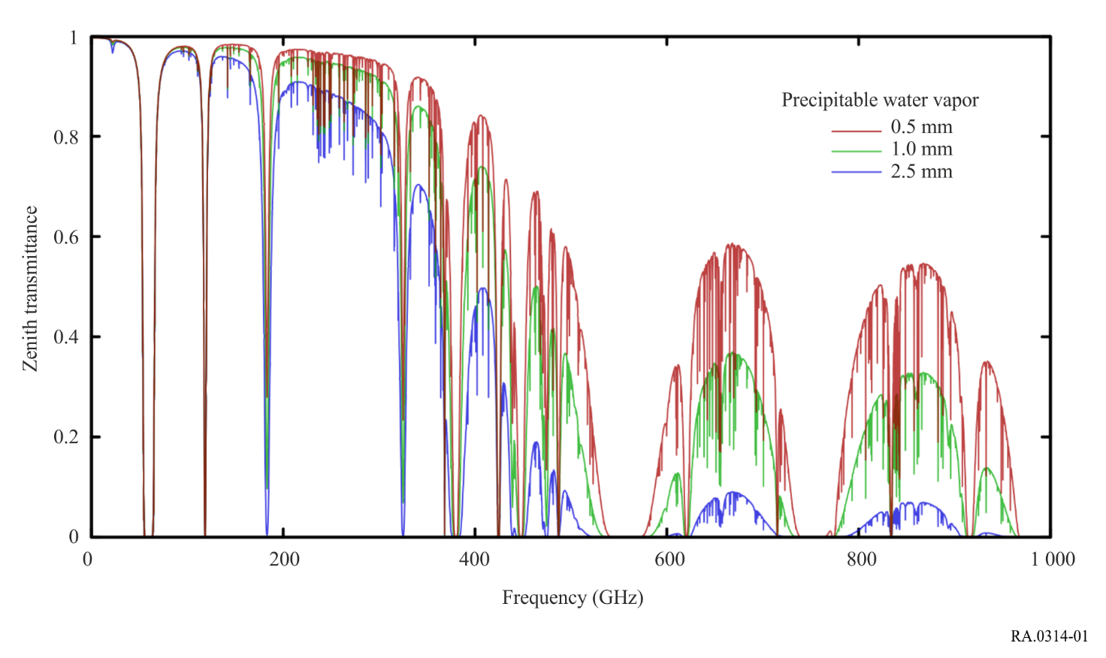
The spectral regions of high transparency are referred to as “atmospheric windows” and coincide with preferred frequency bands for Earth-based radio astronomy observations. The spectral transmittance curves shown here correspond to different values of precipitable water vapour (PWV) at a high, dry site. The three PWV values here correspond approximately to the annual quartiles at the site of the Atacama Large Millimeter/submillimeter Array.
Figure 2
Emission line spectrum illustrating the wealth of spectral lines detected in cosmic sources
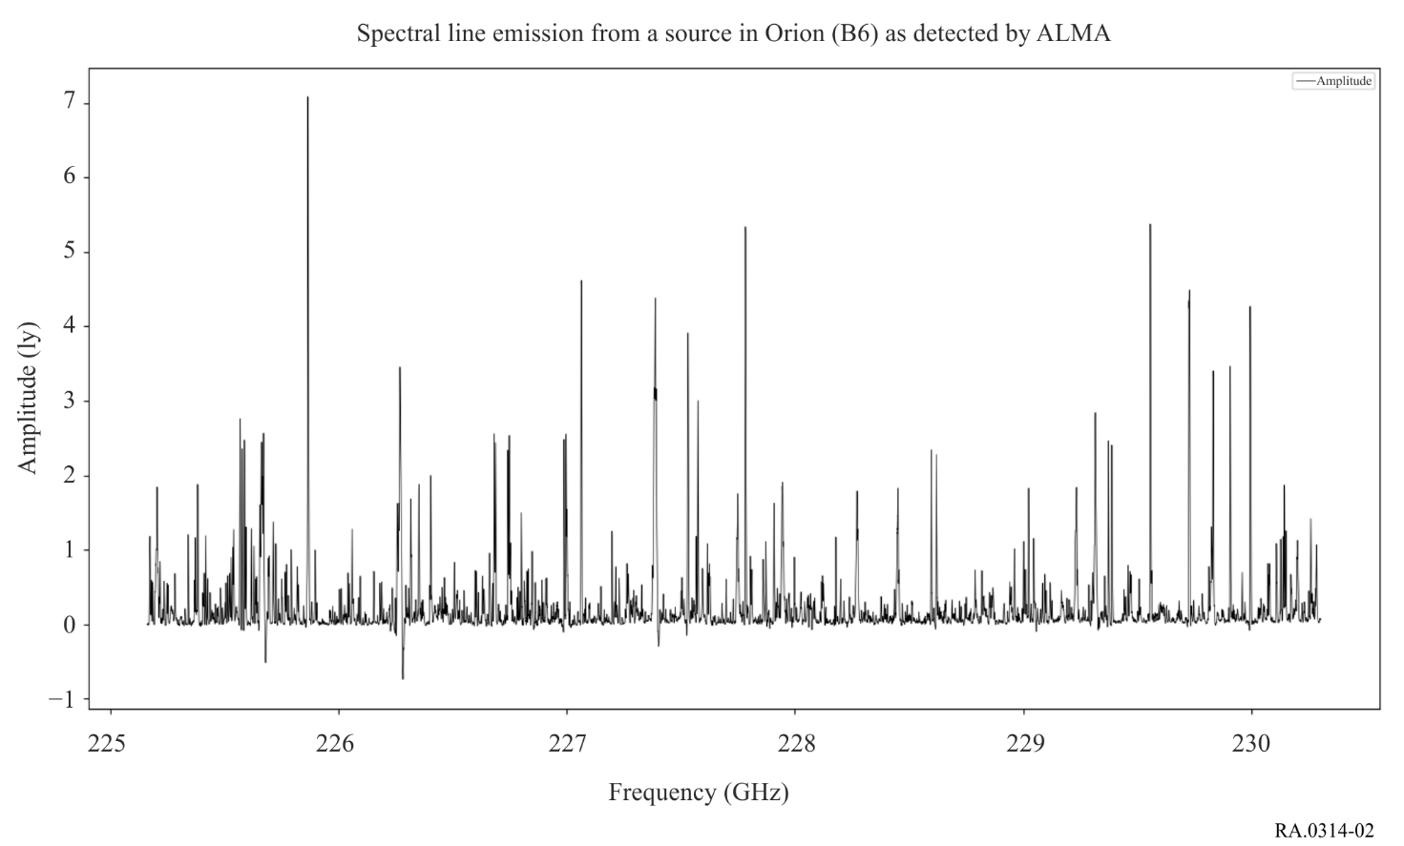
Radio astronomy observations reveal a wealth of spectral lines detected with a single observation over wide bandwidths. The intensity of each line is a function of the physical conditions of the astronomical source, including temperature and density. The spectral lines listed in Tables 1 and 2 include some of the strongest lines and some of the most astronomically interesting transitions detected from cosmic sources, but many other spectral transitions provide important information for astronomical research. Figure 2 shows a small portion of a spectrum from a source in the Orion molecular cloud in a portion of ALMA Band 6 (211-275 GHz). There is signal in nearly every channel. Each line corresponds to a molecular or atomic transition. Thousands of lines have already been observed in entire frequency region between about 10 MHz and 1 THz and above. The vertical axis is a measure of the flux-density per beam, where a jansky (Jy) is 10⁻²⁶ W m⁻² Hz¹.
Figure 3
The expansion of the universe results in an apparent Doppler shift of spectral lines for distant sources
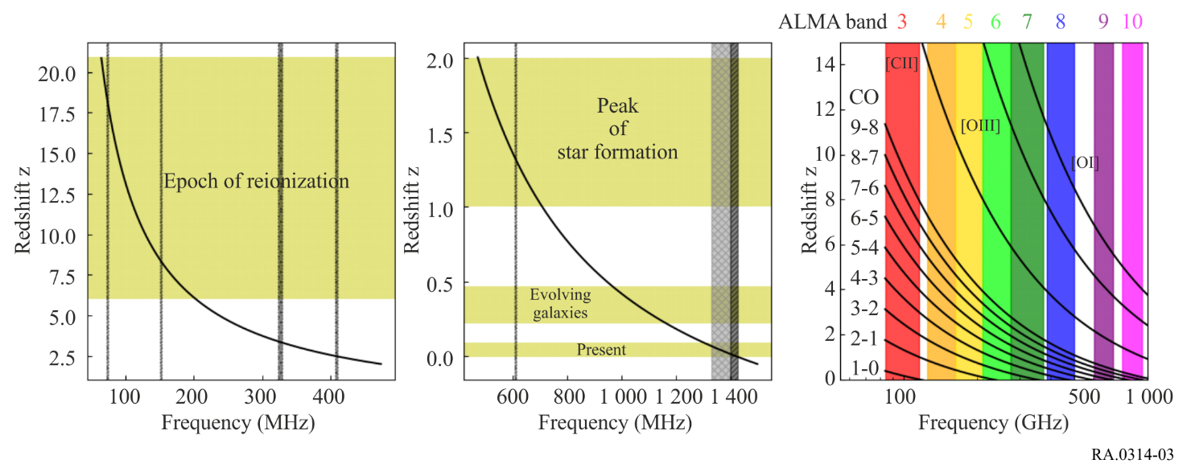
The parameter z represents the redshift and is calculated by (f_{emit} – f_{obs})/f_{obs}.
The left and middle panels of Fig. 3 illustrate redshifted frequencies of the neutral atomic hydrogen H i line. Yellow boxes highlight redshift ranges especially relevant for astronomical research (Table 4). Grey dotted ranges denote frequency bands in which RAS has a co-primary allocation in at least one Region, checked ranges denote noting in RR No. 5.149 only, hatched regions denote primary allocation and noting in RR No. 5.340. All frequencies in the left and middle panels are currently observable by radio telescopes and they will be observed in their entirety by the Square Kilometre Array, one of the largest radio telescopes built in the near future. The right panel of Fig. 3 illustrates the redshifted frequencies for selected CO rotational transitions and [CII], [OIII], and [OI] fine structure lines (note that the square brackets denote a forbidden line) listed in Tables 1 and 2 above and in Recommendation ITU-R RA.1860. The colour-shaded vertical regions indicate the frequency range of the Atacama Large Millimetre/submillimetre Array receivers (bands). Observations of multiple CO lines from the same source enable the study of the physical conditions (temperature and density) associated with the molecular clouds and star forming regions in both nearby and extremely distant objects.
Figure 4
Spectral energy distributions of the strongest known cosmic sources
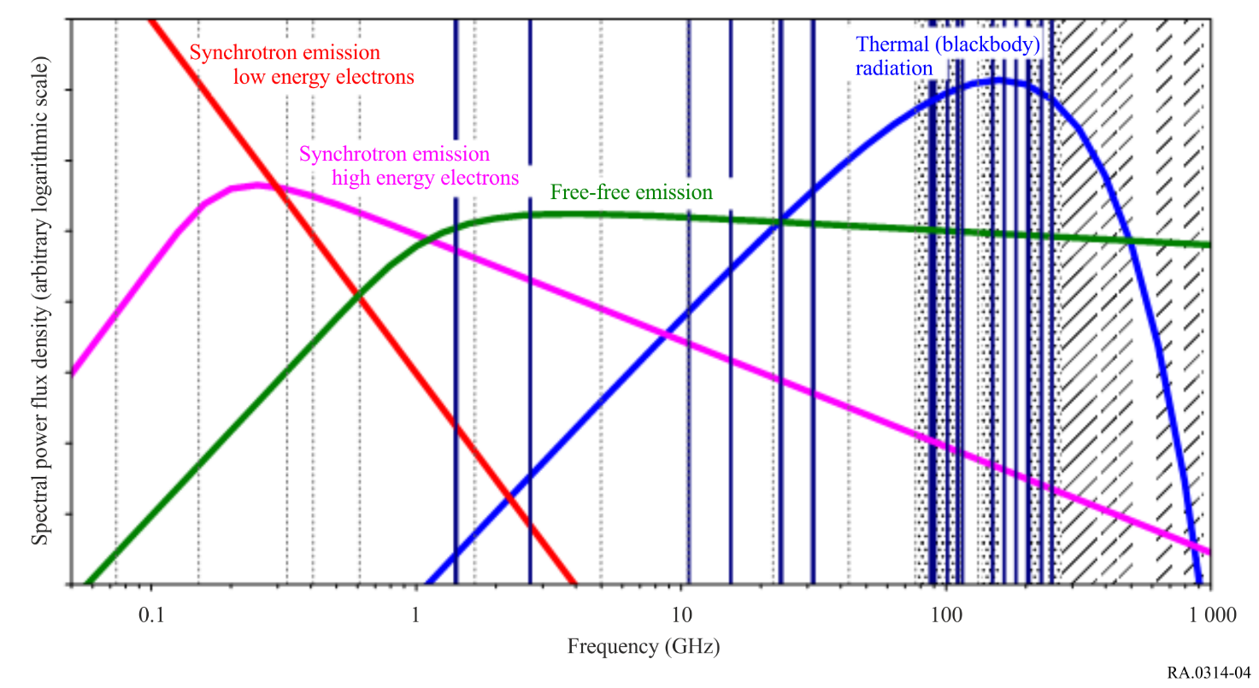
Radio astronomy observations at multiple frequencies are required to define the continuum spectrum of stars, galaxies, quasars, pulsars, and other cosmic radio sources. As illustrated in Fig. 4, the frequency bands specified in Table 3 are spaced at approximately one-octave separation in order to sample the spectral energy distribution of cosmic sources. Frequency bands allocated to the radio astronomy service on a co-primary basis for continuum observations are denoted by dotted lines in Fig. 4. Frequency bands also identified in RR No. 5.340 are denoted by solid lines. Frequency bands above 275 GHz identified for radio astronomy in RR No. 5.565 are denoted by hatched areas; these regions are appropriate for both continuum and spectral line observations. Linewidths in Fig. 4 are broader than the frequency allocations in many instances. Less than 1.7% of the radio spectrum below 11 GHz is allocated to the radio astronomy service on a co-primary basis and only 0.52% below 11 GHz is designated as ‘all emissions prohibited’ in RR No. 5.340.
Representative spectral power flux-density distributions of pulsars (synchrotron emission of low energy electrons), supernova remnants (synchrotron emission of high energy electrons), ionized gas (free-free emission), and thermal sources (blackbody radiation) are illustrated in Fig. 4. Since the observed flux-density of an astronomical object is the combination of its intrinsic luminosity and distance to the source, the y-axis of Fig. 4 is on a relative logarithmic scale. The spectrum from one astronomical source can also be a linear combination of the displayed spectra, with contributions of variable strength from the different radiation processes. Measuring the shape of the observed spectrum then allows astronomers to derive relevant physical parameters of the object. The spectral power flux-density distributions shown in Fig. 4 span four orders of magnitude, for example from −290 to −250 dB(W m⁻² Hz⁻¹). The exquisite sensitivity of radio astronomy receivers enables detection of very faint astronomical objects, at microjansky levels, where 1 jansky (Jy) is 10⁻²⁶ W m⁻² Hz⁻¹.

