RECOMMENDATION ITU-R S.1713
Methodology to calculate the minimum separation angle at the Earth’s surface
between a non-geostationary satellite in a high Earth orbit
“active” arc and a geostationary satellite
(Question ITU-R 241/4)

(2005)

The ITU Radiocommunication Assembly,
considering
a) that in the great majority of high Earth orbit (HEO) satellite system designs, the apogee for each satellite occurs at the highest latitude point in its orbit, and each satellite transmits only while it is within an “active” arc around the apogee;
b) that the key parameter to determine the worst case of interference between a HEO system and a GSO system is the minimum separation angle at which an active HEO satellite is seen by any earth station operating with a GSO satellite;
c) that for systems described in considering a) the minimum separation angle referred to in considering b) occurs whenever a satellite is at the beginning or end of the active arc (i.e. lowest latitude point in the active arc);
d) that the separation angle at which a HEO satellite is seen from an earth station varies with the latitude and longitude of that earth station and the longitude of its associated GSO satellite;
e) that the determination of the minimum separation angle between a HEO system and a GSO network would facilitate rapid preliminary assessments of the potential for a HEO system to share a band with GSO systems,
recommends
1 that the methodology described in Annex 1 may be used to compute the separation angle at which a given HEO satellite is “seen” from a given earth station operating with a given GSO satellite;
2 that Annex 2 may be used to determine the increase in noise temperature of the GSO link due to interference from the HEO satellite.
NOTE 1 – Annex 3 applies iteratively the methodologies contained in Annexes 1 and 2 to determine the minimum separation angle at which an active satellite in a given HEO system can be seen by any earth station operating to any GSO satellite, and thus calculates the worst case of increase in noise temperature of the GSO link .
NOTE 2 – Annex 4 gives examples of the application of Annexes 1 to 3.

Annex 1
Determination of minimum separation angle for
HEO interference to GSO downlink
Figure 1 is a two-dimensional illustration of the path taken by a satellite orbiting the Earth. In general this will be an elliptical orbit, where one of the two focal points is coincident with the Earth’s centre of gravity, O, and the orbit plane is inclined with respect to the Earth’s Equatorial plane. (The GSO is a special case, in which the ellipse becomes a circle in the Equatorial plane.)
figure 1
Plane geometry of an elliptical orbit
In most HEO systems a satellite in such an orbit will transmit (and receive) only while it is within a limited arc containing the apogee, A, and hence will cause (or suffer) interference only while it is within that arc, which is commonly termed the active arc. The great majority of HEO systems are designed so that the apogee is the highest latitude point within the orbit, and in such cases the maximum interference levels potentially occur when a satellite is at the beginning or the end of its active arc. The length of the active arc varies from system to system. In Fig. 1 the start of the active arc is shown as s, and the end as e. The orbit dynamics are such that the satellite travels rapidly in the region of the perigee, P, and relatively slowly in the region of the apogee. (In fact the area swept out by radius vector, r, per unit of time, i.e. r²/2δθ/δt, is constant throughout the orbit.)
Step 1: The first step here is to determine the length Os from the basic orbit characteristics.
Information normally provided to ITU-R concerning a HEO system includes the following: apogee height (AB (km)); perigee height (PL (km)); eccentricity, ε; inclination; i degrees; true anomaly of start (and end) of active arc (angle POs in Fig. 1, i.e. 180° – θº).
As an alternative to the true anomalies of s and e, the time periods for the satellite to travel from s to apogee and from apogee to e are often given, e.g. ±4 h. In such cases the value of θ may be deduced, either by setting up a time-step simulation to determine it, or by integration based on the fact that r²/2.δθ/δt is constant, but both options are relatively complex. For ITU-R studies it is usually more convenient for either the true anomaly of s (or e), or angle θ, to be given explicitly, and this is assumed here; however, the electronic version of the EXCEL spreadsheet appended to this Recommendation contains a visual basic routine to determine θ from the time before apogee at which the satellite reaches s (or the time after apogee at which the satellite reaches e).
It may be noted that the information required by RR Appendix 4 to be supplied when any filing for a non-GSO satellite system is submitted to the Radiocommunication Bureau includes the apogee and perigee heights and the eccentricity, but currently the active arc limits, which are relevant only for non-GSO systems of the HEO class, are not listed in the data to be supplied. However, for non-GSO systems (implicitly including HEOs) planned to use bands in which RR Article 22 epfd limits apply, one of the parameters required by RR Appendix 4 is the minimum height above the Earth’s surface at which any satellite in the system transmits. For a HEO satellite this is sC in Fig. 1.
From Fig. 1, using the equation of an ellipse and plane trigonometry, a quadratic equation for x in terms of AB, PL, ε and θ may be formed, and solved for x, and length Os may then be found from triangle Oms.

figure 2
Plane triangle extracts
It is unlikely that a GSO link would be designed to operate with elevation (el) lower than 5°, for which EG works out to be 41 124.624 km. el' may exceed 5°, but E'G clearly exceeds that length. Hence the condition for E to be “visible” to G is 35 786 km ≤ EG < 41 124.624 km
E is visible to s but E' is obscured from s
by the Earth. E₀ is on the contour for which s
is at 0º elevation. Then triangle OsE₀ is right-angled, and hence sE₀ = ((Os)² − (6 378)²)^{0.5}.
So the condition for E to be visible to s is
sE < ((Os)² − (6 378)²)^{0.5}.

Step 2: The next step is to find the latitude of s and its longitude relative to the simultaneous apogee longitude, which may be done using Fig. 3. This is a three-dimensional representation of the orbit, using the same symbols as in Fig. 1 – so Os is as calculated in Step 1. By applying the spherical Cosine Rule to spherical triangles OBCD and CODF in Fig. 3, and then applying the spherical Sine Rule to spherical triangle ONBC, it may be deduced that the longitude of s relative to A (α_{C}) and its latitude (λ_{C}) are given by:
$$α_{C} = −∠\text{FOD} = −{\text{tan}}^{−1}[\text{tan}(θ)/{\text{cos}}(i)] \text{and} λ = ∠\text{FOC} = {\text{cos}}^{−1}[\text{sin}(θ)/{\text{sin}}(α_{c})]$$
Step 3: Having found the latitude and instantaneous relative longitude of s, the corresponding interference separation angle (ϕ) at any earth station, E, operating to any geostationary satellite, G, may be calculated using Fig. 4, in which points C, O, F, N and s are identical to those in Fig. 3. Thus in Fig. 4 the latitude of E is λ_{E} and its longitude relative to the longitude of A is α_{E}, and the longitude of G relative to the longitude of A is α_{G}. Then, since α_{C}, α_{E}, λ_{C}, λ_{E}, α_{G}, OE (Earth’s radius), OG (GSO radius) and Os are known or have been calculated,
– by applying the spherical Cosine Rule to spherical triangle ONCE, and then applying the plane Cosine Rule to plane triangle OsE, the length sE may be calculated;
– by applying the spherical Cosine Rule to spherical triangle OCFJ, and then applying the plane Cosine Rule to plane triangle OsG, the length sG may be calculated; and
– by applying the spherical Cosine Rule to spherical triangle OEJK, and then applying the plane Cosine Rule to plane triangle OEG, the length EG may be calculated.
And finally in plane triangle EsG, since the three sides sE, sG and EG have now been calculated, the angle ϕ may be found by using the plane Cosine Rule.
Thus, by employing this procedure, the interference separation angle, ϕ, may be calculated for any GSO downlink (i.e. for an earth station in any geographical location receiving from a GSO satellite on any longitude), if the HEO inclination angle, apogee height, perigee height, eccentricity, and either the true anomaly or the time relative to apogee of the start (or end) of the active arc are known.
To find the minimum value of ϕ a simple computer program may be written to cycle through a range of combinations of α_{E}, λ_{E} and α_{G}, employing the above procedure to calculate ϕ for each combination, and then select the lowest value. Since interference can occur only for combinations of α_{E}, λ_{E} and α_{G} for which E is visible to both G and s (see Fig. 4), but all such combinations must be investigated, it is convenient to arrange for the simple program to include wide ranges of the three variables and then to exclude from the reckoning any combinations where E is obscured by the Earth from either G or s or both G and s. This is illustrated in the following plane triangle extracts from Fig. 4.

Annex 2
Calculation of increase in GSO link noise due to interference from a HEO satellite at the start of its active arc
From Fig. 4 it can be seen that interference from a HEO satellite at s to the link between a geostationary satellite at G and an earth station at E will enter that earth station’s receiver via a side lobe of its antenna pattern. The corresponding increase in noise temperature of the GSO link is given by:
$$\text{10} \text{log}(({ΔT}/T)/{\text{100}}) = E_{1}−\text{20} \text{log}(4 π d/λ)+G(ϕ)−\text{10} \text{log}(k T) \text{dB}$$
where:
ΔT/T: link noise increase expressed as a percentage
E₁: e.i.r.p. density of carrier transmitted by HEO satellite (dB(W/Hz))
d: length of interference path sE (m)
λ: wavelength (m) = (0.3)/f where f is the HEO carrier frequency (GHz)
G(ϕ): receive gain of earth station antenna at frequency f and at off-axis angle ϕ (dBi)
T: noise temperature of GSO link (K)
k: Boltzmann’s constant, i.e. 10log(k) = −228.6 dB(W/Hz/K).
T may be either the noise temperature of the GSO downlink alone, or the GSO system noise temperature referred to the earth station receiver input, depending on how it is preferred to express ΔT/T.
For the calculation of G(ϕ), since the methodology in this Annex relates to interference between non-GSO and GSO systems it is appropriate to employ the gain patterns prescribed in Recommendation ITU-R S.1428, where G(ϕ) is expressed in terms of D/λ and D is the antenna diameter (m).

Annex 3
Iterative implementation of the methodology in Annex 1
In the attachment the procedure developed in Annex 1 is implemented in an EXCEL spreadsheet, which contains Visual Basic routines to cycle through all combinations of earth station latitude and longitude and GSO satellite longitude for which both the GSO satellite and the start of a HEO system active arc are simultaneously visible, and thus identify the minimum separation angle at any earth station for which mutual interference could occur. For the convenience of the user the simple steps described in Annex 2 are incorporated into the spreadsheet to provide an output giving the maximum value of ΔT/T due to that interference if required. As is evident from the examples in Annex 4, the spreadsheet covers all types of orbit in which a limited active arc is employed, provided that the arc does not intersect any line between the GSO and the Earth’s surface at latitude ±81.3°.
The only input data required are the following parameters of the HEO system:
– height of apogee (km);
– height of perigee (km);
– eccentricity (as a decimal fraction);
– orbit inclination angle (degrees);
– one (or more) of three parameters to define the start s (or end "e") of the active arc, i.e.:
– either geocentric angle between s and apogee (degrees),
– or time taken for a satellite to move between s and apogee (h),
– or height of s (km).
If the user wishes the corresponding value of ΔT/T to be calculated the following additional input parameters are needed:
– maximum HEO satellite e.i.r.p. density (dB(W/Hz));
and the following parameters of the GSO link:
– diameter (m) of the antenna in the earth station of the GSO link;
– receive gain pattern of the antenna in the earth station of the GSO link (dBi vs. angle off-axis);
– noise temperature of GSO link (K);
– frequency (GHz).

Annex 4
Examples of application of the methodology
In its 2nd to 8th rows, Table 1 below lists the orbital characteristics of 12 different designs of HEO systems compiled from information contributed to ITU-R. To illustrate such systems their types of Earth tracks are compared in Figs. 5 to 7. The 11th row of Table 1 gives the apogee longitudes used in preparing Figs. 5 to 7; these apogee longitudes have been selected solely for convenience of illustration and no other significance is intended here.
TABLE 1
1. HEO system | 1 | 2 | 3 | 4 | 5 | 6 | 7 | 8 | 9 | 10 | 11 | 12
2. Apogee height (km) | 35 970 | 44 640.5 | 39 000 | 35 800 | 52 700 | 40 000 | 50 400 | 27 288.3 | 20 180 | 34 800 | 39 300 | 27 470
3. Perigee height (km) | 4 500 | 26 931.5 | 500 | 35 800 | 18 900 | 31 600 | 21 200 | 517.4 | 20 180 | 20 600 | 1 075 | 310
4. Orbit eccentricity | 0.59 | 0.21 | 0.74 | 0 | 0.4 | 0.1 | 0.347 | 0.66 | 0 | 0.55 | 0.72 | 0.67
5. Orbit inclination (degrees) | 50 | 42.5 | 63.43 | 63.4 | 60 | 40 | 63.4 | 63.435 | 63.4 | 45 | 63.4 | 45
6. Angle of s with respect to the apogee (degrees) | 35 | 31 | (29.5) | 60 | (30) | 37 | (24) | 40 | (30) | (32.3) | 25 | (28)
7. Time of s with respect to the apogee (h) | (−3.13) | (−3) | −3.5 | (−4) | −4 | (−2.95) | −3 | (−2.55) | −1 | −4 | (−3.06) | −2
8. Height of s (km) | (27 200) | (42 800) | (26 900) | N/A | (48 000) | (39 000) | (47 900) | (16 500) | N/A | (30 850) | (30 700) | (21 400)
9. Minimum separation angle  (degrees) | 39.85 | 35.84 | 52.50 | 26.94 | 49.35 | 31.34 | 55.49 | 40.05 | 51.84 | 37.63 | 55.51 | 37.98
10. Check using simulation (degrees) | (39.78) | (35.78) | (52.50) | (26.86) | (49.25) | (31.40) | (55.47) | (40.91) | (51.86) | (37.47) | (55.49) | (37.26)
11. Apogee longitude (degrees E) | −150 | −108 | −62 | −43 | −130 | −38 | −110 | −83 | −30 | −18 | 27 | 57
12. Earth station longitude (degrees E) | −97.63 | −110.81 | 14.89 | 17.33 | −43.32 | 38.65 | −34.89 | −75.38 | −35.33 | 76.7 | 101.86 | 82.72
13. Earth station latitude (degrees N) | 73.63 | −46.70 | 2.58 | −7.73 | −3.15 | −5.44 | −2.01 | 73.63 | 73.63 | −0.86 | 1.43 | 73.63
14. GSO satellite longitude (degrees E) | −130.29 | −102.22 | −61.32 | −58.88 | −119.52 | −37.55 | −111.09 | −108.04 | −67.99 | 0.50 | 25.66 | 50.06
15. Example ΔT/T (%)⁽¹⁾ | 0.204 | 0.072 | 0.150 | 0.200 | 0.058 | 0.108 | 0.058 | 0.572 | 0.386 | 0.128 | 0.122 | 0.312
(¹⁾ Values calculated via Annex 2 for E₁ = −21 dB(W/Hz), D = 3 m, T = 100 K, f = 11 GHz and G(ϕ) from Recommendation ITU-R S.1428-1.
N/A: not available.

The 6th, 7th and 8th rows are different ways of stating the start (or end) of the active arc. In these three rows the unbracketed values are those contributed to ITU-R; the bracketed values were obtained from computer simulation of each of the systems, pausing each run at the unbracketed value and noting the two corresponding bracketed values. The results in the 9th row were determined from Annex 3 using the unbracketed values to determine the start of the active arc. (When the bracketed values were used in Annex 3 the results were marginally different, but the differences were within the accuracy of the computations performed.) A check on each result was performed via computer simulation, yielding the minimum separation angles shown in italics in the 10th row; as can be seen, these are in close accord with the values in the 9th row and thus confirm the validity of Annex 3.
Additionally, based on the apogee longitudes in the 11th row, the combination of earth station and GSO satellite locations for which the minimum off-axis angle would occur in each case was obtained using Annex 3, and these are given in the 12th, 13th and 14th rows of Table 1.

Figure 5
Parts of Earth tracks of HEO systems 1 to 4, showing active arcs (i.e above – –)
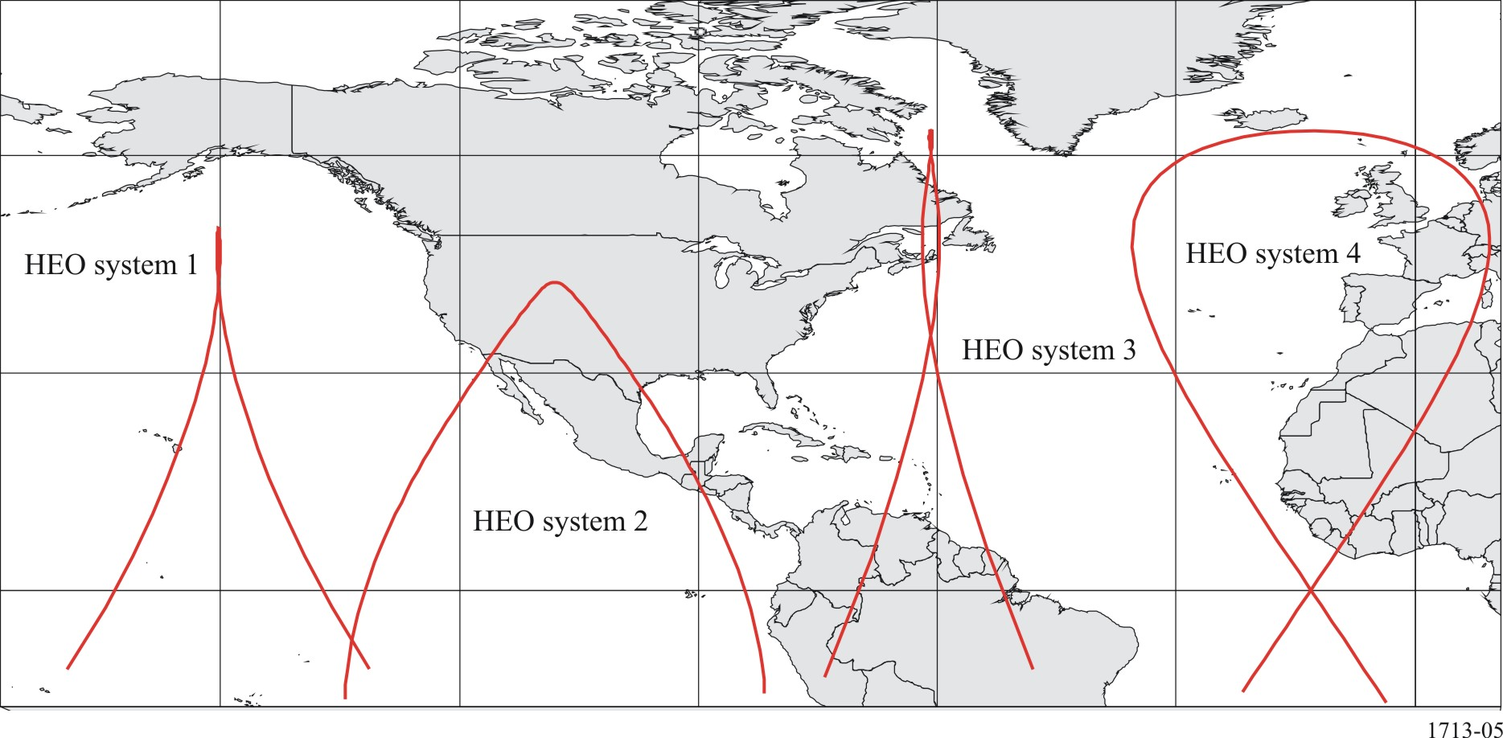

Figure 6
Parts of Earth tracks of HEO systems 5 to 8, showing active arcs
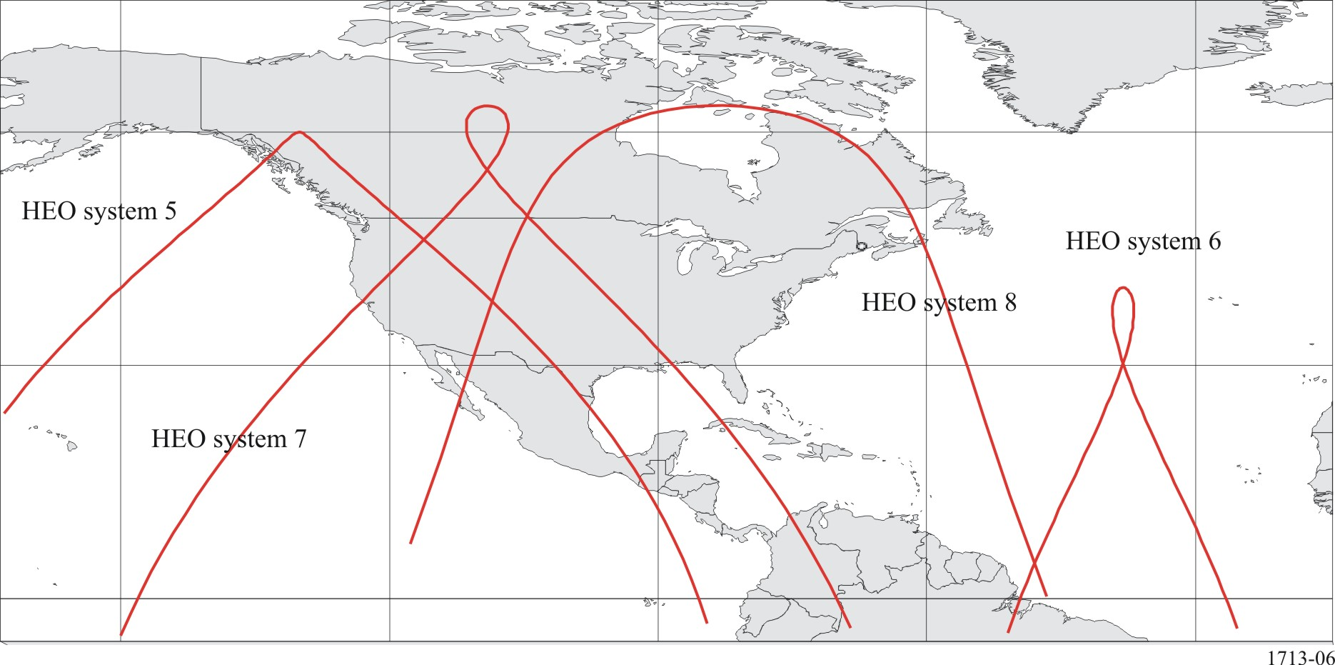
Figure 7
Parts of Earth tracks of HEO systems 9 to 12, showing active arcs
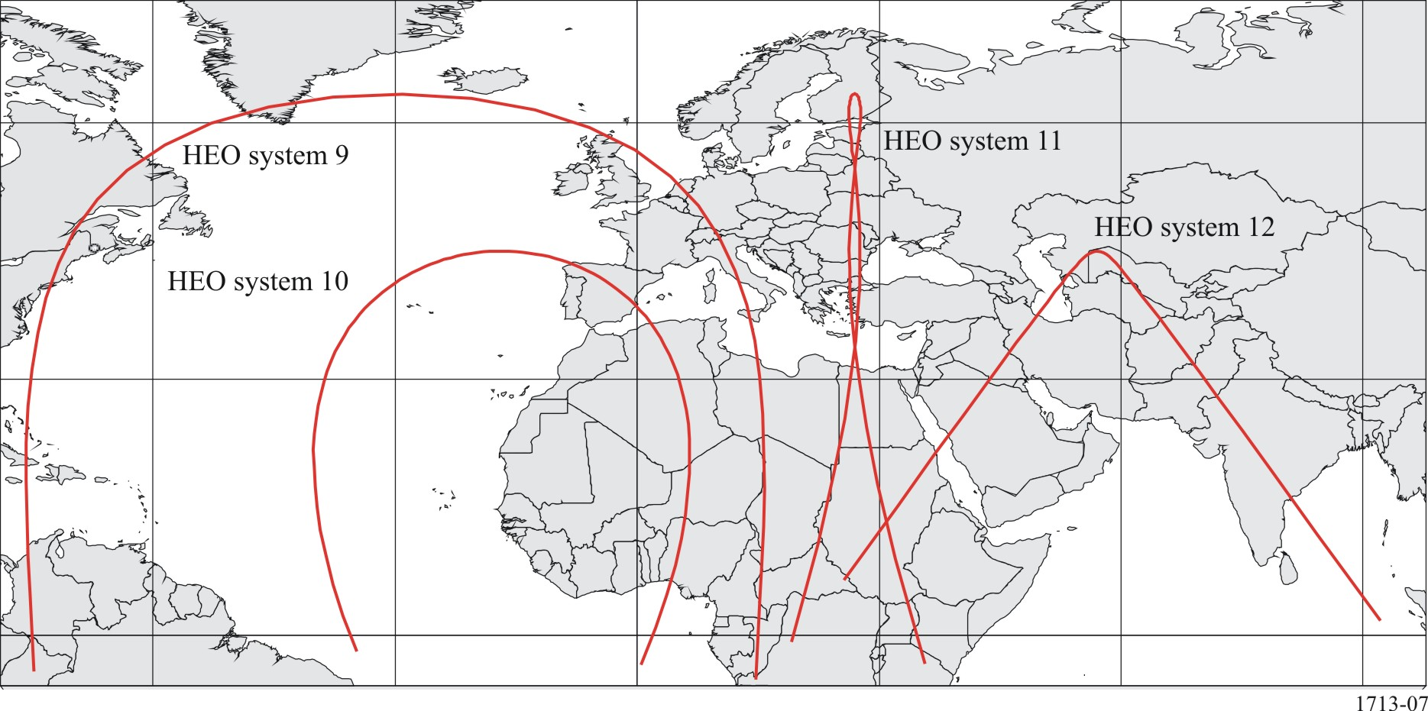
Finally, the availability of Annex 3 provides a means to verify the truth of considering c) in example cases. This was done for systems 1, 4 and 8 with the aim of broadly spanning the system types, by finding the minimum off-axis (or separation) angle for progressively reduced values of the geocentric angle, θ, between a HEO satellite and apogee. The results are shown graphically in Fig. 8.

figure 8
Variation of minimum off-axis angle with HEO satellite distance from apogee
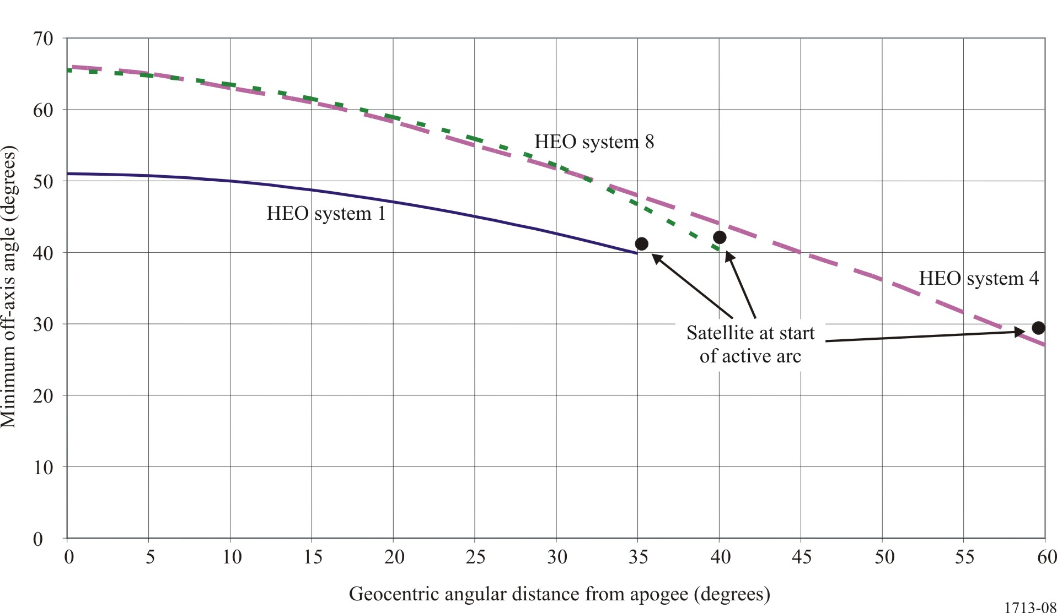
Figure 8 clearly demonstrates that, for typical HEO systems, the further a satellite is from the apogee of its orbit the smaller is the minimum off-axis angle at which it is seen by earth stations operating to geostationary satellites.

The attachment includes an additional Visual Basic routine in order to make use of this item of data, if it is entered. In that case, not only is the minimum separation angle calculated, but the absolute locations of earth station and GSO satellite for which that angle obtains are also calculated, provided that the longitude of the HEO apogee is entered as an additional input. See associated EXCEL file labelled “MinseparationHEOangle”.

