|  |
| --- |
| **Recommendation ITU-R SA.1016-1**  **(08/2019)** |
| **Sharing considerations relating to space research service (deep space)** |
| **SA Series**  **Space applications and meteorology** |

Foreword

The role of the Radiocommunication Sector is to ensure the rational, equitable, efficient and economical use of the radio-frequency spectrum by all radiocommunication services, including satellite services, and carry out studies without limit of frequency range on the basis of which Recommendations are adopted.

The regulatory and policy functions of the Radiocommunication Sector are performed by World and Regional Radiocommunication Conferences and Radiocommunication Assemblies supported by Study Groups.

# Policy on Intellectual Property Right (IPR)

ITU-R policy on IPR is described in the Common Patent Policy for ITU-T/ITU-R/ISO/IEC referenced in Resolution ITU‑R 1. Forms to be used for the submission of patent statements and licensing declarations by patent holders are available from <http://www.itu.int/ITU-R/go/patents/en> where the Guidelines for Implementation of the Common Patent Policy for ITU‑T/ITU‑R/ISO/IEC and the ITU-R patent information database can also be found.

|  |  |
| --- | --- |
| Series of ITU-R Recommendations  (Also available online at <http://www.itu.int/publ/R-REC/en>) | |
| **Series** | Title |
| **BO** | Satellite delivery |
| **BR** | Recording for production, archival and play-out; film for television |
| **BS** | Broadcasting service (sound) |
| **BT** | Broadcasting service (television) |
| **F** | Fixed service |
| **M** | Mobile, radiodetermination, amateur and related satellite services |
| **P** | Radiowave propagation |
| **RA** | Radio astronomy |
| **RS** | Remote sensing systems |
| **S** | Fixed-satellite service |
| **SA** | **Space applications and meteorology** |
| **SF** | Frequency sharing and coordination between fixed-satellite and fixed service systems |
| **SM** | Spectrum management |
| **SNG** | Satellite news gathering |
| **TF** | Time signals and frequency standards emissions |
| **V** | Vocabulary and related subjects |

|  |
| --- |
|  |

|  |
| --- |
| ***Note***: *This ITU-R Recommendation was approved in English under the procedure detailed in Resolution ITU-R 1.* |

*Electronic Publication*

Geneva, 2019

© ITU 2019

All rights reserved. No part of this publication may be reproduced, by any means whatsoever, without written permission of ITU.

RECOMMENDATION ITU-R SA.1016-1[1]*

Sharing considerations relating to space research service (deep space)

(1994-2019)

Scope

This Recommendation gives the frequency sharing considerations relating to space research service (deep space) in the 2 110-2 120 MHz, 2 290-2 300 MHz, 7 145-7 190 MHz, 8 400-8 450 MHz, 31.8-32.3 GHz and 34.2-34.7 GHz bands.

Keywords

Frequency sharing, deep space, SRS earth stations, SRS space stations

Relevant ITU-R Recommendations and Reports

Recommendations ITU-R SA.509, ITU-R SA.684, ITU-R SA.1014, ITU-R SA.1015, ITU‑R SA.1157

Report ITU-R SA.2066

The ITU Radiocommunication Assembly,

considering

*a)* that the feasibility of frequency sharing between stations of space research service (deep space) and stations of other services is presented in Annex 1 and Annex 2;

*b)* that earth stations of space research service (deep space) can cause harmful interference to receiving aeronautical mobile stations, receiving space stations, and receiving microwave sensor stations that come within line-of-sight;

*c)* that earth stations of space research service (deep space) can cause harmful interference to receiving mobile stations that are not separated sufficiently;

*d)* that high power transmissions from terrestrial stations can interfere with the space stations of space research service (deep space), especially during the near-Earth operations of space stations;

*e)* that earth stations of space research service (deep space) can receive harmful interference from transmitting aeronautical mobile stations, transmitting space stations, and active microwave sensor stations that come within line-of-sight;

*f)* that earth stations of space research service (deep space) can receive harmful interference from transmitting mobile stations that are not separated sufficiently;

*g)* that space stations of space research service (deep space) can adversely affect stations of radio astronomy service,

recommends

**1** that, with successful operational coordination, space research service (deep space) should be able to share frequency bands in the Earth-to-space direction with stations in the services already allocated in the same band, except the following stations for which sharing is not feasible:

– receiving aeronautical mobile stations, receiving space stations, and microwave sensor satellites, when any of these may come within line-of-sight;

– receiving mobile stations that come within the separation distance required for interference protection;

– transmitting terrestrial stations having an average e.i.r.p. exceeding 82 dBW in the bands near 2 GHz, 85 dBW in the bands near 7 GHz, and 84 dBW in the bands near 34 GHz (see Note 1);

**2** that, with successful operational coordination, space research service (deep space) should be able to share frequency bands in the space-to-Earth direction with stations in the services already allocated in the same band, except the following stations for which sharing is not feasible:

– transmitting aeronautical mobile stations, transmitting space stations, and active microwave sensor satellites, when any of these may come within line-of-sight;

– transmitting mobile stations that come within the separation distance required for interference protection;

– the radio astronomy service;

**3** that the following Note should be regarded as part of this Recommendation.

NOTE – For transmitters in the fixed and mobile services, Article **21** of ITU Radio Regulations specifies much lower e.i.r.p. limits.

Annex 1  
  
Sharing considerations relating to space research service (deep space)

# 1 Sharing considerations in the frequency bands allocated to the space research service (deep space) in the Earth-to-space direction

The ITU Radio Regulations (RR) identifies the frequency bands 2 110‑2 120 MHz, 7 145‑7 190 MHz, and 34.2–34.7 GHz for use by the space research service (deep space) in the Earth-to-space direction. In addition, the frequency band 16.6–17.1 GHz is identified as a secondary allocation for use by space research service (deep space). Table 1 and the following subsections consider the possibility of interference to the space research service (deep space) in these frequency bands.

TABLE 1

Potential interference in Earth-to-space bands

|  |  |
| --- | --- |
| Source | Receiver |
| Deep space earth station | Terrestrial or earth station |
| Deep space earth station | Earth orbiting satellite |
| Terrestrial or earth station | Deep space station |
| Near-earth station | Deep space station |

## 1.1 Potential interference to terrestrial/aircraft receivers or earth station receivers from deep space earth station transmitters

The normal total transmitter power for current deep space earth stations is 43 dBW in 2 GHz and 7 GHz bands, and 30 dBW in 34 GHz band (see Recommendation ITU-R SA. 1014). For a minimum elevation angle of 10 degrees, the e.i.r.p. directed towards the horizon does not exceed 50 dB (W/4 kHz) in 2 GHz and 7 GHz bands, and 37 dB (W/4 kHz) in 34 GHz band, assuming the reference earth station antenna radiation pattern of Recommendation ITU-R SA. 509. Thus the e.i.r.p. towards the horizon meets the requirements of Nos. **21.10** and **21.11** of the RR. For higher SRS earth station transmitting powers, the elevation angles need to be increased accordingly to meet the Radio Regulations e.i.r.p. limits towards the horizon.

Aircraft stations within line-of-sight of a deep space earth station may encounter total power flux-densities as shown below in Fig. 1. For an aircraft altitude of 12 km, the maximum line-of-sight distance to an earth station is 391 km. In this case, assuming 100 kW earth station transmit power and −10 dBi transmit antenna gain (Recommendation ITU-R SA. 509), the total power flux-density (pfd) at the aircraft can never be lower than −83 dB (W/m2). As the separation distance and earth station antenna direction change, the aircraft station may experience much higher pfd and interference levels. Therefore, coordination with airborne stations is generally not practicable.

Figure 1

Power flux-density versus distance from SRS earth station

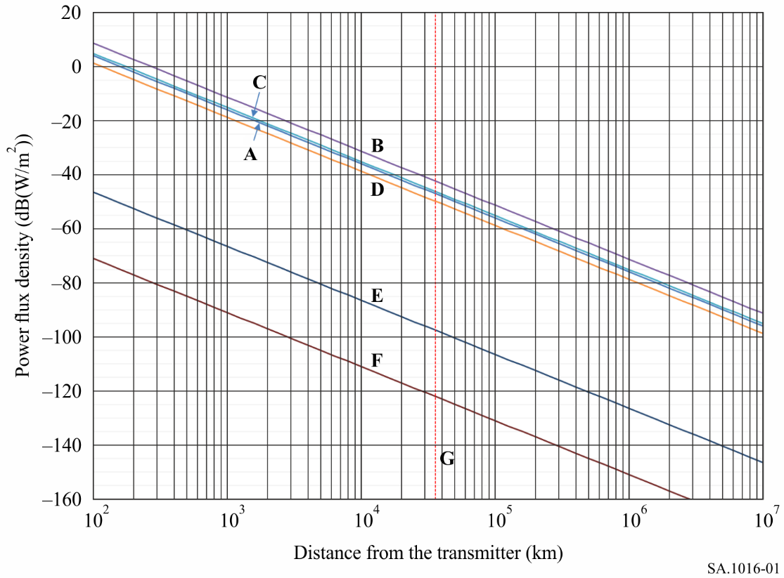

Transmitter: Deep space earth station, 70 m diameter antenna

A: main beam, 34.5 GHz, 1 kW

B: main beam, 17 GHz, 10 kW

C: main beam, 7 170 MHz, 20 kW

D: main beam, 2 115 MHz, 100 kW

E: 5 deg off-axis (14.5 dBi gain, Rec. ITU-R SA.509), 2 115 MHz, 100 kW

F: > 48 deg off-axis (–10 dBi gain, Rec. ITU-R SA.509), 2 115 MHz, 100 kW

G: geostationary orbit altitude: 35 800 km

Furthermore, propagation mechanisms of super refraction, ducting, and precipitation scatter may couple emissions from deep space earth station transmitters into terrestrial receivers and into receivers of other earth stations. However, except for airborne terrestrial receivers, coordination for these cases is generally practicable. See § 2.3 for discussion of interference from airborne transmitters, and see § 3 for coordination considerations.

## 1.2 Potential interference to satellite receivers from deep space earth station transmitters

Satellites that come within the deep space earth station beam will encounter pfd as shown in Fig. 1. When the earth station is tracking a spacecraft whose direction is such that the antenna beam passes through the geostationary satellite orbit (GSO), the pfd at that point on the orbit will vary with time as shown in Fig. 2. For example, the total pfd will be −95 dB (W/m2) or higher for 32 minutes. The Figure assumes a transmitter power of 50 dBW, a 70-m antenna, and the reference earth station antenna pattern of Recommendation ITU‑R SA.509. An important observation is that the minimum pfd at the GSO within line-of-sight of a deep space earth station is at least −122 dB (W/m2), regardless of antenna pointing direction.

Figure 2

Time duration which the pfd at a point on the geostationary  
satellite orbit may exceed a minimum pfd

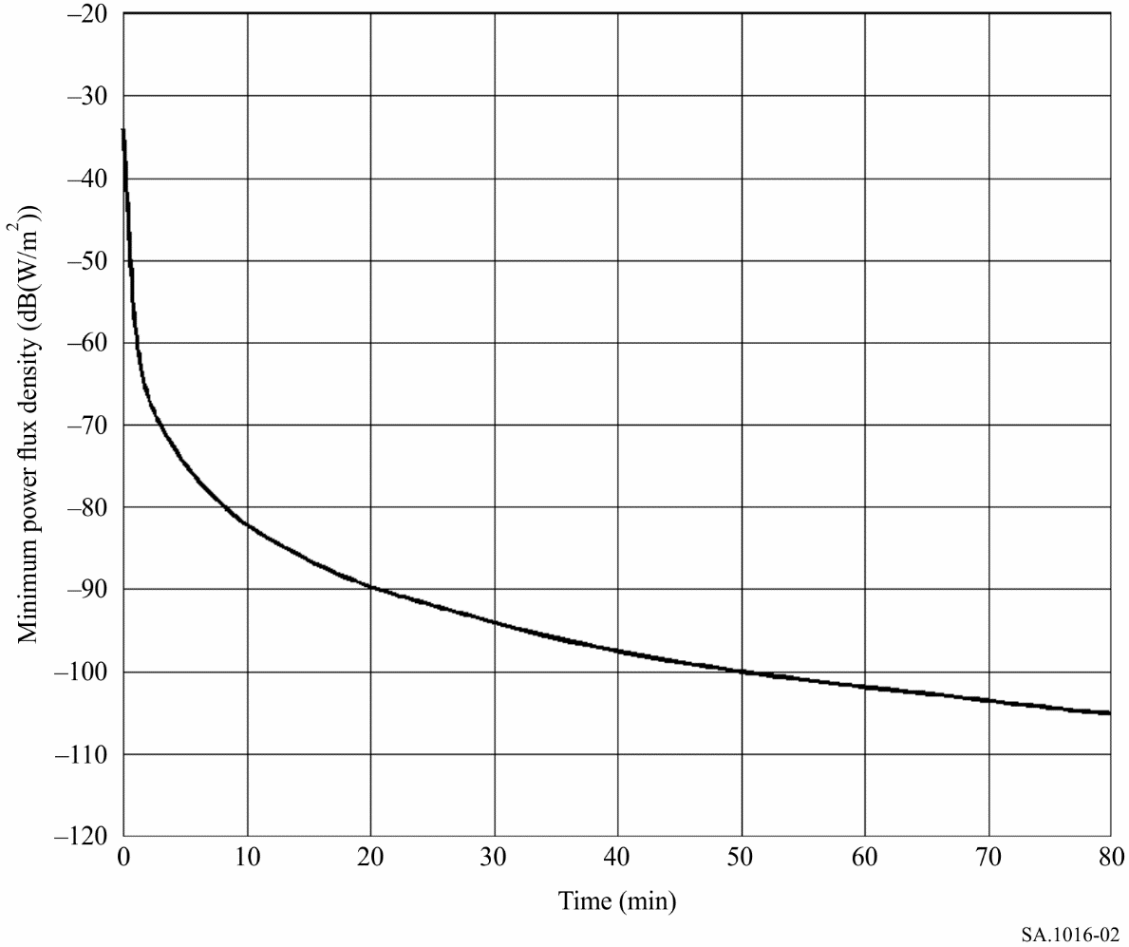

Transmitter: Deep space earth station, 100 kW, 70 m diameter antenna, 34.5 GHz

Additionally, the duration and magnitude of signals from deep space earth station transmitters, which may interfere with satellites in non-geostationary orbits, depends upon those orbits and the direction in which the earth station antenna is pointing.

## 1.3 Potential interference to deep space station receivers from terrestrial transmitters or earth station transmitters

Terrestrial transmitters or earth station transmitters within sight of a deep space station are potential sources of interference. Figure 3 shows the space station distance at which the interference power density from such a transmitter equals the receiver noise power density.

Figure 3

Spacecraft distance from terrestrial transmitter for interference power equal to receiver noise power

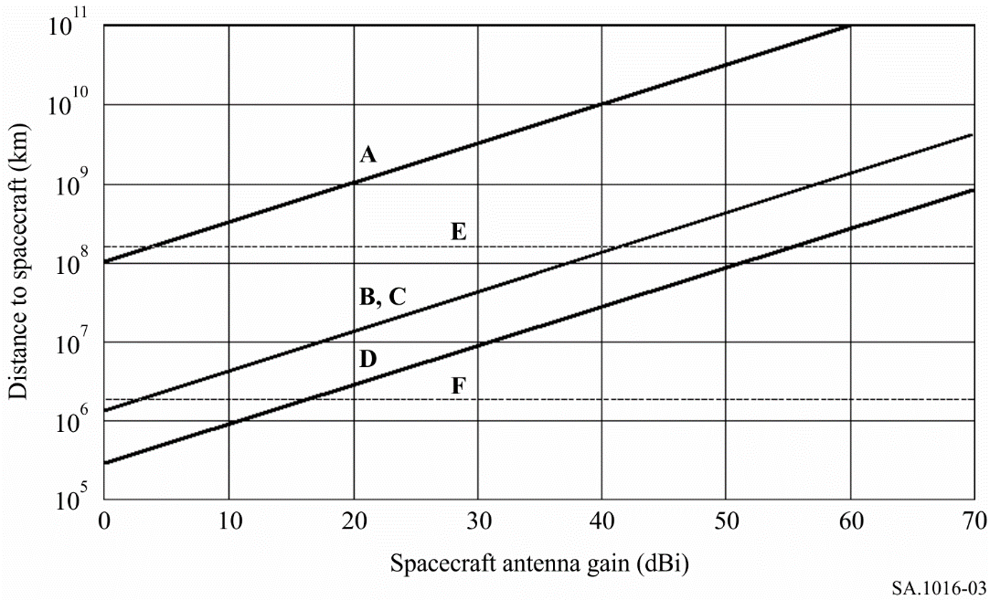

A: trans-horizon transmitter: 2 115 MHz e.i.r.p.: 93 dB (W/10 kHz) receiver noise power: −191 dB (W/20 Hz)

B: radiolocation transmitter: 34.5 GHz e.i.r.p.: 48.8 dB (W/Hz) receiver noise power: −182.6 dB (W/20 Hz)

C: radiolocation transmitter: 17 GHz e.i.r.p.: 40.9 dB (W/Hz) receiver noise power: −186 dB (W/20 Hz)

D: radio-relay transmitter: 7 170 MHz e.i.r.p.: 55 dB (W/10 kHz) receiver noise power: −189 dB (W/20 kHz)

E: 1 AU = 1.5 × 108 km

F: inner boundary of deep space: 2 × 106 km

For example, a trans-horizon station with 93 dB (W/10 kHz) e.i.r.p. in the 2.1 GHz band could interfere with a space station receiver at ranges up to 4.1 × 109 km (600 K noise temperature, 3.7 m spacecraft antenna). The possibility of interference at such a great distance poses a threat to space missions to planets as far away as Uranus. Stations with lower e.i.r.p., or with antennas pointing away from the ecliptic plane, have less potential for interference.

## 1.4 Potential interference to deep space station receivers from Earth orbiting satellite transmitters

Earth orbiting satellites typically have antennas directed to the Earth or to other satellites. Interference with deep space station receivers may occur for those brief periods when the satellite antenna is directed to permit main beam coupling. As received at deep space stations, signals from satellites will almost always be weaker than those from earth stations.

# 2 Sharing considerations: space-to-Earth bands

The Radio Regulations identifies the frequency bands 2 290-2 300 MHz, 8 400‑8 450 MHz, and 31.8‑32.3 GHz for use by the space research service (deep space) in the space-to-Earth direction. In addition, the frequency band 37‑38 GHz is identified for use by space research service without restricting it to deep space or near-Earth, and 12.75-13.25 GHz is identified as a secondary allocation for use by space research service (deep space). Table 2 and the following subsections consider the possibility of interference to the space research service (deep space) in these frequency bands.

TABLE 2

Potential interference in space-to-Earth bands

|  |  |
| --- | --- |
| Source | Receiver |
| Deep space station | Terrestrial or earth station |
| Deep space station | Earth orbiting satellite |
| Terrestrial or earth station | Deep space earth station |
| Earth orbiting satellite | Deep space earth station |

## 2.1 Potential interference to terrestrial or earth station receivers from deep space station transmitters

Figure 4 shows the pfd at the surface of the Earth caused by typical deep space stations. These stations often use low gain, wide beam antennas while near Earth. As such, within six hours after launch, they are usually at a sufficient distance for the pfd at the surface of the Earth to be less than the maximum permitted by the Radio Regulations for protection of line‑of-sight radio-relay systems.

Figure 4

Power flux-density at the surface of the Earth versus spacecraft distance

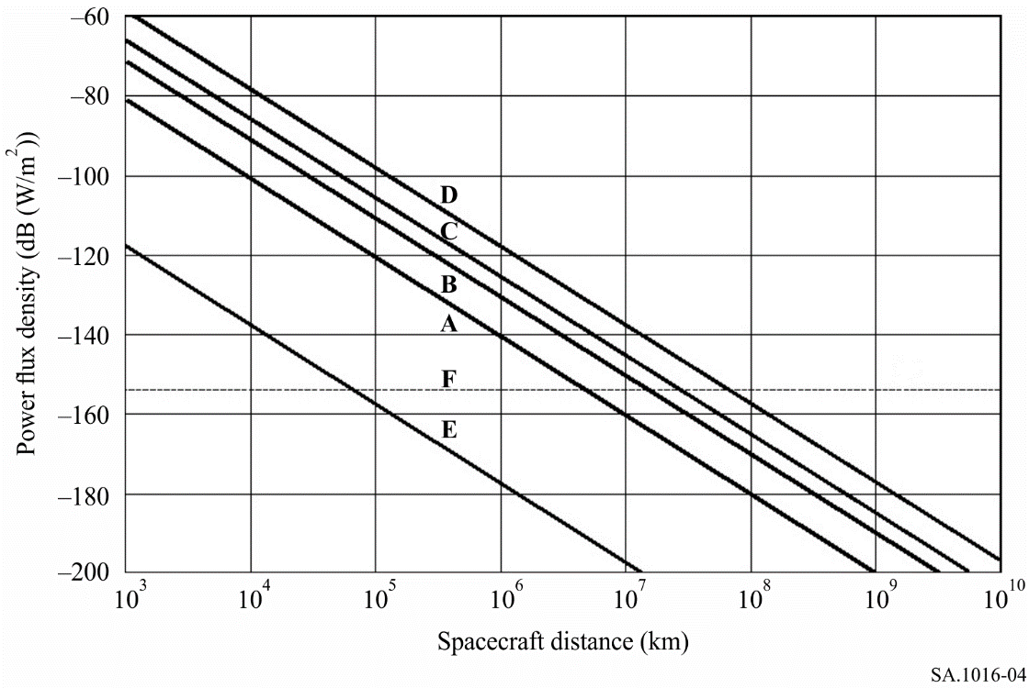

A: 13 dBW transmitter, 37 dBi antenna gain, 2 295 MHz

B: 13 dBW transmitter, 48 dBi antenna gain, 8 425 MHz

C: 13 dBW transmitter, 52 dBi antenna gain, 13 GHz

D: 13 dBW transmitter, 60 dBi antenna gain, 32 GHz

E: 13 dBW transmitter, 0 dBi antenna gain

F: −154 dB (W/m2) power flux-density, 2-GHz band, RR No. **21.16** (Table **21-4**)

Note: According to RR Table **21-4**, the pfd limits are −154 dB (W/m2) in 2.2-2.3 GHz band,   
−150 dB (W/m2) at 8.4-8.5 GHz band, −120 dB (W/m2) at 31.8-32.5 GHz band and 37-38 GHz band for non-GSO space research satellites, and −125 dB (W/m2) at 37-38 GHz band for GSO space research satellites.

When the transmitting space station is using a higher gain directional antenna, there is the potential for interference with sensitive terrestrial receivers if their antennas are directed to permit main beam coupling. A space station operating at 2.3 GHz with an e.i.r.p. of 51 dBW at a distance of 5 × 108 km could create an input of −168 dBW to a trans-horizon receiver (27 m antenna, main beam). The duration of such interference would be of the order of a few minutes, once a day, because of the rotation of the Earth.

## 2.2 Potential interference to Earth orbiting satellite receivers from deep space transmitters

Considerations of this interference are similar to those for the space station to terrestrial receiver case can be found in § 2.1, with the exception of the path geometry. Depending on the changing conditions of that geometry, occasional brief interference is possible.

## 2.3 Potential interference to deep space earth station receivers from terrestrial transmitters or earth station transmitters

Interference to deep space earth station receivers may come from terrestrial or earth stations over line-of-sight paths, by tropospheric phenomena, or by rain scatter. For coordination considerations see § 3.

Terrestrial services utilizing high power transmitters and high gain antennas are potential interference sources. Earth station transmitters are less likely sources of interference, depending on e.i.r.p. in the direction of the deep space earth station. Coordination should enable adequate protection from radio-relay stations.

Aircraft transmitters within line-of-sight of a deep space earth station may cause harmfulinterference. As an example, Table 3 shows the levels that the received interference exceeds the maximum power spectral-density (PSD) p.s.d. levels allowed for a reference deep space earth station. In the calculations for this Table, an aircraft is assumed to be flying at 12 km altitude with a maximum line-of-sight distance of 391 km, and transmitting an e.i.r.p. of −26 dB (W/Hz), calculated using 10 dB (W/4 kHz) and 0-dBi antenna gain. In these calculations, the reference earth station antenna is assumed to have −10 dBi gain and only free space losses are considered.

TABLE 3

Interference from assumed aircraft transmitter

|  |  |  |  |
| --- | --- | --- | --- |
| Frequency (GHz) | Maximum allowable interference p.s.d.  dB (W/Hz) | Received interference p.s.d. from aircraft dB (W/Hz) | Amount by which interference exceeds maximum allowable p.s.d.(1) (dB) |
| 2.3 | −222 | −187.5 | 334.5 |
| 8.4 | −221 | −198.8 | 222.2 |
| 13 | −220 | −202.6 | 117.4 |
| 32 | −217 | −210.4 | 66.6 |
| 37 | −217 | −211.7 | 5.3 |
| (1) Received interference p.s.d. from aircraft minus the deep space earth station interference limit p.s.d. | | | |

Airborne radionavigation transmitters that may operate in the 32 GHz region of the spectrum are a particular example of potential sources of harmful interference to deep space earth station receivers. This class of transmitter includes a wide variety of characteristics in terms of output power, CW/pulse/chirp modulation, and fixed/scanning antennas with narrow or wide beam patterns. The probability and degree of interference from a particular transmitter can be determined on a case‑by‑case basis. Nevertheless, it is generally true that if an airborne radionavigation transmitter is within line-of-sight of the deep space earth station receiver, the maximum allowable level of interference can be exceeded for a time sufficient to cause degradation to service, or worse, interruption of service.

As a result, coordination with airborne stations is generally not practicable.

## 2.4 Potential interference to deep space earth station receivers from Earth orbiting satellite transmitters

An analysis of the potential for interference in the 2 290-2 300 MHz band from satellites in highly eccentric orbits may be found in Annex 2. It is concluded that sharing is not feasible. This conclusion is also valid for satellites in circular and moderately eccentric orbits.

## 2.5 Potential interference to deep space earth station receivers from Earth orbiting satellites that are transmitting to a geostationary relay satellite

Table 4 presents the parameters for a link between a user spacecraft and a geostationary data relay satellite (DRS), which grazes the surface of the Earth near the location of a deep space earth station. It is assumed that the main beam of the earth station antenna is directed to different elevation angles and the user satellite passes through the main beam.

TABLE 4

Parameters for a relay satellite link to deep space earth station (2 290 MHz)

|  |  |
| --- | --- |
| DRS user-satellite altitude (km) | 1 000 |
| Transmitter power (dBW) | 1-7.0 |
| Transmitter bandwidth (MHz) | 10 |
| Transmitter antenna diameter (m) | 1 |
| Transmitter antenna gain | Rec. ITU-R S.672 |
| Earth-station antenna diameter (m) | 70 |
| Earth station antenna gain | Rec. ITU-R SA.509 |
| Harmful interference criterion (dB (W/Hz)) | −217 |

Figure 5 shows the received interference p.s.d. for deep space earth station antenna pointing to different elevation angles. The Figure shows that, in all cases, there are ranges of satellite elevation angles when the received interference exceeds the protection criterion for the earth station receiver.

Figure 5

Received interference p.s.d. at deep space earth station  
pointing at elevation angles 10, 20, 30 and 40 degrees

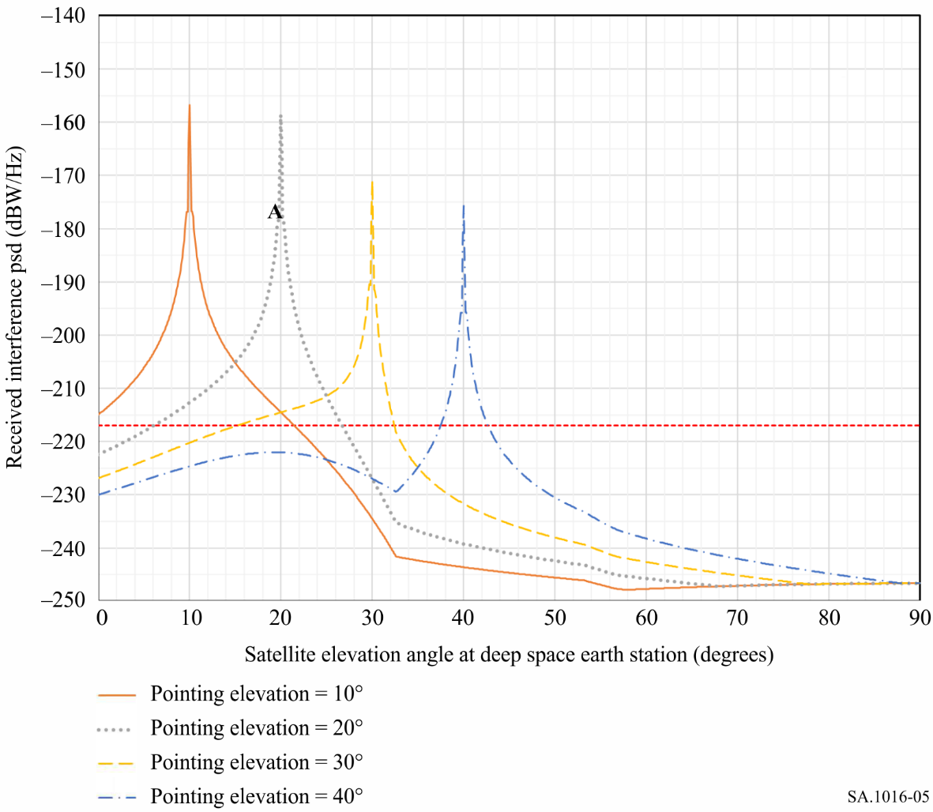

To reduce the interference p.s.d. to below the protection level of the deep space earth station receiver, the DRS user satellite must remain at least 2.6 degrees away from the main beam axis of the earth station antenna, remembering that the actual required separation angle depends on the pointing elevation of the deep space earth station. For example, if the deep space earth station is tracking a spacecraft at Mars, then the DRS user satellite with parameters shown in Table 4 will pass through the beam at less than 2.6 degrees from the beam axis with a frequency ranging between twice a day to once every 3 days. In this case, the satellite has an orbital period of 105 minutes and can produce interference exceeding protection of the earth station for a duration between 0.6 minutes and 4.6 minutes. The frequency and duration of interference depend upon the satellite orbital parameters.

Although an interference interval of less than 1 minute is relatively unimportant for some radio services, in the space research service it can result in irreplaceable loss of scientific data for several minutes (see § 1.1).

The analysis presented above considers only a single user-satellite and one deep space earth station. A greater number of satellites would increase the probability of interference. It is concluded that band sharing by space research service (deep space) and links between user spacecraft and geostationary relay satellites is not feasible.

# 3 Discussion

## 3.1 Intersections of satellite orbits and antenna beams from deep space earth stations

The probability that a satellite will be in the main beam of the antenna of a deep space earth station strongly affects the possibility of band sharing between the concerned links.

Statistics on antenna pointing have been analysed for a comprehensive set of deep space missions. It was found that the earth station antenna gain in the direction of the geostationary-satellite orbit will be 10 dBi or more for 20% of the time.

Satellites that are not geostationary can pass through one or more deep space tracking beams each day. Details of visibility statistics and in-beam duration times for satellites in low orbits are contained in Report ITU-R SA.2066.

## 3.2 Coordination and sharing

The very high e.i.r.p. and extreme sensitivity of deep space earth stations usually result in exceptionally large coordination areas.

Sharing with stations that are within line-of-sight (LoS) of deep space earth stations is not feasible. Stations within LoS will cause harmful interference to receivers of deep space earth stations, or they will be exposed to harmful interference from transmitters of these stations. Note that aeronautical mobile stations and earth orbiting satellites frequently come within LoS of deep space earth stations.

Sharing of deep space Earth-to-space bands with stations utilizing high average e.i.r.p. is not feasible because of potential interference to stations in deep space. It is currently considered that stations with an e.i.r.p. that is more than 30 dB below the implemented or planned e.i.r.p. for space research earth stations do not pose a significant problem. Typically, this means an average e.i.r.p. no greater than 82 dBW at 2 GHz, 85 dBW at 7 GHz, and 84 dBW at 34 GHz bands, since the SRS earth station transmit e.i.r.p. is 112  dBW in 2 GHz, 115 dBW in 7 GHz, and 114 dBW in 34 GHz bands (see Recommendation ITU-R SA.1014).

# 4 Conclusion

Criteria and considerations presented in this Annex lead to the following conclusions.

## 4.1 Sharing of Earth-to-space bands

With successful coordination, space research service (deep space) should be able to share Earth-to-space bands with stations in the services already allocated in the same band, except the following stations in which sharing is not feasible:

– receiving aeronautical mobile stations, receiving space stations, and microwave sensor satellites, when these may come within line-of-sight,

– receiving mobile stations that may come within the separation distance required for interference protection, and

– transmitting terrestrial stations having an average e.i.r.p. exceeding 82 dBW in the frequency bands near 2 GHz, 85 dBW in the frequency bands near 7 GHz, and 84 dBW in the frequency bands near 34 GHz.

Note that, for transmitters in the fixed and mobile services, Article **21** of the Radio Regulations specifies much lower e.i.r.p. limits.

## 4.2 Sharing of space-to-Earth bands

With successful coordination, space research service (deep space) should be able to share space-to-Earth bands with stations in the services already allocated in the same band, except the following stations in which sharing is not feasible:

– transmitting aeronautical mobile stations, transmitting space stations and active microwave sensor satellites when any of these may come within line-of-sight;

– transmitting mobile stations that may come within the separation distance required for the interference protection; and

– the radio astronomy service.

Annex 2  
  
Feasibility of sharing between space research satellites   
in eccentric orbits and space research (deep space) earth stations

# 1 Introduction

The purpose of this Annex is to describe potential interference situations between spacecraft operating in highly elliptic orbits and SRS earth stations sharing the band 2 290-2 300 MHz.

A complete list of SRS earth station sites and relevant system characteristics for these stations are given in Recommendation ITU-R SA.1014. These SRS earth stations provide two-way communication between the Earth and spacecraft travelling at lunar to planetary distances. This communication requirement includes tracking, telemetering, command, monitoring, and operations control.

Table 5 gives the sites for three major earth stations belonging to deep space network (DSN), which are used as examples in this study. To achieve continuous radio contact with the spacecraft, these three deep space earth stations have been located approximately 120 degrees longitude apart, thus ensuring that at least one station is within the field of view of the spacecraft at all times. Furthermore, since most spacecraft on deep space missions follow orbits within 30 degrees of the equatorial plane, these three major DSN stations are located within 45 degrees north or south of the equator.

TABLE 5

Major deep space network (DSN) sites

|  |  |  |  |  |
| --- | --- | --- | --- | --- |
| Location | Antenna reflector diameter (m) | Geocentric radius (km) | Geocentric latitude (degrees) | Geocentric longitude (degrees) |
| USA (Goldstone) | 70 | 6 371.993 | 35.24435 | 243.11408 |
| Australia (Canberra) | 70 | 6 371.709 | −35.22123 | 148.98128 |
| Spain (Madrid) | 70 | 6 370.019 | 40.24099 | 355.15119 |

Since the great distances, involved in deep space communications, result in signal attenuations of 200 to 300 dB, the successful operation of the DSN requires the ability to receive and amplify very low field strength signals. This is accomplished by the use of high-sensitivity receivers characterized by low noise temperatures, high stability, and both narrow and wideband reception.

The DSN operational requirements render it more susceptible to interference than most other communications systems. The possibilities of interference to the DSN discussed in this Annex are confined to a band-sharing situation between the DSN and space research spacecraft that operate in highly elliptic orbits in the space research band 2 290-2 300 MHz.

# 2 Interference criterion

The DSN sites used in the interference study are the three 70-metre antennas located at Goldstone, Madrid, and Canberra. Concerning interference into these sites, any wideband signal or noise spectrum would degrade the signal-to-noise ratio of the receiver and would affect both the carrier tracking phase locked loop and the data channels. In this case, the spectral density of the interfering signal must be at least 6 dB below the spectral density of the receiver system noise in order not to degrade the receiver more than l dB (See Recommendation ITU-R SA.1157). With a system noise temperature at 2 GHz of 16 K, the corresponding receiver noise spectral density is given by *kT* or:

10 log *k* + 10 log *T* = −216.6 dB (W/Hz)         at 2 GHz

Using the 6 dB interference signal criterion, the maximum allowable interference spectral density must be not greater than −222.6 dB (W/Hz) at 2 GHz at the receiver front end.

Due to the nature of operation of the DSN antennas. (i.e., normally tracking from horizon to horizon in the ecliptic plane), and the non-linear function of the spacecraft relative velocity with respect to time, any statistical model attempting to describe the off-axis coupling between the spacecraft and DSN antennas is overwhelmed by the number of parametric variations. It is for this reason that in this analysis the DSN antenna gain is assumed to be represented by a 0-dB isotropic response. This assumption represents a compromise between a gain of greater than 0 dBi for off-axis angles between 0 degree and 19 degrees and a gain of less than 0 dBi for off-axis angles greater than 19 degrees (see Recommendation ITU-R SA.509).

Using this assumption, the effective area of the 0-dB isotropic DSN antenna is given by:

*Ar* = λ2*/4π* or *Ar* = 0.08 λ2 (1)

where λ is the wavelength of interest.

For the 2.3 GHz band (wavelength = 13 cm), this corresponds to an effective antenna area of   
−28.6 dB (m2); or, when used in conjunction with the front end interference spectral density criterion of −222.6 dB (W/Hz), yields a maximum pfd of about −194 dB  (W/(m2 ⋅ Hz)).

# 3 Spacecraft orbit and transmitter characteristics

For the purpose of this study, it was assumed that the highly elliptical spacecraft orbit is four-day earth synchronous; i.e. the spacecraft passes over the same point every four sidereal days. To accomplish this, the spacecraft orbit is assumed to have an apogee of 199 445 km and a perigee of 300 km. Additionally, an inclination of 40 degrees was used. In order to visualize the orbit in relation to the Earth, Fig. 6 shows the position of the spacecraft projected on to the Earth for one particular ascending node of 65 degrees, and argument of perigee of 90 deg. As an example, Goldstone was chosen as the ground station of interest (shown with an *). Figure 6 indicates spacecraft positions at which there is a direct line-of-sight visibility from the spacecraft to the station. In order to show the relative velocities involved in this highly elliptic orbit, Fig. 6 shows two points on either side of perigee P. The time required to traverse from point 1 to 2 is approximately 54 minutes. The time required to complete the rest of the orbit is about 5 690 minutes, resulting in a ratio of time spent above the equator of less than 1%.

FIGURE 6

Orbital ground track and visibility to Goldstone  
(Argument of perigee = 90 deg, ascending node = 65 deg)

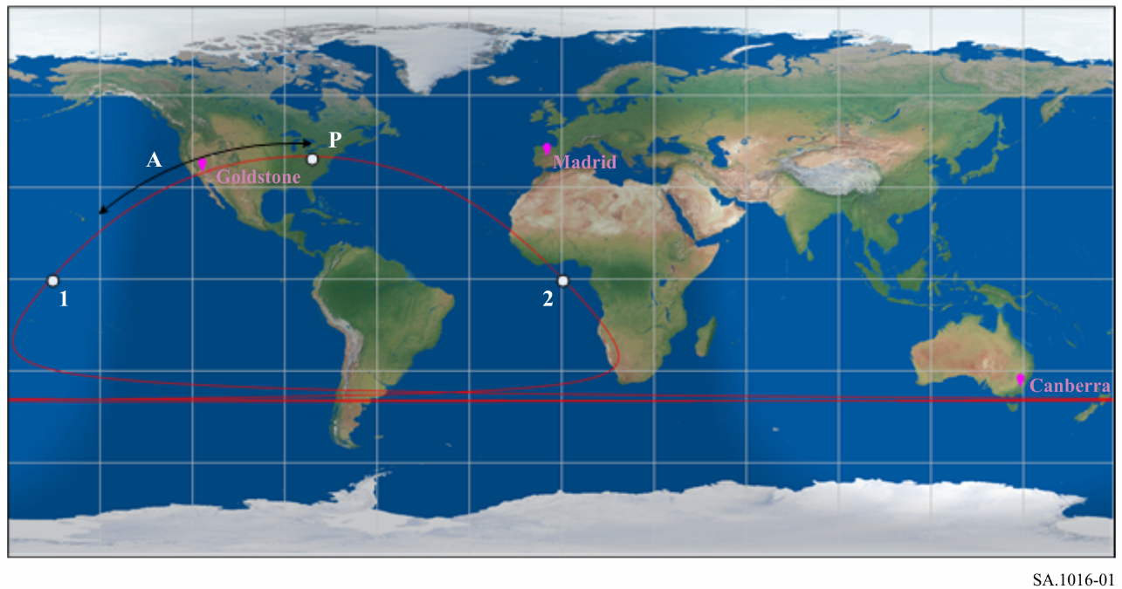

P: perigee, A: visibility

The spacecraft emission characteristics were assumed to be 6 W transmitter power, −2 dB antenna gain, 100 kHz emission spectrum, and 10 dB spectral peaking factor. Additionally, the spacecraft was assumed to be continuously transmitting (i.e. the programme calculated only those times at which, if the spacecraft were to transmit with a gain of −2 dB in all directions, the pfd at the surface of the Earth would be above the DSN threshold interference levels).

The characteristics of the spacecraft orbit and transmitter used in the above study are summarized below in Table 7.

TABLE 7

Spacecraft orbit and transmitter parameters

|  |  |
| --- | --- |
| Apogee | 199 455 km |
| Perigee | 300 km |
| Inclination | 40° |
| Argument of perigee | 90° and 270° (northern and southern perigee) |
| Longitude of the ascending node | −180° to 180° |
| **Spacecraft** |  |
| Power | 6 W |
| Gain | −2 dB omnidirectional |
| Bandwidth | 100 kHz |
| Spectral peaking factor | 10 dB |

# 4 Results and conclusions

Figure 7 presents the results for a spacecraft orbit with an argument of perigee of 90 degrees (northern perigee); and Fig. 8 shows the results for an argument of perigee of 270 degrees (or southern perigee). Both Figures give the percentage of time that the p.s.d. interference criterion of −222.6 dB (W/Hz) at the DSN receive front end is exceeded, as a function of the orbital longitude of the ascending node. These values range from no interference to some stations at particular ascending nodes, to orbital values of about 1.6%.

The particular conclusion to be drawn from these data is that for 40 degrees inclination no ascending nodes exist at which the spacecraft could be injected into orbit, and which would not cause interference to at least one of the DSN sites. In fact, a majority of the ascending nodes would cause excess interference levels to all three DSN ground stations. It is based up on this observation, with the orbit and spacecraft parameters assumed in this analysis, that sharing between the DSN and spacecraft operating in the space research band 2 290–2 300 MHz in highly elliptic orbits is seen to be not feasible.

FIGURE 7

Interference levels for argument of perigee of 90 degrees

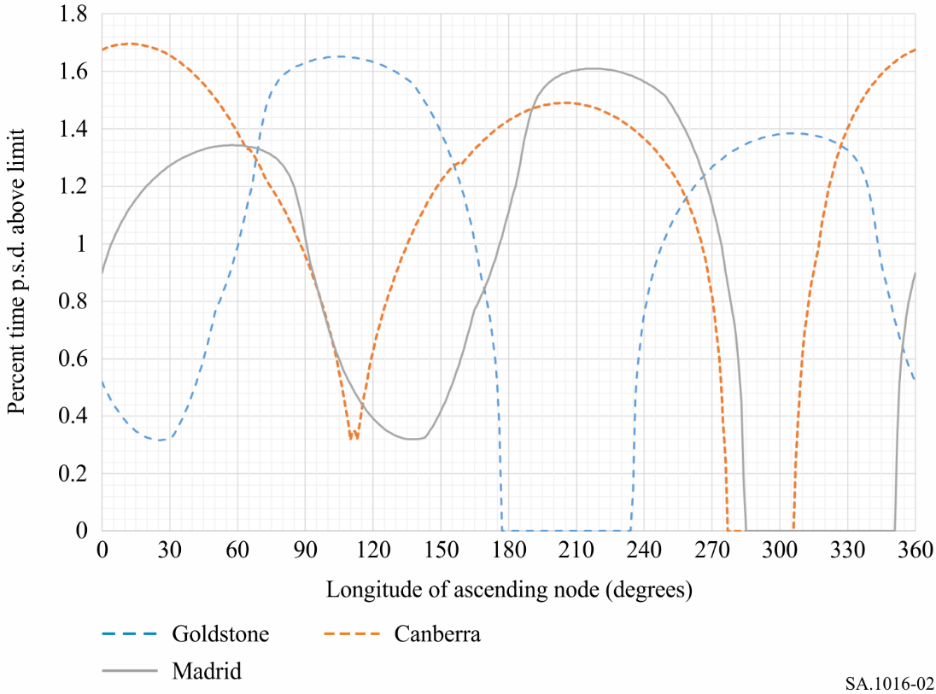

FIGURE 8

Interference levels for argument of perigee of 270 degrees

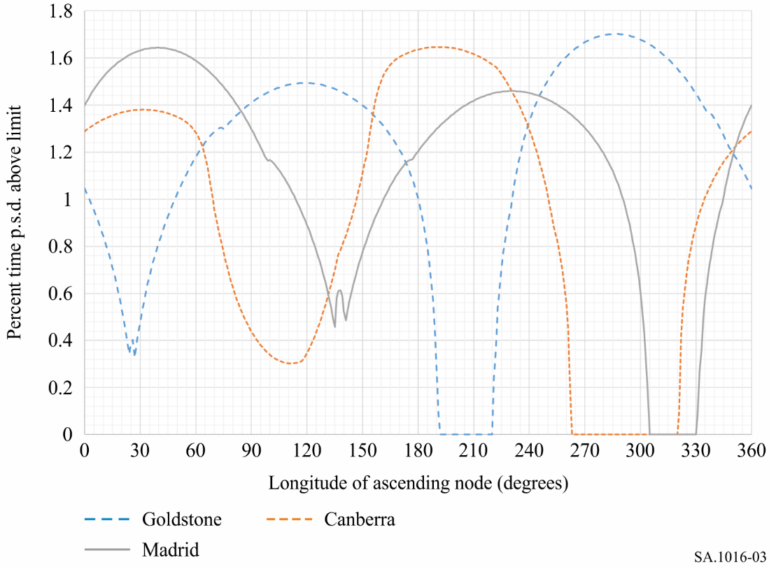

1. * Radiocommunication Study Group 7 made editorial amendments to this Recommendation in the year 2023 in accordance with Resolution ITU-R 1.