3rd Round of TDAG Web Dialogues
12-21 May 2020, Online
TDAG Web Dialogues:
Partnerships for Digital Transformation: Engaging Stakeholders for Meaningful Impact
Date: 21 May 2020
Title: Panellists pictures and bios

OPENING REMARKS
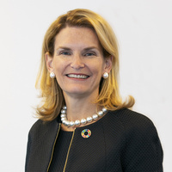 | Ms Doreen Bogdan-Martin, Director of the ITU Telecommunication Development Bureau (BDT)
Doreen Bogdan-Martin was elected Director of the ITU Telecommunication Development Bureau on the 1st of November 2018. She took office on the 1st of January 2019. She is a strategic leader with 30 years' high-level experience in international and inter-governmental relations and a long history of success in policy and strategy development, analysis and execution. She has advised governments around the world on policy and regulatory issues, and is a regular presenter at high-level international forums and summits
Prior to her election, Ms Bogdan-Martin oversaw the organization's Membership, Corporate Communications, External Affairs and UN Liaison teams, and was instrumental in establishing the Broadband Commission for Sustainable Development, on which she continues to serve as Executive Director.
She was one of the principal architects of the annual Global Symposium for Regulators, directed ITU's first global youth summit #BYND, oversees ITU's contribution to the EQUALS Global Partnership for Gender Equality in the Digital Age, and is leading ITU's collaboration with UNICEF and others on the GIGA project to connect the world's schools. Prior to joining ITU, Ms Bogdan-Martin was a Telecommunications Policy Specialist in the National Telecommunication and Information Administration (NTIA), US Department of Commerce.
She holds a Master's degree in International Communications Policy from American University in Washington, DC, post-graduate certification in Strategies for Leadership from the Institute for Management Development in Lausanne, Switzerland, and is certified in Accountability and Ethics by the United Nations Leaders Programme.
She is an affiliate of the Harvard University Berkman-Klein Center for Internet and Society, and a Generation Unlimited Champion. She serves on a number of advisory bodies, including the Geneva-Tsinghua Initiative, the SDG Lab Advisory Board, and the UN Technology Innovation Labs. She is also an amateur radio operator.
MODERATOR
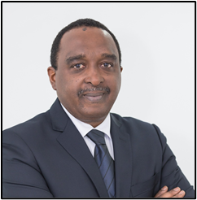 | Mr Bocar BA, CEO, SAMENA Telecommunications Council

Commissioner Broadband Commission for Sustainable Development - UN
Member Global Future Council for New Network Tech – 5G, World Economic Forum - WEF
Member 2020 G20 Summit Advisory Board - Digital Economy Task Force (DETF) - Saudi Arabia
Chairman Chief Regulatory Officers Meeting (CRO) - ITU
For decades, Bocar BA has been delivering impact in the Telecom/ICT industry of the MEA region, facilitating collaboration among private-sector and government sector entities in the pursuit of digitization and socio-economic conducive policies. BA's professional engagement is recognized in industry-wide advocacy activities, especially toward promoting investment sustainability in the private sector of the Middle East. His innate people-centric approach has mobilized multiple consensus-building platforms, cross-regional stakeholders, and issue-specific advocacy on important sector-development challenges. He is known in leading platforms and global telecommunications development institutions, as an objective-minded representative of the private sector and an advocate of effective policy-making and future-friendly regulation, which are crucial for fulfilling the Sustainable Development Goals (SDGs) that all nations across the globe have agreed to in the larger interest of their socio-economic development needs. BA is a principal advisor to various business, investment, and regulatory entities and assists governments in addressing matters relating to digital infrastructure investment, innovation catalysts, sustainable digital economy, job-creation, and citizen-centric public-sector delivery through the use of ICTs.

PANELLISTS
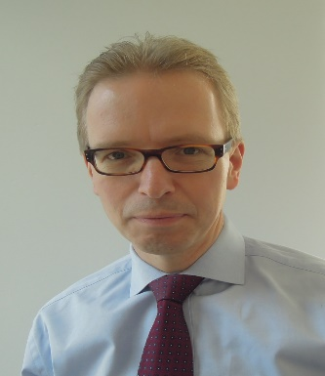 | H.E. Ambassador CARL HALLERGARD, Deputy Head of the European Union Delegation to the UN and other international organizations in Geneva
Carl Hallergard took up his functions as Deputy Head of Delegation to the United Nations in Geneva on 1 September 2016.
Between 2012 and 2016, Carl Hallergard was Head of Political and Security Council Affairs at the Delegation of the European Union to the United Nations in New York.
From 2006 to 2012 he served in the Cabinet of High Representatives Javier Solana and Catherine Ashton with responsibilities focusing mainly on Eastern Europe and the Western Balkans.
Earlier assignments include service in the European Community Humanitarian Office from 1996, as well as in the Policy Planning and Early Warning Unit at the Council of the European Union from 2000, which included a stint as Head of Cabinet of the EU Special Representative in the former Yugoslav Republic of Macedonia in 2001-2002.
Mr Hallergard is married with two children and holds Master Degrees from the Stockholm School of Economics and the College of Europe in Bruges.

Mr John Giusti, Chief Regulatory Officer, GSMA
As Chief Regulatory Officer for the GSMA, John Giusti is responsible for leading the organisation’s public policy and industry advocacy agenda with governments, regulators and international institutions, as well as overseeing the work of the GSMA Mobile for Development Foundation and engaging with key development organisations worldwide.
Prior to joining the GSMA in 2011, Giusti spent 17 years at the US Federal Communications Commission (FCC), working in a variety of capacities. Most recently, he served as chief of staff and senior policy advisor to Commissioner Michael Copps, where he provided legal, strategic and policy support to the Commissioner on all major agency actions, including the implementation of the National Broadband Plan. He also previously ran the FCC’s International Bureau, where he managed the agency’s relationships with its foreign counterparts and served as the its chief negotiator at meetings of the International Telecommunication Union, the Inter-American Telecommunications Commission and other multilateral organisations. Giusti was educated in the United States, earning a Juris Doctorate from Boston University School of Law and a Bachelor of Science in Telecommunications from the University of Florida. He has been a member of the Massachusetts bar since 1994.

Ms Oyeronke Oyetunde, General Manager, Regulatory Affairs, MTN Group

Oyeronke Oyetunde is General Manager of Regulatory Affairs for the MTN Group, with over 15 years’ experience in the regulatory & legal environments. Having worked as a lawyer in private practice in Nigeria specializing in business advisory services and TMT, Oyeronke joined MTN Nigeria as a Regulatory Affairs Advisor in 2004. She rose through the ranks to become the General Manager of Regulatory Affairs of MTN in 2012. Since November 2017 she has been the Group Head of Regulatory Affairs for the MTN Group.

Mr Marc Vancoppenolle, Global Head of Government Relations, NOKIA
Since January 2016, Marc Vancoppenolle is leading the global Government Relations function at Nokia. His responsibilities include Policy and Regulatory Affairs as well as the leadership of the Nokia advocacy activities around the globe. He and his team are working with institutions and stakeholders to create a favorable political and regulatory environment fostering broadband investments and digitalization at large.
Prior to this role, Marc led for 4 years the Alcatel-Lucent Public and Regulatory Affairs function for EMEA and APAC.
Marc has over 25 years of experience in the telecommunication industry. He joined Alcatel in 1991 where he took various international and worldwide technical, commercial, marketing and communication leadership roles based in Belgium and in France. He holds a Master of Science, with a specialization in Telecommunication from the University of Leuven complemented with marketing studies from the University of Antwerp. He is Vice-Chair of the BUSINESSEUROPE Digital Economy Taskforce and an advisor to FITCE Belgium (forum for ICT & Media professionals).

Ms Jane Coffin, Senior VP Internet Growth, Internet Society (ISOC)
Jane Coffin is responsible for the Internet Society’s Internet Growth project teams. The Internet Growth project teams are focused on Community Networks, Internet exchange points (IXPs) & interconnection, peering, and community development, and a new critical project on measuring the health of the Internet. Her work also focuses on access and development strategy, where she and other ISOC colleagues and partners focus on coordination of collaborative strategies for expanding Internet infrastructure, access, and related capacities in emerging economies with partners.
Prior to joining ISOC, Jane worked on Internet and telecommunications policy issues for the Office of International Affairs at the National Telecommunications and Information Administration – U.S. Department of Commerce. She was an active participant in Internet discussions in the ITU, OAS-CITEL, and OECD, working closely with the five regional Internet registries (RIRs) and other Internet technical community stakeholders. She was very involved in policy discussions on open Internet standards and issues related to BGP, IPv4, IPv6, and MPLS. While at NTIA, Jane was an advocate for the deployment of Internet exchange points (IXPs) to increase international Internet connectivity (IIC), and was an ITU-T SG-3 IIC co-Rapporteur and an IIC coordinator in CITEL’s PCC.I. She was Vice-Chair of the Federal IPv6 Task Force, and a Vice-Chair of the ITU Council Child Online Protection Working Group.
From 2002-2006, she served as Chief of Party, and Deputy Chief of Party on two separate USAID projects in Moldova and Armenia. Jane worked closely with regulators, policy-makers, senior officials and parliamentarians, Internet service providers, and stakeholders on regulatory strengthening, market access and competition, and liberalization and privatization activities in Moldova and Armenia.
Jane worked for AT&T as a Director of International Affairs/Government Affairs, where she worked on international telecommunications issues, including VOIP, ENUM, and ICAIS, and was a Rapporteur in ITU-D Study Group 1 for universal access/universal service in rural and remote areas.
She holds a BA in Classics from the University of Massachusetts at Amherst, attended the College Year in Athens program in Athens, Greece, and was an American Field Service (AFS) exchange student in Falun, Sweden (1985-86).

Mr Christopher Fabian, Senior Advisor on Innovation and co-Leader of the Innovation Unit, UNICEF
Chris Fabian (@hichrisfabian) leads UNICEF Ventures, which invests in open source technology for the public good. The team focuses on investments that address issues like climate change, job loss, human population movements, and pandemics.
Chris co-founded UNICEF’s Innovation Unit in 2007, as well as advising Secretaries-General Ban Ki-moon and António Guterres on frontier technology issues including AI, data science, blockchain, and cryptocurrency. His teams created products like RapidPro, an SMS-based platform for moving information with more than 7m users, MagicBox which uses AI to track Ebola and other diseases, and four corridors for building policy around drones and UAVs. In 2019 he launched GIGA, an initiative to finance connecting every school in the world to the internet.
Chris is a Commissioner on Global Health Futures for the Lancet / FT, and holds honorary scholar positions at the Chinese Central Academy for Fine Arts, and New York University, as well as Edmund Hillary and Tribeca Disruption Fellowships. He was a member of Time Magazine’s “100 Most Influential People” list in 2013. He holds a Bachelor’s degree in Philosophy from the American University in Cairo and a Master’s in Communication from the New School in New York.

Ms Lindl Rowe, Director ITU, APT & APECTEL, Department of Infrastructure, Transport, Regional Development and Communications, Australia

Ms Lindl Rowe is a Director at the Department of Infrastructure, Transport, Regional Development and Communications within the Australian Government. She leads a team responsible for Australia’s engagement with specialised international organisations including the International Telecommunication Union, Asia Pacific Telecommunity and APEC Telecommunications and Information Working Group. She is Australia’s Councillor to the ITU.
Prior to taking on this role she worked for Australia’s national Computer Emergency Response Team (CERT), CERT Australia, for eight years where she led the development and implementation of their cyber security exercise program and the expansion of their national and international partnerships teams. Lindl has over 17 years’ experience working in various roles within the Australian Government.

Christian Patouraux, Founder & CEO, Kacific Broadband Satellites
Christian Patouraux has over two decades of experience in the satellite industry.
He began his satellite career with SES, initially as a satellite engineer, procuring, launching, testing and operating 12 spacecrafts, then as an independent business development consultant, playing key roles in launching broadband businesses, implementing large teleports, deploying airline and maritime broadbands, and developing satellite multi-play and IPTV businesses.
He went on to develop satellite offerings for new markets in Asia Pacific as head of special projects for MEASAT. Christian was also Executive Vice President and Chief Development Officer at O3b Networks, where his work was fundamental to launching the company’s maritime business.
In 2013, he founded Kacific Broadband Satellites to bring high speed, low-cost connectivity to remote regions of the Asia Pacific, fostering greater internet usage, fuelling economic growth and improvements in service delivery across covered regions.
Kacific’s first satellite, Kacific1, was launched into geostationary orbit on 16 December 2019. The satellite is now operational and Kacific offers direct internet access, via wholesale channels, to government agencies, institutions, businesses, community groups and households within the satellite's total footprint area.
Christian holds a Master of Engineering from the Polytechnic school at the University of Brussels, a Master of Aeronautics / Turbomachinery from the Von Karman Institute, Belgium and an MBA from Insead.

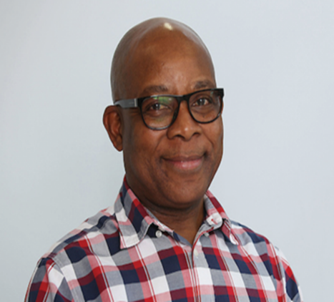 | Mr Wellington Makamure, Regional CEOSouthern Africa, Liquid Telecom
Wellington Makamure is the Regional CEO for Liquid Telecom Southern Africa. The region comprises of Liquid Telecommunications operations in Zimbabwe, DRC, Botswana, Mozambique. He is also the sitting CEO for Liquid Telecom Zimbabwe. Wellington has been with Liquid Telecom since February 2009. He joined Liquid telecom in London, UK as Group Executive Strategy.
He then relocated and moved back to Zimbabwe in mid-2010 as the Managing Director of the then new set up. He was part of and one of the main pivots and leads in the initial set up, planning, build and development of the pioneer Liquid Telecom Fibre network and business based in Zimbabwe.
He was then subsequently promoted to Regional Chief Executive for the Liquid Telecom business in the Southern Africa Region, in 2018.
Wellington is now overseeing the Southern Africa business portfolio for Liquid Telecom. He also sits on several intercompany Boards as a non-executive board member: Liquid Telecom (Zambia), Liquid Telecom Botswana, ZOL Zimbabwe, and has other board and advisory roles in public and private sector organisations.
Wellington has had extensive Executive level work experience across Africa and in the United Kingdom. He has worked in several industries, viz: telecommunications, consumer electronics and industrial electronics since 1982. Has held positions varying from engineering, project management, marketing up to senior and executive levels. Wellington has worked at these senior executive levels in both the Public and Private sector.

DISCUSSANTS ON THE SECOND SEGMENT OF THE DIALOGUE

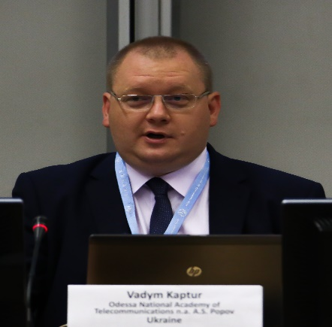 | Mr Vadym Kaptur, Vice-Rector on Scientific work, A.S. Popov Odessa National Academy of Telecommunications
Mr Vadym Kaptur is Vice-Rector on Scientific work of A.S. Popov Odessa National Academy of Telecommunications, Ukraine.
ITU, UN ESCAP & EBRD expert in the fields related to broadband networks, cybersecurity, mobile services and ICT in general.
Vice-Chairman of ITU-D Study Group 1 (since 2014), Co-Rapporteur on ITU-D Question 1/1 “Strategies and policies for the deployment of broadband in developing countries” (since 2015)
Ph.D. in telecommunications (2008), Laureate of the State Prize of Ukraine in Science and Technology (2014), author of than 260 scientific publications.

Eng. Sante Vallese Verdolini, President of the Paraguayan Communications Company and HOLA Paraguay S.A.

Eng. Sante Vallese Verdolini is President of the Paraguayan Communications Company (Copaco) and Hola Paraguay.
Electronic Engineer, graduated from the National University of Asunción. He has a Master’s degree in Business Management.
Official with outstanding experience in ANTELCO, COPACO and VOX.
From 1989 to 2001 he worked in the National Telecommunications Administration (ANTELCO).
From 2001 in the transformation of ANTELCO to COPACO, he continued in the company, where he occupied the position of international sub manager, later manager of business management and regulation, then Commercial Manager, International Affairs Advisor and Presidential Cabinet Advisor. In 2010, COPACO bought the telephone company Hola Paraguay S.A. (VOX), since then he has been member of the company directory.
He taught at the Polytechnic Faculty of UNA from 1994 to 2012 and was an alternate member of the Directing Council of the Polytechnic Faculty.
He has been president on several occasions of Ibero-American Association of Telecommunications Companies (ASIET), vice president of Ibero-American Association of Research Centers and Telecommunications Companies (AHCIET) from July 2010 to July 2018. Representative of Hola Paraguay S.A. (VOX) in the Japanese Paraguayan Chamber of Commerce from 2012 to 2014.
He has made several exhibitions in international forums on behalf of Antelco, Copaco and VOX among which they mention: Mercosur, Hispano-American Association of Research Centers and Telecommunications Companies. Also, Summit of Senior Executives, ICT, Capacity Latam and NexTV Latam, AHCIET International Traffic Meeting and various global Telecommunications meetings.
In addition, Vallese has several publications of articles in international journals in the field of telecommunications.
His training is complemented by training in Telecommunications in countries such as: Japan, Peru, Dominican Republic, USA and Brazil. And he has represented ANTELCO, COPACO and VOX.

Dr Abdulkarim Ayopo Oloyede, Senior Lecturer, University of Ilorin, Nigeria
Vice-Chairman of ITU Telecommunication Development Advisory Group (TDAG)
Dr. Abdulkarim Oloyede is a Lecturer (Teaching Research and Consulting) in the Department of Telecommunication Science, University of Ilorin, Nigeria. He received his first degree in Electrical Engineering in 2008. He obtained his Masters and PhD degrees in Telecommunications Engineering at University of York, the UK in 2010 and 2015 respectively. Dr Oloyede joined the service of the University of Ilorin in 2012. He is also a Post-Doctoral Researcher at the University of York, York, UK as a Rutherford Commonwealth Fellow. He is the Head of the Radio and TV unit for the Kwara State University, Malete, Nigeria. He is currently the Co-Chair for AFRINIC Policy Development Working Group (PDWG), A member of the ICANN At-Large Advisory Committee (ALAC) to the ICANN Board representing the Africa Region and Vice Chairman for the ITU- D Telecommunication Development Advisory Group (TDAG). He is also a Vice Rapporteur for the ITU-D study Question 5/2. He is the Chair for the ICANN AFRICA Strategic Plan (FY20-FY25) Committee, He is also a member of the ICANN RSSAC Caucus, a member of the Internet Society (ISOC) and a Registered Engineer in Nigeria and the UK. He is also a member if IEEE. He is a Board Chair for a Nigerian based group of primary and secondary schools and a Board member for a Nigerian based Microfinance Bank. He has taken several courses with GSMA, and the United State Telecommunication Training Institute (USTTI).
Currently, his area of Interest is Telecommunication Policy, Internet Governance High Altitude Platforms (HAP), Cognitive Radio, Telecommunication policies for rural areas in Africa and Radio Propagation Models.
He is an author or co-author of over 50 scientific publications in leading journal and conferences around the world. He has travelled to over 40 countries across the five continents of the world.

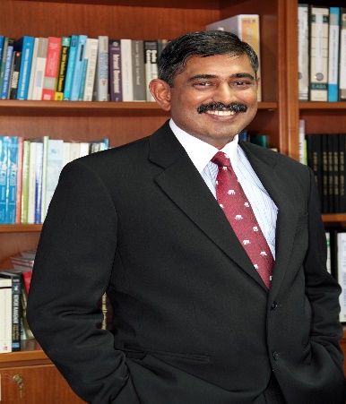 | Professor Sureswaran Ramadass, Professor Emeritus, Malaysian University of Science and Technology (MUST)
Professor Sureswaran Ramadass is Professor Emeritus at the Malaysian University of Science and Technology (MUST). He is also the Chairman (Steering Committee) of the ITU (International Telecommunications Union) IPv6 and IOT Center of Expertise and focuses on 5G technology.
Prior to this, he was the founding Director and Professor at the National Advanced IPv6 Centre of Excellence (NAV6), Universiti Sains Malaysia.
In Industry, he is the Chief Scientist at NLTVC Sdn Bhd. (NLTVC is a Next Generation Internet Communications research and development company)
He obtained his BsEE/CE (Magna Cum Laude) and Masters in Electrical and Computer Engineering from the University of Miami in 1987 and 1990 respectively. He graduated top student in the College of Engineering. He obtained his PhD from Universiti Sains Malaysia (USM) in 2000 while serving as a full-time faculty.
Some of his recognitions include being awarded:
- The “Anugerah Tokoh Negara” (National Academic Leader) for Innovation and Commercialization in 2008 by the Minister of Higher Education. This award is given in recognition to contributions to Innovation and commercialisation in the area of science and technology
- Emeritus Chair, IPv6 Forum Education Programme.
- The Wireless World Research Forum Fellow in April 2010. This fellowship award was presented in recognition to his contribution in the area of Next Generation Networks and IPv6.
- Malaysian Innovation Award by the Prime Minister in 2007 and again by the Minister of Science and Technology in 2009. These Awards were given in recognition for his contribution towards innovations in the areas of Multimedia Conferencing Systems and Real-time Advanced Security Monitoring.
In 1989, Prof Sureswaran joined MODCOMP, Florida as a senior technical team member. MODCOMP, a wholly owned subsidiary of AEG Daimler Benz, focused on real-time operating systems. Their customers included Jet Propulsion Laboratory (JPL) and the National Aeronautics and Space Administration (NASA) for their remote space vehicles.
His career as an entrepreneur begin as early as 1991, when he co-founded ICON Business System, Inc (Florida) in 1991. As Vice President of Engineering, he was responsible for the entire engineering and R&D divisions of ICON. In 1992, he sold his shares and returned to Malaysia to join USM as a lecturer. In 1993, he formed and grew the Network Research Group to become a world recognised research center. In 2005, he became the first and founding Director of NAv6 (the Next Generation Internet Center) in Universiti Sains Malaysia (USM).
Prof Sureswaran's involvement in the field of IPv6 is deep and vast. Prof Sureswaran is currently Emeritus Chair of the IPv6 Forum Education Certification Program. He is also the Malaysian IPv6 Forum Chairman. Prof Sureswaran was the first Research Steering Committee Chair for MYREN (Malaysian Research and Education Network) and is currently the MYREN IPv6 WG Chair. He was also the Chairman of the Asia Pacific IPv6 Task Force (APV6TF) and was involved in promoting IPv6 within the region and globally.
In 2014, he was nominated and elected as Chairman for APAN (Asia Pacific Advanced Networks. He is still currently the Treasurer for the APAN Board and the Head of APAN Malaysia.
His recent active participation in the global IPv6 arena includes being a consultant to International Telecommunication Union (ITU), a United Nations Agency. His expertise was valuable in formulating a proposal on the expansionary approach to Global IPv6 Address Allocation. In 2019, he wrote the "Upgrading Guide to IPv6 for 5G Networks" for ITU. Till today, he continues his work in IPv6 and 5G for ITU.
He was also one of the 18 finalists for the ICANN at large Directorship in the year 2000. ICANN is the organisation that manages and maintains the global Internet. He was a Director of the Japanese AI3 (Asian Internet Interconnections Initiative) to connect over 17 participating countries with Satellite IPv6 Networks. He is currently an affiliated Senior Member of the Echonet Consortium of Japan and the Chair of the Echonet Society of Malaysia. He was also appointed as an Advisor to the Japanese Government’s Ministry of Public Management, Home Affairs, Posts and Telecomm (MPHPT) in the early 2000s.
In the world of Innovation and Commercialization, Prof Sureswaran founded and headed the team that successfully took Mlabs Systems Berhad, a high technology Internet based Video Conferencing company to a successful listing on the Malaysian Stock Exchange in 2005. Mlabs is the first university based company to be listed in Malaysia. He sits on the advisory boards of numerous technology companies.
Prof Sures is the founder of the globally recognized CNE6 (Certified Network Engineering IPv6 Program). He currently assists numerous countries globally in their IPv6 Certified Engineering Training Programs as well as developing their IPv6 Capabilities. In Malaysia, he is currently the Founder and Chair of the IPv6 Society of Malaysia as well as the IPv6 Forum Malaysia.
Prof Sures is currently assisting to further enrich the postgraduate program of MUST, which now has the largest number of PhD students (amongst Private Universities). His is currently the coordinator for the Industry 4.0 Program and Msc in Internet Engineering Programs. Prof Sureswaran’s academic contributions are vast. He has published research papers in over 200 international and national level journals, research conferences and research presentations. He has filed over 12 patents (awarded currently 6 patents) and is often invited to present keynote addresses in the areas of Internet Security, IPv6 and The Future Internet. He has written or provided chapters for 9 books. He has chaired numerous international conferences and has received over RM21 million in research funding and grants from numerous organizations globally. He has also received over 40 International and National level awards for Innovation and has graduated 18 PhD students till date.

______________

