**POST EVENT REPORT- ICTs for Girl’s Day-2014  
 Celebrated by E-village (a project of Pakistan Social Association)**

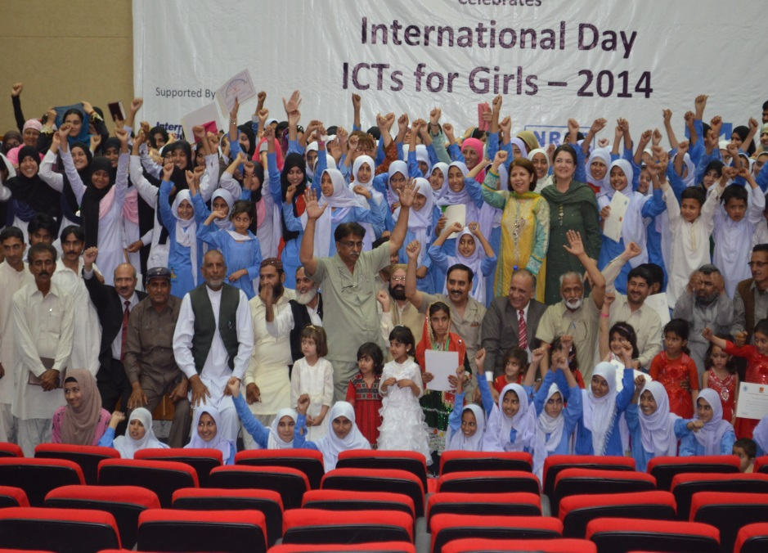In Line with Global Initiative taken by ITU-UN,E-village, a project of Pakistan Social Association celebrated ‘ ICTs for Girls Day’ on 24th April-2014 in Islamabad. More than 400 girls from almost all parts of Pakistan including remote areas of Baluchistan, KPK, and AJK participated in the event. ICTs professionals and NGO Leaders highlighted the role of Information and Communication Technologies (ICTs) in Development sectors,specially in Health, education, Agriculture and Good Governance.

**Background Of Girls in ICTs Day:24 April-2014**

On 8 April 2011, ITU announced the establishment of an international “Girls in ICT Day”, which will be held every year on the fourth Thursday in April. Girls around the world gathered on 28 April 2011 to celebrate the first annual international Girls in ICT Day. The Day celebrates girlsinterests and strengths, and encourages them to choose a career in information and communication technologies.

“Girls in ICT Day” is the direct result of the adoption of Resolution 70 by ITU’s Plenipotentiary Conference in Guadalajara, Mexico, in October 2010. The Resolution, “Gender mainstreaming in ITU and promotion of gender equality and the empowerment of women through information and communication technologies”, resolved to incorporate a gender perspective in the   
implementation of all plans of ITU specially in developing countries.  
  
Girls should be empowered by ICT was the main idea behind the women Empowerment Programinitiated by E-village project in 2009. The aim to celebrate this day is to exchange ideas and experiences and to find out ways and meansto educate girls and young women that information and communication technologies are tools of empowerment, and that a career in ICTs not only offers new ways of Education, but it opens many venues towards an economically strong females which would enable a much stronger Nation.ICTs are opening new horizons and opportunities for girls. Although women and men have the same choices of careers, but in developing countries, there is still a mindset that distinguishes between typically male and female occupations. Traditionally girls are depraved of technical education specially in Rural areas. ICTs provide equal opportunities for males and females and girls can prove that they have equal understanding and motivation to get latest technologies. ICTs for girls Day create much required awareness in this regard.

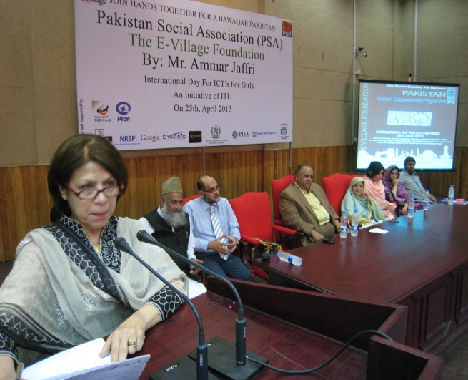 **Last year (2013) Conference of ICTs for Girls Day by E-village:**

Under E-village project PSA trained nearly 300 girls all over Pakistan in year 2013, and these young girls were awarded certificates inlast year conference. Toppers were presented with Medals. The event tookplace ,in Pakistan Manpower Institute auditorium at Zero point, Islamabad. Chairperson of Pakistan Science Foundation Dr. Mudassara was the Chief Guest on the occasion. Few distinguished guests were DG National Talent Pool DR.FayyazRanjha, Programme Head, Ms Salma Khalid National Rural Support Programme, Program head ,MsIffatJamil.Plan International organization join the ceremony .NGOs like Plan International , Community Services Programme (CSP) and Youth in Action (Balochistan)joined hands together for the celebration of the International Day for ICTs For Girls, in 2013.

**Salient Features of this year Event:24-April,2014**

1. **Main Speakers of the Event**:

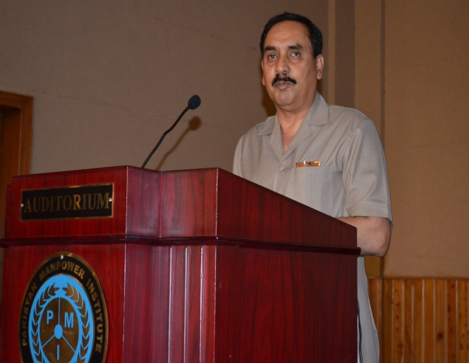Mr.Zafar Iqbal QadirDG NCRD was the Chief Guest of the conference. Speakers from almost all walks of life were present. Prominent ladies like Chairperson CWE, Mrs. Zarreen Ammar, Ms. Salma Khalid, Programe Manager NRSP, Ms. AsmaQadeerKhan(Vice President Balochistan Women Affairs), MsMalihaElaahiMarketing Manager,from Teradata graced the occasion. Vice Chancellor Sarhad university Mr.Saleem-ur-Rehman, Vice President PISA Dr.NazirVaid, and President PIE, Mr.Tahir Chaudhry highlighted and stressed the role of Girls in implementing the use of ICTs specially in villages. They informed that if a girl is trained in ICT skills she would train her brothers, sisters and after that her own kids after her marriage.

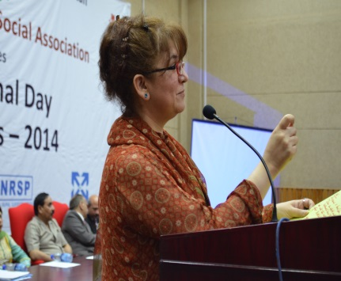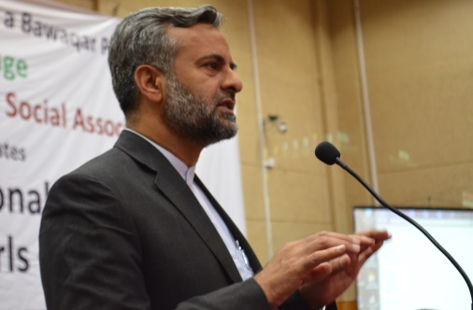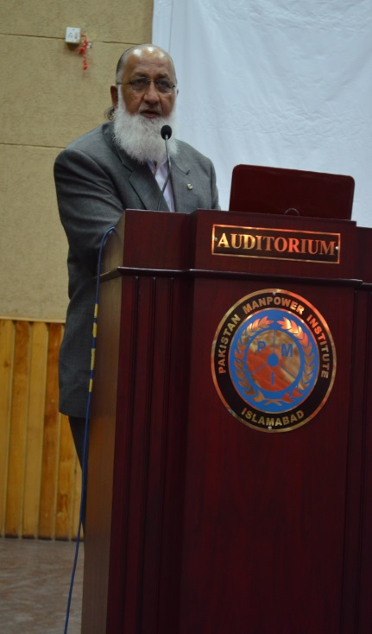

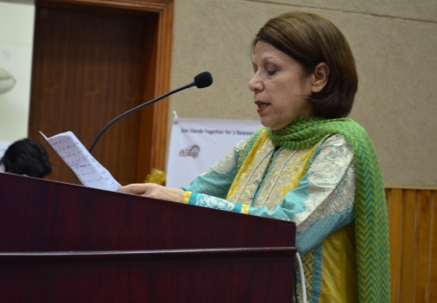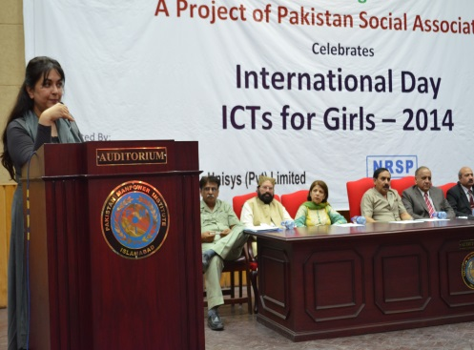

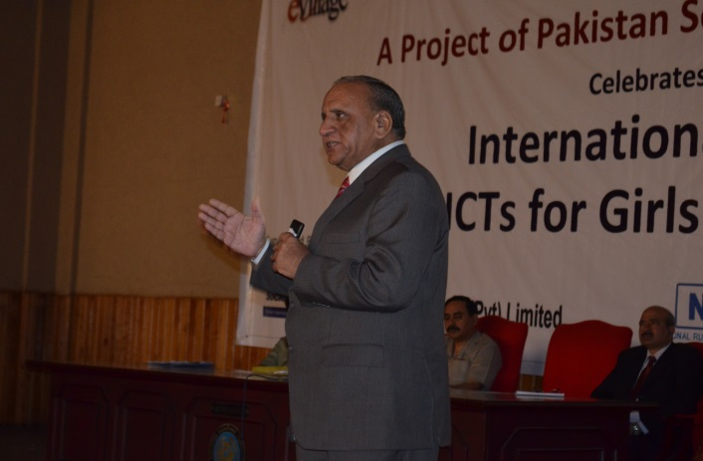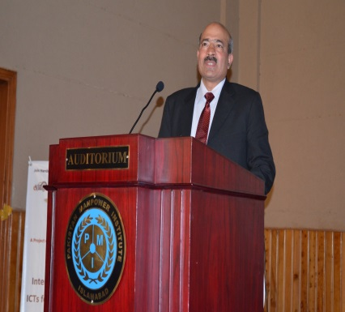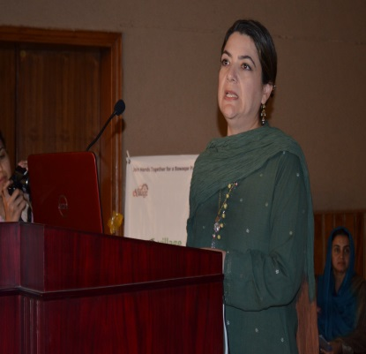

President PSA Mr.Ammar Jaffri informed the participants that currently 3000 girls are being trained in ICT skills in 120 E-villages in remote rural parts of Pakistan.He further informed that today ICTs have become the vehicle of progress in education, health, agriculture and good governance.

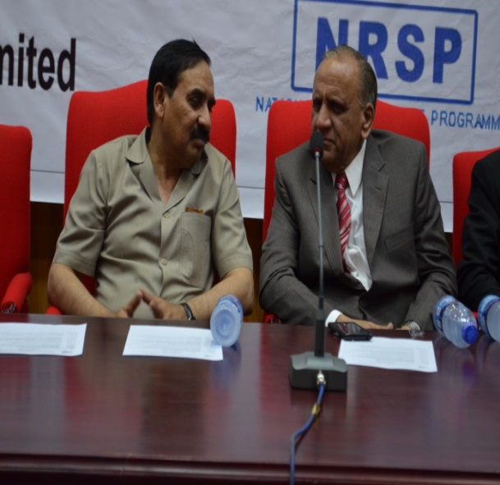

DG NCRD, Mr.Zafar Iqbal Qadir, appreciated the efforts of E-village in taking the ICTs to rural areas of Pakistan. He said that E-village team is doing excellent job of bridging the digital divide and delivery of ICTs skills in remotest parts of Pakistan specially in KPK and Baluchistan. Mr.Zafar Iqbal Qadir further announced that NCRD would work hand in hand with E-village team, in delivery of trainings to the NGOs and Government Leaders in the areas of ICTs for development in Pakistan.

**Remote Participation of the Global Leaders in the Conference**

Beside the Participation of eminent Female Leaders of our society, Global Leaders also participated in ICTs for Girl’s Day-2014 remotely through recorded messages..

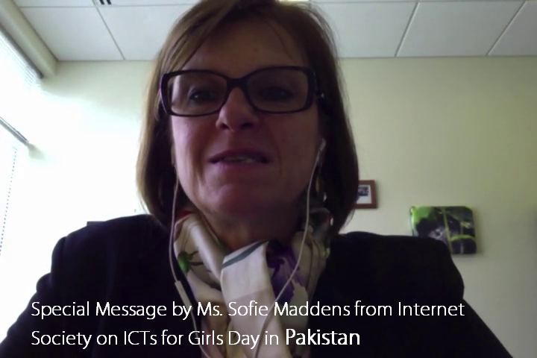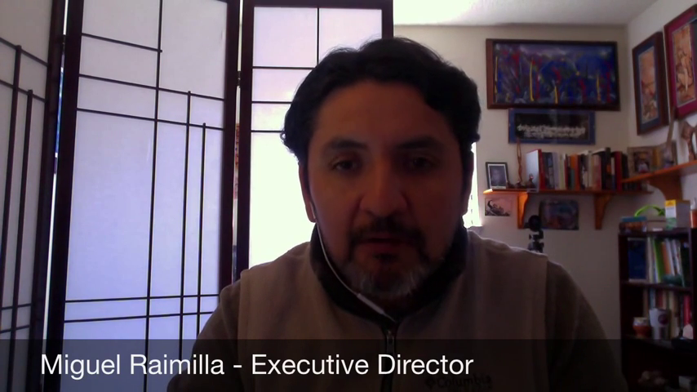MrMiguel Ramilia Executive Director of Telecentre.orginformed the participants that by empowering women and girls in ICTs skills we can not only educate few in a society but prepare the entire community to accept the upcoming changes specially in Development Sector in a society. Stressing the importance and relevancy of the day Mr Miguel congratulated the E-village team in Pakistan for joining hands with the world community for celebrating ICTs for girls days. He specially highlighted the role of E-village project in providing tools and services in rural parts of Pakistan specially for women empowerment. He hoped that this would go a long way in bringing Pakistan in line with International Community on road to progress through use of ICTs and trained women and girls would become better citizens of Pakistan. He mentioned that Telecentre.org would extend all possible support to E-village project in Pakistan to promote their aims and objectives.

MS Sofie Maddens ISOC Senior Director of Global services on ICTs highlighted the importance of Girls in promoting the use of ICTs in development sector specially in Education and health. She appreciated the efforts of E-village team in making sustained and committed efforts in introducing ICTs in rural parts of Pakistan. Introducing the role of ISOC in bringing developed and developing world closer and minimizing digital divides in different parts of the societies.

**Recognition Certificates and Award Ceremony**

Awards, Recognition certificates and Gold Medals were awarded to the students, teachers and community leaders. Special awards and gold medals were given to girls students who secured first position in the exam after their three months training based on E-village software. E-village supervisors and community leaders were also awarded certificates in recognition of their services.

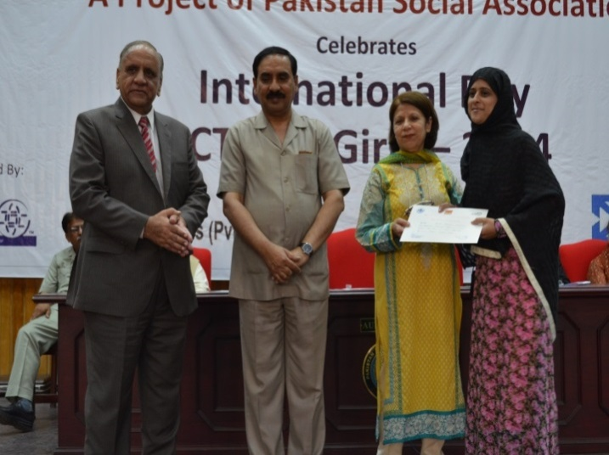Gold medals were awarded to three girls from Baluchistan, AJK and Punjab for their outstanding efforts in promoting E-villages in their respective areas. Chief Guest awarded the

certificates and gold medals.

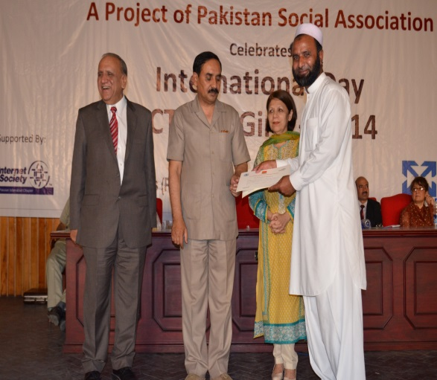

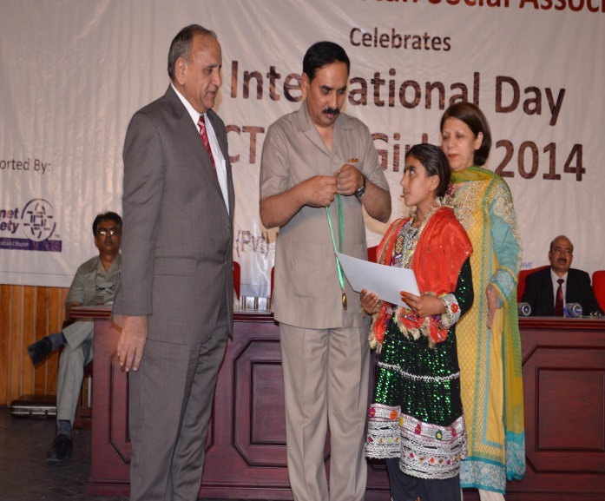

**:**

**Awards to Coordinators of E-village Project**

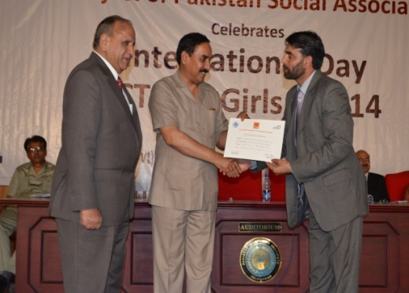President Pakistan Social Association, (E-village Foundation) Mr.Ammar Jaffri informed the audience that E-village has now expanded to 120 E-villages all around Pakistan and currently 3000 students are getting training in ICTs skills through E-village Project. But this success story is a team work of E-village Project coordinator and all Regional Coordinators. They all were given recognition Certificates and Awards.

* Regional Coordinator Balochistan:

MrGhulam Mohammad Muri

* Regional coordinator AJK:

Mr.Siddique Hussain Qureshi

* Regional Coordinator Punjab:

Col Abuzar Khan

* Regional Coordinator (Capital)Islamabad:

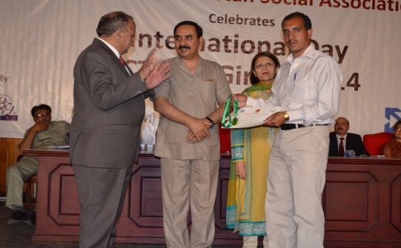Mr.IftikharaliJanjua

* Project Coordinator:

Ms.Fozia Nausheen

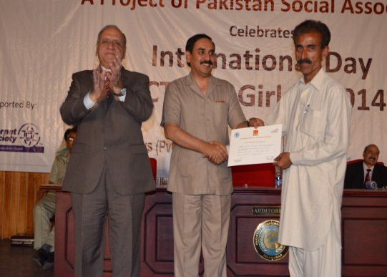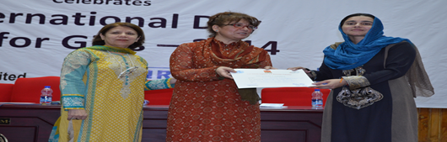

**General Photographs of the Event**



