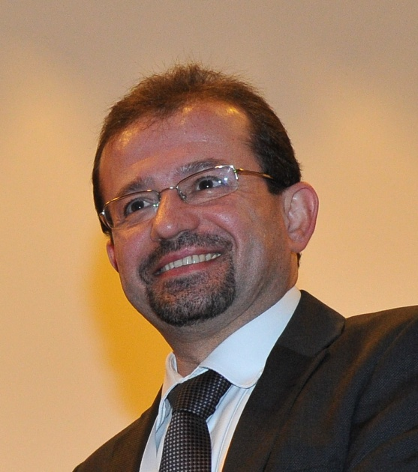

**Dr. Ahmed Dabbagh**

**Director, Technology Transfer & Partnership**

**Sharjah Research, Technology & Innovation Park**

A pioneer in the field of innovative platforms and resources, Dr. Ahmed Dabbagh has an experience of

24 years in senior technical and academic positions. Currently, Dr. Ahmed Dabbagh is a senior Advisor of digital transformation, Artificial Intelligence and strategic planning for R&D, Innovation and Creativity at different local and federal government entities. Dr. Dabbagh is working for Sharjah Research, Technology and Innovation Park as Director of Technology Transfer & Partnership. His main role is to advise the establishment of the culture of Innovation and to build a human capital in

the domain of creativity. Dr. Dabbagh worked for Emirates Identity Authority the past two years, and his

main role was to design a full strategic planning of Innovation & Creativity to achieve EIDA strategic

objectives for the next years. Dr. Dabbagh was a strategic committee member to design the next 5 years

strategic plan of the organization to answer the need of Government vision 2021. Dr. Dabbagh is a

visiting Professor at Paris-Sorbonne University Abu Dhabi for the Master program teaching Information

Technology in Management, Leadership and Strategic planning for management. Dr. Dabbagh is the

Vice-Chair of the Education Society Chapter at the IEEE UAE Section, where he was awarded for his

distinguished contribution and leadership in supporting the Society for 2013. He is also appointed as the

Industry Relations Officer by the IEEE UAE Section. Prior to joining EIDA, Dr. Dabbagh was the Director of

Services Development at Ankabut, the UAE Advanced Network for Research & Education for 4 years. His

main achievements, the establishment of eFADA, the UAE Higher Education Library Consortium and also

the implementation of the UAE Educational Cloud. Dr. Dabbagh was the Director of the Academic e-

Services Department (Faculty Development) at Ajman University of Science and Technology, UAE. Dr.

Dabbagh was a Professor and visiting Professor at different universities in UAE teaching specifically

master programs as Information Technology in Management, Leadership and Educational Technology at

Ajman University, Hamdan Bin Mohamed Smart University and Paris-Sorbonne Abu Dhabi University. Dr.

Dabbagh was working in France & Germany for several years in the domain of micro-controllers and a

wide range of micro-processors architectures ranging from 16 bits up to 64 bit with the very known

Semiconductors industry like Thomson, STMicroelectronics, Siemens, Motorola, Apart from being the

co-author of 2 books, namely: Intellectual Property for Electronic Systems: An essential introduction,

IEC2007 and Cognitively Informed Intelligent Interfaces: Systems Design and Development, he is also the

holder of 6 International patents (3 European, 2 American and one in Japan). Dr. Ahmed Dabbagh has

been actively associated with IEEE's Computer Society, VSI and various other organizations. Besides eLearning, his other areas of specialization include microelectronics, telecommunications and many more.

Dr. Dabbagh gained a Master of Science “D.E.A.” in Images and Signal Processing from the University of

Rennes in 1991 and a PhD in Telecommunications from the University of Rennes, France, in 1995.