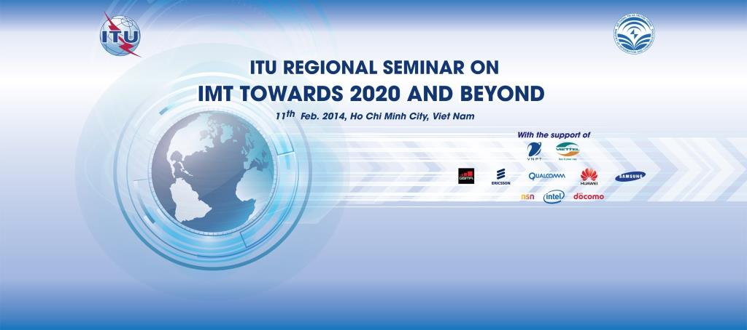
The ITU Asia-Pacific Regional Seminar on “IMT towards 2020 and beyond – Technology & Spectrum” is being organized by ITU and is kindly hosted by Ministry of Information and Communication of Viet Nam with support from various sponsoring entities; on 11th of February 2014 in New World Saigon Hotel, Ho Chi Minh City - Viet Nam.
The Seminar is essentially targeted towards the senior officials from Ministries, Regulators, Industry, National Spectrum Managing organizations, academia and International organizations involved in developing ICT policies, regulations, operations, strategies and other associated development activities in Asia Pacific region.
The objective of this event is to highlight the importance of IMT for ICT development and emphasize the need to adopt harmonized solutions to issues related technological advancement and spectrum availability for IMT systems in future. It will give good insight into the development of IMT technologies near term as well as on ITU and external research activities for beyond 2020 and provide the opportunity to ask questions to those experts involved in the work. The provisional program and other relevant information including the practical information for participants, registration and fellowship request forms of the event could be accessed at:
http://www.itu.int/en/ITU-D/Regional-Presence/AsiaPacific/Pages/Events/2014/Feb_Vietnam/IMT2020.aspx
Please Note:
This one day event would be followed by the meeting of ITU-R Working Party 5D, the group dealing with IMT systems, from 12-19 February 2014 details of which can be found at: http://www.itu.int/md/R00-SG05-CIR-0044&type=sitems/es

PROGRAM

TECHNOLOGY SESSION (TS)
Moderated by : Mr. Hakan Ohlsen, Ericsson Vietnam
​Topic | ​Speaker
Seminar Opening | ​Mr. Doan Quang Hoan, Director General ARFM
Seminar remarks | Ms. Aurora Rubio, Head ITU AO for south east Asia
Seminar Address | ​Mr. Stephen Blust, Chairman ITU-R WP5D
Mobile market and traffic growth | Ms. Amy Sanders, ALU
​3GPP IMT technology development and spectrum aspects | ​Mr. Antti Toskala, NSN
Research trends and IMT beyond 2020 | ​Mr. Johan Skold, Ericsson
Mobile​ devices and services – Present & Future | ​Mr. Haeyoung Jun, Samsung
Spectrum and technology in Vietnam | ​Mr. Dinh Chi, ARFM
​Questions and Answers
​

SPECTRUM SESSION (SS)
Moderated by: Mr. Le Van Tuan, ARFM
IMT activities conducted by ITU-D | ​Mr. Aamir Riaz, ITU-D
Estimated future spectrum needs for IMT | ​Mr. Hiroyuki Atarashi, NTT DoCoMo
LSA facilitates national spectrum access for IMT | ​Mr. Eiman Mohyeldin, NSN
​IMT for developing countries | Mr. Soglo Bienvenu, Qualcomm
​New trends on TV-Content Consumption | Mr. ​Lasse Wieweg, Ericsson
Possible candidate bands for IMT for WRC-15 | ​Mr. Jiao Jian, Huawei
Sharing and compatibility studies towards WRC-15 | ​Mr. Reza Arefi, Intel
​Questions and Answers

