**Session 7: Policy and Regulation**

Dr.Naranmandakh.T, General-Secretary, Communications Regulatory Commission, Mongolia

**Title: Regulatory Frameworks in ICT Sector of Mongolia**

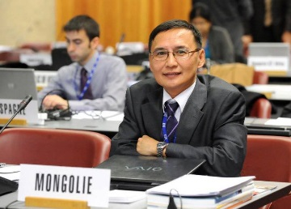**Bio:**

He has been appointed the General-Secretary at the Chairman’s Office, Communications Regulatory Commission of Mongolia from 2012, and joined as Director General of Department since 2008.

Prior to this he was Senior officer, Vice-Director, Director-General at various Government organizations as civil servant such as National Development Board, Department of Telecommunications, Ministry of Infrastructure and Development, Post and ICT Authority, Mongolia.

He has almost 30 years of experience in the field of communications. With his extensive knowledge of ICT, he has worked in many national and sector development initiatives of the country. He has been made tremendous contributions in ICT development of Mongolia, including the establishment of the USOF and Regulatory authority, heavily involved in the activities to restructure and develop the country’s ICT sector policy program, and improvement in management of regulatory body.

He has also attended and actively participated in a number of regional and international events and conferences on ICT development and regulations. Dr.Naranmandakh has presented several papers, including co-rapporteur of CG (APT), and chaired meeting sessions the ITU/APT events.

He holds an M.Eng in Telecommunications from Asian Institute of Technology, Thailand, and obtained Ph.D. degree in Information Networks from Mongolian University of Science and Technology.

**Abstract:**

The presentation will start brief overview of the Government structure of ICT sector, implementation ofkey sector development plans/program and initiatives in Mongolia. Then, policy and regulatory framework experiences for introduction new ICT service and technology in market, partnerships with private sector and cooperation NGO. Paper will touch some regulatory frameworks for unique ICT needs and challenges for landlocked developing countries like Mongolia. Results examples of international projects with ITU and other organizations on policy and regulations. Some aspects will cover including inputs/outcomes proposals for session and coordination of national ICT policy and regulatory frameworks with ASP regional initiative, activities and partnerships by regional organizations, governments, industry and other development partners supports.