**Mr. Pavel Mamchenkov**

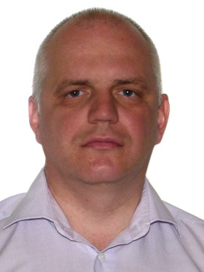Throughout the whole period of professional career in telecommunications Mr. Pavel Mamchenkov is directly involved in regulation, development, operation and researches of the latest advances in telecommunication with the primary emphasis on radiocommunications and spectrum management in government, private sector and socio-economic related trends in telecommunications on global, regional and national basis. The comprehensive experience includes intensive activities in spectrum management area focused on development of strategies, implementation of economic aspects in regulation, spectrum re-allocation and re-farming, spectrum sharing as well as spectrum pricing and further related topics.

***Experience and Competencies***

26 years of professional engagement in telecommunications, radiocommunication and spectrum management, of which twelve years of research and analysis practice with R&D centres, seven years of regulatory practice with the Telecommunication Administration, and seven years of operational spectrum planning practice with mobile operator company.

More than 18 years of participation in ITU activities resulting in the strong knowledge of spectrum regulatory procedures, allocation methods, legal instruments, software tools and issues at the international level. The qualified ITU’s expert. Six missions on Spectrum Management and ICT Development in developing countries to carry out surveys of national spectrum regulatory institutions, development of spectrum management master-plans.