|  |
| --- |
| **ITU Regional training on “Planning Internet of things (IoTs) networks”**  **25 – 28 September 2018**  **Bandung, Indonesia** |
|  |

**PRACTICAL INFORMATION FOR PARTICIPANTS**

1. **Venue**

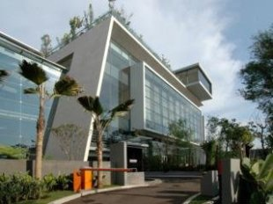

The ITU Regional training on “Planning Internet of things (IoTs) networks” will be held in Bandung, Indonesia, 25 – 28 September 2018, at:

**Hotel Hilton Bandung (Ballroom)**

Jalan HOS. Tjokroaminoto No.41-43, Bandung, West Java, Indonesia

1. **Accommodation**

Hilton Hotel (also meeting venue for the events)

Hilton Hotel is ideally located for business and leisure travellers. The Hotel is on the most prominent road in bandung – Pasirkaliki area, near the City Centre and major cultural attractions of Bandung, West Java - Indonesia. The Hotel is just 20 minutes’ drive from Husein Sastranegara International Airport.

The design and decoration provides a unique ambience and a sense of warmth and intimacy. Furthermore, the hotel's host of recreational offerings ensures there is plenty to do during your stay. Discover an engaging blend of professional service and a wide array of features at Hilton Hotel.

**Hotel Hilton Bandung (venue)**  
Jalan HOS. Tjokroaminoto No.41-43, Arjuna, Cicendo, Kota Bandung, Jawa Barat 40172

Tel.: (+62 22) 86066888  
Fax.: (+62 22) 86066888  
Website: <http://www3.hilton.com/en/hotels/indonesia/hilton-bandung-BDOHIHI/index.html>   
E-mail: [Nadia.Nalarrhine@hilton.com](mailto:Nadia.Nalarrhine@hilton.com) or [Ringsing.Wulandari@hilton.com](mailto:Ringsing.Wulandari@hilton.com)

*Free return airport transfers (for minimum two consecutive nights*

***Booking period: immediately until 20 September 2018***

|  |  |  |
| --- | --- | --- |
| **Official accommodation** | Room type | Room rate |
| **Hotel Hilton Bandung (venue)** Jalan HOS. Tjokroaminoto No.41-43, Arjuna, Cicendo, Kota Bandung, Jawa Barat 40172  Tel.: (+6222) 86066888 Fax.: (+6222) 86066888 Website: <http://www3.hilton.com/en/index.html>  E-mail: [Nadia.Nalarrhine@hilton.com](mailto:Nadia.Nalarrhine@hilton.com) or [Ringsing.Wulandari@hilton.com](mailto:Ringsing.Wulandari@hilton.com)  Related image  **Rate includes:**   * Daily International Buffet Breakfast * Free Wi-Fi connection * In-room tea and coffee making facilities * Daily replenished in-room mineral water   **Indonesian nationals are requested to contact the Sheraton reservation team:**  Name: [Ringsing.Wulandari@hilton.com](mailto:Ringsing.Wulandari@hilton.com)  Tel.: (+6222) 86066888 | Deluxe Room  Premium  Executive  Junior Suite | IDR 1,000,000 nett  IDR 2,000,000 nett  IDR 1,750,000 nett  IDR 3,500,000 nett |
| **Alternative accommodation in the vicinity of the meeting venue, to be individually arranged by each delegate** |  |  |

1. **Visa and Immigration Requirements**

While holders of Diplomatic Passports or Ordinary Passports from ASEAN Member States do not require visa to enter Indonesia for a visit less than 14 days, other Asia Pacific countries may need a visa to enter Indonesia. No matter what type of visa you are going to use, your passport must be valid for at least 6 (six) months from the date of your arrival.

• USD 10 for 7 days.

• USD 25 for 1 month per person.

Visitors eligible for a visa-on-arrival facility are nationals from: Australia, India, Iran, Japan, Maldives, New Zealand, People’s Republic of China, Republic of Korea and Taiwan.

Visitors with the visa-free facility will be able to proceed directly to the immigration clearance counter. The countries and administrative districts to be granted the 30-day visa-free facility are as follows: Brunei Darussalam, Hong Kong Special Administrative Region, Macao Special Administrative Region, Malaysia, Singapore, Thailand, the Philippines, and Vietnam.

Kindly check current visa requirement with your respective embassies of Ministry Foreign Affairs of travel agent before travelling. The procedure how to obtain visa can be access through <https://www.kemlu.go.id/en/pelayanan-kekonsuleran/Default.aspx>

1. **Transportation from and to Airport/Train Station**

Airport taxis are available from Husein Sastranegara International Airport and Bandung rail Station to the Hilton Hotel and the other Hotels with a fare of around IDR 100,000 (about US $7). Delegates need to arrange their own transportation from airport/Rail Station to their respective hotels. Delegates  are  free  to  choose  where  to  stay  at  the  nearby  hotels  but  no  transportation will be provided.

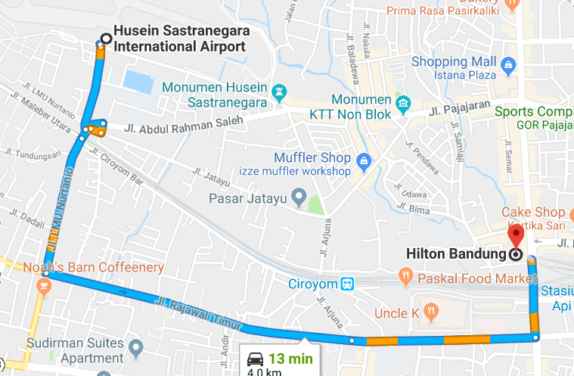

Bandung train station to Venue is approx. 7mt walking distance.

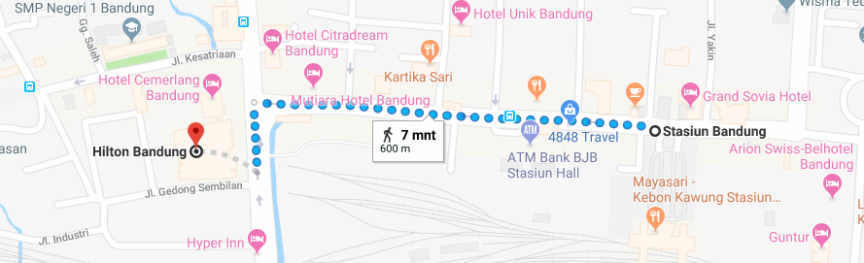

1. **Communication**

The Country Code for Indonesia is +62

The City Code for Bandung is +66(0)22

Area Codes in Indonesia are referred to as STD codes. STD codes for some cities are: Bandung: (0)22

Dialing Indonesia: Landline

International access code (00 or +) followed by 62, then STD CODE followed by Landline no.

e.g. +62 22 XXXXXXXX

Dialing Indonesia: Mobile

International access code (00 or +) followed by 62 and the 10 / 11‐digit Mobile no. eg. +62 XXXXXXXXX.

1. **Language**

English is spoken in most hotels, shops and restaurants as well as in major tourist destinations.

1. **Tourism information**

**Shopping Area**

Bandung is famous for its culinary and factory outlets. Here are some Factory Outlet Information:

1. Jeans lovers will find their need at Jalan Cihampelas is only 10 minutes drive from the hotel.
2. Factory Outlets at Jalan Dago is only 15 minutes drive from the hotel.
3. FO Rumah Mode at Jalan Setiabudi is only 10 minutes drive from the hotel.
4. Factory Outlets at Jalan Riau is only 20 minutes drive from the hotel.
5. Paris Van Java Mall is only 15 minutes drive from the hotel.
6. Ciwalk Mall from the hotel is only 10 minutes drive, located at Jalan Cihampelas.
7. Bandung Super Mall is only 30 minutes drive away, located at Jalan Gatot Subroto.
8. Pasir Kaliki Mall...
9. Trans Studio
10. **Weather**

The weather in Bandung is usually mild, humid, with occasional light rain. Average temperature range in Bandung during September varies from 23o to 30o Celsius (73o to 86o Fahrenheit). medium tropical clothing would be appropriate. The conference rooms where the meetings will be held are air-conditioned, with a temperature maintained in the range of 23o to 24o Celsius (73o to 75o Fahrenheit).

1. **Time**

Time in Bandung, Indonesia, is 7 hours ahead of Greenwich Mean Time (GMT +7).

1. **Electricity and power sockets**

|  |  |
| --- | --- |
| In Indonesia, the standard current is 220 volt AC with a frequency of 50 Hz. The picture shows the main type of power socket used in Indonesia. Participants should therefore ensure to bring the appropriate adaptor for their electrical appliances. | D:\Z' Downloads\images.jpg |

1. **Currency**

|  |  |
| --- | --- |
| The official currency in Indonesia is Rupiah (IDR/Rp). Bank notes are Rp 100.000, Rp 50.000, Rp 20.000, Rp 10.000, Rp 5.000, Rp 2.000, Rp 1.000. The approximate exchange rate at the time of preparation of this information note is:  USD 1 = Approx Rp 14 400 (XX Agustus 2018)  Major currencies can be exchanged in all banks, money changers, and airport. Banks are open from 0800h to 1500h on weekdays. Money changers can also be easily found at tourist spots. Delegates are strongly recommended to use registered money changers that have the “PVA” logo. |  |

**Contacts**

|  |  |
| --- | --- |
| **Mr Andreas Christiono ITU Area office for Southeast Asia & Timor Leste** Jakarta Tel.: +62 21 380 2322 / 2324 Fax.: +62 3890 5521 Mob.: +62 852 1085 9616 E-mail: [andreas.christiono@itu.int](mailto:andreas.christiono@itu.int) | **Mr Brian Dipta Pratama**  **Ministry of Communication and information Technology**  Directorate Standardization of postal and ICT equipment  Tel.:021 3835840  Fax : 0213835845  Mob.:085716262488  Email : Bria001@kominfo.go.id |

_______________