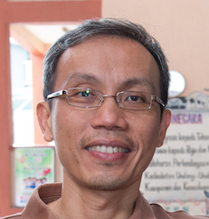 | Chan Fook Wing  Centre for Agriculture and Biosciences International (CABI)

Mr. Chan Fook Wing works as an IT Specialist with CABI (Centre for Agriculture and Biosciences International). CABI is an international not-for-profit organization working to improve lives by providing information and applying scientific expertise to solve problems in agriculture and the environment. He has managed and supported international development projects in agriculture, nutrition, ecosystems and the environment. Trained as an engineer, his expertise and experience are in building databases, websites, operating and maintaining IT networks and operating systems.

