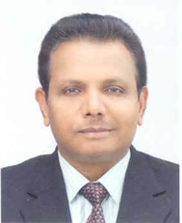 | Sanjay K Srivastava, Ph D  Chief of Disaster Risk Reduction  Economic and Social Commission for Asia and the Pacific (ESCAP)

Sanjay K Srivastava, Ph D (Applied Physics), is presently Chief of Disaster Risk Reduction at UN Economic and Social Commission for Asia and the Pacific (ESCAP). He was ESCAP Regional Adviser on Disaster Risk Reduction from Oct 2009 to June 2014; Head of SAAARC Disaster Management Centre – New Delhi from 2007-2008; Deputy Project Director of Disaster Management Support Programme at Indian Space Research Organisation (ISRO); Scientist/Engineer at ISRO HQ Bangalore since 1991. He is the recipient of ISRO’s Team excellence award in 2008-09 for his contributions towards harnessing space technology applications for the benefits of rural poor.
He has more than 100 publications on disaster risk reduction, including research papers in peer reviewed international journals, intergovernmental reports and books. His areas of expertise include: Early warning systems for hydro-metrological disasters, ICT and space applications for disaster response and risk assessment, post-disaster need and damage assessment and recovery planning, integration of disaster risk reduction in climate change adaptation, mainstreaming disaster risk reduction in sectoral developmental planning and indigenous knowledge for disaster risk reduction.

