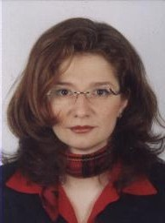 | Dr. Nevena Alexandrova-Stefanova  Agricultural research, innovation systems and knowledge-sharing

B.Sc. in Molecular Biology; M.Sc. in Plant molecular biology and physiology; M.Sc. in Pedagogy; PhD in marker-assisted plant biotechnologies; post-doctoral fellowship in biosafety for developing countries (ICGEB, Trieste, Italy).
She joined FAO and the Regional Office for Europe and Central Asia in 2008 after having twelve years of experience as researcher, research manager and science-communicator in agricultural biotechnologies, biosafety, and knowledge-sharing issues on national and international levels. Presently, her areas of work cover agricultural innovation systems (AIS) and knowledge-sharing for sustainable agricultural development in the region. The areas, where the programme is currently focused, are policy advice and practical approaches to provide better access to demand-driven knowledge, research and education, and services to smallholder farmers (men and women), including through information and communication technologies (ICTs); generation and adoption of sustainable technologies and frameworks that would improve farmers’ livelihoods and provide benefits for environment.
Languages: Bulgarian, English, French, Russian, Italian, German, and some Spanish.

