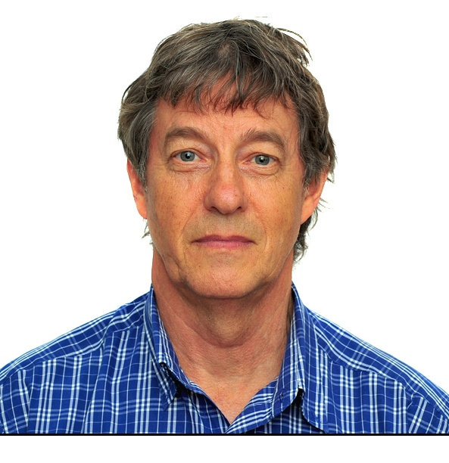
Dr. Noel Magor is head of Unit Impact Acceleration at the International Rice Research Institute’s (IRRI).
He provides leadership for building the framework and principles for enabling rapid and large scale impact of improved rice systems technologies along the value chain. This includes innovations in gender and marginal farmer inclusion, mulit-channel delivery of seed and crop production and post-harvest innovations, ICT for extension and capacity building.
The purpose is to provide an environment for IRRI with strong public, private and civil society partnerships that is catalytic for technology out-scaling and up-scaling. The unit supports and complements IRRI’s research divisions of social sciences, crop and environmental sciences, plant breeding and partnerships and communication. The team may form expert alliances for ICT for Extension, for farmer business organization and as appropriate.
Dr. Magor’s career over 40 years has focused on easy-to-implement and sustainable rural development solutions. Expertise spans agricultural technology development, ICT for Extension, understanding and inclusion of women and small and marginal farmers and the mobilisation of public, civil and private organisations for long-term collective impact and capacity development for the next generation of rice scientists and rural industry agricultural service providers.
Dr. Magor obtained his PhD from the Department of Politics in Adelaide University. He also has a MAgr in Tropical Agronomy from Sydney University, a Graduate Diploma Teaching (Sec) from Adelaide CAE, and a BAgSc, also from Adelaide University.

Dated: August, 2016

