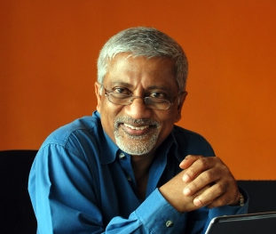 | Rohan Samarajiva  Founding Chair  LIRNEasia

Professor Rohan Samarajiva is founding Chair of LIRNEasia, an Asian infrastructure policy and regulation think. Since 2006, LIRNEasia has been working on agricultural value chains with a focus on knowledge, information and technology. Currently LIRNEasia is testing a mobile app intended to assist smallholders adhere to standards for export. Professor Samarajiva has held appointments at universities in the United States and the Netherlands and served as Director General of the Telecommunications Regulatory Commission of Sri Lanka.

