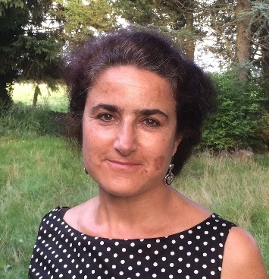 | Treinen Sophie  Food and Agriculture Organization of the United Nations  Knowledge Outreach Team Leader  Coordinator of Knowledge Management and Gender Programme  Facilitator of World Summit on Information Society e-agriculture Action Line

Ms. Sophie Treinen is the Knowledge Outreach Team Leader at the Food and Agriculture Organization of the United Nations, where she is responsible for the organization’s good practices and the use of Information and communication technologies in agriculture, managing an international team of professionals. Her team provides assistance worldwide to interventions addressing the role of information, communication and knowledge sharing in rural areas. Her major responsibility is to develop approaches for developing institutional and individual capacities to share knowledge, capitalize on experiences and good practices. She pays particular attention to systems which make the most of digital and more conventional technologies to address stakeholders’ needs. She is also applying participatory approaches and examining gender issues linked to the introduction of new digital Information and Communication Technologies (ICTs).
With about 30 years of experience, Sophie possesses a varied experience in raising awareness for sustainability issues within the UN, governments, private sector and civil society. She is the FAO Focal Point for the World Summit on the Information Society Action Line on e-agriculture and served as the Organization’s Communication Lead for the UN Global Information Society Group.

Before her assignment with FAO, she worked for international cooperation and development organizations (European Union, Non-Governmental Organizations and private sector).
She is a member of the International Association of Facilitators (IAF) and a member of the Knowledge Management for Development Community (KM4Dev) and FAO focal point on knowledge management and knowledge sharing of Learn4Dev network.

Contact: sophie.treinen@fao.org

