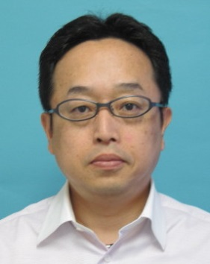 | Tetsuya UCHINO  Business Strategy Unit.  (Global Business/Social Inovation)  Fujitsu Kyushu Systems Limited

■Since joining Fujitsu Kyushu Systems Ltd. in 1991, I've worked as an Account Engineer on Fujitsu Business PKG and ERP systems, pre-sales and global business development on both domestic and international scales for over 25 years.
■Encompassing my entire career, including 8 years of foreign residence, I have more than 15 years of experience in the global business field.

