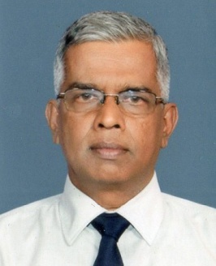 | W.A.G. Sisira Kumara  Director (Information and Communication), Department of Agriculture under the Ministry of Agriculture, Sri Lanka

W.A.G. Sisira Kumara graduated for BSc in agriculture and did his masters in Communication Designing in UK. He joined the Department of Agriculture in 1984 as a Subject Matter Specialist in Horticulture and later he developed skills in AV media and ICTs. Now, he is working as the Director (Information and Communication) at the Department headquarters. His centre involved in the production of radio, video and print media, and promotion of agro tourism and implementing ICT’s for food crop sector.

He played a major role for developing ‘Sri Lanka E-agriculture Strategy’ with the assistance of FAO, ITU and CABI.

