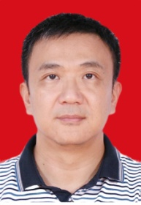

DR WU YIN, SENIOR ARCHITECT CHINA COMMUNICATIONS SERVICES CHINA
Profile

Dr. Wu Yin received PhD in wireless communications from University of Newcastle upon Tyne, UK. Dr. Yin has been working in the wireless communication fields more than 25 years and he has both academic as well as industrial experiences, where he has been working for the top wireless communication company in the world, i.e. Huawei Technologies and ZTE Corporation, as an architect for six years. Dr. Yin so far has more than 50 granted wireless communications patents and many of them have been applied in practice. Dr. Yin has been appointed as one visiting fellow in the CCSR research centre of Surrey University, which is ranked top three among European universities in wireless communication. Dr. Yin has been appointed as the president of the IOT agriculture & environment committee in Guangdong province, China, and his team achieved many successful IOT agriculture application such as in the poultry, farming and fishing industry fields, and received many national honors and awards. In addition, Dr. Yin is also a senior expert in China communication service and senior consult in many government association.

