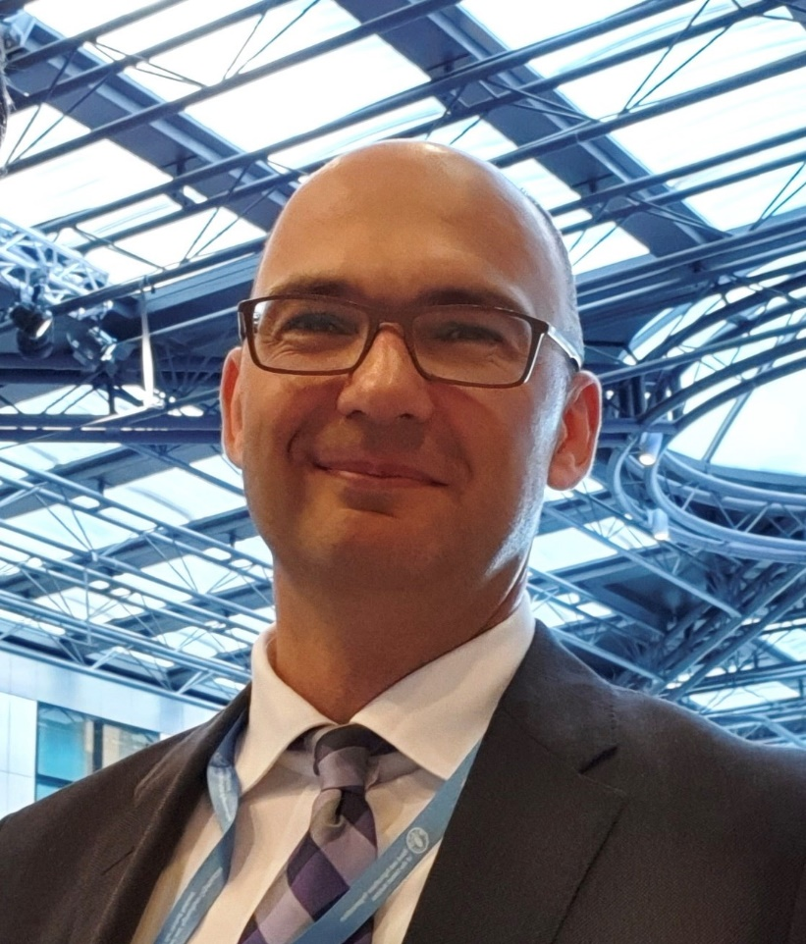
Mr Jakovljevic is the Deputy Director of IT Division of FAO , with more than 20 years of IT experience and use of technology in the International Development. He is a strategic leader in the field, aiming to harness the power of technology towards achieving SDG goals. His work focuses on driving Digital Transformation, organizational modernization and enabling Innovation scale up and delivery.

Prior to joining FAO, Mr Jakovljevic held positions with UNICEF and WHO , with leadership roles in East Asia and Pacific, European Region, and driving Global initiatives in the other parts of the world.

Mr. Jakovljevic has Master's and Bachelor’s degrees from the University of Houston, Texas.

