Bio
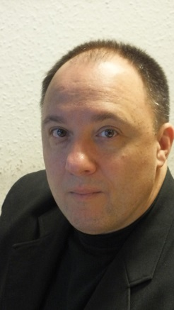
I was graduated in Kiev in 1989 as a locator engineer and I worked for the army and the governmental frequency management until 2000.
I am currently employed by the National Media and Infocommunication Authority, Hungary since 2000 as a frequency manager, where I am responsible, among other tasks, for the legal regulation of the Hungarian frequency management and its IT support.

