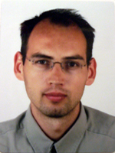
Robert Bestak obtained the PhD degree in Computer Science from ENST Paris, France (2003) and MSc degree in Telecommunications from Czech Technical University in Prague, CTU, (1999). Since 2004, he has been an Assistant Professor at Department of Telecommunication Engineering, Faculty of Electrical Engineering, and CTU. His main research interests include 5G networks, big data in mobile network, and spectrum management. He is the Czech representative in the IFIP TC6 working group. He has served as Steering and Technical Program Committees member for numerous IEEE/IFIP international conferences (Networking, WMNC, NGMAST, etc.). He participated in several national and EU founded research projects (FP7-ROCKET, FP7-TROPIC, etc.)

