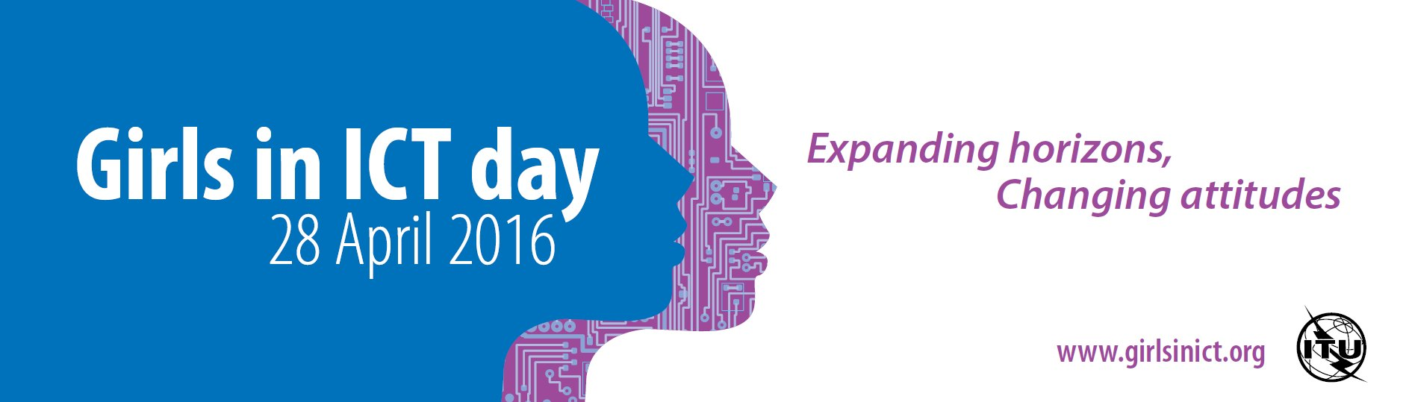

**Girls in ICT Day Quiz**

1. Since when the International Girls in ICT Day has been celebrated worldwide?
2. 2001 b) 2006 c) 2011 d) 2015
3. Which ITU Plenipotentiary Resolution calls for celebration of International Girls in ICT Day?
4. 15 b) 35 c) 70 d) 140
5. According to the ITU PP Resolution, when should be celebrated the International Girls in ICT Day?
6. 1st Monday of January of every year
7. 2nd Tuesday of February every year
8. 3rd Wednesday of March every year
9. 4th Thursday of April every year
10. Since its inception, in how many countries Girls in ICT Day has been celebrated?
11. 20 b) 50 c) 100 d) 150
12. Since its inception, how many events have been organized within framework of Girls in ICT Day worldwide?
13. 100 b) 1000 c) 5000 d) 10000

M / F

1. Gap in Internet user penetration rate between males and females is
2. 15.4% in developed countries and 5.4% in developing countries
3. 5.4% in developed countries and 15.4% in developing countries

Here, please write your   
four digit number

__ __ __ __

1. 11.4% in developed countries and 3.4% in developing countries
2. 29.4% in developed countries and 33.4% in developing countries
3. Which of statements below are true for Europe?   
   (More than one answer is correct)
4. Less than 30% of the ICT workforce are women
5. 19% of ICT entrepreneurs are women

Here please write your   
four digit number  
(the same as above)

__ __ __ __

1. 9% of app developers are women in Europe
2. Only 20% of European women aged 30 with ICT-related degrees   
   work in ICT sector
3. Which Sustainable Development Goals are of special importance to Girls and   
   ICT Day movement (More than one answer is correct)?
4. SDG 4 (Quality Education)
5. SDG 5 (Gender Equality)
6. SDG 8 (Decent Work and Economic Growth)
7. SDG 10 (Reduced Inequalities)