  INTERNATIONAL TELECOMMUNICATION UNION |  |   AGENCY FOR ELECTRONIC COMMUNICATIONS AND POSTAL SERVICES

International Conference: Regulating the Electronic Communications Market
26 September – 27 September 2016

The Regional Development Forum for Europe
27 September – 28 September 2016

Budva, MONTENEGRO

The Agency for Electronic Communications and Postal Services (EKIP) and the International Telecommunication Union (ITU) – the Telecommunication Development Bureau, are organizing the 14th International Conference “Regulatory activity in the electronic communications sector”. The Conference under the working title “Regulating the Electronic Communications Market”, whose programme activities are connected with the Regional Development Forum for Europe (RDF) will take place within the Festival of ICT achievements - INFOFEST 2016, as we previously informed by the invitation letter in June 2016.

With the sincere hope that you will accept our invitation to participate in the Conference, we would like to take the opportunity to inform you that these meetings, intended to take place in the hotel "Maestral" in Przno, will be held in the hotel "Avala Resort & Villas" in Budva - the most famous Montenegrin tourist centre.

Bearing in mind that this year’s Conference represents a continuation of the activities in the area of the regulation of the electronic communications sector, and that Regional Development Forum for Europe represents an opportunity for high-level dialogue between experts of ITU - the Telecommunication Development Bureau and decision-makers, governments and regulators of ITU Member States, Sector Members and Academia within separate programme sessions, the most actual topics are envisaged for the consideration, as follows:
- Market analysis and regulatory measures prescribed to the operators with significant market power,
- Digital Single Market,
- Mapping of broadband infrastructure and services,
- Quality of Service and Experience,
- Network neutrality,
- Roaming,
- Service quality,
- Use of limited resources,
- User protection,
- Future development plans.

With that regards, we expect that the representatives of the European regulatory agencies, ministries, operators of electronic communications, as well as the representatives and experts from international organizations and institutions responsible for policy development and regulation of electronic communications to participate in the Conference and the Regional Forum and thereby contribute to their success and quality.

We also take this opportunity to remind that all those who are interested in participation in the Conference and Forum in the capacity of panellists or speakers are invited to submit the name of their presentation by 1 September 2016 to the e-mail address conference@ekip.me, whereas their presentations should be submitted by 20 September 2016.

Documents relating to the Conference and the Regional Forum, including the Agenda, the Registration Form and Practical Information for participants will be posted on:
- the website of the Agency for Electronic Communications and Postal Services (EKIP):
http://www.ekip.me/eng/Infofesteng/index.php
- the website of the International Telecommunication Union (ITU) http://www.itu.int/en/ITU-D/Regional-Presence/Europe/Pages/Events.aspx,

The Conference will be held in English and Montenegrin with simultaneous interpreting in both languages.

Participants who may need an entry visa for Montenegro should contact the nearest embassy or consulate of Montenegro for assistance well in advance. A list of embassies and consulates of Montenegro in the world can be found on the website of the Ministry of Foreign Affairs and European Integration: http://www.mvpei.gov.me/rubrike/misije/Ambasade-i-konzulati-CG-u-svijetu/

As in all previous years, the organizers of the Conference will provide other contents for the participants of the Conference, which will contribute to a relaxed working atmosphere in order to achieve best possible effects of the mutual communication of participants (cocktail and a boat trip around the Bay of Kotor).

We look forward to meeting you and spending time together in the hotel "Avala Resort & Villas" in Budva, in the beautiful Mediterranean setting.

TIME AND VENUE OF THE CONFERENCE

The Conference will be held:
- on Monday, 26 September 2016, 09:30 – 17:00, and
- on Tuesday, 27 September 2016, 09:30 – 13:00.

The Regional Forum will be held:
- on Tuesday, 27 September 2016, 14:00 – 18:00, and
- on Wednesday, 28 September 2016, 09:30 – 13:00.

Both events will take place in the hotel "Avala Resort & Villas" in Budva, an impressive contemporary building, just a few steps away for the beautiful Old Town and yachts marina.

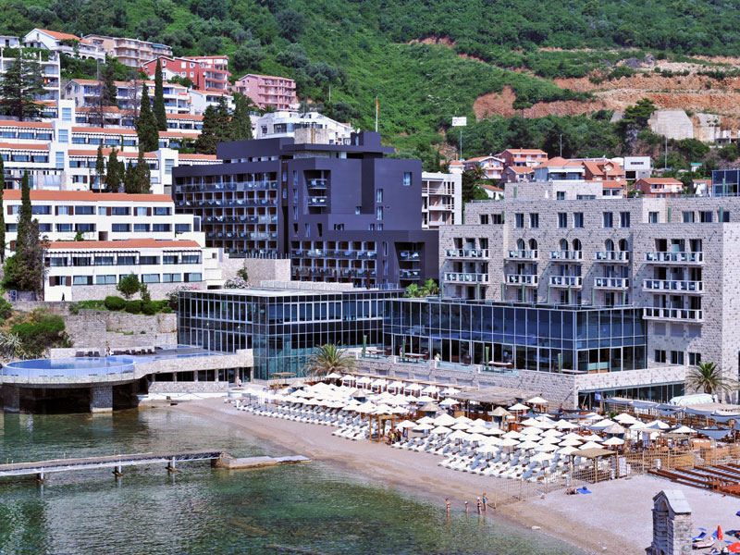
„Avala Resort &Villas“, beachfront design architecture hotel anchors the historic Budva, nearby the Old Town where the beaches and port meets the timeless Adriatic sea and represents a unique location for modern urban visitors to Montenegro. The guests should expect panoramic sceneries, an exceptional restaurants and lounge bars, Spa club, panoramic outdoor swimming pools, musical and cultural events and much more, which is reason why we hope that inspite of the location change, your stay in Montenegro will make unforgettable.

Old Town Budva

Old Town Budva, one of the oldest settlements on the Adriatic coast, according to historical records first mentioned more than two and a half thousand years ago as the “town of Illyria,” is a place that must be visited during a stay in the Montenegro.

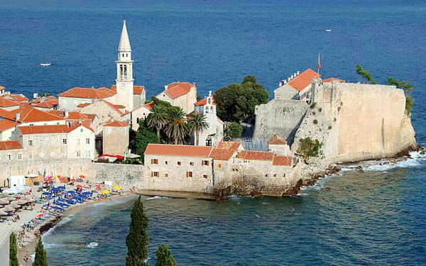
The Old Town is a unique architectural and urban whole, surrounded by medieval walls, complete with a fortress, towers and gates. Along the narrow streets and on the small piazzas and squares, there are lines of cafes, boutiques, bars, restaurants, galleries, while the town becomes a genuine “Theatre City” during the summer months, named by the festival which has been enriching this old costal town for the last 3 decades, lending it a special colour and charm.

Its many religious buildings – the oldest church of Santa Maria in Punta, the Church of St John and the Church of St Sabbas the Sanctified – have the special value. Next to the Church of St John are the remains of an early Christian basilica while the remains of the Church of St Maria are located on the Citadela. Original Roman columns, set into the walls of Budva’s oldest gate, can also be seen in the Old Town. The main cultural institutions include the City Museum of Budva, with its archaeological and ethnographic collections, the Modern Gallery and the memorial home of “Stefan Mitrov Ljubisa” are also to be found there.

The climate is mild and sunny throughout the tourist season from May till the end of October. The average number of sunny days in a year is 240, and the season lasts for 180 days. The sea is dark blue with transparency of 38 to 56 meters.

Distance from Budva:
Tivat airport: 20 km
Podgorica: 64 km
Podgorica airport: 68 km
Cetinje: 33 km
Bar 40 km
Kotor: 22 km
Miločer: 8 km
Sveti Stefan: 10 km

CONDITIONS FOR PARTICIPATION AND APPLICATION FORM

The Regulatory Conference and the Regional Forum will be held within the Festival of ICT achievements - Infofest 2016. In addition to participation in the Conference, all registered participants can attend the programme contents of the Infofest.

More information on Infofest 2016 may be found at www.infofest.com.

The Application Form for Participation in the Conference and the Regional Forum as well as the terms and conditions for participation can be found attached to this Invitation Letter.

Opening Ceremony of the Infofest 2016 will held on 25 September 2016 at 20:00.

CONTACT

Contacts of the Conference and the Regional Forum organizers are as follows:

Agency for Electronic Communications and Postal Services of Montenegro
Tel: +382 20 406 700
Fax: +382 20 406 702
E-mail: conference@ekip.me
Address: Bulevar Džordža Vašingtona 56, II sprat, 81000 Podgorica, Montenegro
Contact person: Mr Boris Jevric
Related website: http://www.ekip.me/eng/Infofesteng/index.php

or

International Telecommunication Union (ITU)
Tel.: +41 22 730 6065
Fax: +41 22 730 6453
E-mail: EURregion@itu.int
Address: Place des Nations, 1211 Geneve 20, Switzerland
Contact person: Mr Jaroslaw Ponder
Related Website: http://www.itu.int/en/ITU-D/Regional-Presence/Europe/

