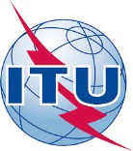
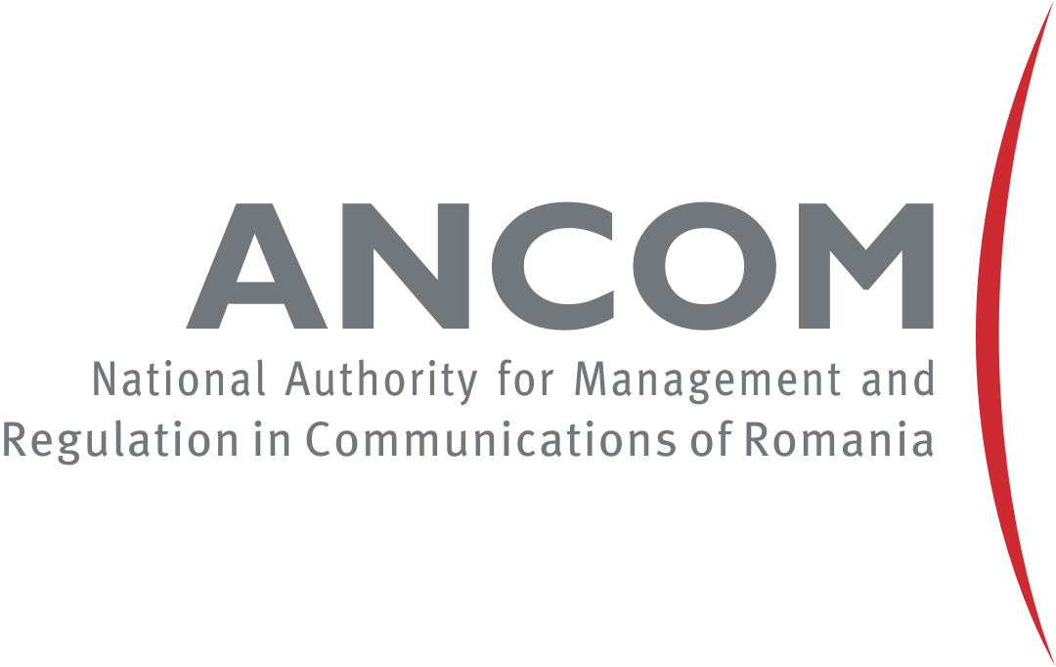

Regional Seminar for Europe and CIS
on
Spectrum Management and Transition to Digital Terrestrial Television Broadcasting
21-23 March 2016

Athénée Palace Hilton
1-3 Episcopiei

Bucharest, Romania

DRAFT AGENDA
Monday, 21 March 2016
9:00 – 10:00 | Registration
10:00 – 10:30 | Welcome Addresses  - Ministry of Communications and Information Society, Romania  - Mr. Bogdan Iana, Executive Director for Radio Spectrum and Numbering Management, National Authority for Management and Regulation in Communications (ANCOM), Romania  - Jaroslaw Ponder, Europe Coordinator, International Telecommunication Union
10:30 – 11:00 | Group Photo and Coffee Break
11:00 – 12:30 | Session 1: European Regional Initiative and actions in CIS region  - Update on the outcomes of WRC-15  Ms Ilham Ghazi, Head of Broadcasting Services Division, Radiocommunication Bureau, ITU  - Update on the outcomes of meetings on Q8/1 & Resolution 9 and workshop on analogue to digital transition and spectrum fee  Mr Istvan Bozsoki, Head, Spectrum Management and Broadcasting Division  - Update on the outcomes of the ITU Regional Workshop for CIS on Experience in the Implementation and Operation of Digital TV Broadcasting in the CIS  CIS Office, ITU (TBC)
12:30 – 14:00 | Lunch Break
14:00 – 15:20 | Session 2: Digital terrestrial television transition – national experiences with the transition and the legislation/regulation of the countries related to transition  - Albania  - Loreta Andoni, Coordinator of Innovation Department and Good Governance, Ministry of Innovation and Public Administration  - Vasil Mitezi, Director of Monitoring Department, Electronic and Postal Communication Authority (AKEP)  – Elkeda Domi, Head of Spectrum Monitoring Sector, Auddiovisual Media Authority  - Bulgaria  – Lyubomir Panchev, Expert, Ministry of Transport, Information Technology and Communications  – Vanya Staneva, Chief Expert Broadcasting Department, Communications Regulation Commission  - Greece  - Constantinos Bakalis, Hellenic Telecommunications & Post Commission (NRA)  - Hungary  - Pados László, National Media and Infocommunications Authority  - Montenegro  - Jelena Vulicevic Gordijan, Manager for Maritime and Airspace radiocommunications and PMR Systems, Agency for Electronic Communications and Postal Services (EKIP)  - Vesna Popovic, Manager for Spectrum Management, Agency for Elctronic Communications and Postal Services (EKIP)  - Moldova  - Veaceslav Pascal, Technical Director, State Enterprise RADIOCOMUNICATII  – Tatiana Gândea, National Regulatory Agency for Electronic Communications and Information Technology (ANRCETI)  - Poland  – Aleksander Soltysik, Ministry of Digital Affairs  - Romania  - Laurențiu Tănase, Expert in the Audiovisual Unit, Radio Spectrum and Numbering Management Executive Division, ANACOM  - Serbia  - Milena Jocić Tanasković, Ministry of Trade, Tourism and Telecommunications  - Open Discussion
15:20 – 15:40 | Coffee Break
15:40 – 17:00 | Session 2 (cont’d): Digital terrestrial television transition – national experiences with the transition and the legislation/regulation of the countries related to transition – cont’d  - Country Experiences

Tuesday, 22 March 2016
9:30 – 10:50 | Session 3: Digital terrestrial television transition – ITU and broadcasters experiences with the transition  - Mr Istvan Bozsoki, Head, Spectrum Management and Broadcasting Division  - Ms Ilham Ghazi, Head of Broadcasting Services Division, Radiocommunication Bureau, ITU  - Mr Lars Backlund, Broadcast Networks Europe (TBC)  - Country Experiences - cont’d  - Open Discussion
10:50 – 11:10 | Coffee Break
11:10 – 12:30 | Session 4: Utilization of the Digital Dividend (DD)  - Ms Ilham Ghazi, Head of Broadcasting Services Division, Radiocommunication Bureau, ITU  - EBU (TBC)  - European Commission (TBC)  - Country Experiences (planned utilization and implementation)  (Albania, Bulgaria, Greece, Hungary, Montenegro, Moldova, Poland, Romania, Serbia, …)  - Open Discussion
12:30 – 14:00 | Lunch Break
14:00 – 15:20 | Session 5: Spectrum management  - Country Experiences (Structure, Spectrum management tools, Cross-border frequency coordination, spectrum fee, auctions, monitoring, etc.)  (Albania, Bulgaria, Greece, Hungary, Montenegro, Moldova, Poland, Romania, Serbia, …)  - Open Discussion
15:20 – 15:40 | Coffee Break
16:40 – 17:00 | Session 5 (cont’d): Spectrum management  - Country Experiences  - Open Discussion

Wednesday, 23 March 2016
9:30 – 10:50 | Session 6: Presentations  - BDT activities in field of Spectrum Management  Mr Istvan Bozsoki, Head, Spectrum Management and Broadcasting Division, ITU  - ITU-R Documents Database Search Facility  TBD, ITU  - SM tools (country demonstration if any)
10:50 – 11:10 | Coffee Break
11:10 – 12:00 | Additional proposals and conclusions  - Needs of countries for ITU assistance  - Moderated by Istvan Bozsoki and Jaroslaw Ponder, ITU  - Participating countries (Albania, Bulgaria, Greece, Hungary, Montenegro, Moldova, Poland, Romania, Serbia, …)  - Closing Remarks  - Jaroslaw Ponder, Europe Coordinator, ITU  - ANCOM
12:00 – 14:00 | Lunch

