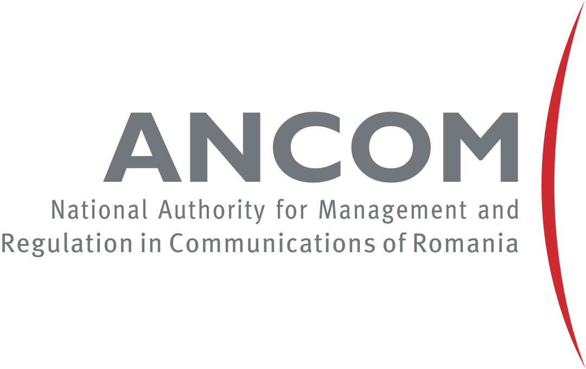

Regional Workshop on Spectrum Management and Transition to Digital Terrestrial Television Broadcasting for Europe and CIS,
Bucharest, Romania, 21-23 March 2016

REGISTRATION FORM

Women candidates are encouraged

(Please print/type clearly)
1. Mr/Ms ___________________________________ _________________________________________
(Surname) (First name)
2. Country ____________________________________________

3. Administration/organization _________________________________________________________________________

4. Title ______________________________________________________________________________________________

5. Tel.:________________________ E-Mail:________________________________________________

 | Date: |  |  | Signature:
Please fill in and send this Form  no later than 15 March 2016 to: |  |  | ITU: eurregion@itu.int

