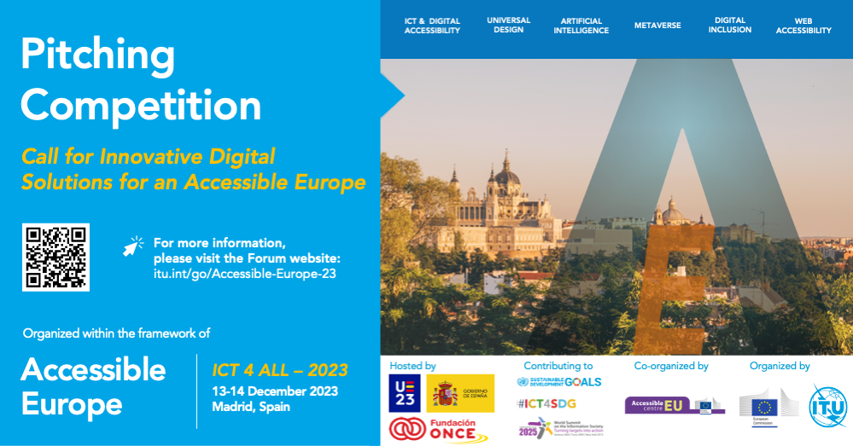

Submission Form for Pitching Competition:

Call for Innovative Digital Solutions for an Accessible Europe

1. Introduction

In its fifth edition, the [Regional Forum for Europe "Accessible Europe: ICT 4 ALL - 2023"](https://www.itu.int/go/Accessible-Europe-23) will feature the Pitching Competition for Innovative Digital Solutions for an Accessible Europe.

The Pitching Competition seeks submissions on new concepts of technology, digital applications or interfaces that are developed for use by persons with vision, hearing, speech, cognitive and physical disabilities. Albeit not exclusively, these may include hardware and peripherals for specific use, services accessible through the web or software integrated into mobile devices.

After an initial screening based on eligibility criteria, selected candidates will have the opportunity to present their innovative solutions in-person during a dedicated pitching session at the Regional Forum, where a public vote will be held to recognize the most impactful solutions presented.

Eligible projects will be compiled into a stocktaking report, published on the [Accessible Europe website (https://www.itu.int/go/Accessible-Europe-23)](https://www.itu.int/go/Accessible-Europe-23), and further disseminated within the European ICT stakeholder community. Interested participants will have their projects considered for the [World Summit of the Information Society (WSIS) Prizes](https://www.itu.int/net4/wsis/stocktaking/Prizes/) 2024.

Only submissions received before 25 October 2023 23:59 CEST (UTC+2) will be considered.

Kindly note that there is no submission fee. However, all travel, accommodation, and related expenses for attending the Forum will be borne by the competitors.

For any questions please email: [eurregion@itu.int](mailto:eurregion@itu.int) and [easurmen.itu@gmail.com](mailto:easurmen.itu@gmail.com).

Note: The application contains open-ended questions for which you need to prepare beforehand. Please check the submission template on [the Forum website](https://www.itu.int/go/Accessible-Europe-23).



14%

Next

2. Section 1 - Eligibility screening

**\* 1. What is the current development stage of your solution?**

*The solution must be in the final stage of development or have been finalized within the past three years.*

 In the final stage of development

 Finalized within the past three years

 Neither

Please provide a brief explanation or evidence supporting your response above.



**\* 2. Does your solution originate from the Europe region?**

[Link to the list of countries](https://www.itu.int/en/ITU-D/Pages/Contact/Geneva.aspx)

 Yes  No

Please provide a brief explanation or evidence supporting your response above.



**\* 3. Is your solution:**

* **Based on information and communication technologies,**
* **Compatible with most known operating systems,**
* **Compatible with widely available assistive accessibility devices or systems/platforms?**

 Yes  No

Please provide a brief explanation or evidence supporting all three points above.



**\* 4. Does your solution have a clear aim to benefit persons with disabilities and specific needs?**

 Yes  No

Please provide a brief explanation or evidence supporting your response above.



**\* 5. Which of the following categories best qualifies your project?**

 Persons who are deaf or hard of hearing

 Persons with visual impairments

 Persons with speech impairments

 Persons with cognitive and intellectual disabilities

 Persons with physical disabilities

Please provide a brief explanation or evidence supporting your response above.



**6. Does your solution fit into any other secondary category?**

 Persons who are deaf or hard of hearing

 Persons with visual impairments

 Persons with speech impairments

 Persons with cognitive and intellectual disabilities

 Persons with physical disabilities

Please provide a brief explanation or evidence supporting your response above.



29%

Prev

Next

3. Section 2 - General information about the organization and project

**\* 1. Name of Institution/Organization**

**\* 2. Type/legal entity**

*The pitching competition seeks submissions from individuals and teams across the private, public, non-profit, and academic sectors.*

**\* 3. Please provide a brief description of the Institution/Organization.** (Up to 3000 characters)

**\* 4. Name of the Solution**

*\** **5. Please provide a brief description of the Solution.** (Up to 3000 characters)

**\* 6. Where your Institution or Organization is registered**

Country/Territory

City

* + **7. Contact information of the Organization**

Telephone/Mobile (+country code)

Email

* + **8. Organization/Institution/Solution Social media and Website**

Website

LinkedIn

Facebook

Twitter

Instagram

Other 1

Other 2

43%

Prev

Next

4. Section 3 - General information about the submitter

The submitter will be considered as the focal point for any communications or queries about the submission.

**\* 1. Name(s) of the submitter (legal name as it appears in the passport)**

**\* 2. Last name(s) of the submitter (legal name as it appears in the passport)**

**\* 3. Occupational title of the submitter**

**\* 4. Contact information of the submitter**

Telephone/mobile (+country code)

Email address

Secondary phone number

Secondary email address

**5. If you have an additional contact person, please share their information.**

Name(s)

Last Name(s)

Role

Email address

Phone number

57%

Prev

Next

5. Section 4 - Solution description

**\* 1. Solution Overview: Photo 1**

Up to five high-resolution pictures of the solution, containing the main components (screen pictures or device pictures).

Please submit in PNG, JPG, JPEG formats.

Choose File

**\* 2. Solution Overview: Photo 2**

Up to five high-resolution pictures of the solution, containing the main components (screen pictures or device pictures).

Please submit in PNG, JPG, JPEG formats.

Choose File

**3. Solution Overview: Photo 3**

Up to five high-resolution pictures of the solution, containing the main components (screen pictures or device pictures).

Please submit in PNG, JPG, JPEG formats.

Choose File

**4. Solution Overview: Photo 4**

Up to five high-resolution pictures of the solution, containing the main components (screen pictures or device pictures).

Please submit in PNG, JPG, JPEG formats.

Choose File

**5. Solution Overview: Photo 5**

Up to five high-resolution pictures of the solution, containing the main components (screen pictures or device pictures).

Please submit in PNG, JPG, JPEG formats.

Choose File

**6. Solution Overview:**

Please provide a link to a video of the solution (if applicable)

**\* 7. Components Description:**

A description of the components of the solutions, including the interfaces, hardware or software, and the standards used or developed for the solution.

(Up to 2500 characters)

* **8. Main Use Case Scenario:**

A detailed description of the solution’s main use case, the actors involved (i.e. beneficiaries, collaborators), the sequence of actions, the input and outputs, etc.

(Up to 4000 characters)

**\* 9. Business Development Plan:**

Please outline your plan for business development of this solution.

(Up to 2000 characters)

**10. Please upload any instructions for use (if applicable) or any other related supporting documents for your solution here.**

Please submit in PDF format.

Choose File

71%

Prev

Next

6. Section 5 - Participation

* **1. Will a representative from your organization be able to attend and present your solution in English and in-person at the Accessible Europe pitching session, covering all related expenses for your participation?**

*Eligible competitors will be invited to present their projects in-person during the dedicated pitching session at the Accessible Europe Forum held on 13-14 December in Madrid, Spain. ITU is not able to provide financial assistance for this purpose; all associated expenses will be borne by the competitor.*

*The event will be conducted in English, and all presenters are kindly requested to present in English.*

 Yes  No

86%

Prev

Next

**1. I hereby certify that:**

 All information submitted is true, complete, and up-to-date.

 I have read, understood, and agree with all conditions and requirements set forth in the documentation provided for Accessible Europe 2023.

 I am authorized to submit this application on behalf of my institution/organization.

 My team adheres to ethical standards of conduct, and controls the majority of the intellectual property rights of the solution submitted. We account for the majority of the effort and resources dedicated to its creation and prototyping.

 The submission does not:

1. violate the intellectual property rights of third parties;
2. contravene applicable national laws and international law;
3. depict or incite hatred, defame, abuse, harass, stalk, threaten a speciLc person or social group, incite violence or conMict or otherwise violate the legal rights of third parties (including those of privacy and publicity)
4. violate the terms of use of any social media service, website, mobile application or any other platform used in connection with such submission.

 I understand ITU reserves the right to verify eligibility for participation in the pitching competition as well as the accuracy of the information submitted.

 I would like my entry to be also submitted for the World Summit of the Information Society (WSIS) Prizes 2024.

* **2. Signee**

**Name(s) and Last Name(s) of the signee and submitter (legal name as it appears in the passport)**

100%

Prev

Submit

**Thank you for your submission!**

**Please note that submissions will undergo a preliminary screening to ensure compliance with the eligibility criteria and accuracy of the provided information.**

**Submissions will be reviewed in the order they are received, and the call may conclude once we have attained the desired number of eligible entries.**