How to use the online validation tool
- You need to have a TIES user account.
  - If you do not have a TIES user account then you need to visit the following website http://www.itu.int/TIES/index.html and request it online.
- Type in the TIES username and password to login
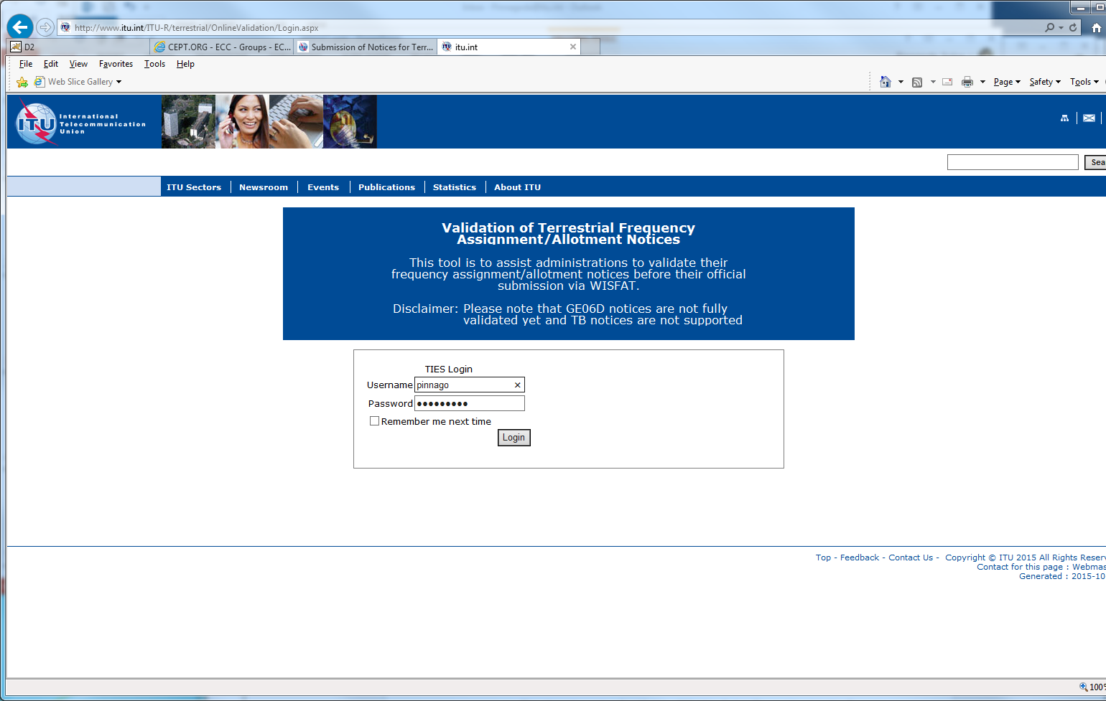
TIES Password
TIES Username
- Click on “New validation”
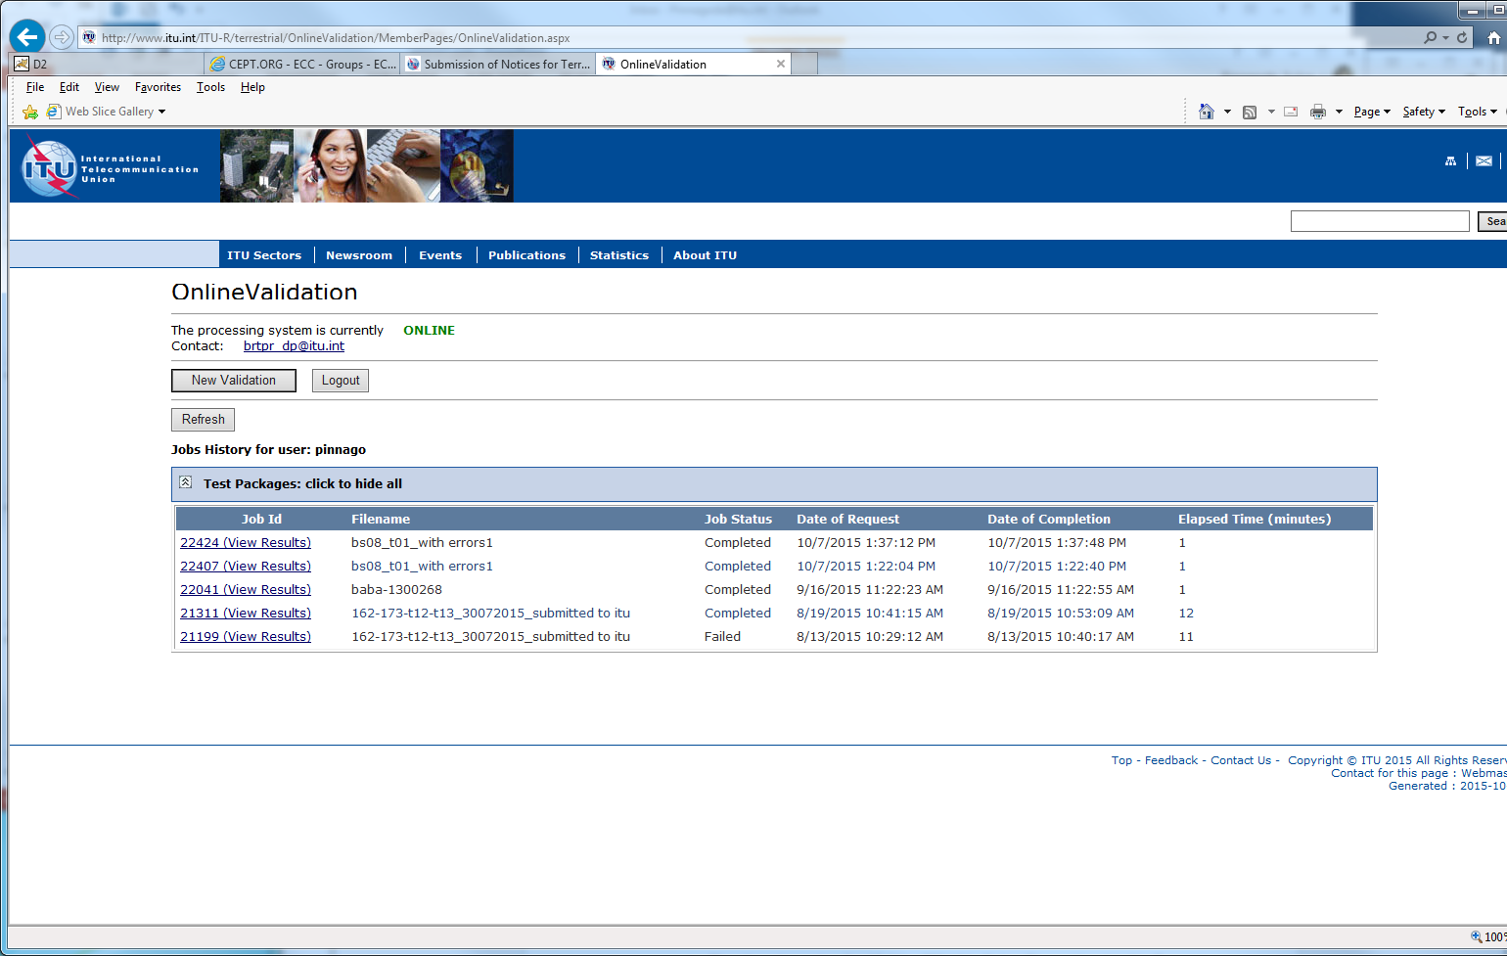
New Validation
- Click on “Browse” to select the file to validate
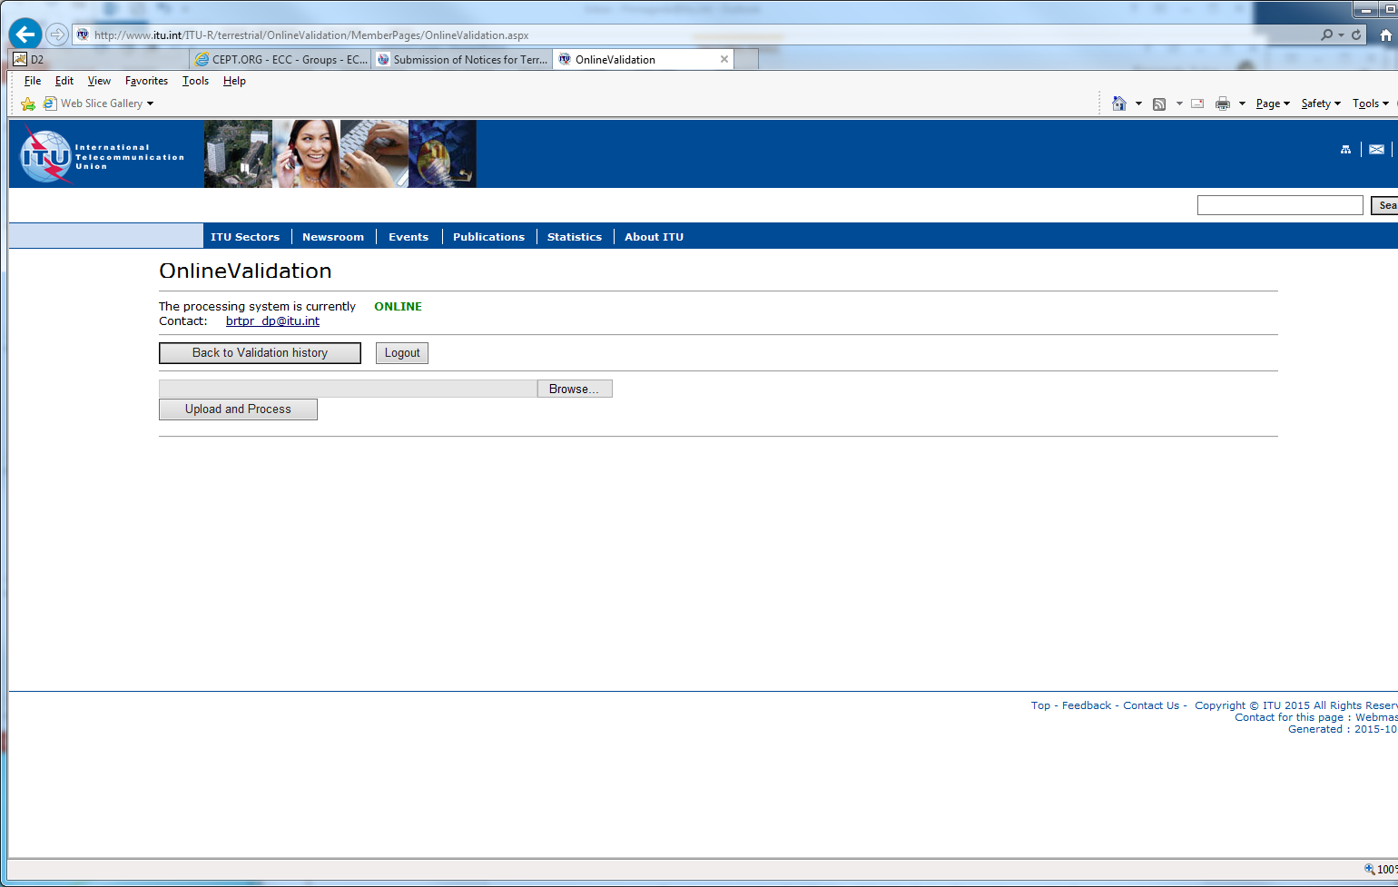
Browse
- Click on “Upload and Process”
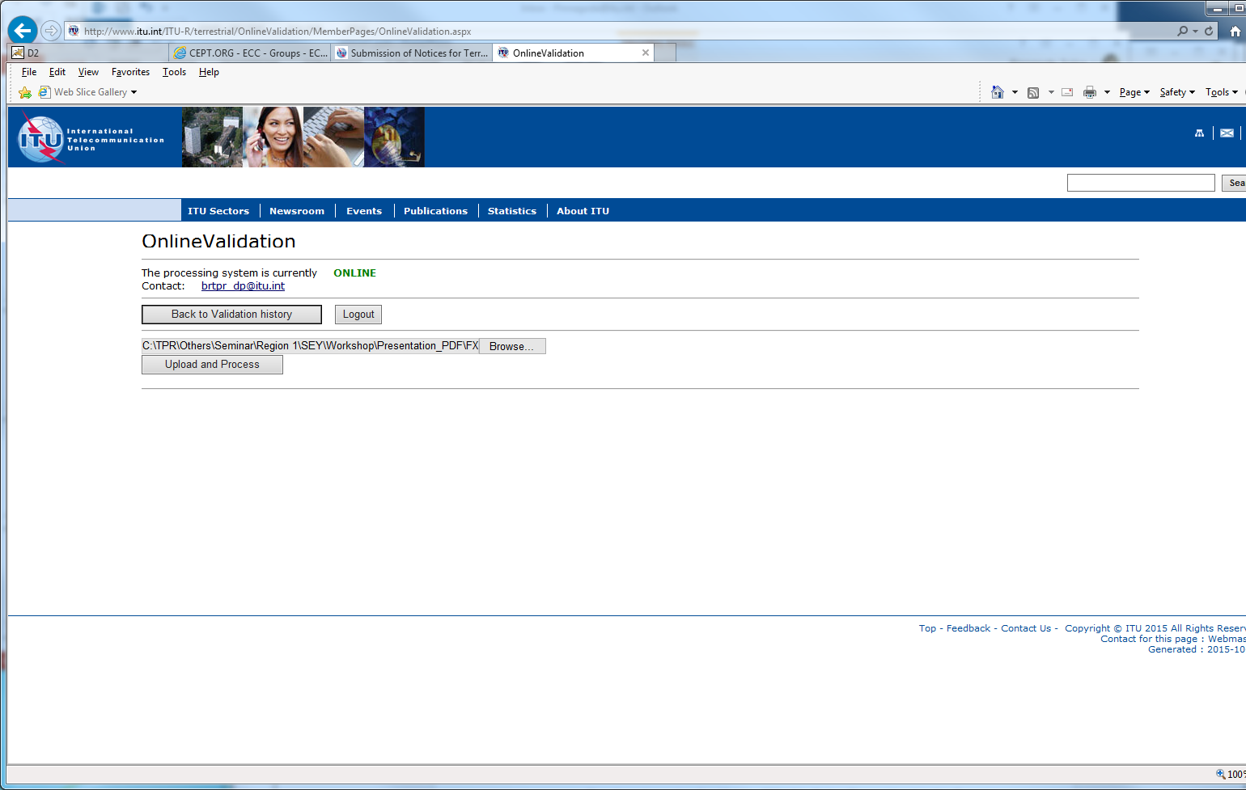
Upload and process

- The job is now sent for validation. You may click on “New Validation” to submit another file or click on “Back to Validation history”
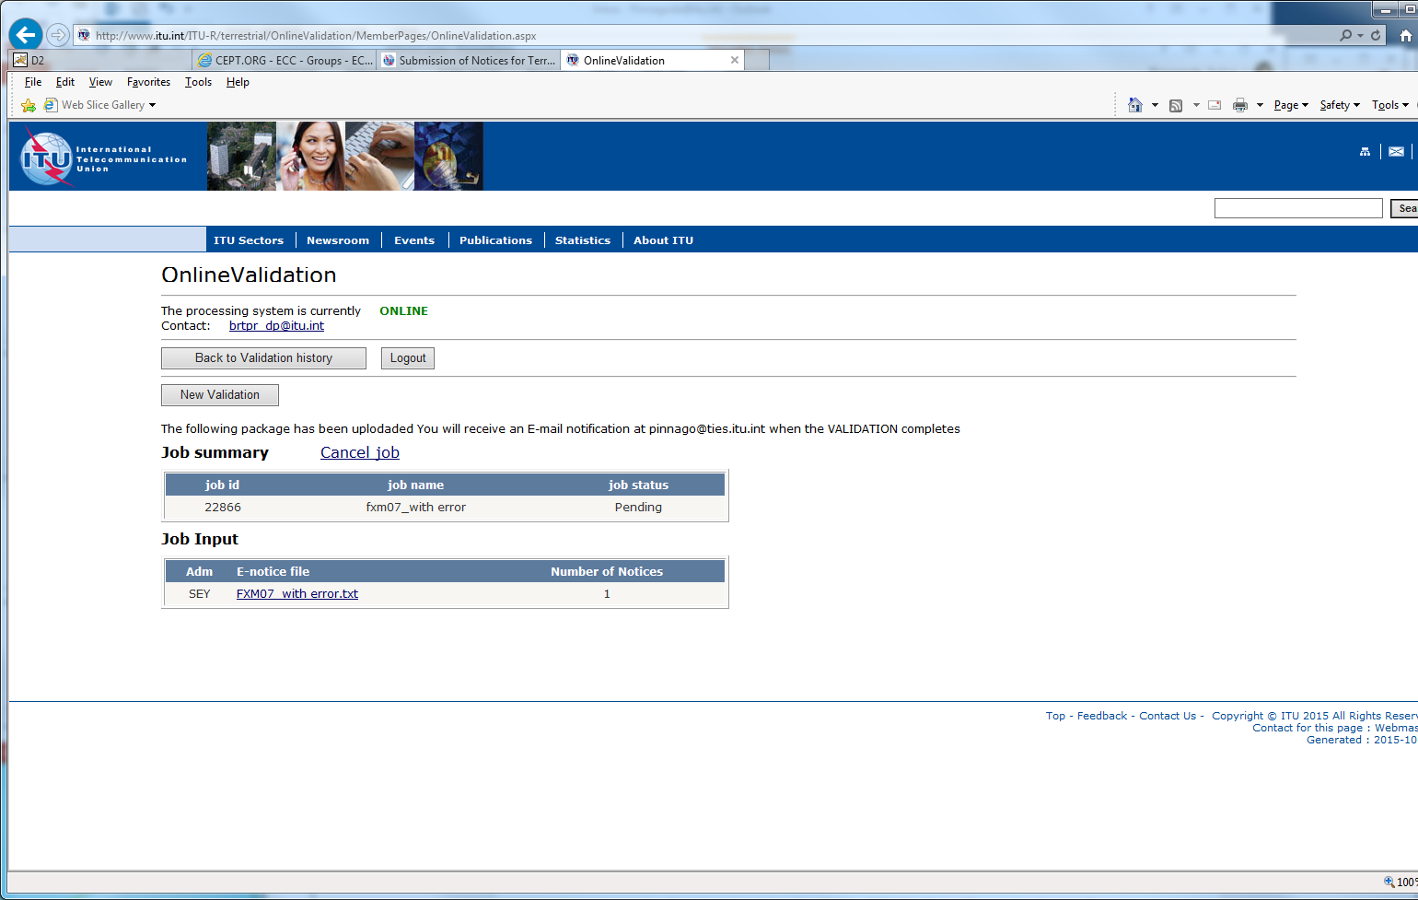
Back to Validation history
- You may click on “Refresh” to see the progress of the processing. Once the validation is completed, you may click on JodID (View Results), you will also receive an e-mail to your TIES account.
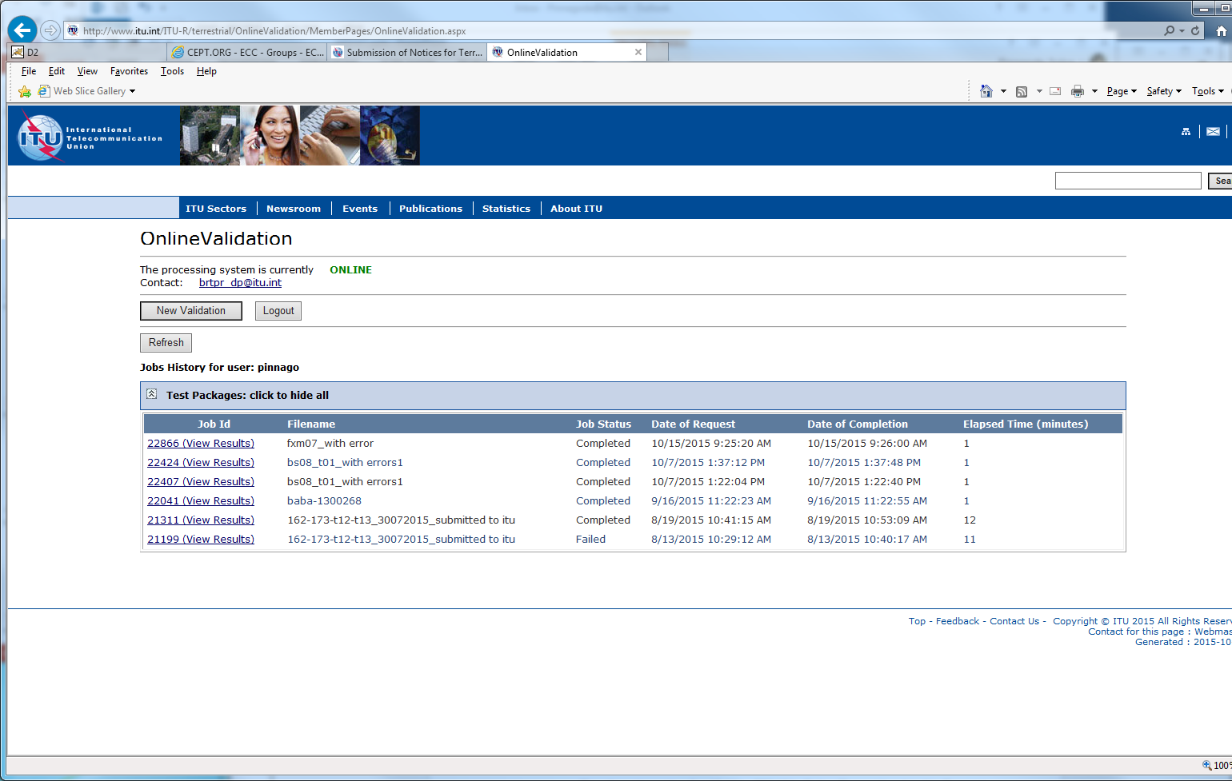
View Results
- If there are any errors or warning it will display them on the screen. You may correct and upload again.
