SUSTAINABLE RURAL COMMUNICATION --------NEW APPROACH TO GREEN TELECOM
Introduction

Nationally, electricity grid currently meets barely 33% of Telecom Infrastructure energy needs & therefore, they are forced to address the deficit by other energy sources available to them. Majority of off-grid energy sources in use today are non-renewable and polluting. It is fair to expect that users of off-grid power prioritize public interest over profits. It is difficult to justify use of harmful fuels when cleaner and affordable options exist or, if the use of such fuel is for non-essential purposes such as e.g. air-conditioning and lighting at a late-night party or power for an advertising billboard. On the other hand, it is clear that services like trains, telephone, hospitals, movement of food, security etc are absolutely essential and must be available 24x7 without interruption or deterioration of quality.

The importance of telecom and the need to connect those who are unconnected cannot be lost sight of in our legitimate concern over the collateral damage to the environment. We cannot throw the baby with the bath water. Any measures that hurt economics of connecting the unconnected, in villages and remote areas, will hurt those who need infrastructure most. Indeed the cost of connecting them is already high.

Infrastructure Providers are delivering increasingly high productivity and savings to all stakeholders in the communications sector. Their efforts are delivering low prices benefiting ‘Aam–Aadmi’, low-income users of voice and data services.

At present the energy expenses (OPEX) is nearly 30% of the total network operating costs. It is important to recognize that much of the increased pollution comes from diesel that telecom operators / infrastructure providers are forced to use because conventional grid power is barely available for more than 25% of the time. The data with regard to the requirement and usage of power to support telecom infrastructure is anomalous. Power generation has been the real problem as cost of running telecom equipments is very high using Diesel. The use of diesel by Telecom Infrastructure players is not voluntary but forced on them since the Electricity Boards (EBs) are unable to meet even a fraction of the demand for power. If the EBs could meet demand, naturally there would be no need for diesel.

It is estimated that the ICT sector worldwide is responsible for around 2% of global CO2 emissions. This includes the impact of personal computers, servers, cooling equipment, fixed and mobile telephone instruments and networks, local area networks, office communications and printers. The world’s increasing need for the computation, data storage, and communication is driving the rapid growth in telecommunication and enhancing the emissions associated with such technologies. By 2020, ICT is expected to account for about 3% of global emissions worldwide. Of the current CO2 emissions, the contribution from the global telecommunication systems – mobile, fixed and communication devices- is estimated to be around 230 million tonnes of CO2, or approximately 0.7% of global emissions. The worldwide growth in the use of mobile phones as well as the multiplication of data centres are expected to contribute to this trend. However the pervasive use of ICT is expected to simultaneously lead to significant positive net externalities on account of what are called the second order and third order effects of the use of ICT's worldwide. Second order effects are the immediate consequences of the use of ICT is in terms of changing processes like reducing travel for business reasons and for social interactions, while third order effects are the expected changes in the organizational structures and modalities of transacting business and social interactions over the longer-term, which would reduce the need for travel and face-to-face interactions.

The sector wise distribution of the CO2 emissions in India for 2007 is given below. It may be noted that the CO2 emissions have increased by 52% from 1994.

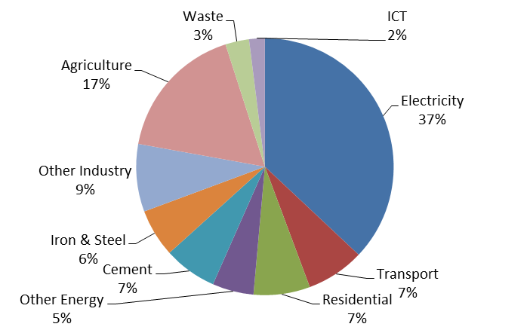
Source : TRAI Recommendations on Approach towards Green Telecom, April 2011

Mobile Infrastructure Companies recognise that renewable energy is important for their long term success: Alternate renewable energy sources like solar panel, wind turbines, bio-gas, etc. are still in nascent stages of commercial viability. The telecom industry has already commenced testing and implementing various alternate renewable energy sources and will adopt those that can be scaled easily across the country. They are working closely and constructively with Ministry of Natural Resources and Environment (MNRE) to facilitate movement to cleaner power including solar, wind and other sources. They are participating in several efforts to improve the viability of renewable energy.

The Telecom Infrastructure Companies are willing to be Anchor clients for RESCOs distributed model.

Suggested Approach

Infrastructure Providers propose more realistic, effective and sustainable steps towards how the telecom players can collaborate with Renewable Energy Supply Companies (RESCOs) not just to reduce dependence on diesel but also to assist communities struggling without access to grid power.

It is important for the telecom operators to deploy clean energy solutions once they are available at an affordable cost. While this is not possible currently, it can be expedited if telecom players work closely with Renewable Energy Service Companies (RESCOs). This will be mutually beneficial to both sides as also would help towards the goals of “Green Telecom”.

The chief barrier facing RESCOs to provide with green energy sources is the absence of business models that would enable these costs to be recovered in a reasonable time frame. The biggest challenge here is the absence of scale.

Telecom industry can play a constructive role in improving the economics of energy production and usage, especially in rural areas. As a single large user of the clean energy that RESCOs can produce, telecom operators can serve as their anchor clients. This will provide the much needed scale to RESCOs and address the cost-price deficit – rather, would also possibly remove it altogether in some areas. As a result, the communities around the RESCO facilities too could receive cheap power. The proposal then should be for the stakeholders including, infrastructure players, telecom operators, RESCOs and the community to collaborate on building micro power stations.

This model has the advantage of providing the right incentives for all stakeholders. By proposing RESCOs-off Grid solutions for clean energy, it also reduces the dependence on the resources of the electricity grid and promotes much needed decentralization besides providing continuous power supply. Delivering electricity to surrounding communities will provide lighting and other emergency support to begin with and has multiplier effects in almost every activity of interest in rural areas.

