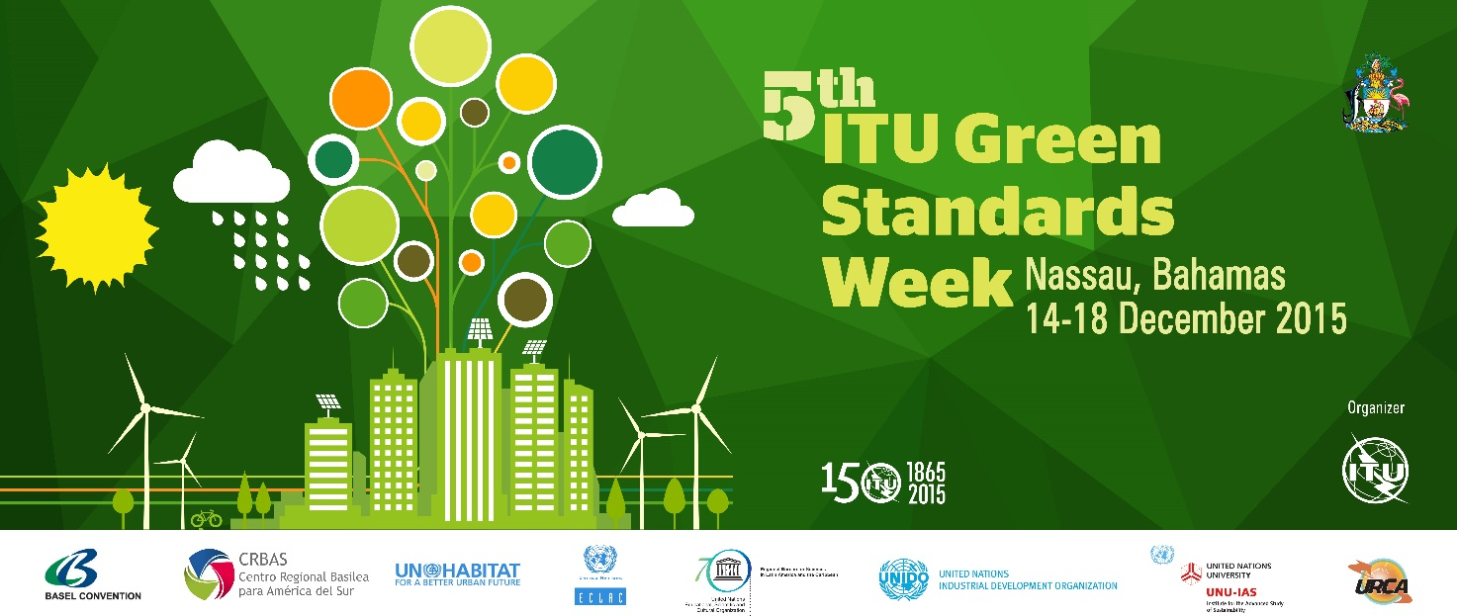

Practical Information for Participants

1 Event Venue
Atlantis, Paradise Island, Bahamas
Address: #1 Casino Drive
P. O. Box N-4777
Paradise Island, Bahamas
Tel.: 1-242-363-3000
Website: http://www.atlantisbahamas.com

2 Hotels
Recommended Hotel | Atlantis, Paradise Island  #1 Casino Drive  Paradise Island, Bahamas  Telephone: 1-242-363-3000
Hotel website : | http://www.atlantisbahamas.com

The list of proposed hotels may be found in Annex D. Preferential group rates have been secured at Atlantis, Paradise Island and rooms are limited, so participants are advised to book early.

3 Arrival and transportation

To/from Lynden Pindling International Airport (LPIA):

Taxis

Taxis are located outside the airport/hotels and may also be hired by the hour. From the
Nassau airport taxi rates are approximately $27 to downtown Nassau (venue location), $18 to Cable Beach and $33 to Paradise Island (plus the bridge toll). Fares are based on two passengers; there is an additional charge for extra passengers and extra luggage.
- Bahamas Taxi Cab Union – 1-242-323-5818
- Meter Cab – 1-242-323-5111(to 4)

Note: Paradise Island and Nassau are connected by a short bridge ride and Paradise Island is not accessible by public transportation. If you plan to stay in Nassau, you will need to take a taxi to and from Paradise Island.

4 Visa – Formalities for entering the Bahamas
Entry requirements differ depending on what country you are a resident and citizen of. Visit the following link to find out the necessary documentation you will need to ensure a smooth entry into The Bahamas https://www.bahamas.com/entry-requirements
For any questions regarding visas, please visit the following link: http://nassau.usembassy.gov/

5 Currency and exchange
The Bahamian Dollar is the currency of Bahamas
Symbol: BSD$
Minor Unit: 1/100 = Cent
Coins: Freq. Used: $1, $20, 1, 5, 25, 50
Banknotes: Freq. Used: $1, $2, $5, $10, $20, $50, $100
The approximate exchange rate is:
1 USD = BSD $1.00
1 Euro = BSD $1.11030 (may vary)
Credit cards and travellers checks are accepted at most locations on Nassau & Paradise Island. +PLUS and Cirrus ATMs can be found at banks on Nassau & Paradise Island and on most of the major Out Islands.
Local Commercial banks open Monday – Thursday 9:30am – 3:00pm and Friday 9:30am – 4:30pm.

6 Language
English (more British than American) is the national language of The Bahamas and is intertwined with an appealing Bahamian dialect.

7 Climate
The climate in the Bahamas is sub-tropical. In the islands there are basically two seasons: Wet and Dry. Average temperatures range between 70 to 90 degrees Fahrenheit. The Wet Season is from June through November which is also the hurricane season. The height of the tropical activity is traditionally between August and October. Brief heavy showers are common throughout the year.

8 Local time
Standard Time Zone: UTC/GMT -5 Hours
Daylight Savings Time +1 Hour
Current Time Zone UTC/GMT -4 Hours
DST started on Sunday, March 8, 2015 at 2:00 AM local standard time.
DST ends on Sunday, November 1, 2015 at 2:00 AM local daylight time.
***DST – Daylight Savings Time

9 Telecommunications
The country code for Bahamas is +1 242
Both visitors and business travellers will find that telecommunication services in The Bahamas are comparable with the service found in most developed nations. A 100% digital switching system allows direct-distance dialling to more than 100 countries. The US and Canada are a direct-dial away and most hotels provide direct-dialling service from guest rooms and/or the conference centre.
For those who refuse to be unleashed from their cell phones, it is very easy to stay connected while visiting The Islands of The Bahamas. Local Service providers have in place, roaming agreements with 128 companies worldwide. To access the local GSM roaming system, simply turn on your phone and wait while it connects to the network.

10 Electricity
The following plugs/sockets are used:
Electrical outlets in The Bahamas are 60 cycles/120 volts, which is compatible with all US appliances. British and European appliances require a flat two-pin adaptor and 220-volt converter.
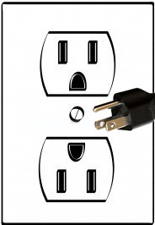

11 Health
Two hospitals are fully equipped to respond to emergency medical situations. Princess Margaret Hospital and Doctor’s Hospital are both located in Nassau.
- Doctors Hospital – 1-242-302-4600
- DHHS Ambulance – 1-242-302-4747
- Princess Margaret Hospital – 1-242-322-2861
- PMH Ambulance – 919, 911, 1-242-356-5448
Vaccination Requirements | A YELLOW FEVER VACCINATION CERTIFICATE is required from travelers over age one arriving from countries with a risk of Yellow Fever transmission or having transited for more than 12 hours through the airport of a country with a risk of yellow fever transmission; as identified by the World Health Organization (WHO).  For a full listing of countries required to have a Yellow Fever Vaccination Certificate for entry into The Bahamas kindly visit:  http://wwwnc.cdc.gov/travel/yellowbook/2014/chapter-3-infectious-diseases-related-to-travel/yellow-fever#4259  ***American Airlines requires a Yellow Fever Vaccination Certificate for Trinidadians travelling to The Bahamas.  CENTRAL AND SOUTH AMERICA  Argentina French Guiana Peru  Bolivia Guyana Suriname  Colombia Panama Trinidad & Tobago  Ecuador Paraguay Venezuela

12 Internet connectivity
Internet connection will be available at the meeting venue. Payment may be required at certain hotels.

13 Contact
For any questions, please contact:
Mrs. Barbara Moss
Tel.: 1-242-396-5214
E-mail: bmoss@urcabahamas.bs

Annex D: List of hotels:
List of hotels

NAME OF HOTEL | TYPE OF ROOM | PRICE including tax | CONTACT/COMMENT
Hotels located on Paradise Island
Atlantis, Paradise Island (Event Venue) | Beach Tower – Run of the House  Coral Tower- Run of the House  Royal Tower – Run of the house | Beach Tower -$155.00 plus fees and tax  Coral Tower - $182.00 plus fees and tax  Royal Tower - $203.00 plus fees and tax  For additional fees and tax information please see Annex E | Reservations Link  https://aws.passkey.com/event/14179124/owner/12844514/home  Group Code: GURCAD5  Or  Call 1-888-877-7525 or 954-809-2100  Contact Center Hours:  Mon-Thurs 9:00am to 11:00pm EST  Fri 9:00am to 8:00pm EST  Sat/Sun 9:00am to 8:00pm EST  Questions Email Us
*Comfort Suites, Paradise Island | King Bed Suite– Single occupancy  Double Bed Suite – Single occupancy | $138.00 plus fees and tax  $191.00 plus fees and tax  Guests 12 years and older are subject to an additional 17.15 USD energy surcharge and a 5.00 USD housekeeping gratuity per person per night. | www.comfortsuitespi.com/
Hotels located in Nassau
**British Colonial Hilton |  |  | reservations.nassau@hilton.com  www.bchiltonnassauhotel.com
***Melia Nassau Beach |  |  | Melia Reservations – 1-242-327-6000  or  www.melianassaubeach.com/
***SuperClubs Breezes Resort & Spa |  |  | Breezes Reservations – 1-242-327-5356  http://www.breezes.com/
*: Include High speed internet/ plus Complimentary Hot American Buffet Breakfast daily. In addition complete access to all amenities at the famed Atlantis Resort
**: Include Wifi access/ Mini Refrigerator
***: All inclusive, include High speed internet/ daily housekeeping services. Include all meals & drinks/ land & water sports

ANNEX E – ATLANTIS RESORT CHARGES

TAXES, LEVIES, and FEES - Royal, Coral, Beach
Taxes: 7.5% VAT* assessed on all charges, except gratuities
Resort Levies: 10.75% PITDA**/NPIPB*** based on nightly room rate
Resort Fee: $45.00 plus VAT per room per night – Resort Fee Includes:
Wi-Fi in guest rooms and lobby areas for up to four (4) devices per room
- Access to the Fitness Center up to two (2) guests per day per room
- In-Room Coffee and Tea
- Unlimited local phone calls
- Access to the Atlantis Movie Theatre
- Casino Lessons
- Resort shuttle service
* Value Added Tax
** Paradise Island Tourism Development Association (Inc VAT)
*** Nassau/Paradise Island Promotion Board (Inc VAT)

GRATUITIES - Royal, Coral, Beach, Cove, and Reef

Bellman: $6.00 per person, one time charge, 12 years old and over

Pool/Beach Attendant/Lifeguard: $1.60 per person, per night, 12 years old and over

Housekeeping – Royal, Coral, and Beach:
- Rooms: $5.00 per person, per night, 12 years old and over
- 1 Bedroom Suite: $5.00 per person, per night, 12 years old and over
- 2 Bedroom Suite: $10.00 per person, per night, 12 years old and over

Room Rates are quoted based on single or double occupancy. Additional occupants over double occupancy will be charged at a rate of fifty dollars ($50) per person, per night, plus applicable Resort Charges, with a maximum of four (4) persons per guest room allowed.
The above charges are mandatory pursuant to applicable union contracts, will be automatically added to the final bills of the Group or individual attendees as applicable (provided, however, the Group agrees to pay such charges not otherwise paid by individual attendees) and are subject to change at any time upon notice to the Group.

