ANNEX 2

**ITU Workshop on ICT Innovations in Emerging Economies   
Tunis, Tunisia, 30-31 March 2015**

***Practical information for participants***

# 1 Event Venue

**Le Palace Gammarth Hotel**

Address: Complex Cap Gammarth   
 P.O Box 862078 La Marsa  
 Les Cotes de Carthage – Tunisie

Tel.: +216 71 912 000

Fax: +216 71 911 442 / +216 71 911 971

E-mail: [thalasso@lepalace.tn](mailto:thalasso@lepalace.tn) (Contact: Mrs. Lamia LAARIDHI)

Website: <http://www.lepalace.tn/>

# 2 Hotels

Block reservations and preferential rates have been obtained at the following hotel which is also the meeting venue.  Delegates are requested to make their hotel reservations directly.

**Le Palace Gammarth Hotel**

Complex Cap Gammarth   
 P.O Box 862078 La Marsa  
 Les Cotes de Carthage – Tunisie

Tel.: +216 71 912 000

Fax: +216 71 911 442 / +216 71 911 971

[thalasso@lepalace.tn](mailto:thalasso@lepalace.tn) (Contact: Mrs. Lamia LAARIDHI)

Room Rates: single (with breakfast): 185 TND // Double (with breakfast): 210 TND

# 3 Arrival and Transportation

Delegates are advised to take a Taxi from the airport to their respective hotel. Cost is **10 TND** approximately 4.5€.

# 4 Visa – Formalities for Entering Tunisia

For any questions regarding visas, please contact the following local coordinator:

Mr. Mohsen NAHDI

Tel.: (Office) +216 70 30 28 62

Mobile: +216 98 22 02 03

E-mail: [mohsen.nahdi@tunisietelecom.tn](mailto:mohsen.nahdi@tunisietelecom.tn)

# 5 Currency Exchange

The currency in Tunisia is the Dinar. Its approximate exchange rate with the Euro and the USD are:

**1 Euro** = 2.18583

**1 USD** = 1.93184

# 6 Language

The official working language is French.

# 7 Climate

The high averages at 20 degrees Celsius; the low at 10 degrees Celsius

# 8 Local Time

Standard time zone: GMT+1.

# 9 Telecommunications

The country code for Tunisia is +**216**

# 10 Electricity

The following plugs/sockets are used:

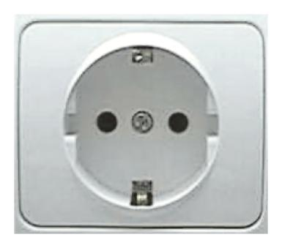Electrical sockets (outlets) in Tunisia are one of the two European standard electrical socket types: The "Type C" Europlug and the "Type E" and "Type F" Schuko

**Voltage: 220 V**

# 11 Health

No vaccinations are required.

# 12 Internet connectivity

Internet connection will be available at the meeting venue. Payment may be required at certain hotels.

# 13 Local Host Contact

For any questions, please contact:

Mr. Mohsen NAHDI

Tel.: (Office) +216 70 30 28 62

Mobile: +216 98 22 02 03

E-mail: [mohsen.nahdi@tunisietelecom.tn](mailto:mohsen.nahdi@tunisietelecom.tn)