|  |
| --- |
| **ITU Kaleidoscope Academic Conference 2013 and  Joint ITU-IEICE Workshop on Education about Standardization**  **22-25 April 2013, Kyoto Japan** |

**GENERAL INFORMATION**(As of 20 December 2012)

2013’s ITU Kaleidoscope Academic Conference (K-2013) will be held at Kyoto University, Japan, 22-24 April 2013, organized by the ITU Telecommunication Standardization Sector (ITU-T) with the support of the K-2013 Steering and Host Committees.

The Workshop on Education about Standardization, jointly organized by ITU-T and the Institute of Electronics, Information and Communication Engineers (IEICE), Japan, will take place on 25 April 2013 at the same venue.

Participants are requested to take note of the following practical information:

1. **VENUE**

**2nd floor of the Clock Tower Centennial Hall, Yoshida Campus, Kyoto University**

**Address:** Yoshida-Honmachi, Sakyo-ku, Kyoto-City, Kyoto 606-8501 Japan

**Website**: <http://www.kyoto-u.ac.jp/en/clocktower>

1. **CONFERENCE FACILITIES AND REGISTRATION**

Registration will start from 09:00 on Monday, 22 April 2013, on the 2nd floor of the **Clock Tower Centennial Hall of Kyoto University**.

The opening session will commence at 09:30. All sessions scheduled will be indicated in the lobby on the 2nd floor.

1. **ACCESS TO THE CLOCK TOWER CENTENNIAL HALL, YOSHIDA CAMPUS, KYOTO UNIVERSITY**

The majority of the event’s international participants will enter Japan through **Kansai International Airport.**

Kansai International Airport: <http://www.kansai-airport.or.jp/en/index.asp>

Participants entering Japan through another airport will find more information here:

<http://www.kyoto.travel/plan_your_visit/access_info/>

Kyoto is easily reachable from a number of major cities in Japan, including Tokyo. Please see below:

<http://www.kyoto.travel/2009/11/from-major-cities-1.html>

**From Kansai International Airport to Kyoto Station**

* **JR WEST Train (Ltd. Exp. HARUKA / Rapid Services)**

HARUKA Ltd. Exp. offers a direct line to Kyoto Station. These trains depart every 30 minutes and the journey from the airport to Kyoto Station takes 80 minutes. Rapid Services are less expensive, but will require that one changes trains at Osaka Station.

<http://www.kyoto-u.ac.jp/en/access/getting/getting_1.htm>

International visitors have the option of obtaining a “**KANSAI Area Pass**” which allows its holder to purchase discounted tickets on HARUKA Ltd. Exp.

<http://www.jr-odekake.net/en/jwrp/kansai.html>

* **Airport Limousine Bus**Buses depart every 30 minutes and the journey from the airport to Kyoto Station takes 120 minutes.

<http://www.kate.co.jp/pc/index_e.html>

* **Shuttle Services**

For a fixed fee, shuttle services will take you to the address of your choice in Kyoto. Reservation is required at least two days in advance.

<http://www.yasaka.jp/english/index.html>  
 <http://www.mk-group.co.jp/english/shuttle/index.html>

**From Kyoto Station to Yoshida Campus**

From the Bus Terminal at Kyoto Station, take Kyoto City Bus #206 from platform D2 to“**Kyodai Seimon-mae**” (approx. 50min. / 220 yen).

A second option is to take Subway Karasuma Line bound for Kokusaikaikan to Imadegawa Station (approx. 10min. / 250yen), and then from Bus Stop #1 take Kyoto City Bus #201 bound for Hyakumanben/Gion and get off at “**Kyodai Seimon-mae**” (approx. 10min. / 220yen). <http://www.city.kyoto.jp/koho/eng/access/transport.html>

In a taxi this journey will take 20 minutes and cost approximately 2000 yen.

If your hotel is not near the Kyoto Station, please see below.

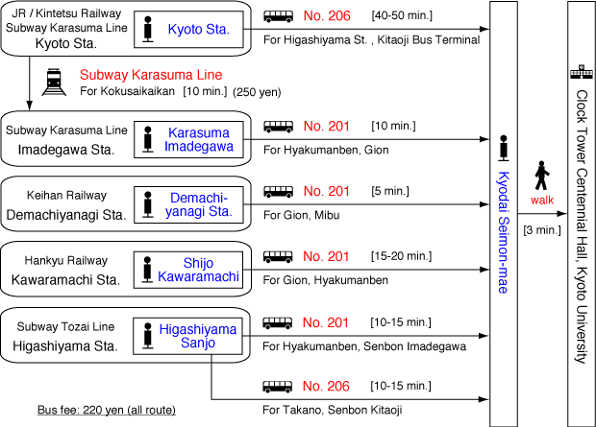

**From the Bus Stop to the Clock Tower:**

It takes 5 min. on foot from “**Kyodai Seimon-mae**” bus stop to the venue.

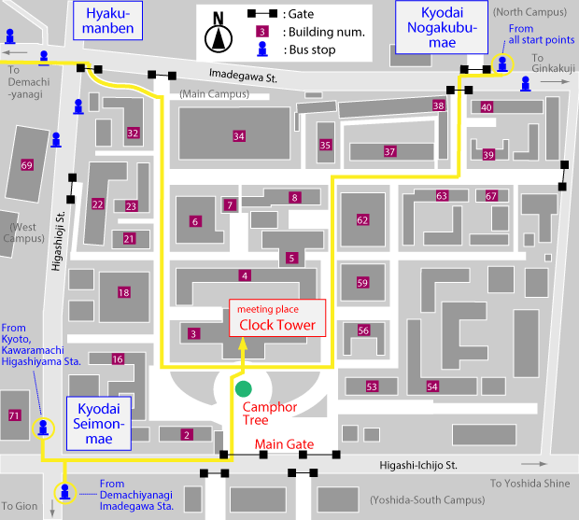

1. **HOTELS**

There are only a few hotels near the conference venue. We recommend that attendees consider booking hotels near **one of the following stations: JR/Subway/Kintetsu Kyoto Station, Subway Shijo Station, Hankyu Karasuma Station** or **Hankyu Kawaramachi Station. Participants are requested to book their room by contacting the hotel of their choice directly.** The hotels listed below have **not blocked** rooms for participants of these events, and it is therefore strongly recommended that international visitors book their hotel rooms as early as possible.

|  |  |  |  |  |
| --- | --- | --- | --- | --- |
|  | | Room Rate (JPY) per night | | Remark |
| **The Westin Miyako** |  | Single use | 17000+ | 30 minute walk to the venue |
|  | Twin use | 34000+ |
| URL | <http://www.miyakohotels.ne.jp/westinkyoto/english/index.html/> | |  |
| **Kyoto Gion Hotel** |  | Single use | 9500+ | 15min. by bus to the venue |
|  | Twin use | 17000+ |
| URL | <http://www.apahotel.com/~language/en/hotel/kyotogion/index.html> | |
| **APA Hotel Kyoto Ekimae** |  | Single use | 9500+ | Near Kyoto Station |
|  | Twin use | 17000+ |
| URL | <http://www.apahotel.com/hotel/kansai/01_kyoto-ekimae/english/index.html> | |
| **Toyoko-Inn Kyoto**  **Karasuma** |  | Single use | 6980+ | Near Karasuma  Station |
|  | Twin use | 9480+ |
| URL | <http://www.toyoko-inn.com/e_hotel/00053/index.html> | |
| **Rakuten**  **Travel** |  | Single use | - | You can find many hotels at the site |
|  | Twin use | - |
| URL | <http://travel.rakuten.com/hotel/asia/japan/kyoto/shi.html> | |

1. **VISA AND IMMIGRATION INFORMATION:**

Participants requiring a visa should apply at a Japanese consulate or a diplomatic mission in their respective country, well in advance of their departure.

Participants are also advised to contact their local travel agents or carriers. Visa processing by the Embassy may take two weeks or more.

For more information, please visit the website of the Ministry of Foreign Affairs of Japan at:

<http://www.mofa.go.jp/j_info/visit/visa/>

Participants requiring supporting documents to their visa should **fill out all items in the Application Form of ANNEX 1**, and then email or fax the form to one of the following contact points together with **a copy of the photograph page of their passport, no later than 21 March 2013.**

The contact persons are as follows:

Hideki Suganami (Mr.) / Junkichi Fujisawa (Mr.)

The ITU Association of Japan

Phone: +81 3 5357 7625/+81 3 5357 7626

Fax: +81-3-3356-8170

E-mail: [kaleidoscope-visa@ituaj.jp](mailto:kaleidoscope-visa@ituaj.jp) (e-mail is preferred)

1. **SOCIAL EVENT**

A reception will be held at Kyoto University on the evening of **Monday 22April 2013**. Details will be provided in due course.

1. **PRACTICAL INFORMATION**
   1. **About Kyoto:**

Kyoto was once the capital of Japan. It has 2.7 million inhabitants and is one of Japan’s more traditional cities. <http://www.kyoto.travel>; <http://www.pref.kyoto.jp/en/index.html>

* 1. **Weather:**

The temperature in Kyoto during April ranges from 10 to 20 degrees centigrade. Average rainfall in April is about 100 mm.

* 1. **Time Zone:** GMT + 9 hours.
  2. **Banks & Currency:**

The Japanese currency unit is Japanese Yen (JPY). There are four kinds of bills (10,000 yen, 5,000 yen, 2,000 yen and 1,000 yen), and six kinds of coins (500 yen, 100 yen, 50 yen, 10 yen, 5 yen and 1 yen). Japanese Yen (JPY) is the only currency accepted at stores and restaurants. Major foreign currencies may be exchanged for JPY at foreign exchange dealers at the International Airports (requires the presentation of a passport). Japanese banks are usually open Monday to Friday from 9:00 to 15:00. The exchange rate at 21November 2012 was 82.26 Japanese Yen to 1 US Dollar. Major credit cards are accepted by most hotels, restaurants, department stores, but not local small shops.

* 1. **Tipping:** Tipping is not customary in Japan.
  2. **Electricity:**

The standard power supply in Japan is 100 volts.

The frequency is 60 Hz in Western Japan, which includes Kyoto.

The type of power outlet/connector used in Japan is two-parallel-pronged, as pictured below.

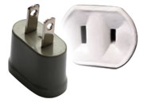

1. **LOCAL CONTACT POINT:**

For any additional information, please contact:

Hideki Suganami (Mr.) / Junkichi Fujisawa (Mr.)

The ITU Association of Japan

Phone: +81 3 5357 7625/+81 3 5357 7626

Fax: +81-3-3356-8170

E-mail: [kaleidoscope-local@ituaj.jp](mailto:kaleidoscope-local@ituaj.jp)

-------------------------------------------------

**ANNEX 1**

|  |
| --- |
| **Kaleidoscope Conference 2013 and  Joint ITU-IEICE Workshop on Education about Standardization**  **22-25 April 2013, Kyoto, Japan** |
| **Application Form for Visa Supporting Documents** | |
| Name (□Mr. □Ms. □Dr.):Family Name Middle Name Given Name (*):  **\*If you are a Chinese participant, please write your full name in Chinese characters.** Official TitleDepartment:Organization **(**):**  **\*\*If you are a Chinese participant, please write your organization in Chinese characters as well.** Country (where you live)Address (*1): **(*1) VISA supporting documents will be sent to the address above by courier service.** Phone No. Fax No. E-mailPASSPORT INFORMATION:Passport No. : Date of Issue: / / (DD/MM/YYYY)Expiry Date : / / (DD/MM/YYYY)Place of Birth: Date of Birth: / / (DD/MM/YYYY)Nationality: **FLIGHT INFORMATION**(*2) **:**  **Arrival** in Tokyo (Haneda / Narita) from city Date__________ Flight No. Time  **Departure** from Tokyo (Haneda/Narita) to city Date__________ Flight No. Time  **(*2) For VISA supporting documents, a planned flight schedule is available as well.**  **HOTEL ACCOMMODATION**  This information is **NOT for hotel reservation, but NEEDED for staying schedule for visa supporting documents.** Hotel name : **Check in date**: (DD/MM/YY) **Check out date:** (DD/MM/YY) If making your own accommodation arrangement other than recommended hotels in Kyoto, please indicate your contact address and phone number:Hotel Address_______________________________________________________ **Hotel phone No.**  **Date: Signature:**  **Deadline of Submission: 21 March 2013 for all visa related documents** | |
| **Please Return this form To:**  Hideki Suganami (Mr.) / Junkichi Fujisawa (Mr.)  The ITU Association of Japan  Phone: +81 3 5357 7625/+81 3 5357 7626 Fax: +81-3-3356-8170  E-mail: [kaleidoscope-visa@ituaj.jp](mailto:kaleidoscope-visa@ituaj.jp) (Email is much more desirable.) | |