 |  | International Telecommunication Union
 |  | ITU-T | Technical Report
 |  | TELECOMMUNICATION  STANDARDIZATION SECTOR  OF ITU |  | (08/2021)
 | ITU-T Focus Group on Environmental Efficiency for Artificial Intelligence and other Emerging Technologies (FG-AI4EE)
FG-AI4EE D.WG2-02

Computer processing, data management and energy perspective
Working Group 2 - Assessment and Measurement of the Environmental Efficiency of AI and Emerging Technologies
 | Focus Group Technical Report

FOREWORD

The International Telecommunication Union (ITU) is the United Nations specialized agency in the field of telecommunications, information and communication technologies (ICTs). The ITU Telecommunication Standardization Sector (ITU-T) is a permanent organ of ITU. ITU-T is responsible for studying technical, operating and tariff questions and issuing Recommendations on them with a view to standardizing telecommunications on a worldwide basis.

The procedures for establishment of focus groups are defined in Recommendation ITU-T A.7. ITU-T Study Group 5 set up the ITU-T Focus Group Environmental Efficiency for Artificial Intelligence and other Emerging Technologies (FG-AI4EE) at its meeting in May 2019. ITU-T Study Group 5 is the parent group of FG-AI4EE. Deliverables of focus groups can take the form of technical reports, specifications, etc., and aim to provide material for consideration by the parent group in its standardization activities.

Deliverables of focus groups are not ITU-T Recommendations. For more information about FG-AI4EE and its deliverables, please contact Charlyne Restivo (ITU) at tsbfgai4ee@itu.int.

NOTE
This is an informative ITU-T publication. Mandatory provisions, such as those found in ITU-T Recommendations, are outside the scope of this publication. This publication should only be referenced bibliographically in ITU-T Recommendations.

© ITU 2021
This work is licensed to the public through a Creative Commons Attribution-Non-Commercial-Share Alike 4.0 International license (CC BY-NC-SA 4.0). For more information visit https://creativecommons.org/licenses/by-nc-sa/4.0/ .

Summary
This technical report proposes a set of good practices to improve the energy efficiency of cyber-physical applications – making use of IoT, AI, and Digital Twins. First, the report introduces the cyber-physical paradigm, engineering reference framework, and a couple of system deployments models. Secondly, it defines three end-to-end use case typologies to be addressed (i.e. monitoring application using smart IoT systems and AI software; smart application using Edge computing and Cloud data center; and simulation applications using Digital Twin pattern). Energy efficiency practices are discussed adopting a circular value-chain model that consists of three main steps: Data Storage; Data Transfer/Move; and Data Processing/Analytics. Finally, this report offers a set of recommended practices relating to each component of the three end-to-end use case typologies.

Keywords
Cyber-physical systems and applications, Energy efficiency, Big Data, AI, IoT, Digital Twins.

Change Log
This document contains Version 1 of the ITU-T Technical Report on “Computer processing, data management and energy perspective” approved at the ITU-T Study Group 5 meeting held virtually on XXX.

Editors: | Stefano NATIVI  European Commission DG JRC | Email: Stefano.NATIVI@ec.europa.eu
 | Paolo BERTOLDI  European Commission DG JRC | Email: Paolo.BERTOLDI@ec.europa.eu
 | Tiago SERRENHO  European Commission DG JRC | Email: Tiago.SERRENHO@ec.europa.eu

CONTENTS
1 Scope 1
2 References 1
3 definitions 6
4 Abbreviations AND ACRONYMS 7
5 Conventions 8
6 Computer processing, data management and energy perspective 8
6.1 Introduction 8
6.2 Cyber-physical paradigm (IoT, AI analytics, and Digital Twin innovative technologies) 9
6.3 Digital Twin pattern 9
6.4 Cyber-physical reference framework 10
6.4.1 Smart assets (or things) 11
6.4.2 Smart gateways 11
6.4.3 Smart systems 11
6.4.4 Smart services 12
6.5 Cyber-physical system deployment models 12
6.5.1 Cyber-physical architecture three-layers deployment 12
6.5.2 Cyber-physical architecture four-layers deployment 12
7 End-to-end use cases addressed 14
7.1 Monitoring application using smart IoT systems and AI software 14
7.2 Smart application using Edge computing and Cloud data center 14
7.3 Simulation applications using Digital Twin pattern 15
8 Energy efficiency criteria 15
8.1 Adopted methodology 15
8.2 Data storage 15
8.2.1 Metrics and criteria 15
8.2.2 Energy Efficiency best practices on data storage: 16
8.3 Data transfer – 5G, Wireless, and Copper networks 18
8.3.1 Energy efficiency of 5G Base Stations 19
8.3.2 Energy efficiency best practices with Passive Optical Networks 19
8.3.3 Energy Efficiency best practices with Copper Networks 20
8.4 Data processing 21
8.4.1 Energy Efficiency best practices on data processing 21
8.4.2 ML energy consumption and efficiency 22
9 Appliance of Energy criteria to the end-to-end considered by this report 25
9.1 Monitoring application using smart IoT systems and AI software 26
9.2 Smart application using edge computing and Cloud data center 28
9.3 Simulation applications using Digital Twin pattern 32

List of Figures
Page
Figure 1 - The archetype of cyber-physical paradigm 9
Figure 2 - Digital Twin communication pattern 10
Figure 3 - Cyber-physical architecture reference framework 10
Figure 4 - Three-layers deployment schema of cyber-physical architectures 12
Figure 5 - Four-layers deployment schema of cyber-physical architectures 13
Figure 6 - Cloud as an extended enterprise data centre 14
Figure 7 - Minimum PSU efficiency and power facto requirements from January 2023. Source: Regulation on ecodesign requirements for servers and data storage products EU 2019/424 16
Figure 8 - An example Energy Usage Report for a simple exponential function. Image taken directly from[72] 24
Figure 9 - Neural network with sub-models. Source: MIT [60] 25

List of Tables
Page
Table 1. Energy efficiency good practices for implementing monitoring application using smart IoT systems and AI software 26
Table 2. Energy efficiency good practices for implementing smart application using edge computing and Cloud data center 28
Table 3. Energy efficiency good practices for implementing simulation applications applying the Digital Twin pattern 32

Draft Technical Report ITU-T D.WG2-02
Computer processing, data management and energy perspective

Summary
This technical report proposes a set of good practices to improve the energy efficiency of cyber-physical applications – making use of IoT, AI, and Digital Twins. First, this report introduces the cyber-physical paradigm, engineering reference framework, and a couple of system deployments models. Then, it defines three end-to-end use case typologies to be addressed (i.e. monitoring application using smart IoT systems and AI software; smart application using Edge computing and Cloud data center; and simulation applications using Digital Twin pattern). Energy efficiency practices are discussed adopting a circular value-chain model that consists of three main steps: Data Storage; Data Transfer/Move; and Data Processing/Analytics. Finally, this report offers a set of recommended practices relating to each component of the three end-to-end use case typologies.

Scope
This technical report presents a set of well-adopted energy efficiency practices for cyber-physical system classes and applications – enabled by AI, Big Data, IoT, and other innovative technologies.
To do so, a set of relevant and significant use cases are first introduced; Secondly, system classes are identified. Finally, according to a circular value-chain model, the system efficiency practices are specified and mapped to the components of the cyber-physical systems.

References
- Recommendation ITU-T Y.3502 (2014), Information technology - Cloud computing - Reference architecture.
- ISO/IEC 30141 (2018), Internet of Things (loT) — Reference Architecture, Geneva.
- European Commission, 2020 Strategic Foresight Report, available at: https://ec.europa.eu/info/strategy/priorities-2019-2024/new-push-european-democracy/strategic-foresight/2020-strategic-foresight-report_en
- European Commission, A European Strategy for Data https://ec.europa.eu/digital-single-market/en/policies/building-european-data-economy
- European Green Deal Communication https://ec.europa.eu/info/sites/info/files/european-green-deal-communication_en.pdf
- IEEE STC on Sustainable Computing
- Lean ICT: for a sober digital sobriety, 2019, The Shift Project, The carbon transition think tank. https://theshiftproject.org/en/article/lean-ict-our-new-report
- L. Belkhiret al., 2018, Assessing ICT global emissions footprint: Trends to 2040 & recommendations. Journal of Cleaner Production, 177, 448-463.
- Cambridge Bitcoin Electricity Consumption Index. https://www.cbeci.org
- Bradford, A., 2020, The Brussels Effect: How the European Union Rules the World. Oxford University Press.
- European Commission, Ethics guidelines for trustworthy AI, https://ec.europa.eu/digital-single-market/en/news/ethics-guidelines-trustworthy-ai
- ISO/IEC 30141 (2018), Internet of Things (loT) — Reference Architecture, Geneva.
- Stefano NATIVI et al., 2020, IoT 2.0 and the Internet of Transforrmation (Web of Things and Digital Twins), EUR 30382 EN, Publications Office of the European Union, Luxembourg, ISBN 978-92-76-22403-7, doi:10.2760/553243, JRC120372
- Recommendation ITU-T Y.3502 (2014), Information technology - Cloud computing - Reference architecture.
- European Union, 2012, Energy Efficiency Directive, https://eur-lex.europa.eu/legal-content/EN/TXT/PDF/?uri=CELEX:32012L0027&from=EN
- Nativi, S. et al., 2021, Digital Ecosystems for developing Digital Twins of the Earth: The Destination Earth case, Remote Sensing, ISSN 2072-4292, Vol. 13, No. 11, pp. 2119, JRC124802. Available at: https://www.mdpi.com/2072-4292/13/11/2119
- Nativi, S. and Craglia, M., 2021, Destination Earth: Ecosystem Architecture Description, EUR 30646 EN, Publications Office of the European Union, Luxembourg, ISBN 978-92-76-32434-8, doi:10.2760/08093, JRC124168. Available at: https://publications.jrc.ec.europa.eu/repository/handle/JRC124168
- Nativi, S. et al., Destination Earth: Survey on “Digital Twins” technologies and activities, in the Green Deal area, EUR 30438 EN, Publications Office of the European Union, Luxembourg, ISBN 978-92-76-25160-6, doi:10.2760/430025, JRC122457. Available at: https://publications.jrc.ec.europa.eu/repository/handle/JRC122457
- European Commission, 2017, Regulation on ecodesign requirements for servers and data storage products EU 2019/424, https://eur-lex.europa.eu/legal-content/EN/TXT/?qid=1553786820621&uri=CELEX%3A32019R0424
- European Commission, 2017, Trends in data centre energy consumption under the European Code of Conduct for Data Centre Energy Efficiency, https://publications.jrc.ec.europa.eu/repository/bitstream/JRC108354/kjna28874enn.pdf
- Implement Efficient Data Storage Measures https://www.energystar.gov/products/implement_efficient_data_storage_measures
- European Commission, 2013, Commission guidelines: Ecodesign requirements for computers and servers https://ec.europa.eu/energy/sites/ener/files/documents/comm_2013-617_imp_2009-125_directive.pdf
- Song, J. et al., 2019, Energy efficiency optimization in big data processing platform by improving resources utilization: https://www.sciencedirect.com/science/article/abs/pii/S2210537917300379
- Bittencourt, L. et al., 2018, The Internet of Things, Fog and Cloud continuum: Integration and challenges. Internet of Things journal, pp. 134-155.
- ISO/IEC/IEEE 42010 (2011), Systems and software engineering - engineering. Technical report.
- Sitton-Candanedo, I. et al., 2020, Edge Computing Architectures in Industry 4.0: A General Survey and Comparison, Part of the Advances in Intelligent Systems and Computing book series (AISC, volume 950), pp. 121-131.
- Edge Computing Consortium (ECC) and Alliance of Industrial Internet (AII), 2017, Edge Computing Reference Architecture 2.0, 55 pages.
- Adams, J. & Cser, A. (2017) Forrester data: Cloud security solutions forecast, 2016 To 2021 (global). [Online]. Available from: https://www.tatacommunications.com/wp-content/uploads/2019/02/Forrester-Report.pdf.
- Bashroush, R. & Lawrence, A., 2020, Beyond PUE: Tackling IT’s Wasted Terawatts. [Online]. Available from: https://uptimeinstitute.com/beyond-pue-tackling-it%E2%80%99s-wasted-terawatts [Accessed: 16 July 2020].
- Cisco, 2020, Cisco Annual Internet Report - Cisco Annual Internet Report (2018–2023) White Paper. [Online]. 9 March 2020. Cisco. Available from: https://www.cisco.com/c/en/us/solutions/collateral/executive-perspectives/annual-internet-report/white-paper-c11-741490.html [Accessed: 10 April 2020].
- Flexera, 2019, RightScale 2019 State of the Cloud Report. [Online]. Available from: https://resources.flexera.com/web/media/documents/rightscale-2019-state-of-the-cloud-report-from-flexera.pdf.
- Greenpeace & North China Electric Power University (2019) Powering the Cloud: How China’s Internet Industry Can Shift to Renewable Energy. [Online]. Available from: https://www.greenpeace.org/eastasia/press/1255/electricity-consumption-from-chinas-internet-industry-to-increase-by-two-thirds-by-2023-greenpeace-2/ [Accessed: 13 July 2020].
- Masanet, E. et al., 2020, Recalibrating global data center energy-use estimates. Science. [Online] Vol. 367, No. 6481, pp. 984–986. Available from: doi:10.1126/science.aba3758.
- Mytton, D., 2020, Assessing the suitability of the Greenhouse Gas Protocol for calculation of emissions from public cloud computing workloads. Journal of Cloud Computing. [Online] Vol. 9, No. 1, pp. 45. Available from: doi:10.1186/s13677-020-00185-8.
- Mytton, D., 2020, How much energy do data centers use? davidmytton.blog. [Online]. Available from: https://davidmytton.blog/how-much-energy-do-data-centers-use/ [Accessed: 20 April 2020].
- Shehabi, A. et al., 2016, United States Data Center Energy Usage Report. [Online]. Available from: doi:10.2172/1372902 [Accessed: 5 May 2020].
- Shehabi, A. et al., 2018, Data center growth in the United States: decoupling the demand for services from electricity use. Environmental Research Letters. [Online] Vol. 13, No. 12, pp. 124030. Available from: doi:10.1088/1748-9326/aaec9c.
- Synergy Research Group, 2020, Hyperscale Data Center Count Reaches 541 in Mid-2020; Another 176 in the Pipeline. [Online]. 7 July 2020. Available from: https://www.srgresearch.com/articles/hyperscale-data-center-count-reaches-541-mid-2020-another-176-pipeline [Accessed: 3 October 2020].
- Thibodeau, P., 2017, Data centers decline as users turn to rented servers. [Online]. 11 April 2017. Computerworld. Available from: https://www.computerworld.com/article/3188885/data-centers-decline-as-users-turn-to-rented-servers.html [Accessed: 3 October 2020].
- Hinterman R., 2016, Green Cloud? The current and future development of energy consumption by data centers, networks and end-user devices, https://doi.org/10.2991/ict4s-16.2016.13
- Leiserson, C.E., et al., 2020, There’s plenty of room at the Top: what will drive computer performance after Moore’s law?. Science Vol. 368, No. 6495, eaam9744. https://doi.org/10.1126/science.aam9744
- Bertoldi, P. et al., Trends in data centre energy consumption under the European Code of Conduct for Data Centre Energy Efficiency, EUR 28874 EN, Publications Office of the European Union, Luxembourg, 2017, ISBN 978-92-79-76445-5, doi:10.2760/358256, JRC108354
- Del-Valle Soto, C., et al., 2019, Smart Campus: An Experimental Performance Comparison of Collaborative and Cooperative Schemes for Wireless Sensor Network, July, Energies Vol.2019, No. 12, pp. 3135. doi:10.3390/en12163135
- Song, J. et al., 2019, Energy efficiency optimization in big data processing platform by improving resources utilization, Sustainable Computing: Informatics and Systems, Vol. 21, pp. 80-89, ISSN 2210-5379, https://doi.org/10.1016/j.suscom.2018.11.011.
- Procaccianti, G. et al. (2016), Empirical evaluation of two best practices for energy-efficient software development, Journal of Systems and Software, Vol. 117, pp. 185-198, ISSN 0164-1212, https://doi.org/10.1016/j.jss.2016.02.035.
- Acton, M. et al., 2020, 2020 Best Practice Guidelines for the EU Code of Conduct on Data Centre Energy Efficiency, European Commission, Ispra, JRC119571
- Intel, 2011, Energy Efficient Software Guidelines, Peter Larsson: https://software.intel.com/content/dam/develop/external/us/en/documents/energy-efficient-software-guidelines-v3-4-10-11-140545.pdf, accessed in January 2021
- Ericsson, 2020, Breaking the energy curve: https://www.ericsson.com/495d5c/assets/local/about-ericsson/sustainability-and-corporate-responsibility/documents/2020/breaking-the-energy-curve-report.pdf, accessed in January 2021
- Montevecchi, F. et al., 2020, Energy-efficient cloud computing technologies and policies for an eco-friendly cloud market : final study report. [Online]. Available from: http://op.europa.eu/en/publication-detail/-/publication/bf276684-32bd-11eb-b27b-01aa75ed71a1/language-en [Accessed: 16 January 2021].
- Google, 2020, Google Edge Network Infrastructure. [Online]. 2020. Available from: https://peering.google.com/#/infrastructure [Accessed: 5 August 2020].
- Brady, G.A. et al., 2013, A case study and critical assessment in calculating power usage effectiveness for a data centre. Energy Conversion and Management. [Online] Vol. 76, pp. 155–161. Available from: doi:10.1016/j.enconman.2013.07.035.
- Lei, N. & Masanet, E., 2020, Statistical analysis for predicting location-specific data center PUE and its improvement potential. Energy. [Online] Vol. 201, pp. 117556. Available from: doi:10.1016/j.energy.2020.117556.
- Whitehead, B. et al., 2014, Assessing the environmental impact of data centres part 1: Background, energy use and metrics. Building and Environment. [Online] Vol. 82, pp. 151–159. Available from: doi:10.1016/j.buildenv.2014.08.021.

- EcoDataCenter, 2017, 100% renewable power. [Online]. Available from: https://ecodatacenter.uk/renewable-power/ [Accessed: 16 January 2021].

- Lawrence, A., 2020, Data center PUEs flat since 2013. Uptime Institute Blog. [Online]. Available from: https://journal.uptimeinstitute.com/data-center-pues-flat-since-2013/ [Accessed: 9 January 2021].

- García-Martín, E. et al., 2019, Estimation of energy consumption in machine learning, Journal of Parallel and Distributed Computing, Vol. 134, pp. 75-88.

- Sharma V. and Vikrant Kaulgud, 2020, Developing energy-efficient machine learning, https://www.accenture.com/us-en/blogs/technology-innovation/sharma-kaulgud-developing-energy-efficient-machine-learning, accessed in February 2021
- Strubell, E. et al., 2019, Energy and Policy Considerations for Deep Learning in NLP, Proceedings of the 57th Annual Meeting of the Association for Computational Linguistics, Association for Computational Linguistics, pp. 3645–3650. doi: 10.18653/v1/P19-1355.

- Kumar, M. et al., 2020, Energy-Efficient Machine Learning on the Edges, 2020 IEEE International Parallel and Distributed Processing Symposium Workshops (IPDPSW), New Orleans, LA, USA, pp. 912-921, doi: 10.1109/IPDPSW50202.2020.00153.

- Zhang, Y. et al., 2010, Energy Efficiency in Telecom Optical Networks. IEEE Communications Surveys Tutorials, Vol. 12, No. 4, pp.441–458.

- Guenach, M. et al., 2015, Improving the Energy Efficiency of Broadband Copper Access Networks: Review and Performance Analysis, IEEE Systems Journal. Vol.11, pp.1-16. doi: 10.1109/JSYST.2015.2437413.

- Acton, M. et al., EU Code of Conduct on Energy Consumption of Broadband Equipment Version 6, EUR 28519 EN, doi: 10.2760/602762

- Valcarenghi, L. et al., 2012, Energy efficiency in passive optical networks: where, when, and how?, IEEE Network, Vol. 26, No. 6, pp. 61-68, November-December, doi: 10.1109/MNET.2012.6375895.

- MIT, MIT News, 2021: https://news.mit.edu/2020/artificial-intelligence-ai-carbon-footprint-0423 [Accessed in April 2021]

- Cai H. et al., 2020, Once-for-All: Train One Network and Specialize it for Efficient Deployment, International Conference on Learning Representations, 2020, https://openreview.net/forum?id=HylxE1HKwS.

- Bender, E. et al., 2021, On the Dangers of Stochastic Parrots: Can Language Models Be Too Big? FAccT, 2021. http://faculty.washington.edu/ebender/papers/Stochastic_Parrots.pdf

- Patterson, D. et al., Carbon Emissions and Large Neural Network Training. https://arxiv.org/ftp/arxiv/papers/2104/2104.10350.pdf

- Henderson, P. et al., 2020, Towards the Systematic Reporting of the Energy and Carbon Footprints of Machine Learning. Journal of Machine Learning Research Vol. 21, No. 248, pp. 1–43. http://jmlr.org/papers/v21/20-312.htm

- Schwartz, R. et al., 2020, Green AI. Commun. ACM 63, Vol.12, pp. 54–63, December. doi:https://doi.org/10.1145/3381831

- Hinton, G., et al., 2015, Distilling the knowledge in a neural network. arXiv preprint arXiv:1503.02531

- [Zafrir, O., 2019, Q8BERT: Quantized 8Bit BERT. arXiv:1910.06188 [cs.CL]

- Fedus, W. et al., 2021, Switch Transformers: Scaling to Trillion Parameter Models with Simple and Efficient Sparsity: https://arxiv.org/abs/2101.03961. [Accessed on 11.01.2021]

- Lannelongue, L. et al., 2020, Green algorithms: Quantifying the carbon footprint of computation, arXiv: 2007.07610
- Lacoste, A. et al., 2019, Quantifying the Carbon Emissions of Machine Learning: https://arxiv.org/abs/1910.09700
- Lottick K. et al., Energy Usage Reports: Environmental awareness as part of algorithmic accountability: https://arxiv.org/abs/1911.08354

- Peter, H. et al., Towards the Systematic Reporting of the Energy and Carbon Footprints of Machine Learning: https://arxiv.org/pdf/2002.05651.pdf

- Dhar, P., 2020, The carbon impact of artificial intelligence. Nat Mach Intell, Vol. 2, pp. 423–425. https://doi.org/10.1038/s42256-020-0219-9

- ITU FG-AI4EE D.WG3-2 (2021), Smart Energy Saving of 5G Base Station: Based on AI and other emerging technologies to forecast and optimize the management of 5G wireless network energy consumption. https://www.itu.int/pub/publications.aspx?lang=en&parent=T-FG-AI4EE-2021-D.WG3.02
- Recommendation ITU-T L.1300 (2015) - Best practices for green data centres, International Telecommunications Union, Geneva

Definitions
3.1 Terms defined elsewhere
This Technical Report uses the following terms defined elsewhere:
3.1.1 Artificial Intelligence [ISO/IEC DIS 22989]: Set of methods or automated entities that together build, optimize and apply a model so that the system can, for a given set of predefined tasks, compute predictions, recommendations, or decisions. AI systems are designed to operate with varying levels of automation.
3.1.2 Big Data [ITU-T Y.3600]: A paradigm for enabling the collection, storage, management, analysis and visualization, potentially under real-time constraints, of extensive datasets with heterogeneous characteristics.
3.1.3 Cloud computing [NIST]: a model for enabling ubiquitous, convenient, on-demand network access to a shared pool of configurable computing resources (e.g., networks, servers, storage, applications and services) that can be rapidly provisioned and released with minimal management effort or service provider interaction.
3.1.4 Cyber-physical systems [NIST]: smart systems that include engineered interacting networks of physical and computational components
3.1.5 Data Center [ITU-T L.1300]: a repository for the storage, management and disseminations of data.
3.1.6 Deep Learning [ISO/IEC]: approach to creating rich hierarchical representations through the training of neural networks.
3.1.7 Digital Twin [W3C]: a digital replica of a living or non-living physical entity. It is a virtual representation of a connected real thing or a set of things representing a complex domain environment. It can be used to represent real-world things/systems that may not be continuously online, or to run simulations of new constructions, applications and services, before they are deployed to the real world.
3.1.8 Edge Computing [ISO/IEC TR30164]: distributed computing in which processing and storage takes place at or near the edge, where the nearness is defined by the system's requirements.
3.1.9 Energy efficiency [ITU-T L1310]: the relationship between the specific functional unit for a piece of equipment (i.e., the useful work of telecommunications) and the energy consumption of that equipment
3.1.10 Infrastructure-as-a-Service (IaaS) [IEEE Software Defined Networks]: a platform supporting the resources needed by other layers. IaaS can be “programmed” by utilizing provisioning tools. Because of this programming interface, even if IaaS is often (but not only) made of “physical” resources, IaaS can be considered as a component.
3.1.11 Internet of Things [ISO/IEC 3142]: an infrastructure of interconnected physical entities, systems and information resources together with the intelligent services which can process and react with information of both the physical world and the virtual world and can influence activities in the physical world
3.1.12 Machine Learning [ISO/IEC]: process using computational techniques to enable systems to learn from data or experience.3.2.13 Platform-as-a-Service (PaaS) [IEEE Software Defined Networks]: systems offering rich environments where to build, deploy, and run applications. PaaS provides infrastructure, storage, database, information, and process as a service, along with well-defined APIs, and services for the management of the running applications, such as dashboards for monitoring and service composition.
3.1.13 Sensor [ITU-T Y.2221]: an electronic device that senses a physical condition or chemical
compound and delivers an electronic signal proportional to the observed characteristic.

3.2 Terms defined here
3.2.1 Big Data Analytics Platform: an ecosystem of services and technologies that needs to perform analysis on voluminous, heterogeneous, and dynamic data.

Abbreviations and acronyms
This Recommendation uses the following abbreviations and acronyms:
5G  AI  API | 5th Generation of Wireless Networks  Artificial Intelligence  Application Programming Interface
BD | Big data
CO2  CPE  CPU | Carbon Dioxide  Customer Premises Equipment  Central processing unit
DL | Deep Learning
DCIE  GPU | Data Centre Infrastructure Efficiency  Graphical Processing Units
KPI | Key Performance Indicator
IaaS  IEC  IEEE | Infrastructure-as-a-Service  International Electrotechnical Commission  Institute of Electrical and Electronics Engineers
ICT  IoT  IT  ISO | Information and Communications Technology  Internet of Things  Informational Technology  International Organization for Standardization
ML | Machine Learning
NLP  OLT  ONU  PaaS  PON  PSU | Natural Language Processing  Optical Line Termination  Optical Network Unit  Platform-as-a-Service  Passive Optical Networks  Power Supply Unit
PUE | Power usage effectiveness
RAM | Random-Access Memory
VLAN | Virtual Local Area Network

Conventions
None.

Computer processing, data management and energy perspective

Introduction
By 2023, 5.3 billion people will have access to the internet, up from 3.9 billion in 2015 (Cisco, 2020). Data centers support the Information Technology (IT) equipment required to provide the services accessed by these billions of internet users. Ranging from small cabinets to large warehouses hundreds of thousands of square meters in size [36], data centers are designed to provide reliable access to power, cooling, and internet connectivity for the IT equipment located within – servers, networking, and storage [34].
By 2021, there will be 7.2 million data centers around the world, down from 8.5 million in 2015 [39]. This fall is due to the ongoing migration of computing resources to the cloud. In the past, customers bought and owned physical equipment which they were responsible for deploying into space leased from data center operators. Most of the growth in usage is now in the cloud where customers buy units of compute, storage, and networking, paying based on usage by the second, hour, or per user request. The top three cloud providers by usage – Amazon Web Services, Microsoft Azure, Google Cloud Platform (Flexera, 2019) – make up the majority of the $236 billion cloud market (Adams & Cser, 2017), and are responsible for some of the largest data center operations. These “hyperscale” cloud providers now operate 541 data centers as of 2020, with another 176 under construction (Synergy Research Group, 2020).
Estimates of global data center energy consumption for 2020 range from 196 terawatt hours (TWh)[33] to 287 (TWh) [40], and there is considerable variance in how this is expected to grow over the coming years. Some projections suggest that global data center energy has plateaued and will grow by only 5% to 209 TWh in 2023 [33]. Other projections suggest that data centers in China alone will use 266 TWh of electricity by 2023 [32] and 96.2 TWh in the EU28 by 2025, 60% from cloud data centers [49].
Although some of the uncertainty in these figures is due to rapid technological change, such as the introduction of new processors e.g. Graphical Processing Units (GPUs) for machine learning; the growing numbers of Internet of Things (IoT) devices [37]; and the impact of the end of Moore’s Law CPU performance improvements [41], the range in figures also highlights another challenge: transparency. Moving to the cloud means customers no longer have any visibility into the resource consumption of their IT infrastructure (Mytton, 2020a). Whereas when customers purchased and ran their own IT equipment, they could directly calculate energy usage and embodied emissions, the data needed to make environmental assessments is not provided by the cloud vendors. This makes it difficult to begin to address data center energy because the numbers needed to pinpoint areas of focus in the area with most growth are not available.

Cyber-physical paradigm (IoT, AI analytics, and Digital Twin innovative technologies)
Cyber-physical systems are smart systems that include engineered interacting networks of physical and computational components. Cyber-physical frameworks make use of much of the existing technologies (communication network technologies, information technologies, sensing/control technologies, software technologies, hardware/device technologies) and combine them to improve operations, lower costs, create new products and business models, enhance engagement and customer experience. Often, these frameworks are also referred to as IoT or Digital Twins systems and applications. Figure 1 depicts the archetype of cyber-physical frameworks
Cyber-physical frameworks enable a very wide spectrum of applications and implement the integration of systems from different vertical sectors (enterprise, consumer, government, industries etc.) [10]. Cyber-physical application domains embrace: smart city, smart grid, smart home/building, digital agriculture, smart manufacturing, intelligent transport system, smart energy, digital health, etc.

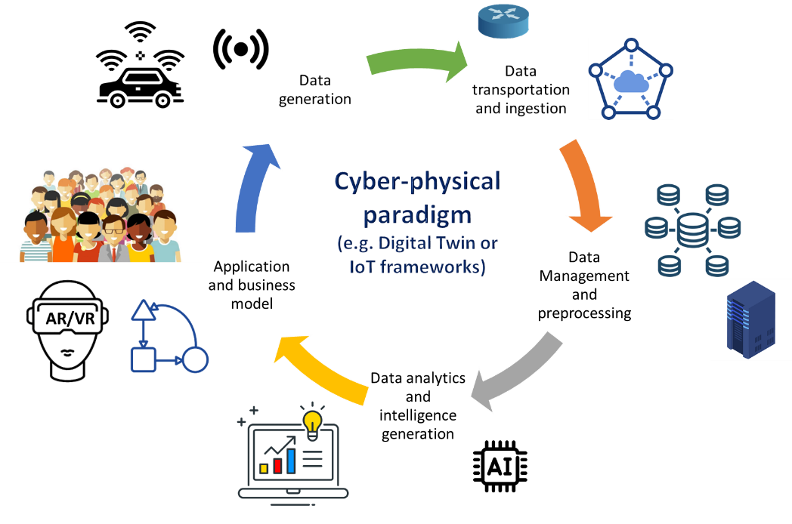
Figure 1 – The archetype of cyber-physical paradigm

Digital Twin pattern
Digital Twin communication pattern implements the cyber-physical paradigm; it has been around for several years in the manufacturing sector; nowadays, due to the digital revolution of our society, it is getting more and more popular in the other sector of our economy and society. The pattern is showed in Figure 2.

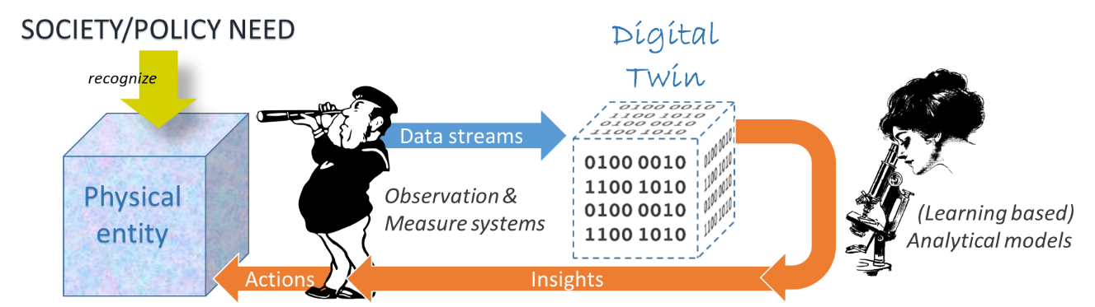
Figure 2 – Digital Twin communication pattern

Cyber-physical reference framework
Mobile technology (e.g. 5G and the next coming 6G), cloud computing (e.g. cloud-based data centers and edge computing), big data and deep analytics (e.g. predictive, cognitive, real-time and contextual) play important roles for cyber-physical systems and applications, by gathering and processing data to achieve the final result of controlling physical entities and impacting virtual entities [10] [11].
In a general setting, cyber-physical platform reference framework considers the following main digital components belonging to four different technology tiers [11], which are depicted in Figure 3:
- assets/sensors;
- networks;
- computing systems;
- (big) data analytics platforms;
- software applications.
The archetypal engineering architecture (or reference framework) of a cyber-physical (e.g. Digital Twin or IoT) platform is showed in Figure 3 [1] [2] [3] [7] [20].

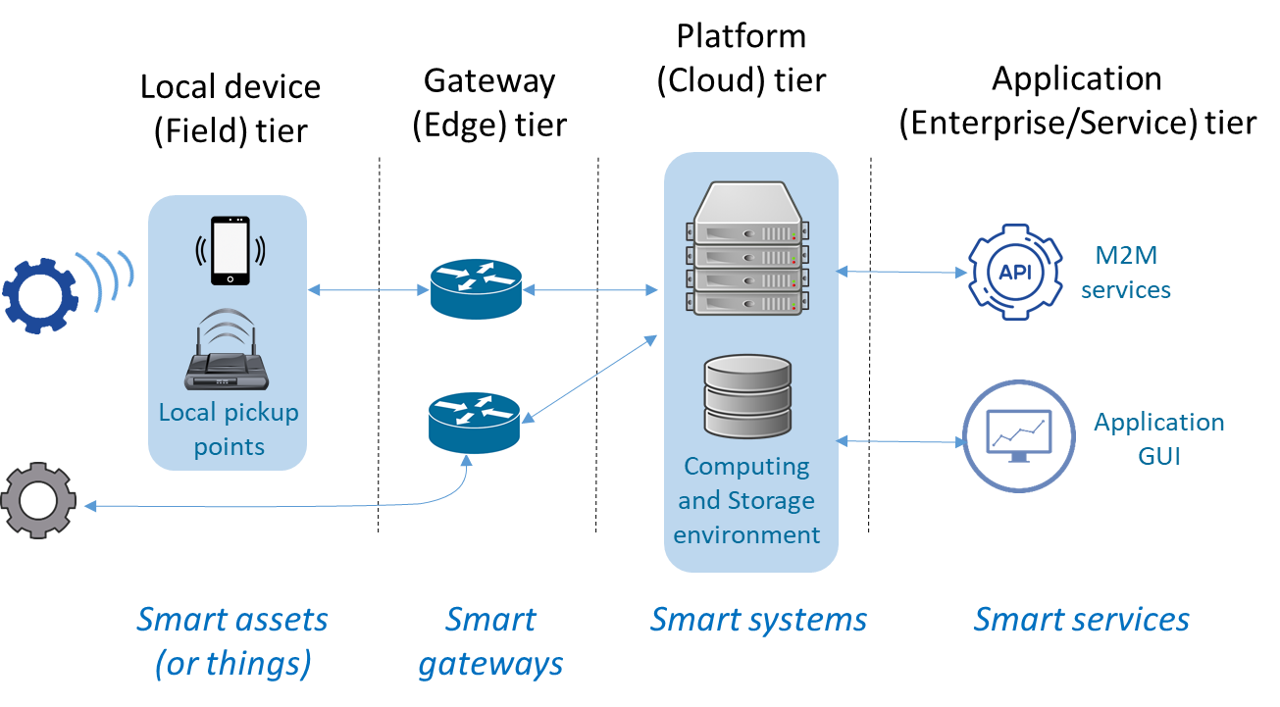
Figure 3 – Cyber-physical architecture reference framework

The Field tier consists of smart assets (e.g. sensors), while the Gateway (or Edge) and Platform (or Cloud) tiers contain smart gateways and systems, respectively. Finally, the Application (or Enterprise/Service) tier manages smart services [20] [21] [22].

Smart assets (or things)
Local device (or Field) tier comprises different types of devices, ranging from a smart machine to a sensor or an actuator and representing the networked edge node. They are also called smart assets (or things) because they use ICT capabilities (such as network, computing, and storage) to implement autonomy and collaboration.

Smart gateways
The Gateway (or Edge) tier contains the edge gateways. They are computing devices (i.e. a functional unit that can perform substantial computations) that operate as connectors (e.g. by implementing network connection and protocol conversion) between the smart assets (i.e. the physical world local devices) and the digital world. Real-time data analytics is performed by these components. Wherever necessary, for security and transparency reasons, a digital ledger (for example by using block-chain technology) may be included.

Smart systems
The Platform (or Cloud) tier consists of computing servers (and software) that enable non-real-time analytics and manage the cyber-physical system as a whole, by orchestrating the diverse components and the required ICT capabilities, in order to enable the final application/service business logic. These smart systems are commonly constructed based on the collaboration of multiple distributed smart gateways and servers to support elastic expansion of network, computing, and storage resources –see virtual infrastructures and platforms. Cloud computing and edge computing servers are typical examples of smart systems.

Cloud Data Centers and edge/fog computing systems
While cloud data centers are large facilities deployed in a limited number of locations (due to special infrastructure and management needs), in a digitally transformed society, cloud users are spread everywhere –IoT and 5G enabled applications are significant examples. Commonly, clients and users are far from the cloud data centers which are managed by their preferred providers. Edge and/or fog computing infrastructure are likely to be closer to those devices and applications to bring computing capacity with lower response time [19]. Therefore, in the edge computing model an important part of computing and sometimes storage happen in the edge of the network and not in the cloud data center.
In principle, this allows to reduce the data quantity to be moved around the network and distribute the computing load. Edge computing infrastructures connect the physical and the digital worlds enabling the development of smart systems and applications. While cloud computing effectively supports non-real-time and long-period data driven scenarios, edge computing is effective for real-time and short-period data driven scenarios –such as local decision-making. Commonly, edge computing does not replace cloud services but complement them, reducing storage requirements, decreasing latency, and providing real-time responses to users’ and application requests.
“The edge” can be defined in several different ways. Some providers define their edge as a Points of Presence (PoP) in major cities. These PoPs may operate a complete copy of the system to offer all functionality, located closer to the user for lower latency and reduced data transfer. These PoPs may be located in in major internet exchanges (IXs) such as in LINX (London), AMS-IX (Amsterdam), DE-CIX (Frankfurt), JPNAP (Tokyo). Other providers operate a subset of their platform functionality, such as popular content caching, in a large number of PoPs. These may be deployed in Internet Service Provider (ISP) networks much closer to the user, such as in the telephone exchange in the closest town, or near to radio cell towers. For example, Google has three layers to its network and the most granular edge caching nodes are deployed close to major population centres with multiple nodes within countries, not just in the main IXs (Google, 2020).

Smart services
The Application (or Service) tier contains the business logic software that generates and expose actionable intelligence to the cyber-physical system users and clients. The business logic software makes use of smart systems functionalities. Cyber-physical smart services range from observation & monitoring, to decision making and simulation.

Cyber-physical system deployment models
According to the end-to-end application considered, the cyber-physical computing architecture, depicted in Figure 3, can be deployed using either a three-layer or a four-layer model [22].

Cyber-physical architecture three-layers deployment
A three-layers model is common for application scenarios where smart services are distributed, i.e. deployed in one or more scattered areas, each of them characterized by a low traffic volume. Most of data processing is done at run-time by the smart gateways and the cloud-enabled service environment is used to enable services distribution and reach user devices. Smart systems are not deployed in a dedicated layer (not much data exchange and secondary processing are needed) but are part of either the gateway or the service layers [10][11][22].
Smart assets are processed locally by the smart gateways, which provide real-time streaming data analysis. In addition, the smart gateways aggregate multiple and heterogeneous data streams sending non-real-time data to the cloud for storing and possible additional processing. Finally, each smart gateway implements network services (noticeably, access to and local management of smart assets), security services, and small-scale local data storage.
Typical examples of these application scenarios are: smart devices monitoring and control, and smart environmental protection. The three-layer deployment model is showed in Figure 4.

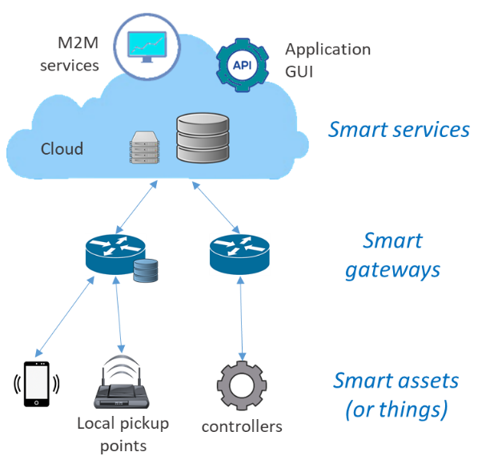
Figure 4 – Three-layers deployment schema of cyber-physical architectures

Cyber-physical architecture four-layers deployment
A four-layers model is common for application scenarios where smart services are deployed centrally, and the traffic volume is high [22]. A large amount of data and many local application systems are deployed at the edge of the network. Therefore, it is necessary to provide a large amount of computing and storage resources near the edge –i.e. distributed smart systems. This is achieved by deploying a layer consisting of a set of locally distributed smart systems. They are in charge of aggregating data for secondary processing; the primary processing, the real-time one, was already done by the smart gateways and the smart assets. The locally distributed smart systems are interconnected to exchange data and knowledge. These (commonly cloud-based) systems support horizontal elastic expansion of computing and storage resources and implement real-time decision-making and optimization operations locally [10][11][22]. The service environment (cloud-enabled) is then used to connect with users –see ubiquitous Internet connection.
Typical examples of these application scenarios are: video analysis, distributed grid, and smart manufacturing. The four-layer deployment model is showed in

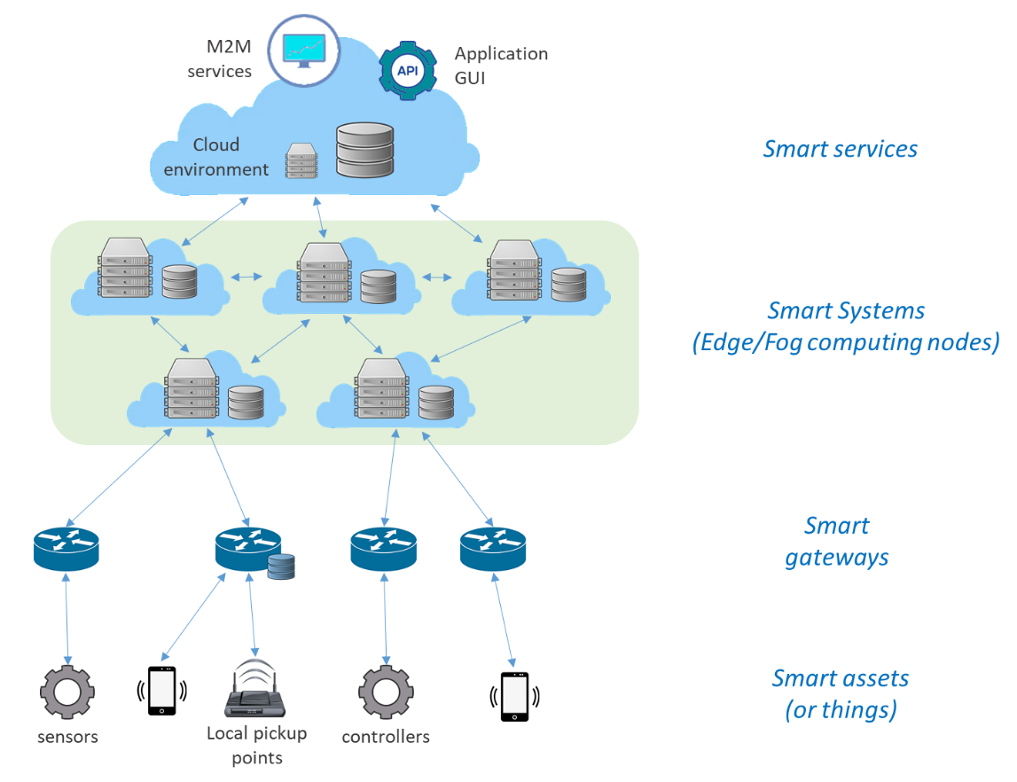
Figure 5 – Four-layers deployment schema of cyber-physical architectures

Cloud environment deployment
Cloud platforms can be public, private, and hybrid. In particular, a cloud can be seen as an extension of an enterprise Data Center (i.e. a private facility operated for the sole use of supporting a single organization) – see Figure 6.
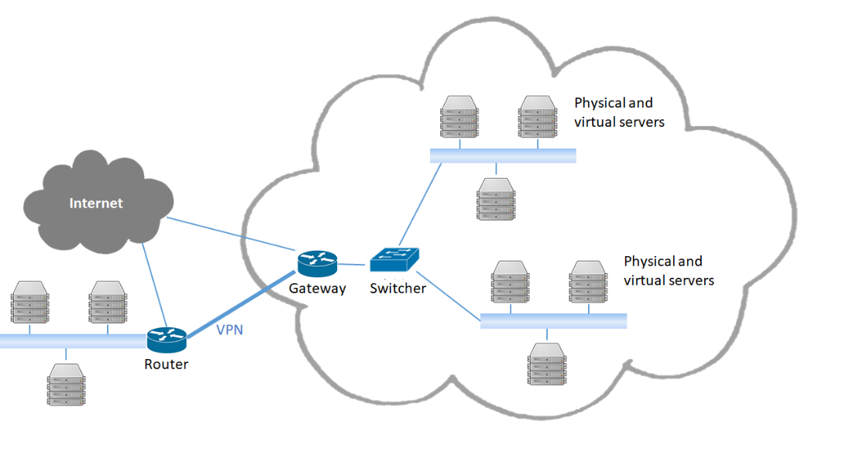
Figure 6 – Cloud as an extended enterprise data centre
Cloud platform performances depend on various cloud-services operation factors including [2]:
- availability of the service;
- response time to complete service requests;
- transaction rate at which service requests are executed;
- latency for service requests;
- data throughput rate (input and output);
- number of concurrent service requests (scalability);
- capacity of data storage;
- (for IaaS and PaaS) the number of concurrent execution threads available to an application;
- (for IaaS and PaaS) the amount of memory (RAM) available to the running program;
- data center network IP address pool and/or VLAN range capacity.
Cloud energy consumption is influenced by its performances and, hence, its implemented services and operations.

End-to-end use cases addressed
For the scope of this technical report, we distinguish three different types of cyber-physical use cases, building on a combination of innovative technologies:
- monitoring applications using smart IoT systems and AI software;
- smart applications using Edge computing and Cloud data center;
- simulation applications using the Digital Twin pattern.
For these use case typologies, we analyze the energy perspectives related to their computer processing and data management aspects.

Monitoring application using smart IoT systems and AI software
These applications commonly implement a three-layers deployment schema –see Figure 4.

Smart application using Edge computing and Cloud data center
Smart applications and systems build on collaboration of multiple distributed smart servers that connect the physical and the digital world providing real-time data analysis and actionable intelligence –see the cyber-physical systems and the Digital Twin pattern.
These applications commonly implement a four-layers deployment schema –see Figure 5.

Simulation applications using Digital Twin pattern
These applications commonly implement a four-layers deployment schema –see Figure 5.

Energy efficiency criteria
This chapter aims to give an overview of the energy efficiency criteria applicable to the use cases studied in this technical report. The purpose of this analysis is to give objective and quantitative energy efficiency criteria for the ICT goods, networks and services used in the use cases. In the case of goods, networks and services without available quantitative energy efficiency standards, there will be outlined the best available technologies present in the market that can somehow potentiate the energy efficiency in the AI and Emerging Technologies in study.
The Energy Efficiency Directive 2012/27/EU of the European Parliament and of the Council of 25 October 2012 [13] outlines the definition of energy efficiency as the “ratio of output of performance, service, goods or energy, to input of energy.” in line with energy efficiency general definition used in ITU-T documents, e.g. ITU-TL.1330.

Adopted methodology
The methodology chosen to accommodate the different measures within a certain use of an ICT good, network or service, was to consider a circular value-chain process consisting of three main steps:
- Data Storage;
- Data Transfer/Move; and
- Data Processing/Analytics.

The concept is that each of these stages of data management and use have different energy efficiency criteria and needs and will be analyzed on its own.
For its larger part, the functionalities that make the technologies in study, such as AI or other emerging technologies, depend on current ICT goods and networks, albeit with different configurations originating from the innovative aspect of these technologies. For this, the ICT goods and networks outlined in the paragraphs below represent the best available practices and technologies in the field, so that this technical report may endure the test of time.

Data storage
Regarding Data Storage, one is led to first consider Data Centers as these structures are computer warehouses that store a large amount of data for different organizations to meet their daily transaction processing needs. They contain servers for the collection of data and network infrastructure for the utilization and storage of the data.

Metrics and criteria

Power usage effectiveness (PUE) and Data Centre Infrastructure efficiency (DCIE)
The metric commonly used by the ICT industry to identify the energy efficiency of a Data Centre is the PUE, which is the ratio of total Data Centre input power to IT load power. A higher PUE means that more energy is used by the supporting infrastructure such as lighting, cooling and power distribution rather than energy going to IT equipment. PUE has been criticized as a measure of efficiency because it only considers energy usage and was intended only as a site-specific metric rather than one used for comparison between facilities. PUE may decrease when IT load increases because the IT equipment is drawing more energy, even though the efficiency of the data center has not actually improved (Brady et al., 2013).

The ideal value of PUE is 1.0 which indicates all energy goes to the IT equipment. However, this is generally not attainable at present due to the consumption of electricity by UPS, fans, pumps, transformers, lighting and other auxiliary equipment in addition to the consuming IT Load.

The most efficient data centers are approaching low values, such as EcoDataCenter in Falun, Sweden, which has a PUE of 1.15 [54], and Google’s fleet of data centers which achieved a Q2 2020 trailing twelve-month global average of 1.10. However, there are indications that PUE improvements are plateauing [55].
PUE has been shown to correlate poorly with carbon emissions [52], so should not be the only metric tracked [53]. Another metric used to measure the Data Centres efficiency is the DCIE, which is expressed as a percentage and is calculated by dividing IT equipment power by total facility power (DCIE = IT Equipment Power/Total Facility Power x 100%).

The EU Code of Conduct for Data Centres [41], a voluntary programme, has been created in response to the increasing energy consumption in data centres and the need to reduce the related environmental, economic and energy supply impacts and with the aim to inform and stimulate operators and owners to reduce energy consumption in a cost-effective manner and without hampering the critical function of data centres. In a 2017 report by the JRC on the trends in data centre energy consumption under the Code of Conduct, an overview is given of a decrease of the average PUE of Data Centres throughout the years for the whole 289 data centre sample. Some best practices on ways to improve the overall PUE of data centres are given [46] [79] , like free cooling technologies (direct and indirect air, direct and indirect water) or project management procedures that can be implemented and have a positive impact in the overall efficiency of the structures .

Energy Efficiency in PSU
An example of an energy efficiency criteria applicable to the stage of data storage may regard with PSU – Power Supply Unit. Regarding the PSU, the EU regulation on eco-design requirements for servers and data servers and data storage products, outlines that from 1 January 2023, for servers and online data storage products, with the exception of direct current servers and of direct current data storage products, the PSU efficiency at 10 %, 20 %, 50 % and 100 % of the rated load level and the power factor at 50 % of the rated load level shall not be less than the values reported in the table below.
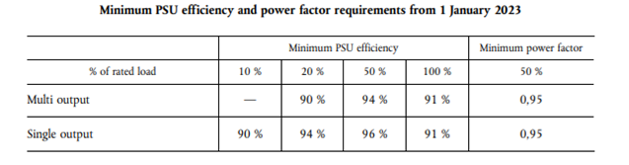
Figure 7 – Minimum PSU efficiency and power factor requirements from January 2023

Energy Efficiency best practices on data storage:
Data Storage ‘data storage product’ means a fully functional storage system that supplies data storage services to clients and devices attached directly or through a network. [2]
Both Energy Star [13] and the EU Code of Conduct for Energy Efficiency in Data Centres [46] present a set of energy efficiency measures that can be implemented in data storage facilities. The concepts within are of making better use of existing storage hardware, reducing the volume of data to be stored and using storage equipment that consumes less energy.
As for making better use of existing storage hardware, storage tiers are outlined as the assignment of different categories of data to various types of storage media, with the ultimate goal of reducing the storage cost. These tiers are determined by performance needs, the cost of the storage media, and how often this data is accessed. There is a defined grading system on the tier storage policies where the most frequently accessed data are placed on the highest performing storage, whereas the rarely accessed data go on low-performance, cheaper storage.
Storage virtualization is another measure to improve energy efficiency in the storage stage. Storage virtualization is the pooling of physical storage from multiple network storage devices into what appears to be a single storage device that is managed from a central console. Storage virtualization enhances storage performance, enables the use of storage tiers, and makes it easier to expand storage capacity.
Thin provisioning presents an application with a virtual volume of just about any size, but allocates physical storage space on a just-enough, just-in-time basis by centrally controlling capacity and allocating space to an application as data is actually written.
Another big part of energy efficiency in data storage measures relies on the reduction of the volume of data to be stored. Data Compression is performed by software that uses a formula or algorithm to determine how to shrink the size of the data. Compression functionality is built into a wide range of technologies, including storage systems, databases, operating systems and software applications used by enterprise organizations.
Deduplication software works by retaining one unique instance of a file or data block and replacing all duplicates with a pointer to the original.
Snapshot technology is another measure that can be applied in order to save energy in the storage stage. Snapshot technology works like as to avoid downtime, instead of making a full backup of the data, high-availability systems may instead perform the backup on a snapshot—a read-only copy of the data set frozen at a point in time—and allow applications to continue writing to their data. Snapshots create temporary virtual “copies” of data that only include data changes.
Not specific related to data centre storage but very important are other strategies like the decommissioning of unused servers and the consolidation of lightly utilized servers can also be measures to be implemented since often, data centres, possess aged and no use still running servers. The management of Airflow is an important aspect of data centre energy optimization Some of the best practices include the redefinition of the server racks into a Hot Aisle/Cold Aisle Layout, where the rows of server racks are oriented so that the fronts of the servers face each other instead of being in the same air flow direction.
The Containment/Enclosures arrangements when used in combination with the Hot Aisle/Cold Aisle Layout can also improve the efficiency of data centres server rooms. This containment refers to the various physical barriers that eliminate the mixing of cold air with hot air coming out of the server racks. This configuration allows for higher temperatures in the server rooms, which saves energy due to the slowing down of the fan speeds and increase of chilled water temperatures and the increase of the use of free cooling techniques.
Another measure that can be implemented within the design of data centres are the introduction of variable speed fan drives of computer rooms’ air conditioning and can be adjusted on the demand of the Data Centre which is constantly changing.
Finally, Energy Star indicates Properly Deployed Airflow Management Devices like the positioning of Diffusers, blanking panels, structured cabling systems, the elimination of sub-floor obstructions, floor grommets and the correct placing of vented tiles as measures to improve the overall efficiency of the data centre under the management of airflow measures.

Data transfer – 5G, Wireless, and Copper networks
This section aims to evaluate the best available technologies regarding data transfer and networks. The scope of this chapter is to evaluate the network technologies and data transfer protocols aiming for a better energy efficiency in the use cases studied.
Regarding mobile networks, the 5th generation, or 5G, will highly contribute for the accomplishment of the expectations of the IoT ecosystem and all its interdepending stakeholders in terms of accessibility and network speeds.
5G has been studied to be up to 90 percent more energy efficiency per traffic unit than legacy 4G networks, with several hardware and software solutions that help to save energy. However, experts expect, similarly to what happened with other technologies before, that the deployment of 5G network will lead to an increase of energy consumption. With companies expecting to be increasing their energy consumption due to an increase of traffic, the technology needs to be rolled-out in a way that the higher energy consumption of this technology is met with befitting measures that minimize this increase. Some of the measures outlined in a recent position paper [48] that may contribute to a smoother and more efficient technology transition are:
- “Prepare the network”: which includes the replacement of existing networks instead of adding new ones;
- “Activate energy-saving software”: which refers to energy saving features in the 5G network components, such as micro-sleep functions;
- “Build 5G with precision”: which concerns the avoidance of over-dimensioning hardware by considering the needs of the area of installation, to save on energy and costs;
- “Operate site infrastructure intelligently”, including the use of artificial intelligence to operate site infrastructure.
On another aspect, presently, the impact of wireless networks on the energy footprint of the ICT sector, could be said to be quite small due to the protocols that are used. Nevertheless, as more and more traffic is being transferred towards wireless networks, with the IoT being heavily depending in wireless technologies, the traffic is also increasing, thus making the energy efficiency of such communications non-negligible.
For example, in an evaluation with four of the most popular IoT protocols (Zigbee, LoRa, Bluetooth and WIFI) that constituted a Wireless sensor network, in a Smart Campus experience [43], an assessment of the energy efficiency of these protocols was performed. With a network of sensors being composed of sensors, radio transmitters and receivers, CPU and memory and the power source (battery), the authors identify some issues that can affect the node battery consumption. The term unbalanced energy depletion is presented and describes a situation where the nodes that are closer to the coordinator node carry more traffic, and so they consume more energy than those nodes further away from the root node. This imbalance causes the overall energy to be distributed non-uniformly in the network, making some nodes to run out of power faster than others. Looking at the energy side of the networks, the authors have identified that this is an important issue in the warranty of stable networks, due to the life of batteries. The IoT protocol found by the authors, in this network, the most efficient protocol was found to be Zigbee, both in a cooperative and collaborative configurations of the network.

Energy efficiency of 5G Base Stations
According to a technical report of the ITU FGAI4EE [78] the introduction of 5G into the networks with 2G, 3G and 4G brings more power consumption. Moreover, though 5G can provide faster and more services, its energy efficiency is not always optimal especially at the initial stage of deployment or with low traffic. On the other side, it is possible to re-use the 4G energy saving practices and technologies (e.g. carrier shutdown, channel shutdown, symbol shutdown, etc) [78]. While enhanced technologies have been developed in 5G era (e.g. deep sleep, symbol aggregation shutdown, etc.). Finally, Big Data and AI must be further utilized to implement intelligent and self-adaptive energy saving solutions and strategies, based on specific site traffic and other site-related conditions. According to [78] an AI-driven smart procedure for energy saving includes the following steps:
- Data Acquisition: The network performance data and MR/ CDT data of the base station are obtained through network management or data acquisition system.
- Data Processing: The collected data are pre-processed as being cleaned, constructed, aggregated and screened as training data for scene recognition, load forecasting and other models.
- Scenario Identification: The machine learning algorithm is used to identify the application scenario and determine the energy-saving shutdown scheme and function.
- Threshold Determination: According to the energy-saving target to be achieved, the appropriate energy-saving threshold is determined.
- Time-span Determination: Based on the historical traffic data, the machine learning algorithm is used to predict the traffic load in a certain period of time in the future to determine the energy saving time and activate the time window.
- Execution Strategy: The integrated energy-saving strategy is sent to the network management system to perform the energy-saving operations on 5G base station, such as deep sleep, carrier shutdown, symbol shutdown and corresponding activation time window.
- Feedback and Optimization: The performance data of the base station are collected to evaluate whether the expected target is achieved or not, and the closed-loop iterative optimization threshold strategy is adopted.
Naturally, in addition to network traffic monitoring, there are also AI techniques for traffic forecast.

Energy efficiency best practices with Passive Optical Networks
Communication networks are responsible for a great amount of energy consumption in the ICT ecosystem. Passive Optical Networks (PON) are important to have in consideration when addressing energy efficiency practices. One of the most promising methods to save energy in fiber access networks is to put network devices (an Optical Network Unit - ONU or Optical Line Termination - OLT or parts of them) into sleep mode when there is no traffic to be transmitted. However, putting these devices into sleep mode may incur packet delays. Ultimately, to save energy in Passive Optical Networks, using an efficient energy management with scheduling for the sleep and wake up period is a challenging task, although rewarding.
Energy saving of optical networks in four different levels are addressed in [60] – Components, transmission, network and applications.
- Component level, integrated all-optical processing components such as optical buffers, switching fabrics, and wavelength converters, may significantly reduce energy consumption.
- Transmission level, low-attenuation and low-dispersion fibers, energy-efficient optical transmitters and receivers (which improve the energy efficiency of transmission) are also being introduced.
- Network level, energy-efficient resource allocation mechanisms, green routing, long-reach optical access networks, etc. are trying to reduce energy consumption of optical networks.
- Application level, mechanisms for energy efficient network connectivity such as "Proxying" and green approaches for cloud computing are being proposed to reduce energy consumption.
As referred in [63], several solutions to reduce energy consumption in ONUs have been proposed by many researchers so far. The article refers that for time-division multiplexed (TDM) PONs with sleep mode, ONUs’ energy consumption can be reduced by switching them to low power mode when idle. However, huge savings can only be achieved if ONUs are capable of quickly regaining synchronization upon wake up, and the power consumed while sleeping is much less than when the ONU is on. Moreover, data link layer solutions alone (e.g., sleep mode) may be effective when network utilization is low, but when network utilization increases, physical layer support (e.g., quick resynchronization) is necessary. If solutions and ONU architectures with such characteristics are developed, huge energy savings and limited delay increase can be achieved.

Energy Efficiency best practices with Copper Networks
The ecological footprint of broadband access technology has substantially increased during the last decades due to the rapid acceptance and availability of fast and reliable Internet connections. With this an increase of energy consumption in these networks has also been detected. Despite the fact that there is a clear trend to more fiber-based access solutions in the future, DSL-based access will remain relevant.
There are several initiatives, like the EU Code of Conduct Energy Consumption of Broadband Equipment [62] and others that have been addressing the issue of energy consumption and urging the ICT industry to act on its environmental impact.
DSL is a cost-effective solution to bring broadband access to its customers by using the existing copper infrastructure, originally installed for simple voice communication.
The article on improving the energy efficiency of broadband copper access networks [61] outlines some conclusions on best practices to be implemented in broadband networks “At the architecture level, by moving to smaller nodes, and at the component level, by selecting energy-efficient technology and/or by introducing design techniques (for instance, clock and power gating), which benefit from the typical Internet usage (burstiness of traffic, video streaming, day/night cycles), power savings can be obtained, which, in the best case, can reduce by more than half the energy consumption of the access network. Moving to a more distributed access network of small nodes is currently necessary with the introduction of G.vector and the planned introduction of G.fast, one can rethink how these nodes can be cooled (fresh air cooling, passive cooling) and powered (reverse powering) because of the different scales of these nodes. Some of these solutions not only provide energy saving but also assist in enabling the operator to easily deploy these increased numbers of small-sized active components in this network. For instance, by removing the need of active cooling (requiring additional power) in the small nodes, the power budget to feed these small nodes comes within reach of new power schemes such as reverse powering (which do introduce some inefficiency compared with classical powering schemes such as local ac/dc conversion).

The EU Code of Conduct outlines also that “the volume of deployed broadband equipment is increasing dramatically and so is its combined power consumption. Due to low customer aggregation ratios (typically, one Customer Premises Equipment (CPE) per customer), such equipment is typically idle most of the time, most of the time exchanging data only to maintain its network status. It is therefore evident that such equipment can be optimized in terms of its power consumption and activity profiles. Examples of such techniques include dynamic adaptation (e.g., performance scaling), smart standby (e.g., through proxying network presence and virtualization of functions) and energy aware management.”

Data processing
On Data processing, there are several groups of ICT goods that can be evaluated. At first, computers and small servers are the ones that may present as more obvious since these will be responsible for a great part of data processing with the roll-out of the emerging technologies, with the data being processed in cloud or edge computing.
The European Commission’s regulation on Ecodesign requirements for computers and servers from 2014 outline some guidelines for desktop computers, integrated desktop computers, notebook computers (including tablet computers, slate computers and mobile thin clients), desktop thin clients, workstations, mobile workstations, small-scale servers and computer servers. These types of hardware are ultimately expected to be responsible for a big part of the processing of data within the IoT environment. The Ecodesign requirements are presented in Annex II of the Guidelines [17].

Energy Efficiency best practices on data processing
There are several cases of energy efficiency in the different parts of the life of a byte of data that have been studied, especially in terms of the hardware or the infrastructures being used. An area that is still less investigated is the role that coding and software can have in the energy performance in the data processing stages.
A study on the Empirical evaluation of two best practices for energy-efficient software development [45] evaluated the impact of two best practices for energy-efficient software and applied these practices in two widely used software applications, MySQL Server and Apache Webserver and each practice successfully reduced the energy consumption of our test environment and conclude that software design and implementation choices significantly affect energy efficiency. This study is based in previous studies that have been evaluating the connection between software development and energy efficiency, like the work of Capra et al. (2012a), which analyzes the impact of application development environments over the energy efficiency of software applications, concluding for example that a high framework entropy is beneficial for the energy efficiency of small and medium applications. The work of Sahin et al. (2012) which investigates the energy impact of using software design patterns and conclude that the impact of applying a design pattern varies greatly, from less than 1% to more than 700%. The work of Noureddine et al. (2012) analyzes the energy impact of programming languages and algorithmic choices that finds that the algorithm choice has a significant impact on energy consumption. (The recursive algorithm is more energy-efficient than the iterative one) and that the chosen programming language has a significant impact on energy consumption as well. Manotas et al. (2013) investigated the energy impact of web servers in web applications and found that the energy consumption of a web application greatly varies depending on the chosen web server and that the variation depends on the specific feature of the web server. The same web server might be more energy efficient in a specific scenario (e.g., search) and very inefficient in others.
Another article analysing Energy efficiency optimization in big data processing platform by improving resources utilization [44] outlines a proposal for the resources utilization in Big Data processing by allocating different resources according to a task-related Best Resource Ratio (BRR for short), such as “CPU, disk, network in the ratio of 1:2:4”, rather than the resource’s quantity, such as “CPU = 1 GHz, network = 20MB/s”. The study deduces the BRR of data processing tasks, and designs a resource ratio based approach (R²), which includes a task scheduling algorithm and resource allocation algorithm, for energy efficiency optimization. Experiments show that the R² approach can improve energy efficiency by 10%.
In 2011, Intel has produced a white paper on energy-efficient software guidelines, which can be help developers aiming to reduce the energy consumption of their pieces of software [47].

ML energy consumption and efficiency
Power models are built to design better hardware, design better algorithms or design better software to map these algorithms onto hardware.
In the case of ML applications, at the system-level, it is possible to distinguish between two power estimation models [56]:
- Software level: the focus is on the energy consumption of the application or software implementation and explore optimization techniques, working at the level of: application (for example, kernel sizes in a neural network); instructions (for example by using performance counter profiling, understand the cost for each instruction and try to reduce the most expensive part of the code);
- Hardware-level: the focus is on the energy consumption of specific hardware components (for example, processor, memory and IO peripherals).
A general survey of the utilized techniques for both software and hardware levels is provided in [56].
In Machine Learning we can further distinguish two main phases: training and inference (or operational). Research settings typically focus on model training and accuracy performance. In industrial settings, the cost of inference might exceed the training costs in the long term. In this context, it might be more beneficial to use more expensive models to train even if they are more efficient in the inference phase, when in operation.
Motivation: In the context of Deep Neural Networks regarding the training of some machine learning algorithms, the process generally involves a certain number of passes through the dataset, often called epochs. It has been realized in a recent study 0 that there is a threshold of epochs at which the accuracy of machine learning model reached a plateau, but energy consumption continues to increase. The same for larger training data sets that demand more energy to train but do not lead necessarily to a proportional benefit in accuracy. The study suggests that there may be a path for models not reaching full accuracy and still complying with the needs of the user. Other suggestion was to use transfer learning where an existing model could be repurposed for a different task in order to save energy and time.
Advances in techniques and hardware for training deep neural networks have recently enabled impressive accuracy improvements in image processing and across many fundamental Natural Language Processing (NLP) tasks as referred in [58] , with also a great dependence of large computational resources that need similarly substantial energy consumption. In this chapter we are mainly focusing on Deep Learninng algorithms, as it is the set of techniques creating the most power consuming models nowadays. But it is worth noting that this is just a subset of Machine Learning algorithms, and practitioners should also be encouraged to resort to more traditional and power-efficient options (like random forest or XGBoost to name a few) when appropriate.
. Some of the actionable recommendations to reduce costs in NLP that could be adapted in other applications, mentioned by the paper include:
- The reporting of training time and sensitivity to hyperparameters where it would be beneficial to directly compare different models to perform a cost-benefit (accuracy) analysis;
- Prioritize computationally efficient hardware and algorithms.
Most recently, some research developed within Google have also raised awareness of the high computational needs and other ethical risks of the latest NLP models [66], which has put some pressure on Google researchers to emphasize the importance of the topic and justify how the benefits of the model outweigh the energy costs. This other study [67] shows how depending on the choices made for training a large NLP model, like the type of ML model, datacenter and processor; carbon footprint can be reduced up to ~100-1000X.
How to estimate emissions
The research community is more and more asking for a systematic way of reporting the energy and carbon footprints of Machine Learning models [68], and also calling to direct research towards more efficient models focusing on what is called Green AI, to decrease its carbon footprint and increase its inclusivity [69]. On the other side of the balance we have, what is defined here as Red AI, which is AI that targets accuracy using massive computational power.
There are already some efforts to reduce the size of these models through techniques like distillation or quantization [70][71]. They still however rely on a significant amount of processing to produce these reductions. Sparsely activated models have claimed to provide significant savings both for training and inference [72].
In the recent years, some tools, like Green Algorithms tool [72] or the Machine Learning Emissions Calculator [74], have been created that help Machine Learning researchers and practitioners get an understanding of the approximate environmental impact of their experiments. They based their estimations on the location of the server used, the length of the procedure, and the make and model of the hardware. In [66] the authors present the state-of-the-art approaches and software tools to estimate energy consumption from Machine Learning algorithms up to mid-2019.

However, being able to approximately measuring while running the experiments is generally more accurate than indirect estimations a posteriori. At the end of 2019, [75] presented a python package that calculates the energy and C02 emissions of any (python) function and provides an Energy Usage Report to add context to these results (see Figure X2). Another attempt presented a month later is the experiment-impact-tracker framework [A11], which provides a systematic way for the community to consistently account and report energy, compute, and carbon metrics. This tool can make it easier to understand the full training lifecycle, including training attempts performed before the set up used is the final one. Most recently CodeCarbon is also being developed to approximately measure carbon emissions in a more automatic way.
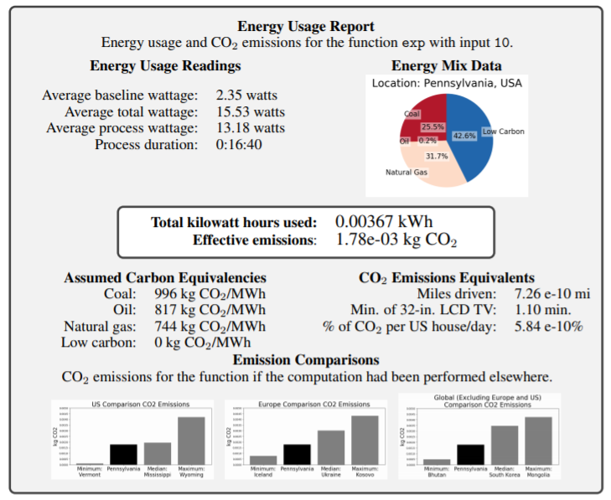

Figure 8 – An example Energy Usage Report for a simple exponential function. Image taken directly from[76]
ML on Edge devices
More and more computation is gradually taking place on edge devices (i.e. IoT), thanks to the explosive growth of internet-connected devices. Edge devices are power or resource-constrained, and typically, a tradeoff between accuracy and efficiency must be found. An article on Energy-efficient Machine Learning on the Edges [59] also considers new hardware architecture for machine learning on edge and hardware-based full stack optimization for machine learning on edge computing as two categories that can be exploited in order to meet the growing demand for resources in machine learning algorithms.
The same applies at the software level and packages where now many projects focus on developing and optimizing software platforms and machine learning packages to meet the low-power requirements of the edge. Algorithms, again, are seen as a key path to reducing the energy consumption of machine learning models, being by reducing the computational requirements, being by the reduction of the accuracy of operations and operands.

In order to address the issue of the large environmental impact of such AI training processes, some solutions have been outlined [65]. A “once-for-all” network, which trains a large model that has many pretrained sub-models of different sizes that can be tailored to a range of platforms without retraining.
Each of these sub-models can operate independently at inference time without retraining, and the system identifies the best sub-model based on the accuracy and latency trade-offs that correlate to the target hardware’s power and speed limits.
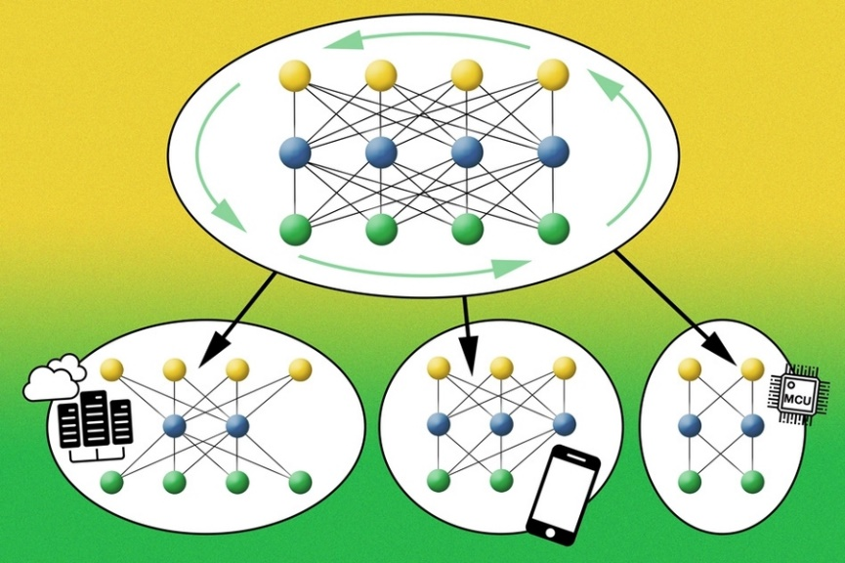
Figure 9 – Neural network with sub-models. Source: MIT [64]
A “progressive shrinking” algorithm trains the large model to support the sub-models at the same time. First, the large model is trained and then the smaller sub-models are trained with the aid of the large model so that they learn simultaneously. Finally, all of the sub-models are supported, allowing for a speedy specialization based on the target platform’s specifications.

Summary
In summary, most of the latest research on the topic is recommending to:
- use sparsely activated Deep Neural Networks for energy savings,
- pay attention to the geographic location of the servers where ML workload runs,
- use of specialized infrastructure that includes accelerators appropriate for the task,
- duly report the energy consumption and CO2 emissions on Machine Learning papers and research, specially when it involves large training of models;
- use also efficiency as an evaluation metric (e.g. floating point operations), in combination with accuracy and other similar metrics;
- include the full training lifecycle in the calculations, which considers previous attempts needed until everything is set up correctly,
- keep energy needs for inference into account, as these can often outweigh the training ones, and
- release pre-trained models to save others the cost of retraining them
This list is non exhaustive but should serve as an indication of the state of play at the time of writing. There are also experts that are urging policy makers to stimulate transparency and the creation of standards, to facilitate the emission calculations in the area of Artificial Intelligence [77].

Appliance of Energy criteria to the end-to-end considered by this report
The energy efficiency good practices (introduced in Chapter 8) are applied to the three end-to-end application typologies introduced in Chapter 7, acknowledging the different components and the three main steps of the circular value-chain discussed.

Monitoring application using smart IoT systems and AI software
In the case of developing and managing monitoring applications by using smart IoT systems and AI software, good practices for energy efficiency are summarized in Table 3.

Table 1 – Energy efficiency good practices for implementing monitoring application using smart IoT systems and AI software
Component | Value-chain step to which it contributes | Energy efficiency good practices | Notes
IoT systems | Data storage | One or more of the following techniques:  - storage tiers  - storage virtualization  - thin provisioning  - data compression  - deduplication  - decommissioning of non-used storage  - snapshot technology | See chapter 8.2
 | Data Transfer (5G) | Implement the AI-driven smart procedure consisting of the steps:  - Scenario Identification  - Threshold Determination  - Time-span Determination  - Execution Strategy  - Feedback and Optimization | See chapter 8.3.1  (for Optical and copper networks, see 8.3.2 and 8.3.3, respectively)
Smart gateways | Data Transfer (5G) | Implement the AI-driven smart procedure consisting of the steps:  - Scenario Identification  - Threshold Determination  - Time-span Determination  - Execution Strategy  - Feedback and Optimization | See chapter 8.3.1  (for Optical and copper networks, see 8.3.2 and 8.3.3, respectively)
 | Data processing (ML) | One or more of the following techniques/strategies:  - Hardware-based full stack optimization  - A “once-for-all” AI network (which trains a large model that has many pretrained sub-models) –notably:  - use sparsely activated Deep Neural Networks for energy savings,  - pay attention to the geographic location of the servers where ML workload runs,  - use of specialized infrastructure that includes accelerators appropriate for the task,  - duly report the energy consumption and CO2 emissions on Machine Learning papers and research –specially when it involves large training of models;  - use also efficiency as an evaluation metric (e.g. floating point operations), in combination with accuracy and other similar metrics;  - include the full training lifecycle in the calculations, which considers previous attempts needed until everything is set up correctly,  - keep energy needs for inference into account, as these can often outweigh the training ones, and  - release pre-trained models to save others the cost of retraining them. | See chapter 8.4.2
Smart services/Cloud | Data storage | One or more of the following techniques:  - storage tiers  - storage virtualization  - thin provisioning  - data compression  - deduplication  - decommissioning of non-used storage  snapshot technology | See chapter 8.2
 | Data Transfer (5G) | Implement the AI-driven smart procedure consisting of the steps:  - Scenario Identification  - Threshold Determination  - Time-span Determination  - Execution Strategy  Feedback and Optimization | See chapter 8.3.1  (for Optical and copper networks, see 8.3.2 and 8.3.3, respectively)
 | Data processing (ML) | One or more of the following techniques/strategies:  - Hardware-based full stack optimization  - A “once-for-all” AI network (which trains a large model that has many pretrained sub-models) –notably:  - use sparsely activated Deep Neural Networks for energy savings,  - pay attention to the geographic location of the servers where ML workload runs,  - use of specialized infrastructure that includes accelerators appropriate for the task,  - duly report the energy consumption and CO2 emissions on Machine Learning papers and research –specially when it involves large training of models;  - use also efficiency as an evaluation metric (e.g. floating point operations), in combination with accuracy and other similar metrics;  - include the full training lifecycle in the calculations, which considers previous attempts needed until everything is set up correctly,  - keep energy needs for inference into account, as these can often outweigh the training ones, and  release pre-trained models to save others the cost of retraining them. | See chapter 8.4.2

Smart application using edge computing and Cloud data center
In the case of developing and managing smart applications building on edge computing and Cloud data center, good practices for energy efficiency are summarized in Table 3.

Table 2 – Energy efficiency good practices for implementing smart application using edge computing and Cloud data center
Component | Value-chain steps to which it contributes | Energy efficiency good practices | Notes
IoT systems | Data storage | One or more of the following techniques:  - storage tiers  - storage virtualization  - thin provisioning  - data compression  - deduplication  - decommissioning of non-used storage  - snapshot technology | See chapter 8.2
 | Data Transfer (5G) | Implement the AI-driven smart procedure consisting of the steps:  - Scenario Identification  - Threshold Determination  - Time-span Determination  - Execution Strategy  - Feedback and Optimization | See chapter 8.3.1  (for Optical and copper networks, see 8.3.2 and 8.3.3, respectively)
Smart gateways | Data Transfer (5G) | Implement the AI-driven smart procedure consisting of the steps:  - Scenario Identification  - Threshold Determination  - Time-span Determination  - Execution Strategy  - Feedback and Optimization | See chapter 8.3.1  (for Optical and copper networks, see 8.3.2 and 8.3.3, respectively)
 | Data processing (ML) | One or more of the following techniques/strategies:  - Hardware-based full stack optimization  - A “once-for-all” AI network (which trains a large model that has many pretrained sub-models) –notably:  - use sparsely activated Deep Neural Networks for energy savings,  - pay attention to the geographic location of the servers where ML workload runs,  - use of specialized infrastructure that includes accelerators appropriate for the task,  - duly report the energy consumption and CO2 emissions on Machine Learning papers and research –specially when it involves large training of models;  - use also efficiency as an evaluation metric (e.g. floating point operations), in combination with accuracy and other similar metrics;  - include the full training lifecycle in the calculations, which considers previous attempts needed until everything is set up correctly,  - keep energy needs for inference into account, as these can often outweigh the training ones, and  - release pre-trained models to save others the cost of retraining them. | See chapter 8.4.2
Smart Systems (Edge/Fog Computing nodes) | Data storage | One or more of the following techniques:  - storage tiers  - storage virtualization  - thin provisioning  - data compression  - deduplication  - decommissioning of non-used storage  - snapshot technology | See chapter 8.2
 | Data Transfer (5G) | Implement the AI-driven smart procedure consisting of the steps:  - Scenario Identification  - Threshold Determination  - Time-span Determination  - Execution Strategy  - Feedback and Optimization | See chapter 8.3.1  (for Optical and copper networks, see 8.3.2 and 8.3.3, respectively)
 | Data processing (ML) | One or more of the following techniques/strategies:  - Hardware-based full stack optimization  - A “once-for-all” AI network (which trains a large model that has many pretrained sub-models) –notably:  - use sparsely activated Deep Neural Networks for energy savings,  - pay attention to the geographic location of the servers where ML workload runs,  - use of specialized infrastructure that includes accelerators appropriate for the task,  - duly report the energy consumption and CO2 emissions on Machine Learning papers and research –specially when it involves large training of models;  - use also efficiency as an evaluation metric (e.g. floating point operations), in combination with accuracy and other similar metrics;  - include the full training lifecycle in the calculations, which considers previous attempts needed until everything is set up correctly,  - keep energy needs for inference into account, as these can often outweigh the training ones, and  - release pre-trained models to save others the cost of retraining them. | See chapter 8.4.2
Smart services/Cloud | Data storage | One or more of the following techniques:  - storage tiers  - storage virtualization  - thin provisioning  - data compression  - deduplication  - decommissioning of non-used storage  - snapshot technology | See chapter 8.2
 | Data Transfer (5G) | Implement the AI-driven smart procedure consisting of the steps:  - Scenario Identification  - Threshold Determination  - Time-span Determination  - Execution Strategy  - Feedback and Optimization | See chapter 8.3.1  (for Optical and copper networks, see 8.3.2 and 8.3.3, respectively)
 | Data processing (ML) | One or more of the following techniques/strategies:  - Hardware-based full stack optimization  - A “once-for-all” AI network (which trains a large model that has many pretrained sub-models) –notably:  - use sparsely activated Deep Neural Networks for energy savings,  - pay attention to the geographic location of the servers where ML workload runs,  - use of specialized infrastructure that includes accelerators appropriate for the task,  - duly report the energy consumption and CO2 emissions on Machine Learning papers and research –specially when it involves large training of models;  - use also efficiency as an evaluation metric (e.g. floating point operations), in combination with accuracy and other similar metrics;  - include the full training lifecycle in the calculations, which considers previous attempts needed until everything is set up correctly,  - keep energy needs for inference into account, as these can often outweigh the training ones, and  - release pre-trained models to save others the cost of retraining them. | See chapter 8.4.2

Simulation applications using Digital Twin pattern
In the case of developing and managing simulation applications by applying the Digital Twin pattern, good practices for energy efficiency are summarized in Table 3.

Table 3 – Energy efficiency good practices for implementing simulation applications applying the Digital Twin pattern
Component | Value-chain steps to which it contributes | Energy efficiency good practices | Notes
IoT systems | Data storage | One or more of the following techniques:  - storage tiers  - storage virtualization  - thin provisioning  - data compression  - deduplication  - decommissioning of non-used storage  - snapshot technology | See chapter 8.2
 | Data Transfer (5G) | Implement the AI-driven smart procedure consisting of the steps:  - Scenario Identification  - Threshold Determination  - Time-span Determination  - Execution Strategy  - Feedback and Optimization | See chapter 8.3.1  (for Optical and copper networks, see 8.3.2 and 8.3.3, respectively)
Smart gateways | Data Transfer (5G) | Implement the AI-driven smart procedure consisting of the steps:  - Scenario Identification  - Threshold Determination  - Time-span Determination  - Execution Strategy  - Feedback and Optimization | See chapter 8.3.1  (for Optical and copper networks, see 8.3.2 and 8.3.3, respectively)
 | Data processing (ML) | One or more of the following techniques/strategies:  - Hardware-based full stack optimization  - A “once-for-all” AI network (which trains a large model that has many pretrained sub-models) –notably:  - use sparsely activated Deep Neural Networks for energy savings,  - pay attention to the geographic location of the servers where ML workload runs,  - use of specialized infrastructure that includes accelerators appropriate for the task,  - duly report the energy consumption and CO2 emissions on Machine Learning papers and research –specially when it involves large training of models;  - use also efficiency as an evaluation metric (e.g. floating point operations), in combination with accuracy and other similar metrics;  - include the full training lifecycle in the calculations, which considers previous attempts needed until everything is set up correctly,  - keep energy needs for inference into account, as these can often outweigh the training ones, and  - release pre-trained models to save others the cost of retraining them. | See chapter 8.4.2
Smart Systems (Edge/Fog Computing nodes) | Data storage | One or more of the following techniques:  - storage tiers  - storage virtualization  - thin provisioning  - data compression  - deduplication  - decommissioning of non-used storage  - snapshot technology | See chapter 8.2
 | Data Transfer (5G) | Implement the AI-driven smart procedure consisting of the steps:  - Scenario Identification  - Threshold Determination  - Time-span Determination  - Execution Strategy  - Feedback and Optimization | See chapter 8.3.1  (for Optical and copper networks, see 8.3.2 and 8.3.3, respectively)
 | Data processing (ML) | One or more of the following techniques/strategies:  - Hardware-based full stack optimization  - A “once-for-all” AI network (which trains a large model that has many pretrained sub-models) –notably:  - use sparsely activated Deep Neural Networks for energy savings,  - pay attention to the geographic location of the servers where ML workload runs,  - use of specialized infrastructure that includes accelerators appropriate for the task,  - duly report the energy consumption and CO2 emissions on Machine Learning papers and research –specially when it involves large training of models;  - use also efficiency as an evaluation metric (e.g. floating point operations), in combination with accuracy and other similar metrics;  - include the full training lifecycle in the calculations, which considers previous attempts needed until everything is set up correctly,  - keep energy needs for inference into account, as these can often outweigh the training ones, and  - release pre-trained models to save others the cost of retraining them. | See chapter 8.4.2
Smart services/Cloud | Data storage | One or more of the following techniques:  - storage tiers  - storage virtualization  - thin provisioning  - data compression  - deduplication  - decommissioning of non-used storage  - snapshot technology | See chapter 8.2
 | Data Transfer (5G) | Implement the AI-driven smart procedure consisting of the steps:  - Scenario Identification  - Threshold Determination  - Time-span Determination  - Execution Strategy  - Feedback and Optimization | See chapter 8.3.1  (for Optical and copper networks, see 8.3.2 and 8.3.3, respectively)
 | Data processing (ML) | One or more of the following techniques/strategies:  - Hardware-based full stack optimization  - A “once-for-all” AI network (which trains a large model that has many pretrained sub-models) –notably:  - use sparsely activated Deep Neural Networks for energy savings,  - pay attention to the geographic location of the servers where ML workload runs,  - use of specialized infrastructure that includes accelerators appropriate for the task,  - duly report the energy consumption and CO2 emissions on Machine Learning papers and research –specially when it involves large training of models;  - use also efficiency as an evaluation metric (e.g. floating point operations), in combination with accuracy and other similar metrics;  - include the full training lifecycle in the calculations, which considers previous attempts needed until everything is set up correctly,  - keep energy needs for inference into account, as these can often outweigh the training ones, and  - release pre-trained models to save others the cost of retraining them. | See chapter 8.4.2

___________________

Source: Regulation on eco-design requirements for servers and data storage products EU 2019/424.
https://github.com/mlco2/codecarbon

