 |  | International Telecommunication Union
 |  | ITU-T | Technical Report
 |  | TELECOMMUNICATION  STANDARDIZATION SECTOR  OF ITU |  | (03-2021)
 | ITU-T Focus Group on Environmental Efficiency for Artificial Intelligence and other Emerging Technologies (FG-AI4EE)
FG-AI4EE D.WG3-02
Smart energy saving of 5G base stations: Based on AI and other emerging technologies to forecast and optimize the management of 5G wireless network energy consumption

Working Group 3 - Implementation Guidelines of AI and Emerging Technologies for Environmental Efficiency

 | Focus Group Technical Report

Technical Report ITU-T FG-AI4EE D.WG3-02
Smart energy saving of 5G base stations: Based on AI and other emerging technologies to forecast and optimize the management of 5G wireless network energy consumption
Summary
This Technical Report explores how network energy saving technologies that have emerged since the 4th generation of wireless networks (4G) era, such as carrier shutdown, channel shutdown, symbol shutdown, etc., can be leveraged to mitigate 5th generation of wireless networks (5G) energy consumption. It also analyses how enhanced technologies like deep sleep, symbol aggregation shutdown, etc., have been developing in the 5G era. This report aims to detail these fundamentals. However, it is far away from being enough, a revolutionized energy saving solution should be taken into consideration. In response to the requirement of an intelligent and self-adaptive energy saving solution, artificial intelligence (AI) and big data technology are introduced to form a more precise energy saving strategy based on specific site traffic and other site-related conditions, thus improving the efficiency, and reducing the manpower required. More details about AI-driven smart energy saving solution will be elaborated. The hope is that this Technical Report can help achieve the most energy-efficient network with good performance and lower operating expense (OPEX) for mobile network operators (MNOs).
Note
This is an informative ITU-T publication. Mandatory provisions, such as those found in ITU-T Recommendations, are outside the scope of this publication. This publication should only be referenced bibliographically in ITU-T Recommendations.
Keywords
5G, AI, base station, energy consumption, energy saving.
Change Log
This document contains Version 1.0 of the ITU-T Technical Report on “Smart energy saving of 5G base station: Based on AI and other emerging technologies to forecast and optimize the management of 5G wireless network energy consumption" approved at the ITU-T Study Group 5 meeting held online, 11-20 May 2021.

Editor: | Tan Rumeng  China Telecommunications Corp.  China | Tel: +86 20 38639526  Fax: +86 20 38639370  Email: tanrum@chinatelecom.cn
Editor: | Shi Ying  China Telecommunications Corp.  China | Tel: +86 20 38639321  Fax: +86 20 38639370  Email: shiying@chinatelecom.cn
Editor: | Chen Lijun  ZTE Corporation  China | Tel: +86 13916030405  Email: chen.lijun2@zte.com.cn
Editor: | Fan Yingying  ZTE Corporation  China | Tel: +86 13818853745  Email: fan.yingying@zte.com.cn
Editor: | Wu Tong  National Institute of Metrology  China | Tel: +86 10-64224092  Fax: +86 10-64204738  Email: wut@nim.ac.cn
Editor: | Liang Liwei  China Telecommunications Corp.  China | Tel: +86 20-87188134  Fax: +86 20-87188796  Email: lianglw1.gd@chinatelecom.cn

Table of Contents
Page
1. Scope 2
2. References 2
3. Terms and definitions 2
3.1. Terms defined elsewhere 2
4. Abbreviations 2
5. Specific contents 3
6. Energy saving technologies for BS 3
6.1. Basic software energy saving technologies for BS 4
6.2. Recommended strategy for 4G/5G fundamentals 6
7. Smart energy saving solutions based on AI 7
7.1. Overview of AI technology 7
7.2. AI based energy saving for 5G BS 8
7.3. Energy saving scheme architecture based on AI 9
7.4. Recommended energy-saving procedure based on AI 10
7.5. Forecasting algorithms comparison in network traffic load 10
7.6. The service awareness energy saving for 5G BS 11
8. Future prospects 11

List of Figures
Page
Figure 1 Forecast levels of network automation by MNOs worldwide 2018-2025 (Source: Analysys Mason) 8
Figure 2 Overall architecture of 5G intelligent energy-saving network 9
Figure 3 AI energy-saving procedure for 5G BS 10

Technical Report ITU-T FG-AI4EE D.WG3-02
Smart energy saving of 5G base stations: Based on AI and other emerging technologies to forecast and optimize the management of 5G wireless network energy consumption
Background
Network energy saving has never been so important. Firstly, climate change is one of the most pressing challenges of our century. The Paris Agreement and the United Nations (UN) Sustainable Development Goals (SDGs) are two great examples of how society works together in tackling this challenge. The UN SDGs set an industry goal of net-zero emissions by 2050. In the guide for the cellular mobile network operators (MNOs) by GSMA about climate target, the goal is to reduce carbon emissions by 45% from 2020 to 2030^{[1] [2]}.
To realize such a target, 5G is becoming the most critical part for two major reasons: the introduction of 5G into the networks with 2G, 3G and 4G, brings more power consumption; the other reason being though 5G can provide faster and more services, its energy efficiency is not always optimal especially at the initial stage of deployment or with low traffic. The good news is we do not have to re-invent the wheels to 5G energy saving.
This Technical Report explores how network energy saving technologies, such as carrier shutdown, channel shutdown, symbol shutdown etc., that have emerged since the 4G era, can be leveraged to mitigate 5G energy consumption. It also analyses how enhanced technologies like deep sleep, symbol aggregation shutdown etc., have been developing in the 5G era. This report aims to detail these fundamentals.
However, it is far away from being enough, a revolutionized energy saving solution should be taken into consideration. In response to the requirement of an intelligent and self-adaptive energy saving solution, artificial intelligence (AI) and big data technology are introduced to form a more precise energy saving strategy based on specific site traffic and other site-related conditions, thus improving the efficiency, and reducing the manpower required. More details about AI-driven smart energy saving solution will be elaborated.
The hope is that this Technical Report can help achieve the most energy-efficient network with good performance and lower operating expense (OPEX) for mobile network operators (MNOs).

1 Scope
This Technical Report focuses on energy saving technology of base stations (BS). Some energy saving technologies since the 4G era will be explained in detail while artificial intelligence (AI) and big data technology will be introduced in response to the requirement of an intelligent and self-adaptive energy saving solution. Intelligent technical guidance for smart energy saving of 5G base stations will also be elaborated in this report.

2 References
[1] Setting climate targets: a step by step guide for mobile network operators to set science based targets (2020), GSMA. https://www.gsma.com/betterfuture/wp-content/uploads/2020/03/Setting_Climate_Targets_singles.pdf
[2] Recommendation ITU-T L.1470 (2020), Greenhouse gas emissions trajectories for the information and communication technology sector compatible with the UNFCCC Paris Agreement.
[3] AI in Network: Use Cases in China (2019), GSMA. https://www.gsma.com/futurenetworks/wp-content/uploads/2019/10/AI-in-Networks-Use-Case-V.03-231019-Document.pdf
[4] 5G energy efficiencies: green is the new black (2020), GSMA. https://data.gsmaintelligence.com/api-web/v2/research-file-download?id=54165956&file=241120-5G-energy.pdf
[5] 5G-era mobile network cost evolution (2019), GSMA. https://www.gsma.com/futurenetworks/wiki/5g-era-mobile-network-cost-evolution/
[6] The artilect war: cosmists vs. terrans by Hugo de Garis.
[7] Big data: a revolution that will transform how we live, work and think by Viktor Mayer-Schonberger.
[8] ISO/IEC 13273 (2015), Energy efficiency and renewable energy resources – Common international terminology – Part 1: Energy efficiency.

3 Terms and definitions

3.1 Terms defined elsewhere
This Technical Report uses the following terms defined elsewhere:
3.1.1 artificial intelligence (AI) [6]: is the area of computer science focusing on creating machines that can engage on behaviours that humans consider intelligent. It combines computer science, physiology and philosophy that is a broad topic consisting of different fields, from machine vision to expert system.
3.1.2 big data [7]: is a term that describes the large volume of data – both structured and unstructured- that inundates a business on a day-to-day basis. Big data can be analysed for insights that lead to better decisions and strategic business moves.
3.1.3 energy efficiency [ISO/IEC 13273]: the ratio or other quantitative relationship between an output of performance, service, goods or energy, and an input of energy.

3.2 Terms defined here
None.

4 Abbreviations
4G 4th Generation of Wireless Networks
5G 5th Generation of Wireless Networks
AI Artificial Intelligence
AAU Active Antenna Unit
BS Base Station
GSMA Global System for Mobile Communications Association
IoT Internet of Things
LTE Long Term Evolution
MIMO Multiple Input Multiple Output
mMIMO massive MIMO
MNOs Mobile Network Operators
ML Machine Learning
NR New Radio
NSA Non-Stand Alone
OPEX Operating Expense
PRB Physical Resource Block
RDD Resilient Distributed Dataset
RRC Radio Resource Control
SA Stand Alone
UN United Nations

5 Specific contents
5G is the most advanced cellular technology in commercial deployment of our era. While 5G offers much faster speed, massive connections, and much lower latency, and would enable a much bigger variety of new applications for both people's lives and vertical industries, it does increase the energy consumption of cellular networks.
While the overall energy efficiency of 5G is better than any of the previous generations, it might not be the case at the initial stage of 5G when the terminal penetration rate is not very high or new killer services still need time to materialize, then the energy efficiency issue of 5G can be a problem for lowering network operation cost. A report from Global System for Mobile Communications Association (GSMA) about 5G network costs suggests up to 140% more energy consumption than 4G ^{[5]}. Energy saving measures in mobile network operators (MNOs) are prioritized as needs rather than measures that are nice-to-have.
What is more important is that sustainability has risen to the top of the agenda for many industries, including telecoms. MNOs need to rethink the usage of energy and its impact on the environment, and this will have a profound effect in the way they plan and deploy the next-generation networks. Thus, a collaborative energy saving solution among equipment, sites and networks will become an inevitable trend in the 5G era.

6 Energy saving technologies for base stations
There are two main methods of base station (BS) energy saving, including hardware and software.
For hardware energy saving, it is mainly achieved by base station equipment architecture design optimization, the increase of chip integration like baseband processing, digital intermediate frequency, transceivers, etc., and the improvement of manufacturing techniques. 10nm or 7nm high-integration chip have been applied to improve computing capacity and reduce power consumption, and new materials such as gallium nitride are applied to improve the power amplifier efficiency of the active antenna unit (AAU) equipment.
For software energy saving, it is very important to find the most efficient match of traffic load and network capacity in a flexible and dynamic way. Based on the different characteristics of services and network traffic load distribution both in time domain and space, the software energy saving solution should adopt a dynamical scheduling strategy to shut down power amplifiers, transceivers, and other network elements without impact on user experience to reduce the redundant power consumption and maximize the base station resource utilization efficiency.
The hardware energy saving will be affected by semiconductor and fundamental other technologies, their massive-scale commercialization, and product design and development. In this document, software energy saving will be the main point.

6.1 Basic software energy saving technologies for BS
In commercial networks, the traffic pattern may vary from site to site, and/or hour to hour. Turning off equipment or parts of the equipment or even putting it into sleep mode when there is little or no traffic to serve can save energy.
By shutting down power amplifiers, transceivers and other different network elements that are not utilized and keeping network capacity adequate yet minimum, network energy consumption can be optimized in line with the network traffic load.

6.1.1 The fundamentals for 4G BS
The beginning of network energy saving came with the fact that many sites had their traffic peaks and troughs, which means certain parts of the base stations could be shutdown to save energy, and these included carrier frequency block, carrier frequency shutdown, channel shutdown and symbol shutdown.

6.1.1.1 Carrier frequency block
In a commercial cellular network, there are often multi-frequency and multi-mode networks. During no traffic or extremely low traffic period, carrier frequency block is the first developing technology deployed for energy saving. Blocking the carrier frequency manually through the maintenance operation command within an operator-defined time can achieve the purpose of energy saving.
As the carrier is blocked manually without traffic load monitoring, it will cause a call drop in the online users. The carrier block is a time-scheduled function that will not be woken up to balance the congestion traffic load. Although this function is very easy to realize, the user experience and network performance will be affected seriously.

6.1.1.2 Carrier frequency shutdown
To solve the impact on user experience and network performance by carrier block, carrier frequency shutdown is developed. In a commercial cellular network, low frequency or legacy network mode is the basic coverage and capacity layer, while high frequency or advanced network mode is the extra capacity layer. During no traffic or extremely low traffic period, the extra capacity layer could be shut down by the BS system after users are handed over or redirected to the basic coverage layer. When the traffic load exceeds the capacity of the basic coverage layer, the extra capacity carrier should be woken up automatically by the BS system.
The carrier frequency shut down function is suitable for multi-frequency networks with regular traffic distribution.

6.1.1.3 Channel shutdown
Since the 4G era, multiple input multiple output (MIMO) has been introduced so that cells can transfer the signal with multiple channels. When network traffic load is low, parts of the channels (power amplifiers (PAs) and transceivers) can be shut down for energy saving. After these parts are shut down, the power spectrum density of the remaining channels should be increased to ensure that the entire cell coverage is unaffected. The physical resource block (PRB) usage rate, radio resource control (RRC) connected users, and voice users will be taken into consideration for cell traffic load judgement.
The channel shut down function is suitable for the single-frequency networks with regular traffic distribution.

6.1.1.4 Symbol/slot shutdown
Symbol shutdown has been developing in the network during a medium traffic period where carrier shutdown and channel shutdown are unavailable.
Symbols in sub-slots are not always in effective use in the long term evolution (LTE) system. The scheduler allocates a certain number of symbols for downlink data in accordance with the system load and service data forecasts and turns off the PA to save energy when there is no information being transmitted. In particular, symbols without cell reference signal (CRS), synchronized signal (SS), or broadcast messages can be shut down.
The scheduler can even concentrate the user data in just a few sub-slots, so that more sub-slots without user data can be shut down, reducing energy consumption more often.

6.1.2 The fundamentals for 5G BS
New technologies used in 5G provide faster and more services which make the 5G system more complex than 4G. However, providing services with a cellular network, transferring signals with multiple channels, etc., 5G and 4G have something in common. Thus, 5G energy saving does not have to start from scratch, all energy saving technologies of 4G can be leveraged.
However, it is far away from being enough, as many more new technologies and enhanced technologies need to happen in the 5G era such as equipment deep sleep, L/NR carrier cooperative shutdown, enhanced channel shutdown and symbol aggregation shutdown. The 5G new radio (NR) standard allows more components to switch off or go to sleep when the base station is in idle mode and requires far fewer transmissions of always-on signalling transmissions.

6.1.2.1 Equipment deep sleep
Equipment deep sleep, a basic function that is introduced in the initial stage of the 5G deployment, can be applied to maximize energy saving efficiency. During no traffic or extremely low traffic periods, the radio frequency unit could be put into deep sleep with only eCPRI (enhanced common public radio interface) processing unit and the power supply unit remaining active. Other units like transceiver, baseband, DIF, etc. could be completely shut down for further energy saving. In order to have little impact on user experience, the connected users will be migrated before the deep sleep.

6.1.2.2 L/NR carrier cooperative shutdown
In the scenario of non-standalone (NSA) network or NSA / standalone (SA) hybrid network, if the long term evolution (LTE) and NR have co-coverage, the L/NR cooperative carrier shutdown function is introduced to shut down the NR carrier during 5G low traffic load period. It is then handed over or the users are redirected to the 4G network through the X2 interface. The 5G carrier will be woken up when the 4G network monitors the NSA radio resource control (RRC) when the users increase.

6.1.2.3 Enhanced channel shutdown
Massive MIMO (mMIMO) is introduced in the 5G network this is why more transceiver channels are required. For 5G 64TR active antenna unit (AAU), enhanced channel shutdown supports smaller-grained channel shutdown. It can support 16, 32, and 48 channels shutdown settings. It is more flexible to deal with different traffic loads.
After the channel is shut down, since there will be a degradation to the total transmit power and antenna gain, the power spectrum density of the remaining channel should be increased to ensure that the entire cell coverage is not affected.

6.1.2.4 Symbol aggregation shutdown
The symbol shutdown reduces the total power consumption of the power amplifier module by discontinuous transmission when the network is under low load. When the base station traffic increases, the power amplifier (PA) module immediately enters the working state. To improve the power saving efficiency, symbol aggregation shutdown is introduced.
When the traffic load is low, the base station can turn off some slots to save energy. To increase the proportion of idle slots, scheduling is carried out by centralizing data into certain slots. For example, priority is given to aggregating data into broadcasting, public channels and centralized transmission of reference signals in the slots. When the traffic load is increased, the normal slot scheduling is restored.

6.2 Recommended strategy for 4G/5G fundamentals
The time distribution of cellular network traffic has often obvious peaks and troughs, while the network configuration is the same over a long period. One key to energy saving solution is to reduce inefficient consumption in low-traffic hours. In a commercial network with various application scenarios, making the traffic load match with energy saving strategy is essential.
The basic energy saving functions with multiple levels are designed for different coverage scenarios, time of day and traffic loads. The recommended strategy for the fundamentals is as follows:
- Symbol shutdown: symbol shutdown can be scheduled at a millisecond level; thus, it can be applied to most scenarios even during medium traffic load. More power will be saved under a lower traffic load. The function can be activated all day.
- Channel shutdown: channel shutdown can be applied to the MIMO system during light traffic load with the logical cell remaining without traffic handover. The power spectrum density of the remaining channels should be increased to ensure that the entire cell coverage is unaffected especially for rural areas. The recommended traffic load is not more than 20% physical resource block (PRB) utilization.
- Carrier shutdown: carrier shutdown including intra-RAT and inter-RAT can be applied to multi-frequency or multi-mode network scenarios with co-coverage during extremely low traffic loads with regular traffic distribution. Users should be handed over to the basic coverage cell before the extra capacity layer is shut down. The recommended traffic load is not more than 10% PRB utilization.
- Deep sleep: deep sleep can be applied in multi-frequency and multi-mode networks during no traffic load especially in the 5G initial area to maximize the energy saving efficiency. Users should also be handed over to basic coverage cells before equipment sleeps. For more components to be shut down during deep sleep, the wake up time should be within ten minutes.

7 Smart energy saving solutions based on AI

7.1 Overview of AI technology
Artificial intelligence (AI) is the area of computer science focusing on creating machines that can engage on behaviours that humans consider intelligent. It combines computer science, physiology and philosophy; broad topics consisting of different fields, from machine vision to expert system.
The element that the fields of AI have in common is the creation of machines that can "think". The ability to create intelligent machines has intrigued humans since ancient times, and with the advent of the computer and over 50 years of research on AI programming techniques, the dream of smart machines is becoming a reality. Combined with the actual scale execution efficiency and effect, some mainstream AI models have been widely used:
• ML/MLlib (Spark) is a spark machine learning library, which can integrate machine learning with spark in a simple, scalable and seamless way (ML mainly operates on data-frame, while MLlib operates on resilient distributed dataset (RDD)). These libraries can also be used in Python through PySpark.
• Scikit-learn is an open source library developed for machine learning (ML). It is based on Python and designed on three other open-source projects Matplotlib, NumPy and SciPy. It focuses on data mining and data analysis that contains a variety of tools for machine learning tasks.
• TensorFlow is an open source machine learning framework created by Google to support its research and product goals, which is easy to deploy on various platforms. The framework allows the development of neural networks and even other computational models using flowcharts. It can be encoded in C++ or Python and run on the CPU or GPU device.
• Keras is an open source software library designed to simplify the creation of deep learning modelling. It is written in Python and can be deployed on top of other AI technologies, such as TensorFlow.
• PyTorch is a machine learning library that provides a wide range of deep learning algorithms. Torch is based on Lua and provides flexibility and speed for optimization.
The research and application progress of artificial intelligence in the field of cellular network is reviewed, and the network intelligent solution based on AI is proposed. It believes that AI can be introduced into the network in three levels: network element intelligence, operation and maintenance intelligence and service intelligence, with the principles of tiered, on-demand, and phased. In this way, ubiquitous intelligence can be achieved.
Some leader operators have introduced intelligent capabilities in their network progress, like operation and maintenance, network planning and optimization. According to the forecast of Analysys Mason as shown in Figure 1, 80% of operators hope that 40% network intelligence will be realized, while one-third of them expect the rate will exceed 80% by 2025^{[3]}.
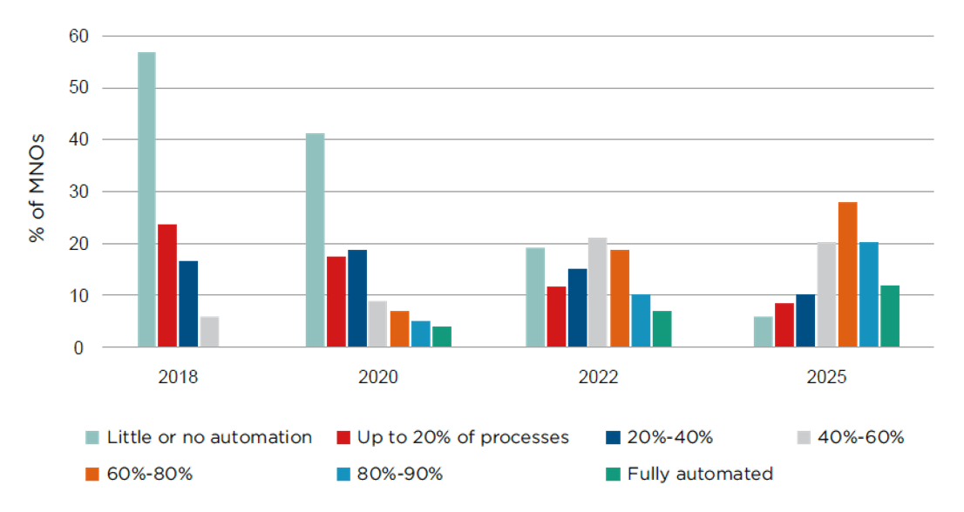
Figure 1 – Forecast levels of network automation by MNOs worldwide 2018-2025 (Source: Analysys Mason)
In response to the requirement of an intelligent and self-adaptive energy saving solution, AI and big data technology are also introduced to BS energy saving for improving the efficiency and reducing the manpower required.

7.2 AI based energy saving for 5G base stations
Nowadays the 5G network deployment is on the fast track around the world. Many MNOs are currently running 2G, 3G, 4G and 5G networks at the same time. The time distribution of cellular network traffic has often obvious peaks and troughs; basic functions applied to the entire cellular network are not a site-specific strategy. This results in less efficiency due to ignoring traffic and neighbouring site patterns which vary from site to site, especially in more complex networks.
This is why AI and big data technology are introduced to form a more precise energy saving strategy based on specific site traffic and other site-related conditions. The AI-driven network energy saving solution can forecast the traffic load of base stations based on historical traffic load, service type, site coverage and user behaviours. Energy saving strategy has automatic configuration based on coverage identification and configuration identification by AI technology. The suitable energy saving strategy combined with different energy saving functions, include an initial relative threshold to the scenario and an executable energy saving time schedule. This will be enabled for the sites that are expected to have energy saving effects. Meanwhile, AI-driven network energy saving solutions can also ensure the balance between network power consumption and network performance based on sufficient model trainings.
The intelligent energy-saving scheme based on AI should include but are not limited to the following basic functions:
1 Scene identification: Based on history traffic model analysis, application scenarios should be automatically identified, such as business district, residential areas, high-speed train, etc., thus more suitable initial energy saving strategies can be selected.
2 Traffic forecast: In most cases, the forecast matches well with the actual traffic, which means energy saving can be enabled in far more occasions. The modelling is based on historical traffic data (PRB utilization, RRC connected users, online users, throughput, etc.), special days or holidays, user behaviour, etc. time series algorithms will then be applied for traffic load forecast.
3 Multi-network coordinate control: To achieve an efficient energy saving strategy specific to a certain cell, the coverage of the cell and its neighbouring cells' coverage and traffic load need to be considered. The reason being any shutdown of a cell with the direction of its users to neighbouring cell(s) has to rely on the good availability of the neighbouring cell(s) including coverage and capacity. Thus, coverage identification depends on operating parameters (site ID, longitude, latitude, antenna height and azimuth) and MR (measurement report) data (cell ID, RSRP (reference signal receiving power), SINR (signal to interference plus noise ratio), TA (time advanced)) is needed. Based on the information analysis, the cell coverage performance can be calculated to identify the relationship between the co-coverage cells.
4 Online iteration and optimization based on network performance: To improve the energy saving efficiency, online iteration and optimization of the threshold can be used instead of the traditional ways which do not consider site variations and results in a safe but inefficient energy saving settings.

7.3 Energy saving scheme architecture based on AI
Figure 2 shows the overall architecture of the intelligent energy saving network. Based on the wireless intelligent application platform, the artificial intelligence algorithm is adopted to achieve the maximum balance between the system performance and the energy saving effect, so as to achieve the network energy-saving and consumption reduction.
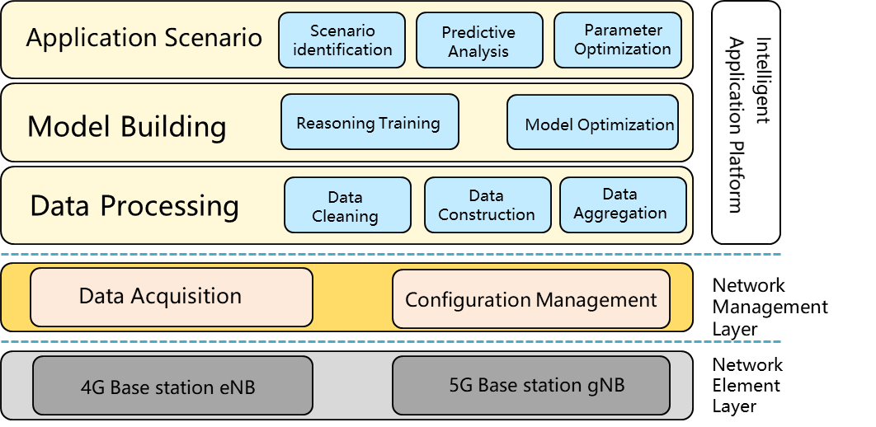
Figure 2 – Overall architecture of 5G intelligent energy saving network
By shutting down the resources that are not utilized and keeping network capacity adequate yet minimum, network energy consumption can be optimized in line with the network traffic load forecast by AI-driven energy saving solutions.
For the 5G era, enhanced AI-driven energy saving solutions can take in to account different efficiency levels of frequency bands and factors where the power efficiency of different networks can vary. By directing users from their less power-efficient spectrum band(s) to other band(s) that are more power-efficient, more radio resources can be shut down to lower network energy consumption.
Alongside energy saving potential, AI-driven solutions can also constantly monitor customer experience, network availability and data traffic to ensure that there is no impact on network performance.

7.4 Recommended energy saving procedure based on AI
As shown in Figure 3, the intelligent energy saving procedure of 5G base station is recommended as follows:
1 Data acquisition: The network performance data and MR/CDT (call detail trace) data of the base station are obtained through network management or data acquisition system.
2 Data processing: The collected data are pre-processed and cleaned, constructed, aggregated, and screened as training data for scene recognition, load forecasting and other models.
3 Scenario identification: The machine learning algorithm is used to identify the application scenario and determine the energy saving shutdown scheme and function.
4 Threshold determination: According to the energy saving target to be achieved, the appropriate energy saving threshold is determined.
5 Time-span determination: Based on the historical traffic data, the machine learning algorithm is used to predict the traffic load in a certain period in the future to determine the energy saving time and activate the time window.
6 Execution strategy: The integrated energy saving strategy is sent to the network management system to perform the energy saving operations on the 5G base station, such as deep sleep, carrier shutdown, symbol shutdown and corresponding activation time window.
7 Feedback and optimization: The performance data of the base station is collected to evaluate whether the expected target is achieved or not, and the closed-loop iterative optimization threshold strategy is adopted.
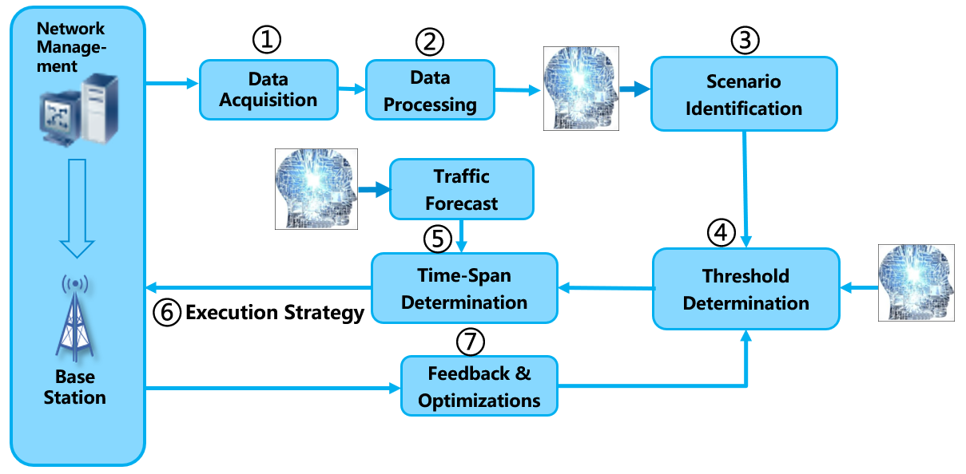
Figure 3 – AI energy saving procedure for 5G BS

7.5 Forecasting algorithms comparison in network traffic load
Traffic load forecasts are two kinds of forecasting algorithms often used in traffic load forecasting. One is a forecasting method based on sequence characteristics, including ARIMA (Auto regressive integrated moving average model), prophet algorithm and other time series algorithms. Based on the characteristics of time series, this kind of algorithm decomposes the time series into periodic, trend and random disturbance parts, to model and predict. The other is the regression forecasting method, including neural network, SVM (support vector machine) and other regression algorithms. The regression model is established based on historical load data to achieve the purpose of forecasting future load.
Compared with regression prediction, the time series algorithm is more suitable for stationary series and may have better operational efficiency. In the wireless network, the traffic load of most cells shows the characteristics of stationary series. The load forecasting value suitable for energy saving algorithm accuracy can be obtained by using the prediction method based on series characteristics.

7.6 The service awareness energy saving for 5G BS
AI-driven energy saving solution with traffic forecast improves the energy saving efficiency of basic functions. But in most multi-mode and multi-frequency cellular networks, it still has some limitations that service efficiency varies from mode to mode, and/or band to band. If all services/users are concentrated in parts of the network/band, more energy consumption could be saved after idle network/band shut down or deep sleep.
AI-driven service awareness in 5G network should also be taken into consideration, as it exploits the differences in the energy efficiency of different types of services to deliver certain services to the most energy-efficient networks, helping achieve the most efficient energy usage without impact on user experience ^{[4]}.
To improve the network energy efficiency based on user redistribution, there are three main steps: target network/band selection, suitable user selection and consequent user direction. Service efficiency varies from network to network, and/or band to band, the most energy-efficient network/band will be selected as the target and the most suitable users will be selected. Also, the energy efficiency pattern may change after user direction, leading to a new round of optimization.
Target network selection: Source network/band and target network/band defined here is a cluster rather than a cell, which can be selected based on coverage identification, traffic load forecast and energy efficiency analysis.
Suitable user selection: Since user experience may vary from network to network, and/or from band to band, in order to guarantee the user experience, user/service selection should be based on precise service identification, comprehensive user experience evaluation and specific business requirement.
Consequent user direction: The selected users, either in idle mode or connected mode should be directed to the target network/band for user network/band distribution. User direction in coordination with other strategies such as camping priority, mobility load balance, network/service slicing, etc. should also be taken into consideration based on the operators' requirements.

8 Future prospects
Major vendors are currently offering AI-driven energy saving solutions, and the commercial application results showed that 80% activation time has been increased and over 10% even 15% energy consumption has been saved in the entire network.
As network-wide intelligence is difficult to achieve overnight, a long-term development plan is required. However, with the continuous accumulation of data from commercial networks, the machine-learning algorithm will enable AI based power saving solutions to be perfect gradually. The AI algorithm itself will be evolved iteratively to realize higher efficiency and accurate strategy adapting when network topology and traffic model changes.
Here are some thoughts on widening the impact:
1 Feedback to vendor industry to design more intelligent equipment to be more adaptive.
2 Impact on consumer products such as cell phones and cell phone software to become more intelligent and corporate with the network in power and signal strength usage.
3 Vendor equipment design to be more integrated with AI to reduce power usage.
As the 5G network deployment has just started and if we compare it to existing 2G/3G/4G networks with abundant data accumulation, how to set initial power saving strategy of 5G power saving and its reference parameters and how to perform the power saving collaboration between 4G and 5G are all undergoing studies. It is said to become optimized along the way when more experience is accumulated after the solution has been widely deployed.
Internet of things (IoT) and enterprise network developments are also big issues in recent years. As more carrier-level solutions are being deployed in enterprises, along with services from different verticals, power saving requirements for these scenarios will also be unique and complicated compared to that of cellular service networks for ordinary people.
______________

