 |  | International Telecommunication Union
 |  | ITU-T | Technical Specification
 |  | TELECOMMUNICATION  STANDARDIZATION SECTOR  OF ITU |  | (12-2022)
 | ITU-T Focus Group on Environmental Efficiency for Artificial Intelligence and other Emerging Technologies (FG-AI4EE)
FG-AI4EE D.WG2-01
Environmental impact self-check assessment

Working Group 2: Assessment and Measurement of the Environmental Efficiency of AI and Emerging Technologies

 | Focus Group Technical Specification
Technical Specification FG-AI4EE D.WG2-01
Environmental impact self-check assessment
Summary
This document provides self-assessment tools and scorecards for a business or enterprise to assess their environmental impacts, whether positive or negative, with both a numerical and qualitative scoring methodology. Additionally, this document contains instructions on how these tools should be used and reviewed. This is not an exhaustive set of areas to self-assess but seeks to hit major areas of focus for a holistic summary that can be reviewed by management for varying levels.
Keywords
Climate scorecard; environmental scorecard; self-assessment; business standards and function assessment; enterprise function assessment; sustainability and climate emissions assessment
Note
This is an informative ITU-T publication. Mandatory provisions, such as those found in ITU-T Recommendations, are outside the scope of this publication. This publication should only be referenced bibliographically in ITU-T Recommendations.
Change Log

This document contains Version 1.0 of the ITU-T Technical Specification on “Environmental Impact Self-Check Assessment” approved at FG-AI4EE sixth meeting held in Ålesund, Norway, 1-2 December 2022.

Author & Editor: | Matthew Edgerton  Accenture  United States of America | Email: matthew@matthewedgerton.com

© ITU 2022
All rights reserved. No part of this publication may be reproduced, by any means whatsoever, without the prior written permission of ITU.

Table of Contents
1 Scope 1
2 References 1
3 Definitions 1
3.1 Terms defined elsewhere 1
3.2 Terms defined in these Technical Specifications 1
4 Abbreviations and acronyms 1
5 Conventions 1
6 Structure of the Technical Specification 1
6.1 Instructions for using table 1 scoring reference card: 2
6.2 Line level / product scorecard 3
6.3 Regional emissions modifier 5
6.4 Overall score modifier regional emissions 5
6.5 Enterprise visibility chart: 6
Bibliography 7

List of Figures
Figure 1 – Emissions footprint by country - reference year 2022 [b-WPR] 5

List of Tables
Table 1 - Scoring rubric – eco-friendly and environmental self-assessment category ranking 3
Table 2 - Product scorecard 5
Table 3 - Enterprise visibility chart 6

Technical Specification FG-AI4EE D.WG2-01
Environmental impact self-check assessment

1 Scope
This document contains a series of scorecards for an organization to grade itself on how well they have built a product or service based upon overall environmental impacts. It defines a set of standard areas to be scored (resource usage, local and extended impact, power consumption, emissions, water consumption, etc.) as well as standardized scoring criteria so that scoring is measured the same across industries, products/services and regions.

2 References
None.

3 Definitions

3.1 Terms defined elsewhere
These Technical Specifications use the following terms defined elsewhere:

3.1.1 Energy consumption [b-ISO/IEC 13273-1:2015]: The quantity of energy applied.

3.1.2 Energy efficiency [b-ISO/IEC 13273-1:2015]: The ratio or other quantitative relationship between an output of performance, service, goods or energy, and an input of energy.

3.1.3 Energy efficiency improvement [b-ISO/IEC 13273-1:2015]: An increase in energy efficiency that comes from technological, design, behavioural or economic changes.

3.2 Terms defined in these Technical Specifications
These Technical Specifications defines the following terms:
3.2.1 Solution Scorecard: a list or series of lists that provide either a quantitative or qualitive value for consumption in rating of self or processes of a company.

4 Abbreviations and acronyms
These Technical Specifications use the following abbreviations and acronyms:
EPA  5G | Environmental Protection Agency  5th Generation of wireless networks

5 Conventions
None.

6 Structure of the Technical Specification
Within this document we shall outline a series of categories for self-assessment and provide a unified scoring criteria. These areas of focus will set forth a global numerical assessment framework to which we can judge climate and eco impacts on a numerical basis and provide a set level of understanding amongst international parties.
When considering such a standard it is imperative to account for regional differences in both climate understanding and educational models. This document will not delve into these factors in granular detail but will take into account such differences within its recommended numerical scoring system.
The general scoring metric that shall be referenced this this document is shown in table 1. Scoring metric to be used runs from -3 to +3 further explanation can be found in the below in figure.
Table 2 is to use the numerical criteria from table 1 – companies are to use table 2 to take a line level detail look at the work, product or service they are recreating, producing or figure 1 demonstrates an additional numerical system to modify final scoring based on regional emissions and take into account local and global impacts from regions in which technology may be impacted by local factors such as governmental corruption, infrastructure inefficiencies or other similar factors. With intention to provide a localized scoring option as well as a harmonized global score.
It is key to note that in figure 1 the map graphic is used only for illustration purposes. Business will need to consult global standards and current emissions projections at the time of their individual assessment.
Table 3 is a final assessment postural scorecard as to be used for executive representation of progress per product, service or initiative but is not intended to provide a numerical scoring as earlier figures. Score tabulated in earlier scorecards can be used to indicate colour coding.

6.1 Instructions for using table 1 scoring reference card:
The below scorecard scoring rubric is designed to give a base level understanding of how to apply numerical scores in Table 2. Companies are encouraged to build upon bases assumptions form each of the below set scoring logic via their chief climate officers and sustainability. Wherein no such officer or business division exist they are encouraged to look up global standards and recommendations as sited by the United Nations, European Union and United States agencies such as the Environmental Protection Agency (EPA).
The interpretation of the scoring logic in these documents is assumed to be in good faith on behalf of the scoring entity. It is advised to err on the side of conservative assessment on emissions figures waste production .et al for the reason that when considering impact standards one should assume the real impact may be worse than projected so caution is advised.
Climate Efficiency and Eco-friendly Self-Assessment Scorecard
Qualitative Impact | Score | Definition and Guidelines
Substantial Positive Environmental Impact | +3 | This technology creates substantial specific and measurable positive environmental change both its local “in use” footprint as well as enabling larger positive environmental impacts whether through social, technical or process enablement or net new creation.
Positive Environmental Impact | +2 | This technology creates specific and measurable positive environmental change though creation of a new environmentally positive negative impact of an existing process by enacting a measurable change through its “in use” footprint:
Slight Positive Environmental Impact | +1 | This technology directly or indirectly improves environmental impacts of existing industry processes, technology, or societal habits.
Neutral – No Positive or Negative Impact | 0 | This technology does not impact positively or negatively ecological, climate or environmental existing industry processes, technology, or societal habits. A zero rating should be used infrequently as the majority of new tech will likely create a net positive or neg impact to the larger world
Slight Negative Environmental Impact | -1 | This technology directly or indirectly worsens environmental impacts of existing industry processes, technology, or societal habits.
Negative Environmental Impact | -2 | This technology creates specific and measurable negative environmental impacts or change by actively worsening an existing process, tech or societal habit through its “in use” footprint
Substantial Negative Environmental Impact | -3 | This technology substantially and measurably decreases environmental health and actively worsens climate impacts both its local “in use” footprint as well as enabling larger negative environmental impacts whether through social, technical or process enablement or net new creation.
Table 1 - Scoring rubric – eco-friendly and environmental self-assessment category ranking

6.2 Line level / product scorecard
Instructions for using table 2 scoring reference card:
The below scorecard is to utilize the standard scoring rubric from table 1 in this document. Enterprises are encouraged to interpret each category as specifically as possible. By applying this to each product or service line if possible. There will be numerous scores within a large company which should yield a more granular look at environmental impact standards.
A final tabulation of the score is to also take into account the regional modification score as detailed in the section titled “Regional Emissions Modifier”
Category | Additional Qualifiers | Scoring
Raw Material Extraction Method | Is extractions method done in a sustainable way?
 | Does the extraction method create waste or emissions
Transportation of Materials | Transportation company validates and audits 3rd party contractors (if used) for green commitments
 | Transportation company uses verifiable green energy or climate conscious fuels/ vehicles and methods with full chain of custody in regard to material handling
 | Shipments sizes are large enough to minimize frequent transport needs
 | Transportation has been localized to areas of manufacturing
Material Hazard and Environmental Leaching Risk | Summary level of risk from manufacturing operations
Material Sustainability | Is this material sustainable
 | Is this material biodegradable
Material Processing Waste | Does the processing of this material create harmful waste
 | Material processing emissions
Transportation Emissions | What percentage of transportation methods are climate friendly or low impact fuels, electric, hydrogen, Natural gas? (80% or higher receives a full +3)
% Land Based Transportation Traditional Fuels
- Greater than 50% requires a “-2”
- Between 25-50% requires “-1”
- Less 1-25% requires “-0”
% Land Based Transportation with green fuels
- Greater than 50% requires a “+3”
- Between 25-50% requires “+2”
- Less 1-25% requires “+1”
% Sea or Ocean Freight
- Greater than 50% requires a “+2”
- Between 25-50% requires “+1”
- Less 1-25% requires “0”
% Air (traditionally an emissions heavy transport method)
- Greater than 50% requires a “-3”
- Between 25-50% requires “-2”
- Less 1-25% requires “-1”
Manufacturing and Product Emissions | Emission level
 | Emissions capture reduction device deployed?
Better than competitors
Each 20% above +1
Worse
Each 20% below -1
Water Use | Combined water usage in manufacturing, service, product
Natural Gas | Combined NG usage in manufacturing, service, product
Power | Percent of power generated by renewables + 1 per 10%
 | Percent of power by legacy or “dirty” sources -1 Per 10%
Light Pollution | Does this product create or have risk of creating light pollution?
Electrical, Signal or Radio Wave Pollution | Does this product create or have risk of creating signal pollution?
Physical Ecosystem Disruption | “In use” footprint of the product, business or service
 | Supporting infrastructure require to support this product or service
Community | Does this product, service or tech influence or have the potential the perception of climate change in a positive light
 | Does this product, service or tech have the potential to enable community involvement in solving climate change or organizing
Table 2 - Product scorecard

6.3 Regional emissions modifier
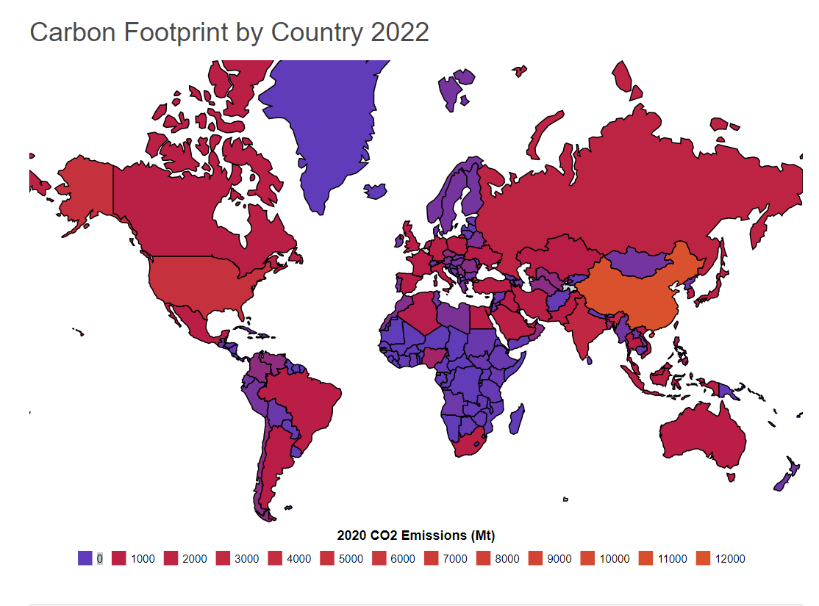
Figure 1 – Emissions footprint by country - reference year 2022 [b-WPR]

6.4 Overall score modifier regional emissions
Companies must take two factors into account where the product or technology is being developed and manufactured as well as where it is being put into use. It is to take the average of the markets for below offset for total climate impact scoring.
In countries with generally accepted greater than 4000 co2 emissions apply a (-2) modifier to total score for each 1000 emissions increase. When discussing emissions on a national or global scale, carbon footprint is typically expressed in units of CO₂—typically metric tons (1,000 kg/2,205 lb = 1 t), million tons (1,000,000 t = 1 Mt) or gigatons (1 billion metric tons/1,000 Mt = 1 GT).
Example:
A telecom is manufacturing a new 5G receiver module for use across China, Japan and the United States. The company has applied the self-scoring metric across all categories detailed in the categorical scoring section of this document for a total score of. The product scored well for a total of +26 positive climate impact. The device is being manufactured in China and rolled out to the above 3 countries for use. The above chart details the emissions for each of the following countries as:
- USA 6000
- China 12000
- Japan 5000
Average or mean of the above is 7666.666
Thereby the total score of +26 is modified by a reduction of -8 for a final climate impact score of +16 (-2 per each 1000 threshold above 3000).
[Data on emissions should confirmed during the time of this self-scoring]

6.5 Enterprise visibility chart:
Using the calculations from the line level scoring metric and organization can represent a high-level dashboard with the below figure by line of business or product for quick reference in internal usage or initiative setting. Once all products, service or businesses are scored:
- Scores greater than 50 = green
- Scores between 35-50 = yellow
- Scores less than 35 = red
- If a category is N/A it can be simply greyed out and as such removed from total scoring in both the line level calculation as well as the below representative high-level breakout
**For scoring adjustment when a category is not applicable remove the number of points that would have been calculated from the max allowable points and move the aforementioned rankings down accordingly.
Department | Service Line | Product | Category
Example (Telecom) | 5g communication | Model XLR 5g Receiver | Manufacturing
 |  |  | Emissions
 |  |  | Resource Consumption
 |  |  | Community
Example (CPG) | Ecofresh Bowl | Ecofresh bamboo bowl | Manufacturing
 |  |  | Emissions
 |  |  | Resource Consumption
 |  |  | Community
Table 3 - Enterprise visibility chart

Bibliography

[b-ISO/IEC 13273-1] ISO (2015). Energy Consumption.

[b-ISO/IEC 13273-1] ISO (2015). Energy Efficiency.

[b-ISO/IEC 13273-1] ISO (2015). Energy Efficiency Improvement.

[b- Bouwman] Bouwman, Van Vuuren, D.P., Derwent, R.G., Posch, M. (2002) A global analysis of acidification and eutrophication of terrestrial ecosystems. Water Air Soil Pollut. 141, 349–382.
[b-EPA] Environmental Protection Agency (2022). Climate indicators. Accessed on 29 September 2022 at https://www.epa.gov/climate-indicators
[b- Grönman] Grönman, K., Soukka, R., Järvi‐Kääriäinen, T., Katajajuuri, J. M., Kuisma, M., Koivupuro, H. K., ... & Linnanen, L. (2013). Framework for sustainable food packaging design. Packaging Technology and Science, 26(4), 187-200.
[b-Yong] Yong, JY, Yusliza, M-Y, Ramayah, T, Chiappetta Jabbour, CJ, Sehnem, S, Venkatesh, M. Pathways towards sustainability in manufacturing organizations: Empirical evidence on the role of green human resource management. Bus Strat Env. 2020; 29: 212– 228 https://doi.org/10.1002/bse.2359
[b-WHO] World Health Organization. Media Centre: Factsheets. Accessed on 29 September 2022 at http://www.who.int/mediacentre/factsheets/fs313/en/index.html
[b-WPR] World Population Review (2022)/ Country Rankings: Carbon Output Map. Accessed on 29 September 2022 at https://worldpopulationreview.com/country-rankings/carbon-footprint by-country
[b-Shen] Shen, L,O., Kannan G, Roohollah K., Ali,D. A fuzzy multi criteria approach for evaluating green supplier's performance in green supply chain with linguistic preferences,Resources, Conservation and Recycling, Volume 74,2013, Pages 170-179
___________

The designations employed and the presentation of material on this [map/ infographic] do not imply the expression of any opinion whatsoever on the part of ITU and of the Secretariat of the ITU concerning the legal status of the country, territory, city or area or its authorities, or concerning the delimitation of its frontiers or boundaries.

