|  |  |  |  |  |
| --- | --- | --- | --- | --- |
|  | | **International Telecommunication Union** | | |
|  | |  | | |
| **ITU-T** | **Technical Report** | |
| TELECOMMUNICATION STANDARDIZATION SECTOR OF ITU | | (12-2022) |
|  | ITU-T Focus Group on Environmental Efficiency for Artificial Intelligence and other Emerging Technologies (FG-AI4EE) | | | |
|  | **FG-AI4EE D.WG3-05**  **Best practice catalogue on environmentally efficient artificial intelligence and blockchain application**  Working Group 3: Implementation Guidelines of AI and Emerging Technologies for Environmental Efficiency | | | |
|  | Focus Group Technical Report | | | |

Technical Report ITU-T FG-AI4EE D.WG3-05

Best practice catalogue on environmentally efficient artificial intelligence and blockchain application

Summary

Technical Report FG-AI4EE D.WG3-05 provides a list of best practices for environmental efficiency in artificial intelligence and blockchain applications. First, the report provides an introduction to highlight the added value of the combined use of AI and blockchain technologies. In fact, these technologies offer different, complementary features, hinting at the possible added value of combining the two. Then, the report collects, summarizes, and organizes the best practices on energy efficiency for AI and blockchain technologies, respectively from relevant ITU-T Recommendations and deliverables produced by the AI4EE FG. Finally, the report identifies and lists a set of best practices for the joint use of AI and blockchain technologies. These recommendations target the developers of societal applications making use of these combined technology instruments.

Keywords

Energy efficiency: blockchain; AI

**Note**

This is an informative ITU-T publication. Mandatory provisions, such as those found in ITU-T Recommendations, are outside the scope of this publication. This publication should only be referenced bibliographically in ITU-T Recommendations.

Change log

This document contains Version 1.0 of the ITU-T Technical Report on “*Best practice catalogue on environmentally efficient artificial intelligence and blockchain application*” approved at FG-AI4EE sixth meeting held in Ålesund, Norway, 1-2 December 2022.

|  |  |  |
| --- | --- | --- |
| **Editor:** | Mattia Santoro  Consiglio Nazionale delle Ricerche  Italy | Email: mattia.santoro@cnr.it |
| **Editor:** | Enrico Boldrini  Consiglio Nazionale delle Ricerche  Italy | Email: enrico.boldrini@cnr.it |
| **Editor:** | Stefano Nativi  Consiglio Nazionale delle Ricerche  Italy | Email: stefano.nativi@cnr.it |

|  |  |  |
| --- | --- | --- |
| **Contributor:** | Rebecca Gonzales  Amazon Web Services  United States of America | Email: [regonz@amazon.com](mailto:regonz@amazon.com) |

ã ITU 2022

All rights reserved. No part of this publication may be reproduced, by any means whatsoever, without the prior written permission of ITU.

**Table of Contents**

1 Scope 1

2 References 1

3 Terms and Definitions 1

3.1 Terms defined elsewhere 1

3.2 Terms defined in these Technical Report 2

4 Abbreviations and acronyms 2

5 Conventions 3

6 Added Value of AI and Blockchain Combination 3

6.1 Blockchain for AI 5

6.2 AI for Blockchain 6

7 Best practices for AI energy efficiency 8

7.1 Hardware 9

7.2 Software 9

7.3 Location/Energy Sources 9

8 Best practices for blockchain energy efficiency 10

9 Best practices on the use for AI and blockchain application 11

Appendix A - Use cases for Blockchain and AI 13

Appendix B – AWS Architecture for Optimizing Deep Learning workloads 17

List of Figures

Figure 1 *-* Examples of AI tasks 3

Figure 2 - Popular on the blockchain 4

Figure 3 - AWS Machine Learning Lifecycle [b-de Chateauvieux, 2022] 8

Figure 4 - Blockchain architecture options and differences [ITU-T L.1317]. 11

Figure 5 – Main functions provided by blockchain and AI to address the COVID-19 pandemics [b-Nguyen] 14

Figure 6 - The architecture of the credit evaluation system [b-Mao] 15

Figure 7 - Predictive energy trading platform implementation and use-case deployment [b-Jamil] 16

Figure 8 – AWS Optimizing Deep Learning workloads for Sustainability: Data Processing 17

Figure 9 – AWS Optimizing Deep Learning workloads for Sustainability: Model Building 17

Figure 10 – AWS Optimizing Deep Learning workloads for Sustainability: Model Training 18

Figure 11 – AWS Optimizing Deep Learning workloads for Sustainability: Inference 18

Technical Report ITU-T FG-AI4EE D.WG3-05

Best practice catalogue on environmentally efficient artificial intelligence and blockchain application

# 1 Scope

This document contains a list of best practices on artificial intelligence and blockchain applications that have taken environmental efficiency into full consideration. The growing energy demands of AI and blockchain is directly contributing to carbon emissions. The best practices contained in this report support relevant stakeholders in making better environmental decisions and reduce the environmental footprint of these technologies. The best practices also act as benchmarking tools that allow operators and service providers to assess their own operation, improve process management and learn from the industry leaders.

# 2 References

[ITU-T L.1317] Recommendation ITU-T L.1317 (2021), *Guidelines on energy efficient blockchain systems*.

[ITU-T X.1400] Recommendation ITU T Χ.1400 (2020), *Terms and definitions for distributed ledger technology*.

[ITU-T F.751.2] Recommendation ITU-T F.751.2 (2020), *Reference framework for distributed ledger technologies*

# 3 Terms and Definitions

## 3.1 Terms defined elsewhere

These Technical Report use the following terms defined elsewhere:

**3.1.1 Artificial Intelligence (AI)** [b-ITU FG-AI4EE D.WG1-01]: An interdisciplinary field, usually regarded as a branch of computer science, dealing with models and systems for the performance of functions generally associated with human intelligence, such as reasoning and learning.

**3.1.2 Blockchain** [b-ITU FG-AI4EE D.WG1-01]:A type of distributed ledger that is composed of digitally recorded data arranged as a successively growing chain of blocks with each block cryptographically linked and hardened against tampering and revision.

**3.1.3 Cloud computing** [b-ITU FG-AI4EE D.WG1-01]: Paradigm for enabling network access to a scalable and elastic pool of shareable physical or virtual resources with self- service provisioning and administration on-demand.

**3.1.4 Consensus Mechanism (a.k.a. consensus protocol)** [b-ITU FG-AI4EE D.WG1-01]: Defines strict rules for creating new blocks and adding new data to them without favoring one participant over another.

**3.1.5 Deep Learning** [b-ITU FG-AI4EE D.WG1-01]:Approach to creating rich hierarchical representations through the training of neural networks with one or more hidden layers.

**3.1.6 Distributed ledger** [b-ITU FG-AI4EE D.WG1-01]:A type of ledger that is shared, replicated, and synchronized in a distributed and decentralized manner.

**3.1.7 Distributed ledger technology (DLT)** [ITU-T X.1400]:Technology that enables the operation and use of distributed ledgers.

**3.1.8 Edge Computing** [b-ITU FG-AI4EE D.WG1-01]:Distributed computing in which processing and storage takes place at or near the edge, where the nearness is defined by the system's requirements.

**3.1.9 Energy efficiency** [b-ITU FG-AI4EE D.WG1-01]:The ratio or other quantitative relationship between an output of performance, service, goods or energy, and an input of energy.

**3.1.10 Machine Learning** [b-ITU FG-AI4EE D.WG1-01]:Processes that enable computational systems to understand data and gain knowledge from it without necessarily being explicitly programmed

**3.1.11 Smart contract** [b-ITU FG-AI4EE D.WG1-01]:A program written on a distributed ledger system which encodes the rules for specific types of distributed ledger system transactions in a way that can be validated, and triggered by specific conditions; software program that it is executed automatically and capable of carrying out the terms of the agreement between parties without the need for human intervention; pieces of software that execute a specified action based on the state of the system or a transaction that occurs.

## 3.2 Terms defined in these Technical Report

None.

# 4 Abbreviations and acronyms

This Technical Report use the following abbreviations and acronyms:

AI Artificial Intelligence

AA Autonomous agents

AWS Amazon Web Services

CPU Central Processing Unit

CCM Committee Consensus Mechanism

DER Distributed Energy Resources

DL Deep Learning

DLT Distributed Ledger Technology

DRL Deep Reinforcement Learning

DVFS Dynamic voltage/frequency scaling

EC European Commission

GPU Graphic Processing Unit

GAO United States Government Accountability Office

H-IoT Healthcare Internet of Things

ICT Information and communication technologies

IDS Intrusion Detection system

IoT Internet of Things

IoMT Internet of Medical Things

ISO International Organization for Standardization

LSTM Long Short Term Memory

MEC Mobile Edge Computing

ML Machine Learning

NFT Non-Fungible Token

NIST National Institute of Standards and Technology

PBFT Practical Byzantine Fault Tolerance

PoA Proof of Authority

PoLE Proof of Learning

PoET Proof of Elapsed Time

PoS Proof of Stake

PoUW Proof of Useful Work

PoW Proof of Work

SCM Supply Chain Management

SGD Stochastic gradient descent

SG Smart grid

TDAI Trusted Decentralized Artificial Intelligence

UAV Unmanned Autonomous Vehicles

# 5 Conventions

None.

# 6 Added Value of AI and Blockchain Combination

AI and blockchain are two trending technologies featuring distinctive key assets. Different use cases are currently investigating the complementary benefits or added value of combining the two [b-Dinh] [b-Salah].

**AI** refers to the ability of machines to exhibit intelligent behavior (for example, making them able to achieve a target goal when they are provided with an input environment). Thanks to the increasing availability of big data as training set (for example, the large-scale image database ImageNet [b-Deng]), low-cost computing resources (i.e., TFLOPS-class general purpose GPUs [b-LeCun]) and advanced machine learning algorithms, machines currently exhibit high level performances on many tasks once judged intractable by them, including and not limiting to pattern recognition, forecasting and content generation. Some examples include computing vision, natural language processing and deepfakes (see Figure 1).

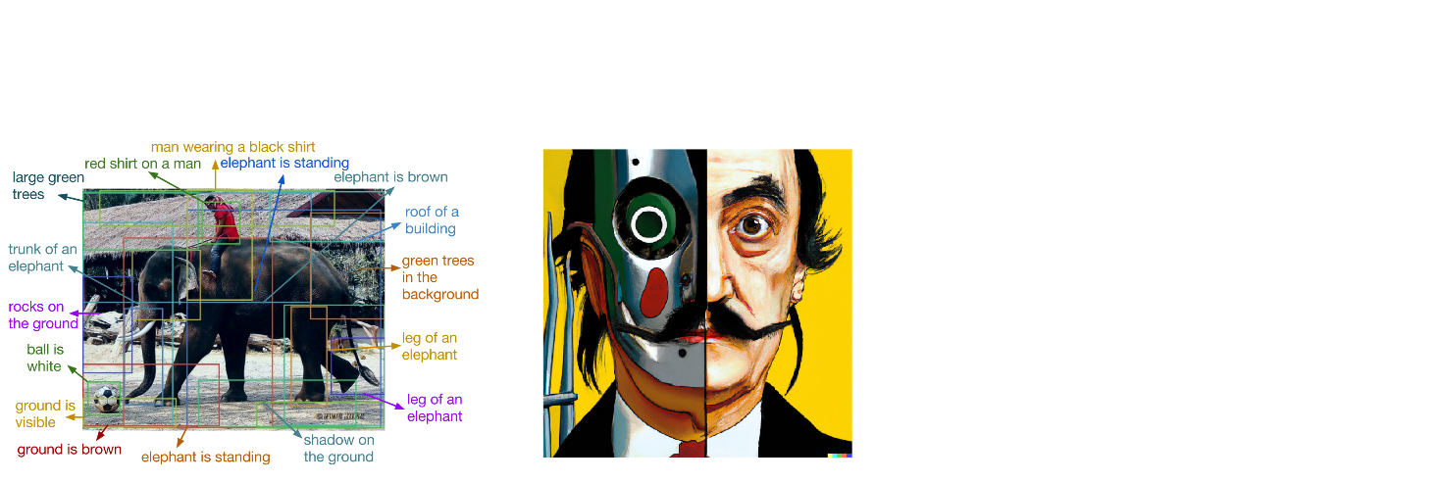

Brainstorm some best practices on environmental efficient AI and blockchain applications

1. Developing AI applications that are effective and efficient in reducing energy consumption while still providing the same or better results as traditional methods.

2. Incorporating blockchain technology into AI applications to create a more decentralized and secure system that is less resource intensive.

3. Working with data providers who have committed to using renewable energy sources to power their data centers.

4. Implementing green computing initiatives within organizations developing AI applications, such as using virtualization technologies to reduce the number of physical servers required.

5. Use AI-enabled smart contracts to automatically enforce environmental regulations, penalties, and incentives related to carbon emissions and other environmental impacts.

Generate a vibrant portrait painting of Salvador Dalì with a robotic half face

Perform dense captioning of the provided input image

Figure 1 *-* Examples of AI tasks

(left) dense captioning output of DenseCap model [b-Johnson]; (center) high quality image generated from textual description by the DALL-E 2 model [b-Ramesh] ; (right) brainstorm session (in green) generated from the top input text by the GPT-3 model [b-Zhang].

**AI distinctive traits**:

* **Big data consumer**: machine learning models are trained with increasing quantity of training data to achieve increasing performances. The first version of OpenAI GPT language model (GPT-1) trained on a 5 GB data set, GPT-2 trained on 40 GB, while GPT-3 training size reached 45TB [b-Zhang].
* **Centralized**: typical training approaches expect all training data loaded on a single machine or data center where the training happens. Usually, few organizations have access to the needed training data and central computing power needed for the training (for example, Google, Facebook, OpenAI).
* **Inexplicable** (black box): much research is focused on methods to understand the expected behavior of trained models, as the trained parameters don’t represent explicit information [b-Rai].
* **Intelligent** (i.e., recognition, optimization, forecasting, content generation): machine learning can now boast performances better than humans on many tasks once judged intractable by machines.
* **Computing intensive**: machine learning models are computing intensive task both during their training and during inference.

**Blockchain** implements a distributed ledger technology. First and widely employed to register the transactions of the Bitcoin cryptocurrency [b-Nakamoto, 2008], currently it is adopted by many other applications where a decentralized consistent ledger is needed, including Non-Fungible Tokens (NFTs), supply chain and smarbitt contracts (see Figure 2).

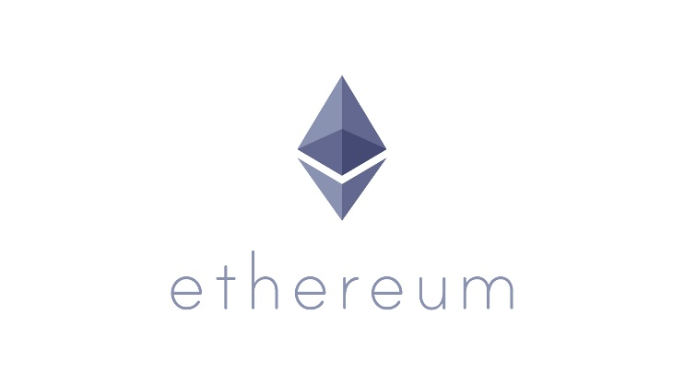



Figure 2 - Popular on the blockchain

(left) BitCoin, the first popular implementation of a blockchain for cryptocurrency; (center) Ethereum blockchain, with smart contract functionality; (right) popular NFTs, a form of digital assets stored in the blockchain along with ownership information.

**Blockchain distinctive traits**:

* **Big data provider**: BitCoin blockchain is currently holding about 390 GB of data in its ledger; Ethereum is holding about 990 GB and are constantly increasing. Moreover, the ledger could hold just the hash values of more large attachments so that big data is only referenced and in turn stored elsewhere (e.g., on a distributed file system).
* **Decentralized**: the blockchain is inherently a distributed technology managed by different nodes, with the intent of eliminating a central point of control and failure
* **Coordinated/automated**: the functioning of a blockchain is regulated by precise rules that each node are obliged to follow to participate to the system.
* **Accountable/secure**: replication of the ledger amongst all the nodes and a strong consensus protocol make the stored data safely kept avoiding risks of disasters or counterfeits.
* **Computing intensive**: in current blockchain the consensus protocol is the coordination mechanisms denoted by a high Central Processing Unit (CPU) intensive task

AI and blockchain technologies offer different, complementary features, hinting at the possible added value of combining the two. Indeed, combining the two technologies has been proven beneficial when each of the two integration directions are considered. On one side, blockchain will bring trustlessness, privacy, and explainability to AI [b-Dinh]; and, in turn, AI can help build a machine learning system on blockchain for better security, scalability, and more effective personalization and governance [b-Dinh]. An overview of the added values is provided in the following sections. Appendix A provides a set of use cases are presented to show the use of blockchain and IA in different application domains.

Also notably, the common trait of both being computing demanding technologies highlights the urgency of providing shared guidelines and best practices in order to assure the sustainability of such combined applications.

## 6.1 Blockchain for AI

The main benefits that blockchain can bring to AI are decentralization, accountability, and coordination.

### 6.1.1 Decentralization

Decentralization for AI means to change from the current approach dominated by few organizations that are privately training AI models towards a participated blockchain based approach, where multiple users and organization potentially contribute to the training of shared AI models. This approach, also referred to as Trusted Decentralized Artificial Intelligence (TDAI), provides a stable distributed medium to secure the AI models’ sharing without the need for intermediaries or trusted third parties and also enables securing, auditing, and validating the learning data to avoid the development of mistaken or biased AI models [b-Adel]. Through the encryption algorithms, timestamps, tree structures, consensus mechanisms, and reward mechanisms, blockchain realizes decentralized point-to-point transactions in a distributed network, which can solve the problems of poor reliability, low security, high cost, and low efficiency in the current centralized model [b-Tian].

Research papers in this field propose different blockchain-based frameworks to implement a decentralized AI system. For example, in [b-Li] a blockchain-based decentralized federated learning framework is presented. In the framework global and local models are stored in a blockchain, and the central server is replaced by smart contracts which aggregate local models to achieve decentralization. Another example is presented in [b-Lyu], where the centralized server is replaced with a distributed collaboration framework to parallelize the calculation between all parties and implement a completely decentralized privacy protection deep learning framework, which records all operations as transactions in blockchain, including uploading and downloading artificial samples or gradients.

It is worth to note that, although such approaches address important issues for a distributed AI-based system, some challenges remain (e.g., slow block-out speed and long confirmation time) and further research is still going on [b-Tian].

### 6.1.2 Accountability

AI-based systems are vastly used in several high-stakes applications like healthcare, business, government, education, and justice, moving us toward a more algorithmic society [b-Kaur]. However, the high complexity of such systems (due to the use of very large amount of data, advanced algorithms, and high computing power) it has become challenging to interpret the logic of these systems, which sometimes makes it difficult to assess these systems properly [b-Kaur]. AI systems can be trained to “notice” patterns in large amounts of data that are impossible for the human brain to comprehend, meaning that no longer are we asking automation to do our tasks but we are asking it to do tasks that we can’t [b-NIST]. Many AI applications have limited take up, or are not appropriated at all, due to ethical concerns and a lack of trust on behalf of their users [b-Miller]. Therefore, the topic of trustworthy AI is considered relevant by the scientific community as well as by government and standard organizations. The International Organization for Standardization (ISO) released a document presenting different approaches to establish trust in AI systems using the properties of fairness, transparency, accountability, and controllability [b-ISO]. In 2018, the European Commission (EC) released the ethical guidelines for trustworthy AI, establishing key requirements that AI systems should meet in order to be deemed trustworthy [b-EC]. The National Institute of Standards and Technology (NIST) proposed a list of nine factors that contribute to a person’s potential trust in an AI system. [b-NIST]. The U.S. Government Accountability Office (GAO) published a framework to identify key practices to help ensure accountability and responsible AI use by federal agencies and other entities involved in the design, development, deployment, and continuous monitoring of AI systems [b-GAO].

Blockchain’s digital record can offer insight into the framework behind AI and the provenance of the data it is using, improving trust in data integrity and in results provided by AI models [b-IBM]. This enables tracing of every aspect of model training in the distributed ledger, including the references to the data training sets, trained models, and evaluation of results. For example, the detection of model errors can be logged in the blockchain to highlight the use of likely biased data in its training and verge to a more explicable AI.

Another important aspect concerns users’ privacy, a critical and growing concern after a series of leaks and misuse of personal data [b-Dinh]. Blockchain can help addressing such concerns by providing the required transparency and accountability about which users' data is accessed, when, and by whom. For example, privacy and security issues of the nonlinear learning model in distributed machine learning are addressed in [b-Chen]; the paper describes a distributed security machine learning system that supports privacy protection designing a decentralized stochastic gradient descent (SGD) algorithm to learn a generic prediction model on blockchain. In [b-Awan] a blockchain-based privacy protection framework is designed to perform gradient aggregation based on cryptographic protocols. A novel type of blockchain-supported federated learning scheme is presented in [b-Qu] to balance privacy and efficiency issues: terminal devices are allowed to exchange global models on the blockchain with local models updates and, by using the PoW consensus mechanism, autonomous machine learning is achieved without any central authorization to coordinate and maintain, effectively protecting private data.

### 6.1.3 Coordination

Coordination of autonomous agents (AA) refers to the capability of blockchain to offer shared and immutable information useful to steer the actions of autonomous AI systems. Individual intelligence provided by AI on a single AA can be leveraged by combining the power of multiple AAs working collaboratively on certain task where decentralized or semi-decentralized setup is either beneficiary or organically exists [b-Shehata]. The distributed ledger provided by blockchain can help addressing some of the most important challenges related to this collaborative model such as security and trust in decentralized environments, latency in decision making process, speed of learning a model, heterogeneous agents with varying capabilities, and tasks allocation and resources optimization [b-Shehata]. Applications can include coordination of Unmanned Autonomous Vehicles (UAV), seabed exploration by means of robots, etc.

## 6.2 AI for Blockchain

The main contributions that AI can bring to blockchain is providing more intelligence in every aspect of blockchain, including: consensus protocols (consensus), analysis of chain data (augmentation) and smart contracts (automation).

### 6.2.1 Consensus

Energy efficiency (or energy consumption) of blockchain solutions is highly related to the underlying mechanism that is used for achieving consensus between the nodes of the network, i.e., the consensus mechanism [b-EUBOF]. In particular, Proof of Work (PoW) based blockchain network has attracted massive computational resources and, providing trustless consensus, it serves no useful purpose [b-Liu]. For this reason, several research papers investigate a new paradigm in which the mathematical problem required to be solved for mining a new block could have some interest by itself beyond the usefulness of supporting the blockchain network, this approach is also referred to as proof-of-useful-work (PoUW) [b-Baldominos]. In this family of consensus algorithms, some investigate how to direct the computation and energy spent on blockchain consensus to the practical function of training AI models. In the Proof-of-learning (PoLE) algorithm [b-Liu], the consensus nodes provide the processing power and strive to train the model for the issued task. Once a model has been created that fulfills the minimal training exactness, the successful miner broadcasts the new block and declares its success. In [b-Baldominos] a PoUW algorithm (named Coin.AI) is presented, the mining scheme requires training deep learning models, and a block is only mined when the performance of such model exceeds a threshold; besides, the paper introduces a proof-of-storage scheme for rewarding users that provide storage for the deep learning models. Another example is the Committee Consensus Mechanism (CCM) [b-Lidesigned to implement a blockchain-based decentralized federated learning framework. In CCM, the nodes obtain the model present in the blockchain and perform the training locally. Afterward, the local gradient is verified by a few honest nodes (the committee) in charge of verification of local gradients and blocks generation. The committee then validates the updates and assign a score on them. Only the qualified updates will be packed onto the blockchain. At the beginning of the next round, a new committee is elected basing on the scores of nodes in the previous round, which means that the committee will not be re-elected.

### 6.2.2. Augmentation

AI can rapidly and comprehensively read, understand, and correlate data at incredible speed, bringing a new level of intelligence to blockchain-based business networks [b-IBM]. This approach, also referred to as augmentation, enables AI to extract useful patterns from the data stored in the blockchain, for example but not limited to optimize or make more secure the blockchain itself. For example, patterns of malicious activity can be detected by AI while analyzing data stored in the blockchain and actions can be performed accordingly.

Privacy enabled content personalization can be achieved by a decentralized blockchain based social network. In this case AI analyses local user data to provide the personalization instead of sending user data to central systems and getting back personalization.

### 6.2.3 Automation

In blockchain a smart contract is a program stored on a blockchain that run when predetermined conditions are met [b-IBM]. Automation refers to the use of AI in the smart contracts executed on a blockchain. While traditional smart contracts implement simple logics (usually to approve transactions in case some condition is verified) [b-Szabo], AI could make them more intelligent in order to solve more complex disputes following a blockchain based fact driven approach. For example, a blockchain governed by an intelligent machine learning algorithm might be able to detect the presence of attacks and automatically invoke the appropriate defense mechanisms or at least isolate the attacked component from the blockchain platform, keeping the rest safe from the attack [b-Dinh]. Similarly, an AI-based smart contract could help making the blockchain more scalable and robust by, e.g., when there is a spike in the number of transactions, increasing the block creation rate, which would increase the throughput at the cost of longer confirmation times.

# 7 Best practices for AI energy efficiency

Artificial Intelligence (AI) technology is a huge opportunity, covering a wide range of application domains and use cases. AI consists of several technologies that enable devices/computers to gather data (from sensors, mobile devices, repositories, etc.), to analyse and understand the information collected, to make informed decisions or recommend action, to learn from experience and to respond based on the needs of the situation [b-ITU FG-AI4EE D.WG2-3].

However, environmental impact of AI is also estimated to be heavy; e.g., [b-Strubell] estimated that a “regular” AI using a single high-performance graphics card has the same carbon footprint as a flight across the United States. The topic is addressed in several research papers and reports, including deliverables from this Focus Group [b-ITU FG-AI4EE D.WG3-1] [b-ITU FG-AI4EE D.WG2-3] [b-ITU FG-AI4EE D.WG2-2].

In [b-ITU FG-AI4EE D.WG3-1] environmental impact of AI is analysed (along with other emerging technologies) taking into account an adjusted model of product life cycle which considers three stages: Materials, Use and End of Life. Particularly relevant for this document are the analysis and recommendations about the Use stage, which deals specifically with energy efficiency. [b-ITU FG-AI4EE D.WG3-1] recognizes four main factors which impact the energy consumption for AI:

* hardware type (CPU, GPU, FGPA);
* hardware architecture;
* application type;
* source of energy (depending on the location).

[b-ITU FG-AI4EE D.WG2-2] empathizes the role of both software and hardware on the energy consumption of machine learning (ML) applications. In particular, as far as software is concerned, the focus is on the energy consumption of the application or software implementation and exploration of optimization techniques, working at the level of: application (e.g., kernel sizes in a neural network); instructions (e.g., by using performance counter profiling, understanding the cost for each instruction and trying to reduce the most expensive part of the code) [b-ITU FG-AI4EE D.WG2-2].

AI energy efficiency is addressed also by cloud providers, which shared some best practices in order to provide their users with guidance to reduce the carbon footprint of their workloads. As an example, Amazon Web Services (AWS) published three documents [b-de Chateauvieux] [b-de Chateauvieux] [b-de Chateauvieux] to describe best practices for the different phases of their Machine Learning Lifecycle Figure 3 (detailed reference architecture and optimization strategies are reported in Appendix B).

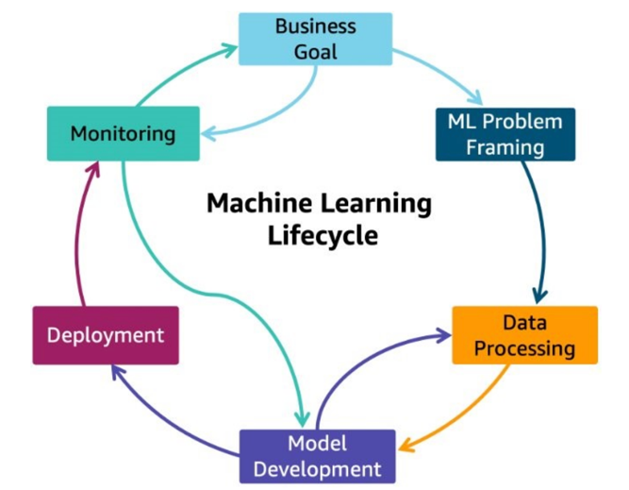

Figure 3 - AWS Machine Learning Lifecycle [b-de Chateauvieux, 2022]

In summary, the referenced documents provide a list of best practices/recommendations, which can be broadly categorized as hardware, software, and location/energy sources.

## 7.1 Hardware

* Dynamic voltage/frequency scaling (DVFS) based techniques;
* CPU-GPU workload division-based techniques. A scaling experiment revealed that CPU and GPU dynamic scaling can save significant amount of energy while providing reasonable performance;
* Architectural techniques for saving energy in specific GPU components, such as caches;
* Hardware cooling solutions;
* Use of specialized infrastructure that includes accelerators appropriate for the task (e.g., hardware accelerators are being investigated to overcome the increasing complexity demand and provide a better energy efficiency for different Deep Learning applications);
* Use of technologies such as low-power FPGAs, which are reprogrammable and flexible, in IoT applications, where the power consumption might go beyond the required power when integrating GPUs.

## 7.2 Software

* Use of sparsely activated deep neural networks for energy savings:
* Avoid training models repeatedly to achieve accuracy by a very small measure may incur very high costs. Training datasets should be equally optimized;
* Due-reporting of the energy consumption and CO2 emissions on ML papers and research, especially when it involves large training of models;
* Use of efficiency as an evaluation metric (e.g., floating point operations), in combination with accuracy and other similar metrics;
* Inclusion of the full training lifecycle in the calculations, which considers previous attempts needed until everything is set up correctly;
* Taking energy needs for inference into account, as these can often outweigh the training ones (e.g., research settings typically focus on model training and accuracy performance, whereas industrial settings, the cost of inference might exceed the training costs in the long term);
* Use of serverless data pipelines so that hardware resources are provisioned only when work needs to be done;
* Release of pre-trained models to save others the cost of retraining them.

## 7.3 Location/Energy Sources

* Payment of attention to the geographic location of the servers where ML workload runs. Tracking the emerging consumption and emission from AI software is equally important as AI deployed hardware. The purpose of such calculation is to measure the amount of CO2 produced by the cloud or the computing resources that are used when executing the algorithm codes. Developers can reduce emissions by targeting their cloud infrastructure in regions that use lower carbon energy sources;
* If available, use cloud regions with sustainable energy sources;
* Promotion of usage of alternative and renewable resources should be sought.

Finally, it must be noted that since AI requires to the utilization of huge amounts of data (big data), it is important to also consider the environmental impacts associated with the capture, storage, analysis and transfer of AI applications using networks and data centres [b-ITU FG-AI4EE D.WG3-1]. These impacts are specifically analyzed in [b-ITU FG-AI4EE D.WG2-3], in the context of IoT-based Smart City applications, and in [b-ITU FG-AI4EE D.WG2-2], as far as cloud-based best practices are concerned.

# 8 Best practices for blockchain energy efficiency

Blockchain can be defined as an open, distributed ledger technology (DLT) that can record transactions between two parties efficiently and in a verifiable and permanent way [b-Iansiti]. [ITU-T F.751.2] provides a high-level architecture which constrains the highly abstract hierarchy of distributed ledgers. A blockchain consists of a shared digital data storage, replicated and synchronized across multiple devices in a network [b-ITU]. The main objective of DLT is to establish trust, accountability and transparency, with no reliance on a single source of authority or in environments where there is a lack of trust between actors [ITU-T L.1317].

Blockchains operate by taking a number of records and putting them in a block and then chaining that block to the next block, using a cryptographic signature [b-ITU]. The consensus mechanism (also called consensus protocol) defines strict rules for creating new blocks and adding new data to them without favouring one participant over another [b-ITU].

Several consensus algorithms exist, the most widely known are [ITU-T L.1317]:

* **Proof of work (PoW)**:The idea behind PoW consensus is to gain the right to validate the state of the ledger by proving to have worked from a computational point of view i.e., to have used a machine (e.g., a computer) to work for the system [b-EUBOF]. Introduced by [b-Nakamoto], the proof-of-work involves scanning for a value that when hashed, such as with SHA-256, the hash begins with a number of zero bits. The average work required is exponential in the number of zero bits required and can be verified by executing a single hash (in a PoW blockchain the nodes that create blocks are referred to as "miners" and the block creation is referred to as "mining"). This gave rise to the larger category of Proof-of-X consensus algorithms where X denotes the resource a network node is consuming/allocating to gain the right to propose and validate the agreement value [b-EUBOF].
* **Proof of stake (PoS)**: In this consensus algorithm each node that wants to participate in the creation of a block will have to deposit an amount as insurance that he will "play by the rules". If a node fails to do so and compromises the consistency of the blockchain, the deposit is lost. This way each node that creates blocks has a "stake" in the success of the blockchain. The higher the deposit, the higher the incentive to ensure the blockchain works as expected. The consensus algorithm selects randomly which node will create each new block taking into account the stake it has in the system. Once selected, the node simply validates the state changes and creates the block without the need to do any additional work as in PoW. The protocol then requires additional validation for the network nodes before accepting the block in the blockchain. In a PoS blockchain the nodes that create blocks are referred to as "validators" or as "forgers" and the block creation is referred to as "minting".
* **Proof of authority (PoA)**:This is similar to the PoS consensus algorithm with the difference that in order to become a validator one needs to be accepted by a centralized authority and not a stake on the system.
* **Proof of elapsed time (PoET)**:In this algorithm, every participant that wants to create a block must wait a random amount of time. The first participant who completes the waiting is selected as leader of the block is selected as the leader and can commit the next block to the blockchain.
* **Practical Byzantine Fault Tolerance (PBFT)**: this algorithm [b-Castro] can be applied to the blockchain to establish the consensus, provided fewer than 1/3 of the nodes are untrusted. There are however limits in its scalability as the exchanged messages grows rapidly with the number of nodes.

It is worth to note that not all of the described consensus mechanisms fit the different blockchain architecture options. Such options, depicted in Figure 4, differentiate according to (i) the permission level given to the participant to participate in the consensus mechanism (Permissionless/Permissioned), and (ii) the control over the user access to the network and the information (Private/Public). An example of an unfit protocol for a blockchain architecture option is PoA in a public and permissionless blockchain.



Figure 4 - Blockchain architecture options and differences [ITU-T L.1317].

Energy efficiency (or energy consumption) of blockchain solutions is highly related to the underlying mechanism that is used for achieving consensus between the nodes of the network, i.e., the consensus mechanism [b-EUBOF].

The topic is addressed in several research papers and reports, including ITU Recommendation [ITU-T L.1317] which specifically recognized the following best practices:

* Choose the level of trust: as long as trust decreases, the energy demand increases and cost increases too. Literature evidence showed that PoA has minimum energy demand; PoW: has the maximum energy demand; and PoS is in between these choices.
* Transaction timeslot: plays crucial role and is a critical parameter that affects the energy performance of a blockchain, since it controls the computational power for solving a blockchain puzzle (in Bitcoin this timeslot is approximately 10 minutes). It is important to realize that this timeslot definition affects the energy demand of all blockchains.
* PoS is a medium choice in terms of energy efficiency: PoS energy demand is affected by the number of validators that are defined for a network. Kusama is a real case PoS case, with specific computational power demand rules for becoming a validator.
* The choice of the devices affects the energy performance.

# 9 Best practices on the use for AI and blockchain application

The previous sections have collected, summarized, and organized the best practices on energy efficiency for AI and blockchain technologies, respectively – they are taken from the relevant deliverables produced by the AI4EE FG.

In addition to these recommendations, which address the two technologies separately, there is the need to adopt a set of best practices for the joint use of AI and blockchain technologies. These recommendations target the developers of societal applications making use of these combined technology instruments. These are the best practices to be followed:

* **Publish AI components on the blockchain**: AI training datasets and trained models shall be published on the blockchain, along with information about the obtained accuracy and computational cost. This enables audit trails and avoids unnecessary trainings that would produce again the same (successful or unsuccessful) results at the cost of wasting computational resources.
* **Efficient publishing on the blockchain**: AI models and the utilized training datasets shall be accessible but not stored on the blockchain. They shall be stored into a distributed file system (e.g., IPFS). The distributed ledger shall be kept minimal in its size, by holding a reference to the datasets and models (e.g., the hash value).

*An example of this approach is reported in [b-Kumar] which implements a distributed deep learning model and uses the IPFS to store the weights of the neural networks and hashes are stored over the blockchain decentralized network.*

* **Blockchain optimization through AI**: ML/DL models should be developed to reduce blockchain energy consumption, for example by addressing possible synchronization issues related to blockchain forking events resulting in a waste of energy and by optimizing distribution of computational load considering device capabilities.

*As an example, AI can be used to avoid duplication of PoW in the context of mobile agents. In this scenario network connectivity can be unreliable and blockchain forking can occur, resulting in wasting of computational and energy resources to obtain nodes synchronization. Recurring to intelligent methods to coordinate the agents can be useful to optimize energy consumption, as reported by [b-Pokhrel] estimation of an average energy [by means of AI][…] serves as a nexus to minimize the number of forking events and capable to optimize energy consumption. Another example is the use of Deep Reinforcement Learning (DLR) to optimize the devices energy allocation in a blockchain-enabled IoT system, as in [b-Yang] [b-Liu].*

* **Optimization of AI training on blockchain**: applications that implement a federated learning approach over a blockchain layer should apply global optimization strategies to minimize the overall energy consumption, while assuring an acceptable global learning delay.
* *As an example, the BAFL system considers Pareto optimization to achieve a balance between overall energy optimization and learning delay [b-Feng].*
* **Intelligent consensus protocols**: the computational resources, utilized for the blockchain consensus mechanism (i.e., PoW - aka *mining*), should be utilized as a contribution to the practical function of AI models training.

*Examples of this approach include Proof-of-learning (PoLE) algorithm [b-Liu], Coin.AI PoUW [b-Baldominosand the Committee Consensus Mechanism (CCM) [b-Li].*

# Appendix A - Use cases for Blockchain and AI

In this appendix, some use cases are presented to show the use of blockchain and IA in different application domains.

## A.1 Healthcare

AI ability to analyze large and complex data structural elements to create a predictive model that personalizes and improves diagnosis, prognosis, monitoring, and treatment administration to improve individual health outcomes are among the most exciting aspects of these technologies [b-Tagde].

On the other hand, blockchain can potentially address many fundamental healthcare problems as this technology is used to control and transport electronic health records, confidentiality, compatibility, standardized shared infrastructure [b-Tagde]. [b- Krittanawong] describes a hypothetical health-care blockchain, which mobilizes data that are currently collected and stored in separate health-care and industry silos, are utilized by separate stakeholders and are often difficult to access by the original data owner (the patient):

* In the current model (a), patient data are maintained on centralized servers, which might be both difficult to access and incompatible between health-system silos and other stakeholders. Consumer devices have separate proprietary servers
* In the blockchain model (b), smart contracts start as patient-owned data elements, which are the centerpiece for secure and transparent information flow. The data owner (typically a patient) can selectively turn access to individual data elements on or off for various stakeholders. Artificial intelligence (AI) tools can interact with smart contracts, and AI tools can also be blockchain-enabled.

One of the most common integrations of the two technologies is the use of blockchain to store patients’ data to be used as input for AI training. This results in a safe, immutable, decentralized system for the sensitive data that AI-driven techniques must collect, store, and use [b-Marwala].

Other researches, such as [b-Jennath], present a transparent platform for consent-based data sharing with the following features: (i) provenance of the consent of individuals and traceability of data sources used for building and training the AI model is captured in an immutable distributed data store, (ii) the audit trail of the data access captured using Blockchain provides the data owner to understand the exposure of the data, and (iii) it also helps the user to understand the revenue models that could be built on top of this framework for commercial data sharing to build trusted AI models.

Besides health records data, blockchain is also used in healthcare systems to implement federated learning, e.g., sharing locally trained AI models to collaboratively build a global model [b-Kumar].

### A.1.1 COVID-19

The COVID-19 pandemic has drastically accelerated adoption of advanced information and communication technologies (ICTs) in the healthcare sector to mitigate the impact of the pandemic [b-Liu]. Many recent publications investigated the use of emerging technologies (including machine learning and blockchain) to help addressing COVID-19 pandemic, a literature review has been compiled by Nguyen et al. [b-Nguyen]. Figure 5 depicts the main functions provided by AI and blockchain to address the COVID-19 pandemic.

Figure 5 – Main functions provided by blockchain and AI to address the COVID-19 pandemics [b-Nguyen]

In [b-Abdel-Basset] a framework to restrict the spread of the COVID-19 pandemic is presented, based on the use of artificial intelligence (AI), 5G, blockchain, Industry 4.0, the Internet of Things (IoT), the Internet of Medical Things (IoMT), big data, and drones. The proposed framework restricts the spread of COVID-19 outbreaks, ensures the safety of the healthcare teams and maintains patients' physical and psychological healthcare conditions. The framework is designed to deal with the severe shortage of PPE for the medical team, reduce the massive pressure on hospitals, and track recovered patients to treat COVID-19 patients with plasma [b-Abdel-Basset]. In particular, the framework uses AI for the monitoring of patient conditions and prediction of COVID-19 outbreaks curve; blockchain is used as a single and consistent data source.

In [b-Liu], the authors describe possible solutions to improve H-IoT (Healthcare Internet of Things) systems in order to support the growing computation-intensive tasks to combat the COVID-19 pandemic. In this work, blockchain is utilized to address the security issue of H-IoT systems. Due to the limited computing and communication resources of the H-IoT system, a permissioned blockchain is chosen in this study due to its limited energy and computational resources. Besides, mobile edge computing (MEC) and energy harvesting methods are adopted to address the limited energy capacity issue. The system, consists of an MEC network that includes several MEC server devices, a permissioned blockchain system deployed on the MEC network, and several H-IoT devices with an energy harvesting module and computing module, which can process the computing tasks at local devices or offload them to MEC server devices.

The described system addresses security by using a permissioned blockchain system and aims to reduce the energy consumption by offloading tasks to MEC server devices as well as by capturing energy using energy-harvesting devices. In addition, a DRL algorithm is employed to optimize both the throughput of the blockchain systems and the energy efficiency of the proposed H-IoT system.

## A.2 Supply Chain Management

For the procurement and supply chain management function of many businesses, the adoption of machine learning (ML) and artificial intelligence (AI) for renewal of their traditional technologies and processes (e.g., with real-time analytics or process automation) is a key factor of development and digital transformation [b-ITU FG-AI4EE D.WG3-7]. A report by IDC [b-IDC] documented that half of the supply chains already undertake AI application development, e.g., for long-term demand forecasting and planning. However, several other factors can play a role in Supply Chain Management (SCM) effectiveness, such as cost control (e.g., increase of fuel prices or raw materials), logistical complexities (e.g., last-mile delivery), etc. By digitalizing their physical assets on a blockchain, SCM systems can leverage the distributed ledger to record every step of production and selling of items in an automatic untampered way. The combined use of the two technologies can increase the automation of a largely paper-based process, by storing all the information in a digital format and tracking a commodity’s pick up-and-delivery timeline, providing a more direct relationship between each stakeholder, i.e., wholesaler, logistics service provider, and consumer. Besides, transparency and traceability are improved as well thanks to the possibility of gathering and analyzing data regarding how goods are made or sourced from, what raw materials they comprise, how they are managed, and so on.

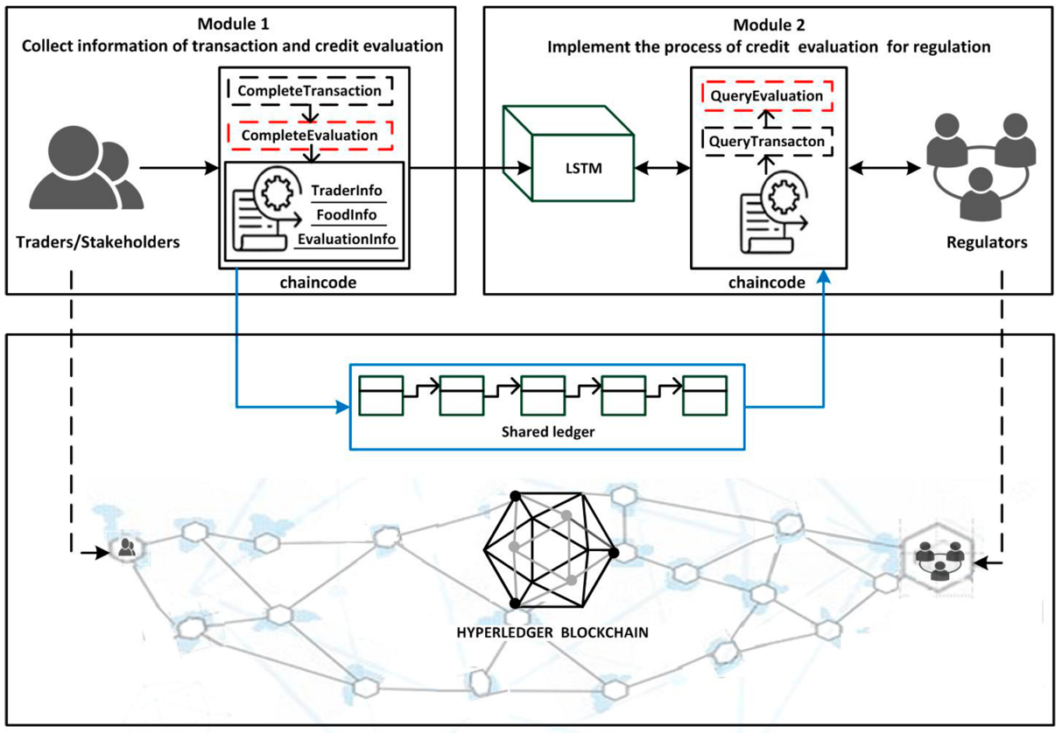

Figure 6 - The architecture of the credit evaluation system [b-Mao]

An example use case combining the use of AI and blockchain in food supply chain is described in [b-Mao]. The research describes a blockchain-based credit evaluation system, depicted in Figure 6, to strengthen the effectiveness of supervision and management in the food supply chain. The system gathers credit evaluation text from traders by smart contracts on the blockchain. Then the gathered text is analyzed directly by a deep learning network named Long Short Term Memory (LSTM). Finally, traders’ credit results are used as a reference for the supervision and management of regulators. By applying blockchain, traders can be held accountable for their actions in the process of transaction and credit evaluation. Regulators can gather more reliable, authentic, and sufficient information about traders.

## A.3 Energy

In the Energy industry, blockchain is often used in assisting to simplify energy exchanges [b-Tanwar]. In fact, the evolution in renewable energy resources opens the door for distributed Peer-to-Peer (P2P) energy trading, such as home and buildings [b-Li], where peers can trade energy with each other without the intervention of any traditional energy distributors, such as grid [b-Jamil].

With the shift from traditional grid to the smart grid (SG), such as Distributed Energy Resources (DER) and microgrids, there is the need for a trusted energy platform, mathematical model, distributed operations, and control algorithms to facilitate stable grid functions, prosumer (i.e., consumers with energy generation and storage capabilities) interaction, and business model. Blockchain can provide a solution to help managing and controlling complex decentralized microgrids and energy systems due to its inherent nature.

AI can be integrated in such platforms to serve several purposes. In [b-Tanwar], a blockchain-based SG system for energy transactions using cryptocurrency is described as a case-study for the AI adoption in blockchain-based smart applications. This framework uses a blockchain and AI approach to complete an energy transaction. In particular, the framework implements an IDS (Intrusion Detection system) utilizing recurrent neural networks to detect fraudulent transactions and network attacks in blockchain-based energy application.

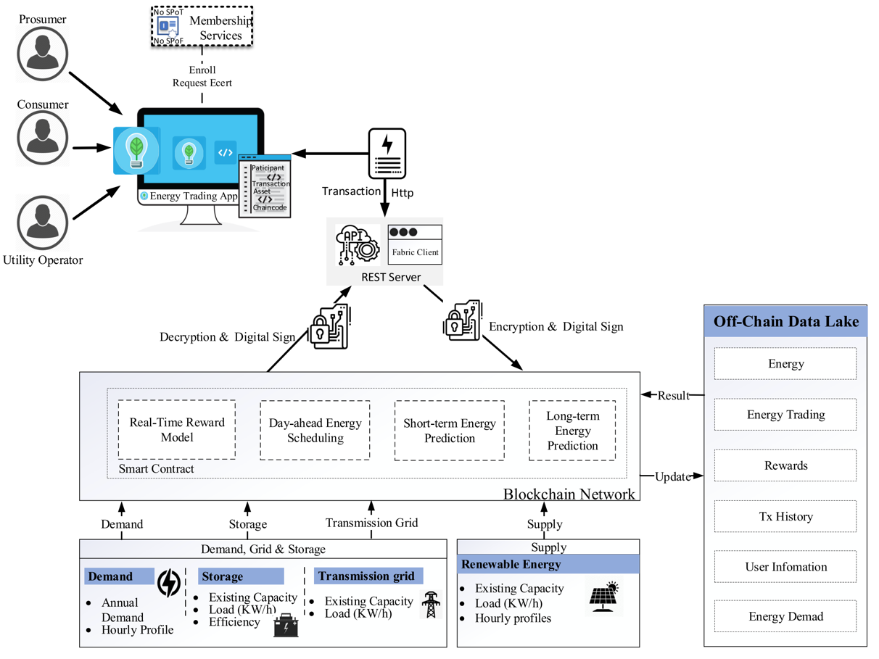

Figure 7 - Predictive energy trading platform implementation and use-case deployment [b-Jamil]

In [b-Jamil], a blockchain-based predictive energy trading platform to provide real-time support, day-ahead controlling, and generation scheduling of distributed energy resources is presented. The proposed blockchain-based platform, depicted in Figure 7, consists of two modules:

* blockchain-based energy trading: allows peers with real-time energy consumption monitoring, easy energy trading control, reward model, and unchangeable energy trading transaction logs;
* smart contract enabled predictive analytics module: aims to build a prediction model based on historical energy consumption data to predict short-term energy consumption.

# Appendix B – AWS Architecture for Optimizing Deep Learning workloads

Amazon Web Service (AWS) published a reference architecture to reduce the carbon footprint of your AI/ML workloads executed on its cloud platform. The following figures provide guidance on the optimization strategies which can be used for the different phases of the AWS Machine Learning Lifecycle: Data processing (Figure 8), Model building (Figure 9), Model training (Figure 10), and Inference (Figure 11).

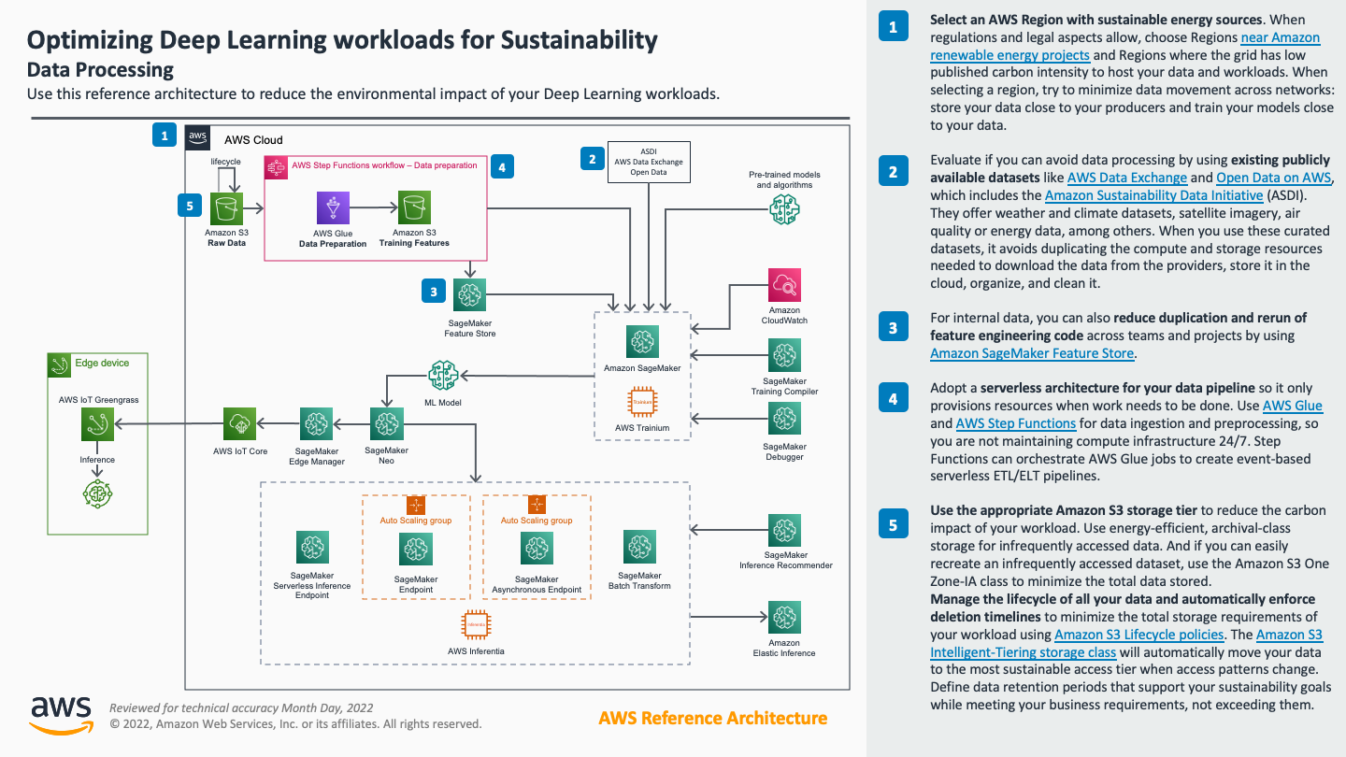

Figure 8 – AWS Optimizing Deep Learning workloads for Sustainability: Data Processing

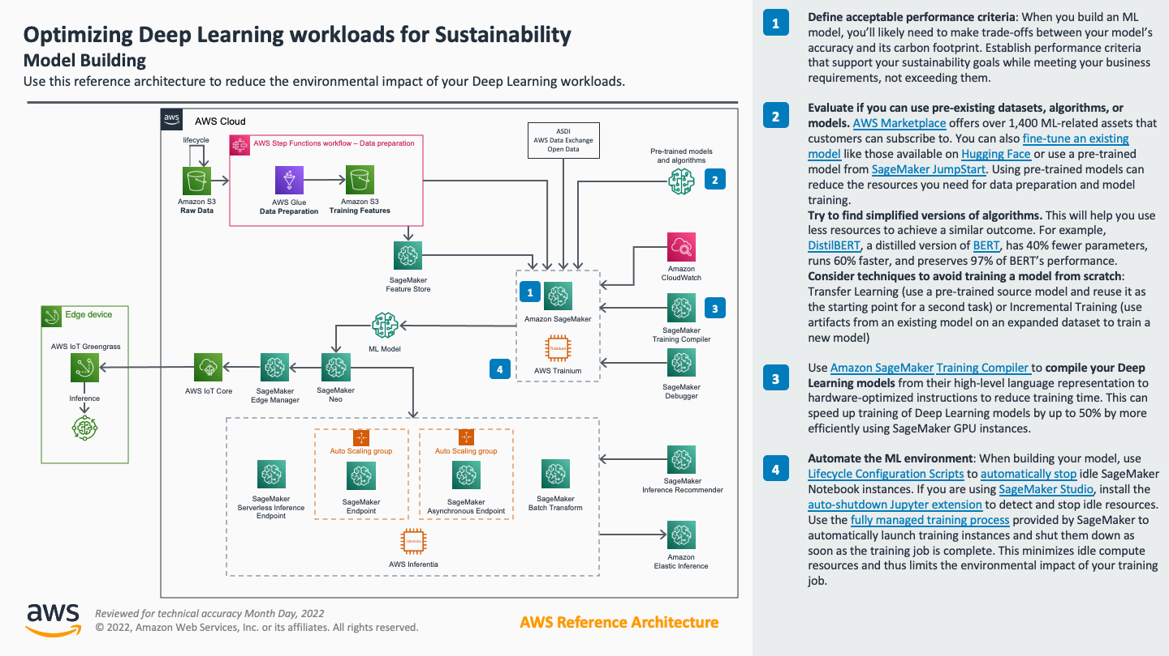

Figure 9 – AWS Optimizing Deep Learning workloads for Sustainability: Model Building

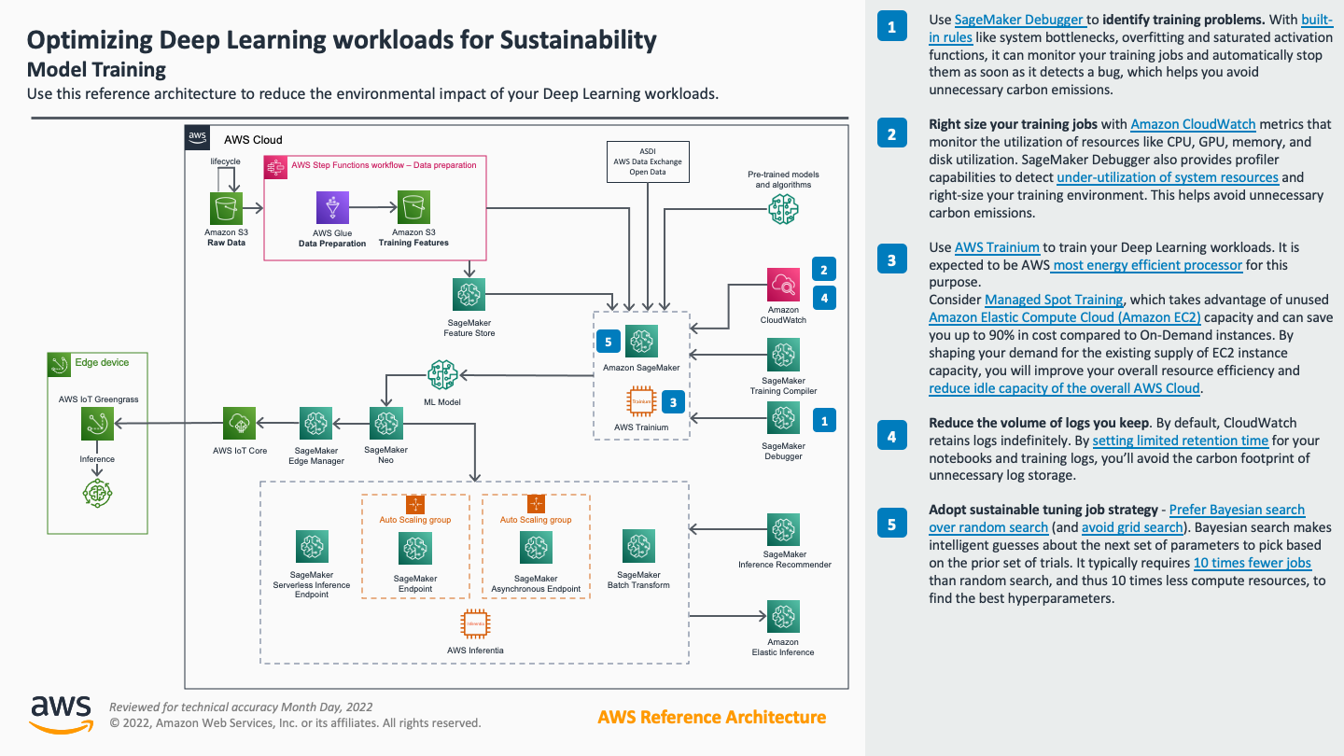

Figure 10 – AWS Optimizing Deep Learning workloads for Sustainability: Model Training

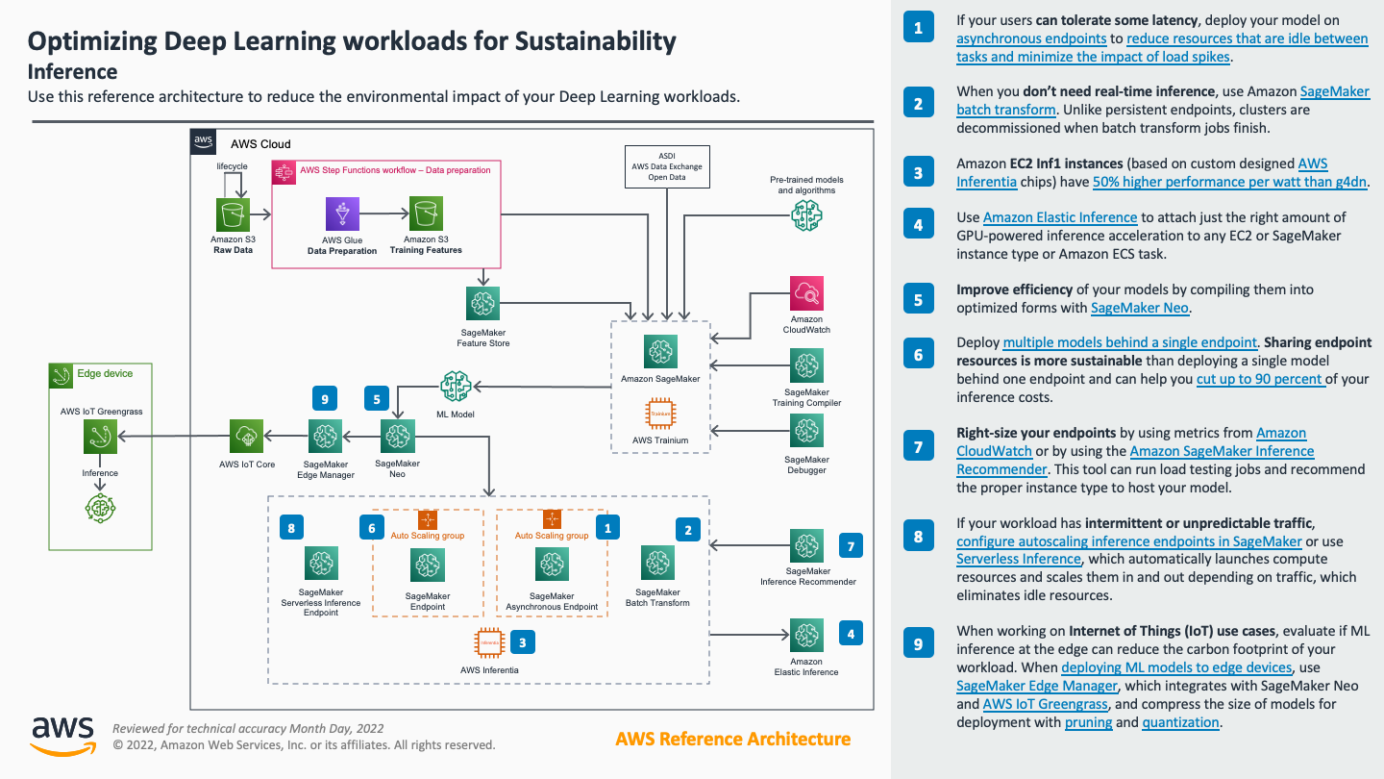

Figure 11 – AWS Optimizing Deep Learning workloads for Sustainability: Inference

Bibliography

[b-ITU FG-AI4EE D.WG2-2] ITU FG-AI4EE D.WG2-2 (2021), Computer processing, data management and energy perspective

[b-ITU FG-AI4EE D.WG2-3] ITU FG-AI4EE D.WG2-3 (2021), Requirements on energy efficiency measurement models and the role of AI and big data.

[b-ITU FG-AI4EE D.WG3-1] ITU FG-AI4EE D.WG3-1 (2021), Guidelines on the implementation of eco-friendly criterias for AI and other emerging technologies.

[b-ITU FG-AI4EE D.WG3-7] ITU FG-AI4EE D.WG3-7 (2021), Guidelines on the Environmental Efficiency of Machine Learning Processes in Supply Chain Management.

[b-ITU FG-AI4EE D.WG1-01] ITU FG-AI4EE D.WG1-01 (2022), Standardized Glossary of Terms.

[b-ITU-U4SSC] ITU (2020), U4SSC: Blockchain for smart sustainable cities. ITU Publishing: Geneva, Switzerland. Retrieved, Jan. 2021 from <http://www.itu.int/pub/T-TUT-SMARTCITY-2020-54>

[b-ITU-DLL] ITU (2017), Distributed Ledger Technologies and Financial Inclusion. Technical Report. Retrieved, Jan. 2021 from <https://itu.int/en/ITU-T/focusgroups/dfs/Documents/201703/ITU_FGDFS_Report-on-DLT-and-Financial-Inclusion.pdf>

[b-Abdel-Basset] M. Abdel-Basset, V. Chang and N. A. Nabeeh, "An intelligent framework using disruptive technologies for COVID-19 analysis", Technol. Forecasting Social Change, vol. 163, Feb. 2021.

[b-Adel] Kareem Adel, Ahmed Elhakeem, Mohamed Marzouk, Decentralizing construction AI applications using blockchain technology, Expert Systems with Applications, Volume 194, 2022, 116548, ISSN 0957-4174, <https://doi.org/10.1016/j.eswa.2022.116548>

[b-Awan] S. Awan, F. Li, B. Luo and M. Liu, "Poster: A reliable and accountable privacy-preserving federated learning framework using the blockchain", Proceedings of the 2019 ACM SIGSAC Conference on Computer and Communications Security, pp. 2561-2563, 2019.

[b-Baldominos] Baldominos A, Saez Y. Coin.AI: A Proof-of-Useful-Work Scheme for Blockchain-Based Distributed Deep Learning. Entropy (Basel). 2019;21(8):723. Published 2019 Jul 25. doi:10.3390/e21080723

[b-Castro] Castro, Miguel and Liskov, Barbara, “Practical Byzantine Fault Tolerance and Proactive Recovery” in ACM Trans. Comput. Syst. Volume 20, pp. 398-461, doi: 10.1145/571637.571640

[b-Chen] X. Chen, J. Ji, C. Luo, W. Liao and P. Li, "When machine learning meets blockchain: A decentralized privacy-preserving and secure design", 2018 IEEE International Conference on Big Data (Big Data). IEEE, pp. 1178-1187, 2018.

[b-de Chateauvieux-1] de Chateauvieux, B.; Pick, E.; Ferguson, D; Sisson, B.; “Optimize AI/ML workloads for sustainability: Part 1, identify business goals, validate ML use, and process data”, 2022, retrieved online on the 5th of Sept. 2022 https://aws.amazon.com/blogs/architecture/optimize-ai-ml-workloads-for-sustainability-part-1-identify-business-goals-validate-ml-use-and-process-data/

[b-de Chateauvieux-2] de Chateauvieux, B.; Pick, E.; Ferguson, D; Sisson, B.; “Optimize AI/ML workloads for sustainability: Part 2, model development”, 2022, retrieved online on the 5th of Sept. 2022 <https://aws.amazon.com/blogs/architecture/optimize-ai-ml-workloads-for-sustainability-part-2-model-development/>

[b-de Chateauvieux-3] de Chateauvieux, B.; Pick, E.; Ferguson, D; Sisson, B.; “Optimize AI/ML workloads for sustainability: Part 3, deployment and monitoring”, 2022, retrieved online on the 5th of Sept. 2022 <https://aws.amazon.com/blogs/architecture/optimize-ai-ml-workloads-for-sustainability-part-3-deployment-and-monitoring/>

[b-Deng] J. Deng, W. Dong, R. Socher, L.-J. Li, K. Li and L. Fei-Fei, ImageNet: A Large-Scale Hierarchical Image Database. IEEE Computer Vision and Pattern Recognition (CVPR), 2009

[b-Dinh] T. Dinh and M. Thai, "AI and Blockchain: A Disruptive Integration" in Computer, vol. 51, no. 09, pp. 48-53, 2018. doi: 10.1109/MC.2018.3620971

[b-EC] European Commission. 2018. Ethics Guidelines for Trustworthy AI. Retrieved June 15, 2022 from <https://ec.europa.eu/digital-single-market/en/news/ethics-guidelines-trustworthy-ai>.

[b-EUBOF] EU Blockchain Observatory & Forum (2021), Energy Efficiency of Blockchain Technologies, retrieved online on the 21 of June 2022 at <https://www.eublockchainforum.eu/sites/default/files/reports/Energy%20Efficiency%20of%20Blockchain%20Technologies_1.pdf>

[b-Feng] L. Feng, Y. Zhao, S. Guo, X. Qiu, W. Li and P. Yu, "BAFL: A Blockchain-Based Asynchronous Federated Learning Framework," in IEEE Transactions on Computers, vol. 71, no. 5, pp. 1092-1103, 1 May 2022, doi: 10.1109/TC.2021.3072033.

[b-GAO] U.S. Government Accountability Office. 2021. Artificial Intelligence: An Accountability Framework for Federal Agencies and Other Entities. Retrieved June 15, 2022 from <https://www.gao.gov/products/gao-21-519sp>.

[b- Iansiti] Iansiti, M., & Lakhani, K. (2017). The Truth About Blockchain.Harvard Business Review.

[b-IBM] IBM, “Blockchain and artificial intelligence (AI)”, Retrieved on June 15 2022 from <https://www.ibm.com/topics/blockchain-ai>

[b-IBM] IBM, “What are smart contracts on blockchain?”, Retrieved on June 16 2022 from <https://www.ibm.com/topics/smart-contracts>

[b-IDC] IDC (2020) Supply Chain Resiliency in a Time of Disruption, accessed online on the 20 of June 2022 at <https://www.oracle.com/a/ocom/docs/applications/scm/idc-supply-chain-planning-paper.pdf>

[b-ISO] International Organization for Standardization, 2020. “Information Technology–Artificial Intelligence–Overview of Trustworthiness in Artificial Intelligence”. Standard. 24028:2020

[b-Jamil] F. Jamil, N. Iqbal, Imran, S. Ahmad and D. Kim, "Peer-to-Peer Energy Trading Mechanism Based on Blockchain and Machine Learning for Sustainable Electrical Power Supply in Smart Grid," in IEEE Access, vol. 9, pp. 39193-39217, 2021, doi: 10.1109/ACCESS.2021.3060457.

[b-Jennath] Jennath HS, Anoop VS, Asharaf S (2020) Blockchain for healthcare: securing patient data and enabling trusted artificial intelligence. Int J Interact Multimed Artif Intell 6:15–23

[b-Johnson] Johnson, Justin and Karpathy, Andrej and Fei-Fei, Li , DenseCap: Fully Convolutional Localization Networks for Dense Captioning, in Proceedings of the IEEE Conference on Computer Vision and Pattern Recognition, 2016

[b-Krittanawong] Krittanawong C, Rogers AJ, Aydar M, et al. Integrating blockchain technology with artificial intelligence for cardiovascular medicine. Nat Rev Cardiol. 2020;17(1):1-3. doi:10.1038/s41569-019-0294-y

[b-Kaur] Davinder Kaur, Suleyman Uslu, Kaley J. Rittichier, and Arjan Durresi. 2022. Trustworthy Artificial Intelligence: A Review. ACM Comput. Surv. 55, 2, Article 39 (March 2023), 38 pages. <https://biblioproxy.cnr.it:2481/10.1145/3491209>

[b-Kumar] Rajesh Kumar, WenYong Wang, Jay Kumar, Ting Yang, Abdullah Khan, Wazir Ali, Ikram Ali, An Integration of blockchain and AI for secure data sharing and detection of CT images for the hospitals, Computerized Medical Imaging and Graphics, Volume 87, 2021, 101812, ISSN 0895-6111, <https://doi.org/10.1016/j.compmedimag.2020.101812>.

[b-LeCun] Y. LeCun, "1.1 Deep Learning Hardware: Past, Present, and Future," 2019 IEEE International Solid- State Circuits Conference - (ISSCC), 2019, pp. 12-19, doi: 10.1109/ISSCC.2019.8662396.

[b-Liu] L. Liu and Z. Li, "Permissioned Blockchain and Deep Reinforcement Learning Enabled Security and Energy Efficient Healthcare Internet of Things," in *IEEE Access*, vol. 10, pp. 53640-53651, 2022, doi: 10.1109/ACCESS.2022.3176444.

[b-Liu] Yuan Liu, Yixiao Lan, Boyang Li, Chunyan Miao, Zhihong Tian, Proof of Learning (PoLe): Empowering neural network training with consensus building on blockchains, Computer Networks, Volume 201, 2021, 108594, ISSN 1389-1286, <https://doi.org/10.1016/j.comnet.2021.108594>

[b-Li] Y. Li, C. Chen, N. Liu, H. Huang, Z. Zheng and Q. Yan, "A blockchainbased decentralized federated learning framework with committee consensus", IEEE Network, vol. 35, no. 1, pp. 234-241, 2020.

[b-Li] Zhiyi Li, Shay Bahramirad, Aleksi Paaso, Mingyu Yan, Mohammad Shahidehpour, Blockchain for decentralized transactive energy management system in networked microgrids, The Electricity Journal, Volume 32, Issue 4, 2019, Pages 58-72, ISSN 1040-6190, https://doi.org/10.1016/j.tej.2019.03.008

[b-Lyu] L. Lyu, J. Yu, K. Nandakumar, Y. Li, X. Ma and J. Jin, "Towards fair and decentralized privacy-preserving deep learning with blockchain", pp. 1-13, 2019.

[b-Marwala] Marwala T, & Xing B (2018) Blockchain and artificial intelligence. arXiv preprint arXiv:1802.04451

[b-Mao] Mao, D.; Wang, F.; Hao, Z.; Li, H. Credit Evaluation System Based on Blockchain for Multiple Stakeholders in the Food Supply Chain. Int. J. Environ. Res. Public Health 2018, 15, 1627. <https://doi.org/10.3390/ijerph15081627>

[b-Miller] Miller Tim. 2019. Explanation in artificial intelligence: Insights from the social sciences. Artificial Intelligence 267 (2019), 1–38.

[b-Nakamoto] Nakamoto, S. (2008), “Bitcoin: A Peer-to-Peer Electronic Cash System”. Retrieved, March 2021 from <https://bitcoin.org/bitcoin.pdf>

[b-Nguyen] Nguyen DC, Ding M, Pathirana PN, Seneviratne A. Blockchain and AI-Based Solutions to Combat Coronavirus (COVID-19)-Like Epidemics: A Survey. IEEE Access. 2021 Jun 30;9:95730-95753. doi: 10.1109/ACCESS.2021.3093633. PMID: 34812398; PMCID: PMC8545197.

[b-NIST] National Institute of Standards and Technology. 2021. “Trust and Artificial Intelligence”. Draft NISTIR 8332

[b-Pokhrel] S. R. Pokhrel, "Blockchain Brings Trust to Collaborative Drones and LEO Satellites: An Intelligent Decentralized Learning in the Space," in IEEE Sensors Journal, vol. 21, no. 22, pp. 25331-25339, 15 Nov.15, 2021, doi: 10.1109/JSEN.2021.3060185.

[b-Qu] Y. Qu, L. Gao, T. H. Luan, Y. Xiang, S. Yu, B. Li, et al., "Decentralized privacy using blockchain-enabled federated learning in fog computing", IEEE Internet of Things Journal, vol. 7, no. 6, pp. 5171-5183, 2020.

[b-Rai] Rai, A. Explainable AI: from black box to glass box. J. of the Acad. Mark. Sci. 48, 137–141 (2020). <https://doi.org/10.1007/s11747-019-00710-5>

[b-Ramesh] Ramesh, Aditya and Dhariwal, Prafulla and Nichol, Alex and Chu, Casey and Chen, Mark. Hierarchical Text-Conditional Image Generation with CLIP Latents, arXiv, https://doi.org/10.48550/arxiv.2204.06125, 2022

[b-Salah] K. Salah, M. H. U. Rehman, N. Nizamuddin and A. Al-Fuqaha, "Blockchain for AI: Review and Open Research Challenges," in IEEE Access, vol. 7, pp. 10127-10149, 2019, doi: 10.1109/ACCESS.2018.2890507.

[b-Shehata] H. A. Shehata and M. El-Helw, "Modeling Collaborative AI for Dynamic Systems of Blockchain-ed Autonomous Agents," 2021 3rd Novel Intelligent and Leading Emerging Sciences Conference (NILES), 2021, pp. 421-426, doi: 10.1109/NILES53778.2021.9600519.

[b-Strubell] Emma Strubell, Ananya Ganesh, and Andrew McCallum. 2019. Energy and Policy Considerations for Deep Learning in NLP. In Proceedings of the 57th Annual Meeting of the Association for Computational Linguistics, pages 3645–3650

[b-Szabo] Szabo, N. (1997). “Formalizing and Securing Relationships on Public Networks”. First Monday, 2(9). https://doi.org/10.5210/fm.v2i9.548

[b-Tagde] Tagde, P., Tagde, S., Bhattacharya, T. et al. Blockchain and artificial intelligence technology in e-Health. Environ Sci Pollut Res 28, 52810–52831 (2021). <https://doi.org/10.1007/s11356-021-16223-0>

[b-Tanwar] S. Tanwar, Q. Bhatia, P. Patel, A. Kumari, P. K. Singh and W. -C. Hong, "Machine Learning Adoption in Blockchain-Based Smart Applications: The Challenges, and a Way Forward," in IEEE Access, vol. 8, pp. 474-488, 2020, doi: 10.1109/ACCESS.2019.2961372.

[b-Tian] R. Tian, L. Kong, X. Min and Y. Qu, "Blockchain for AI: A Disruptive Integration," 2022 IEEE 25th International Conference on Computer Supported Cooperative Work in Design (CSCWD), 2022, pp. 938-943, doi: 10.1109/CSCWD54268.2022.9776023.

[b-Vikhyath] Vikhyath, K.B., Sanjana, R.K., Vismitha, N.V. (2022). Intersection of AI and Blockchain Technology: Concerns and Prospects. In: Awan, I., Benbernou, S., Younas, M., Aleksy, M. (eds) The International Conference on Deep Learning, Big Data and Blockchain (Deep-BDB 2021). Deep-BDB 2021. Lecture Notes in Networks and Systems, vol 309. Springer, Cham. <https://doi.org/10.1007/978-3-030-84337-3_5>

[b-Wang] Wang, Z.; Ogbodo, M.; Huang, H.; Qiu, C.; Hisada, M.; Ben Abdallah, A. AEBIS: AI-Enabled Blockchain-Based Electric Vehicle Integration System for Power Management in Smart Grid Platform. IEEE Access 2020, 8, 226409–226421.

[b-Wang] Wang, Z.; Ogbodo, M.; Huang, H.; Qiu, C.; Hisada, M.; Ben Abdallah, A. AEBIS: AI-Enabled Blockchain-Based Electric Vehicle Integration System for Power Management in Smart Grid Platform. IEEE Access 2020, 8, 226409–226421.

[b-Yang] L. Yang, M. Li, Y. Zhang, P. Si, Z. Wang and R. Yang, "Resource Management for Energy-Efficient and Blockchain-Enabled Industrial IoT: A DRL Approach," 2020 IEEE 6th International Conference on Computer and Communications (ICCC), 2020, pp. 910-915, doi: 10.1109/ICCC51575.2020.9345166.

[b-Zhang] Zhang M, Juntao Li. A commentary of GPT-3 in MIT Technology Review 2021, Fundamental Research, Volume 1, Issue 6, 2021, Pages 831-833, ISSN 2667-3258, <https://doi.org/10.1016/j.fmre.2021.11.011>

______________