|  |  |  |  |  |
| --- | --- | --- | --- | --- |
| ITU Logo | INTERNATIONAL TELECOMMUNICATION UNION  **TELECOMMUNICATION** **STANDARDIZATION SECTOR**  STUDY PERIOD 2017-2020 | | FG-AI4H-D-006 | |
| **ITU-T Focus Group on AI for Health** | |
| **Original: English** | |
| **WG(s):** | | Plenary | Shanghai, 2-5 April 2019 | |
| **DOCUMENT** | | | | |
| **Source:** | | Chairman FG-AI4H | | |
| **Title:** | | Draft ToR for the Working Group "Regulatory considerations on AI for health" | | |
| **Purpose:** | | Admin | | |
| **Contact:** | | Thomas Wiegand Fraunhofer HHI Germany | | Email: [thomas.wiegand@hhi.fraunhofer.de](mailto:thomas.wiegand@hhi.fraunhofer.de) |

|  |  |
| --- | --- |
| **Abstract:** | This document contains the draft ToR for the FG-AI4H Working Group focused on regulatory considerations on AI for health. |

# Proposed structure

The following figure illustrates the proposed structure of the Working Group "Regulatory considerations on AI for health".

The WG has one chair nominated by the Focus Group. ITU or WHO members can each nominate a vice-chair from their regulatory bodies. Vice-chair nominations are confirmed either at Focus Group meetings or by the FG management in-between meetings.

Regulatory bodies are meant here to include national and regional organizations that have in their mandate the responsibility for assessing the safety and efficacy of AI for health technologies within their jurisdictions.

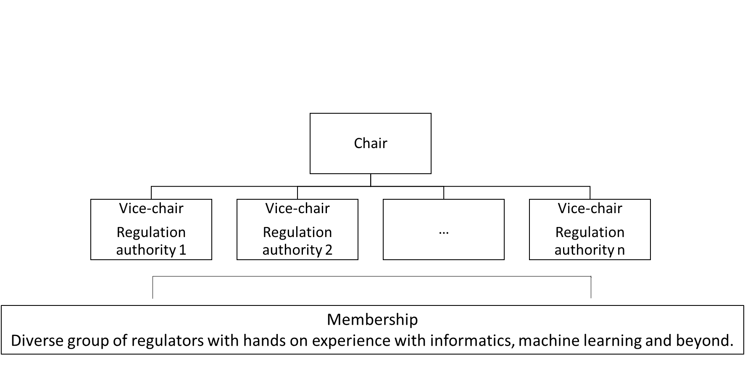

# Scope and Description

The working group “Regulatory Considerations for AI” will help guide the FG in navigating the regulatory landscape; facilitating contacts, information exchange, and collaborative opportunities of the FG with regulatory bodies. The working group will help outline key regulatory considerations that are relevant to regulatory agencies for AI development. The working group will also help define ways to successfully benchmark AI for health algorithms.

Specific issues to be addressed include:

* How can the FG work together with regulatory bodies to ensure that the procedures, benchmarks, and validation principles are useful and relevant for regulators and other stakeholders? This will further facilitate a wider adoption of AI in the health.

Tasks include, but are not limited to:

* Organize networking opportunities to facilitate information and knowledge exchange between experts, regulators, and different stakeholders
* Identify regulatory challenges and opportunities
* Develop an outline of shared key considerations to consider for the regulation of AI in health

**Deliverables and timeframe**

The working group is to deliver the following:

* In close collaboration with the WHO, the working group will develop appropriate key regulatory considerations document that will serve as consensus elements to establish policies and regulations that ensure the safe and appropriate development and adoption and use of AI in health. (Expected timeframe: initial draft by the summer of 2019. Finalize by the end of 2019).
* Outline of opportunities and challenges for the development and adoption of AI in Health and will propose demonstration projects and workshops to help further the understanding of all stakeholders. (Expected timeframe: By the end of 2019 for documentation. TBD for demonstration projects).

**Representations and interactions**

* Chairs and experts of the other working groups of FG-AI4H
* ITU secretariat and WHO representatives
* Invite WG members from different regulatory agencies with relevant expertise.
* Workshops to include participants from different stakeholders (academic institutions, industry (biotech, pharma, informatics, etc.), regulatory agencies, bioethics, patient advocacy groups and other stakeholders).

____________________________