|  |  |  |  |  |
| --- | --- | --- | --- | --- |
| ITU Logo | INTERNATIONAL TELECOMMUNICATION UNION  **TELECOMMUNICATION STANDARDIZATION SECTOR**  STUDY PERIOD 2017-2020 | | FG-AI4H-D-014 | |
| **ITU-T Focus Group on AI for Health** | |
| **Original: English** | |
| **WG(s):** | | N/A | Shanghai, 2-5 March 2019 | |
| **DOCUMENT** | | | | |
| **Source:** | | Huimei Cloud Technology Co.Ltd | | |
| **Title:** | | AI based Quality Control in Stroke Treatment Service | | |
| **Purpose:** | | Discussion | | |
| **Contact:** | | Huiqin Liu Huimei Cloud Technology Co.Ltd. China | | Tel: +86 185 1089 1840  Email: [liuhuiqin@huimei.com](mailto:liuhuiqin@huimei.com) |

|  |  |
| --- | --- |
| **Abstract:** | Great progress has been made in stroke treatment in China, but still some problems are remained：(1) How to improve the low efficiency of hospital information system that delays the treatment; (2) How to improve the low quality of EMR data that affects data utilization and decision support; (3) How to extend quality medical resources to patients across the country. This article is expected to have a method to solve it . |

**Overview**

“*China Stroke Prevention and Treatment Report 2017*” indicates, cerebrovascular diseases are the major cause reducing life span, the incidence rate continually increases by 50% which will reach 1.2 million cases in 2030. “The lancet” survey shows China’s overall Healthcare Access and Quality (HAQ) index of 78 but stroke HAQ index of 31.

World stroke day is organized by 50 countries around the world. The theme is "one in six". One person dies of stroke every six seconds; Every six seconds, one person is permanently disabled by a stroke. The death rate from stroke continues to climb in China, increasing by 10% a year.

Globally, there are 15 million new cases of stroke and 6 million deaths every year. China accounts for nearly one third of the world's stroke patients.

Thus, the medical quality and standard of stroke in China keeps rising, but still needs to be improved. For example, the proportion of cerebral infarction thrombolysis in 3 hours is only 2% [1] in China, and 65.9% of young, grassroots specialists fail to pass the knowledge of acute phase of stroke and secondary prevention guidelines [2]. Strengthening quality control and improving the compliance of guidelines for the diagnosis and treatment of stroke by medical staff have a positive effect on improving quality and long-term prognosis of patients. In nowadays, Medical AI tools are expected to achieve the quality control in stroke treatment, clinical decision supporting system (CDSS) is one of these effective tools.

# Impact

In the past 2 years, CDSS applied in over 50 top hospitals in China that is adopted into electronic medical record (EMR), without process modification, helping more than 50,000 patients during diagnosis and treatment with thousands of stoke patients. The neurology department will expand the applications in more diseases, such as cerebral hemorrhage and epilepsy, to explore the improvement of medical quality and efficiency by AI. As an important means to improve medical quality, CDSS can bring direct economic benefits to hospitals and effectively reduce medical errors and costs.

# Existing Work

There are 2,458 stroke centres in China, in the past 10 years, the level of stroke prevention and treatment in China has been improved, and the medical quality has been significantly improved. The recurrence rate is 7.7%, comparable to European countries, and the overall prognosis is better than the global average.

A few medical tools use AI algorithm for indicators associated with stroke, and then sends a text notification to a neurovascular specialist if it identifies a potential large vessel blockage. Because the tools alert the specialist during the time a first-line provider is reviewing the information, patients may receive attention from a specialist earlier than they would normally. The agency stressed in its announcement that the application should not be a stand in for a full patient evaluation when diagnosing a case. In the same way, CDSS has taken an important role during entire stroke treatment process, specially in neurology department in top hospitals or Stroke Centres in recent years.

# Feasibility

In 2017, the State of Food and Drug Administration of China has released “*Medical device classification catalogue”.* In the statement, Medical AI tools has been officially recognized. One of the tools, CDSS has been widely used in hundreds of top hospitals in China.

Focusing on the supporting function in clinical practice, a few quality control systems have been offered in medical market. Here a type of CDSS which integrated Chinese authoritative guidelines and knowledge basis from Mayo Clinic has been adopted in a cutting edge stroke center in China, and 11 quality control indicators of stroke have been set up. (Figure 2 & Figure 3)

Working process is as follows:

1. embedded into EMR system;
2. collects patients’ clinical data, including: clinical notes and prescriptions;
3. identifies whether enough statins (40mg statins) has been prescribed for intensive lipid-lowering therapy
4. Remind physician in real-time when the physician had not completed the procedure.

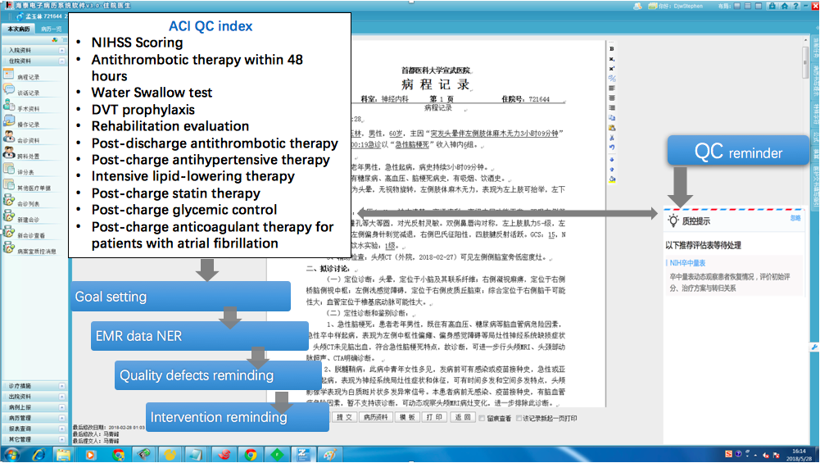

Figure 2. Medical AI Quality Control reminding process

|  |  |
| --- | --- |
| NIHSS scoring | NIHSS (National Institute of Health Stroke Scale )scoring must be done in each day |
| Antithrombotic therapy within 48 hours | Antithrombotic therapy must be administered within 48 hours after admission |
| Water Swallow test | Swallowing function should be evaluated after admission, and feeding instruction and rehabilitation should be conducted for patients with abnormal conditions |
| DVT prophylaxis | Patients with less than 3 grade of muscle strength of lower limbs should accept deep venous thrombosis prevention |
| Rehabilitation evaluation | Rehabilitation department consolation should be ordered and corresponding treatments should be provided |
| Post-discharge antithrombotic therapy | Antithrombotic drugs should be prescribed at discharge |
| Post-charge antihypertensive therapy | Antihypertensive drugs should be prescribed at discharge in patients with hypertension |
| Intensive lipid-lowering therapy | Intensive lipid-lowering therapy should be initiated as early as possible after admission for patients with non-cardiogenic embolism |
| Post-charge statin therapy | statins should be prescribed for discharged patients with non-cardiogenic embolism |
| Post-charge glycemic control | Antidiabetic agents should be prescribed for discharged patients with diabetes mellitus |
| Post-charge anticoagulant therapy for patients with atrial fibrillatio | Anticoagulants should be prescribed at discharge in patients with atrial fibrillation |

Figure 3. 11 quality control indicators of stroke

Natural language processing (NLP) based on deep learning is the key technology of large-scale text recognition and knowledge extraction by CDSS, using conditional random field (CRF) machine learning method, by analysing the definition of words in EMR, to extract key words during stroke diagnosis and treatment processes, prompting doctors to make more comprehensive and personalized diagnosis and treatment for patients.

# Data Availability

The 11 quality control indicators above mentioned are set up according to AHA, ASA, Chinese guidelines and expert consensus of acute ischemic stroke and combined with experience of clinical experts, and they have been tested and actually applied in hospitals for years.

The diagnosis accuracy rate in stroke treatment can reach 93.6%, that it can prompt important diagnosis and differential diagnosis that doctors did not think of or ignored.

Comparison of 3-week data of ACI QC conducted by CDSS: the total average quality compliance rate of departments increased by 33.7% (table 1), and the average compliance rate of 11 key indicators was 93.85%, higher than the national average (table 2).

By using CDSS, the key nodes in the EMR will be automatically mapped to the knowledge base. When the EMR completed by clinician, system will automatically find that the corresponding quality control content was missing in the medical record, and will remind the missing quality control items in homepage of EMR. Doctors can click on the “quality control reminding” to complete the corresponding evaluation, examinations, medication, etc. Informationalized quality control is a standardized check-up in process.

In summary, information technology can help hospitals get real-time monitoring, boost the inspection speed of terminal medical record, guarantee the diagnosis and treatment in right way.

# Benchmarking

A sample is suggested among persistent clinical practice in a top hospital. The evaluation could be taken in these 11 quality control indicators in 3 or 6 months for verification when around 1000-3000 patients with stroke could participate this evaluation. The optimal text recognition F1 value through NER is 92.01% with a good effect, structured data automatically maps snomber-CT and ICD10, which improves system interoperability. The adoption and storage of real-time data based on EMR also provides support for clinical research and big data analysis.

# References：

[1] http://www.medsci.cn/article/show_article.do?id=12b0e172584

[2]Dr.Jianping ,Jia，The Promoting Project for China Neurologist’ Stroke Standardized Treatment

<https://wenku.baidu.com/view/bf65f226dd36a32d737581e4.html>

[3]Dr.Peng,Xiang，Defang,Luo，Study on Qualified Ration of Diagnosis through CDSS based on Artificial Intelligence (First prize of "excellent paper" and in publishment review)

[4]Nan,Cheng，Defang,Luo，Application Research on Electronic Medical Record based on NLP Technology》(Second prize of "excellent paper" and in publishment review)

# Organizer Details

Huimei Cloud Technology Ltd,.Co. is one of the largest providers for medical artificial intelligence solutions, its extensive expertise in knowledge base on algorithm and medical resources , and has provided its CDSS to over 50 top hospitals using in clinical practice and helped with upgrade like National evaluation and HIMSS evaluation.

|  |  |
| --- | --- |
| **Organization Name** | Huimei Cloud Technology Co.Ltd. |
| **Contact Name** | Huiqin,Liu |
| **Contact Email Address** | liuhuiqin@huimei.com |
| **Contact Phone Number** | +86 18510891840 |
| **Project Title** | AI based Quality Control in Stroke Treatment Service |

____________________________