 | INTERNATIONAL TELECOMMUNICATION UNION  TELECOMMUNICATION  STANDARDIZATION SECTOR  STUDY PERIOD 2022-2024 |  | FG-AI4H-Q-032
 |  |  | ITU-T Focus Group on AI for Health
 |  |  | Original: English
WG(s): |  | Plenary | Douala, 6-9 December 2022
DOCUMENT
Source: |  | Editors DEL10
Title: |  | DEL10 Update: AI4H use cases: Topic Description Documents
Purpose: |  | Discussion
Contact: |  | Eva Weicken  Fraunhofer HHI, Germany | Email: eva.weicken@hhi.fraunhofer.de
Contact: |  | Monique Kuglitsch  Fraunhofer HHI, Germany | Email: monique.kuglitsch@hhi.fraunhofer.de
Contact: |  | Markus Wenzel  Fraunhofer HHI, Germany | Email: markus.wenzel@hhi.fraunhofer.de

Abstract: | This document provides an overview of the ITU/WHO Focus Group on AI for Health (FG-AI4H) "AI4H use cases: Topic Description Documents". Each use case is represented by a topic group that is dedicated to a specific health topic in the context of AI. The topic group proposes a procedure to benchmark AI models developed for a special task within this health topic. All members of a topic group create a topic description document (TDD) that contains information about the structure, operations, features, and considerations of the specific health topic. This document constitutes deliverable No. 10 (DEL.10_0) and serves as an introduction to the topic groups and their topic description documents.

Call for participation
If you are interested in contributing to DEL.10_0 "AI4H use cases: Topic Description Documents" you are encouraged to contact Eva Weicken (eva.weicken@hhi.fraunhofer.de) and the FG-AI4H secretariat (tsbfgai4h@itu.int). We would appreciate if you can briefly introduce yourself and your relevant expertise.
Change Notes
This document DEL 10_0 "AI4H use cases: Topic Description Documents" provides the status of the topic groups and their TDDs. Previous versions include:
- Version 10 (DEL 10_0, Douala meeting, “Q”, 06 – 09 December 2022)
- Version 9 (DEL 10_0, Helsinki meeting, “P”, 19 – 22 September 2022)
- Version 8 (DEL 10_0, Berlin meeting, “O”, 31 May – 2 June 2022)
- Version 7 (DEL 10_0, E-meeting “N”, 15 – 17 February 2022)
- Version 6 (DEL 10_0, E-meeting “M”, 28 – 30 September 2021)
- Version 5 (DEL 10_0, E-meeting "L", 19–21 May 2021)
- Version 4 (DEL 10_0, E-meeting "K", 27–29 January 2021; introduction of the updated TDD-template 'FG-AI4H J-105')
- Version 3 (DEL 10_0, E-meeting "J", 29 September–02 October 2020)
- Version 2 (DEL 10_0, E-meeting "I", 7–8 May 2020)
- Version 1 (FG-AI4H-H-210, Brasilia meeting "H", 21–24 January 2020)
- Version 0 with an initial outline (FG-AI4H-G-210, New Delhi meeting "G", 11–15 November 2019)

CONTENTS
Page
1 Scope 5
2 References 5
3 Terms and definitions 6
4 Abbreviations 6
5 Introduction 7
5.1 TDD-template update 9
6 Structure 10
7 Resources and latest document versions of all topic groups 11
7.1 Cardiovascular disease risk prediction (TG-Cardio) 11
7.2 Dermatology (TG-Derma) 11
7.3 Diagnosis of bacterial infection and anti-microbial resistance (AMR) (TG-Bacteria) 12
7.4 Falls among the elderly (TG-Falls) 12
7.5 Histopathology (TG-Histo) 12
7.6 Malaria detection (TG-Malaria) 12
7.7 Maternal and child health (TG-MCH) 12
7.8 Neurological disorders (TG-Neuro) 12
7.9 Ophthalmology (TG-Ophthalmo) 13
7.10 Outbreak detection (TG-Outbreaks) 13
7.11 Psychiatry (TG-Psy) 13
7.12 Radiology (TG-Radiology) 13
7.13 Snakebite and snake identification (TG-Snake) 13
7.14 Symptom assessment (TG-Symptom) 13
7.15 Tuberculosis (TG-TB) 14
7.16 Volumetric chest computed tomography (TG-DiagnosticCT) 14
7.17 Dental diagnostics and digital dentistry (TG-Dental) 14
7.18 AI-based detection of falsified medicine (TG-FakeMed) 14
7.19 Primary and secondary Diabetes risk prediction (TG-Diabetes) 14
7.20 AI and endoscopy (TG-Endoscopy) 14
7.21 Musculoskeletal Medicine (TG-MSK) 15
7.22 AI for human reproduction and fertility (TG-Fertility) 15
7.23 AI in sanitation for public health (TG-Sanitation) 15
7.24 AI for point-of-care diagnostics (TG-POC) 15

List of Tables
Table 1: Overview of the 24 topic groups and their corresponding deliverables 10

List of Figures
Page
Figure 1: Topic groups and the TDD/deliverables 8
Figure 2: Interaction between topic groups ('vertical') and working groups ('horizontal', exemplarily 5/7 working groups) 9

FG-AI4H Deliverable 10_0
AI4H use cases - Topic Description Documents
Summary
The deliverable No. 10_0 "AI4H use cases: Topic Description Documents" of the ITU/WHO Focus Group on Artificial Intelligence for Health (FG-AI4H) serves as an introduction to the 24 use cases, respectively topic groups and their deliverables. The topic groups involve stakeholders from the medical field and ML/AI domain who are dedicated to specific health topics that could benefit from AI. Under the guidance of the topic group driver, the members of each topic group develop a topic description document (TDD) that contains all requirements of the AI-related benchmarking for the respective health topic. The TDD describes the background of the health topic in the context of AI and the structure, operations, and considerations of the topic group. This document provides an overview of the various TDDs developed by FG-AI4H topic groups.
In total, 24 topic groups were established by December 2022. The topic groups represent various health topics in the context of AI including medical fields, e.g., histopathology, cardiology, neurology, radiology. Table 1 includes an overview of all topic groups and their TDDs.
Each topic group works on a TDD that represents the ongoing work of the benchmarking process for the specific health topic. The development of the TDD is an iterative process and updates are presented at each meeting. All topic groups use the same TDD-template which reflects the requirements for the benchmarking process defined by FG-AI4H working groups. The TDD-template was updated by meeting 'J' and is allocated as FG-AI4H-J-105.
The consistent TDD structure also facilitates an internal and external review process of the TDDs before their final approval and publication.

Scope
This document introduces the topic description documents of the ITU/WHO Focus Group on AI for Health. Further, it provides an overview of the status of the various topic groups, their TDDs and the TDD template (including updates).

References
[DEL10_01] FG-AI4H Deliverable DEL10_01, Cardiovascular disease management (TG-Cardio). Last found, DEL10_01 including the subtopic: cardiovascular disease risk prediction using AI
[DEL10_02] FG-AI4H Deliverable DEL10_02, Dermatology (TG-Derma). Last found: DEL10_02
[DEL10_03] FG-AI4H Deliverable DEL10_03, Diagnosis of bacterial infection and anti-microbial resistance (TG-AMR). Last found: DEL10_03
[DEL10_04] FG-AI4H Deliverable DEL10_04, Falls among the elderly (TG-Falls). Last found: DEL_10_04
[DEL10_05] FG-AI4H Deliverable DEL10_05, Histopathology (TG-Histo). Last found: DEL10_05
[DEL10_06] FG-AI4H Deliverable DEL10_06, Malaria detection (TG-Malaria). Last found: DEL10_06
[DEL10_07] FG-AI4H Deliverable DEL10_07, Maternal and child health (TG-MCH). Last found: DEL10_07
[DEL10_08] FG-AI4H Deliverable DEL10_08, Neurological disorders (TG-Neuro). Last found: DEL10_08
[DEL10_09] FG-AI4H Deliverable DEL10_09, Ophthalmology (TG-Ophthalmo). Last found: DEL10_09
[DEL10_10] FG-AI4H Deliverable DEL10_10, Outbreak detection (TG-Outbreaks).Last found: DEL10_10
[DEL10_11] FG-AI4H Deliverable DEL10_11, Psychiatry (TG-Psy). Last found: DEL10_11
[DEL10_12] FG-AI4H Deliverable DEL10_12, Radiology (TG-Radiology). Last found: DEL_10_12
[DEL10_13] FG-AI4H DEL10_13, Snakebite and snake identification (TG-Snake). Last found: DEL10_13
[DEL10_14] FG-AI4H Deliverable DEL10_14, Symptom assessment (TG-Symptom). Last found: DEL10_14
[DEL10_15] FG-AI4H Deliverable DEL10_15, Tuberculosis (TG-Tuberculosis). Last found: DEL10_15
[DEL10_16] FG-AI4H Deliverable DEL10_16, Volumetric chest computed tomography (TG-Diagnostic CT). Last found: DEL10_16
[DEL10_17] FG-AI4H Deliverable DEL10_17, Dental diagnostics and digital dentistry (TG-Dental). Last found: DEL10_17
[DEL10_18] FG-AI4H Deliverable DEL10_18, AI-based detection of falsified medicine (TG-FakeMed). Last found: DEL10_18
[DEL10_19] FG-AI4H Deliverable DEL10_19, Primary and secondary Diabetes risk prediction (TG-Diabetes). Last found: DEL10_19
[DEL10_20] FG-AI4H Deliverable DEL10_20, AI for endoscopy (TG-Endoscopy). Last found: DEL10_20
[DEL10_21] FG-AI4H Deliverable DEL10_21, AI for Musculoskeletal medicine (TG-MSK). Last found: DEL10_21
[DEL10_22] FG-AI4H Deliverable DEL10_22, AI for human reproduction and fertility (TG-Fertility). Last found DEL10_22
[DEL10_23] FG-AI4H Deliverable DEL10_23, Traditional Medicine (TG-TM). tbc
[DEL10_24] FG-AI4H Deliverable DEL10_24, AI for point-of-care diagnostics (TG-POC). Last found DEL10_24
NOTE: Literature references are listed in the bibliography.

Terms and definitions
This document does not rely on terms defined elsewhere. It also does not define any new terms.

Abbreviations
AI | Artificial Intelligence
AI4H | Artificial Intelligence for Health
CE  CfP | Clinical evaluation  Call for Participation (to join a Topic Group)
DAISAM  DASH  FG-AI4H | Data and AI solution assessment methods  Data and AI solution handling  Focus Group on Artificial Intelligence for Health
ITU | International Telecommunication Union
MCH | Mother and child health
ML | Machine Learning
MSK  RC | Musculoskeletal  Regulatory considerations
TDD | Topic Description Document
TG | Topic Group
WG | Working Group
WHO | World Health Organization

Introduction
This draft gives an overview of the various topic description documents developed by the ITU/WHO Focus Group on AI for Health, which is a collaboration between the International Telecommunication Union (ITU) and the World Health Organization (WHO). The initiative is developing a framework for the standardized benchmarking of AI technology for health and operates at the interface of multiple fields, including AI, machine learning, medicine, public health, regulation, statistics, evaluation, and ethics.
The activities of the initiative include topic groups that take charge of specific health domains with corresponding AI/ML tasks. Under the guidance of a topic group driver each topic group develops a topic description document (TDD). Each TDD introduces the health topic being explored, explains the role of AI within this context, and proposes a procedure to benchmark AI models developed for a specific task. The topic description documents also provide information about the structure, operations, features, and considerations of the respective topic groups. The topic description documents are written in a collaborative effort and are iteratively improved over time by all members of a topic group. Topic group members are stakeholders from the medical field and the AI/ML domain dedicated to specific health topics that could benefit from AI.
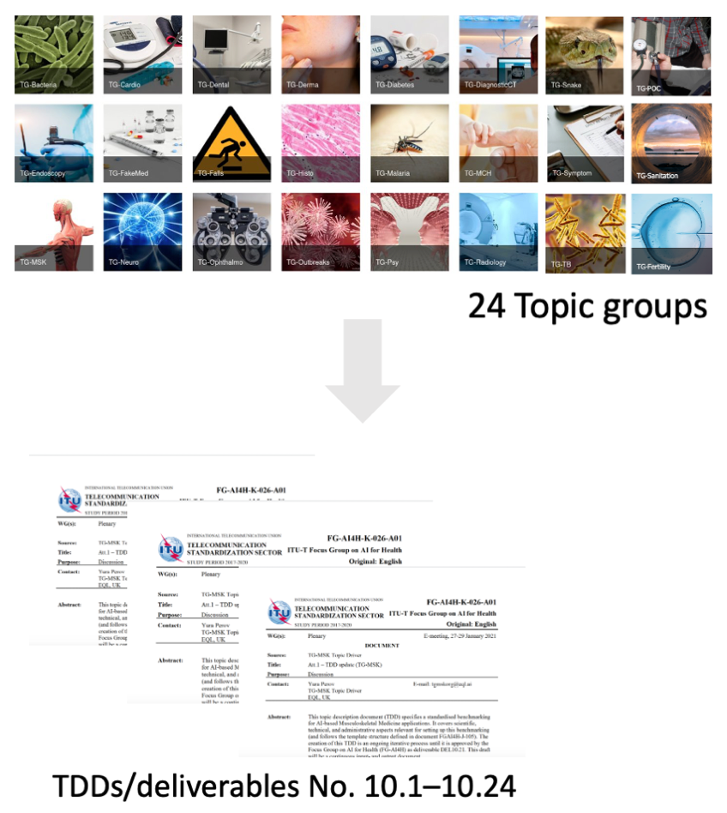
Figure 1: Topic groups and the TDD/deliverables
A generic outline of the topic description documents was proposed in the TDD-template document FGAI4H-C-105 and has been updated by meeting 'J' – FG-AI4H-J-105. The latter document serves as the current TDD-template and is applicable for all topic groups.
The TDD content can be categorized into four components:
- Topic background: What is the health topic considered? Is this of relevance (e.g., does it affect a large and diverse transect of the global population and/or represent a challenge to the healthcare community)? What is the current gold standard for addressing this health topic? Could AI provide a tangible improvement (e.g., in terms of better care, better results, and/or savings in cost and time)? Are there existing AI solutions for this health topic? Has already been worked towards the benchmarking of the aforementioned solutions?
- Topic group features: What subtopics belong to the topic group? How do members of the topic group participate and interact (e.g., via online communication, regular meetings)? What is the status update for this topic group to each meeting?
- Topic group operations: How will the benchmarking be executed (e.g., with regard to input/output data, data labelling/annotation, test dataset acquisition, scores/metrics, architecture, and data sharing policies)? How will the outcome of the benchmarking be disseminated? How will feedback be implemented? Are there existing benchmarking processes of AI systems that are of interest for the benchmarking of this topic group (e.g., publications, frameworks)? How is the retirement after benchmarking of the AI task managed?
- Topic group considerations: How are ethics and legalities addressed by the topic group? What are the regulatory considerations that apply for this topic group (e.g., what are existing regulatory frameworks? Which regulatory requirements are used for the benchmarking of the AI4H system in this topic group?)
In the end, a Declaration of Conflict of Interest by each contributor to this document is provided.
As progress is made within the topic groups, revised versions of the topic description documents are inevitable. These are submitted as input documents and are presented at each meeting by the topic group driver. The changes are discussed and integrated into the improved version.
Parallel to the topic groups, there are working groups that are dedicated to overarching themes that affect all topic groups in a specific aspect of an AI health technology, for example, the Working Group on Regulatory Considerations on AI for Health and the Working Group on Ethical Considerations on AI for Health. Working groups also develop definitions of best practices, establish processes and related policies, define ways to successfully benchmark AI for health algorithms and create reference documents. All these considerations are important for the benchmarking process of all topic groups in the context of the special health topic and are also considered in their TDD.
Figure 2 gives an overview of the interaction between FG-AI4H topic groups ('vertical') and working groups ('horizontal').
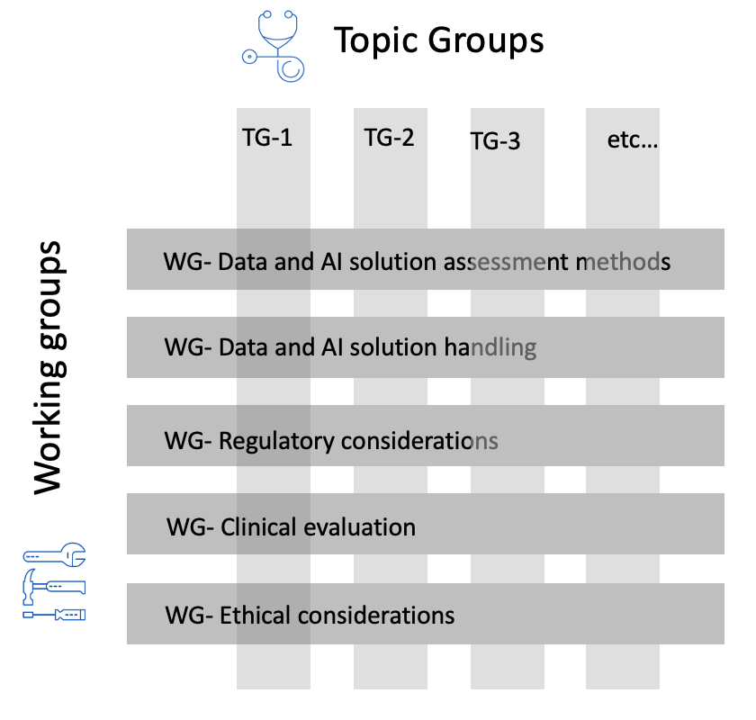
Figure 2: Interaction between topic groups ('vertical') and working groups ('horizontal', exemplarily 5/7 working groups)

TDD-template update
As of meeting 'H', FG-AI4H members resolved an update of the generic TDD template FGAI4H-C-105 that became obvious during the formation process of the TDD and the development and activities within FG-AI4H working groups and topic groups over time. The objective is to create a consistent structure of the TDD template that works for all topic groups and also facilitates the internal and external review process of the TDDs.
A revised version of the TDD template document was submitted as "Draft updated TDD template," allocated as FGAI4H-I-004 to meeting 'I' (E-meeting) in May 2020, including additional sections, change notes, mentioning of the contributors, restructuring of some sections, lists of figures and tables, consideration of health economics and regulation, and a list of optional sub-topics.
During this meeting, FG-AI4H members agreed on further adjustments and more detailed information about the requirements defined by the working groups and their output documents (deliverables 01 – 09) on regulatory - and ethical considerations, on clinical evaluation and on all aspects regarding data (e.g., data acquisition, handling, annotation, storing). The feedback of the deliverable editors (deliverables 01 – 09) has then been implemented in the TDD-template update and the final document has been submitted to FG-AI4H meeting 'J' (E-meeting, September 2020). After passing the FG-AI4H approval process, the updated TDD-template was finally allocated as FG-AI4H-J-105.
The four components of the TDD (TG-background, TG-features, TG-operations, TG-considerations) described before in section 5 have been complemented and updated.
Updates include:
- a new structure with more guidance
- an updated table of contents
- new sections, e.g., regulatory section
- updated sections, e.g., ethical considerations section
- new structuring of the subtopics
- new structuring and description of the benchmarking versions
- a more detailed description of the benchmarking process

Structure
This document DEL 10_0 "AI4H use cases: Topic Description Documents" serves as an introduction to a set of documents that describe several use cases of a specific health topic in the context of AI.
Table 1 gives an overview of the use cases/topic groups, their topic group drivers, and the document number. Starting topic groups might not have a TDD document number yet.
Table 1: Overview of the 24 topic groups and their corresponding deliverables
N° | Topic group | Topic driver(s) | Comments | Document (latest version)
10_01 | Use of AI in cardiovascular disease management (TG-Cardio)  – including clinical predictions sub-topic: cardiovascular disease risk prediction | Benjamin Muthambi  (WatIF Health / IEPH, South Africa) |  | DEL10_01
10_02 | Dermatology (TG-Derma) | Harsha Jayakody (Flash Health, Sri Lanka) | New TG-Driver | DEL10_2
10_03 | Diagnosis of bacterial infection and anti-microbial resistance (TG-Bacteria) | Nada Malou  (Médecins Sans Frontières, France) |  | DEL10_03
10_04 | Falls among the elderly (TG-Falls) | Pierpaolo Palumbo  (University of Bologna, Italy) |  | DEL10_04
10_05 | Histopathology (TG-Histo) | Frederick Klauschen  (Ludwig Maximilians University & Charité, Germany) |  | DEL10_05
10_06 | Malaria detection (TG-Malaria) | Rose Nakasi  (Makerere University, Uganda) |  | DEL10_06
10_07 | Maternal and Child Health (TG-MCH) | Alexandre Chiavegatto  (University of Sao Paulo, Brazil) |  | DEL10_07
10_08 | Neurological disorders (TG-Neuro) | Marc Lecoultre  (UNIL, CHUV, Switzerland) |  | DEL10_08
10_09 | Ophthalmology (TG-Ophthalmo) | Arun Shroff  (Medindia/Xtend.ai, India / USA) |  | DEL10_09
10_10 | Outbreak detection (TG-Outbreaks) | Auss Abbood & Alexander Ullrich  (Robert Koch Institute, DE) and Alexander Radunsky & Khahlil Louisy (Harvard & MIT, USA) | Merging of TG-Sanitation and TG-outbreaks, now 4 co-drivers | DEL10_10
10_11 | Psychiatry (TG-Psy) | Nicolas Langer  (ETH Zürich, Switzerland) |  | DEL10_11
10_12 | AI for Radiology (TG-Radiology) | Darlington Ahiale Akogo (MinoHealth AI labs, Ghana) |  | DEL10_12
10_13 | Snakebite and snake identification (TG-Snake) | Rafael Ruiz de Castañeda  (UniGE, Switzerland) |  | DEL10_13
10_14 | Symptom assessment (TG-Symptom) | Henry Hoffmann  (Ada Health, Germany) & Martin Cansdale (Healthily, UK) |  | DEL10_14
10_15 | Tuberculosis (TG-TB) | Manjula Singh  (ICMR, India) |  | DEL10_15
10_16 | Volumetric chest computed tomography (TG-DiagnosticCT) | Kuan Chen  (Infervision, China) |  | DEL10_16
10_17 | Dental diagnostics and digital dentistry (TG-Dental) | Falk Schwendicke &  Joachim Krois  (Charité, Germany & dentalXrai, Germany) |  | DEL10_17
10_18 | Falsified Medicine (TG-FakeMed) | Franck Verzefé  (Trie Spec Africa, DRC) |  | DEL10_18
10_19 | Primary and secondary diabetes prediction (TG-Diabetes) | Andrés Valdivieso  (Anastasia.AI, Chile) |  | DEL10_19
10_20 | AI for endoscopy (TG-Endoscopy) | Jianrong Wu  (Tencent Healthcare, China) |  | DEL10_20
10_21 | Musculoskeletal Medicine (TG-MSK) | Yura Perov &  Peter Grinbergs  (EQL, UK) |  | DEL10_21
10_22 | AI for human reproduction and fertility (TG-Fertility) | Susanna Brandi &  Eleonora Lippolis  (Merck KGaA, Germany) |  | DEL10_22
10_23 | Traditional medicine | Saketh Thrigulla​ (Ministry of Ayush, India) | New topic group since meeting “P” | follows
10_24 | AI for point-of-care diagnostics (TG-POC) | Nina Linder  (University of Helsinki, Finland) |  | DEL10_24

Resources and latest document versions of all topic groups
This section contains links to the latest versions of the topic description documents, the "Call for Topic Group Participation" (CfTGP), the respective topic driver, and to the individual collaboration sites of the topic groups.

Cardiovascular disease risk prediction (TG-Cardio)
Topic description document (latest version): DEL10_01
CfP: https://www.itu.int/en/ITU-T/focusgroups/ai4h/Documents/tg/CfP-TG-Cardio.pdf
Topic driver: Benjamin Muthambi (Watif Health, South Africa, brm5@caa.columbia.edu)
Collaboration site: https://extranet.itu.int/sites/itu-t/focusgroups/ai4h/tg/SitePages/TG-Cardio.aspx

Dermatology (TG-Derma)
Topic description document (latest version): DEL10_02
CfP: https://www.itu.int/en/ITU-T/focusgroups/ai4h/Documents/tg/CfP-TG-Derma.pdf
Topic driver: Weihong Huang (Xiangya Hospital Central South University, China, whuangcn@qq.com)
Collaboration site: https://extranet.itu.int/sites/itu-t/focusgroups/ai4h/tg/SitePages/TG-Derma.aspx

Diagnosis of bacterial infection and anti-microbial resistance (AMR) (TG-Bacteria)
Topic description document (initial version): DEL10_03
Call for participation: Awaiting CfTGP
Topic driver: Nada Malou (MSF, France, nada.malou@paris.msf.org)
Collaboration site: https://extranet.itu.int/sites/itu-t/focusgroups/ai4h/tg/SitePages/TG-Bacteria.aspx

Falls among the elderly (TG-Falls)
Topic description document (latest version): DEL_10_04
CfP: https://www.itu.int/en/ITU-T/focusgroups/ai4h/Documents/tg/CfP-TG-Falls.pdf
Topic driver(s):
- Inês Sousa (Fraunhofer Portugal, Portugal, ines.sousa@fraunhofer.pt)
- Pierpaolo Palumbo (University of Bologna, Italy, pierpaolo.palumbo@unibo.it)
Collaboration site: https://extranet.itu.int/sites/itu-t/focusgroups/ai4h/tg/SitePages/TG-Falls.aspx

Histopathology (TG-Histo)
Topic description document (latest version): DEL10_05
CfP: https://www.itu.int/en/ITU-T/focusgroups/ai4h/Documents/tg/CfP-TG-Histo.pdf
Topic driver: Frederick Klauschen (Charité Berlin, Germany, frederick.klauschen@charite.de)
Collaboration site: https://extranet.itu.int/sites/itu-t/focusgroups/ai4h/tg/SitePages/TG-Histo.aspx

Malaria detection (TG-Malaria)
Topic description document (latest version): DEL10_06
CfP: https://www.itu.int/en/ITU-T/focusgroups/ai4h/Documents/tg/CfP-TG-Malaria.pdf
Topic driver: Rose Nakasi (Makerere University, Uganda, g.nakasi.rose@gmail.com)
Collaboration site: https://extranet.itu.int/sites/itu-t/focusgroups/ai4h/tg/SitePages/TG-Malaria.aspx

Maternal and child health (TG-MCH)
Topic description document (latest version): DEL10_07
CfP: https://www.itu.int/en/ITU-T/focusgroups/ai4h/Documents/tg/CfP-TG-MCH.pdf
Topic drivers:
- Raghu Dharmaraju (Wadhwani AI, India, rdharmaraju@gmail.com)
- Alexandre Chiavegatto Filho (University of Sao Paulo, Brazil, alexdiasporto@usp.br)
Collaboration site: https://extranet.itu.int/sites/itu-t/focusgroups/ai4h/tg/SitePages/TG-MCH.aspx

Neurological disorders (TG-Neuro)
Topic description document (latest version): DEL10_08
CfP: https://www.itu.int/en/ITU-T/focusgroups/ai4h/Documents/tg/CfP-TG-Neuro.pdf
Topic driver: Marc Lecoultre (ML Labs, Switzerland, ml@mllab.ai)
Collaboration site: https://extranet.itu.int/sites/itu-t/focusgroups/ai4h/tg/SitePages/TG-Neuro.aspx

Ophthalmology (TG-Ophthalmo)
Topic description document (latest version): DEL10_09
CfP: https://www.itu.int/en/ITU-T/focusgroups/ai4h/Documents/tg/CfP-TG-Ophthalmo.pdf
Topic driver: Arun Shroff (MedIndia, India/USA, arunshroff@gmail.com)
Collab. site: https://extranet.itu.int/sites/itu-t/focusgroups/ai4h/tg/SitePages/TG-Ophthalmo.aspx

Outbreak detection (TG-Outbreaks)
Topic description document (latest version): DEL10_10
CfP: https://www.itu.int/en/ITU-T/focusgroups/ai4h/Documents/tg/CfP-TG-Outbreaks.pdf
Topic driver:
- Stéphane Ghozzi (Helmholtz Centre for Infection Research (HZI), Germany, stephane.ghozzi@helmholtz-hzi.de)
- Auss Abbood (Robert Koch Institute (RKI), Germany, AbboodA@rki.de)
Collab. site: https://extranet.itu.int/sites/itu-t/focusgroups/ai4h/tg/SitePages/TG-Outbreaks.aspx

Psychiatry (TG-Psy)
Topic description document (latest version): DEL10_11
CfP: https://www.itu.int/en/ITU-T/focusgroups/ai4h/Documents/tg/CfP-TG-Psy.pdf
Topic driver: Nicolas Langer (ETH Zurich, Switzerland, n.langer@psychologie.uzh.ch)
Collaboration site: https://extranet.itu.int/sites/itu-t/focusgroups/ai4h/tg/SitePages/TG-Psy.aspx

Radiology (TG-Radiology)
Topic description document (latest version): DEL_10_12
CfP: https://www.itu.int/en/ITU-T/focusgroups/ai4h/Documents/tg/CfP-TG-Radiology.pdf
Topic driver: Darlington Ahiale Akogo (minoHealth AI Labs, Ghana, darlington@gudra-studio.com)
Collab. site: https://extranet.itu.int/sites/itu-t/focusgroups/ai4h/tg/SitePages/TG-Radiology.aspx

Snakebite and snake identification (TG-Snake)
Topic description document (latest version): DEL10_13
CfP: https://www.itu.int/en/ITU-T/focusgroups/ai4h/Documents/tg/CfP-TG-Snake.pdf
Topic driver: Rafael Ruiz de Castaneda (Université de Genève, Switzerland, Rafael.RuizDeCastaneda@unige.ch)
Collaboration site: https://extranet.itu.int/sites/itu-t/focusgroups/ai4h/tg/SitePages/TG-Snake.aspx

Symptom assessment (TG-Symptom)
Topic description document (latest version): DEL10_14
CfP: https://www.itu.int/en/ITU-T/focusgroups/ai4h/Documents/tg/CfP-TG-Symptom.pdf
Topic driver: Henry Hoffmann (Ada Health, Germany, henry.hoffmann@ada.com) ​
Collab. site: https://extranet.itu.int/sites/itu-t/focusgroups/ai4h/tg/SitePages/TG-Symptom.aspx

Tuberculosis (TG-TB)
Topic description document (latest version): DEL10_15
CfP: https://www.itu.int/en/ITU-T/focusgroups/ai4h/Documents/tg/CfP-TG-TB.pdf
Topic driver: Manjula Singh (ICMR, India, singhmanjula.hq@icmr.gov.in)
Collaboration site: https://extranet.itu.int/sites/itu-t/focusgroups/ai4h/tg/SitePages/TG-TB.aspx

Volumetric chest computed tomography (TG-DiagnosticCT)
Topic description document (latest version): DEL10_16
CfP: https://www.itu.int/en/ITU-T/focusgroups/ai4h/Documents/tg/CfP-TG-DiagnosticCT.pdf
Topic driver: Kuan Chen (Infervision, China, ckuan@infervision.com)
Collab. site: https://extranet.itu.int/sites/itu-t/focusgroups/ai4h/tg/SitePages/TG-DiagnosticCT.aspx

Dental diagnostics and digital dentistry (TG-Dental)
Topic description document (latest version): DEL10_17
CfP: https://www.itu.int/en/ITU-T/focusgroups/ai4h/Documents/tg/CfP-TG-Dental.pdf
Topic drivers:
- Falk Schwendicke (Charité Berlin, Germany, falk.schwendicke@charite.de)
- Joachim Krois (Charité Berlin, Germany, joachim.krois@charite.de)
Collaboration site: https://extranet.itu.int/sites/itu-t/focusgroups/ai4h/tg/SitePages/TG-Dental.aspx

AI-based detection of falsified medicine (TG-FakeMed)
Topic description document: DEL10_18
CfP: https://www.itu.int/en/ITU-T/focusgroups/ai4h/Documents/tg/CFP-TG-FakeMed.pdf
Topic driver: Franck Verzefé (TrueSpec-Africa, DRC, fverzefe@gmail.com)
Collab. site: https://extranet.itu.int/sites/itu-t/focusgroups/ai4h/tg/SitePages/TG-FakeMed.aspx

Primary and secondary Diabetes risk prediction (TG-Diabetes)
Topic description document (latest version): DEL10_19
CfP: https://www.itu.int/en/ITU-T/focusgroups/ai4h/Documents/tg/CfP-TG-Diabetes.pdf
Topic driver: Andrés Valdivieso (Anastasia.ai, Chile)
Collab. site: https://extranet.itu.int/sites/itu-t/focusgroups/ai4h/tg/SitePages/TG-Diabetes.aspx

AI and endoscopy (TG-Endoscopy)
Topic description document: DEL10_20
CfP: https://www.itu.int/en/ITU-T/focusgroups/ai4h/Documents/tg/CfP-TG-Endoscopy.pdf
Topic driver: Jianrong Wu (Tencent Healthcare, China)
Collab. site: https://extranet.itu.int/sites/itu-t/focusgroups/ai4h/tg/SitePages/TG-Endoscopy.aspx

Musculoskeletal Medicine (TG-MSK)
Topic description document: DEL10_21
CfP: https://www.itu.int/en/ITU-T/focusgroups/ai4h/Documents/tg/CfP-TG-MSK.pdf
Topic Co-drivers (tgmskorg@googlegroups.com):
- Peter Grinbergs (EQL, UK)
- Yura Perov (Individual Contributor, UK)
- Kate Ryan (EQL, UK)
Collab. site: https://extranet.itu.int/sites/itu-t/focusgroups/ai4h/tg/SitePages/TG-MSK.aspx

AI for human reproduction and fertility (TG-Fertility)
Topic description document: DEL10_22
CfP: https://www.itu.int/en/ITU-T/focusgroups/ai4h/Documents/tg/CfP-TG-Fertility.pdf
Topic Co-drivers:
- Susanna Brandi (Merck KGaA, Germany, susanna.brandi@merckgroup.com)
- Eleonora Lippolis (Merck KGaA, Germany, eleonora.lippolis@merckgroup.com)
Collab. site: https://extranet.itu.int/sites/itu-t/focusgroups/ai4h/tg/SitePages/TG-Fertility.aspx

Traditional Medicine (TG-TM)
Topic description document: follows
CfP: follows
Topic Co-driver: Saketh Thrigulla (Ministry of Ayush, India)
Collab. site: https://extranet.itu.int/sites/itu-t/focusgroups/ai4h/tg/SitePages/TG-TM.aspx

AI for point-of-care diagnostics (TG-POC)
Topic description document: DEL10_24
CfP: https://www.itu.int/en/ITU-T/focusgroups/ai4h/Documents/tg/CfP-TG-POC.pdf
Topic driver: Nina Linder (University of Helsinki, nina.linder@helsinki.fi)
Collab. site: https://extranet.itu.int/sites/itu-t/focusgroups/ai4h/tg/SitePages/TG-POC.aspx
____________________________

