ITU-T Focus Group Digital Financial Services (FG DFC) Collaboration Site Guide
Site: https://extranet.itu.int/sites/itu-t/focusgroups/fgdfc/
NOTE: Access to the FG DFC Site
- ITU members may access the FG DFC Site using a TIES account.
- Non-members may access the FG DFC site using a Guest account.

PRACTICAL INFORMATION FOR USERS/PARTICIPANTS

- TIES and Guest Accounts
- What is TIES?
TIES (Telecommunication Information Exchange Service) is a set of networked information resources and services offered by ITU without any charge to ITU Members (Member States, Sector Members, Associates, and Academia) to support their participation in the activities of the Union.
- How do I register for a TIES account?
TIES is available without any charge to ITU Members (Member States, ITU Sector Members, Associates and Academia) If you qualify for a TIES account, please complete the ITU User Account Online Application form.
- What is a Guest account?
A Guest account is an account allowing access to a limited number of resources available from ITU. While TIES accounts enjoy facilities such as automatic subscription to Study Group mailing lists and access to the ITU-T's Study Group documentation and informal FTP areas, guest accounts have access only to public resources (for example, newsletter subscriptions). Anyone can create a Guest account, but access to services reserved to members may be granted on a case-by-case basis.
- How can I register for a Guest account?
You can register for a Guest account using the ITU User Account Online Application form.

- Using the Sort and Filter Functions on the documents

- To sort on the Name of the documents, click Name and choose Ascending or Descending order.
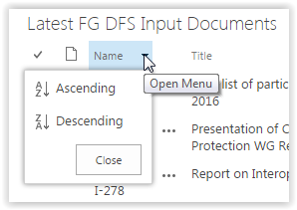
- To filter via Meetings, click on Meeting and select the Meeting/s you wish to be filtered. Only the documents from the Meetings you selected will be displayed. To reset, click on Clear Filters from Meeting.
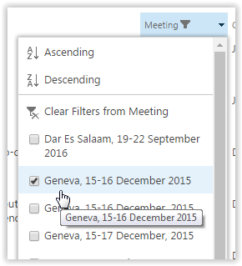
- To filter and/or sort via Source, click on Source and apply the sorting and filtering you need. To reset, click on Clear Filters from Source.
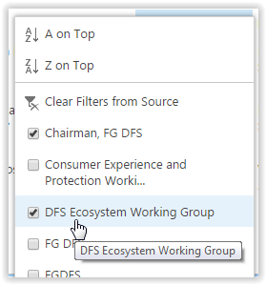
Office Client Minimum Software Requirements
- Office 2010 or Office 2013
For full offline and integrated experience

